LAB REPORT: Junior Security Analyst Intro

📌 Basic Information
- Platform: TryHackMe
- Room Name: Junior Security Analyst Intro
- Date Completed: June 2026
- Time Spent: 1hr
- Score: 100%

🎯 Learning Objectives
What you wanted to learn:
- Understand what a Junior Security Analyst role is
- Learn the daily responsibilities of entry – level security anaysts
- Identify required skills for junior security positions
- Understand career progression in cybersecurity

📖 Key Concepts Learned
- What a Junior Security Analyst does
Entry – level cybersecurity role
Monitor security systems and respond to alerts
Log analysis, incident triage, documentation
- Required skills for entry-level
TECHNICAL SKILLS:
- TCP.IP, DNS
- Operating systems (Windows, Linux)
- Security tools (SIEM, IDS, firewalls)
- Log anaysis and incident response
SOFT SKILLS:
- Communication skills for reporting incidents
- Problem solving abilities
- Attention to details
- Career path
Entry level -> Mid level -> Senior level:
- Junior Security Analyst (0-2 years)
- Security Analyst (2-4 years)
- Senior Security Analyst (4-7 years)
- [FILL: Add more levels from the room]
Alternative Paths:
- Penetration Tester
- Security Engineer
- Incident Response Specialist
- Responsibilities
- Monitor SIEM alerts continuously
- Triage security incidents
- Document findings in ticketing system
- Escalate confirmed threats to senior analysts
- Participate in security team meetings

📸 Screenshots
- Task Completion
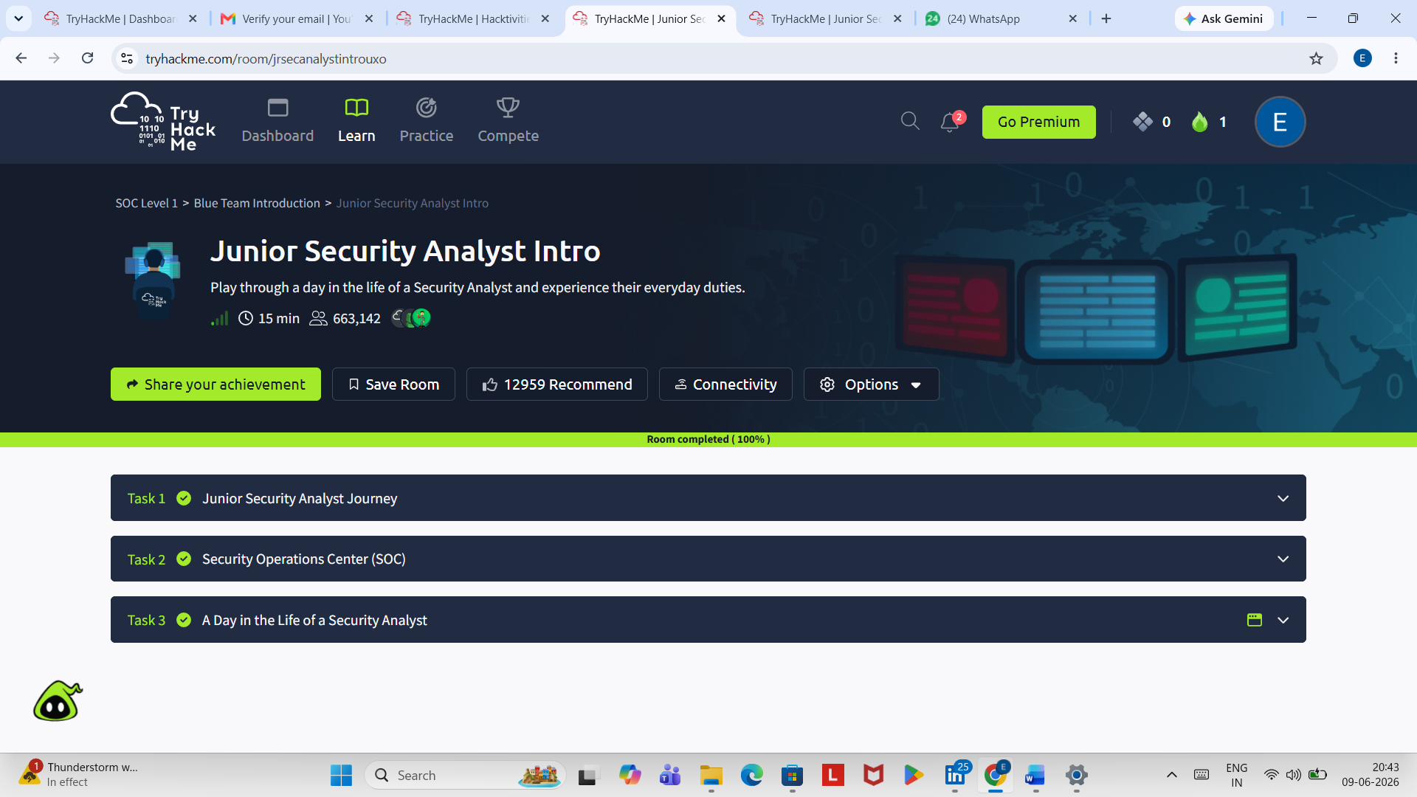

- Room Progress
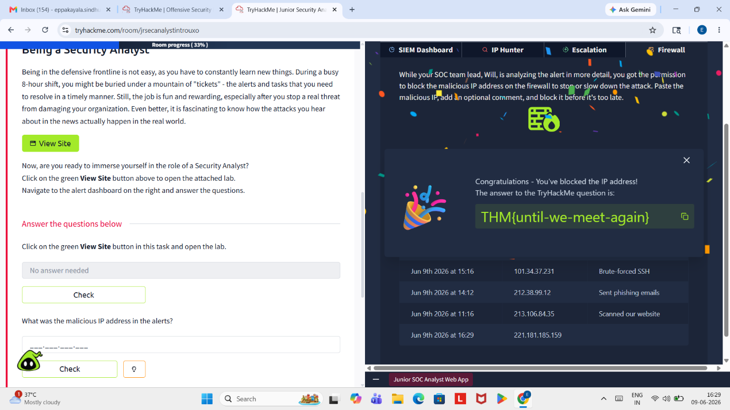

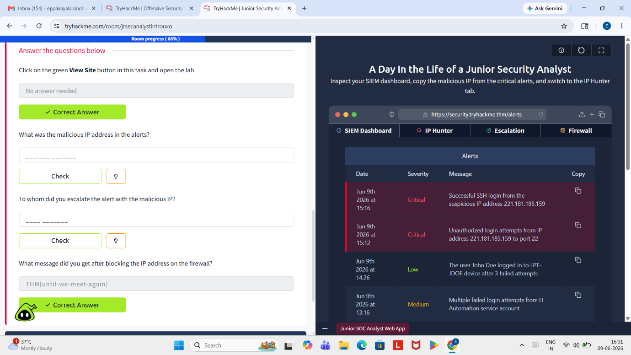

- Key Concepts from the room
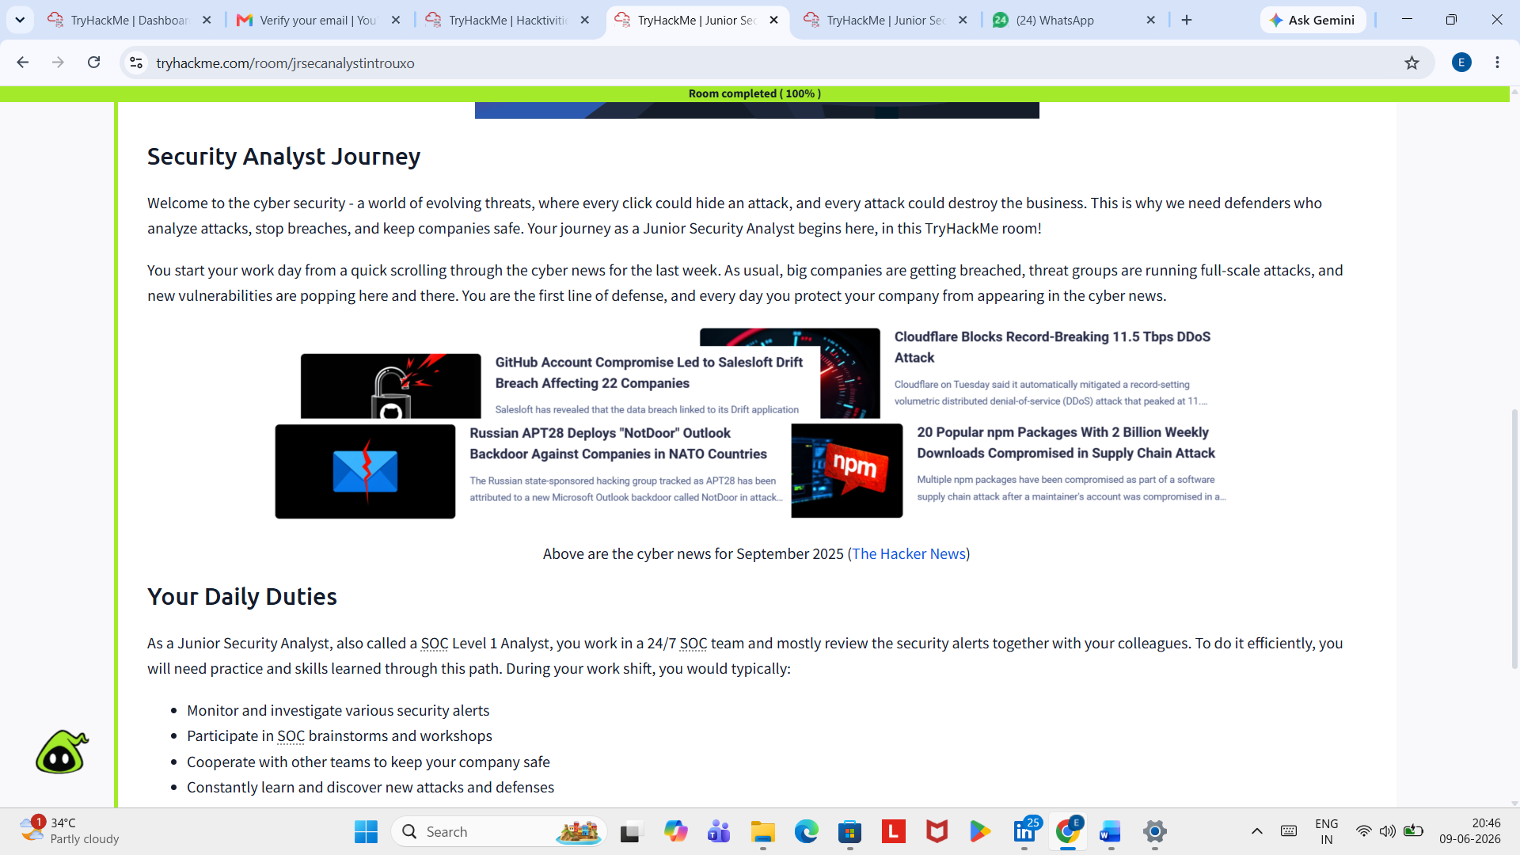

💡 Key Takeaways
From this lab, I learned:
- Junior Security Analyst is the entry-level role in cybersecurity
- Daily work includes monitoring alerts, triaging incidents, and documentation
- Required skills: networking, OS knowledge, SIEM tools
- Career path: Junior → Analyst → Senior → Specialist/Manager

📚 Additional Resources
─────────────────────────────────────────────
- TryHackMe Room: [Junior Security Analyst Intro] (https://tryhackme.com/room/jrsecanalystintrouxo )

🏆 Self-Assessment
─────────────────────────────────────────────
Confidence Level: ⭐⭐⭐⭐☆
Understanding: I understand junior analyst basics, but need hands-on practice with tools
Next Steps: Complete SOC Role in Blue Team lab next

📝 Notes for Future Reference
─────────────────────────────────────────────
- This was one of my first SOC labs on TryHackMe
- All tasks completed successfully (100%)
- Ready to move to next lab: SOC Role in Blue Team

Author: Sindhu Eppakayala
Date: 09-06-2026

