LAB REPORT: SOC Role in Blue Team

📌 Basic Information
─────────────────────────────────────────────
Platform: TryHackMe
Room Name: SOC Role in Blue Team
Room URL: https://tryhackme.com/room/soc-fundamentals
Date Completed: June 9, 2026
Time Spent: 1hr
Difficulty Level: Beginner
My Score: 100%

🎯 Learning Objectives
─────────────────────────────────────────────
What I wanted to learn from this lab:
1. Understand what a SOC (Security Operations Center) is
2. Learn the role of SOC Analysts in cybersecurity
3. Understand the difference between Blue Team and Red Team
4. Learn about SOC Analyst tiers (Tier 1, Tier 2, Tier 3)

📖 Key Concepts Learned
─────────────────────────────────────────────
- What is a SOC?
- SOC = Security Operations Center
- A centralized team that monitors, detects, and responds to cyber threat
- Works 24/7 to protect an organization's systems and data
- Primary function: Proactive threat monitoring and incident response

2. SOC Analyst Roles (By Tier)
Tier 1 SOC Analyst (Entry Level):
- Performs basic alert triage
- Determines if a detection is harmful or false positive
- Reports detections through proper channels
- Escalates confirmed incidents to Tier 2
- MY ROLE: This is what I'm training for

Tier 2 SOC Analyst (Intermediate):
- Investigates complex incidents escalated by Tier 1
- Performs deeper analysis and threat hunting
- Creates incident response reports

Tier 3 SOC Analyst (Expert):
- Handles advanced threats and incidents
- Designs security architecture
- Mentors Tier 1 and Tier 2 analysts

- Blue Team vs Red Team
Blue Team | Red Team
Defensive security | Offensive security
Protects systems | Simulates attacks
SOC, DFIR, Threat Detection | Penetration Testing, Ethical Hacking
Defenders | "Attackers" (authorized)

Key Point: SOC Analysts are part of the Blue Team

4. Security Operations Workflow
1. Monitor → Continuous monitoring of systems/networks
2. Detect → Identify suspicious activity/anomalies
3. Triage → Determine if alert is real threat or false positive
4. Investigate → Analyze the incident deeper
5. Respond → Contain and remediate the threat
6. Report → Document findings and lessons learned

## 🛠️ Tools & Technologies Mentioned
─────────────────────────────────────────────
- SIEM (Security Information and Event Management) → Log analysis
- IDS/IPS (Intrusion Detection/Prevention Systems) → Network monitoring
- EDR (Endpoint Detection and Response) → Device security
- Firewalls→ Network traffic control
- Ticketing Systems → Incident documentation

## 📸 Screenshots
─────────────────────────────────────────────
- Task completion

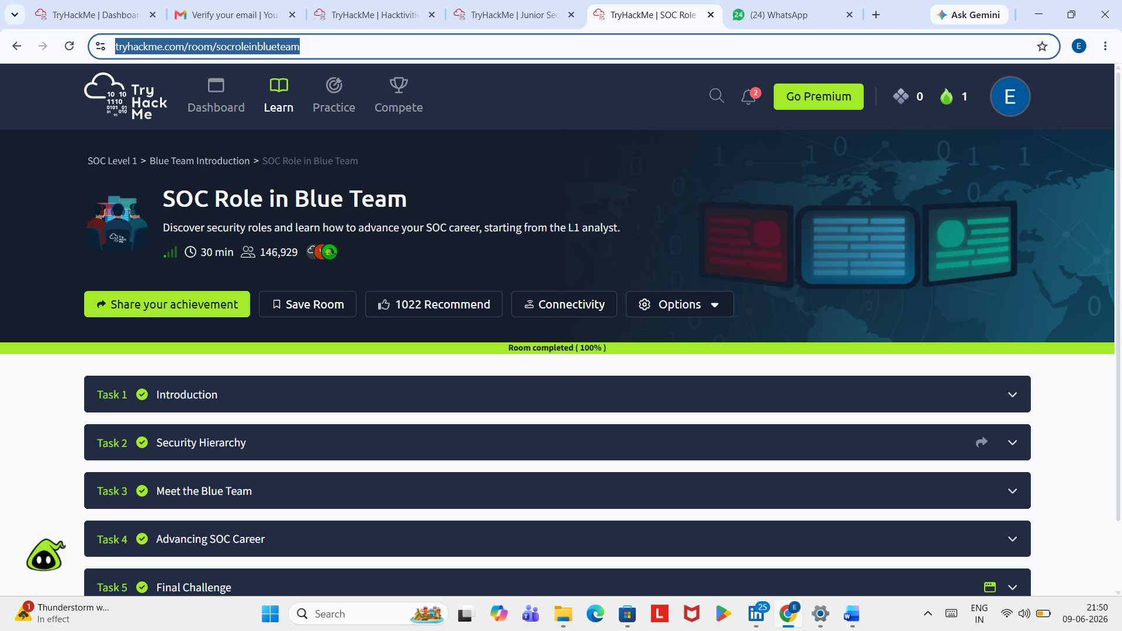

2. Room progress
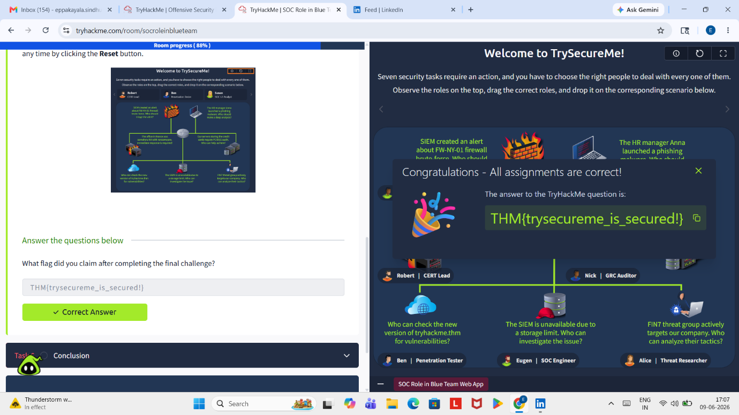

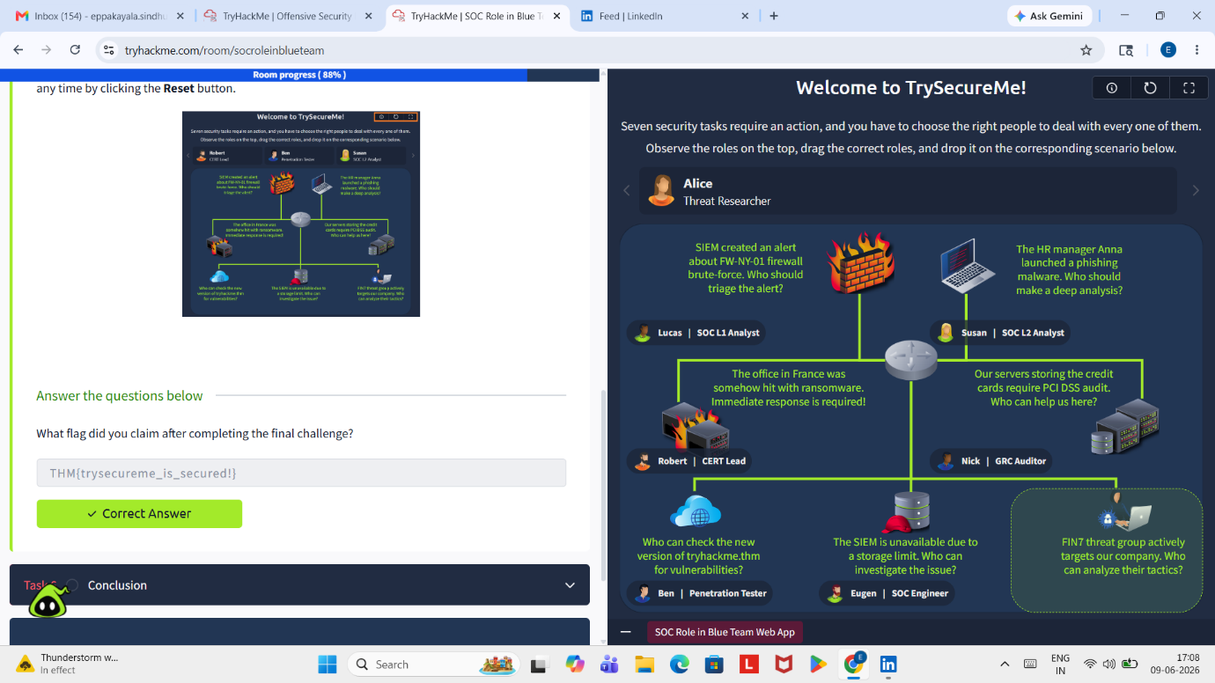

Key Concepts
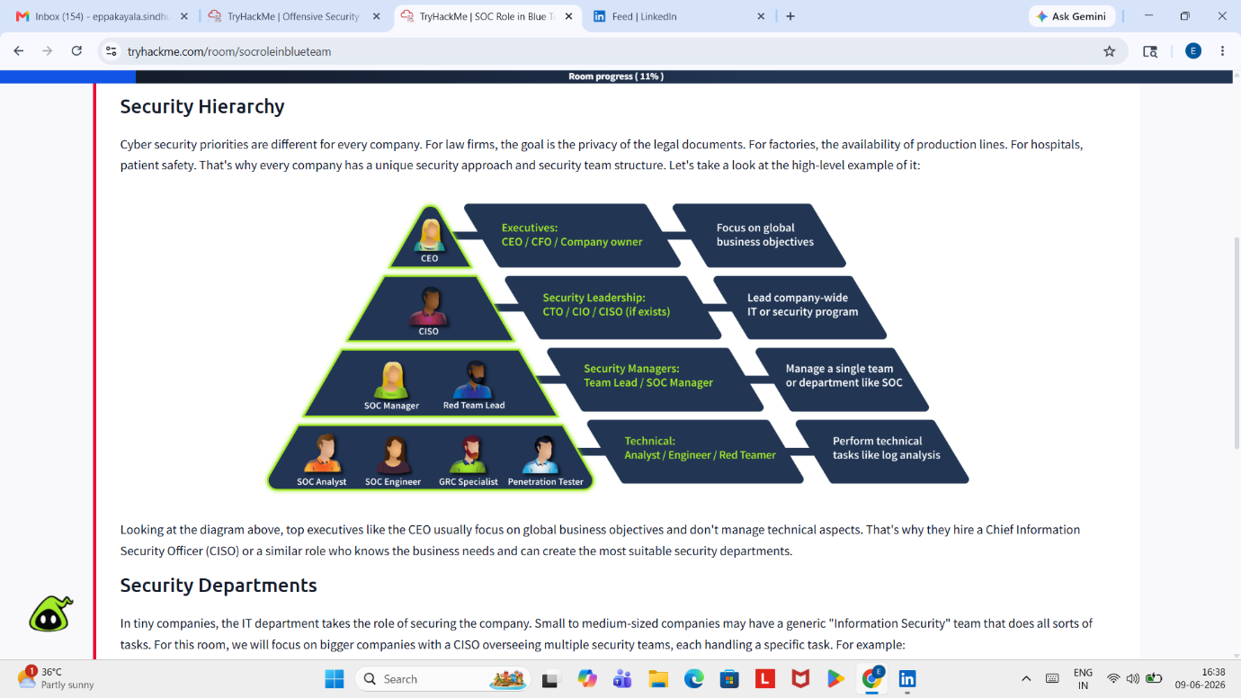

## 💡 Key Takeaways
─────────────────────────────────────────────
From this lab, I learned:
1. SOC L1 Analysts perform basic alert triage to determine if detections are harmful
2. They report detections through proper channels (ticketing systems, escalation)
3. SOC is part of Blue Team (defensive security)
4. SOC operates 24/7 for continuous protection
5. There are 3 tiers of SOC Analysts (Tier 1 = Entry, Tier 2 = Intermediate, Tier 3 = Expert)

## 📚 Additional Resources
─────────────────────────────────────────────
- TryHackMe Room: [SOC Role in Blue Team] (https://tryhackme.com/room/soc-fundamentals)

## 🏆 Self-Assessment
─────────────────────────────────────────────
Confidence Level: ⭐⭐⭐⭐☆ (4/5)
Understanding: I understand SOC basics well, but need hands-on practice with SIEM tools
Next Steps: Complete Defensive Security Intro lab to practice defensive concepts

📝 Notes for Future Reference
─────────────────────────────────────────────
- This was my second SOC lab on TryHackMe
- All tasks completed successfully (100%)
- Ready to move to next lab: Defensive Security Intro

Author: Sindhu Eppakayala
Date: 09-06-2026

