LAB REPORT: Introduction to SIEM

📌 Basic Information
─────────────────────────────────────────────
Platform: TryHackMe
Room Name: Introduction to SIEM
Room URL: https://tryhackme.com/room/introtosiem
Date Completed: June 13, 2026
Time Spent: 1.5 hours
Difficulty Level: Beginner
My Score: 100%

🎯 Learning Objectives
─────────────────────────────────────────────
What I wanted to learn from this lab:
1. Understand what SIEM (Security Information and Event Management) is
2. Learn the capabilities and functions of SIEM tools
3. Understand what visibility SIEM provides for security monitoring
4. Learn how SIEM is used for threat detection

📖 Key Concepts Learned
─────────────────────────────────────────────
- What is SIEM?
- SIEM = Security Information and Event Management
- [FILL: What you learned - e.g., "Tool that collects data from endpoints and network devices"]
- [FILL: e.g., "Provides visibility across the entire network"]
- [FILL: Add more from the room]

2. SIEM Capabilities
- What SIEM Does:
- Collects logs from various sources (servers, firewalls, endpoints)
- Correlates events to detect patterns
- Generates alerts for suspicious activity
- Provides real-time monitoring

- SIEM Visibility:
- Network traffic monitoring
- User authentication logs
- System performance data
- Security event detection

3. How SIEM Works
- SIEM Workflow:
1. Collection → Collects logs from endpoints/network devices
2. Correlation → Links related events together
3. Analysis → Analyzes patterns for threats
4. Alerting → Generates alerts for suspicious activity
5. Reporting → Creates reports for compliance

4. SIEM in SOC Operations
- Role in SOC:
- SOC analysts use SIEM for continuous monitoring
- SIEM alerts help detect threats quickly
- Centralized log management for investigation

🛠️ Tools & Technologies Mentioned
─────────────────────────────────────────────
- Splunk
- Elastic Stack (ELK)

📸 Screenshots
─────────────────────────────────────────────
- Task completion

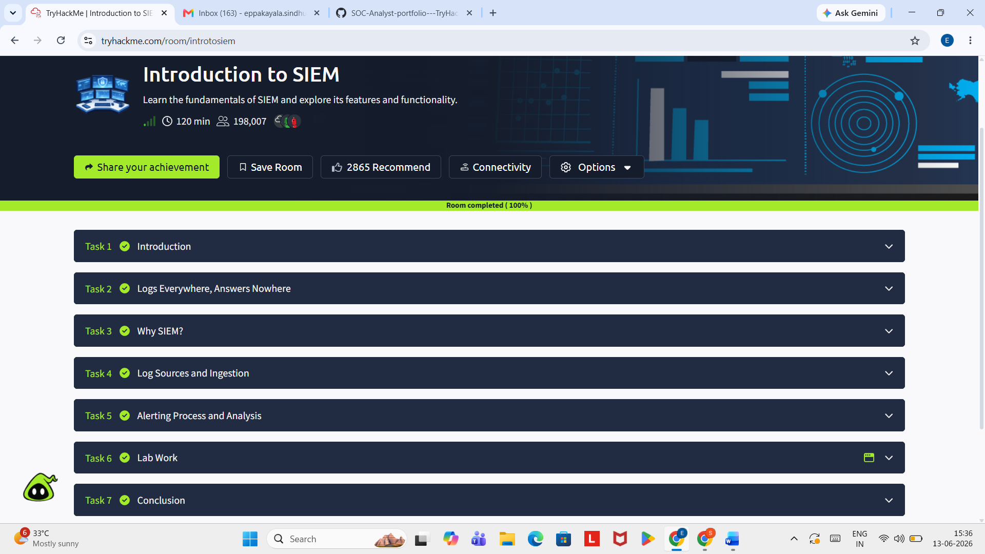

2. SIEM dashboard

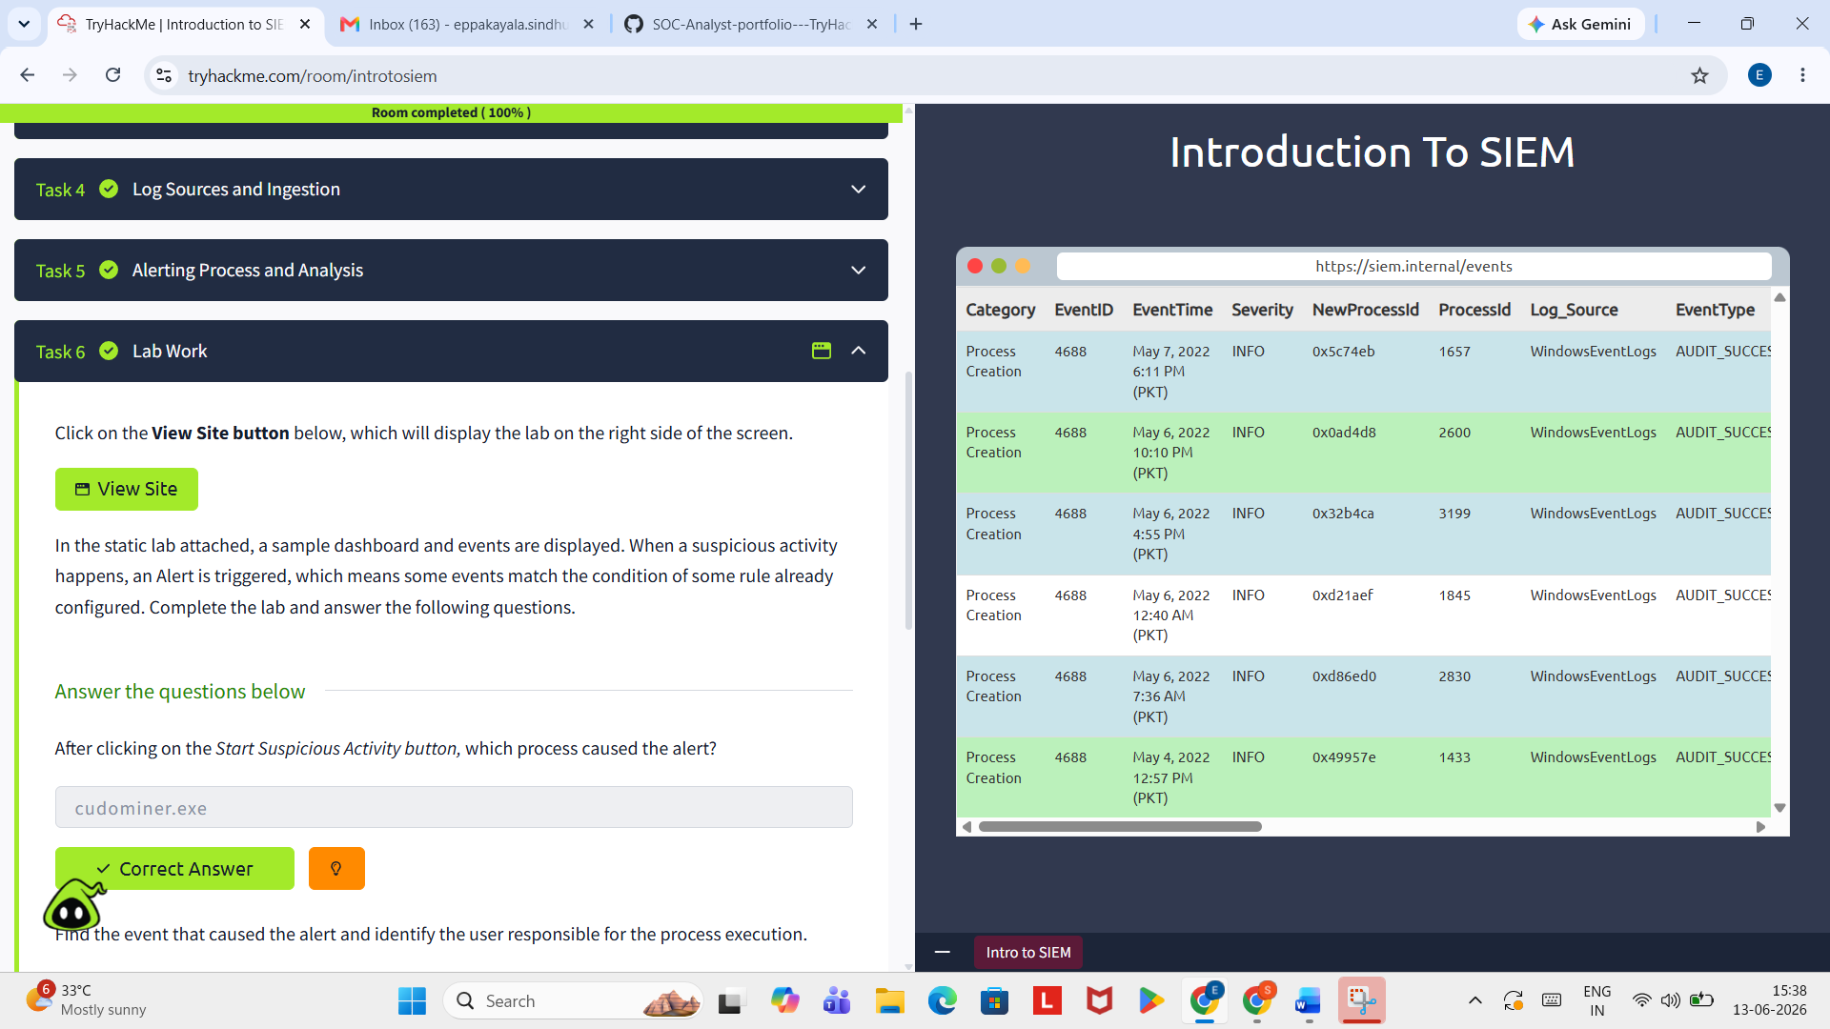

3. Key concepts from the room

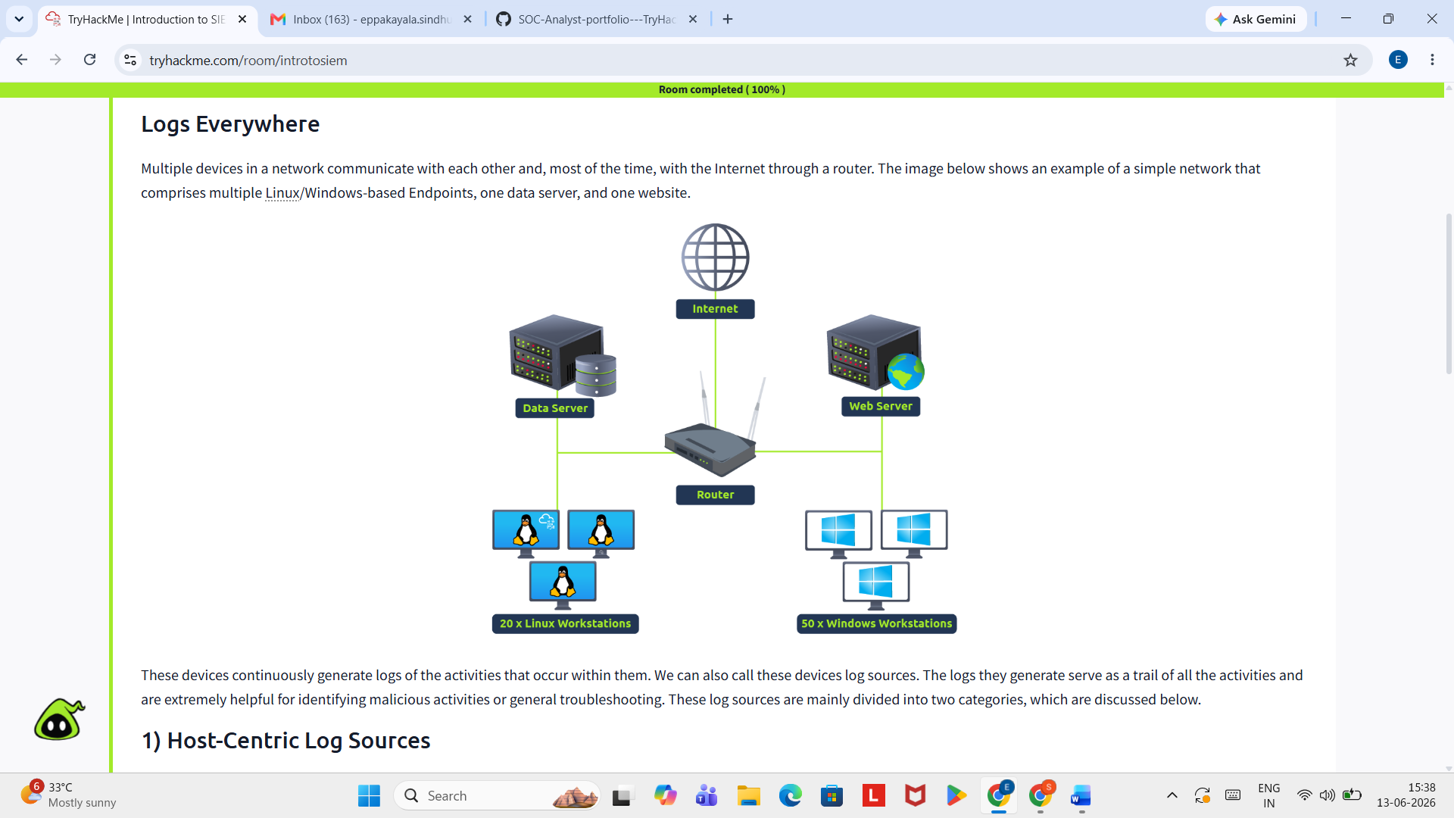

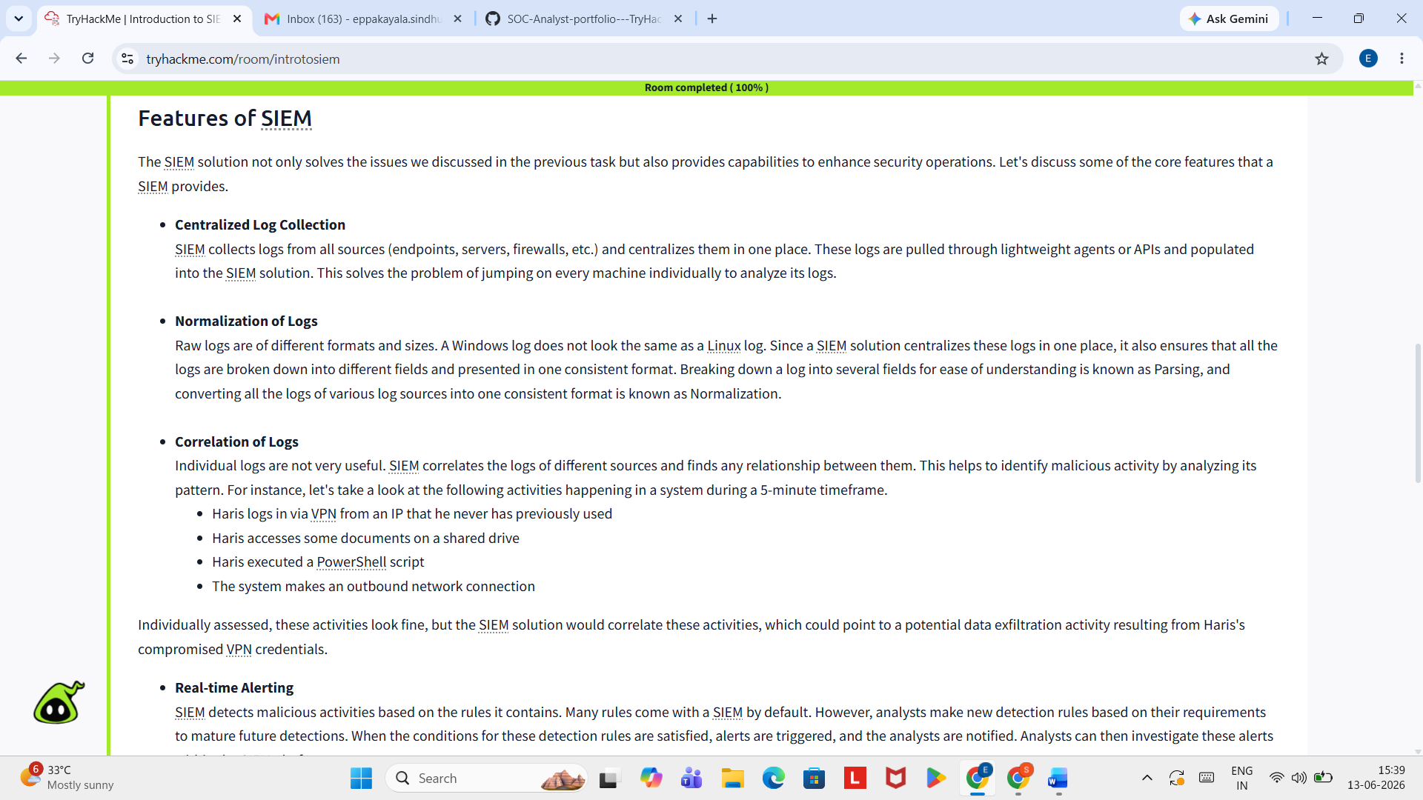

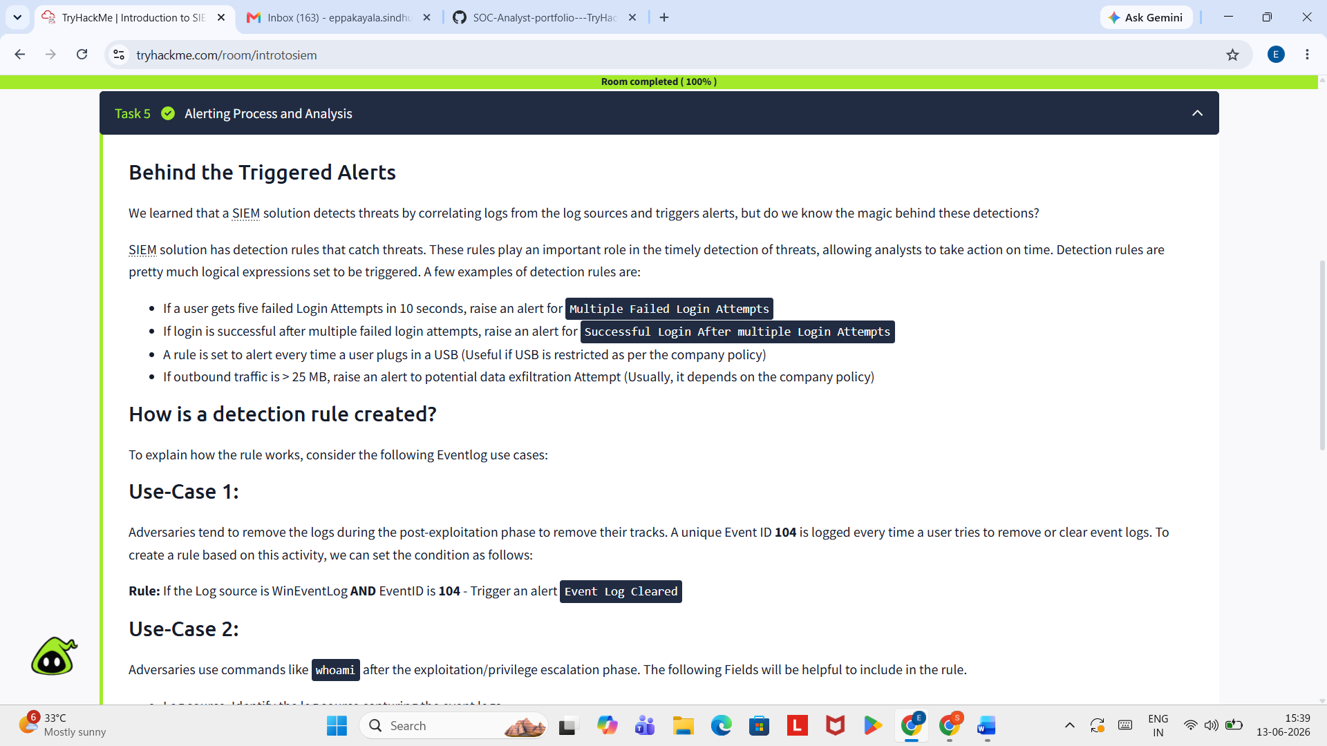

💡 Key Takeaways
─────────────────────────────────────────────
From this lab, I learned:
1.SIEM = Security Information and Event Management
2. SIEM collects logs from endpoints and network devices
3. SIEM provides visibility across the entire network
4. SIEM correlates events to detect suspicious patterns
5. SOC analysts use SIEM for continuous threat monitoring

📚 Additional Resources
─────────────────────────────────────────────
- TryHackMe Room: [Introduction to SIEM] (https://tryhackme.com/room/introtosiem)

🏆 Self-Assessment
─────────────────────────────────────────────
Confidence Level: ⭐⭐⭐⭐☆ [FILL: Rate 1-5 stars]
Understanding: I understand SIEM basics
Next Steps: Introduction to EDR

📝 Notes for Future Reference
─────────────────────────────────────────────
- This was my 4th SOC lab on TryHackMe
- All tasks completed successfully (100%)
- Ready to move to hands-on SIEM: Introduction to EDR

Author: Sindhu Eppakayala
Date: June 13, 2026

