A COMMUNITY SERVICE PROJECT REPORT ON

Organic Farming

Submitted in partial fulfilment for the award of the degree of

BACHELOR OF TECHNOLGY

IN

Computer Science and Engineering

BY

INDUKURI MEGHA SINDHU

22A81A05F3

Under the Esteemed Supervision of

Mrs.D.S.L MANIKANTESHWARI

Assistant Professor

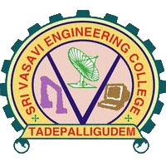

Department of computer science and Engineering (Accredited by N.B.A)

SRI VASAVI ENGINEERING COLLEGE(Autonomous)

(Affiliated to JNTUK, Kakinada) Pedatadepalli,

Tadepalligudem-534101, AP

2022-2023

SRI VASAVI ENGINEERING COLLEGE

(Autonomous)

Department of Computer Science and Engineering

Pedatadepalli, Tadepalligudem





This is to certify that the Community Service Project Report entitled “ORGANIC FARMING” survey done in UNDRAJAVARAM village, submitted by Megha Sindhu Indukuri(22A81A05F3) , for the award of the degree of Bachelor of Technology in the Department of Computer Science and Engineering during the academic year 2022-2023

Name of the project guide Head of the Department

Mrs.D.S.L Manikanteshwari Dr.D.Jaya Kumari

Assistant Professor Professor and HOD

# ACKNOWLWDGEMENT

First and foremost, we sincerely salute to our esteemed institute SRI VASAVI ENGINEERING COLLEGE, for giving us this golden opportunity to fulfill our warm dream to become an engineer. Our sincere gratitude to our project guide Mrs.D.S.L Manikanteshwari, Assistant Professor, Department of Computer Science and Engineering, for his timely cooperation and valuable suggestions while carrying out this project.

We express our sincere thanks and heart full gratitude to Dr. D. Jaya Kumari, M.Tech, Ph.d, Professor & Head of the Department of Computer Science and Engineering, for permitting us to do our project. We express our sincere thanks and heart full gratitude to Dr. G.V.N.S.R. Ratnakara Rao, Principal, for providing a favorable environment and supporting us during the development of this project.

Our special thanks to the management and all the teaching and non-teaching staff members, Department of Computer Science and Engineering, for their support and cooperation in various ways during our project work. It is our pleasure to acknowledge the help of all those respected individuals.

We would like to express our gratitude to our parents, friends who helped to complete this project.

Megha Sindhu Indukuri

(22A81A05F3)

SRI VASAVI ENGINEERING COLLEGE

(AUTONOMOUS)

Department of Computer Science and Engineering

Pedatadepalli, Tadepalligudem

(2022-2023)

Community Service Project for the UG Program

Academic Performance Improvement

Name of the Student : Megha Sindhu Indukuri

Regd No : 22A81A05F3

Branch : CSE

Semester : II

Topic : ORGANIC FARMING

Area : Undrajavaram

Project Guide : Mrs.D.S.L Manikanteswari

Asst.Professor

(Student) (Project Guide)

Mrs.D.S.L Manikanteshwari

Asst.Professor

contents

* Introduction
* Importance of Organic Farming
* Main Principals of Organic Farming
* Awareness program & Photographs of Survey
* Suggestions
* Conclusion

INTRODUCTION

In every student’s Course work in college, community service is considered crucial as it gives the student a clear picture of outside world. Community service calls as volunteer work. It helps students to develop civic and social responsibility skills and become more aware of what their community needs. We also done community service project by the guidance of our mentor and I have chosen topic is “ORGANIC FARMING”. To do survey near our community area.

Organic farming can be defined as agricultural system that uses ecologically based pest controls and biological fertilizers derived largely from animal and plant wastes and nitrogen-fixing cover crops. Modern organic farming was developed as a response to the environmental harm caused by the use of chemical pesticides and synthetic fertilizers in conventional agriculture, and it has numerous ecological benefits.

Organic farming which is a holistic production management system that promotes and enhances agro-ecosystem health, including biodiversity, biological cycles, and soil biological activity is hence important.

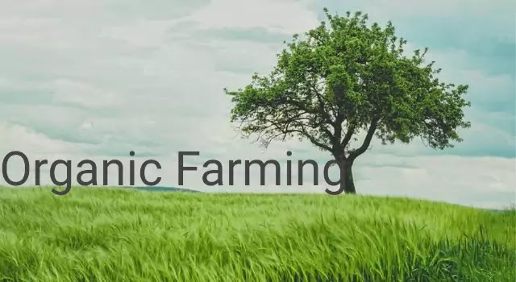

Types of Organic Farming:

Organic farming is divided into two types, namely:

1.Integrated Organic Farming.

2.Pure Organic Farming.

Pure organic farming means avoiding all unnatural chemicals. Integrated organic farming includes the integration of pest management and nutrients management to achieve ecological requirements and demands.

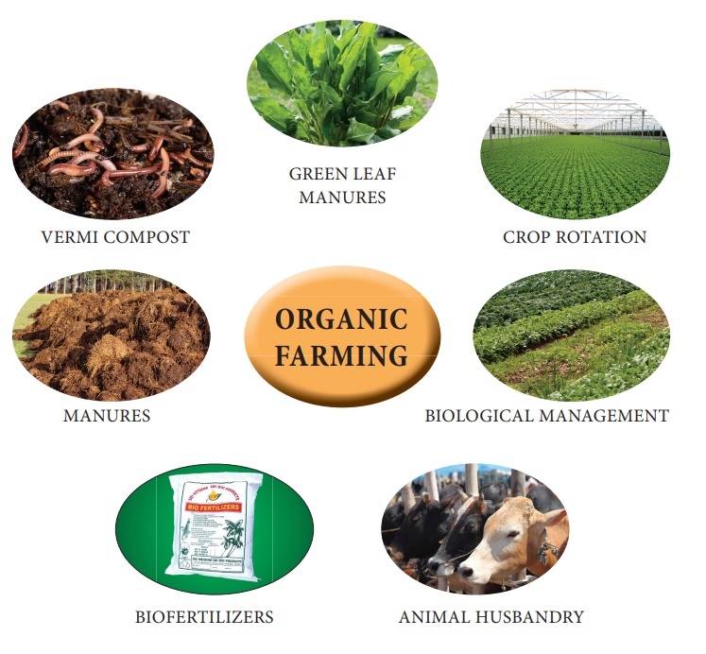

Importance of organic farming

India is a country endowed with indigenous capabilities and the potential for organic agricultural expansion. Despite being behind the curve in the adoption of organic farming for a variety of reasons, India has experienced significant development in organic agriculture and is currently one of the world’s major organic producers.

• It doesn't bring about any ecological contamination since it evades the utilization of substance and plant insurance synthetic compounds.

• Less energy is utilized in organic cultivating contrasted with ordinary horticulture.

• Soil is on better condition as manure is used.

• Less unsettling influence of soil, legitimate structure, high organic issue substance will be kept up.

• Provides healthier food for the people.

Main principles of organic farming

The following are the fundamental principles of organic farming these are the roots from which organic agriculture grows and develops. They express the contribution that organic agriculture can make to the world, and a vision to improve all agriculture in a global context.

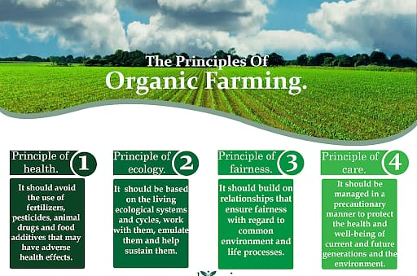

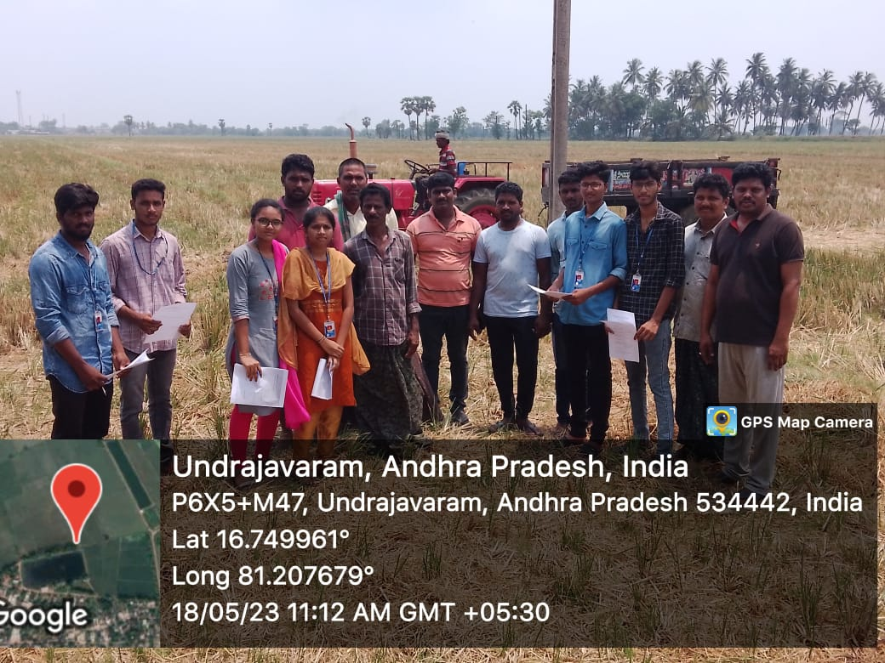

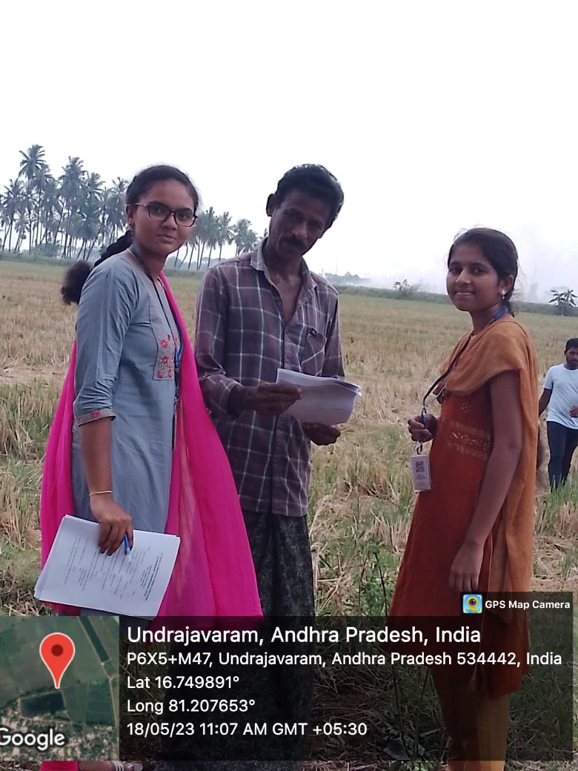

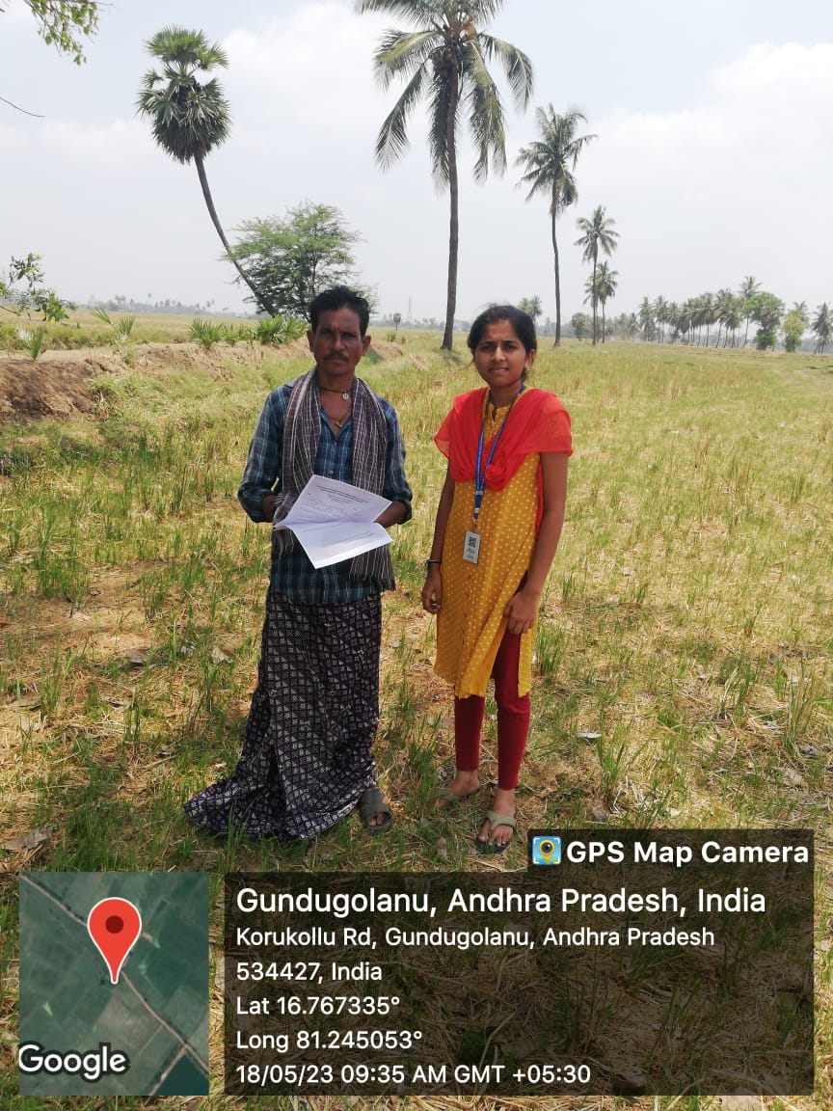

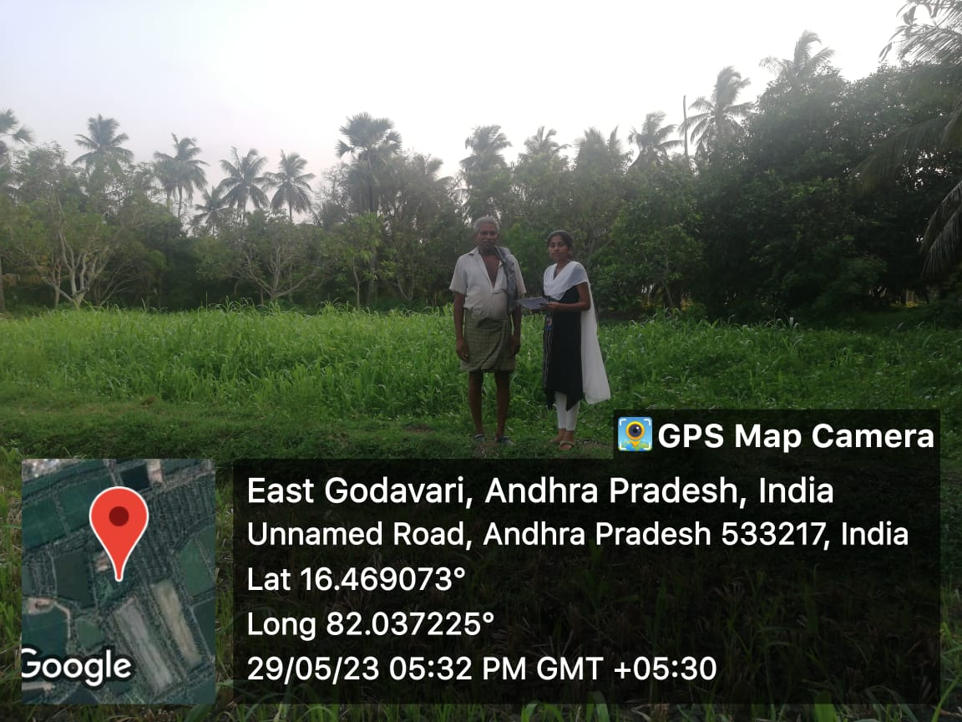

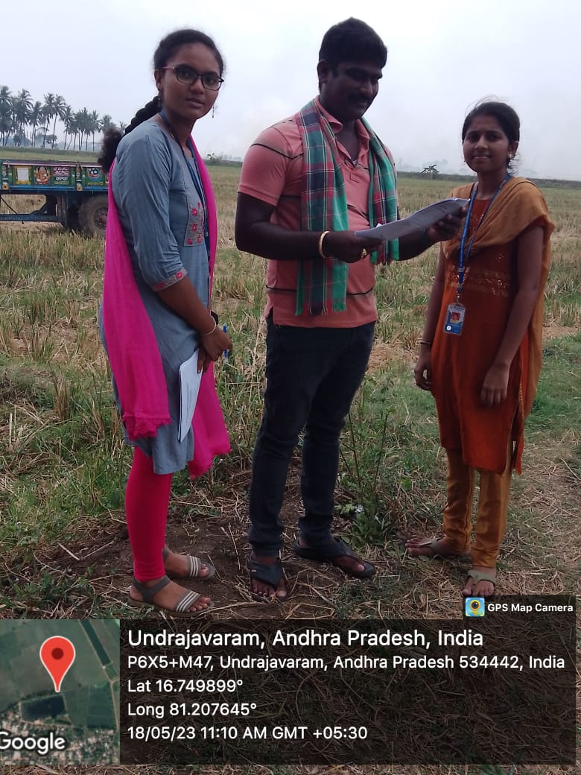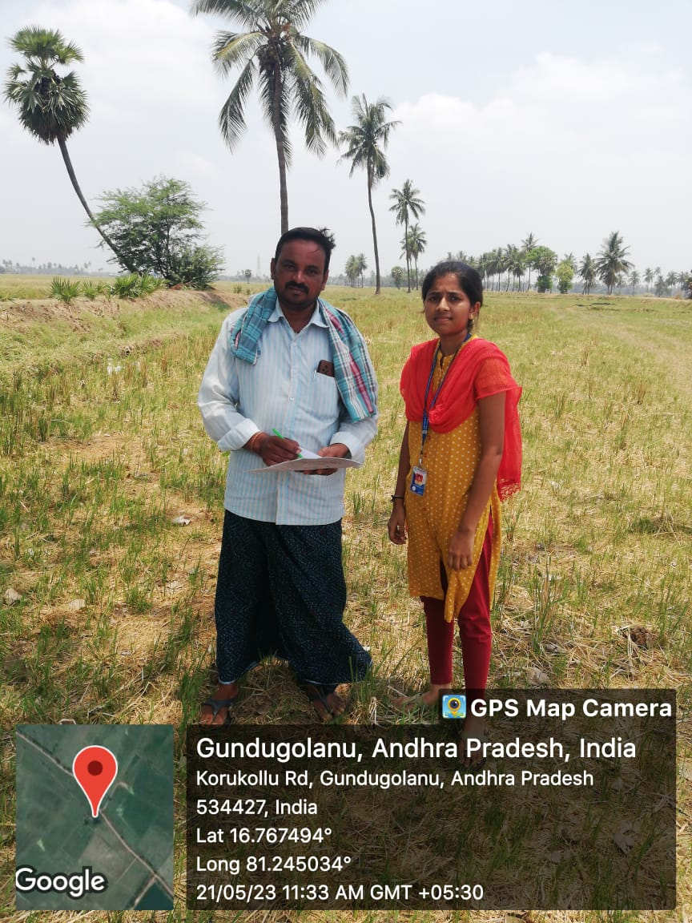

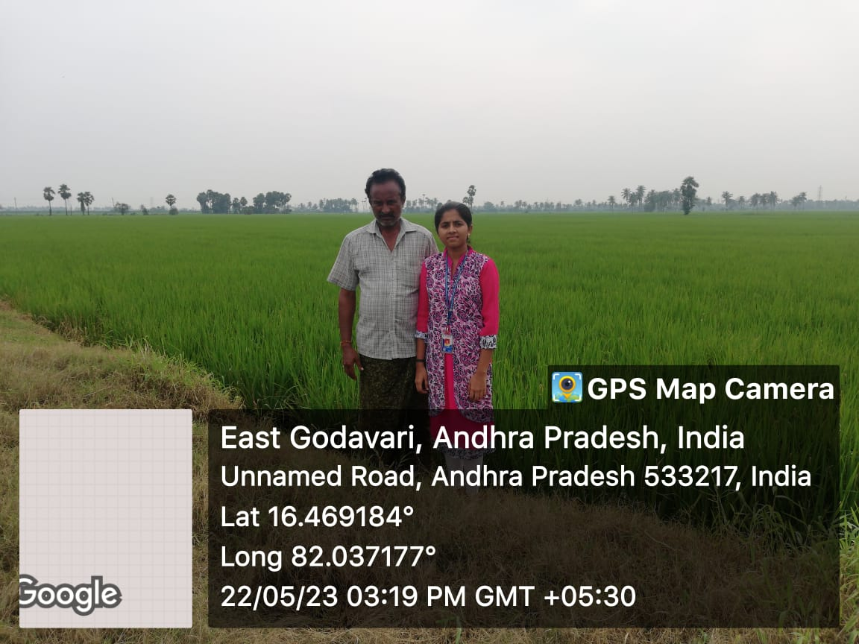

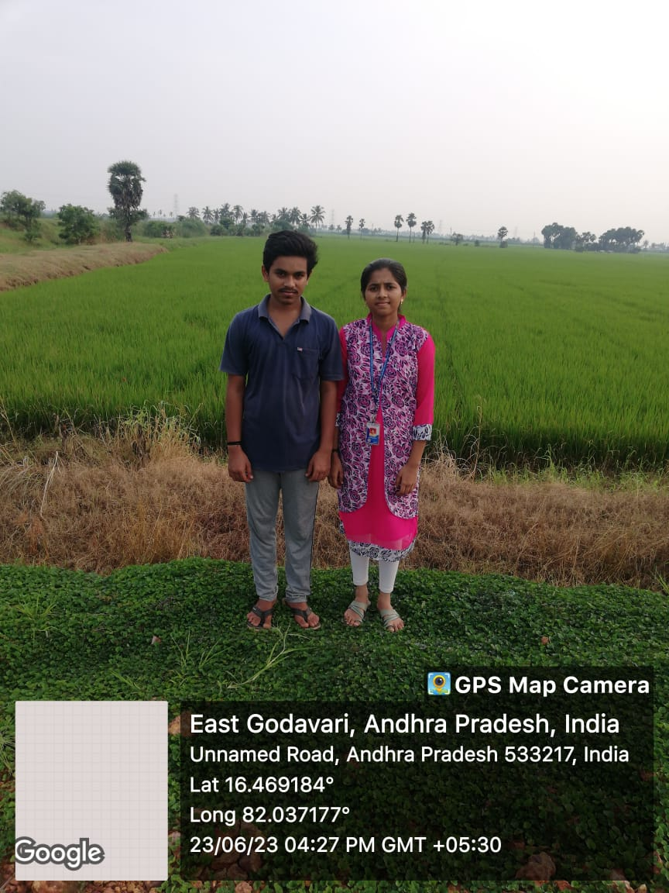

Impact on the environment

In terms of environmental protection, organic farming has a protective function. The environmental impact of organic and conventional agriculture has been thoroughly researched. Organic farming is thought to be less hazardous to the environment since synthetic pesticides are prohibited, the majority of which are potentially harmful to water, soil, and local terrestrial and aquatic fauna. Furthermore, owing to crop rotation procedures, organic farms are better at preserving biodiversity than conventional farms. When compared to conventional farming, organic farming enhances soil physical-biological qualities such as organic matter, biomass, greater enzyme, improved soil stability, enhanced water percolation, holding capacity, reduced water, and wind erosion. Thus, it is extremely important to find a sustainable approach to farming that organizations like Kisaan Mitrr help to achieve. Kisaan Mitrr provides an in-depth cost-benefit ratio, DPR and other utilities necessary for achieving sustainability.

SUGGESTIONS

1. Crop Diversity: Now a days a new practice has come into picture which is called -Polyculture- in which a variety of crops can be cultivated simultaneously just to meet the increasing demand of crops. Unlike the ancient practice which was -Monoculture- in which only one type of crop was cultivated in a particular location.

2. Soil Management: After the cultivation of crops, the soil loses its nutrients and its quality depletes. Organic agriculture initiates the use of natural ways to increase the health of soil. It focuses on the use of bacteria that is present in animal waste which helps in making the soil nutrients more productive to enhance the soil.

3. Weed Management: -Weed-, is the unwanted plant that grows in agricultural fields. Organic agriculture pressurizes on lowering the weed rather than removing it completely.

4. Controlling other organisms: There are both useful and harmful organisms in the agricultural farm which affect the field. The growth of such organisms needs to be controlled to protect the soil and the crops. This can be done by the use of herbicides and pesticides that contain less chemicals or are natural. Also, proper sanitization of the entire farm should be maintained to control other organisms.

5. Livestock: Organic farming instigates domestic animals use to increase the sustainability of the farm.

6. Genetic Modification: Genetic modification is kept away from this kind of agricultural set up because organic farming focuses on the use of natural ways and discourages engineered animals and plants.

CONCLUSION

Organic farming is an essential part of today’s world. Organic cultivating implies cultivating in the organic connection between soil, water, and plants; between soil, soil organisms, and side-effects. Nature receives diverse techniques to gracefully supplement the dirt and keep up the soil’s fruitfulness. The gracefulness of supplements is undisrupted in nature. The plant leaves produce carbs and later change these carbohydrates into sugar, starch, cellulose, lignin, and so on.

Through organic farming, the fertility of soil gets improved. Organic movement and the physical and mineral nature of the dirt are contributing factors. Organic farming is preferred over other modes for this very reason.

Organic farming is a great alternative to conventional farming practices. It follows eco-friendly agricultural practices without making use of harmful chemicals. It helps in maintaining human health as well as protects our environment from harmful chemicals used to raise crops in a field. Going organic is a great way of preventing chemicals and protecting our health and environment but there are a lot of challenges in this field. Due to the high price of organic food, people are not yet accepting the use of organic food. The other challenge in the field of organic farming is to meet the world’s demand for food as the growth of organic crops is slow.

PROJECT LOG BOOK

|  |  |
| --- | --- |
| Student name | MEGHA SINDHU INDUKURI |
| Regd.no | 22A81A05F3 |
| Branch | CSE |
| Year | 2022-2023 |
| Title | ORGANIC FARMING |
| Guide Name | Mrs.D.S.L MANIKANTESWARI |

|  |  |  |  |  |  |
| --- | --- | --- | --- | --- | --- |
| S.No | DATE | Guidance Given | Student activities | Target Achieved | Signature of Guide |
|  |  |  |  |  |  |
|  |  |  |  |  |  |
|  |  |  |  |  |  |
|  |  |  |  |  |  |
|  |  |  |  |  |  |
|  |  |  |  |  |  |
|  |  |  |  |  |  |

Project guide Project coordinator Head of Department