1. Ordinal Position in SQL

Ordinal position refers to the relative position or order of rows or columns within a dataset when a specific order is applied.
It describes where a record stands compared to others after sorting.
In real-world systems, data is almost always consumed in an ordered way. Businesses care about top performers, latest records,highest values, and priority-based results. Ordinal position helps represent this ordering in a meaningful way.
At the row level, ordinal position helps :
- Who is first, second, or third based on a metric.
- Which record is the most recent or the oldest.
- How do tied values behave in rankings.
In real-time projects, ordinal positioning is used in:
- Student ranking systems
- Employee performance reports
- Sales leaderboards
- Financial and analytical dashboards
Ordinal position can also apply to columns, where it represents the physical position of a column within a table.
This is mainly useful for internal processing, ETL tools, and schema validations..

2. Common Table Expression (CTE)
A Common Table Expression (CTE) is a temporary result set in SQL that you can reference within a single query. CTEs simplify complex queries, make them easier to read, and can be reused multiple times within the same query. It is used for:
- Split big queries into smaller, reusable pieces.
- Makes the query easier to read and understand.
- Can handle recursive queries, useful for things like employee–manager hierarchies.
.
It allows complex logic to be broken into clear, readable steps.
CTEs were introduced to solve the problem of deeply nested and unreadable queries.
Instead of writing complex subqueries, developers can define logical steps and give them meaningful names.

WITH cte_name AS (SELECT columns FROM table_name)
SELECT * FROM cte_name;

3. Information Schema
Information Schema is a system-defined metadata repository that stores information about database objects.
It does not store business data; instead, it stores data about the structure of the database.
Metadata includes:
- Database names
- Table names
- Column names and data types
- Constraints and keys
- Indexes, views, and procedures
Information Schema allows developers and systems to query database structure using SQL itself.
This is essential for automation, validation, auditing, and migrations.
In real-time projects, Information Schema is used in:
- ETL pipelines
- Data quality validation
- Schema comparison and migration
Before performing critical operations such as bulk loads or schema changes, systems often consult Information Schema
to ensure required objects exist and are correctly defined.
Information Schema is read-only because it reflects the actual state of the database.
It provides a reliable and consistent way to inspect database structure without risking modification.

SYNTAX:
SELECT column1, column2, ...
FROM INFORMATION_SCHEMA.table_name
WHERE condition;

3.1 List Databases
Select schema_name From information_schema.schemata;

3.2 List Tables in a Database
Select table_name from information_schema.tables
where table_schema = “database_name”;

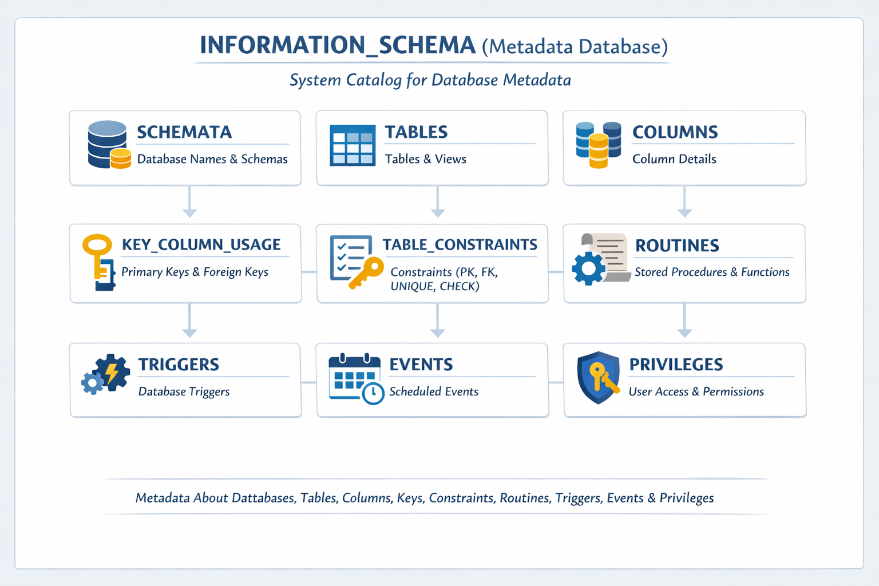
Conclusion
Ordinal Position explains how data is ordered and ranked.
CTE explains how complex logic is structured and made readable.
Information Schema explains how a database describes itself.

