**OUTPUTS:**

Now double click on ‘run.bat’ file to run project and to get below screen

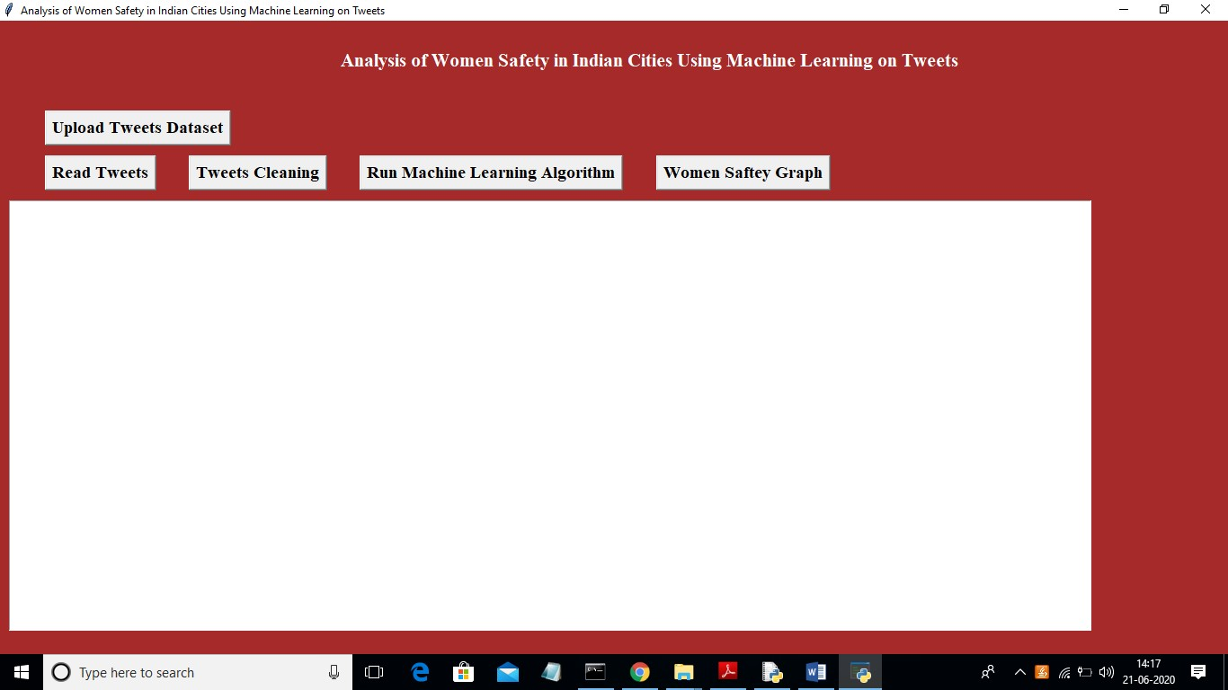

In above screen click on ‘Upload Tweets Dataset’ button and upload tweets

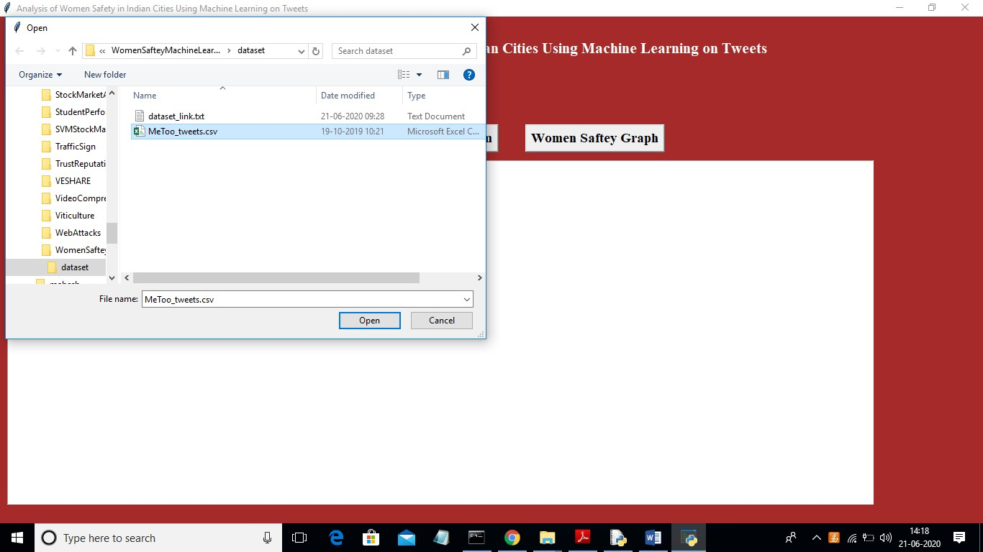

In above screen uploading MeeToo_tweets.csv files and then click on ‘Open’ button to load dataset and to get below screen

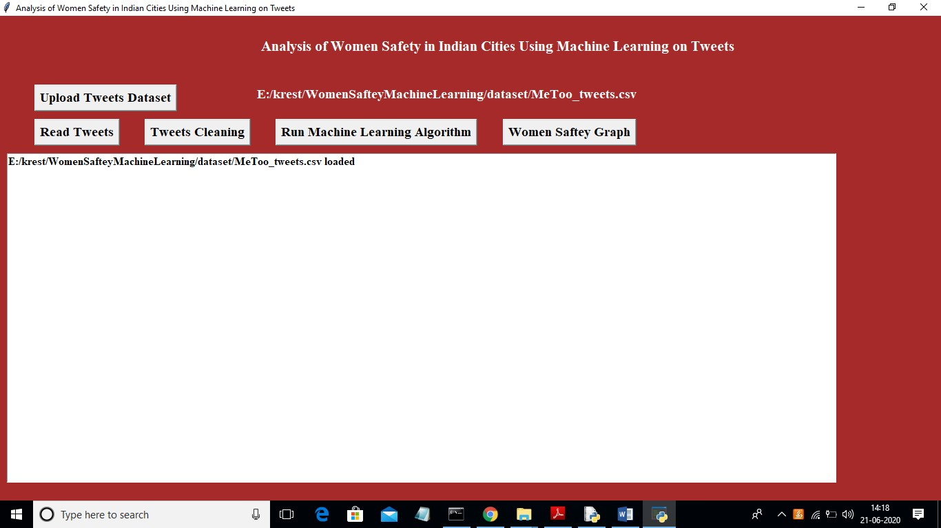

In above screen tweets dataset loaded and now click on ‘Read Tweets’ button to read tweets from dataset

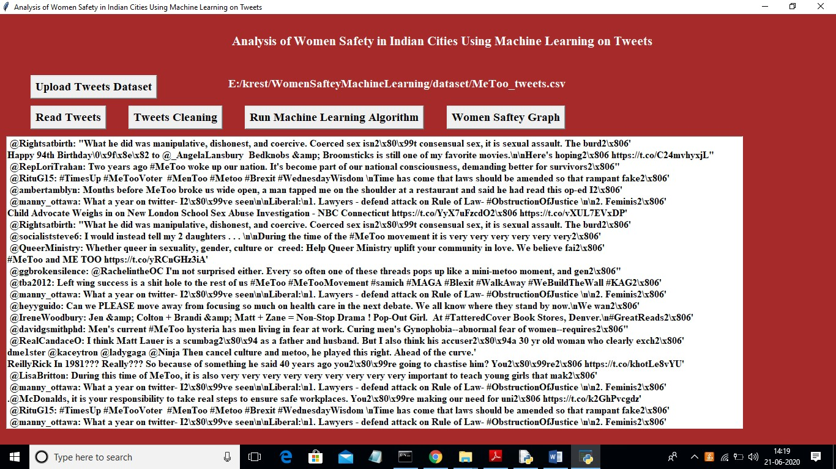

In above screen each line represents one tweet and you can scroll down above screen text area to view all tweets. In above screen we can see all tweets contains special symbols and stop words and to clean those tweets click on ‘Tweets Cleaning’ button

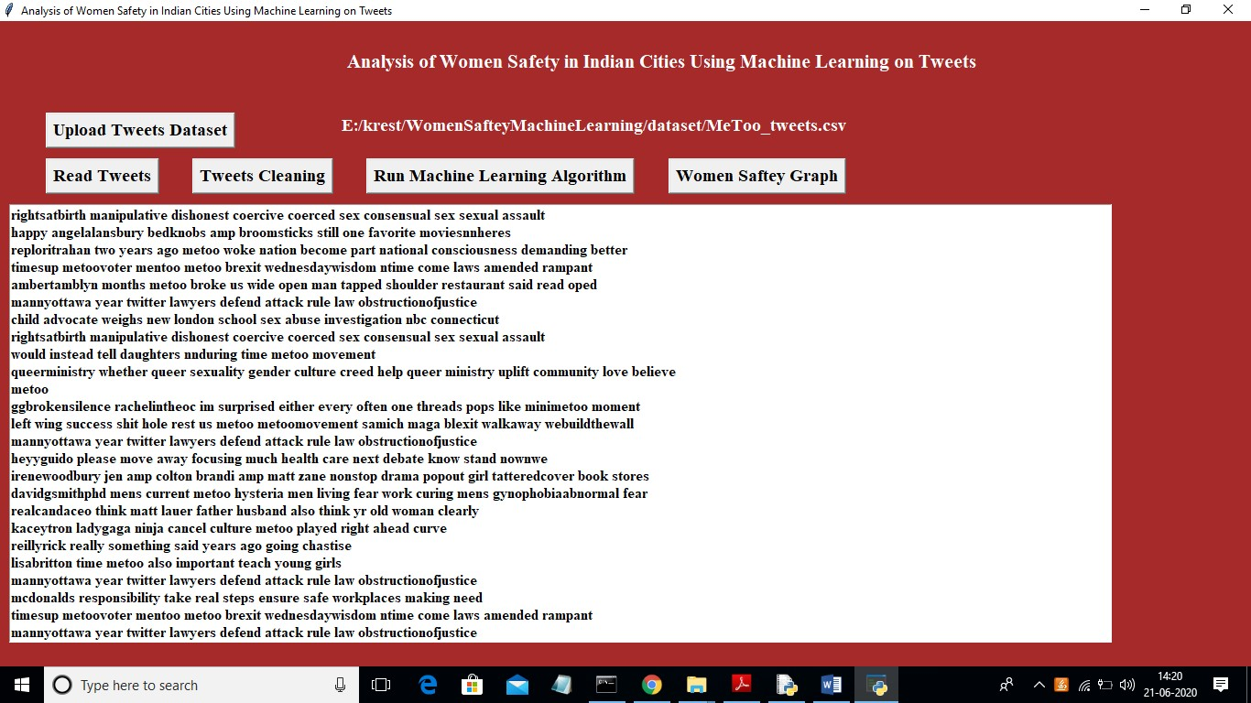

In above screen we can see all special symbols and stop words remove from tweets and only clean words are there and now click on ‘Run Machine Learning Algorithm’ button to predict sentiments from tweets

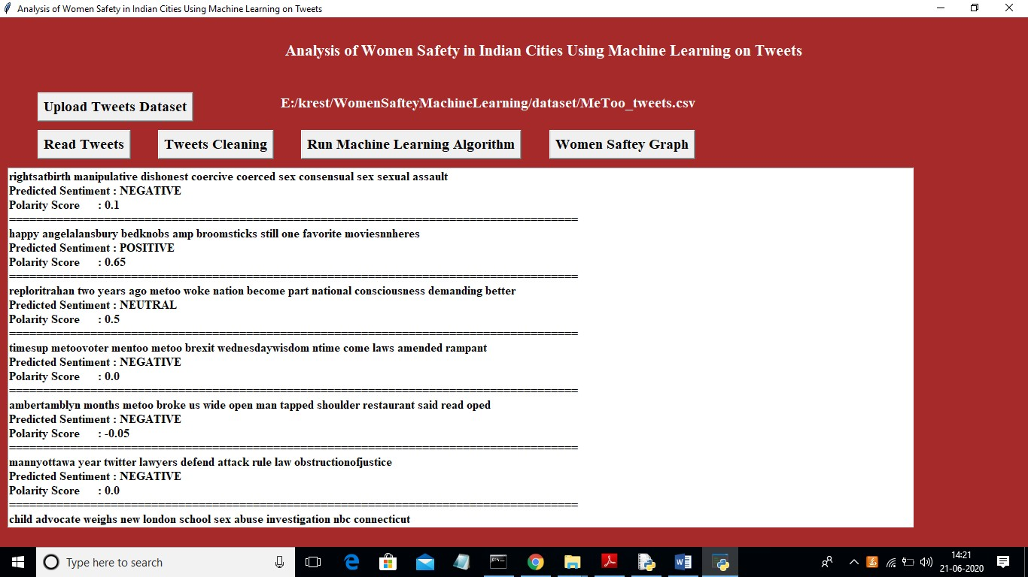

In above screen each tweet having tweet text and then displaying tweets sentiments with polarity score. Scroll down above text area to see all tweets. Now click on ‘Women Saftey Graph’ button to get below results and by seeing that result user can easily understand whether area is safe or not. If area is safe then more peoples will express either positive or neutral tweets and if not safe then more peoples will discuss negative tweets.

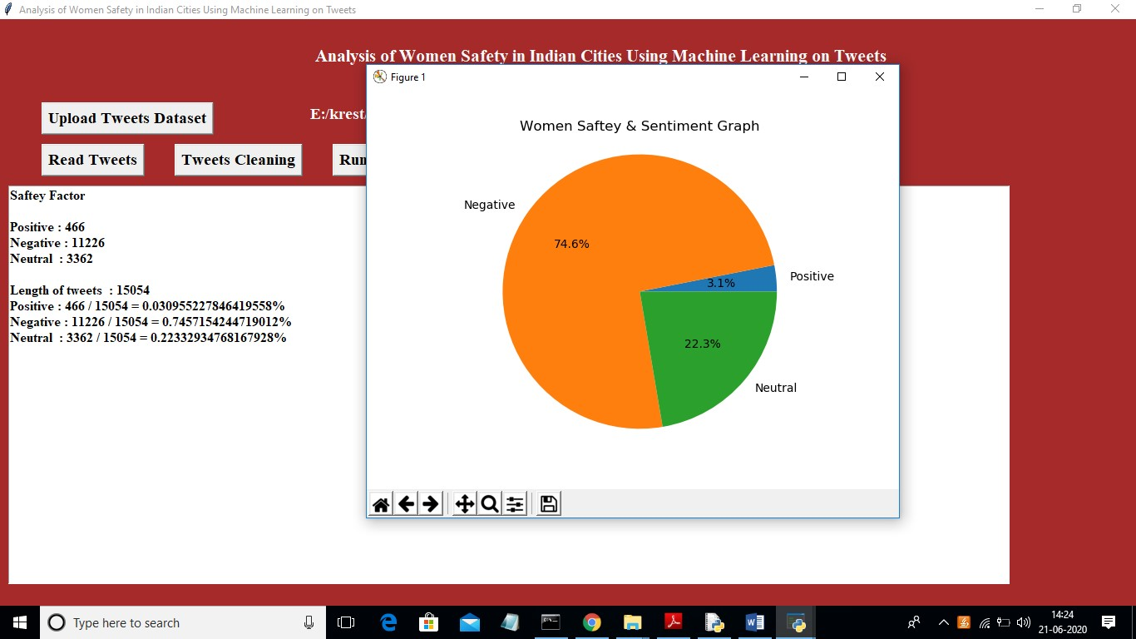

In above screen 0.74 multiply by 100 will give 74% which means 74% peoples are talking negative and area is not safe and only 22 and 3% peoples are talking positive and neutral.