Working Diagram:

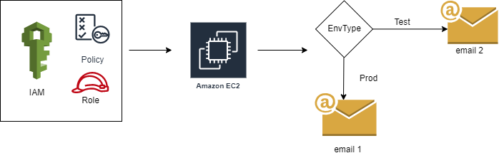

Steps:

Step 1:

1. Download the sample base ec2 template from the AWS documentation in the below link.

<https://docs.aws.amazon.com/AWSCloudFormation/latest/UserGuide/sample-templates-services-us-west-2.html#w2ab1c33c58c13c17>

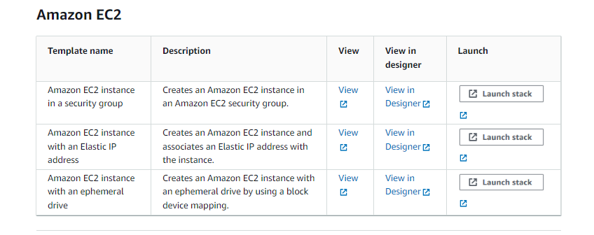

b) Open the template in clouddesigner in aws cloudformation console. Refresh the page from the top right corner of the page and the ec2 instance with attached security group appears in the window.

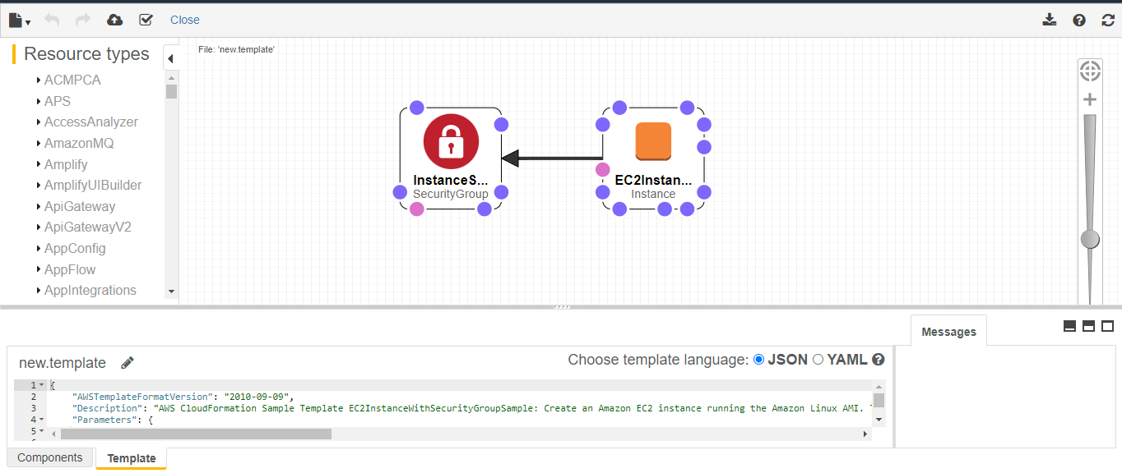

c) Review the file as json or yaml format in AWS CloudFormation Designer integrated editor and copy the file to vscode or any other code editor for further modifications.

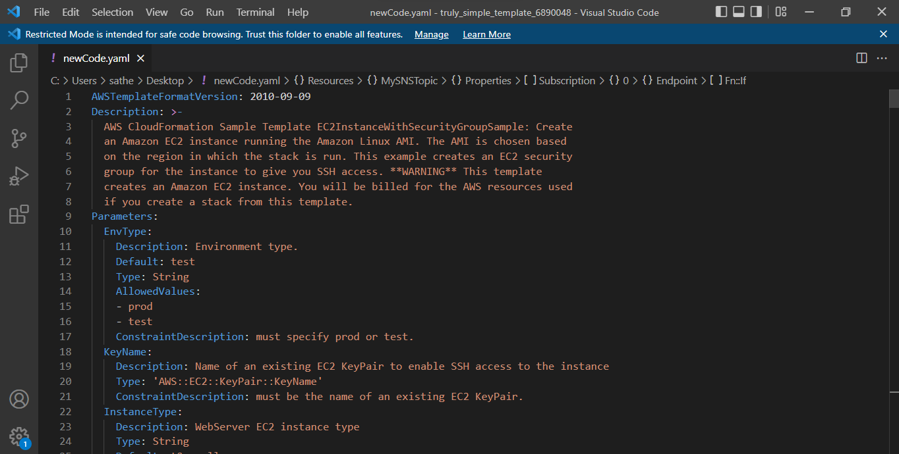

Review the code and look for all the resources created in Resources section, parameters in Parameters section, mappings for mappings section and for outputs in Outputs in outputs section.

Step 2:

a) Look for AWS IAM Role Type in aws cloudformation documentation and copy down the required resources i.e. RootRole and RootInstanceProfile from the Resources section from the example "IAM Role with Embedded Policy and Instance Profiles"

RootRole:

Type: 'AWS::IAM::Role'

Properties:

AssumeRolePolicyDocument:

Version: "2012-10-17"

Statement:

- Effect: Allow

Principal:

Service:

- ec2.amazonaws.com

Action:

- 'sts:AssumeRole'

Path: /

Policies:

- PolicyName: root

PolicyDocument:

Version: "2012-10-17"

Statement:

- Effect: Allow

Action: '*'

Resource: '*'

RootInstanceProfile:

Type: 'AWS::IAM::InstanceProfile'

Properties:

Path: /

Roles:

- !Ref RootRole

b) Also update the ec2 Instance Properties section with "IamInstanceProfile:!Ref RootInstanceProfile"

i.e. IamInstanceProfile: !Ref RootInstanceProfile

Step 3:

A) Look for SNS type in documentation, copy down the example "An Amazon SNS topic with two Amazon SQS queue subscriptions"

MySNSTopic:

Type: AWS::SNS::Topic

Properties:

Subscription:

- Endpoint:

Fn::GetAtt:

- "MyQueue1"

- "Arn"

Protocol: "email"

B) update the protocol type as email which is required as per the requirement.

Step 4:

Look for conditions in documentation, copy the sample code for conditions under examples "simple condition" and place it in the template as a separate section.

I.e. Conditions:

determineemail: !Equals

- !Ref EnvType

- prod

Step 5:

Update the EnvType Parmeter in the parameters section which is referred in the conditions section.

EnvType:

Description: Environment type.

Default: test

Type: String

AllowedValues:

- prod

- test

Step 6:

update the condition flag "determineemail" to be endpoint of SNS.

Subscription:

- Endpoint:

'Fn::If':

- Determineemail

- 'sindhu.subramanian291@gmail.com'

- 'sindhus.29@gmail.com'

Protocol: email

Step 7:

Save the template file and paste it in the AWS CloudFormation Designer integrated editor and save the file as DemoStack.template.

Step 8:

Refresh the clouddesigner on the upper right corner of the console. The updated Template diagram appears on the screen.

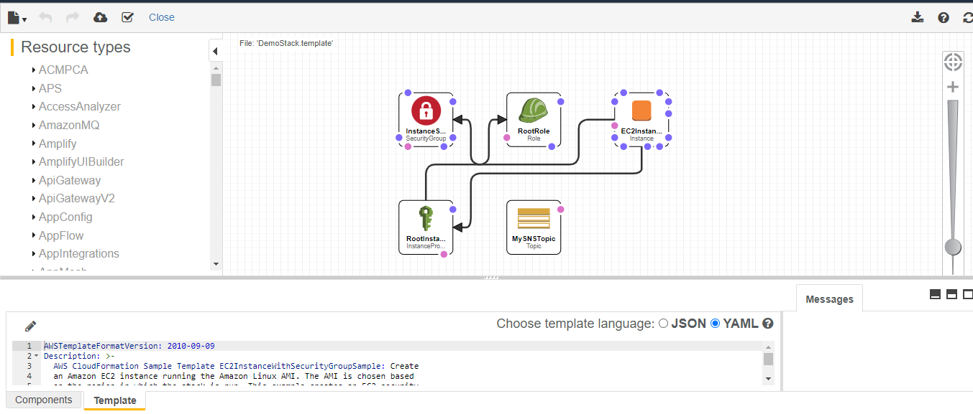

The clouddesigner diagram is as follows:

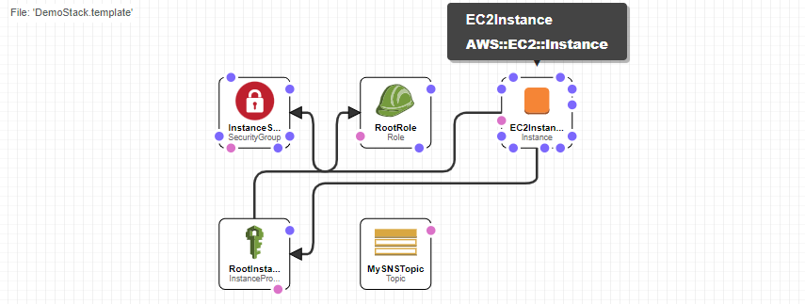

Step 9:

A) Validate the template and upload it to the “create Stack” page. Prerequisite – Prepare template page occurs. click Next

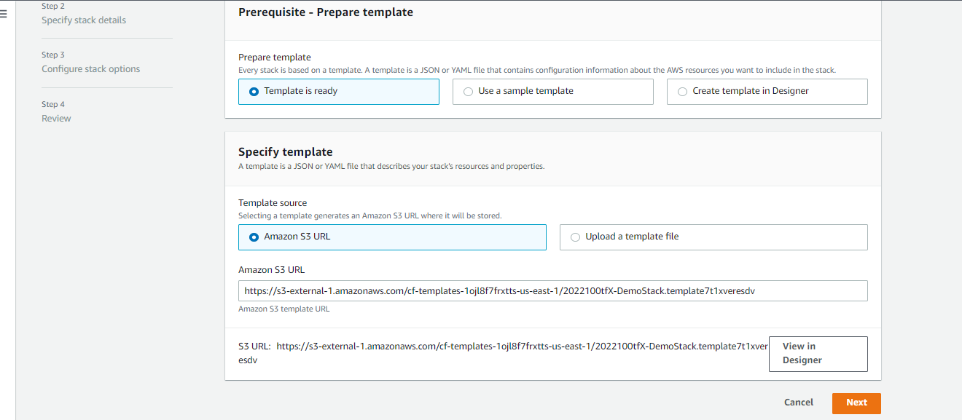

b) Enter the Stack Name and the Parameters value Env Type, InstanceType and KeyName.

Click Next.

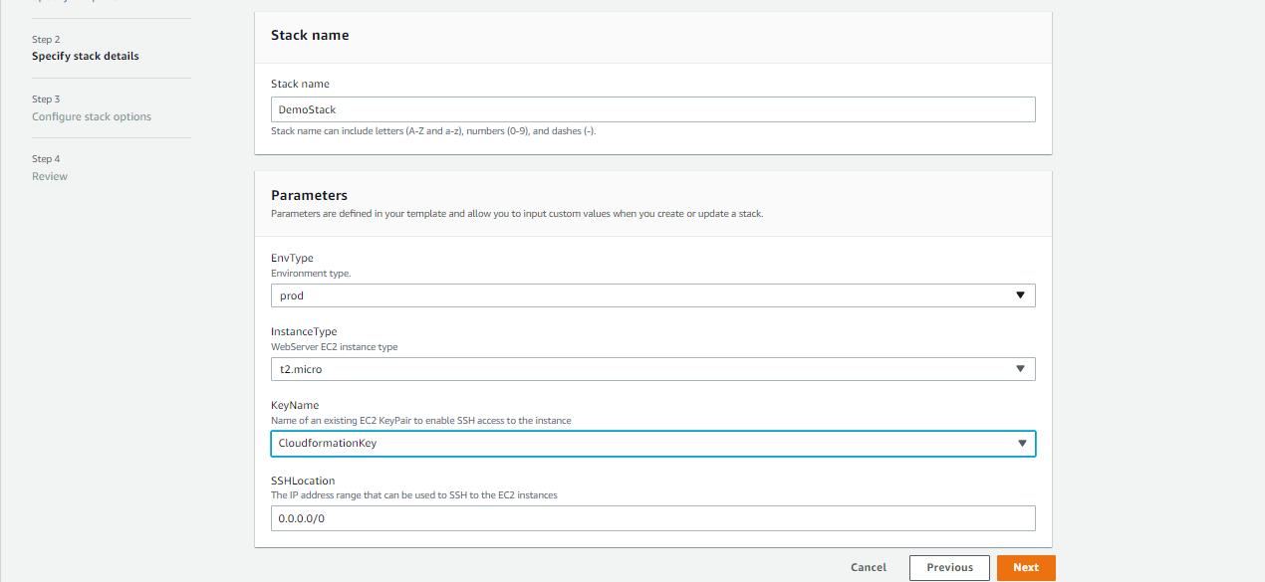

c) The Configure stack options page with details Tags, permissions and Advanced options occurs. Review and click on Next.

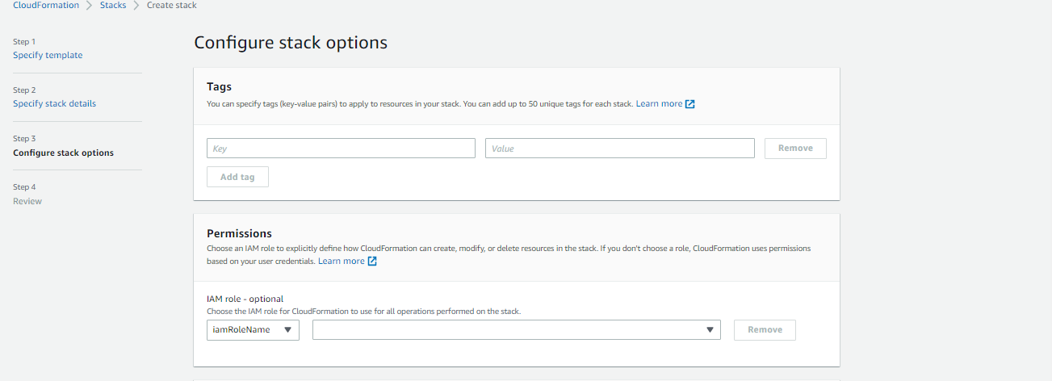

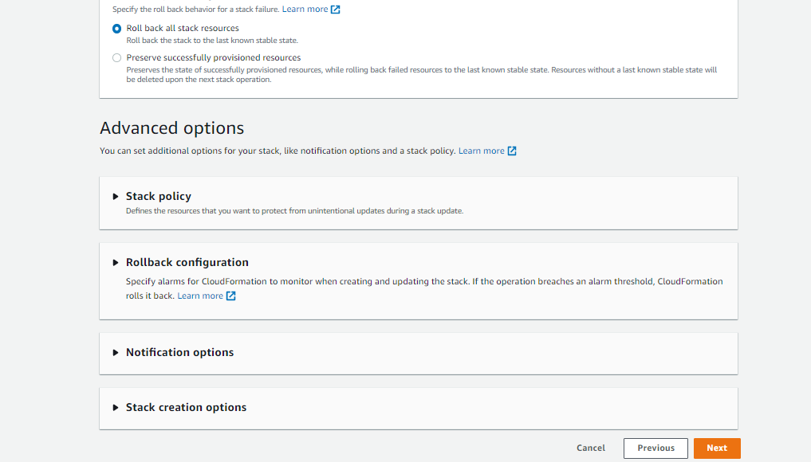

d) Review DemoStack page occurs. Review all details and check the **a**cknowledge checkbox to create IAM resources.

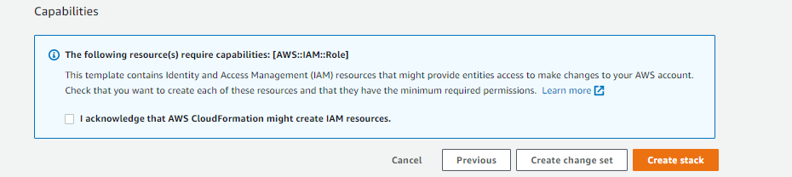

click on create stack.

Step 10:

The Stack creation steps can be viewed in the Events tab.

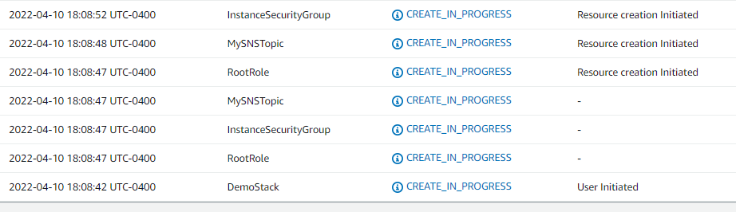

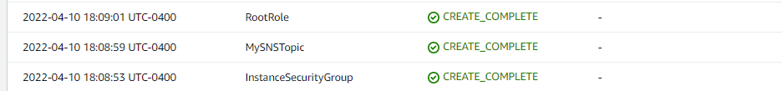

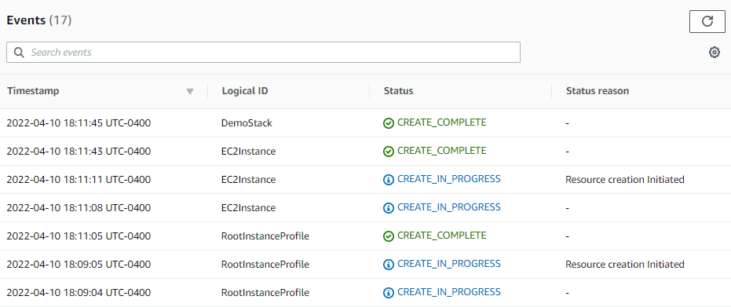

Step 11:

1. The Instance is created.

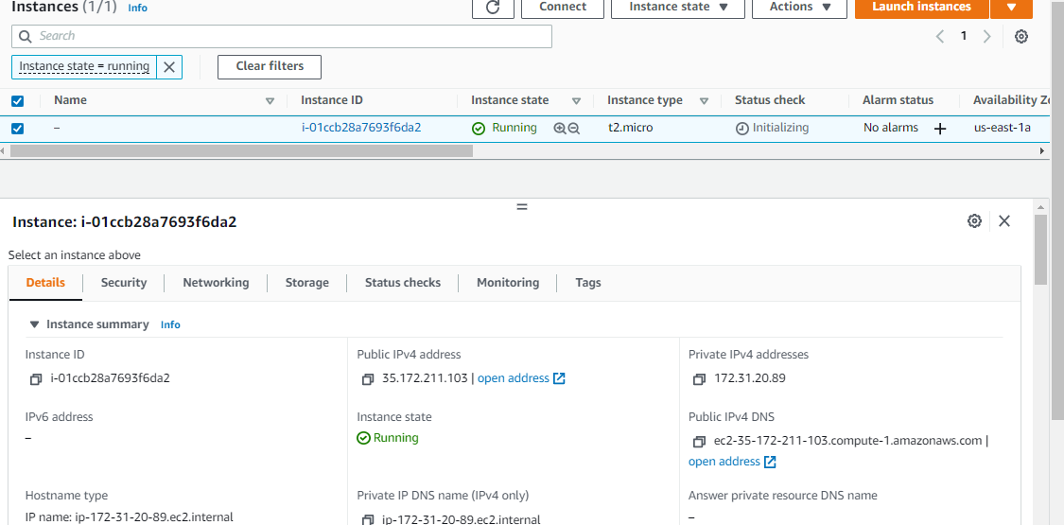

Look for the other resources that are created by the cloudformation.

b) DemoStack SecurityGroup:

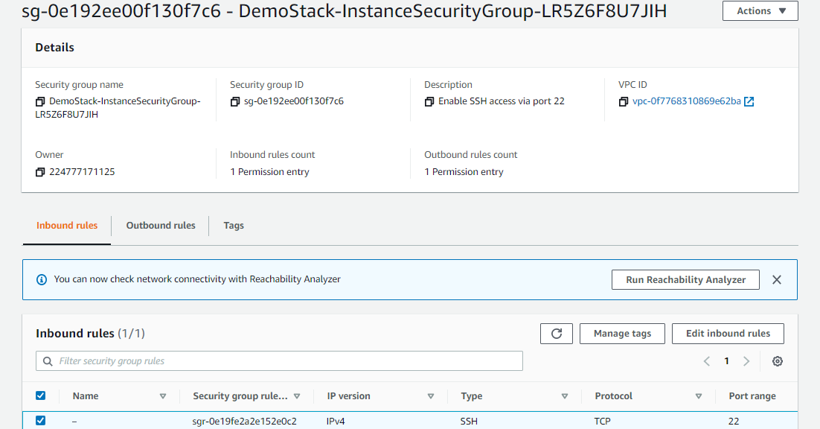

c) DemoStack RootRole with the attached Policy root:

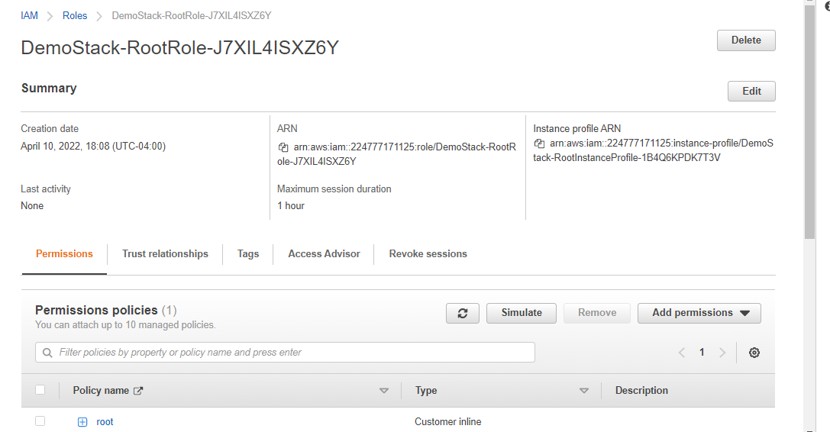

The ARN for the Instance Profile is : Instance profile ARN

arn:aws:iam::224777171125:instance-profile/DemoStack-RootInstanceProfile-1B4Q6KPDK7T3V

d) SNS Topic & Subscription:

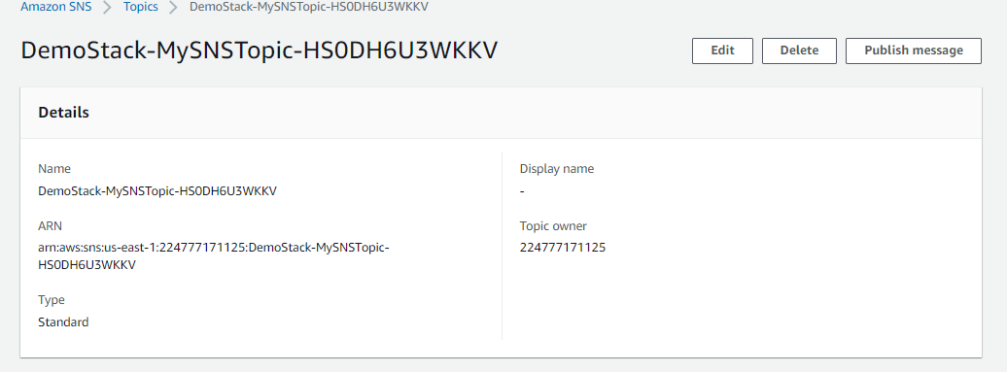

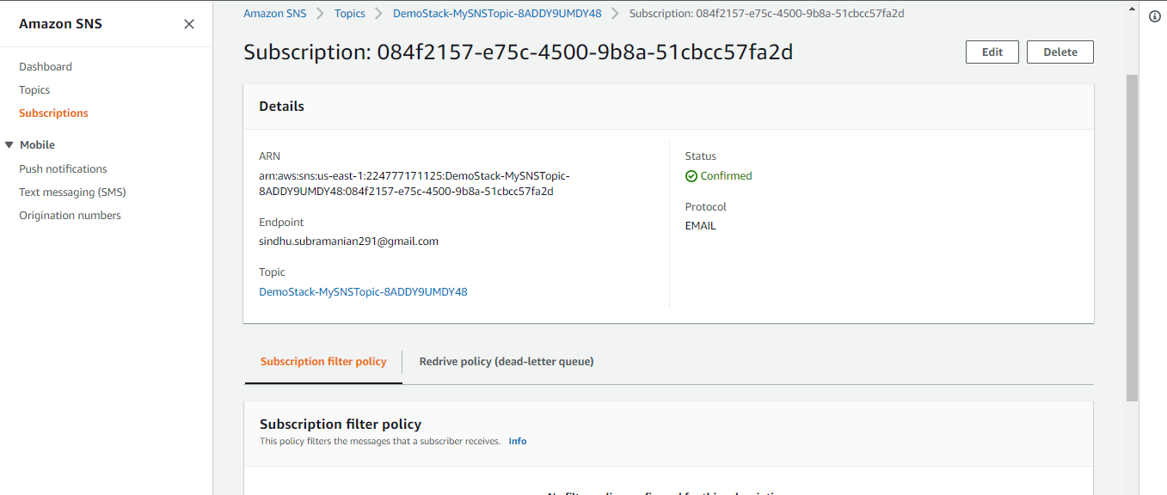

Step 11:

Look for the outputs section in the Outputs tab.

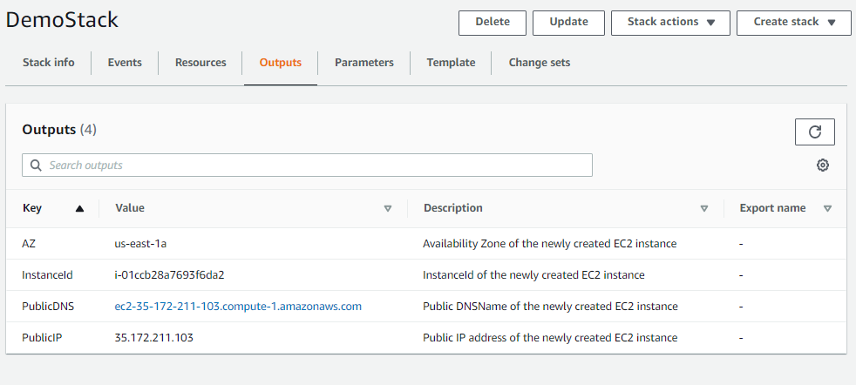

Step 12:

Email Notification:

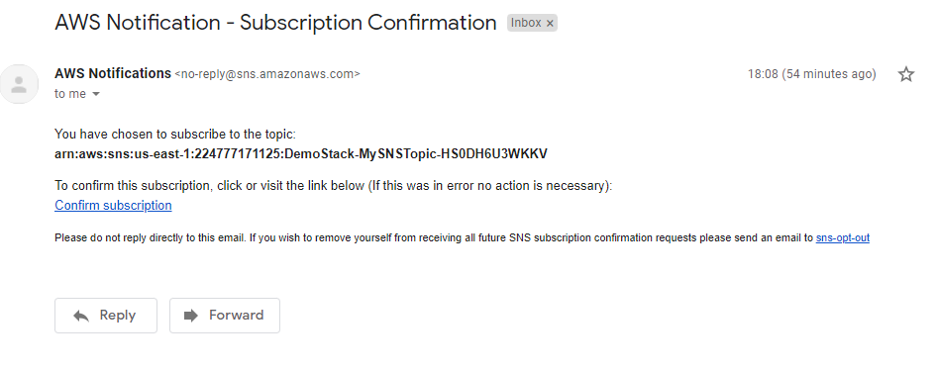

Step 13:

Delete Stack:

