Working Diagram:

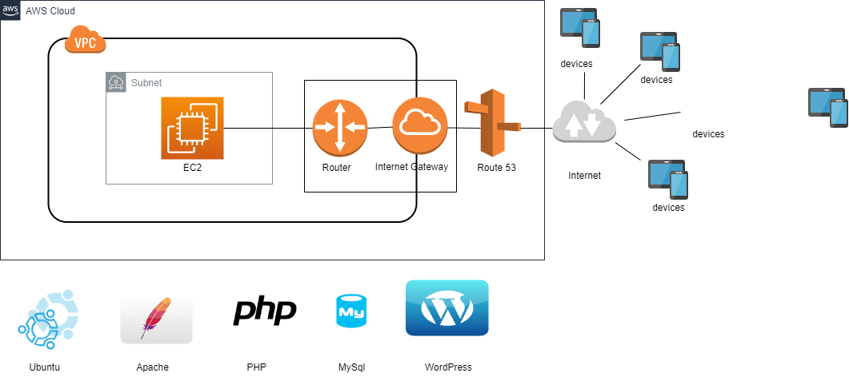

Step 1:

Create VPC, Internet Gateway, add public routes to the main route table and create subnet.

a) create custom VPC named InnovationVPC with assigned public IPV4 CIDR range.

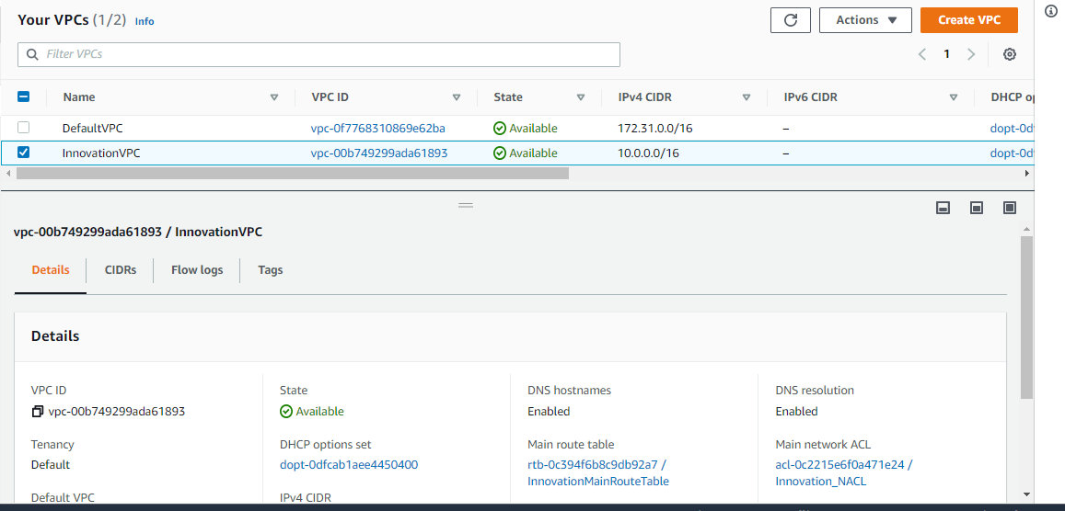

b) Create Internet gateway i.e. Innovation-IGW and attach the VPC to it.

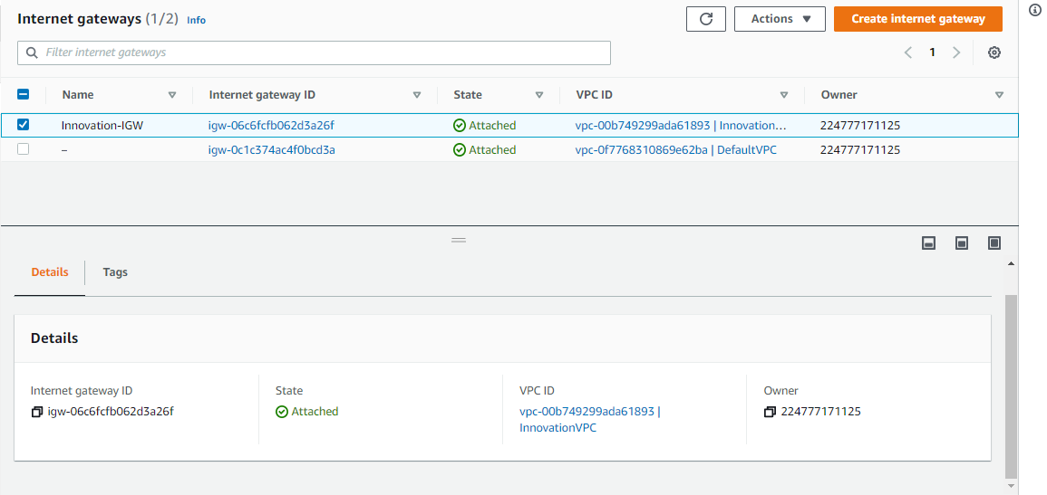

c) create Innovation_Subnet with assigned IPV4 CIDR range.

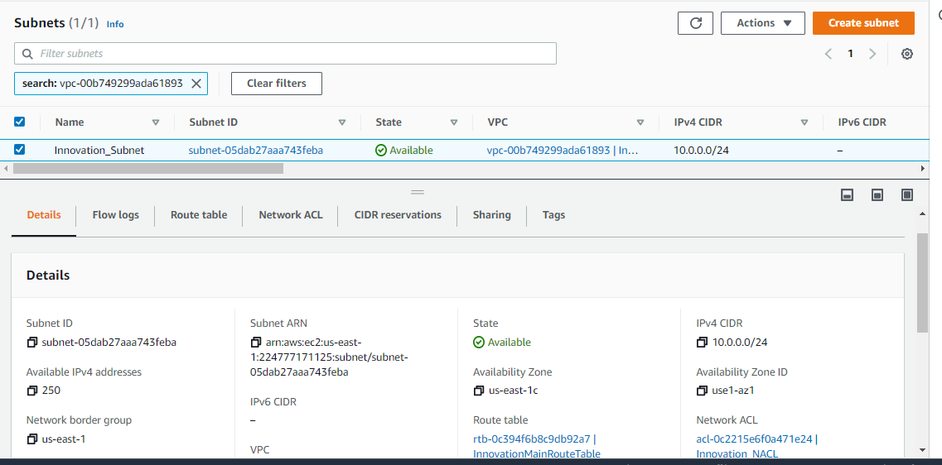

d) Add Public routes i.e. 0.0.0.0/0 to the routes under InnovationMainRouteTable.

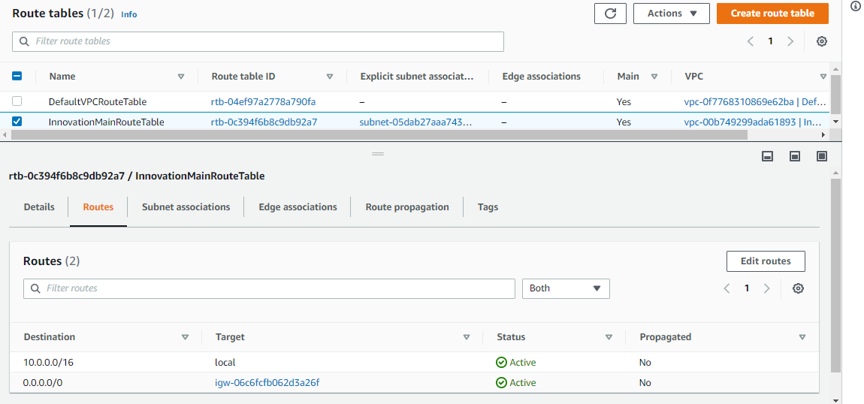

Step 2:

Using EC2 instance configure the Ubuntu server and install the required software to host the WordPress site. Launch Instances with ubuntu AMI free tier as shown below, with instance type t2.micro, create security group with allow SSH Protocol (from your IP address) and HTTP Protocol on port 80. Create a new keypair and launch instances.

Ubuntu free-tier AMI:

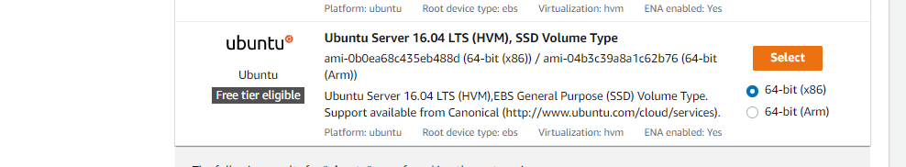

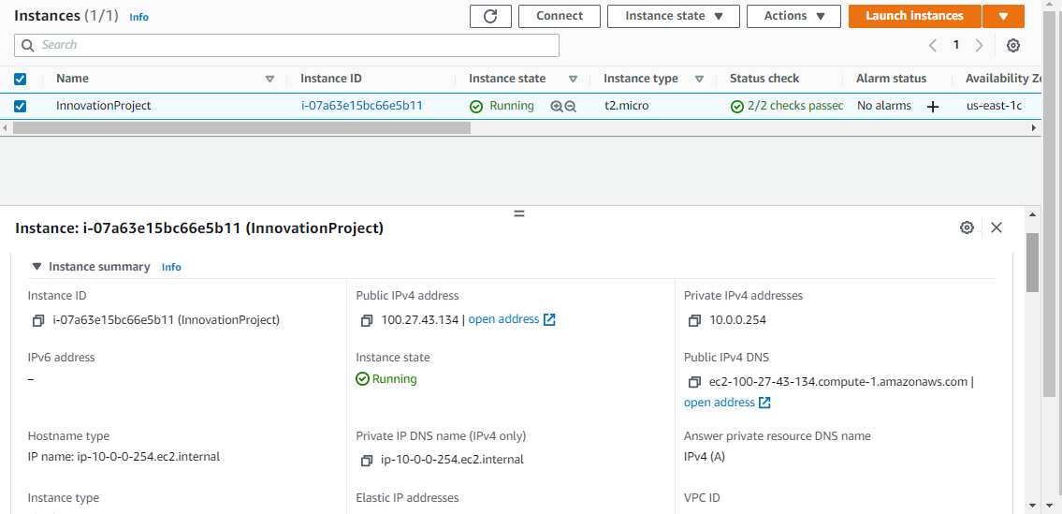

Step 3:

In Route 53, create a new public hosted zone and update the nameservers in Domain Providers.

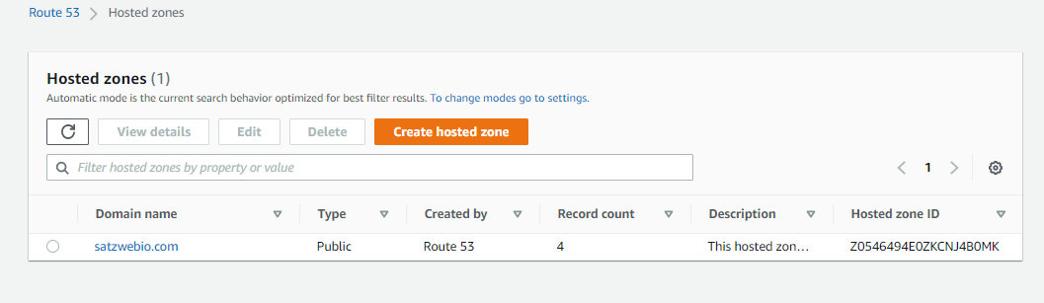

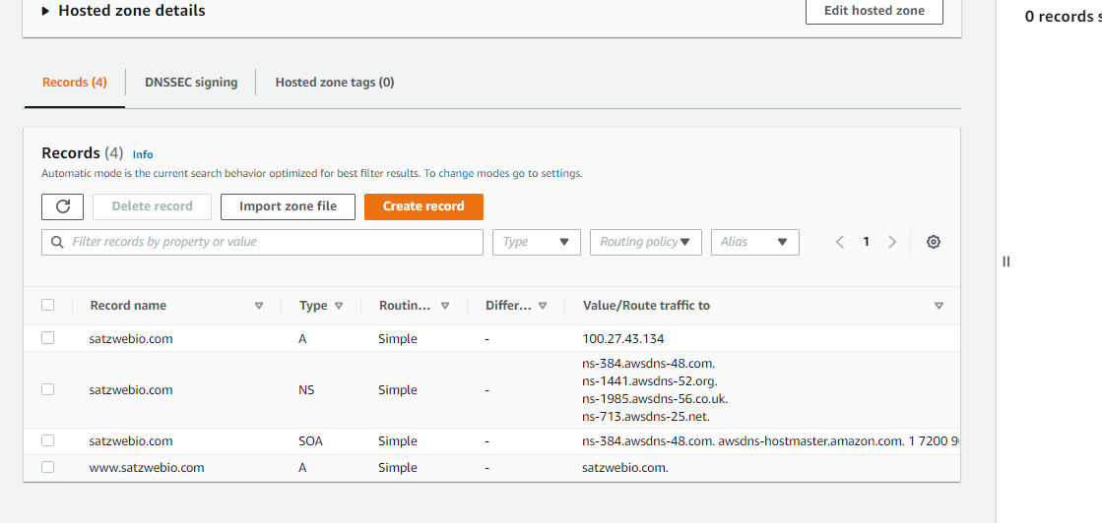

Step 4:

Connect the server through SSH and install some useful applications. Apache, MySQL, PHP etc   
 I.e. SSH -i ubuntu@public ip DemoKeyPair.pem

A) Run the command install sudo apt-get update - install available upgrades of all packages currently installed on the system from the sources configured via sources

B) To install Apache run the command sudo apt-get install apache2,

C) To install Mysql run the command sudo apt-get install mysql-server. It asks for password. Enter the new password.

D) To install php run the command sudo apt-get install php libapache2-mod-php php-mcrypt php-mysql

e) Restart the server through the command sudo service apache2 restart

If the following error occurs: unable to resolve host ip addr, enable dnshostname in vpc.

The ubuntu home page opens.

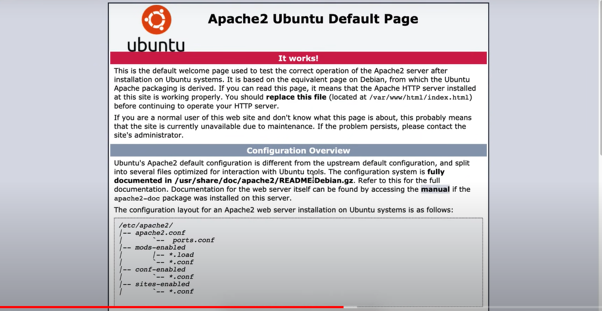

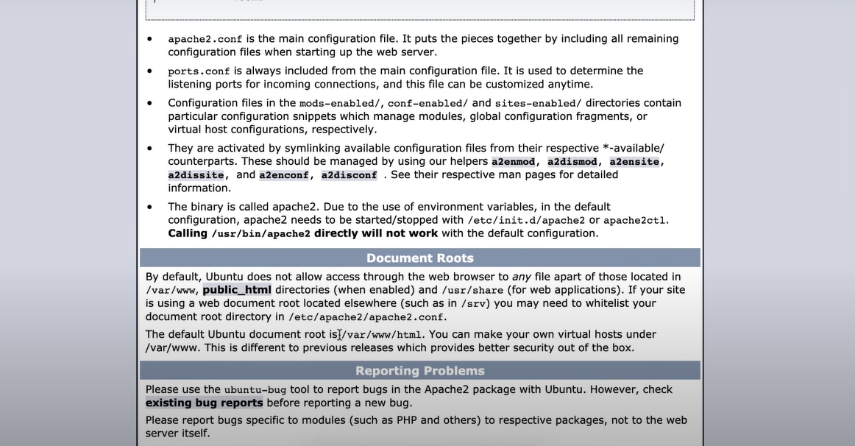

The default document root is var/www/html, where all wordpress setup has to be placed.

Step 5:

Navigate to the /var/www/html path and follow the below steps:

A) Open wordpress.org and navigate to “Get Wordpress” and copy the link location.

b) Run the command to download installation wordpress files:

sudo wget https://wordpress.org/latest.zip

//ls=> index.html latest.zip

C) Install unzip through the command sudo apt install unzip and run command sudo unzip latest.zip that unzips the latest.zip file

//ls=> index.html latest.zip wordpress

D) Remove the files from the same path by running command sudo rm latest.zip and sudo rm index.html

//ls-> wordpress

E) Now move the contents of wordpress folder into var/www/html folder.

Run command sudo mv wordpress/* ../html

Also run command sudo rmdir wordpress

All config files are moved to var/www/html folder. When you refresh the browser page wordpress installation screen appears.

Step 6:

connect the hosted zone to our EC2 instances.

A) create A record in route53 to the public ip address.

B) create Alias record www. for the created A record from the above step.

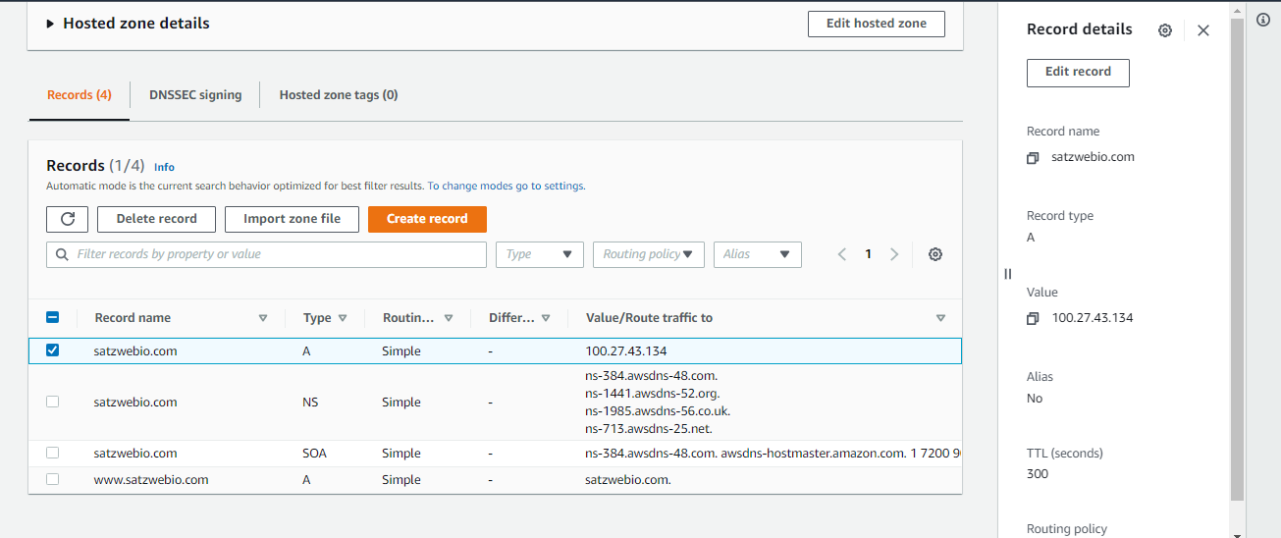

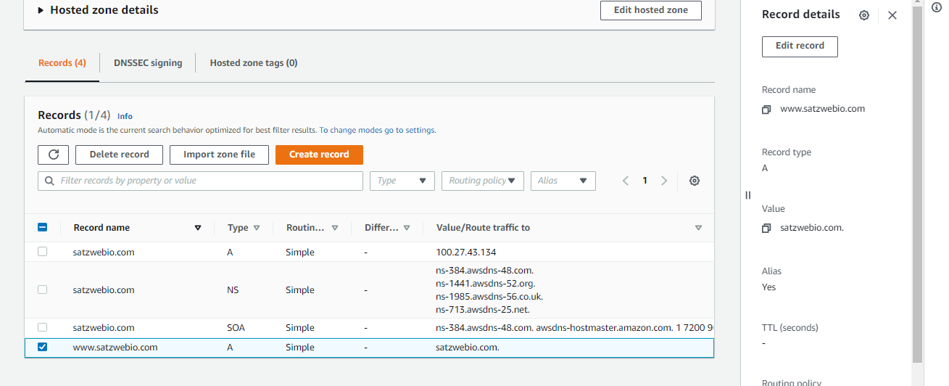

Step 7:

Create database for wordpress :

A) connect to mysql by running the command:

mysql -u root -p ; enter password

Run show databases and check for any databases already exists.

B) create database dbname

I.e.create database innovationdb

;

Query OK, 1 row affected (0.00 sec)

Exit; // exit from mysql

C) On the browser,enter the dbname created from previous step,username=root,password,path=lib_ in the app page

If you get error: Unable to write to wp-config.php file. Run the following commands:

->Create a wp-config.php file manually through sudo nano wp-config.php file

-> Paste the contents from the installation page.

//ctrl+o enter ctrl+x to exit from nano editor.

d) Run the installation on the app page.

Enter the Site title, username, password and email id and give install wordpress. Login to the wordpress admin panel dashboard.

Step 8: check whether the domain name pinged to our server.

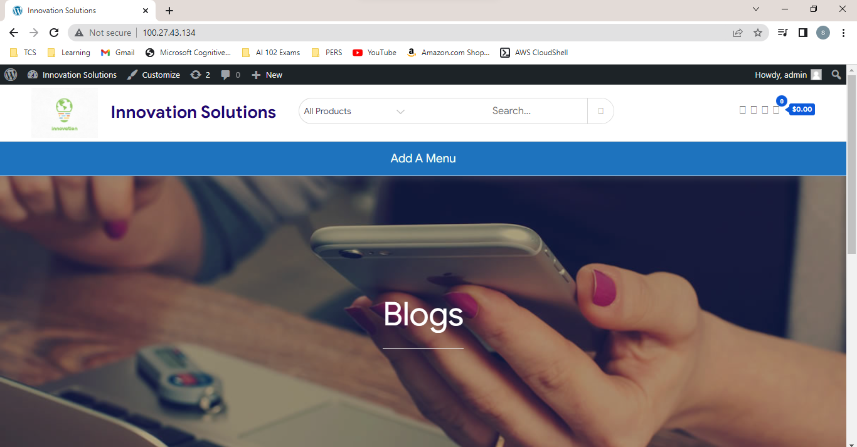

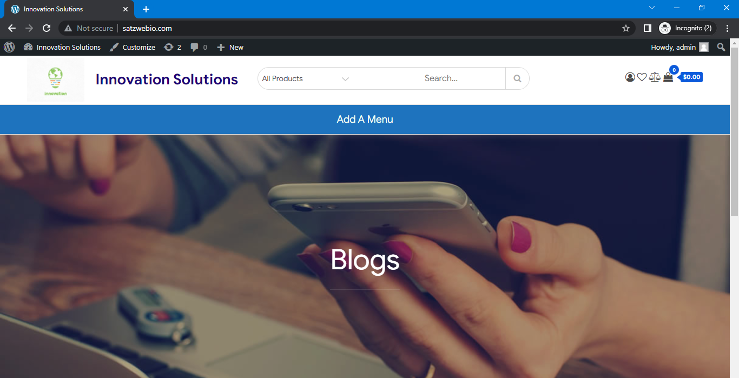

The wordpress site is launched through your domain name.

Additionally, a) Change your theme through settings Appearance->Themes.If the theme installation error occurs, run sudo chown www-data:www-data -R /var/www/html. After refresh browser, the theme gets installed.

b) change logo through settings Appearance->customize

c) change theme colour.

Step 9:

A) Go to general settings->permalink->change to post name and save where only the Post title slug will be used after the primary domain. For this setting to happen, follow the below two steps.

B) Run command sudo a2enmod rewrite –apache enable mode rewrite. Restart the server through sudo service apache2 restart

C) Run command sudo nano /etc/apache2/apache2.conf and search for /var/www and replace AllowOverride All from None. Save and exit. Restart the server through sudo service apache2 restart

Step 10:

A) Go to settings and change wordpress address url and site address url to domain name.

B) Ex: <http://100.27.43.134> to [www.satzwebio.com](http://www.satzwebio.com)

C) Save and check the browser url.