VM Import/Export:

- VM Import/Export enables you to Import virtual machine (VM) images from your existing virtualization environment(On-Prem, DC) to Amazon EC2, and also to Export them back to your On-Prem environment.
- You can import Windows and Linux VMs that use VMware ESX or Workstation, Microsoft Hyper-V , and Citrix Xen virtualization formats.
- VM Import will convert your VM into an Amazon EC2 AMI, which you can use to run Amazon EC2 instances
- AWS SMS (Server Migration Service): For large VM infrastructures, automates the import process there by reducing the workload of migrating large VM infrastructures

Common Uses for VM Import/Export:

- Migrate your existing Applications and Workloads to Amazon EC2
- Import your VM Image Catalog to Amazon EC2
- Create a Disaster Recovery Repository for your VM images

Note for Pricing : VM Import/Export is available at no additional charge, but you are charged for standard usage of Amazon EC2 and Amazon S3.

Working Diagram:

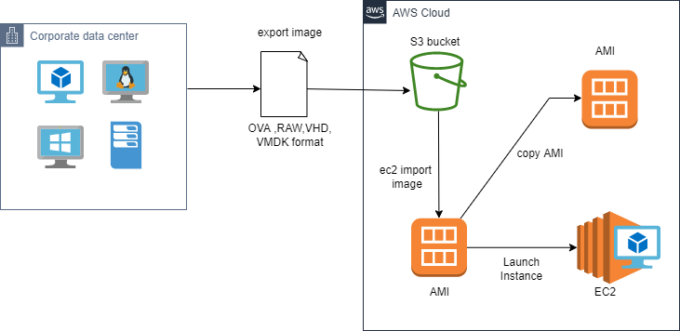

Steps and Prerequisite:

- Download,install and configure latest version of AWS Command Line Interface.
- Create vmimport - VM Import Service Role.
Ex: aws iam create-role --role-name vmimport --assume-role-policy-document "file://C:/AWS/vmimport/trust-policy.json"
aws iam put-role-policy --role-name vmimport --policy-name vmimport --policy-document "file://C:/AWS/vmimport/role-policy.json"
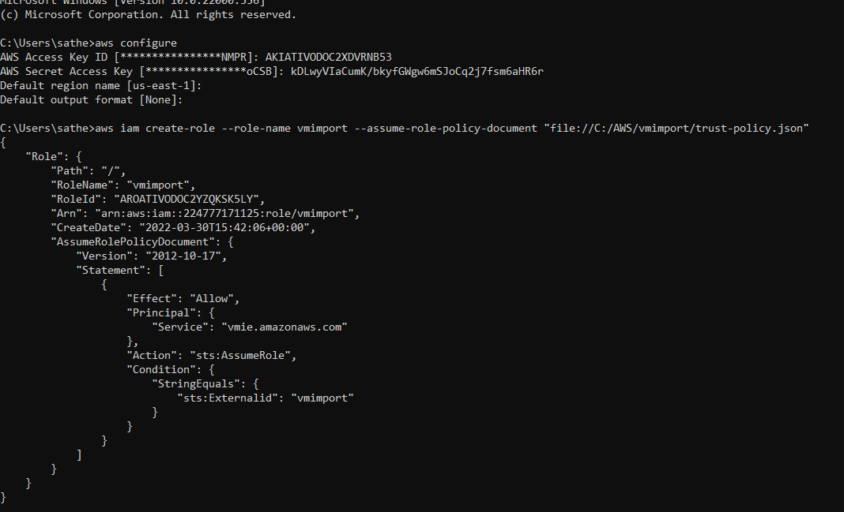
Step 1:

Export VM from its current environment as an OVA file (or VMDK, VHD, or RAW) (if you are testing this make sure the VM has at least one user configured with password)

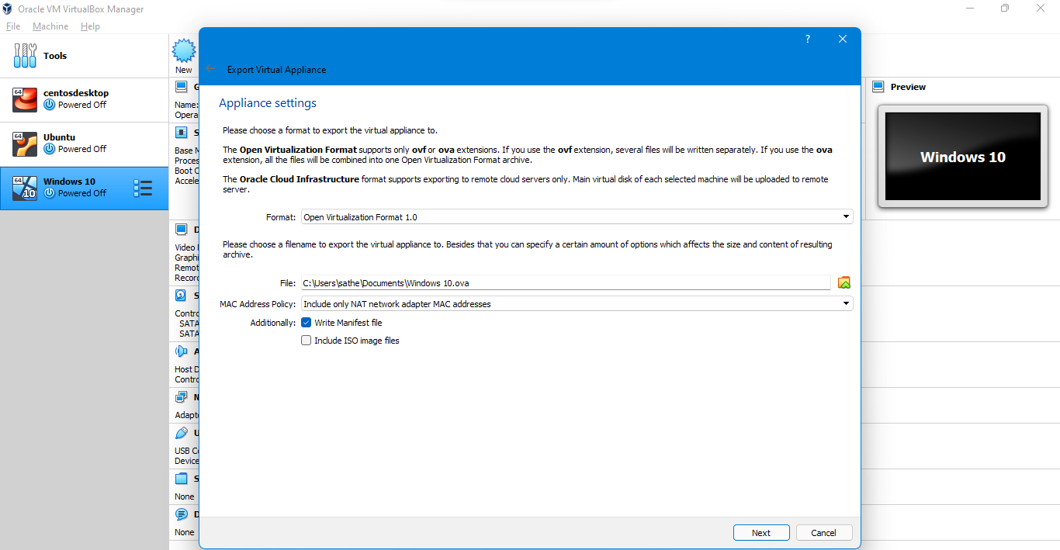
Step 2:
Create a S3 bucket and upload the VM image to S3 using upload /drag and drop ,or using AWS CLI
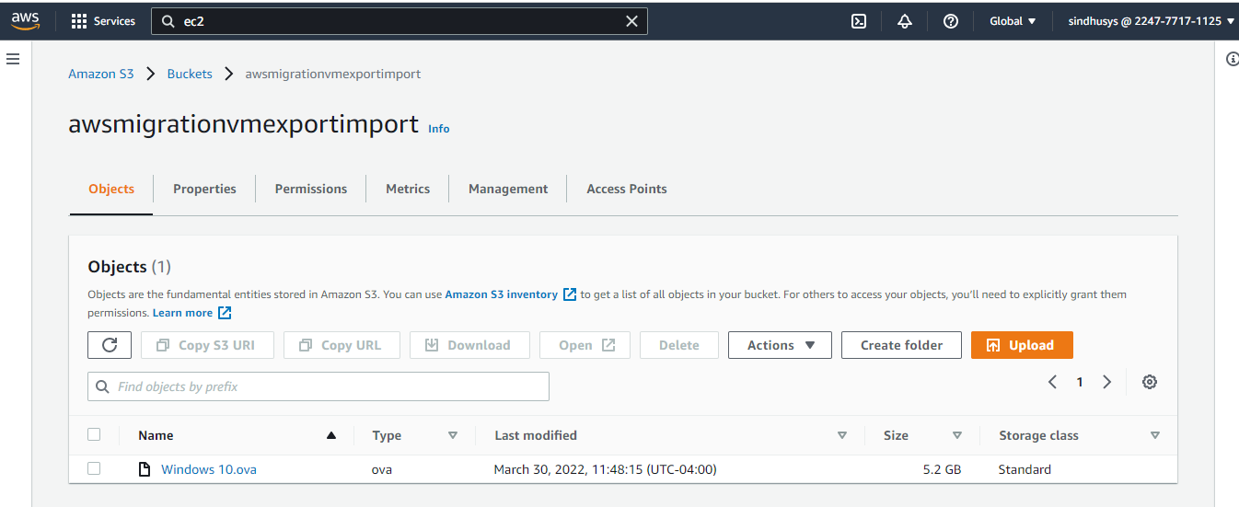
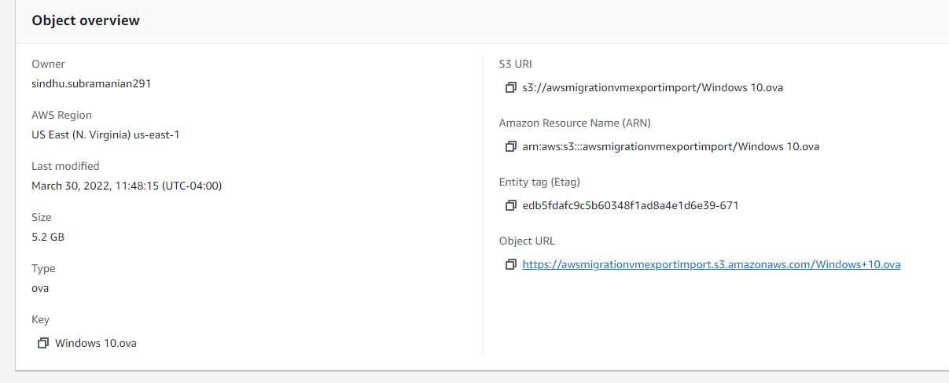
Step3:
Import your VM using the ec2 import-image command
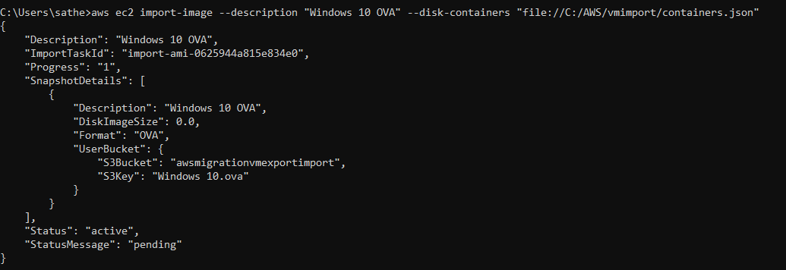
Step 4:
Use the ec2 describe-import-image-tasks command to monitor the import progress.
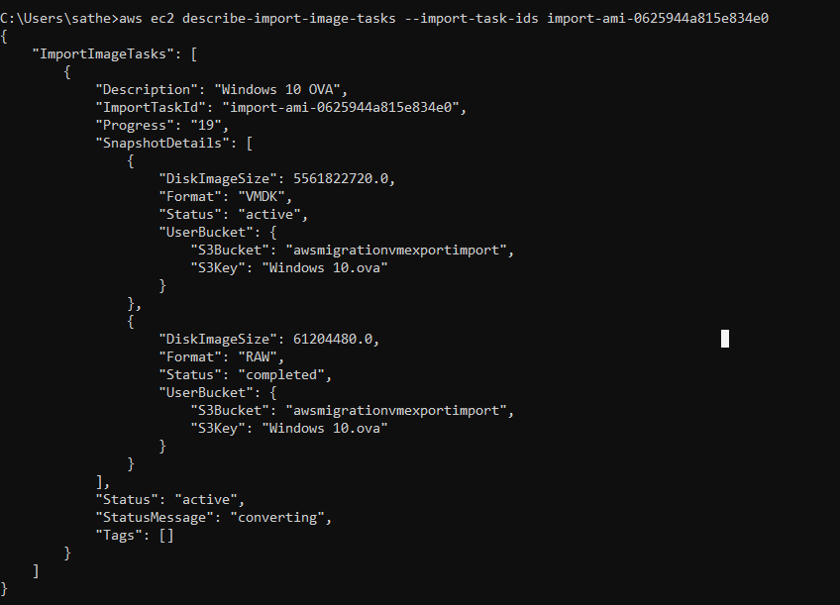
Step 5:
Once Import is completed Launch EC2 Instance from the AMI created, or Copy the AMI to other region

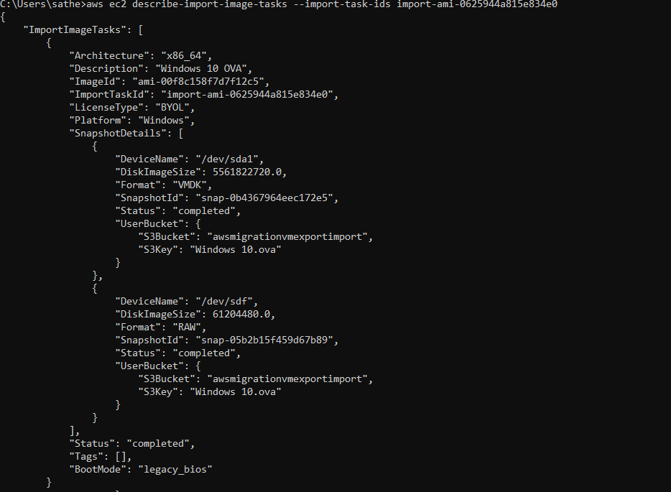
Other Steps:

- Launch Instances from the AMI
- Open the created virtual Machine and check for all backup softwares same as the On Premise Virtual Machine.

