Working Diagram:

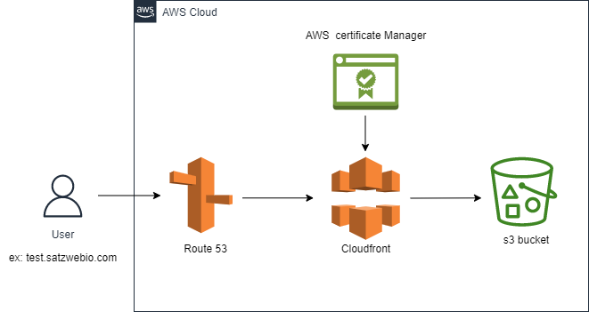

Working steps:

Step 1:

create a Public hosted zone in Route 53 and update the nameservers in the DNS provider system (ex:GoDaddy)

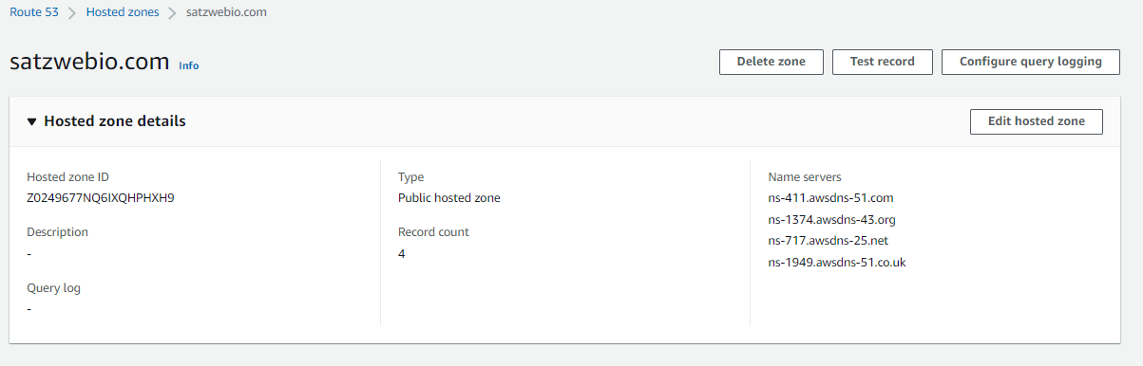

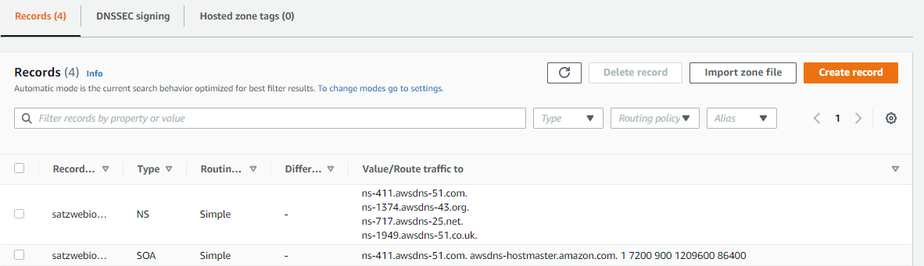

Step 2:

A) create s3 bucket test.satzwebio.com and upload the website configuration files in it.Enable versioning and static website hosting when creating the bucket.

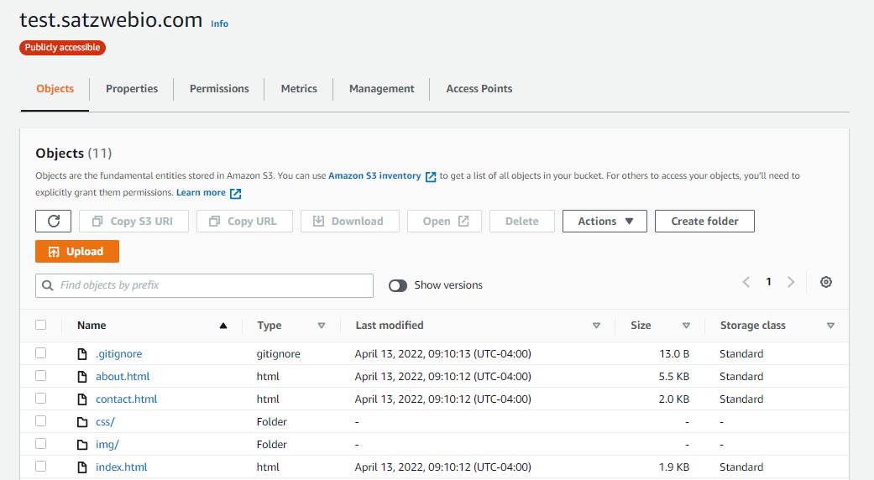

Static website hosting:

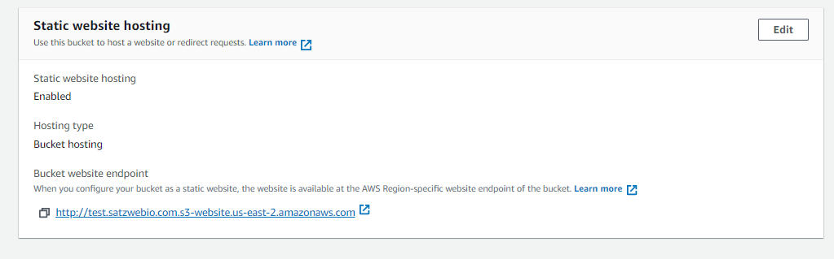

B) once the bucket is created, go to permissions and uncheck the Block public access (bucket settings). Generate the bucket policy from AWS Policy generator and upload it.

The Bucket Policy is as follows:

{

"Version": "2012-10-17",

"Id": "Policy1649848514567",

"Statement": [

{

"Sid": "Stmt1649848510804",

"Effect": "Allow",

"Principal": "\*",

"Action": "s3:GetObject",

"Resource": "arn:aws:s3:::satzwebio2022/\*"

}

]

}

c) Now we are able to host the website through s3 url: <http://test.satzwebio.com.s3-website.us-east-2.amazonaws.com>

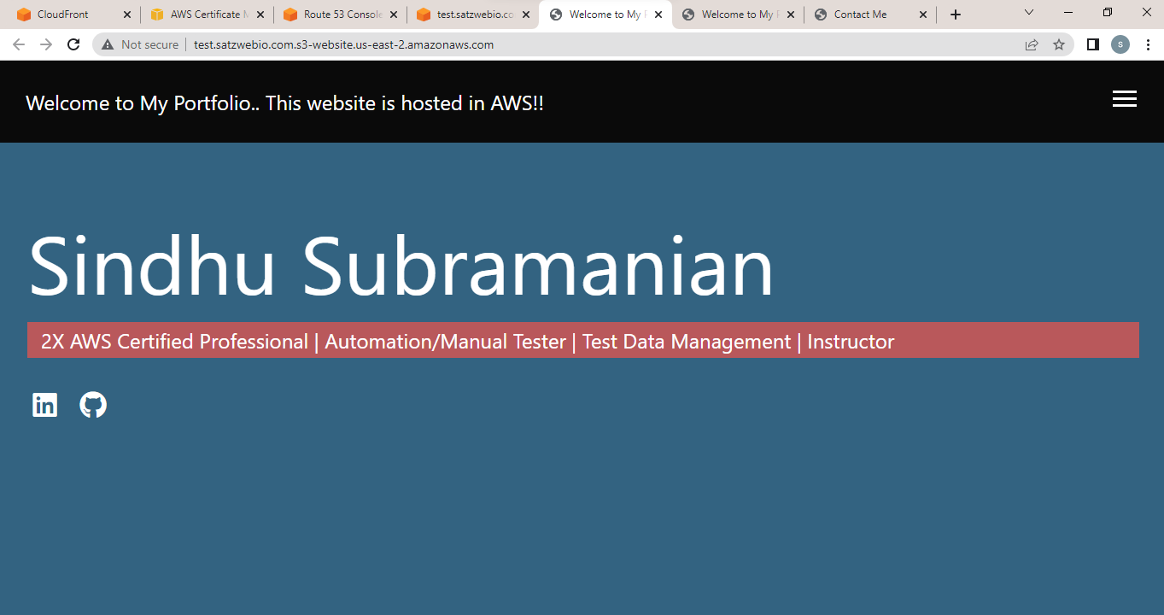

Step 3:

A) Request a public certificate in AWS certificate manager, give Fully qualified domain name as \*.satzwebio.com, validation method DNS/email.

B) Once requested, It will ask you to create CNAME record in Route 53. create it.

And the certificate is issued by AWS.

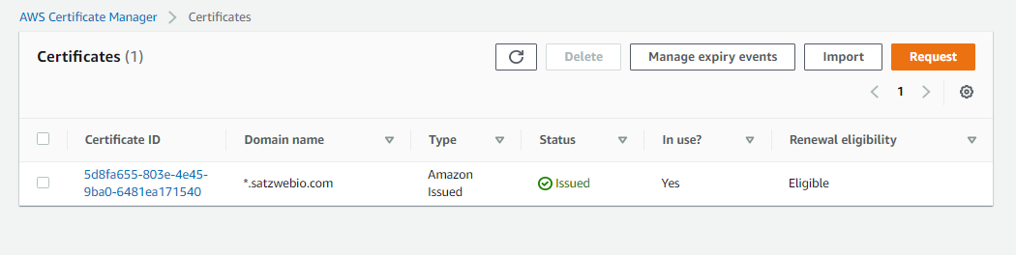

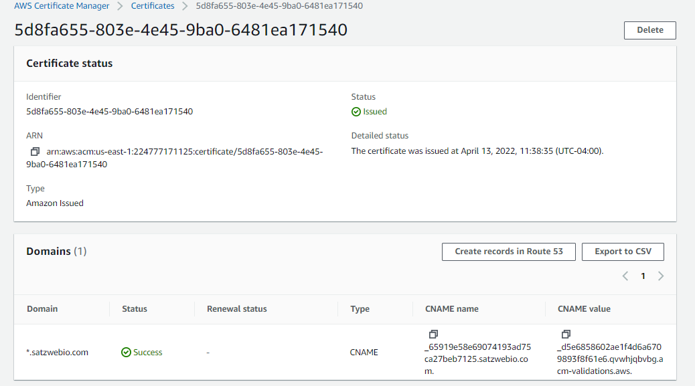

Step 4:

A) create Cloudfront distribution with the origin details from s3, Price class as Use all edge locations (best performance), viewer protocol policy as HTTP and HTTPS, select SSL that is created from ACM, give alternate domain name as test.satzwebio.com and leave all the other settings as default.

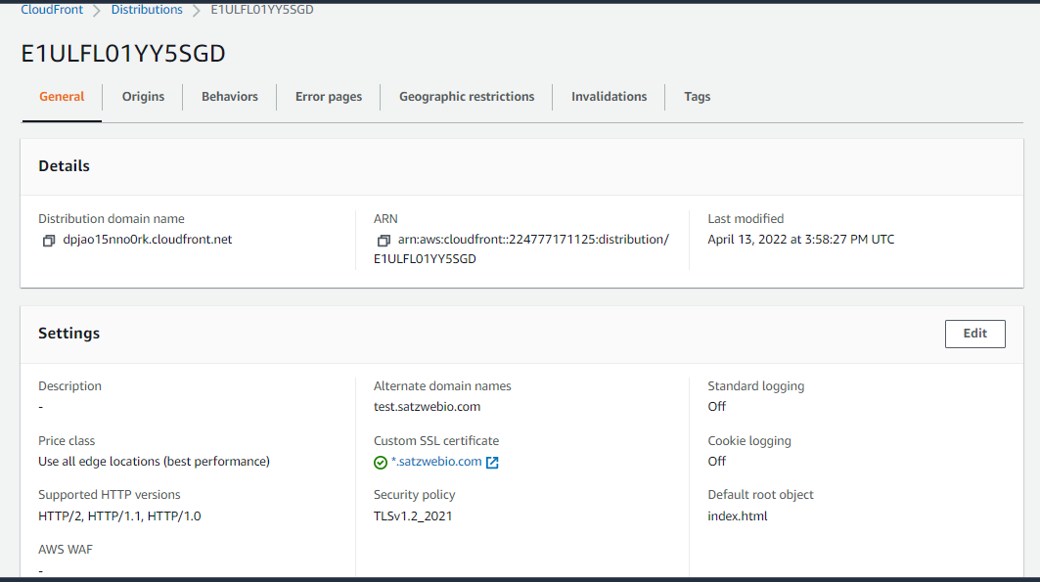

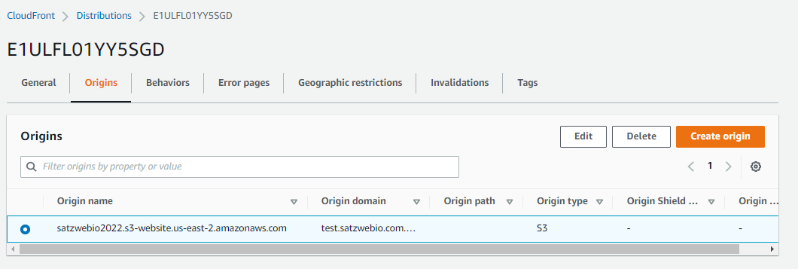

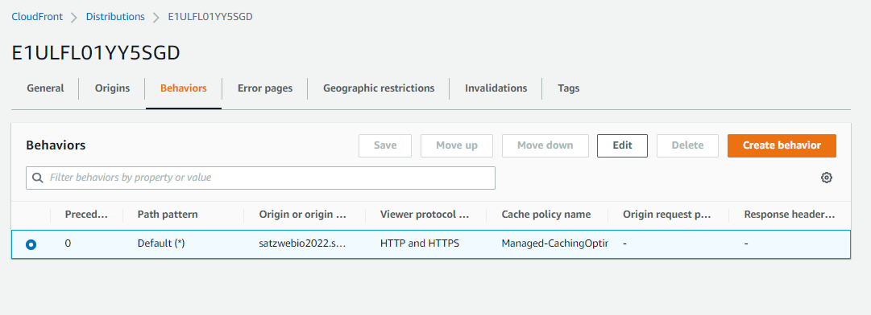

B) Once the cloudfront distribution is deployed and the status gets enabled, we can host our website through the cloudfront endpoint.

EX: dpjao15nno0rk.cloudfront.net

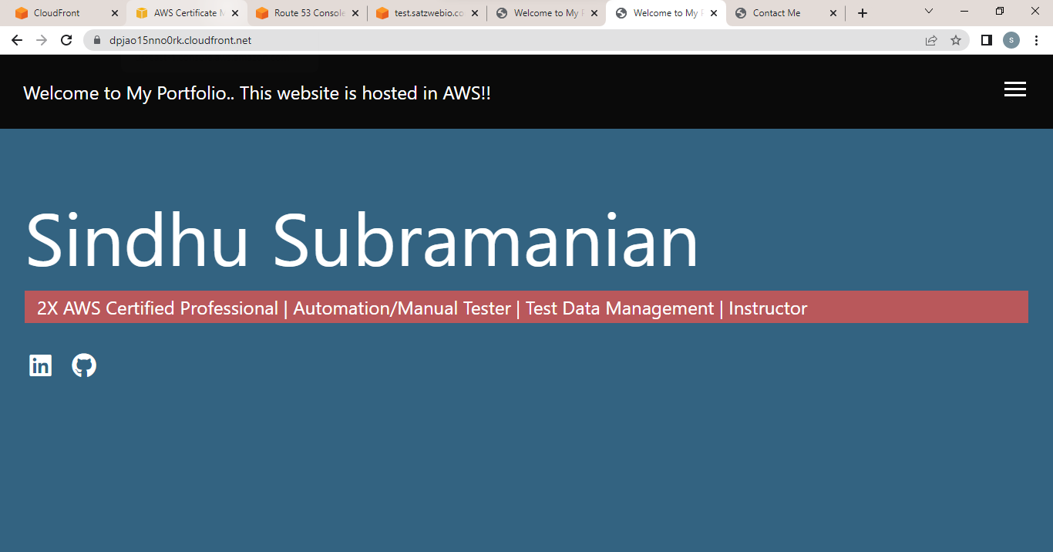

Step 5:

A) create an CNAME record in Route53 with a record name as the domain name with which we can host our website and the value as dpjao15nno0rk.cloudfront.net.

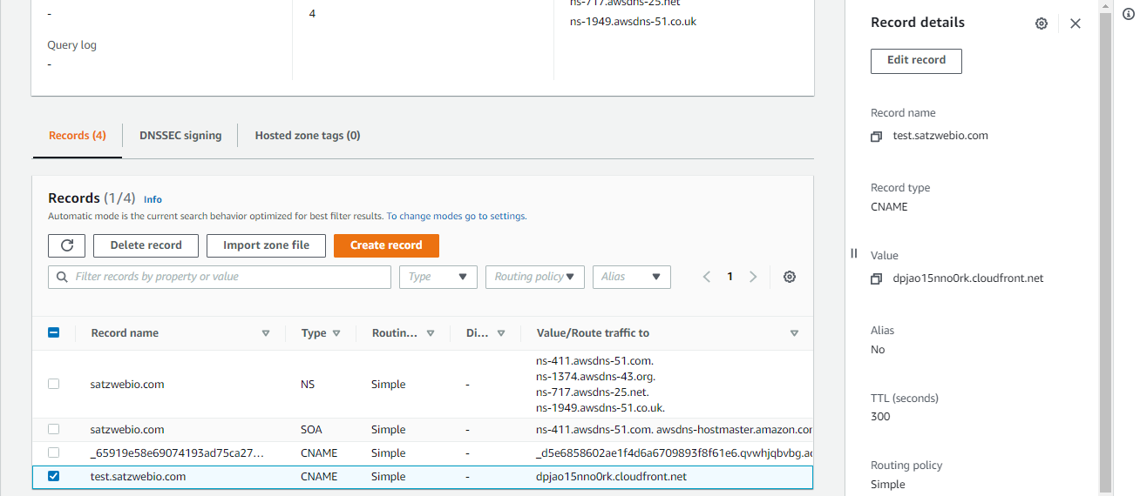

Once it is created, we can now host our website through your domain name:

<https://test.satzwebio.com/>

