1.User clicks on the customer login button
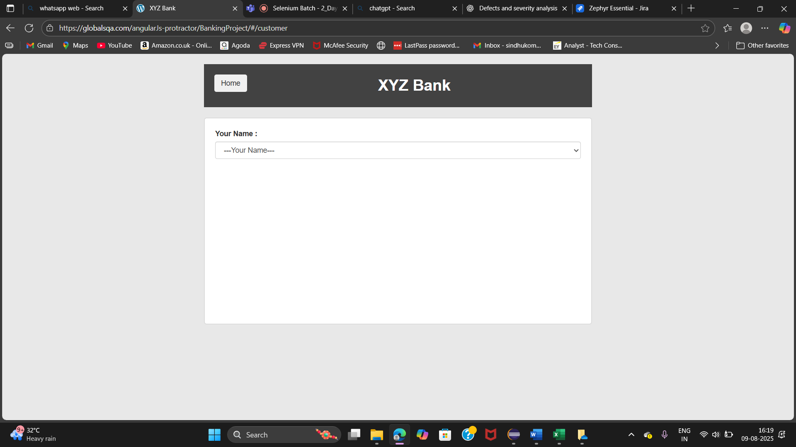
2.User clicks on your name and selects one name
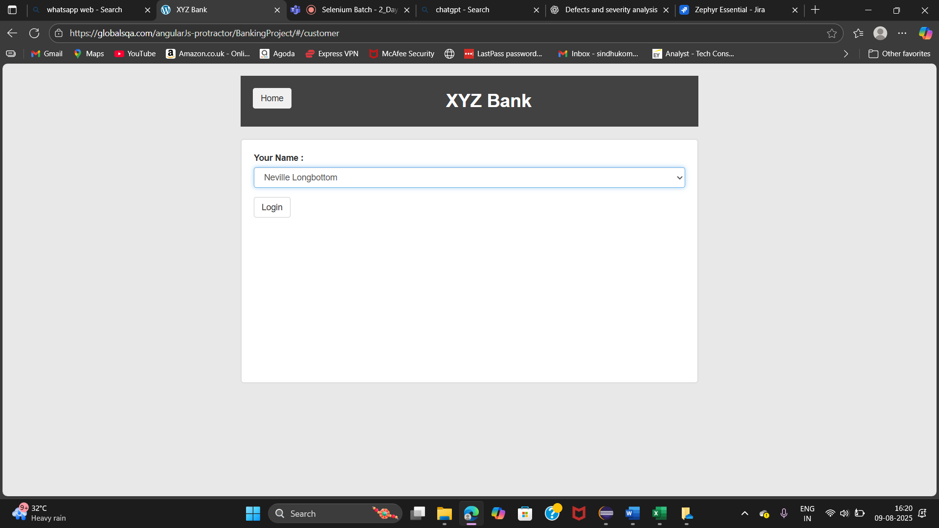
3.User clicks on login button redirects to home page
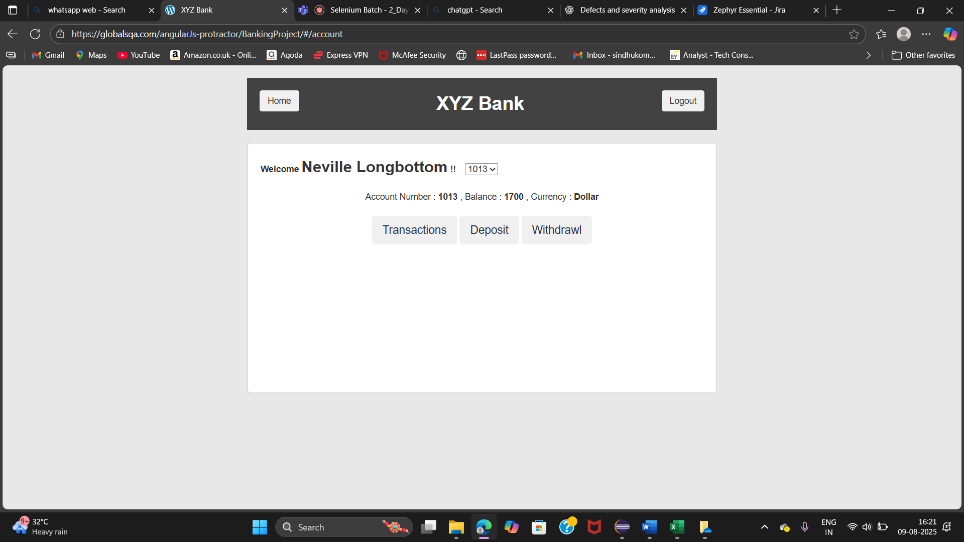

4.User clicks on deposit button and deposits sees a message
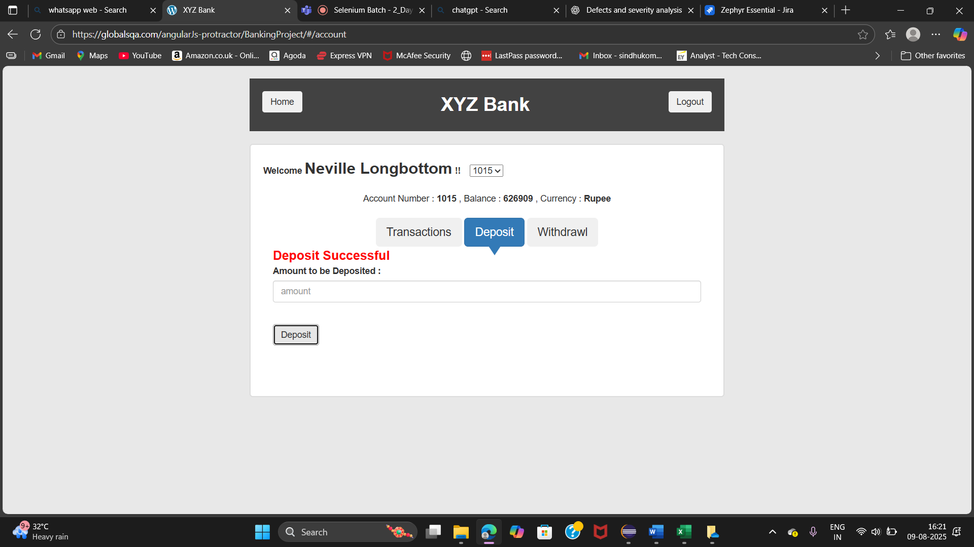
5.User clicks on withdraw button and withdraws sees a message
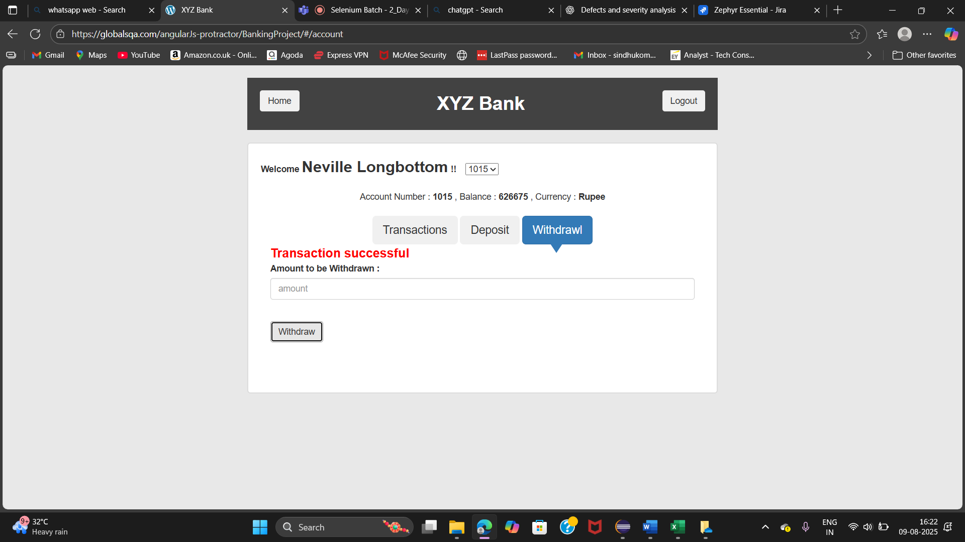
6.User clicks on Transactions button and sees Transactions
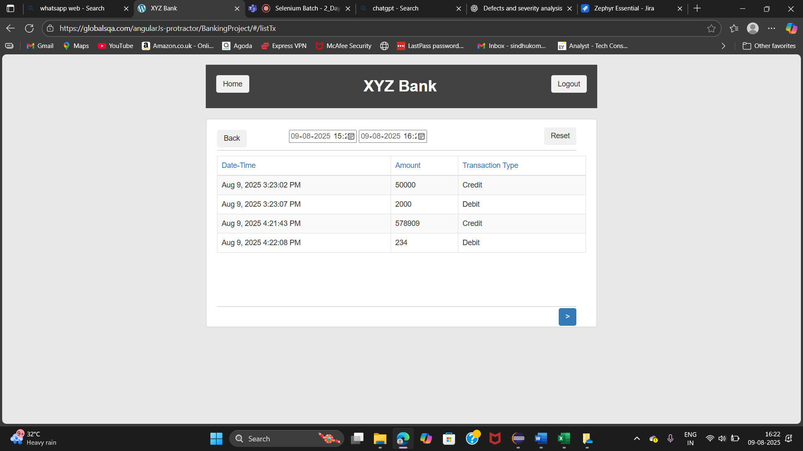
7.User clicks on logout button and logout from account
