1.Manager clicks on the manager login button
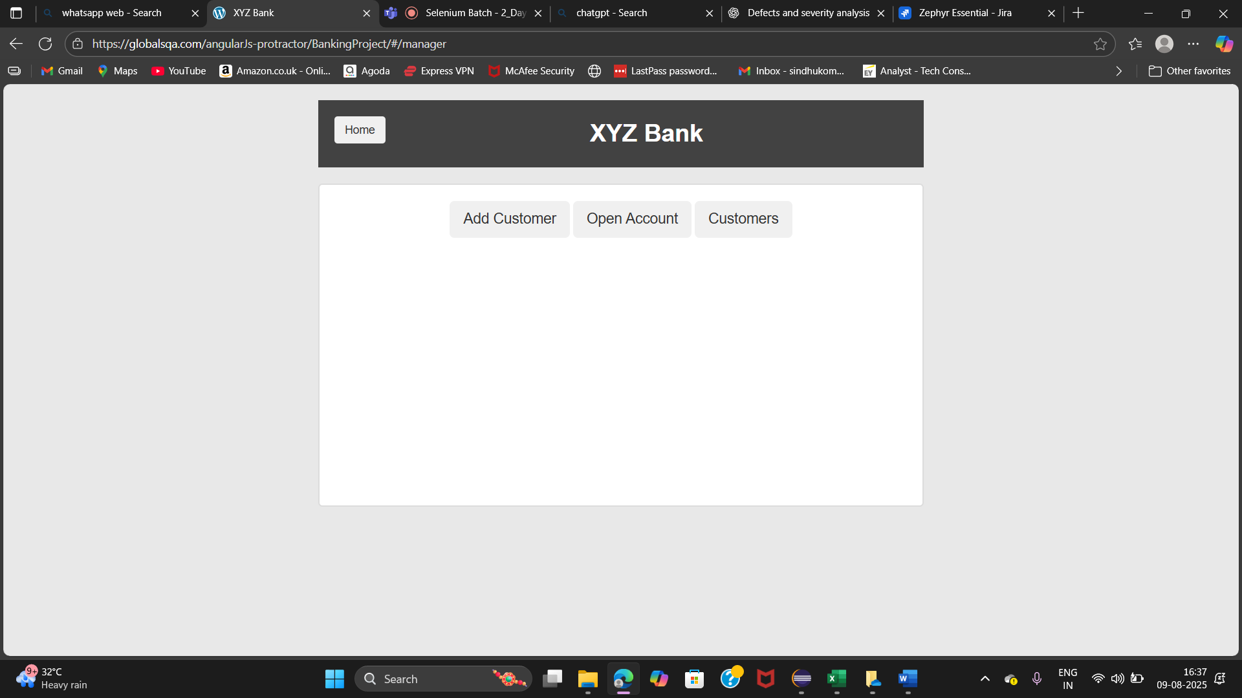
2.Manager clicks Add Customer and enters first name, last name, and postal code
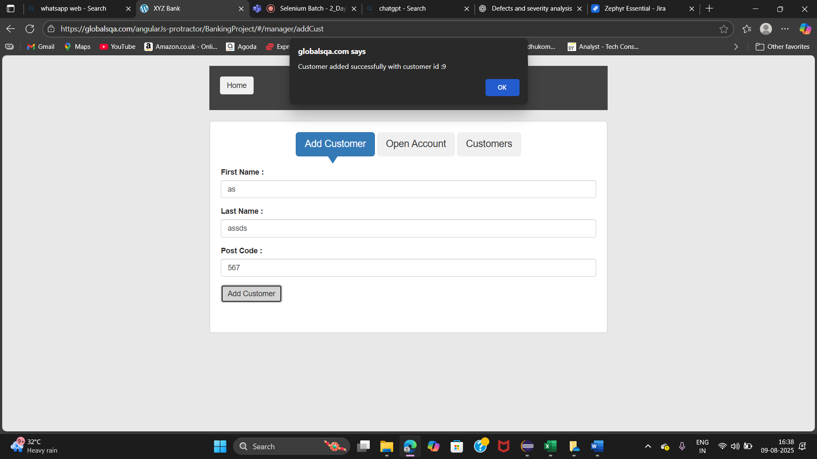
3.Manager clicks on open account and enters customer name and currency
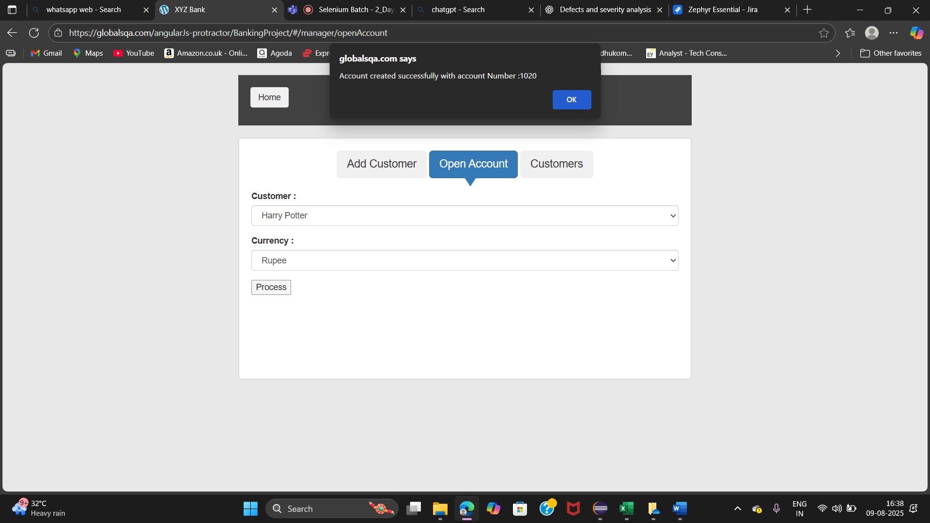
4.Verify that the manager can search for a customer by name and view their details in the customer list.
