1.User enters valid username

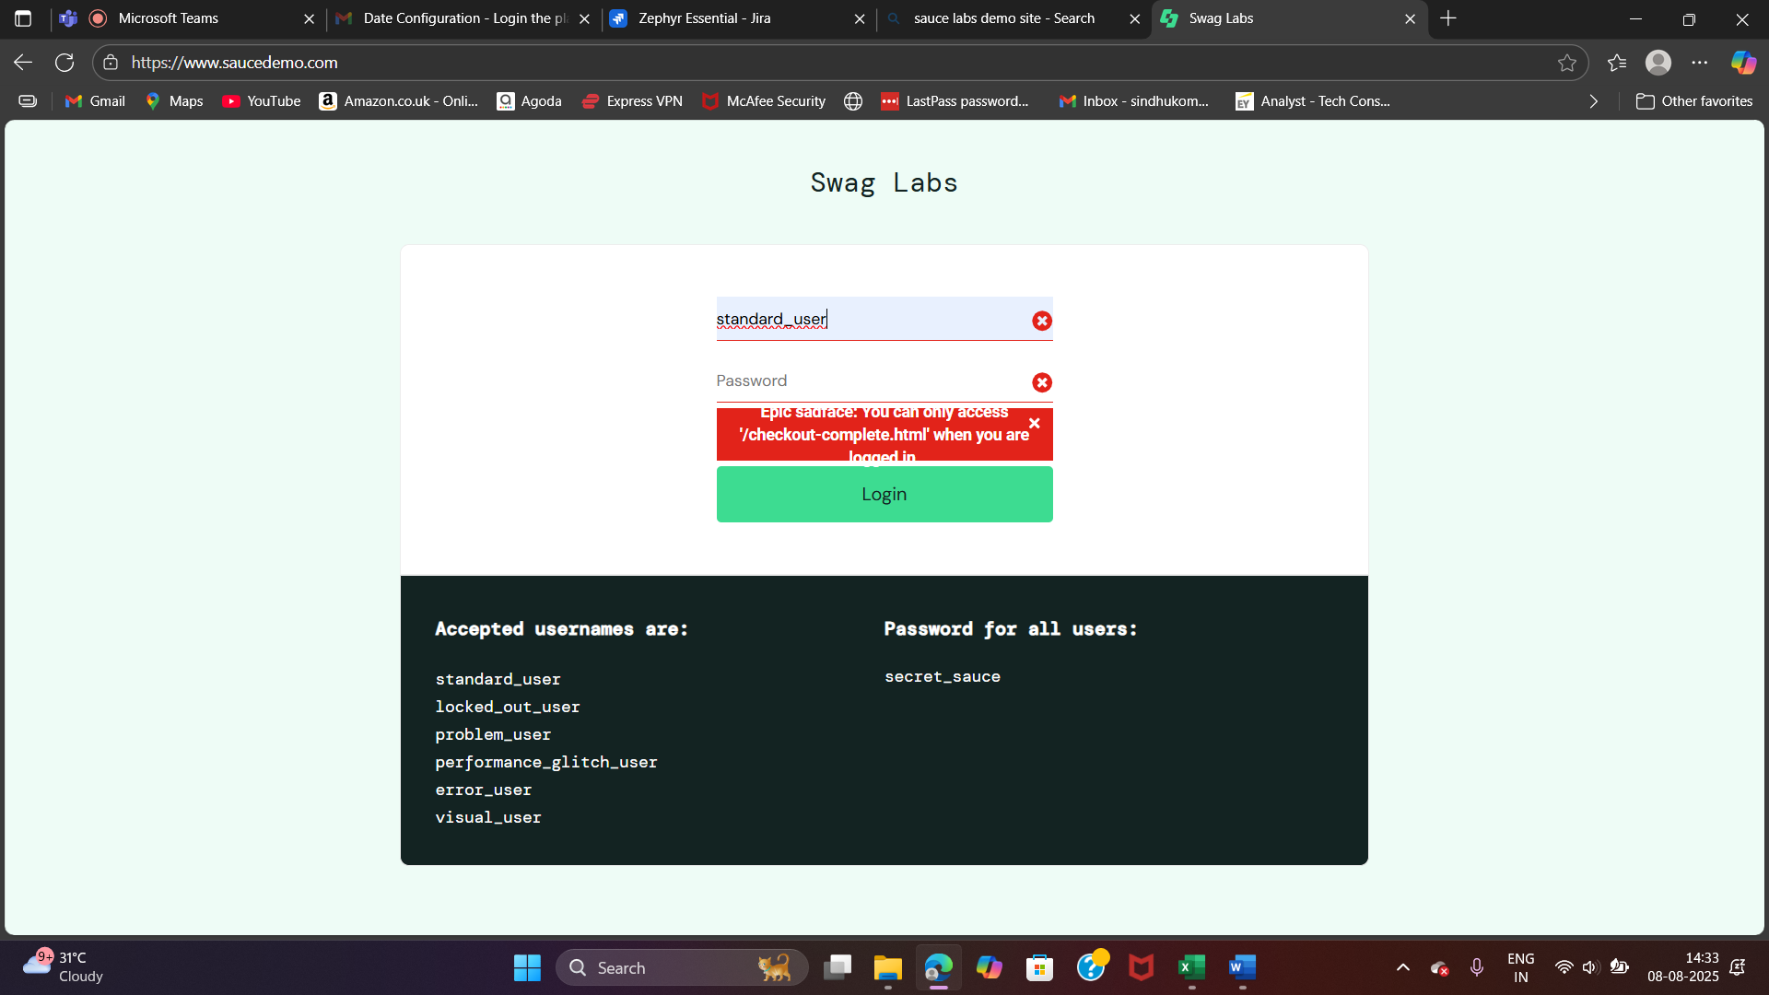

2.User enters valid password

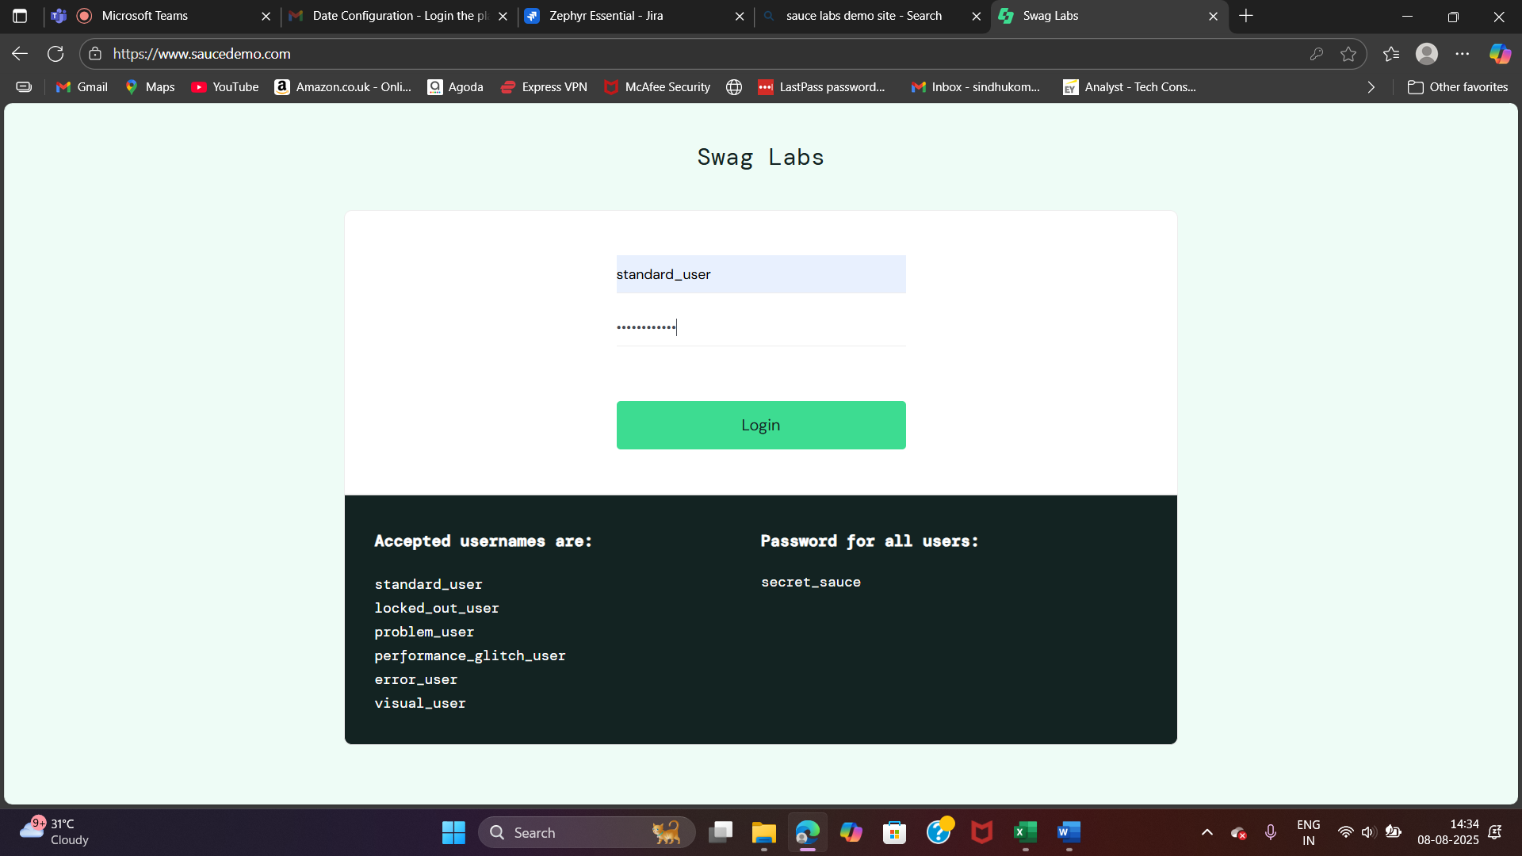

3.User clicks on login button

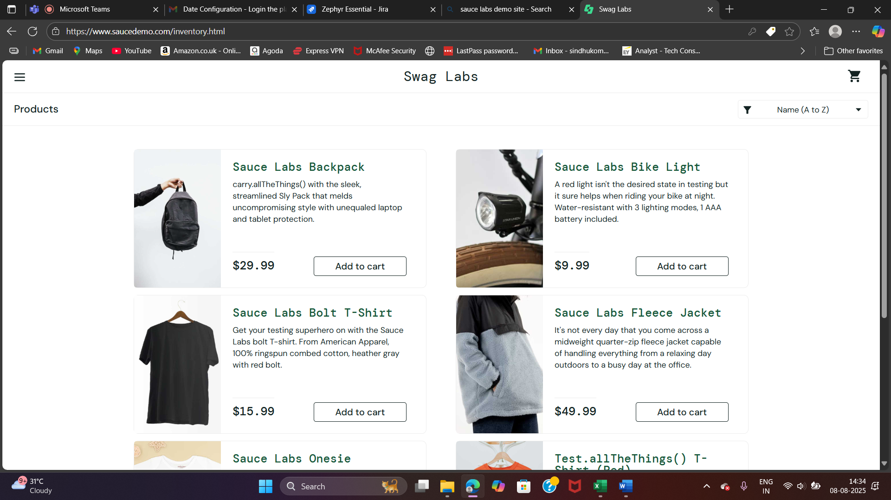

4.User selects Sauce labs backpack product and clicks on Add to cart

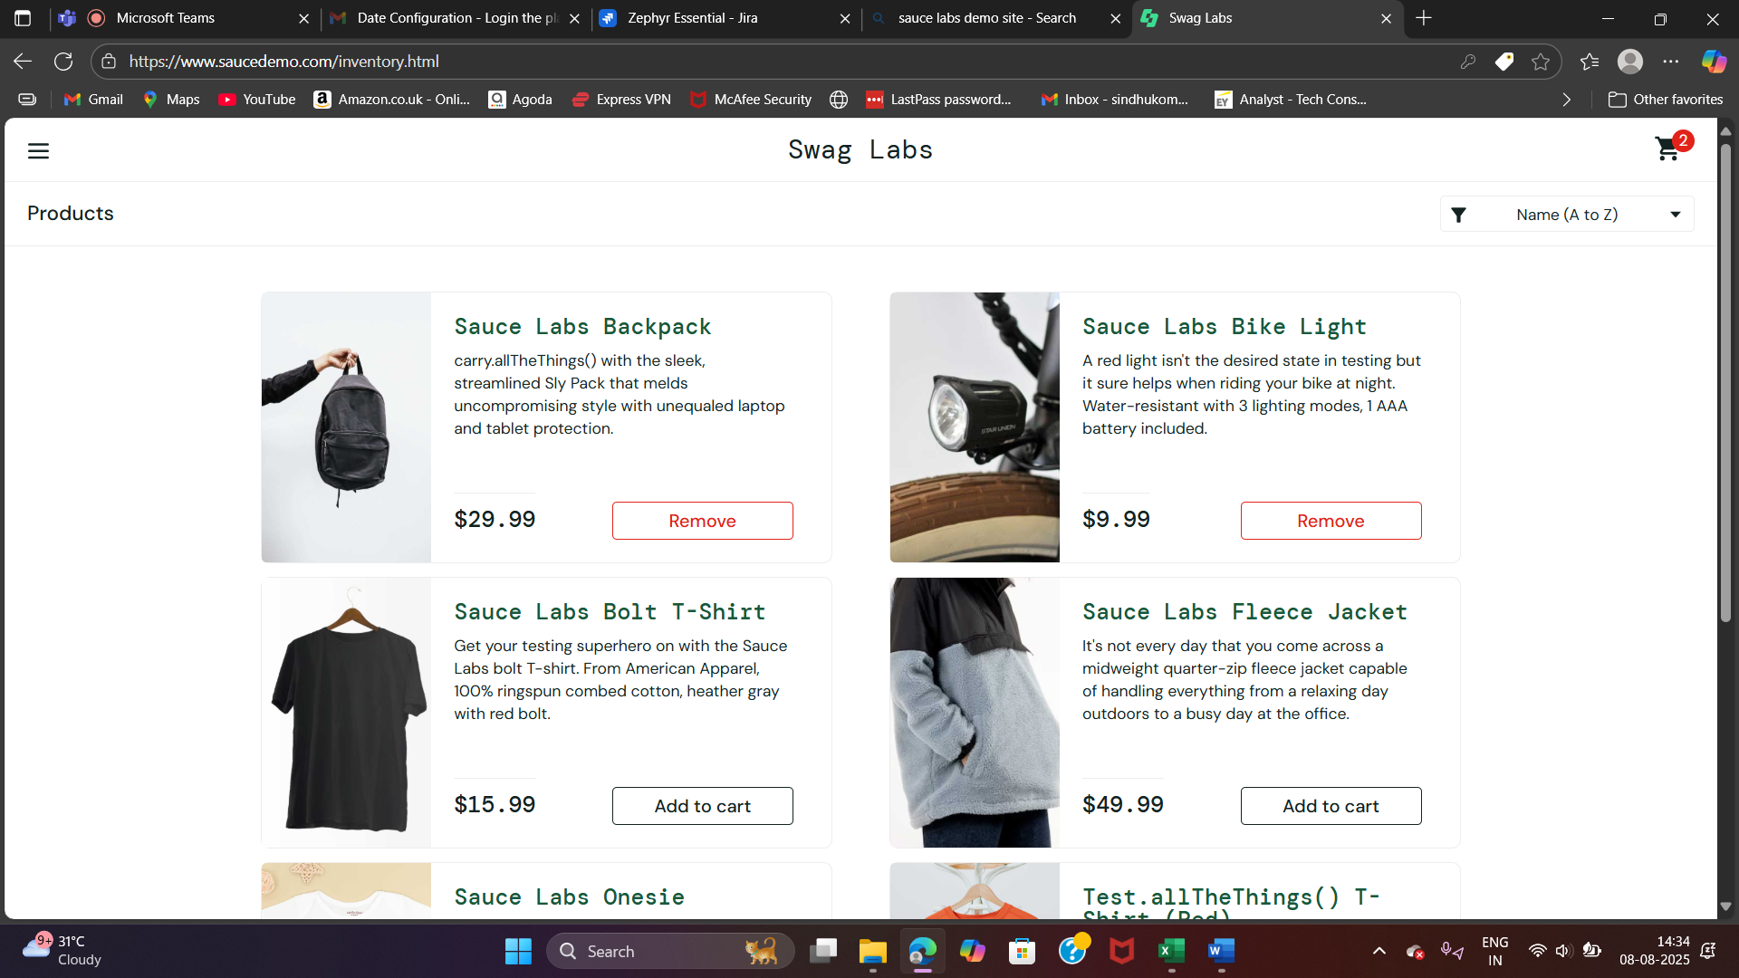

5.user clicks on add to cart image

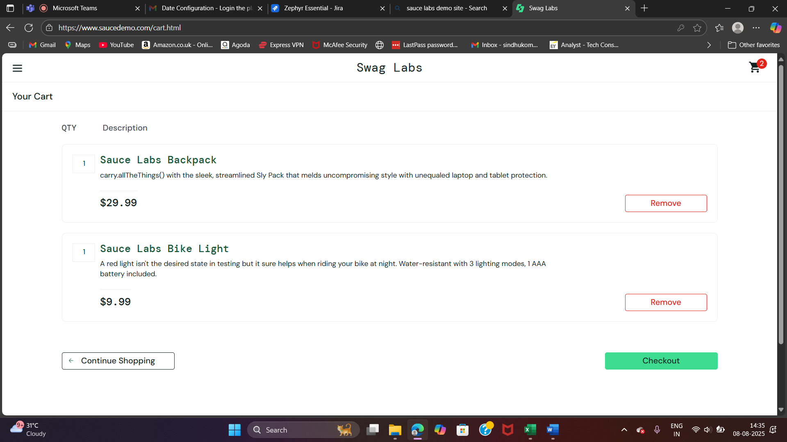

6.User validates the product and quantity and clicks on checkout button

7.User enter the first , last name and Zip code

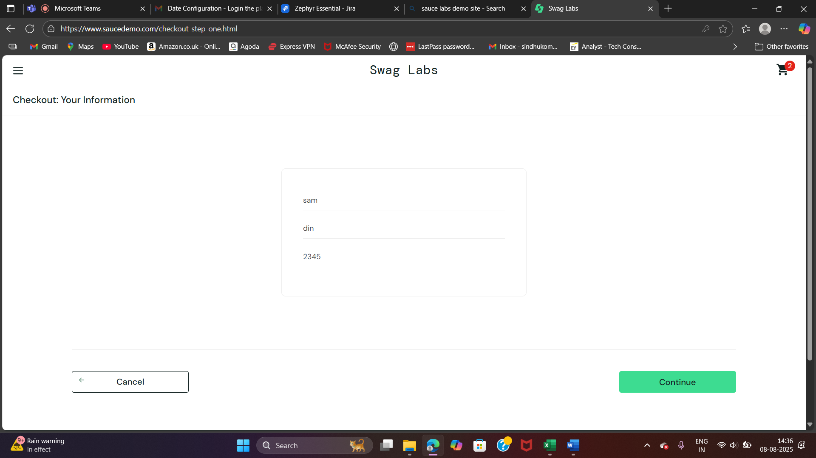

8.User clicks on continue

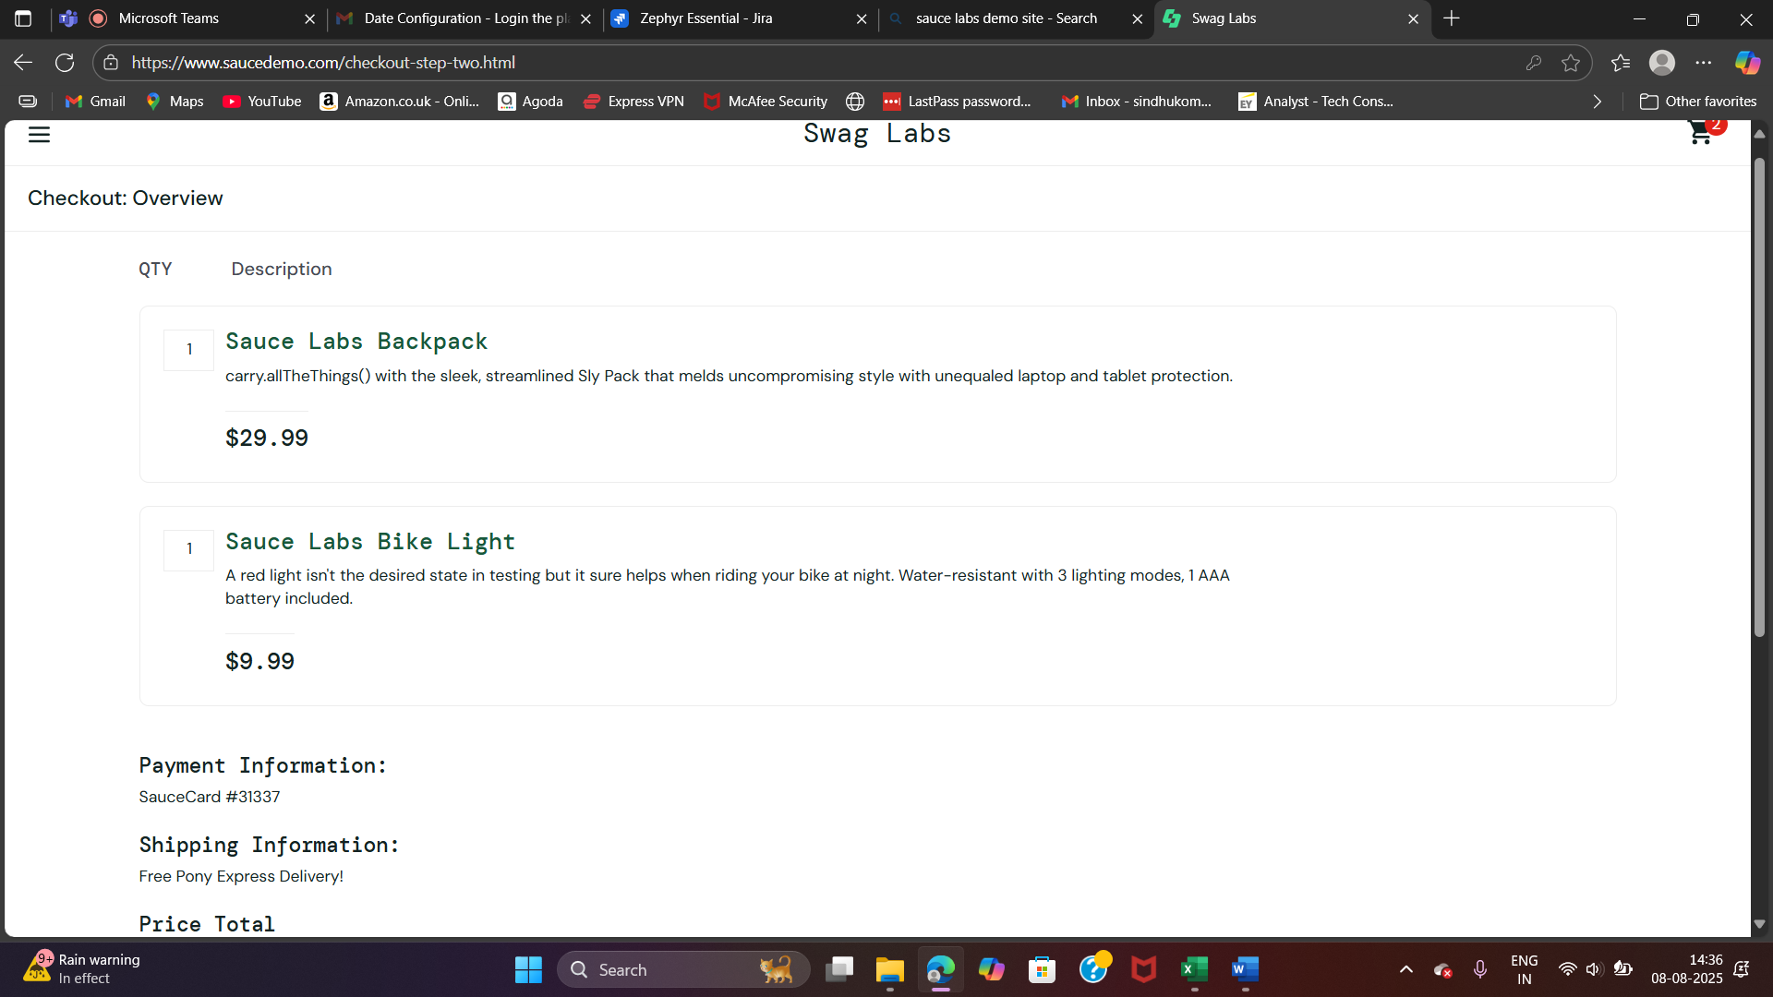

9.User clicks on Finish button

