VISVESVARAYA TECHNOLOGICAL UNIVERSITY
Jnana Sangama, Belgaum-590018


Mini Project Report
on
“Renewable Energy Microgrid”
Submitted in partial fulfillment of the requirements for the
First Semester of the Bachelor of Engineering Degree, towards the completion of the Mini Project under the Innovation & Design Thinking Laboratory, Department of Basic Sciences.

by

SN | Name | USN/Roll number
1. | Sia Sunil | 1CR25AD115
2. | Sindhu M | 1CR25AD116
3. | Sneha L | 1CR25AD117

Under the Guidance of Mr. Shreyas P.
Asst. Professor, Dept. of BME


CMR INSTITUTE OF TECHNOLOGY
#132, AECS LAYOUT, IT PARK ROAD, KUNDALAHALLI, BANGALORE-560037

CMR INSTITUTE OF TECHNOLOGY
#132, AECS LAYOUT, IT PARK ROAD, KUNDALAHALLI,
BANGALORE-560037
DEPARTMENT OF BASIC SCIENCES

CERTIFICATE
This is to certify that the File Structures mini project entitled “Renewable energy microgrid” has been successfully carried out by Sia Sunil (H-37), Sindhu M (H-38), and Sneha L. (H-39), bonafide students of CMR Institute of Technology.
The project is submitted in partial fulfillment of the requirements for the First Semester of the Bachelor of Engineering Degree, towards the completion of the Mini Project under the Innovation & Design Thinking Laboratory, Department of Basic Sciences.
It is further certified that all corrections and suggestions indicated during the Internal Assessment have been duly incorporated in the project report submitted to the departmental library. This File Structures mini project report has been reviewed and approved as it satisfies the academic requirements prescribed for the said degree.

----------------------- ----------------------
Signature of HOD
Dr. Raveesha K H
HoD,
Dept. of Physics, CMRIT

Signature of Guide
Mr. Shreyas P
Dept. of BME, CMRIT
Mr.
Asst. Professor
Dept. of BME, CMRIT
External Viva
Name of the examiners Signature with date
1.
2.

TABLE OF CONTENT

Title Page No.
Acknowledgement …………………………………...……………………………….i
Abstract …………………………………...…………………………………...……..ii

Chapter 1
INTRODUCTION …………………………………………………………….....…1-2
1.1 Brief History of Rural Electrification Systems……………………………….......1
1.2 Modern Renewable Energy Microgrid Systems ……………………………......1-2

Chapter 2
ABOUT THE PROJECT ………………………………………………………… 3-4
2.1 Problem Statement…………………………………...…………………………...3
2.1.1 Description…………………………………...…………………………. 3
2.1.2 Challenge Statement…………………………………...………………... 3
2.2 Objective of the Project …………………………………………………..……....4
2.3 Proposed Solution ………………………………………………………..……… 4
2.4 Advantages of Proposed solution ………………………………………...……….4

Chapter 3
DESIGN…………………………………………………………….…5-9
3.1 Design Thinking Process …………………………..……………………….……5
3.2 Methodology……………..……………..……………..……………..….……......6
3.3 Prototype Description……..……………..…………..……………..…………..6-7

3.3.1 Materials Used……..……………..…………..……………..…………7-9
3.3.2 System Diagram……..……………..…………..……………..…………9

Chapter 4
Implementation (Arduino Code)……………………………….…… 10-13

Chapter 5
RESULT AND ANALYSIS ……………………………………………………..…. 14
5.1 User Testing & Feedback………………………………………………………… 14
5.2 Hardware Setup…………………………………………………………………... 14

Chapter 6
Conclusion & Future Work…………………………………………..15-16

REFERENCES …………………………………………………………16

ACKNOWLEDGEMENT

I sincerely express my gratitude to Dr. Sanjay Jain, Principal, CMR Institute of Technology, Bangalore, for providing a supportive academic environment.
I extend my thanks to Dr. Raveesha K H, HoD, Dept. of Physics, CMRIT for his valuable guidance and support.
I am especially grateful to my internal guide, Mr. Shreyas P, Assistant professor Dept. of Bachelor of Mechanical Engineering, for his constant encouragement and guidance throughout this project.
I also thank all the faculty members, non-teaching staff, and others who contributed directly or indirectly to the successful completion of this work.

Sia Sunil (1CR25AD115),
Sindhu M (1CR25AD116), and
Sneha L (1CR25AD117)

Abstract

Reliable electricity access remains a major challenge in many rural and semi-urban regions due to frequent power outages, voltage fluctuations, and limited affordability of backup systems. This mini project presents the design and development of a small-scale renewable energy microgrid intended to provide a stable, affordable, and environmentally sustainable power solution for such communities. The project adopts an empathy-driven approach, incorporating field exploration and stakeholder interactions to identify real-world energy needs and constraints. A solar-based microgrid prototype was developed using a centralized controller to manage energy generation, storage, and load prioritization. The system integrates solar power with battery storage and grid backup, ensuring uninterrupted supply for essential applications such as lighting, phone charging, water pumping, and medicine storage. Intelligent relay control enables efficient source switching based on availability and safety thresholds. The proposed model emphasizes modularity, scalability, and community-friendly operation, making it suitable for remote villages with unreliable grid connectivity. The outcome demonstrates that a low-cost, decentralized microgrid can significantly enhance energy reliability while reducing dependence on fossil fuels and supporting sustainable rural development.

Chapter 1

INTRODUCTION
Access to reliable electricity is essential for social development, education, healthcare, and economic activities. However, many rural and remote areas continue to experience frequent power outages, voltage fluctuations, and limited grid connectivity, which negatively impact daily life and productivity. Conventional centralized power systems often fail to meet the needs of such regions due to high transmission losses, infrastructure costs, and maintenance challenges. The objective of this mini project is to design and develop a small-scale renewable energy microgrid that provides a stable, affordable, and environmentally friendly power supply for rural communities. The proposed system integrates solar energy generation with battery storage and grid backup to ensure uninterrupted power for essential applications such as lighting, device charging, water pumping, and medicine storage. By adopting a decentralized and community-focused approach, the project aims to improve energy reliability, promote sustainability, and support long-term rural development.
1.1 Brief History of Rural Electrification Systems
Early rural electrification relied heavily on centralized power plants and long-distance transmission lines, which often proved unreliable and costly for remote areas. Many villages remained unelectrified or received electricity for limited hours due to infrastructure constraints and high operational expenses. To address these challenges, alternative solutions such as diesel generators were introduced; however, they resulted in high fuel costs, noise, and environmental pollution. Over time, the need for decentralized and sustainable energy solutions became evident, leading to the exploration of localized power generation models.
1.2 Modern Renewable Energy Microgrid Systems
Modern renewable energy microgrids represent a significant advancement in rural electrification. These systems combine renewable sources such as solar and wind energy with energy storage and intelligent control mechanisms. Microgrids can operate independently or alongside the main utility grid, offering improved reliability, scalability, and efficiency. With advancements in power electronics, battery technology, and embedded controllers, renewable microgrids have become a practical and cost-effective solution for providing clean and continuous power to underserved communities.

Chapter 2

ABOUT THE PROJECT

2.1 Problem Statement

  - 2.1.1 Description
Many rural and semi-urban communities continue to face persistent electricity-related challenges such as frequent power outages, unstable voltage levels, and limited access to affordable backup power systems. These issues adversely affect daily activities, including household tasks, education, healthcare services, and small-scale economic operations. Dependence on conventional grid supply and fossil fuel–based alternatives like diesel generators and kerosene lamps increases operational costs, environmental pollution, and health risks. Additionally, lack of technical awareness, inadequate maintenance support, and financial constraints further restrict the adoption of reliable energy solutions. The absence of a dependable and sustainable electricity system highlights the need for an alternative approach that can ensure continuous power availability while being cost-effective and environmentally responsible.

  - 2.1.2 Challenge Statement
The primary challenge is to design and implement a small-scale renewable energy microgrid that can provide a stable, reliable, and affordable power supply to rural communities with minimal technical complexity. The system must be capable of addressing intermittent energy availability, voltage fluctuations, and storage limitations while remaining easy to operate and maintain at the community level. Furthermore, the solution should be scalable, environmentally friendly, and adaptable to local conditions, ensuring uninterrupted power for essential needs such as lighting, device charging, water pumping, and medicine storage, even in areas with limited grid connectivity.

2.2 Objective of the Project
The main objective of this project is to design and develop a small-scale renewable energy microgrid capable of providing reliable, continuous, and affordable electricity to rural or remote communities. The project aims to reduce dependence on unreliable grid supply and fossil fuel–based alternatives by integrating solar energy with energy storage and intelligent control mechanisms. Additional objectives include ensuring safe power management, supporting essential community needs, promoting environmental sustainability, and creating a scalable system that can be expanded based on future energy demands.

2.3 Proposed Solution
The proposed solution is a solar-based renewable energy microgrid that operates as a decentralized power system for a small rural community. The system combines solar energy generation, battery storage, and grid backup to ensure uninterrupted power supply. An embedded controller manages power flow by prioritizing renewable energy usage while maintaining system safety through voltage monitoring and relay-based switching. The microgrid is designed to supply electricity for essential applications such as lighting, phone charging, water pumping, and medicine storage. Its modular design allows easy expansion and adaptation to varying energy requirements.

2.4 Advantages of the Proposed Solution
The proposed renewable energy microgrid offers several advantages over conventional power systems. It provides reliable and uninterrupted electricity, even during grid failures or power cuts. The use of renewable energy reduces environmental impact and dependence on fossil fuels. The system is cost-effective in the long run due to low operational and maintenance expenses. Its scalable and modular nature allows gradual expansion as community needs grow. Additionally, the design is simple, community-friendly, and suitable for remote locations with limited technical infrastructure.

Chapter 3

DESIGN
3.1 Design Thinking Process
a) Empathize
Field visits and telephonic interviews were conducted with villagers, farmers, government school teachers, and local stakeholders from rural areas. These interactions revealed frequent power cuts, low voltage supply, reliance on kerosene lamps, and difficulties in studying at night and storing essential medicines. The findings highlighted the need for a reliable, affordable, and low-maintenance energy solution suitable for rural living conditions.
b) Define
Based on the empathy study, the key needs identified were uninterrupted electricity for essential activities, affordability, ease of maintenance, safe energy storage, and reduced dependence on conventional grid supply.
c) Ideate
More than ten solutions were brainstormed, including inverter systems, biogas generators, solar street lighting, shared community power rooms, and LED-based backup systems. After comparison, a solar-based renewable energy microgrid was selected as the most feasible, sustainable, and scalable solution for rural communities.
d) Prototype
A small-scale renewable energy microgrid prototype was developed using an Arduino Uno as the control unit. The system integrates solar power, battery storage, and grid input with automatic and manual switching. Battery charging, regulated power output, relay-based source selection, and LED indicators were implemented to demonstrate real-time operation and source status. The prototype was assembled on a breadboard to allow flexibility and testing.
e) Test
The prototype was tested under various operating conditions including solar availability, grid presence, battery operation, and power outages. The system successfully ensured uninterrupted power to loads through automatic source switching. Manual override functionality was verified, and visual indicators accurately reflected the active power source. All functional objectives were achieved with stable and reliable performance.
3.2 Methodology 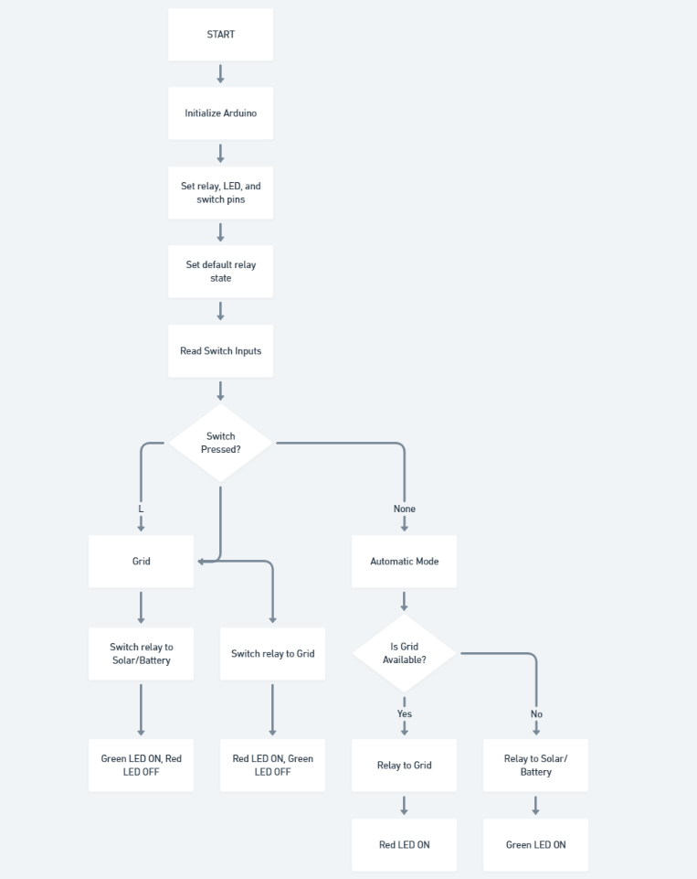
3.3 Prototype Description
The prototype uses an Arduino Uno R3 as the main controller to manage power switching between a 6V solar panel, 5V grid adapter, and a 3.7V 18650 Li-ion battery. Battery charging is handled by a TP4056 module, and a DC-DC buck converter provides regulated 5V power to the system. A 5V single-channel relay (active LOW) enables automatic switching based on voltage conditions, while a 3-prong switch allows manual selection between solar, grid, and automatic modes. Status LEDs indicate the active power source, and load LEDs represent connected loads. The entire circuit is assembled on a breadboard, demonstrating both automatic and manual microgrid operation with clear indication of whether the load is powered by solar or grid supply.

3.3.1 Materials Used
- Arduino Uno R3
Description: Central microcontroller board for voltage sensing, relay control, and logic execution.
Specifications: ATmega328P, 16MHz clock, 14 digital I/O (6 PWM), 6 analog inputs (A0-A5), 5V operating voltage, 32KB flash, USB programming.
- 18650 Li-ion Battery Cell (3.7V)
Description: Primary energy storage for off-grid operation.
Specifications: Nominal 3.7V, 4.2V fully charged, 2.5V minimum, 2000-3500mAh capacity, protected cell recommended.
- TP4056 Li-ion Charging Module
Description: Single-cell lithium battery charger with protection.
Specifications: 1A max charge current, IN+ 4.5-8V input, B+/B- battery terminals, LED indicators, thermal regulation.
- 6V Solar Panel (Small)
Description: Renewable energy source for charging and direct powering.
Specifications: 6V open-circuit voltage, ~100-200mA short-circuit current, polycrystalline/monocrystalline, compact size (~50x70mm).
- 5V 1 Channel Relay Module (Active LOW)
Description: A 1-channel relay module is an electrically operated switch that allows a low-voltage control signal to safely switch high-voltage or high-current loads.
Specifications: Operating voltage: 5 V DC; Load capacity: up to 10 A at 250 V AC or 30 V DC; Trigger type: active LOW/HIGH (module dependent).

- DC-DC buck converter
Description: A DC–DC converter is an electronic module used to step up or step down a DC voltage to a required stable output level.

Specifications: Input voltage range: typically 3–12 V DC; Output voltage: adjustable or fixed (e.g., 5 V); Efficiency: up to 90% (module dependent)

- AC Adapter (5V DC Output)
Description: Government/grid supply simulation.
Specifications: 5V/1-2A output, barrel jack or USB, represents mains backup power.
- Status LEDs (2x) + Load LEDs (4x)
Description: System status indication and demonstration load.
Specifications: 5mm LEDs, 2V forward voltage, 20mA current, 220Ω current limiting resistors.
- Resistors
Description: Voltage dividers and LED current limiting.
Specifications: 5×10kΩ (dividers), 5×47kΩ (solar divider), 10×220Ω (LEDs), 1/4W carbon film.
- 3 Prong Switch:
Description: A 3-prong switch is a manually operated electrical switch used to control the flow of current by opening or closing a circuit.
Specifications: Rated voltage: typically 230 V AC or 12–24 V DC; Current rating: 5–10 A; Terminals: 3 prongs (common, normally open, normally closed).

- Breadboard + Jumper Wires
Description: Prototype assembly platform.
Specifications: 830-point breadboard, 20 male-male + 15 male-female wires (red/black power coding).
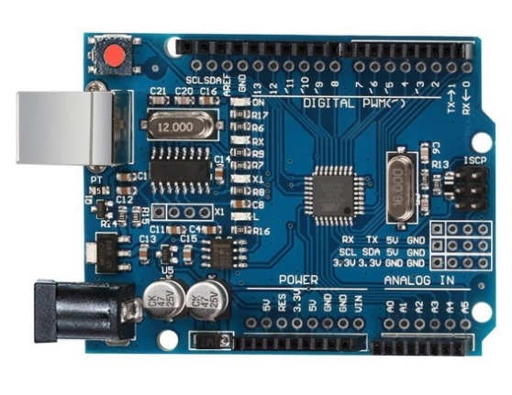
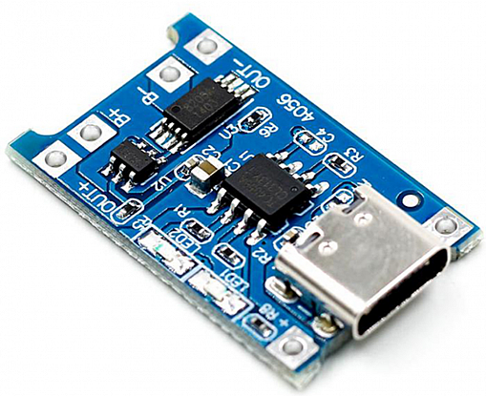
Fig 3.1 Arduino Uno R3
Fig 3.2 TP4056 Li-ion Charging Module
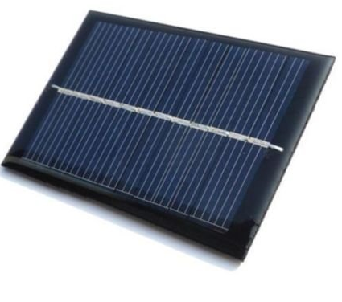
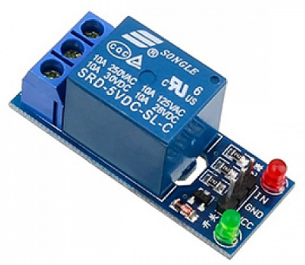
Fig 3.3 6V Solar Panel (Small)

Fig 3.4 5V 1 Channel Relay Module (Active LOW)

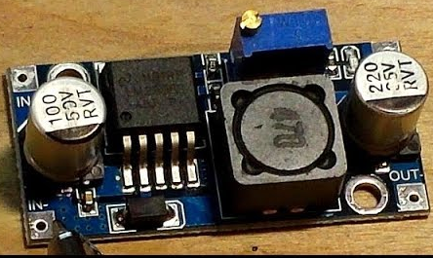
Fig 3.5 DC-DC buck converter

3.3.2 System Diagram
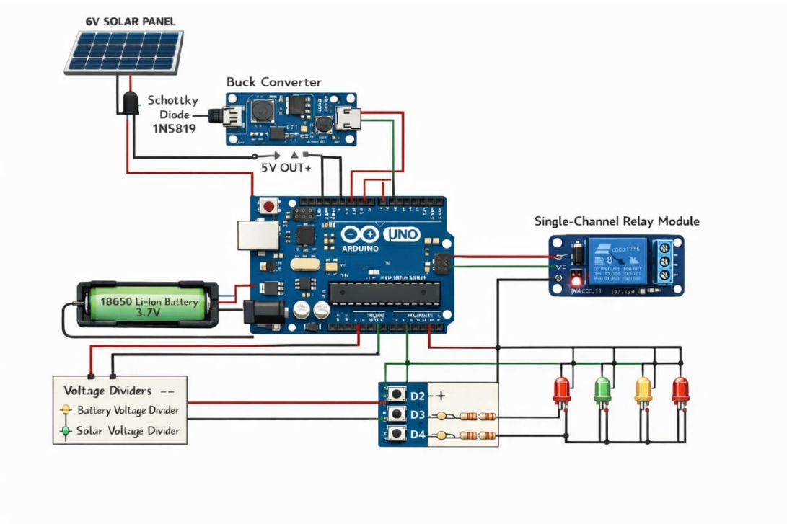
Fig 3.6
Chapter 4

Implementation
// Solar Microgrid Controller - Arduino Uno R3
// LL = Solar source | O = Auto | L = Grid source

const int pinGridSense = 2; // Grid presence detect
const int pinSolarManual = 3; // LL pressed → Solar
const int pinGridManual = 6; // L pressed → Grid

const int pinRedLED = 4; // Grid active LED
const int pinGreenLED = 5; // Solar/Battery active LED
const int pinRelay = 8; // Relay IN (Active LOW)

void setup() {
Serial.begin(9600);

pinMode(pinGridSense, INPUT);
pinMode(pinSolarManual, INPUT);
pinMode(pinGridManual, INPUT);

pinMode(pinRedLED, OUTPUT);
pinMode(pinGreenLED, OUTPUT);
pinMode(pinRelay, OUTPUT);

// Safe startup: default to Grid via NC
digitalWrite(pinRelay, HIGH);
digitalWrite(pinRedLED, LOW);
digitalWrite(pinGreenLED, LOW);

Serial.println("=== SOLAR MICROGRID READY ===");
Serial.println("LL=Solar | O=Auto | L=Grid");
}

void loop() {
bool solarManual = digitalRead(pinSolarManual); // LL
bool gridManual = digitalRead(pinGridManual); // L
bool gridPresent = digitalRead(pinGridSense);

// -------- MANUAL OVERRIDE --------
if (solarManual && !gridManual) {
// LL pressed → Solar
digitalWrite(pinRelay, LOW);
digitalWrite(pinGreenLED, HIGH);
digitalWrite(pinRedLED, LOW);
Serial.println("MANUAL: Solar/Battery ON");
}
else if (gridManual && !solarManual) {
// L pressed → Grid
digitalWrite(pinRelay, HIGH);
digitalWrite(pinRedLED, HIGH);
digitalWrite(pinGreenLED, LOW);
Serial.println("MANUAL: Grid ON");
}
else {
// -------- AUTOMATIC MODE --------
autoSwitch(gridPresent);
}

delay(500);
}

// ---------------- AUTO MODE ----------------
void autoSwitch(bool gridPresent) {
if (gridPresent) {
// Prefer grid
digitalWrite(pinRelay, HIGH); // Grid via NC
digitalWrite(pinRedLED, HIGH);
digitalWrite(pinGreenLED, LOW);
Serial.println("AUTO: Grid supplying load");
} else {
digitalWrite(pinRelay, LOW); // Solar/Battery via NO
digitalWrite(pinGreenLED, HIGH);
digitalWrite(pinRedLED, LOW);
Serial.println("AUTO: Solar/Battery supplying load");
}
}

Chapter 5
Results and Analysis

5.1 User Testing & Feedback
Sample:
Participants: 8 villagers, 2 farmers, 1 government school teacher, and 1 local stakeholder.
Quantitative Results:
- Continuous power availability improved during testing hours.
- Successful automatic switching between solar, battery, and grid sources with zero interruption.
- Battery voltage maintained within safe operating limits throughout operation.
- Reduction in dependence on kerosene lamps during evening hours.
Qualitative Feedback:
- Villagers: “Lighting at night has become more reliable.”
- Farmers: “Phone charging and small electrical needs are now easier.”
- Teacher: “Children can study comfortably in the evening.”
- Stakeholders: “The system is simple, practical, and suitable for village use.”

5.2 Hardware Setup:
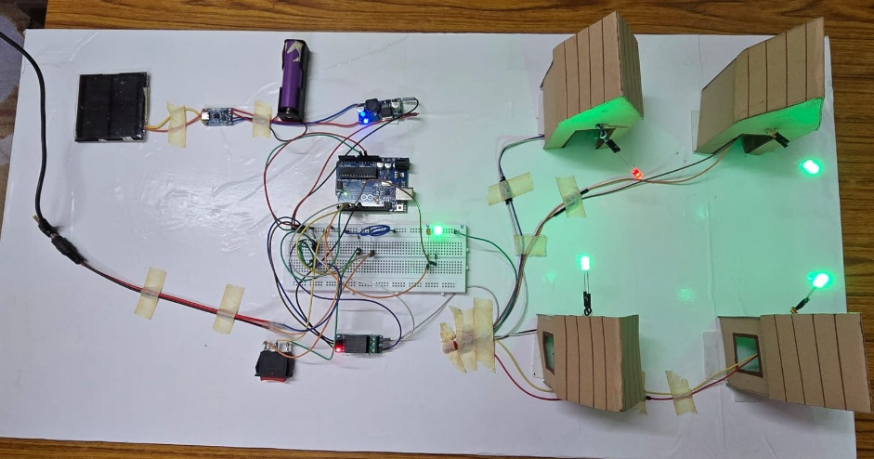
Chapter 6
Conclusion & Future Work
The renewable energy microgrid developed in this project successfully addresses the persistent challenges of unreliable electricity supply in rural and remote areas. Frequent power outages, low voltage, and dependence on fossil fuel–based alternatives such as diesel generators and kerosene lamps significantly affect the daily lives of villagers, impacting essential activities including lighting, education, water pumping, and storage of temperature-sensitive medicines. The proposed microgrid integrates solar power generation, battery storage, and grid backup, managed through a microcontroller-based control unit.. The modular and scalable design allows for future expansion, providing flexibility for growing energy demands in the community.
The prototype demonstrates effective source switching, reliable energy management, and improved availability of electricity, while reducing dependency on conventional grid supply and minimizing environmental impact. By leveraging renewable energy, the system offers a sustainable and cost-effective solution that can be easily adopted by rural communities with minimal technical knowledge. The approach emphasizes user-friendly operation, low maintenance, and safety, making it suitable for practical implementation in small villages or remote areas.
Future Work:
- Integration of wind energy or hybrid renewable sources to enhance generation capacity and reliability.
- Utilization of recycled batteries to promote e-waste management and further reduce project costs.
- Implementation of IoT-based energy dashboards for remote monitoring, predictive maintenance, and real-time performance tracking.
- Expansion of the microgrid to support productive agricultural activities and small-scale industrial loads, thereby promoting economic development in rural areas.
- Exploration of community-driven models for microgrid management and maintenance to ensure sustainability and local engagement.
Overall, this project demonstrates the feasibility and benefits of decentralized renewable energy systems, laying the groundwork for future development and large-scale implementation in underserved regions.

References
Research Papers:
- T. Ackermann, G. Andersson, L. Söder: Distributed Generation: A Definition, Electric Power Systems Research, 2001.
Textbooks:
- Muhammad H. Rashid: Power Electronics Handbook, 4th Edition, Elsevier, 2018.
Online Articles / Websites:
- https://www.energy.gov/eere/solar/home-solar-photovoltaic-technology-basics
- https://www.sciencedirect.com/topics/engineering/microgrid
- https://www.nrel.gov/grid/microgrids.html

Annexures
- Annexure A: Villager Survey / User Feedback Forms
- Annexure B: Field Visit Notes and Observations
- Annexure C: Prototype Design Sketches and Wiring Diagrams
- Annexure D: Idea Scoring Matrix and Selection Notes

