**Team Members**: Lakshmi Shri Shivaram Ponallaghi, Sindhuja Madishetty, Keerthana Yadavelli

**Initial Setup**: Please upload the entire folder “Front-end” to the server. All the files are arranged in their respective folders.

Please import Database related files from the folder Database Tables.

**Live link of our web application:**

<https://in-info-web4.informatics.iupui.edu/~smadishe/Project_Test_version2/loginSA.php>

**Database connectivity**:

config/database.php – Contains class definition related to database connectivity – Server related information

**Database Tables**: User, Product, product_image, Review

**CSS**: libs/css/custom.css – CSS styling tags are defined here

**Bootstrap**: accessed through MaxCDN through below link

<https://maxcdn.bootstrapcdn.com/bootstrap/3.3.7/css/bootstrap.min.css>

**Class definitions:**

* Objects/product.php – Product
* Objects/product_image.php – ProductImage
* Objects/review.php - Review

**Images:**

Uploads/images – Contains jpg files of all images of the available products.

**loginSA.php** – Login Page

* Home – Linked to loginSA.php
* AboutUs – Linked to AboutUs.php
* Register – Linked to registerSA.php

If Login details are entered:

- Successful Login – afterLoginSA.php

- Unsuccessful Login – Error – User not registered or Password is incorrect

**AboutUs.php** – Motivation behind our website

* Home – Linked to loginSA.php
* Register – Linked to registerSA.php
* Login – Linked to loginSA.php
* Logout – Linked to logoutSA.php

**RegisterSA.php** – registration page for the users

* Home – Linked to loginSA.php
* Login – Linked to loginSA.php
* Logout – Linked to logoutSA.php

Successful signup – Data is inserted into User table

- Redirected to loginSA.php

Unsuccessful signup – Error – Problem occurred in signing up, please try again

- Redirected to registerSA.php

**afterLoginSA.php** – Displays successful login of the user and allows to navigate to different pages

* Home – loginSA.php
* Products – products.php
* Logout – logout.php

**navigation.php** - To design navigation bar

* PhoneMax - products.php
* Products - products.php
* Cart - cart.php
* Logout - logoutSA.php

**layout_header.php** - To design the header layout

Includes - navigation.php

Linked to - Max CDN bootstrap framework

* custom.css

**Layout_footer.php -** To design the footer part of the web page

* Includes javascript functions
  + For adding product to the cart - linked to add_cart_to.php
  + For updating quantity of a product in the cart - linked to update_quatity.php

**Paging.php -** to implement pagination techniques

**Read_products_template.php** - to define the template to display individual products on products display page i.e products.php

Image of the product - linked to product.php

Add to cart button - linked to add_to_cart.php

Includes - paging.php

**Products.php -** Main page to display all the products

Includes

* config/database.php
* objects/product.php
* objects/product_images.php
* layout_header.php
* read_products_template.php
* layout_footer.php

**Product.php -** to display information about a particular product

Includes

* config/database.php
* objects/product.php
* objects/product_image.php
* objects/review.php
* layout_header.php
* layout_footer.php

Click Here to Enter Review button - Opens a modal

- Submit button of the modal - Linked to insert_review.php

Add to Cart button - Linked to add_to_cart.php

Update cart button (displayed if the product is already present in the cart) - Linked to cart.php

**add_to_cart.php** - to add a product to the cart

* Linked to products.php

**cart.php** - to display cart

Includes

* config/database.php
* objects/product.php
* objects/product_image.php
* layout_header.php
* layout_footer.php

Update Button - Linked to update_quantity.php (through layout_footer)

Delete Button - remove_from_cart.php

Proceed to Checkout Button - checkout.php

**update_quantity.php** - to update quantity of a product in the cart

Redirected to cart.php

**remove_from_cart.php** - to delete a product from the cart

Redirected to cart.php

**Insert_review.php -** to insert a review into Review table and Overall_rating into Product table in the database

Redirected to products.php

**Checkout.php -** to view the order i.e all the items that are added to the cat for final review and to place order

Includes

* config/database.php
* objects/product.php
* objects/product_image.php
* Layout_header.php
* Layout_footer.php

Place Order Button - Linked to place_order.php

**Place_order.php** - To place the order

Includes

* layout_header.php
* layout_footer.php

**Logout.php -** For logging out of the web application.

Redirected to loginSA.php

**Steps to prepare the input file for machine learning**

1. Export Review table as CSV for MS Excel.

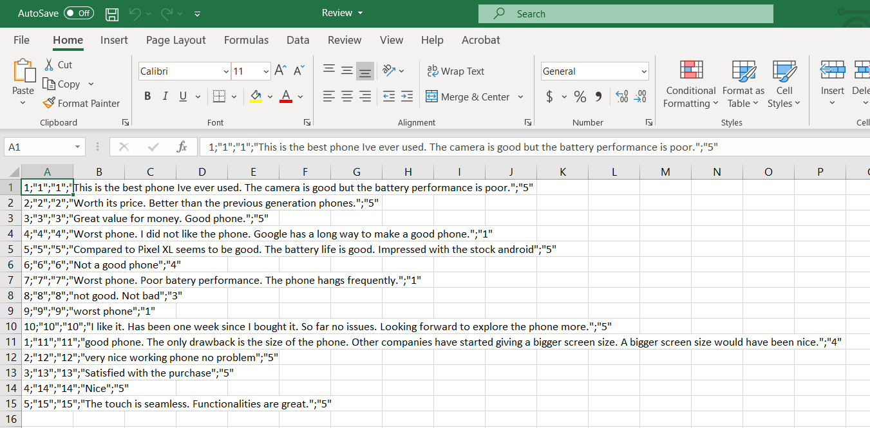

1. Select the first column entirely and click Text to columns in the Data tab of the excel sheet. Click ‘Delimited’ and click Next.

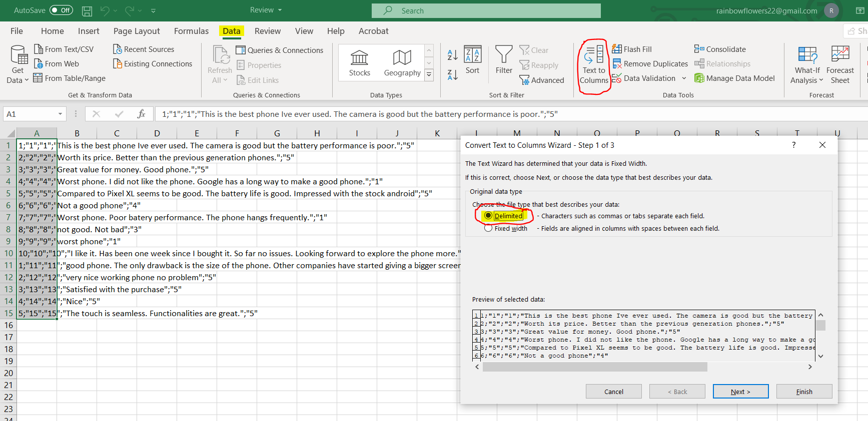

1. Check the Semicolon option and make sure the Text qualifier is quotes(“) and click Next.

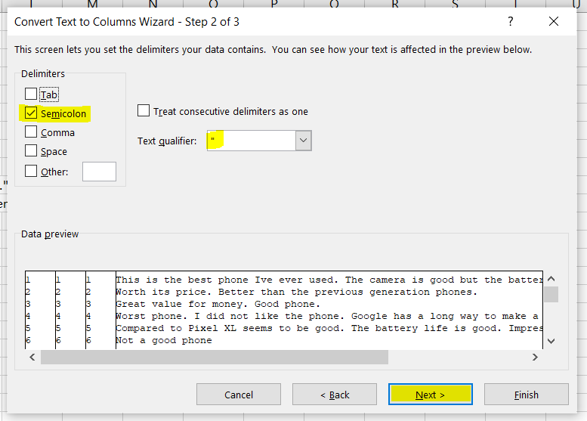

1. In the Data Preview section select all the columns and click Text in Column data format section and click Finish.

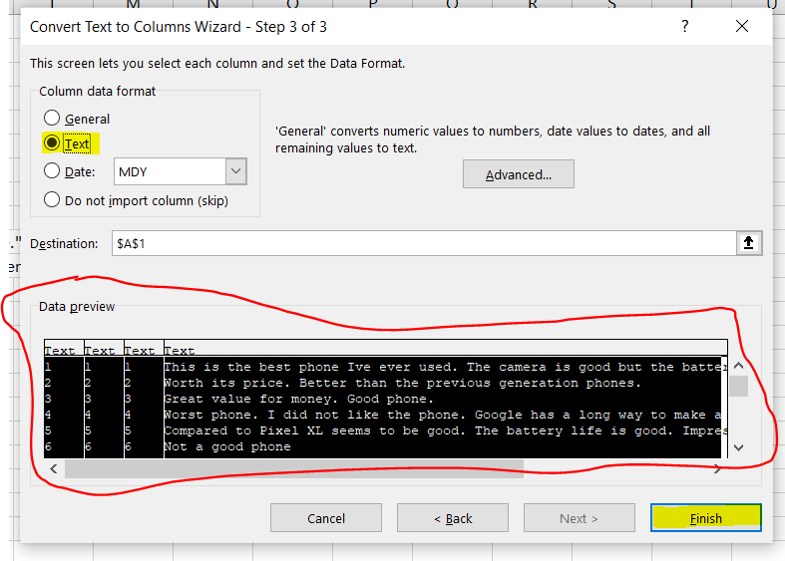

1. The excel file is converted like below.

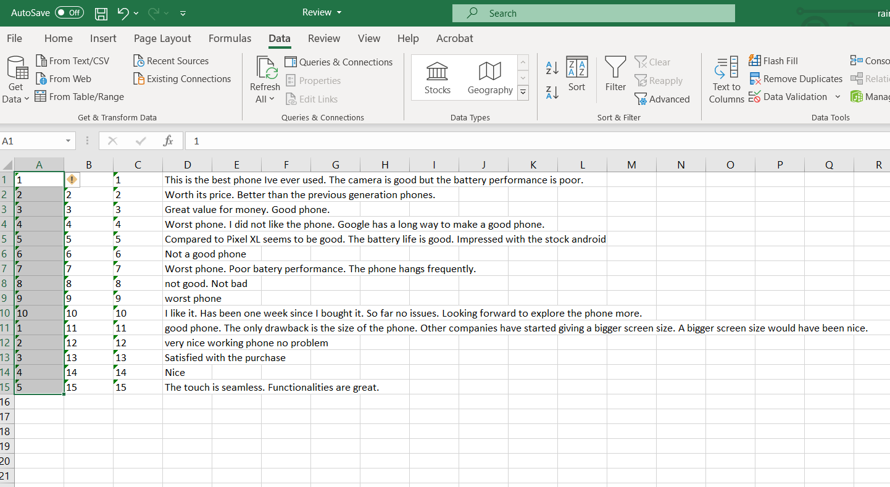

1. Headers are added to this file and this file will be the input for machine learning.

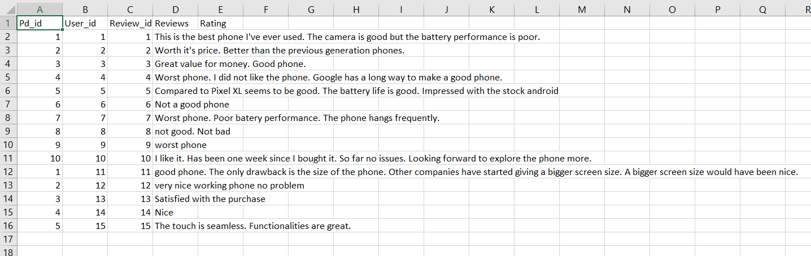

**Steps to Access the ipynb(python) file for Machine Learning**

**(The Machine Learning folder contains all the files required)**

1. Go to the site: <https://colab.research.google.com/>

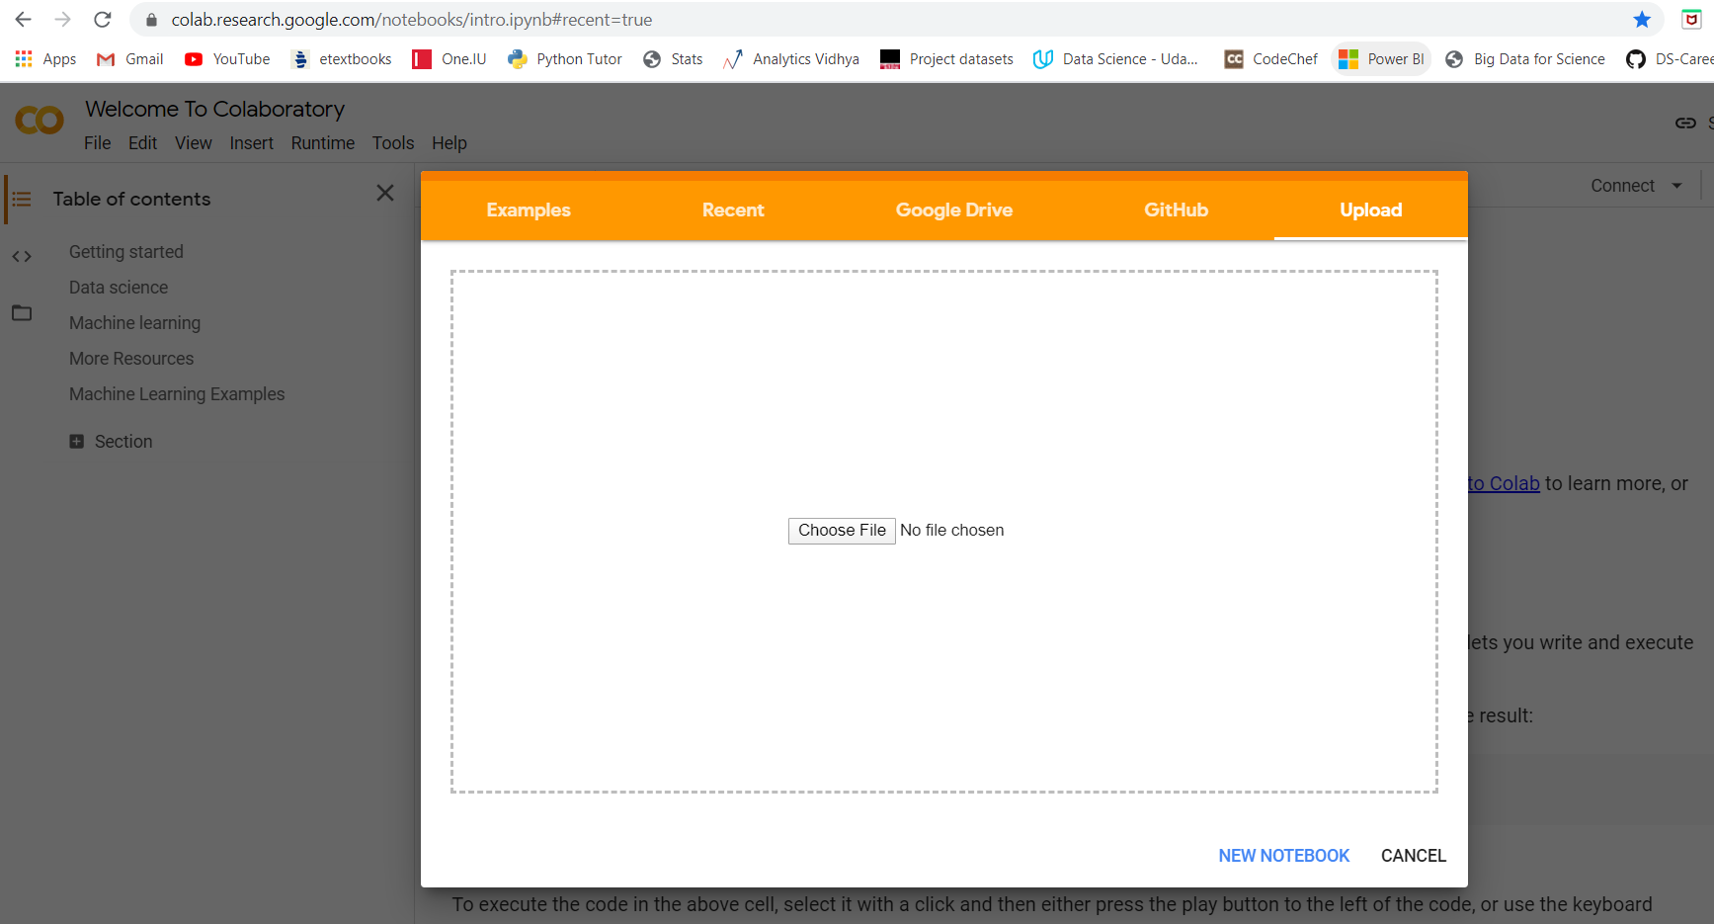

1. Click Upload and load the file **MultipleAlgorithms_MobilephoneRatingPrediction_1.ipynb**
2. Click the folder icon marked in red

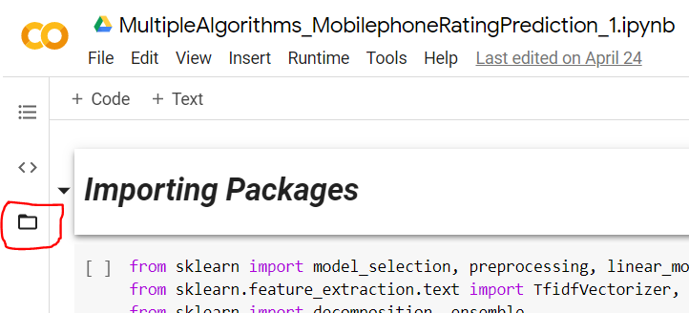

1. Click Upload highlighted in yellow

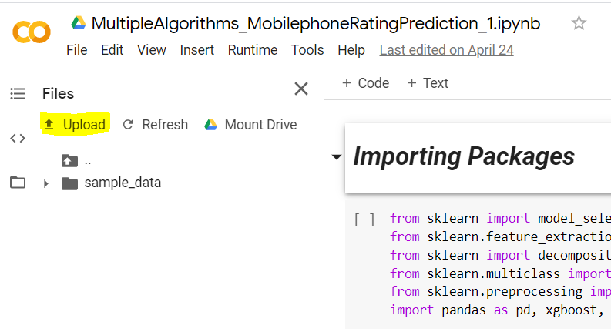

1. Upload the files Amazon_Unlocked_Mobile.csv, Review.csv and Sample_Submission.csv

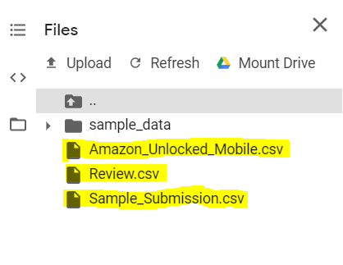

1. Click on the first cell and the run icon highlighted, will appear. Click on the run icon to run that cell. Similarly run all the cells one by one in the same order to run the entire code.

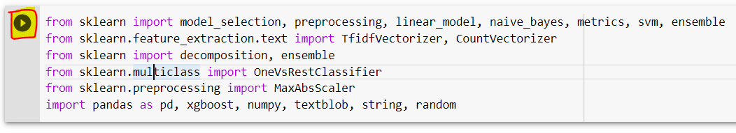

1. After the below cell is run, Review_new.csv is generated. **The other models beyond this cell are only for comparison and they take some time to run.**

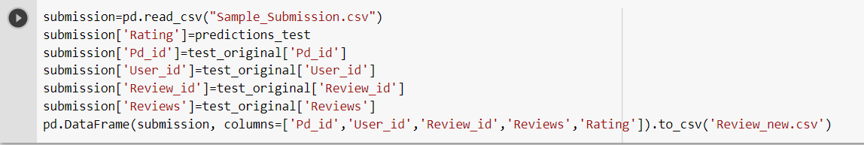

1. Now the Review_new.csv file can be seen on the left side when refreshed. Right click on the file to download it.

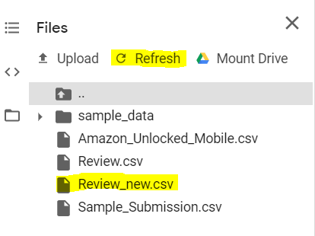

1. The predicted ratings from this file can be uploaded into the database by running the UpdateRating_fromcsv.php script.
2. After all these steps, the ratings for the reviews can be seen on the specific product page where the review was submitted, when refreshed.
3. Click Upload and load the file **MultipleAlgorithms_MobilephoneRatingPrediction_2.ipynb**
4. Repeat steps 3-6 **(This file is only for comparing different machine learning models. This file takes several hours to run. We are not fetching any output from this file. We are only fetching output from the Naive Bayes model from the first file.)**