NUMPY

1. https://numpy.org/doc/stable/user/absolute_beginners.html
2. NumPy is numerical python which is used to perform mathematical and statistical operations.
3. It Provides a high-performance multi-dimensional array object
4. NumPy is memory efficient
5. We can convert array to list & list to array
6. Axis=0 means Row vector and axis=1 means column vector

Note: Elementwise multiplication of two list: Vectorized operations not possible in Python using lists. To over come this we can used NumPy Library

Array Creation and Initialization:

1. Creating an array means declaring an array in the memory location and it can be empty
2. Initialize means assigning values to an array and it won’t be empty
3. We have 1,2,3 dimensional arrays
4. List are heterogeneous where we can use any type of datatypes([1,4,”sindhu”,7.8])
5. Where array is homogenous if we give the list of different data types it will by default convert into string (['7' '2' '9' '10' 'APC' '(3+5j)' '7.23']
6. Two-dimensional Array:

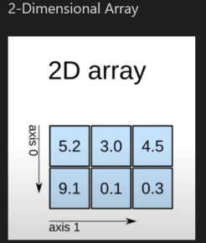

1. Three dimensional Array: j is row vector , k is col vector and i is the layers

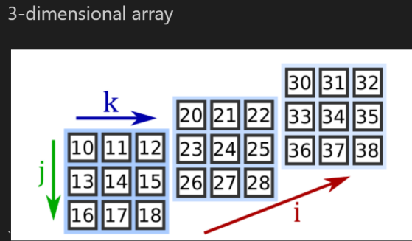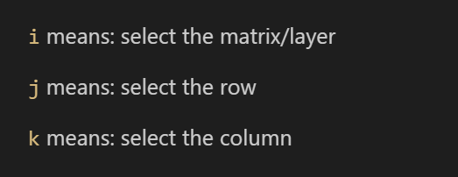

1. We can do initialize all the values with the function Zero, One ,random and Fixed number as well

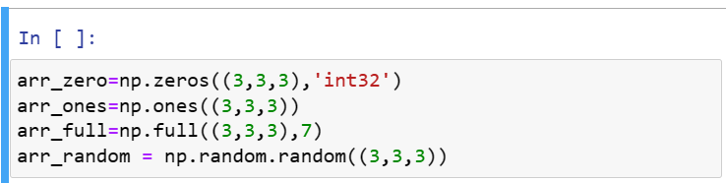

1. Standard Normal Distribution loc=0 => Mean, Scale=1 => std.deviation

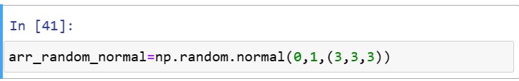

1. We can perform random integers also



1. Print Identify Matrix:

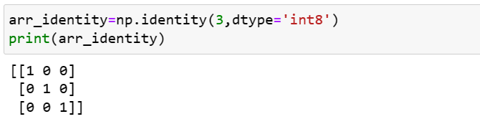

1. Indexing and Slicing in NumPy
   1. Index function returns the index of the specified element in the list (first occurrence)

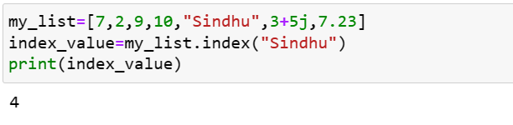

* 1. 2 D array indexing and slicing:

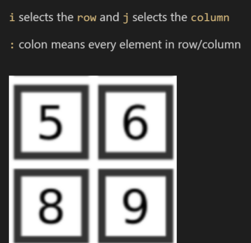

* 1. Printing the diagonal element of the array:

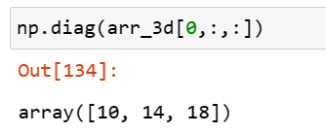

**TYPICAL NumPy BASIC FUNCTIONS**

1. **Inspection Functions:**
   1. ndim: number of dimensions
   2. shape: returns a tuple with each index having the number of corresponding elements
   3. size: No of total elements in the array
   4. dtype: data type of array elements
   5. itemsize: byte size of each array element
   6. nbytes: total size of the array and it is equal to itemsize*size
2. Array Mathematics:

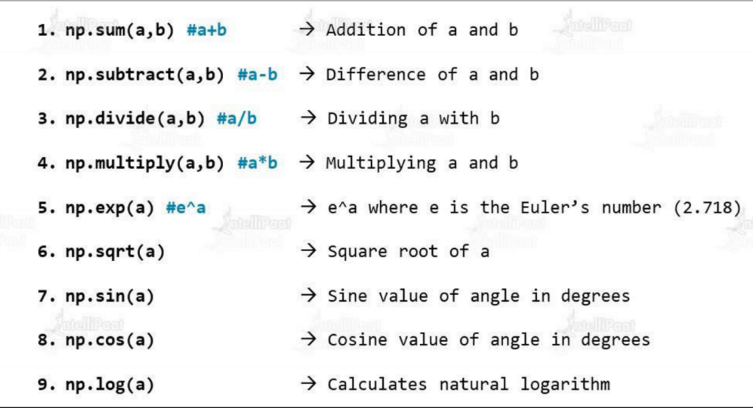

1. U Functions: Universal Functions:
   1. Universal Functions which work on single input
   2. Binary Ufunctions, works on two inputs
   3. In list we cannot directly add the value (we need to append just as value) but in array we can add the value to the existing one

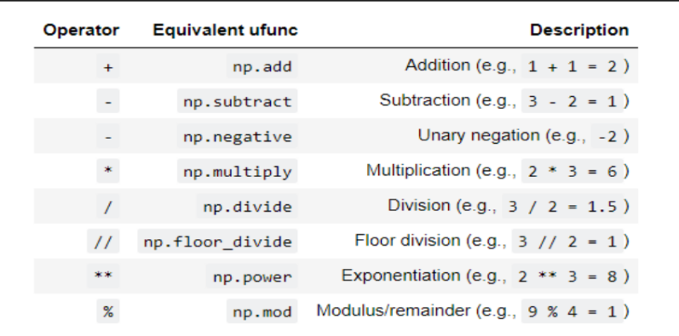

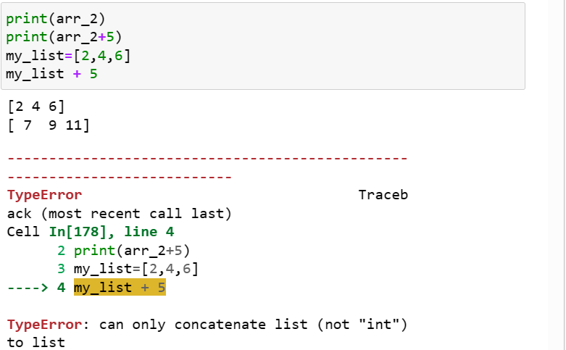

1. Create an array using: np.linspace & np.arange
   1. When it comes to creating a sequence of values, linspace and arange are two commonly used NumPy functions
   2. ***(Interview Question) Here is the subtle difference between the two functions
      1. .linspace allows you to specify the number of values
      2. Arange allows you to specify the size of the step

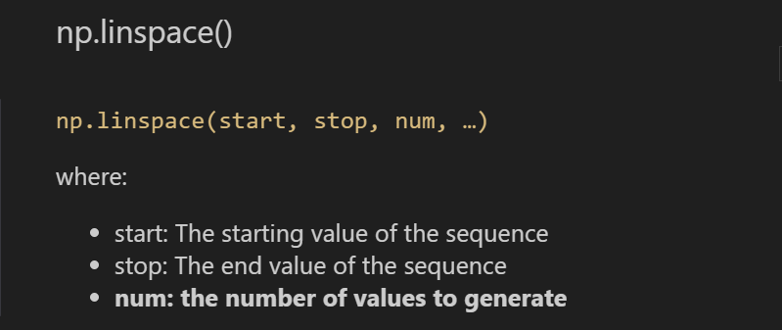



* + 1. Using this method, np.linspace() automatically determines how far apart to evenly space the values
    2. .arange:

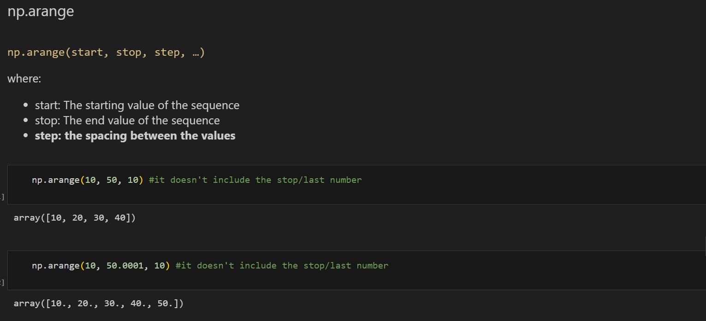

1. BenchMarking Arrays: Just testing the array and list which is faster for that reason we have one library which is TIMEIT

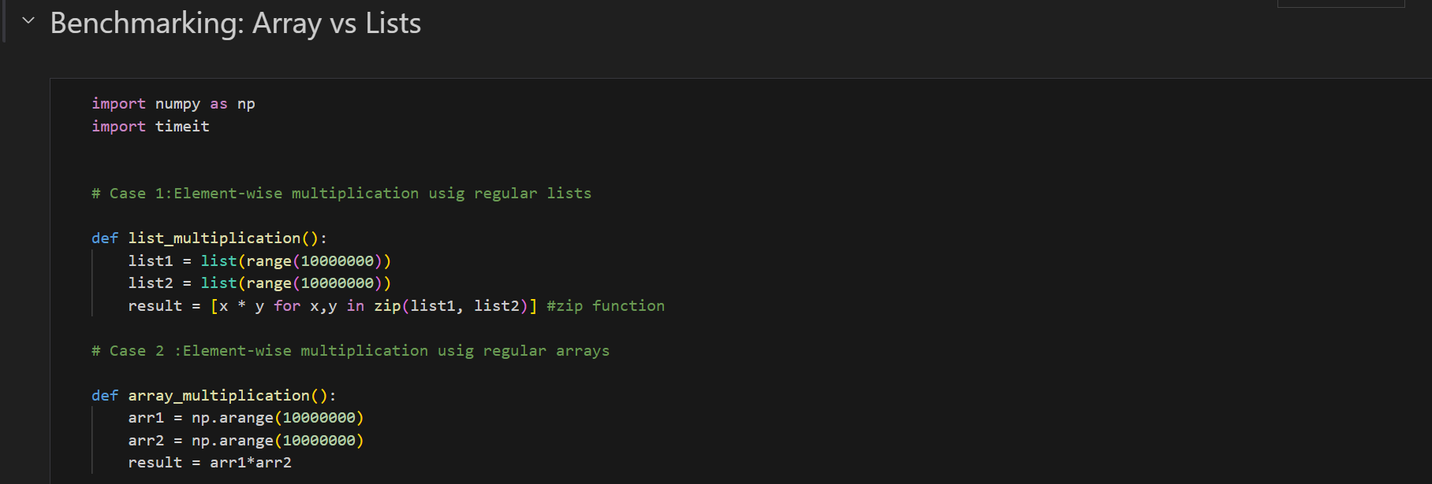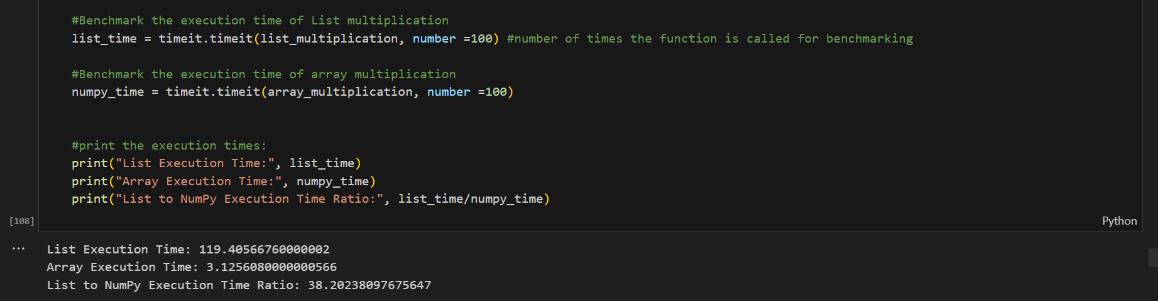

1. Array Manipulation : we can do manipulation with two functions which are resize and reshape

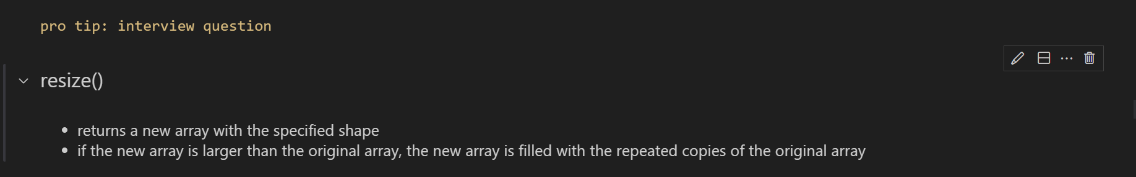

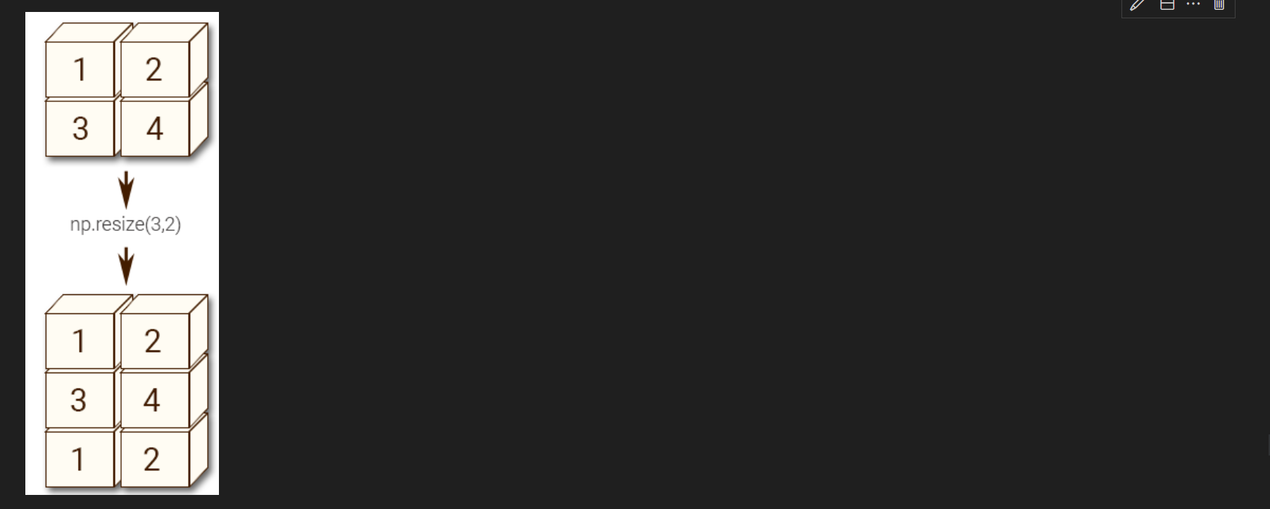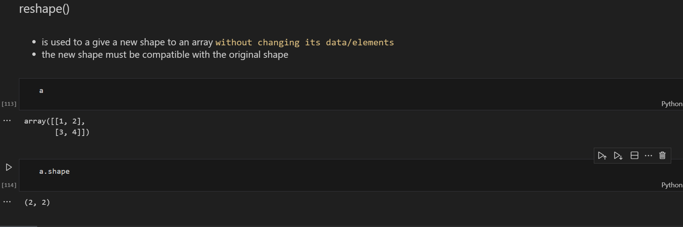

Note: np.reshape() doesn’t create a new array unnecessarily however np.resize() creates a new array

1. Basic Statistics:

