
Department of MCA

Subject: Design Thinking Lab

Phase 3: Ideate Phase

Topic: Impact of Quick Commerce on Local Kirana Shops

Submitted By:

Student Name | USN
E. N. Sirisha | 1RV25MC030
Sindhu T. P | 1RV25MC095
Sinchana S | 1RV25MC094

Academic Year: 2025 – 2026

Project Guide
Dr Divya T. L
Assistant Professor, Dept. of MCA, RVCE

1. Introduction to the Ideate Phase
The Ideate Phase is the third stage of the Design Thinking process and the creative heart of the project. Where the Empathy Phase built understanding of the evolving relationship between quick-commerce apps and local kirana shops, and the Define Phase sharpened that understanding into a single human-centred problem statement, the Ideate Phase deliberately opens the problem back up — generating the widest possible range of potential solutions before narrowing down to the strongest.
Its governing rhythm is divergence followed by convergence: first quantity and freedom, then judgement and selection. Every constraint is temporarily suspended; wild, impractical, and seemingly absurd ideas are as welcome as sensible ones, because they push the team past the obvious first answers and into the territory where genuinely novel solutions live.
This phase carries forward the four "How Might We" questions defined in Phase 2, drawn directly from the primary survey of 95 respondents and the affinity mapping exercise:
- HMW 1: How might we help local kirana shops offer WhatsApp-based ordering and same-day home delivery?
- HMW 2: How might we make kirana shop opening hours and stock availability visible digitally?
- HMW 3: How might we help kirana shops expand product variety for customers?
- HMW 4: How might we preserve the trust and community relationship that makes kirana shops valuable, while adding digital convenience?

This project was carried out by a three-member team. To make the collaborative nature of the ideation visible, contributors are referred to throughout as Sirisha, Sindhu, and Sinchana — each bringing a distinct perspective to every technique. Importantly, each member approached the problem through a different lens:
- Sirisha — "Quick & Digital": focused on fast, technology-light, mobile-first solutions that any kirana shopkeeper can adopt with a basic smartphone.
- Sindhu — "Community & Trust": focused on social, relational, and community-based solutions that reinforce the kirana's human advantage over apps.
- Sinchana — "Product & System": focused on designed system solutions — tools, kits, and flows that work as a coherent whole for both shopkeeper and customer.

Three complementary techniques were applied in sequence. Divergent techniques — Brainstorming and Brain Activities (Brain Dump, Brainwriting, Brain Walk) — generated a large pool of raw ideas from all three lenses. Crazy 8s gave those ideas concrete, sketched form under time pressure, and forced the team past its first comfortable ideas. Convergent techniques — an impact-versus-effort prioritisation matrix and a structured selection process guided by the four HMW questions — then identified and combined the best ideas into a single, well-justified concept.

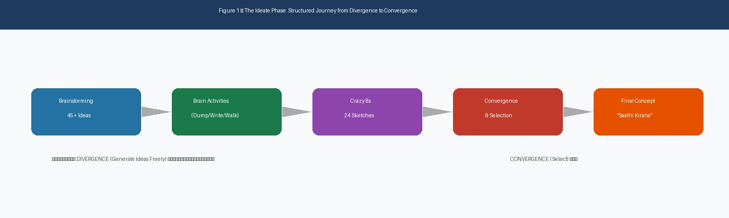
Figure 1 — The Ideate Phase: a structured journey from divergence to a single solution

2. Brainstorming
Brainstorming is the foundational divergent technique: a free, rapid, judgement-free generation of as many ideas as possible. The team followed the four classic rules — defer all judgement, encourage wild ideas, build on the ideas of others, and go for volume over quality at this stage. A single 45-minute session produced more than 45 raw ideas distributed across the three member lenses.
The session was structured in two rounds. In the first, each member independently generated ideas from their own perspective for 15 minutes without looking at what the others were writing. In the second, the boards were shared and each member spent 10 minutes building on the others' raw material — adding, combining, and extending. This two-round structure ensured both personal depth and genuine cross-pollination.
2.1 Three Members, Three Approaches
Rather than have all three members think identically, the team deliberately split the initial generation so that each person attacked the problem from their own distinct angle before cross-pollinating. This ensured the idea pool was genuinely diverse and did not converge prematurely on one obvious direction.

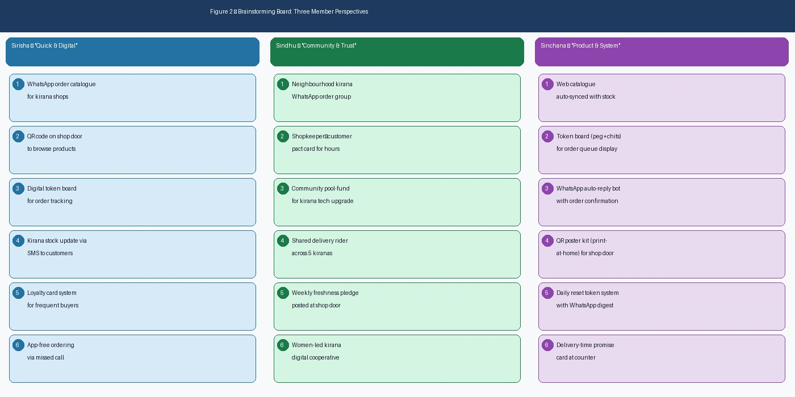
Figure 2 — Brainstorming board: the three members' distinct contributions, colour-coded by lens

The three streams produced strikingly different but complementary material:

Sirisha — "Quick & Digital"  • WhatsApp order catalogue for kirana shops  • QR code on shop door to browse products  • Digital token board for order tracking  • Kirana stock update via SMS to customers  • Loyalty card system for frequent buyers  • App-free ordering via missed call system | Sindhu — "Community & Trust"  • Neighbourhood kirana WhatsApp order group  • Shopkeeper–customer pact card for reliable hours  • Community pool-fund for kirana tech upgrade  • Shared delivery rider across 5 kiranas  • Weekly freshness pledge posted at shop door  • Women-led kirana digital cooperative model

Sinchana — "Product & System"
• Web catalogue auto-synced with kirana stock
• Token board (peg + chits) for order queue display
• WhatsApp auto-reply bot with order confirmation
• QR poster kit (print-at-home) for any shop door
• Daily reset token system with WhatsApp digest
• Delivery-time promise card displayed at counter

When the three streams were brought together, the team immediately noticed that the quick-digital and product-system ideas tackled the most survey-validated kirana pain points — ordering friction, stock invisibility, and delivery absence — while the community ideas addressed the trust, reliability, and social relationship gaps. This early observation hinted that the eventual solution might need to combine a lightweight digital system with a community trust element — a hypothesis the later techniques tested and ultimately confirmed.
2.2 Raw Idea Inventory
A representative selection of the raw brainstorm output is catalogued below, tagged by the HMW question it addresses and the member who originated it. Capturing the inventory in this form ensured no idea was lost before the convergence stage and made the spread across the four HMW questions visible at a glance.

Raw Idea | HMW Addressed | Origin
Web catalogue auto-synced with stock | HMW 2 — Stock Visibility | Sinchana
QR code on shop door to browse products | HMW 1 — WhatsApp + Delivery | Sinchana
WhatsApp auto-reply bot with order confirmation | HMW 1 — WhatsApp + Delivery | Sinchana
Token board (peg + chits) for order queue | HMW 1 — WhatsApp + Delivery | Sinchana
QR poster kit (print-at-home) | HMW 1 — WhatsApp + Delivery | Sinchana
Daily reset token + WhatsApp digest | HMW 1 — WhatsApp + Delivery | Sinchana
Delivery-time promise card at counter | HMW 1 — WhatsApp + Delivery | Sinchana
WhatsApp order catalogue for kirana shops | HMW 1 — WhatsApp + Delivery | Sirisha
Kirana stock update via SMS to customers | HMW 2 — Stock Visibility | Sirisha
Digital token board for order tracking | HMW 1 — WhatsApp + Delivery | Sirisha
Loyalty card system for frequent buyers | HMW 4 — Trust & Convenience | Sirisha
App-free ordering via missed call | HMW 1 — WhatsApp + Delivery | Sirisha
Neighbourhood kirana WhatsApp order group | HMW 3 — Product Variety | Sindhu
Shopkeeper–customer pact card for hours | HMW 4 — Trust & Convenience | Sindhu
Community pool-fund for kirana tech upgrade | HMW 3 — Product Variety | Sindhu
Shared delivery rider across 5 kiranas | HMW 1 — WhatsApp + Delivery | Sindhu
Weekly freshness pledge posted at shop door | HMW 4 — Trust & Convenience | Sindhu
Women-led kirana digital cooperative model | HMW 3 — Product Variety | Sindhu

3. Brain Activity
To push past the obvious first ideas from brainstorming, the team ran three structured "brain" activities. Unlike open brainstorming, these impose light structure that forces deeper and more iterative thinking, prevents early premature convergence, and surfaces ideas that might not emerge in a group discussion — particularly from members who are less vocally dominant.

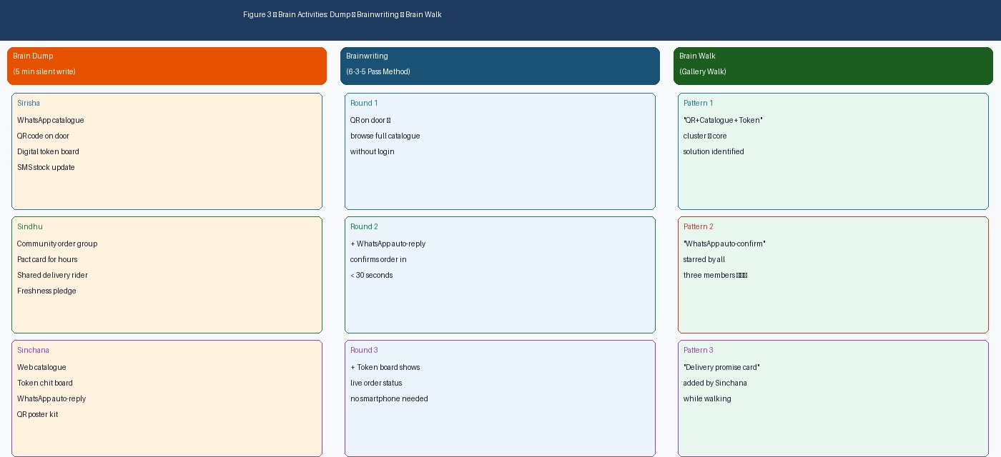
Figure 3 — Brain Activities: Brain Dump → Brainwriting → Brain Walk (flow and outputs)
3.1 Brain Dump
In the Brain Dump, each member silently and individually wrote down every idea in their head as quickly as possible for five minutes, with absolutely no discussion. The rule was simple: write everything, evaluate nothing. Working in silence first prevents louder voices from dominating, prevents early ideas from anchoring the group to one direction, and surfaces ideas that members might hesitate to say aloud in a group setting.
The dump produced a long tail of smaller, more speculative ideas that open brainstorming had not surfaced: a "kirana live status" WhatsApp status that shopkeepers update daily, a photograph-based product catalogue that requires no smartphone app from the customer, an over-the-counter chit system for order confirmation without technology, a weekly digital digest sent to regular customers, and a simple "open/closed" sign linked to WhatsApp status. Several of these smaller ideas became important components of the final concept.

Brain Dump — Key New Ideas Surfaced (not in open brainstorm)

Sirisha: Kirana "live status" on WhatsApp — shopkeeper updates availability each morning
Sirisha: Photo-based catalogue (no app needed by customer, just browse images in WhatsApp)
Sindhu: "Open today" digital flag linked to WhatsApp status to reduce uncertainty
Sindhu: Community trust score — customers rate kirana on a 5-star WhatsApp card monthly
Sinchana: Counter chit system — handwritten order slip with WhatsApp confirmation backup
Sinchana: Weekly digest of new items and offers sent to saved customer list on WhatsApp

3.2 Brainwriting (6-3-5 Method)
The team then ran a brainwriting round adapted from the 6-3-5 method, in which participants write ideas on a sheet and then pass it to the next person, who builds on what the previous person wrote. Because the team has three members, two complete passing rounds were run so that ideas compounded across all three perspectives. This technique is powerful precisely because no idea stays the property of one person — every idea is improved, extended, or challenged by the others.
The compounding effect produced three cornerstone ideas. A simple "QR code on the shop door" grew, round by round, into a QR code linking to a WhatsApp chat, then into a WhatsApp auto-reply that sends the day's catalogue, then into a full order-confirmation flow — the complete ordering journey in three steps. The "daily stock SMS" idea grew into a categorised digital catalogue with price updates. The "shopkeeper pact card" idea grew into a community commitment board displayed at the shop entrance, with shopkeeper-signed commitments on hours, freshness, and delivery.

Starting idea (Round 1)  "QR code on shop door"  → Round 2 (Sindhu adds):  QR links to WhatsApp chat, auto-sends day's catalogue  → Round 3 (Sinchana adds):  WhatsApp auto-reply confirms order + token number  → RESULT: Complete 3-step ordering journey | Starting idea (Round 1)  "Daily stock SMS to customers"  → Round 2 (Sinchana adds):  Categorised WhatsApp catalogue with photos  → Round 3 (Sirisha adds):  Weekly digest of new items and offers on WhatsApp  → RESULT: Full digital catalogue system

3.3 Brain Walk (Gallery Walk)
Finally, in the Brain Walk, all the sheets and sticky notes from the brainstorm and brainwriting rounds were posted around the room. The members then physically walked past them as if through a gallery, silently adding comments, stars, question marks, and new connection lines to each other's work. This movement-based review created a completely different cognitive mode from sitting and discussing — the physical act of walking, stopping, and annotating allowed each member to see the full body of work holistically rather than as a list.
It was during the Brain Walk that the team first physically grouped related sticky notes together. Three powerful clusters emerged: the "QR → WhatsApp → Token" cluster was identified as a coherent ordering system; all three members independently starred the "WhatsApp auto-confirm" idea; and Sinchana added the "delivery-time promise card" idea — inspired by seeing the token board and pact card notes side by side — which became the final trust element of the concept.

Brain Walk — Three Key Clusters Identified

Cluster 1 (Ordering System): QR Code + WhatsApp Catalogue + Auto-reply + Token Board
→ All three members starred this group. Recognised as the core ordering solution.
Cluster 2 (Trust & Visibility): Shopkeeper Pact Card + Freshness Pledge + Daily Hours Update
→ Sindhu flagged this as addressing the 25.3% trust-loyalty finding from the survey.
Cluster 3 (Variety & Community): Shared Delivery + Community Order Group + Bulk Buy Club
→ Team noted this as a longer-term initiative; lower priority for the immediate prototype.

Minutes of Meeting: 12 min

4. Crazy 8 Ideas
Crazy 8s is a fast sketching technique in which each participant folds a sheet of paper into eight panels and sketches eight distinct ideas in eight minutes — one minute per panel. The extreme time pressure is entirely intentional: it silences the inner critic, removes the desire to produce "good" sketches, and forces the mind past its first, safest ideas into more inventive territory. Sketching rather than writing also externalises ideas differently, often revealing spatial, sequential, and visual relationships that words hide.
Each of the three members ran their own eight-in-eight sprint independently, producing twenty-four ideas in total — all shown and described below, colour-coded by member so the three lenses remain visible throughout.

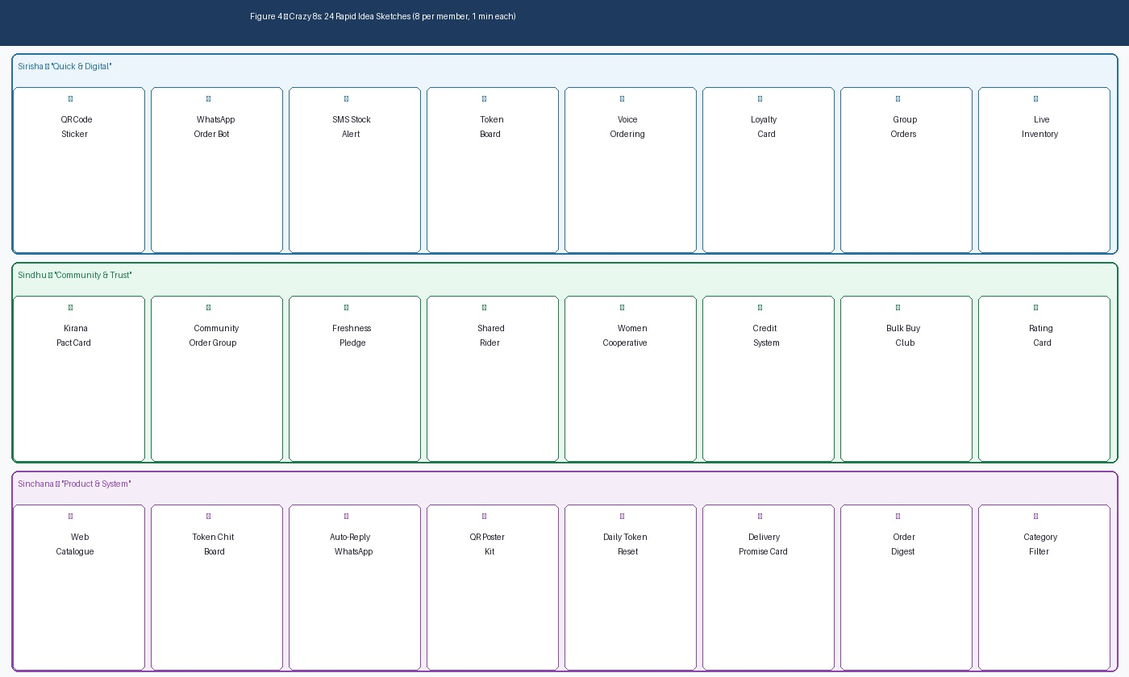
Figure 4 — Crazy 8s: each member's full sheet of eight ideas (24 in total, 1 minute each)

4.1 Sirisha's Eight Ideas — "Quick & Digital" lens
Idea # | Sketch Concept | Insight
1 | QR Code Door Sticker | Customer scans → lands in WhatsApp chat with shopkeeper; zero app download needed
2 | WhatsApp Order Bot | Auto-reply sends today's catalogue; customer replies with item number to order
3 | SMS Stock Alert | Daily morning SMS to regular customers: "Tomatoes ₹40/kg, Atta in stock, Open 8–9pm"
4 | Digital Token Board | Orders appear as numbered tokens on a visible board; customer collects when their number shows
5 | Voice Ordering (Missed Call) | Customer gives a missed call; shopkeeper calls back or sends WhatsApp with catalogue
6 | Loyalty Points Card | Stamp card for frequent buyers; 10 stamps = free delivery or discount — builds repeat behaviour
7 | Group Order Coordinator | One person in an apartment building aggregates orders from neighbours; shared delivery
8 | Live Inventory Dashboard | Simple WhatsApp status updated daily showing top 10 items in stock with prices

4.2 Sindhu's Eight Ideas — "Community & Trust" lens
Idea # | Sketch Concept | Insight
1 | Kirana Pact Card (signed) | Shopkeeper signs a visible commitment to opening hours, delivery days, and freshness standard
2 | Community WhatsApp Order Group | Building-level group where shopkeeper posts daily specials; members order by replying
3 | Freshness Pledge Board | Physical board at shop entrance showing today's fresh items with arrival date
4 | Shared Delivery Rider | 5 nearby kiranas share one delivery rider; splits cost, makes delivery viable for all
5 | Women-led Kirana Cooperative | Women shopkeeper network shares bulk purchase orders to expand product variety together
6 | Credit Trust System (Khata Digital) | WhatsApp-based khata — credit record shared with customer on request, building financial trust
7 | Bulk Buy Club | Customers pre-commit to a weekly order; kirana orders bulk, passes savings on
8 | Shopkeeper Star-Rating Card | Monthly card rating shopkeeper on freshness, availability, and service — posted at entrance

4.3 Sinchana's Eight Ideas — "Product & System" lens
Idea # | Sketch Concept | Insight
1 | Web Catalogue (auto-synced) | Simple one-page website showing live stock; shopkeeper updates via WhatsApp message
2 | Token Chit + Peg Board | Physical peg board with numbered chits; orders pegged in sequence; customer takes chit
3 | WhatsApp Auto-reply Bot | Scanning QR triggers WhatsApp; bot sends catalogue PDF and awaits reply order
4 | QR Poster Kit (Print-at-home) | Printable A4 poster with QR code; shopkeeper prints and tapes to door — zero cost setup
5 | Daily Token Reset System | Board resets each morning; WhatsApp digest sent to yesterday's customers showing order status
6 | Delivery Promise Display Card | Counter card stating: "Orders before 6pm → delivered by 8pm" — sets expectation, builds trust
7 | Order Summary Digest | End-of-day WhatsApp message to shopkeeper: all orders summarised for record-keeping
8 | Catalogue by Category Filter | Catalogue organised into Grocery / Dairy / Snacks / Household — easy for customer to browse

4.4 What the Crazy 8s Revealed
Sketching forced abstraction into concrete, timed form — and seeing all twenty-four ideas side by side made the structure of the solution visible. Sinchana's and Sirisha's ideas consistently clustered around the same three-step system: QR code → WhatsApp catalogue → token/order confirmation. This system appeared in different forms in at least six of the sixteen combined ideas from these two members, suggesting it was not an accident but a genuine core concept. Sindhu's ideas clustered separately around community trust and visible commitment — reinforcing both the pact card and the freshness pledge as the human complement to the digital system.
The Crazy 8s exercise also surfaced the "QR Poster Kit" as a zero-cost setup solution — a critical insight given that kirana shopkeepers operate on thin margins and any adoption barrier must be minimal. This idea was starred by all three members during the review.

Minutes of Meeting: 8 min

4.5 How Might We Questions — Idea Mapping
After completing the Crazy 8s sprints, the team mapped each of the 24 ideas to the four HMW questions from Phase 2. This mapping ensured that the ideation work remained anchored to the defined problem space and highlighted which HMW questions had abundant idea coverage and which needed more attention.

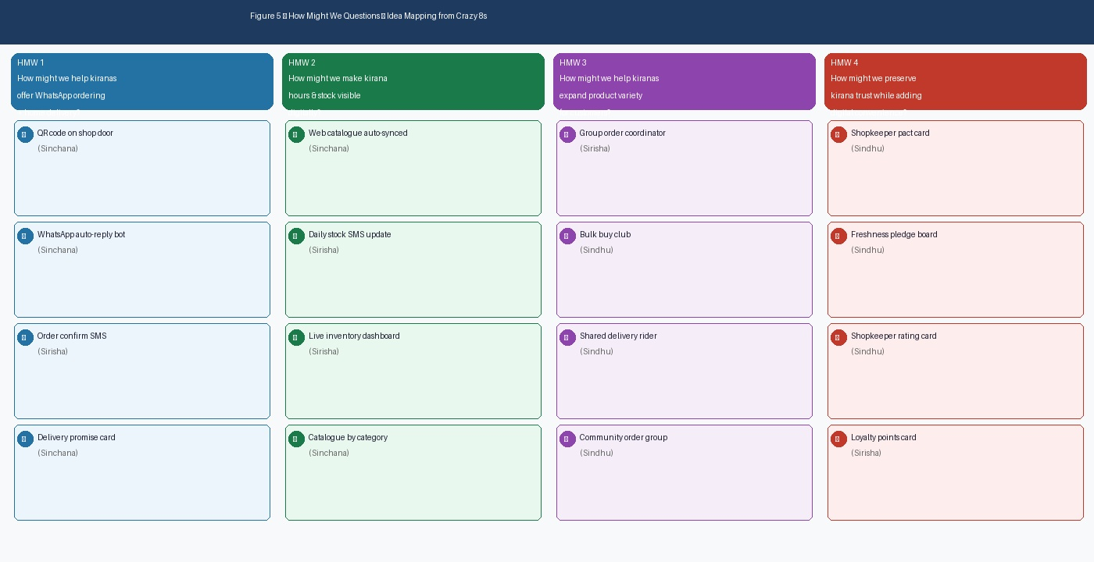
Figure 5 — "How Might We" questions mapped to Crazy 8s ideas by member

HMW 1 (WhatsApp ordering + delivery) attracted the largest cluster of ideas — 11 across all three members — confirming it as the highest-priority and most generative problem dimension. HMW 2 (stock visibility) attracted 6 ideas, all converging on the catalogue and status-update concept. HMW 3 (product variety) attracted 4 ideas, all community-based, signalling that this is a harder structural problem requiring a different type of solution. HMW 4 (preserving trust while adding digital) attracted 6 ideas, with Sindhu contributing the most distinctive ones.

5. Idea Convergence and Selection
Having diverged widely across brainstorming, brain activities, and Crazy 8s, the team now converged. All ideas generated across the three techniques were first reviewed and de-duplicated, then clustered by theme, and finally plotted on an impact-versus-effort prioritisation matrix — a tool that ranks ideas by the value they would deliver to kirana shopkeepers and customers, against the effort and cost they demand to implement.
The goal was to identify ideas in the high-impact, low-effort "do first" quadrant and combine them into a single, coherent concept. The team was explicit that this selection should be driven by survey evidence — not by which member argued most persuasively.
5.1 Selection Criteria
Before plotting, the team agreed on a short set of criteria derived from the design principles established in Phase 2, against which each idea would be assessed:
- Impact — how directly the idea relieves a high-frequency survey pain: ordering friction (Q9: 93.7% open to WhatsApp delivery), stock uncertainty (Q8: 24.2%), or trust gaps.
- Effort and cost — how cheap, simple, and fast it is to implement, given that kiranas operate on thin margins and shopkeepers may have limited smartphone literacy.
- Adoptability — whether the shopkeeper can begin using it today with existing tools (WhatsApp, print-at-home) without waiting for an external platform to be built.
- Scalability — whether it works for a single kirana immediately and can spread to others without re-engineering.

5.2 The Prioritisation Matrix

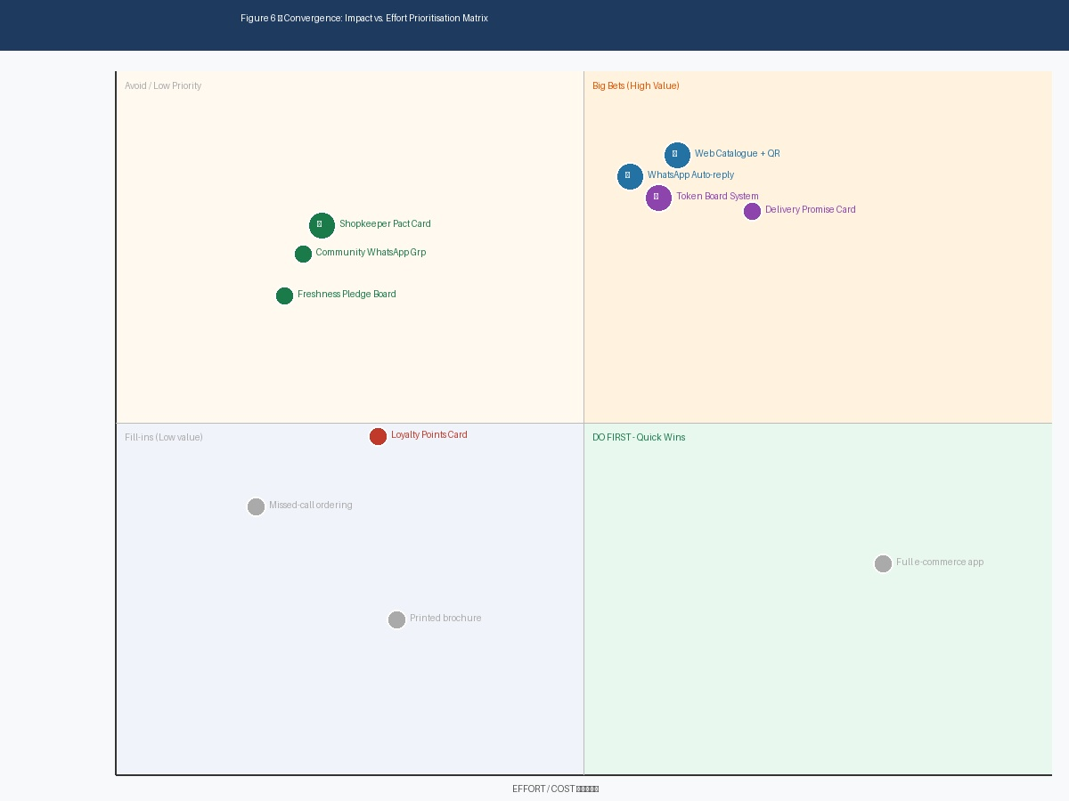
Figure 6 — Impact-versus-effort prioritisation matrix: selected idea cluster highlighted

The matrix revealed one dominant winning cluster and a secondary cluster to pursue later. The five ideas in the "Do First" quadrant — web catalogue with QR code, WhatsApp auto-reply ordering, token board system, delivery promise card, and shopkeeper pact card — all landed in the high-impact, low-effort region. These five ideas share a critical property: they are all buildable today, using existing tools (WhatsApp Business, a printable QR code, a physical peg board, and a printed promise card), without any new technology platform.
The community variety ideas — shared delivery rider, bulk buy club, and women's cooperative — landed in the high-impact but higher-effort region. They are genuinely valuable but require coordination between multiple shopkeepers and are not immediately achievable. They were noted as a second-phase enhancement rather than discarded.
Genuinely low-value or high-effort ideas — a missed-call ordering system (poor customer experience), a full e-commerce app (too expensive for kiranas), and a printed brochure (no digital interaction) — were set aside.

Idea | Impact | Effort | Decision
Web Catalogue + QR Code Poster | Very High (Q9: 93.7%) | Low (print + WhatsApp) | ✅ SELECTED — Core
WhatsApp Auto-reply Bot | Very High | Low (WhatsApp Business) | ✅ SELECTED — Core
Token Board System (peg + chits) | High (visible ordering) | Very Low (physical) | ✅ SELECTED — Core
Delivery Promise Display Card | High (trust + reliability) | Very Low (printed card) | ✅ SELECTED — Support
Shopkeeper Pact Card (community) | High (Q5: 25.3% trust) | Low | ✅ SELECTED — Trust layer
Shared Delivery Rider (5 kiranas) | High (Q8: delivery gap) | Medium-High (coordination) | ⏳ Phase 2 enhancement
Bulk Buy Club | Medium | Medium | ⏳ Phase 2 enhancement
Full e-commerce app | High | Very High (cost) | ❌ Deprioritised
Missed-call ordering | Low (poor UX) | Medium | ❌ Deprioritised

6. The Final Concept — Saathi Kirana Network
The five selected ideas, taken together, are not five separate tools — they are five components of a single, coherent system. The team named this system the Saathi Kirana Network: a lightweight, zero-app, WhatsApp-first ordering, catalogue, and trust platform that any local kirana shopkeeper can set up in under one hour using tools they already have, at near-zero cost.
The governing promise of the concept is: "Bring your kirana into the digital world — without changing what makes it a kirana." The system is designed to add the thin digital layer that the survey revealed 93.7% of consumers want, while preserving the immediacy, proximity, and trust that 85% of local-shop loyalists already value. It does not replace the shopkeeper's relationship with the customer — it amplifies it.

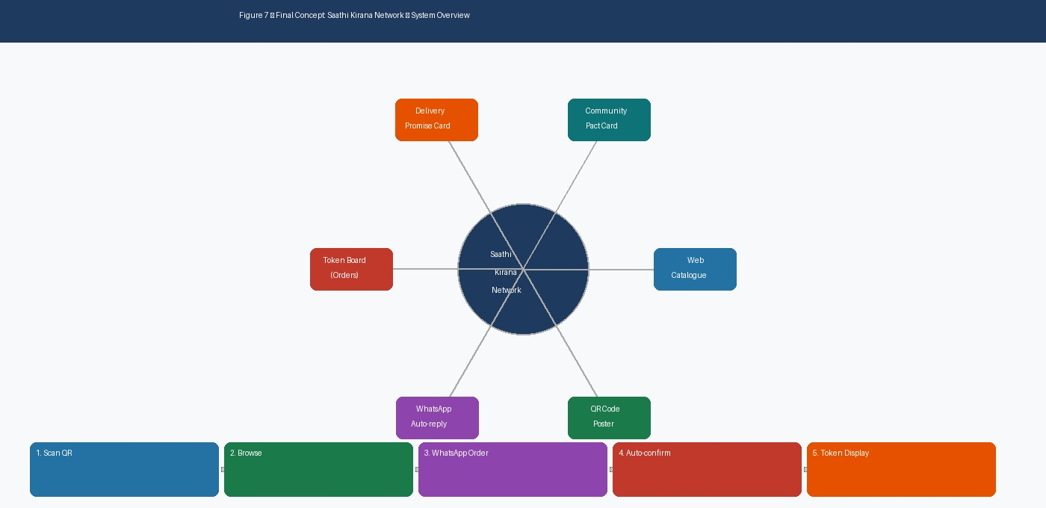
Figure 7 — The Saathi Kirana Network: six components and the five-step customer journey

6.1 How the System Works — Five Steps

Step | What Happens | Tool Used | HMW Addressed
1. Scan QR | Customer scans QR code posted on the kirana door | Print-at-home QR poster | HMW 1 — WhatsApp ordering
2. Browse Catalogue | WhatsApp opens automatically; auto-reply sends today's product catalogue with photos and prices | WhatsApp Business auto-reply | HMW 2 — Stock visibility
3. Select & Order | Customer replies with item name/number and quantity; order placed in seconds | WhatsApp chat | HMW 1 — WhatsApp ordering
4. Auto-Confirmation | Bot sends back order summary, token number, and delivery time promise automatically | WhatsApp Business auto-reply | HMW 4 — Trust & reliability
5. Token Board Display | Shopkeeper pegs order chit on the physical token board; customer tracks order by number | Physical peg board + chits | HMW 1 — Order visibility

6.2 The Six Components and What Each One Solves

Component | What It Is | Survey Pain It Addresses | Who Benefits
QR Code Poster Kit | A5 poster with QR code, printable at home for free | Q9: 93.7% want to order from local shop digitally | Customer + Shopkeeper
Web Catalogue | Simple WhatsApp-linked catalogue, updated by shopkeeper each morning via a message | Q8: 24.2% frustrated by unknown stock availability | Customer
WhatsApp Auto-reply Bot | WhatsApp Business auto-reply sends catalogue + confirms orders without shopkeeper manually typing each time | Q4: 30.5% want faster ordering (convenience) | Customer + Shopkeeper
Token Board (peg + chits) | Physical numbered board at counter; orders visible to both shopkeeper and waiting customers | Q7: 58.9% — busy-schedule ordering; reduces queue anxiety | Customer + Shopkeeper
Delivery Promise Card | Printed card at counter: "Orders before 6pm delivered by 8pm" — sets expectations clearly | Q8: Absence of delivery is a top-3 frustration | Customer
Community Pact Card | Shopkeeper-signed card committing to published hours, freshness standards, and delivery days | Q5: 25.3% trust/familiarity as loyalty driver | Customer + Shopkeeper

6.3 How the Concept Covers All Four HMW Questions

HMW Question | Answer from Saathi Kirana Network
HMW 1: WhatsApp ordering + delivery | QR Poster → WhatsApp Auto-reply → Token Board creates a complete ordering and delivery system
HMW 2: Digital stock visibility | Daily WhatsApp catalogue update makes stock visible to all customers before they leave home
HMW 3: Product variety expansion | Shared delivery and bulk-buy club (Phase 2) expand effective product range across nearby kiranas
HMW 4: Preserve trust + add convenience | Pact Card + Delivery Promise Card + consistent token system build reliability without abandoning the human relationship

DESIRED OUTCOME

To help local kirana shopkeepers reclaim their position as the daily essentials destination for urban young adults —
not by becoming an app, but by adding a zero-cost, WhatsApp-first digital layer that closes the three gaps
the survey identified: ordering friction (93.7% want this), stock invisibility (24.2% frustrated), and delivery absence.

Setup cost to the shopkeeper: ₹0 (WhatsApp Business is free; QR poster is printed at home).
Time to go live: under one hour from decision to first order.

7. Conclusion and Transition to the Prototype Phase
The Ideate Phase took the four "How Might We" questions from the Define Phase and, through a disciplined sequence of divergent and convergent techniques, transformed them into one unified, well-justified concept: the Saathi Kirana Network.
Brainstorming generated breadth across three distinct member perspectives, producing more than 45 raw ideas distributed across all four HMW question areas. The Brain Activities — Brain Dump, Brainwriting, and Brain Walk — pushed the team past its obvious first ideas and produced the three cornerstone discoveries: the QR → WhatsApp → Token ordering flow (from Brainwriting compounding), the zero-cost setup imperative (from Brain Dump), and the three-cluster grouping that separated ordering, trust, and community variety into distinct design targets (from the Brain Walk).
Crazy 8s gave each of the 24 ideas concrete, sketched form under time pressure, making visible for the first time that Sirisha's and Sinchana's ideas were consistently describing the same three-step system from different The HMW-to-idea mapping confirmed that HMW 1 (WhatsApp + delivery) had the most abundant and converging idea coverage, warranting its central role in the final concept.
The impact-versus-effort prioritisation matrix selected five ideas — the web catalogue, WhatsApp auto-reply, token board, delivery promise card, and pact card — and made explicit why the others were either deprioritised (too costly) or scheduled for a second phase (community variety initiatives requiring inter-kirana coordination). The five selected ideas combined naturally into the Saathi Kirana Network: a system that is adoptable today, at near-zero cost, by any kirana shopkeeper with a WhatsApp account and a printer.
The next phase, Prototype, will bring this concept into tangible, testable form: a physical token board with numbered chits, a printed QR poster kit, a WhatsApp Business account configured with the auto-reply catalogue flow, and a printed pact card and delivery promise card. whose feedback will refine the components and confirm whether, together, they genuinely bridge the gap between what local kirana shops currently offer and what the 93.7% of consumers surveyed have said they want.
Minutes of Meeting — Full Ideate Phase Session: 25 min

