ANALYTICAL APPROACH FOR FUTURE BLOCK-CHAIN FORENSIC INVESTIGATION OF BITCOIN TRANSACTION NETWORK
Now-a-days Bitcoin is becoming largest and popular online financial transaction services as it does not store any details of sender and receiver and is highly using for illegal payments and consider as unlaw financial services and government finding difficulty in banning such currency and in such situation, it becomes mandatory to track address of Bitcoin payments by analysing Blockchain Bitcoin Transaction Network.
In proposed paper author is using transition based Safe Petrinet simulation algorithm which describe state changes in a system with transition. In proposed paper author using Bitcoin addresses to model as the places in Petri net and Bitcoin transactions are modelled as transitions in Petri net. If Blockchain transaction contains address, then petrinet will take transition as state change and then save transaction details in database as BTN (Bitcoin Transaction Network).
All Blockchain transaction will be parse and preprocess and then generate BTN network. BTN network will be further analyse using Bitcoin Gene which will track address for illegal payment by searching received and send account address. Gene to indicate where the Bitcoins passed through a given address (called dyeing address) have flown and to determine the relationship strength between the dyeing address and other addresses. In the Bitcoin system, only addresses are related to users. There are two address features related to coins, which are a.balance and a.received.
Pattern matching rules will be applied on received and balance values where all withdraw transaction will be consider as balance and deposit will be consider as received and to sum up both values patterns matching rules will check all transaction must have valid transaction address with one input and multiple output and if any transaction failed to match pattern will be detected as suspected address.
To implement above project, we have downloaded ‘Blockchain’ dataset from below link
https://console.cloud.google.com/bigquery?project=drops-311506&j=bq:US:bquxjob_d45c0c3_17e016a5f6a&page=queryresults
Dataset contains below static features shown in screen shots
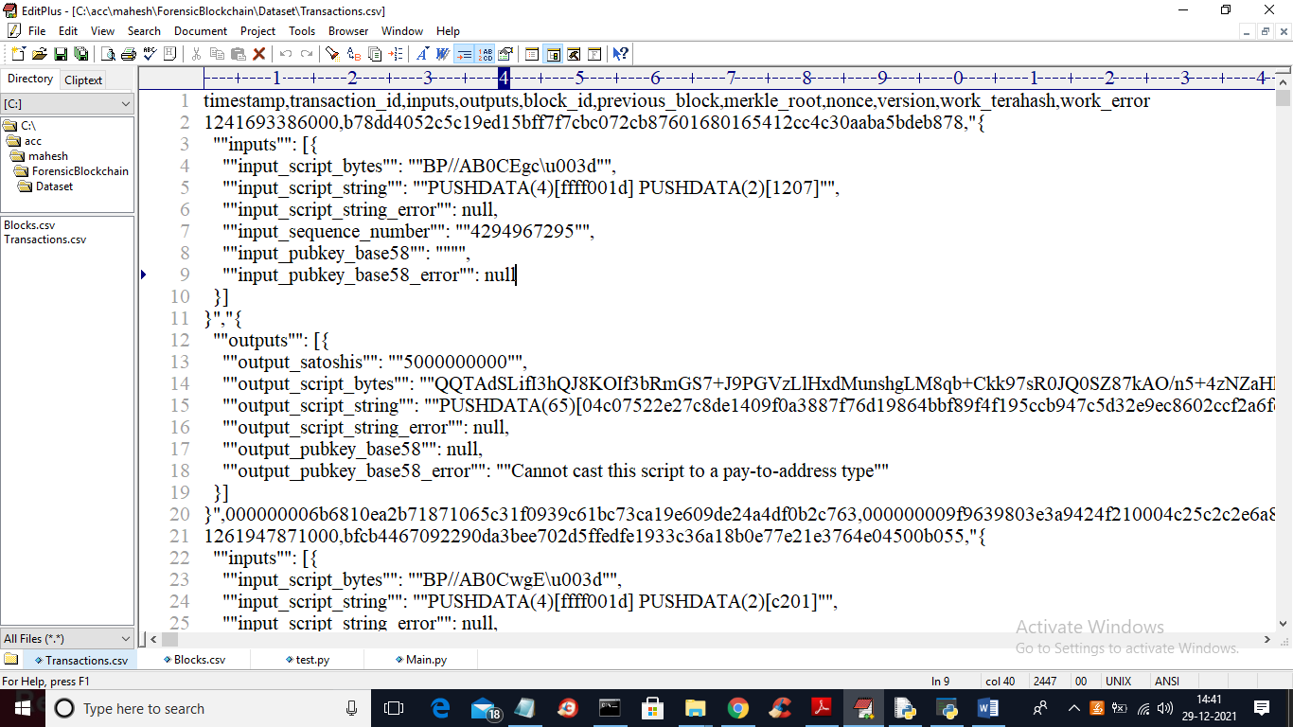
In above screen first row contains dataset column names as STATIC features and then we will calculate deposit and received values as dynamic features. Above Blockchain transaction will be analysed to detect suspected addresses.
To implement this project, we have designed following modules
- Upload Blockchain Transaction: using this module we will upload Blockchain Bitcoin transaction dataset to application.
- Parse and Build BTN Petrinet Simulation: using this module we will parse dataset and then build BTN model using PETRINET.
- Run Pattern Matching Rules Algorithm: using this module pattern matching rules will be applied on BTN network to identify all deposit and withdraw transaction and then detect suspected address by identifying those transaction with None or invalid address.
Below screen with red and green colour comments showing code for above concept implementation
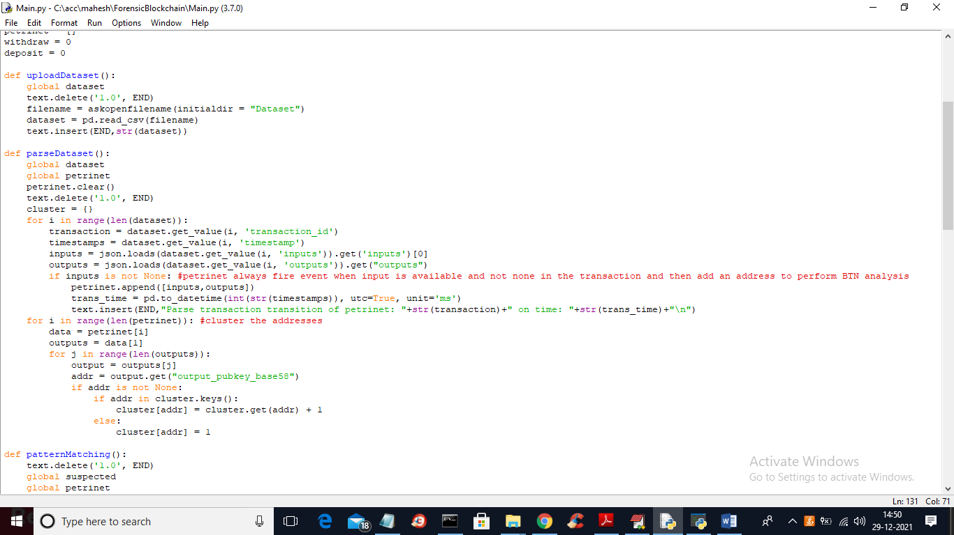
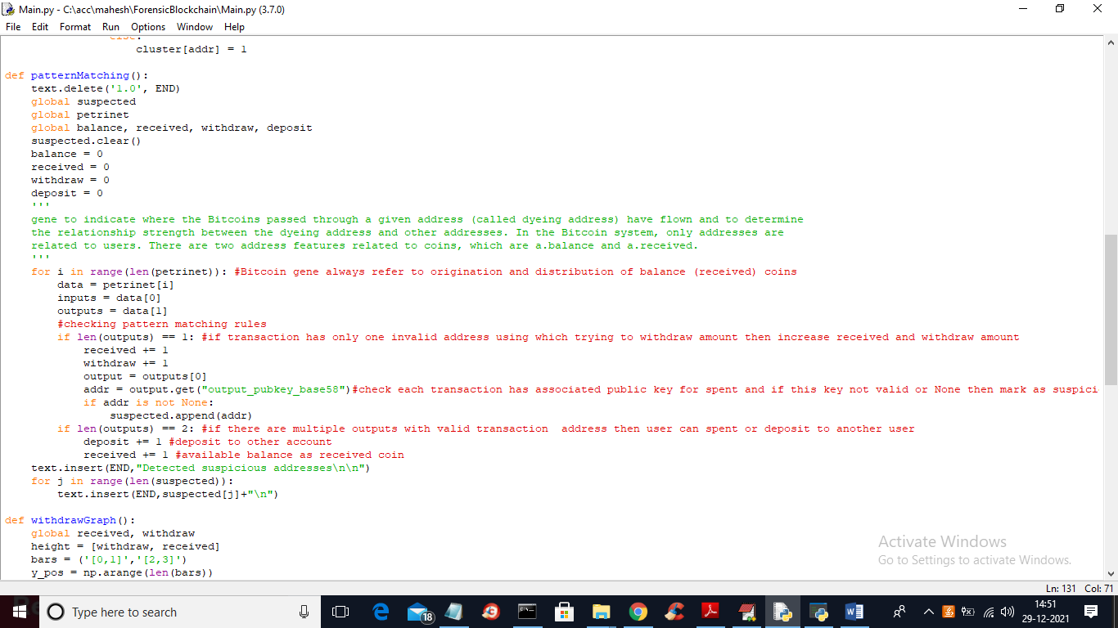
In above screen read red and green colour comments to know about coding concept describe in paper.
SCREEN SHOTS
To run project double click on ‘run.bat’ file to get below screen
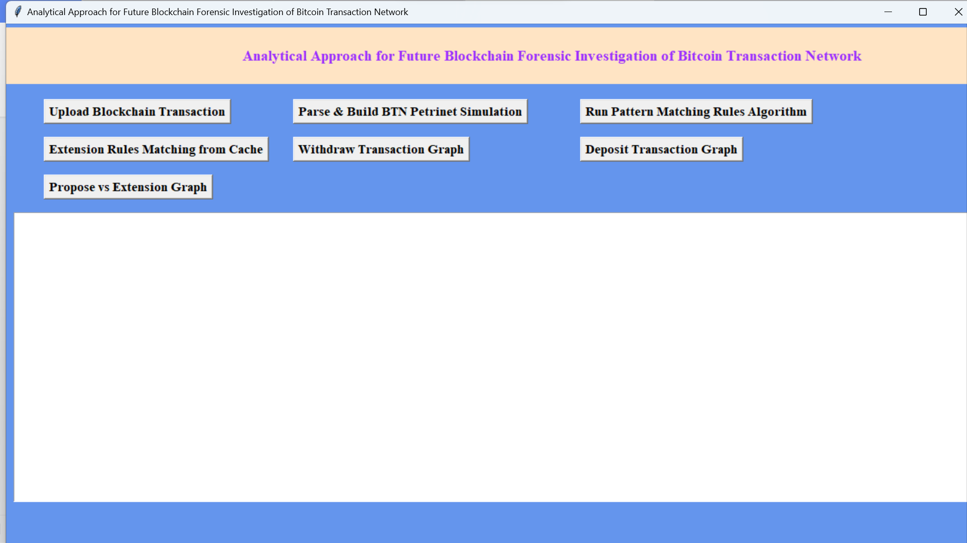
In above screen click on ‘Upload Blockchain Transaction’ button to upload dataset and to get below screen
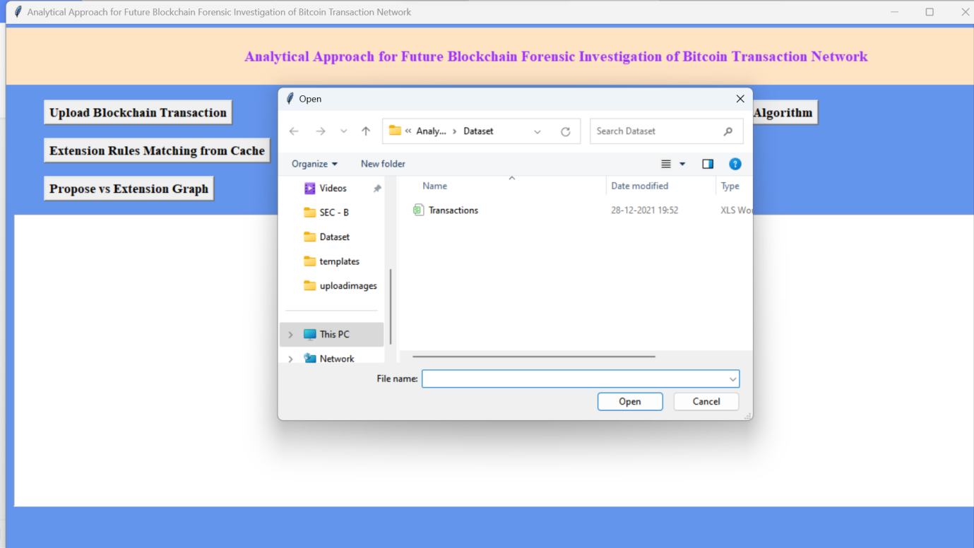
In above screen selecting and uploading ‘Transactions.csv’ dataset and then click on ‘Open’ button to load dataset and to get below output
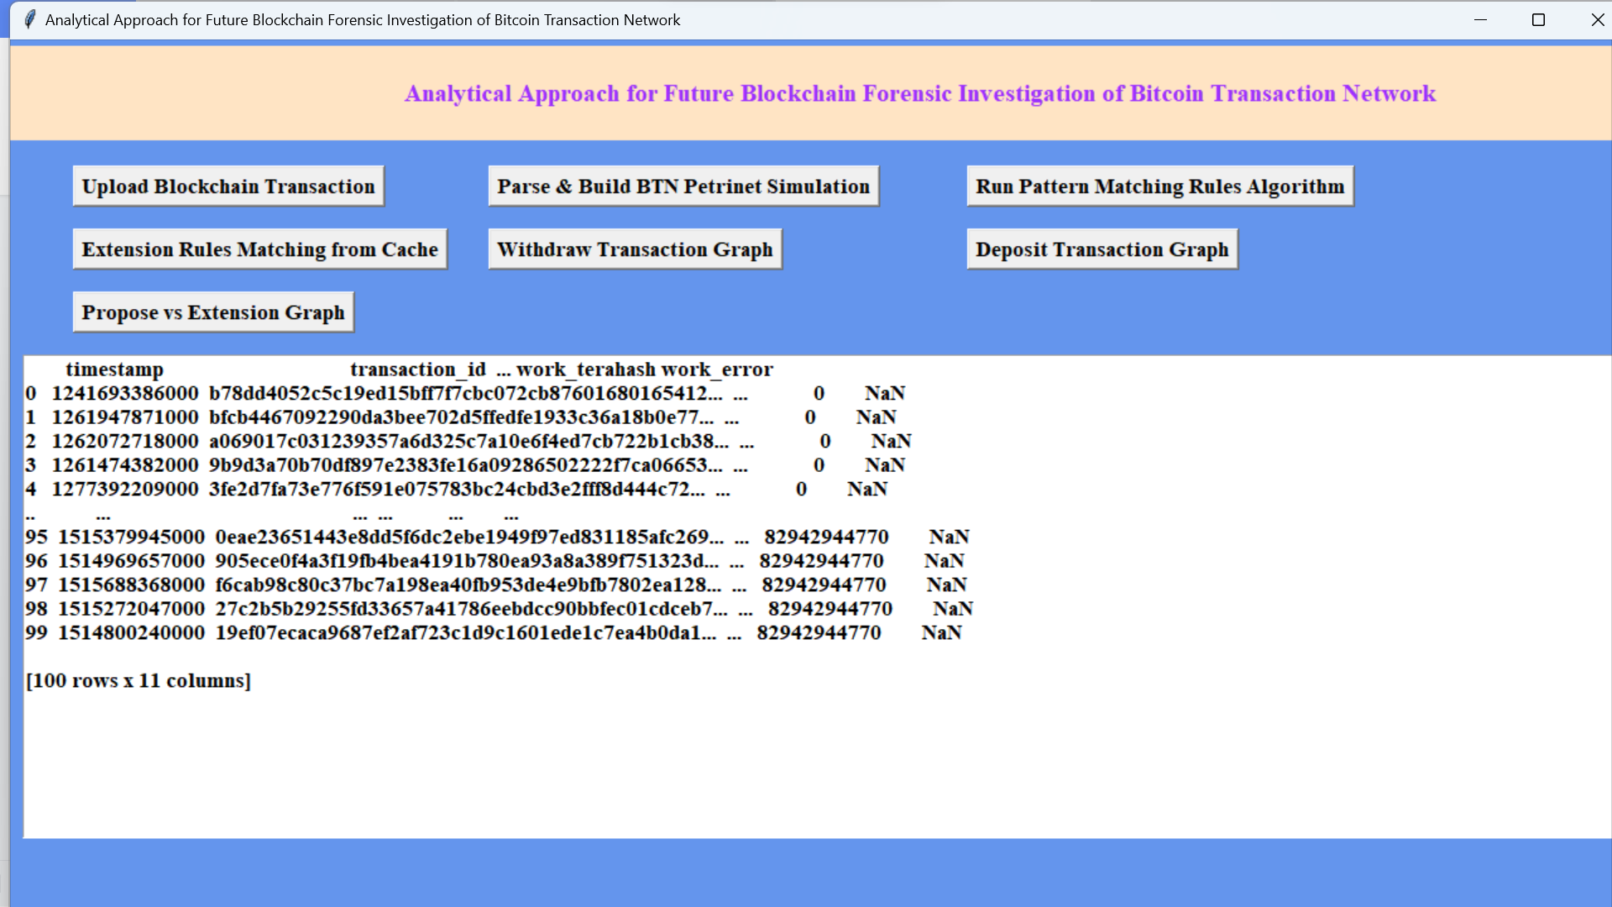
In above screen dataset loaded and now click on ‘Parse & Build BTN Petrinet Simulation’ button to parse above dataset and then build BTN network with all transaction and its addresses.
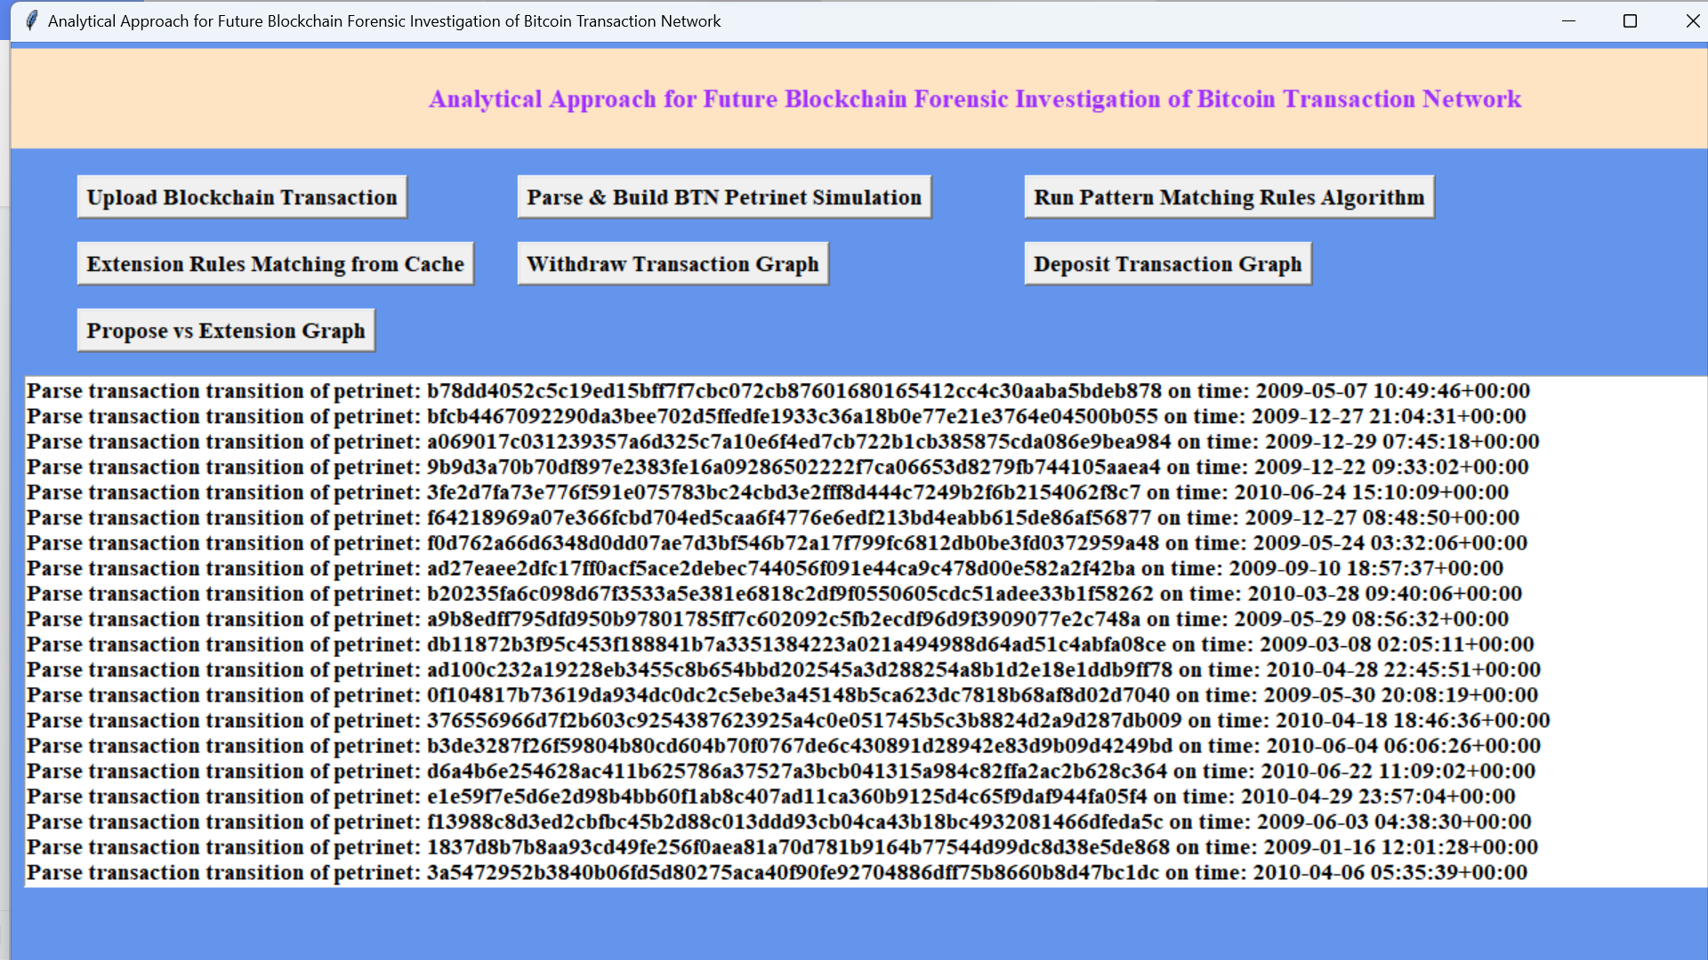
In above screen after parsing displaying each transaction address identified from PETRINET with transaction time. Now click on ‘Run Pattern Matching Rule Algorithm’ to apply pattern matching on each transaction and then detect suspected addresses
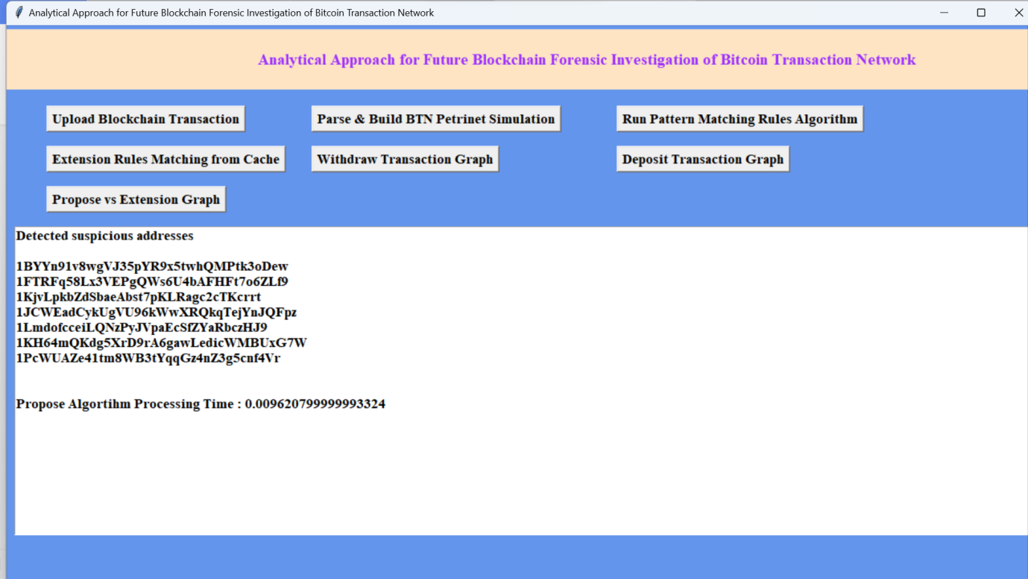
In above screen showing list of all suspected account details with invalid addresses. Now click on ‘Withdraw Transaction Graph’ button to view all withdraw transaction from different accounts
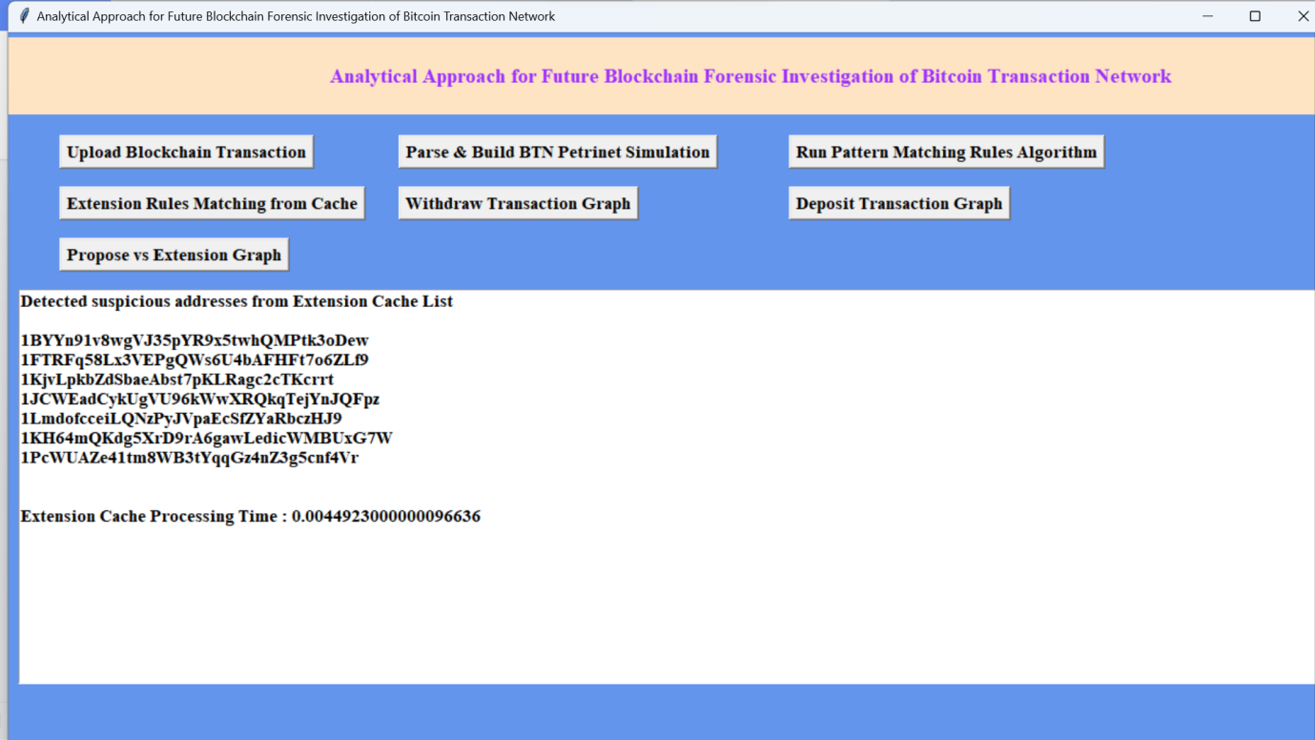
In above screen with extension Cache it took 0.0044 seconds to processes all transaction and now click on ‘Propose vs Extension Graph’ button to get below execution time graph

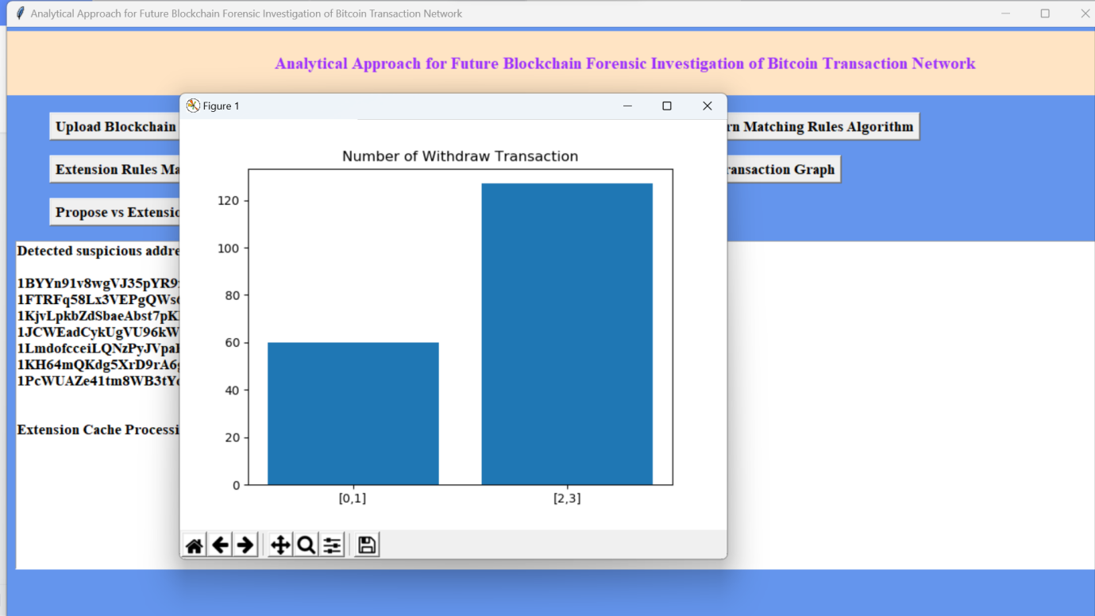
In above screen x-axis represents total withdraw from account 0 to 1 and vice versa and y-axis represents number of gather addresses for that withdrawal. Now click on ‘Deposit Transaction Graph’ button to get below graph

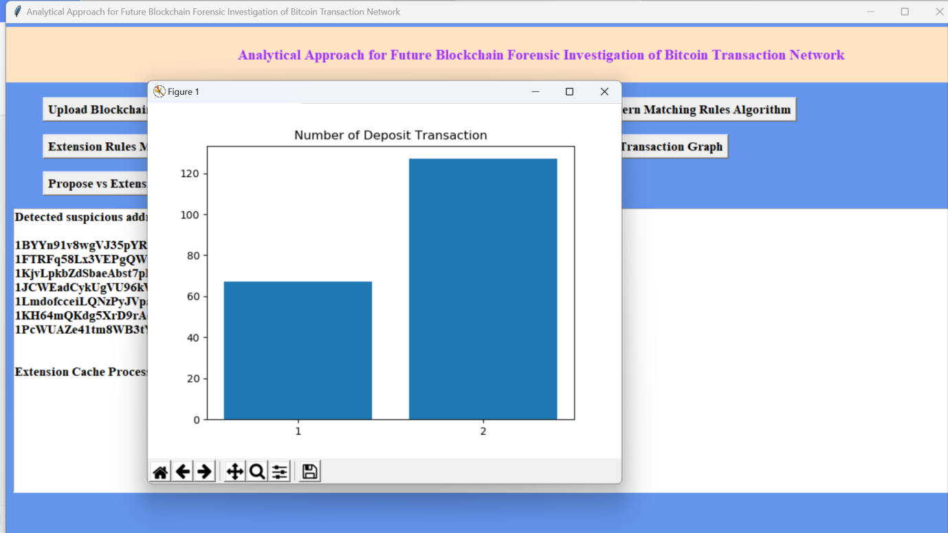
In above screen x-axis represents number of account ID and y-axis represents number of deposit transaction made by that account.

