**PROJECT TITLE : ENVIRONMENTAL MONITORING**

**COLLEGE NAME : ST.MOTHER THERESA ENGINEERING COLLEGE**

**COLLEGE CODE : 9530**

**NAME : M.SINDHUJA**

**TEAM NAME : PROJ_201034_TEAM_1**

**CIRCUIT DIAGRAM**

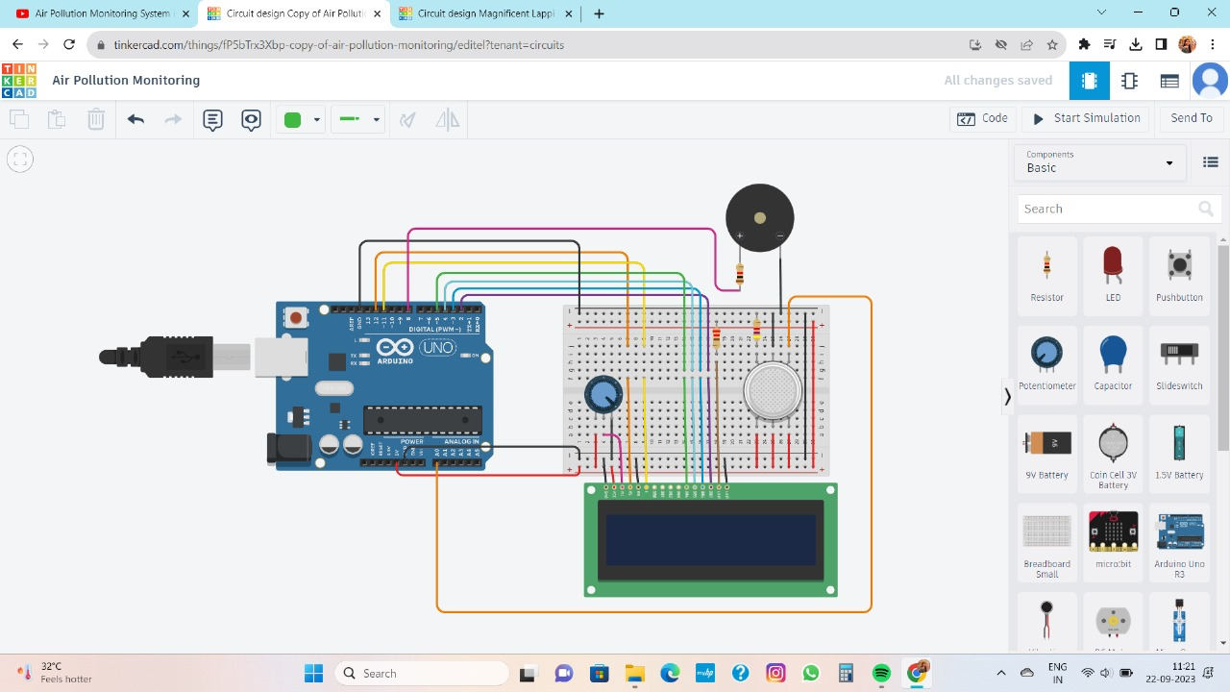

**METHODOLOGY USED WITH FLOWCHART**

**Start**

**Pollution is detected by gas sensor**

**Stop**

**When pollution comes**

**Through this circuit we can reduced pollution.**

**This circuit will monitor the amount of pollution in the air.**

**LCD displays the air is really polluted or not**.

**CODE**

#include <LiquidCrystal.h>

LiquidCrystal lcd(12, 11, 5, 4, 3, 2);

int pin8 = 8;

int analogPin = A0;

int sensorValue = 0;

void setup() {

pinMode(analogPin, INPUT);

pinMode(pin8, OUTPUT);

lcd.begin(16, 2);

lcd.print("What is the air ");

lcd.print("quality today?");

Serial.begin(9600);

lcd.display();}

void loop() {

delay(1000);

sensorValue = analogRead(analogPin);

Serial.print("Air Quality in PPM = ");

Serial.println(sensorValue);

lcd.clear();

lcd.setCursor(0,0);

lcd.print ("Air Quality: ");

lcd.print (sensorValue);

if (sensorValue<=500) {

Serial.print("Fresh Air ");

Serial.print ("\r\n");

lcd.setCursor(0,1);

lcd.print("Fresh Air");

}

else if( sensorValue>=500 && sensorValue<=650 )

{

Serial.print("Poor Air");

Serial.print ("\r\n");

lcd.setCursor(0,1);

lcd.print("Poor Air");

}

else if (sensorValue>=650 )

{

Serial.print("Very Poor Air");

Serial.print ("\r\n");

lcd.setCursor(0,1);

lcd.print("Very Poor Air");

}

if (sensorValue >650) {

digitalWrite(pin8, HIGH);

}

else

{

digitalWrite(pin8, LOW);

}

}

**OUTPUT**

