CODING CHALLENGE

EMPLOYEE_DETAILS_ANALYSIS

OVERVIEW:
The dataset contains employee-related information in an organization such as name, age, department, and salary. It includes both categorical and numerical data, making it suitable for analysis.

DAY1-Observation:
- The Employee Dataset consists of details of the employees,It has 9 columns and 151 rows.
- The Employee Dataset has 9 columns in which(Name,Department,Country,Gender)are categorical data and columns such as(Employee id,Salary,Date of Joining,Performance Rating)are Numerical Data.
- The Employee dataset contains some missing values and inconsistent data, which need to be cleaned before analysis.
- The Employee dataset can be used to understand employee distribution, salary patterns, and departmental insights.

Importing file into Excel:
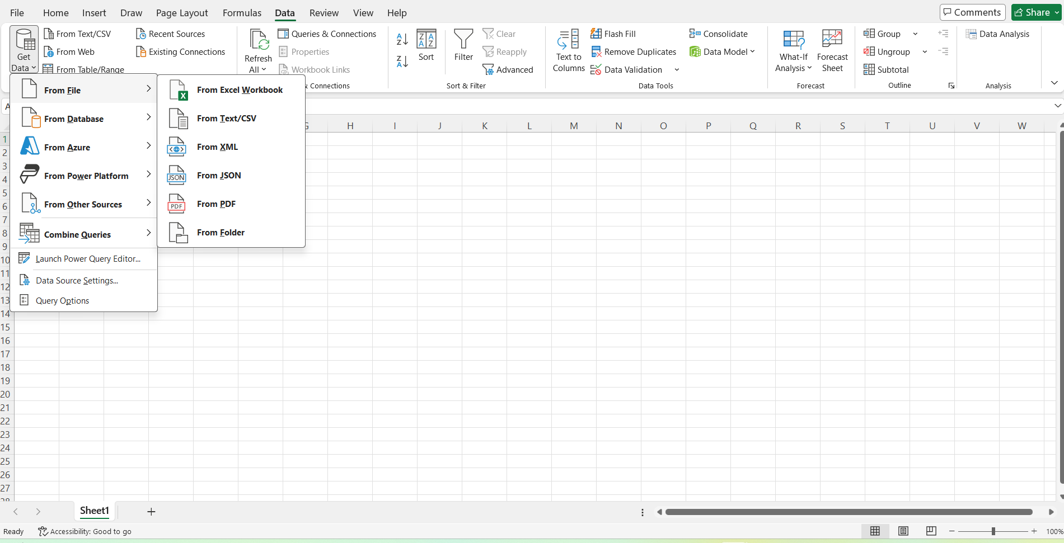
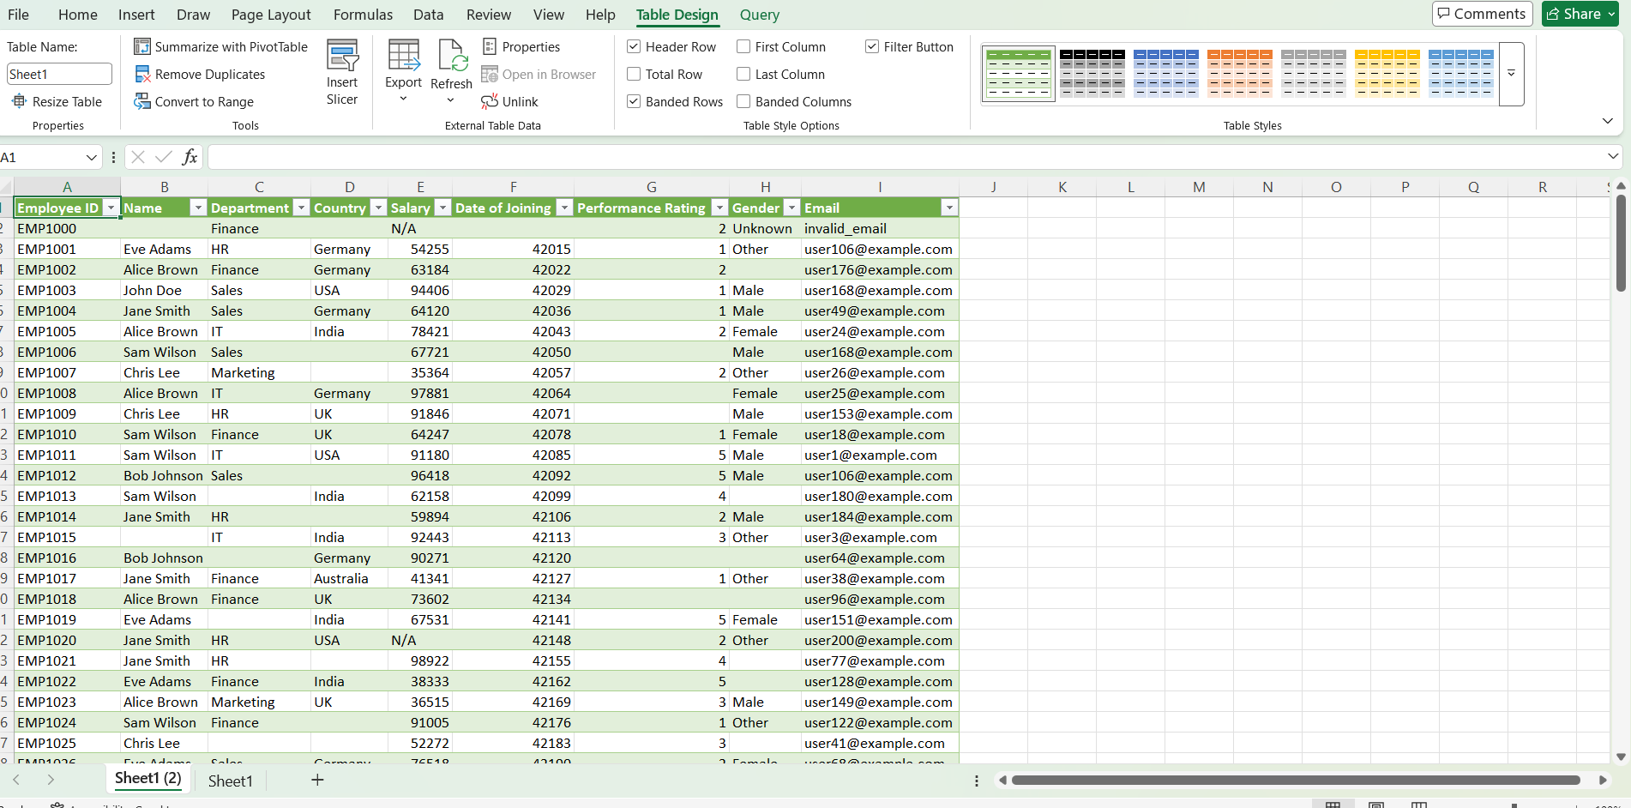

DAY2- Data Entry & Formatting:

- A new column named “Employee First Name” and an extra row were added for practice, and later both were removed using the delete options in the Home tab.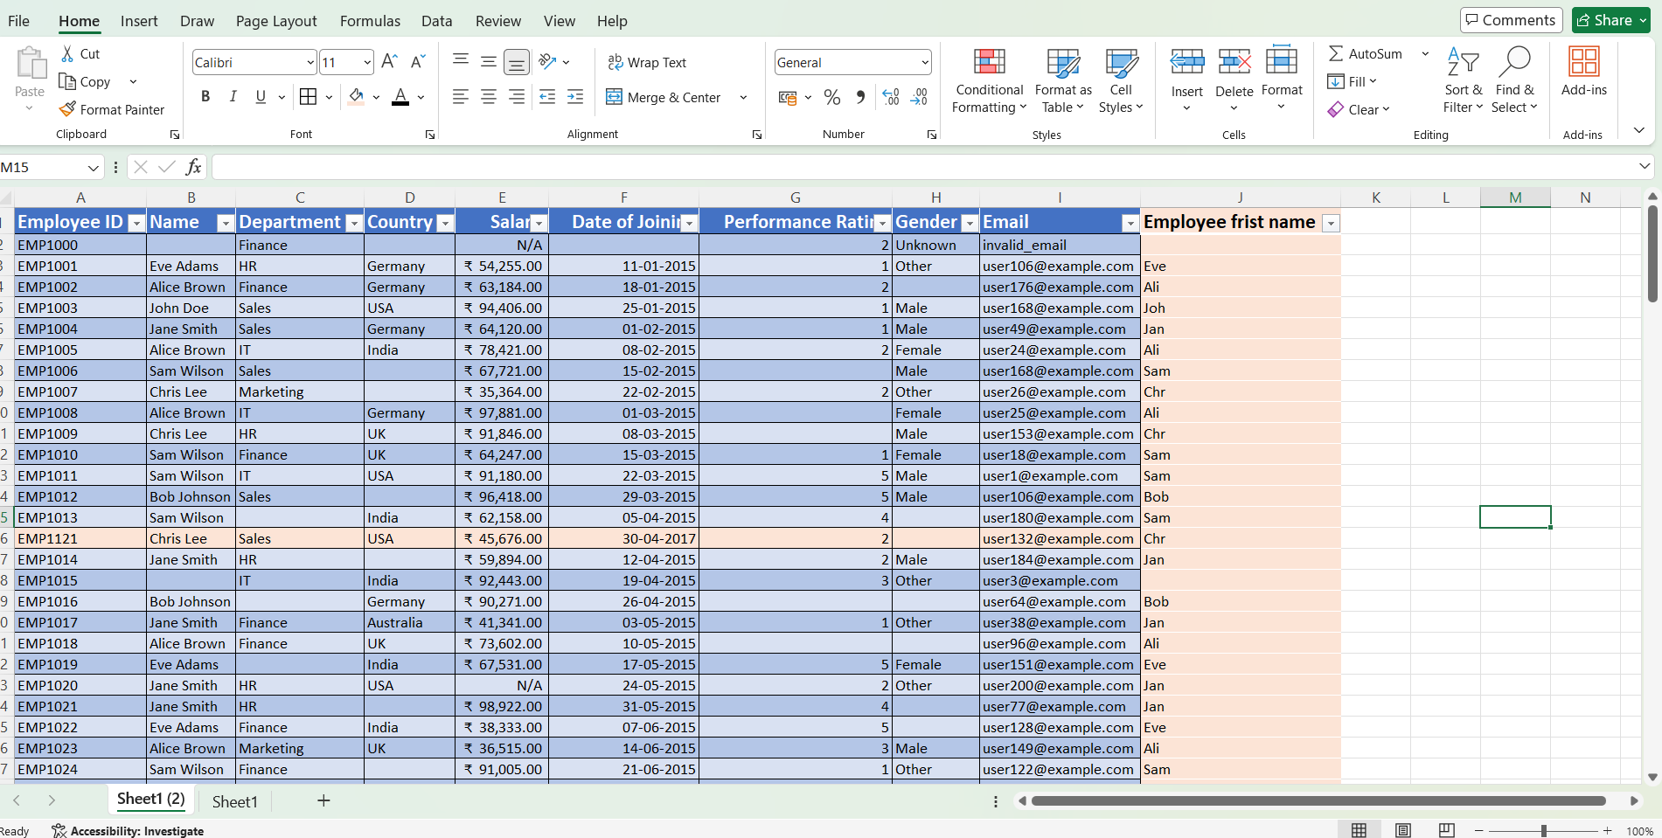

- The dataset was formatted using table design, and the header row was highlighted by increasing the font size and applying bold formatting.
- The Salary column was formatted into currency type, and the Date column was converted into short date format for better readability.
Proper alignment was applied, where text values were aligned to the left and numerical values were aligned to the right
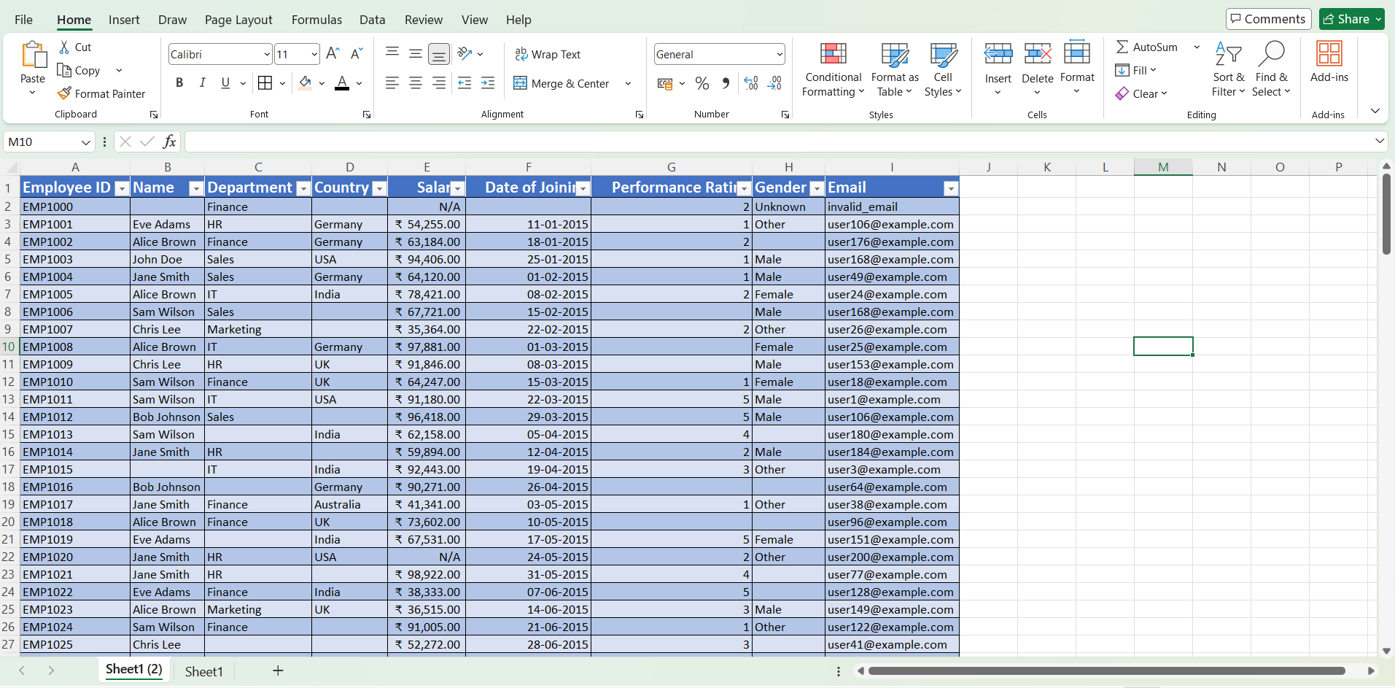

DAY3-Basic Excel Formulas (Part 1).
SUM(), AVERAGE(), MIN(), MAX(), COUNT()
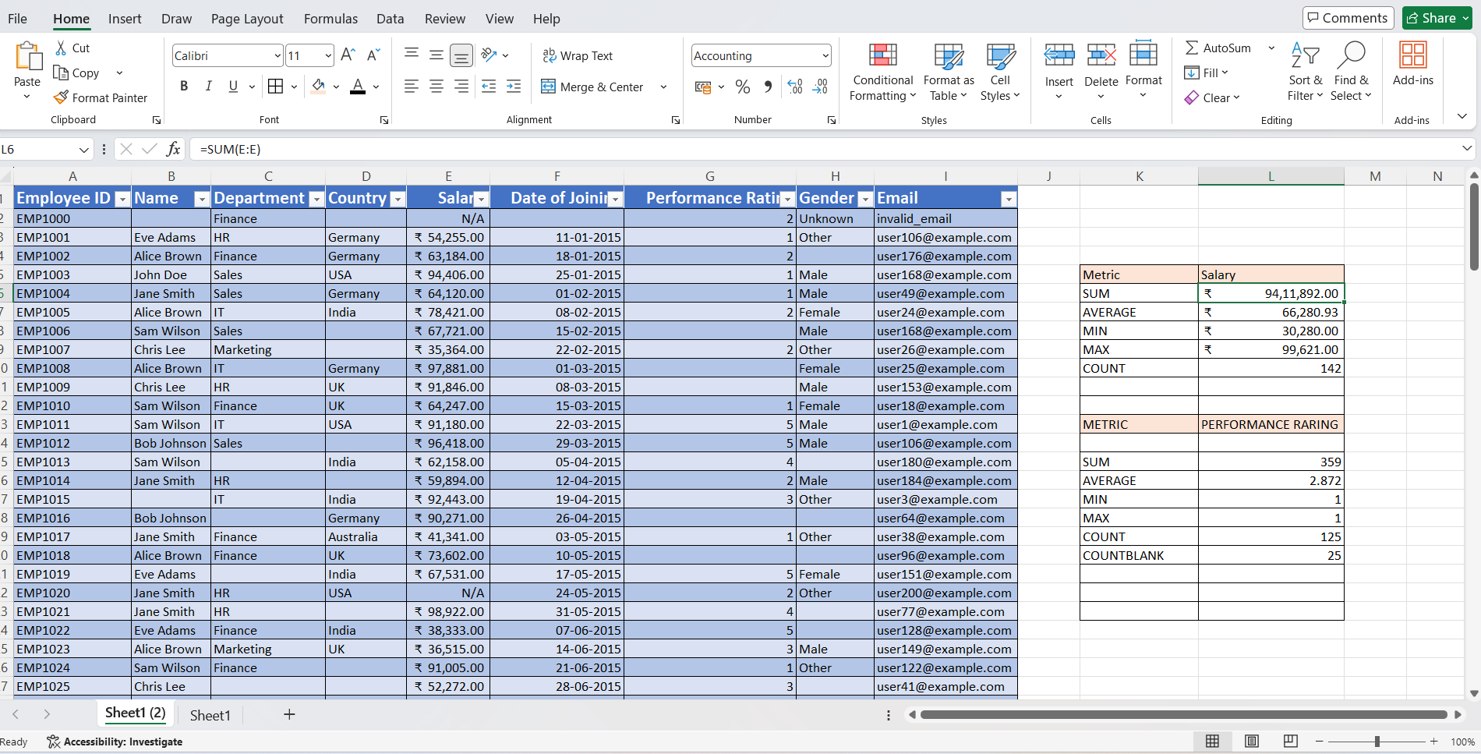
SUM function is used to calculate the total salary of the employees.
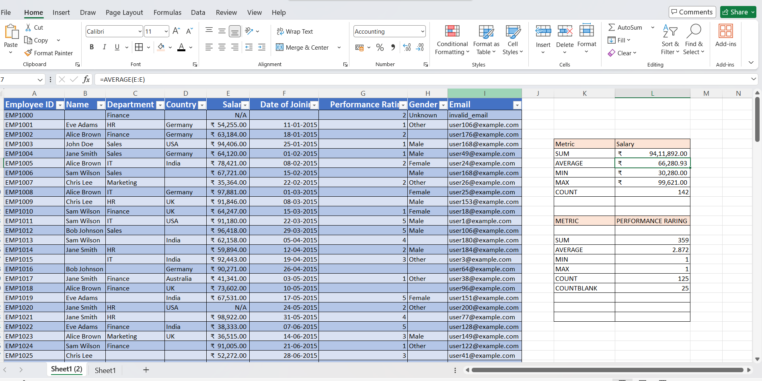
Average function is used to find the typical salaries of the employees
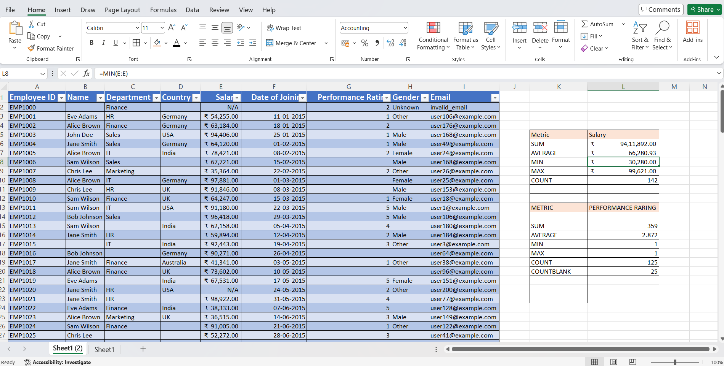
MIN function is used to find the Minimum salary of the employees
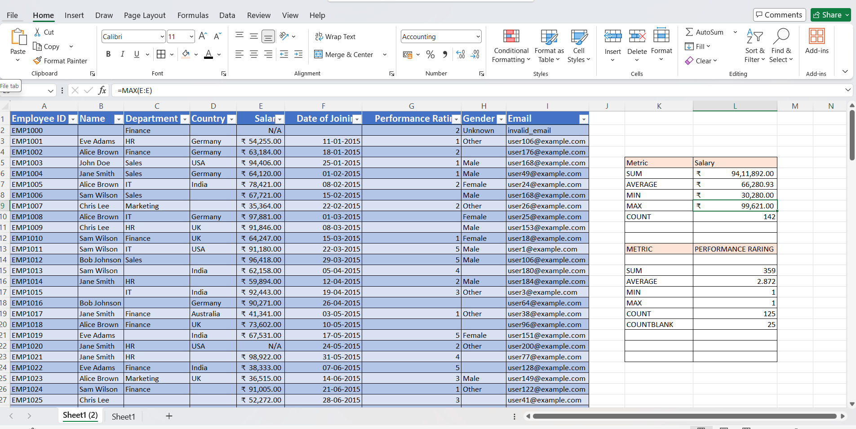
Max function is used to find the maximum salary of the employees
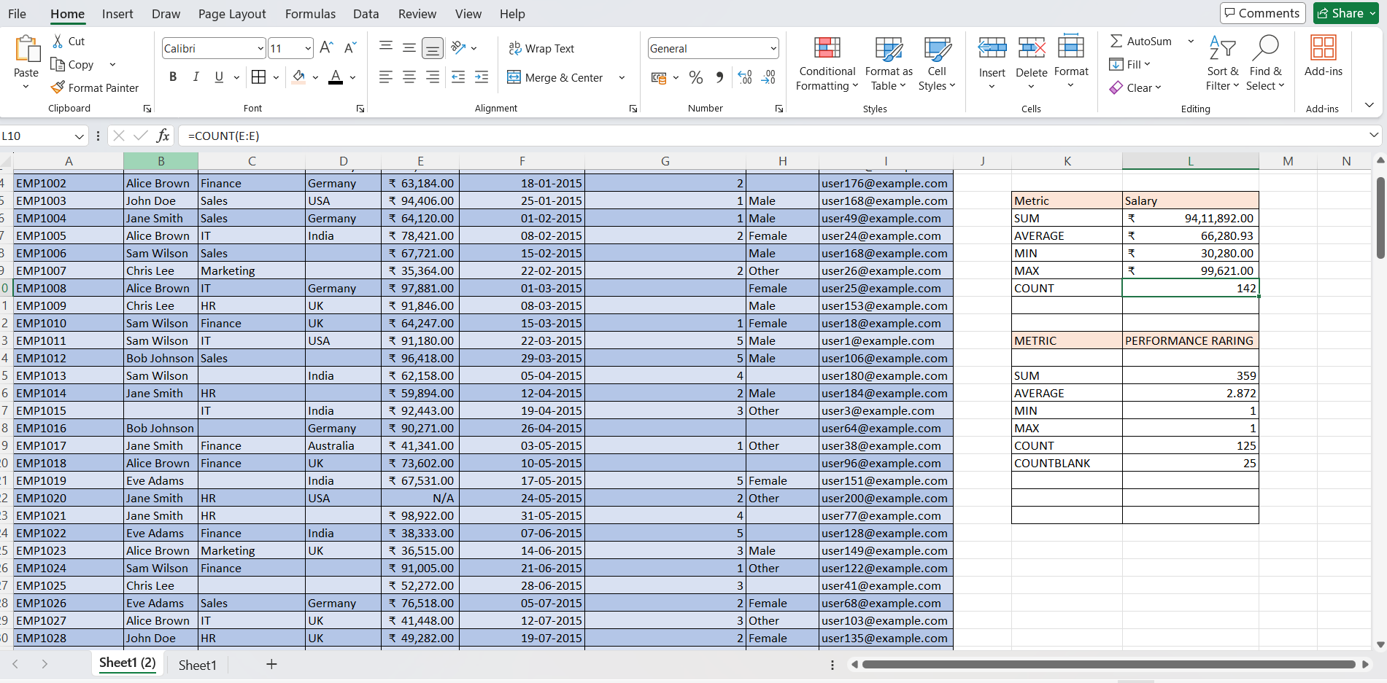
Count value is used to find how many employee have salary value. the COUNT function returned a lower value, which shows that some cells contain non-numeric or invalid data instead of proper salary values.
Likewise these formulas are also used to calculate the,total,minimum,maximum values of performance rating column.
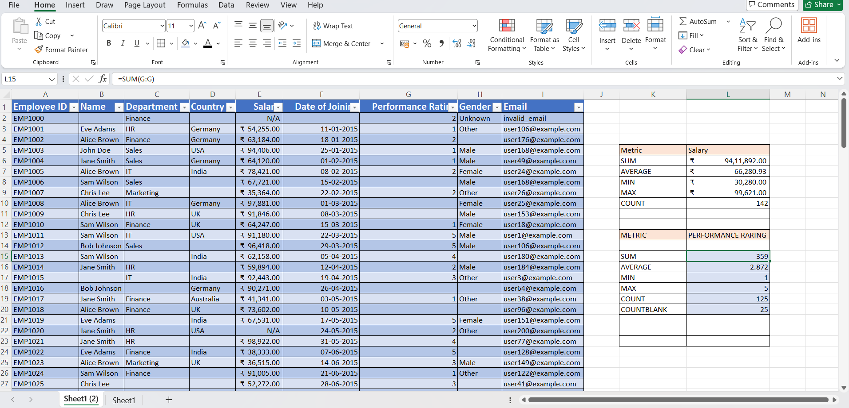
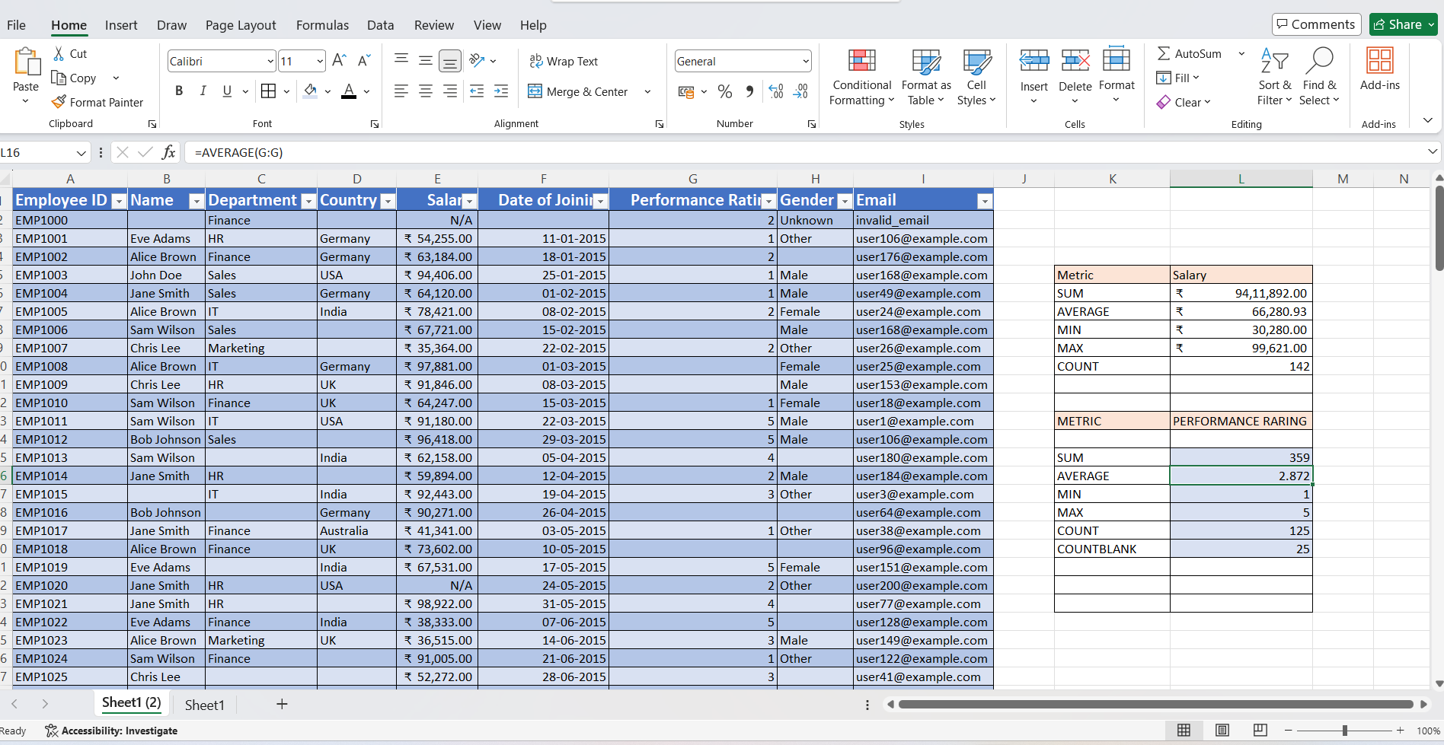
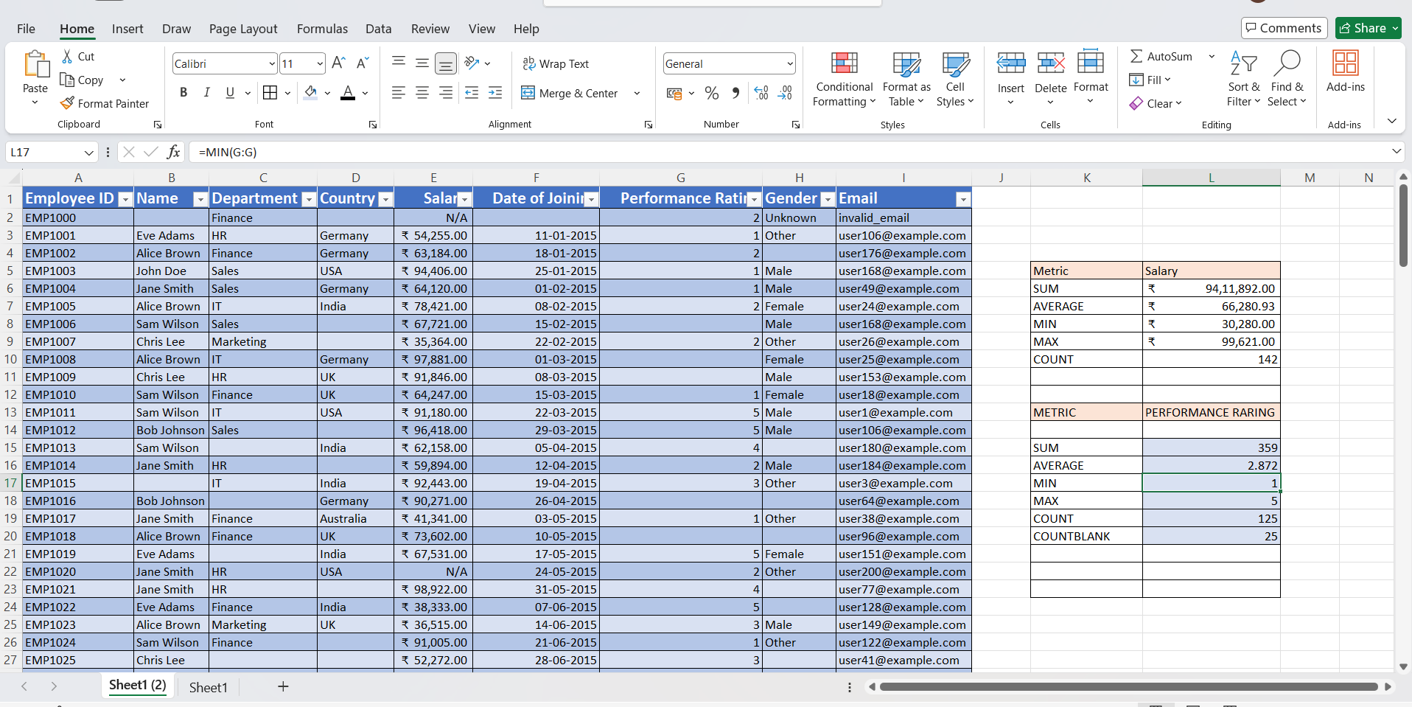
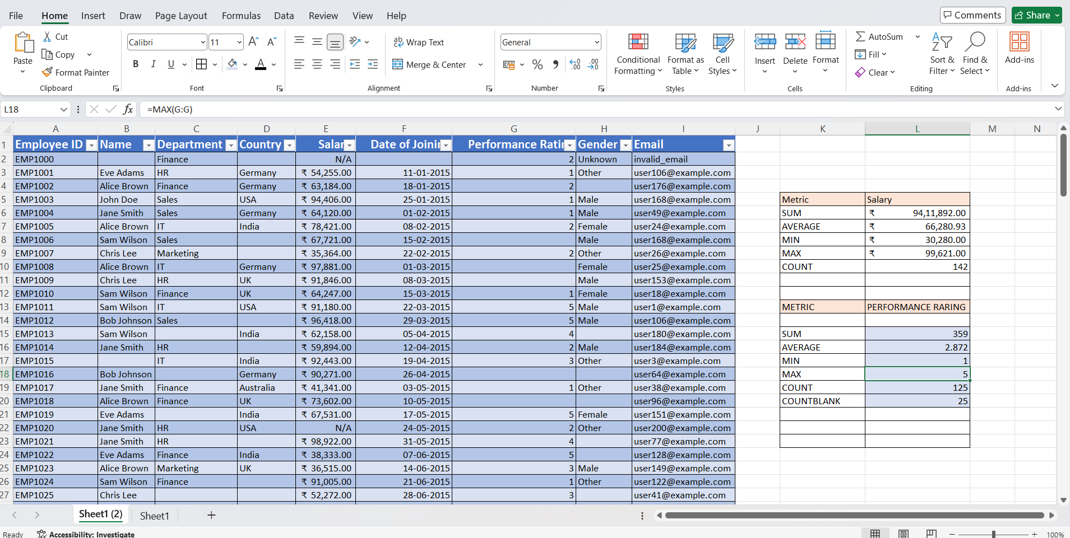
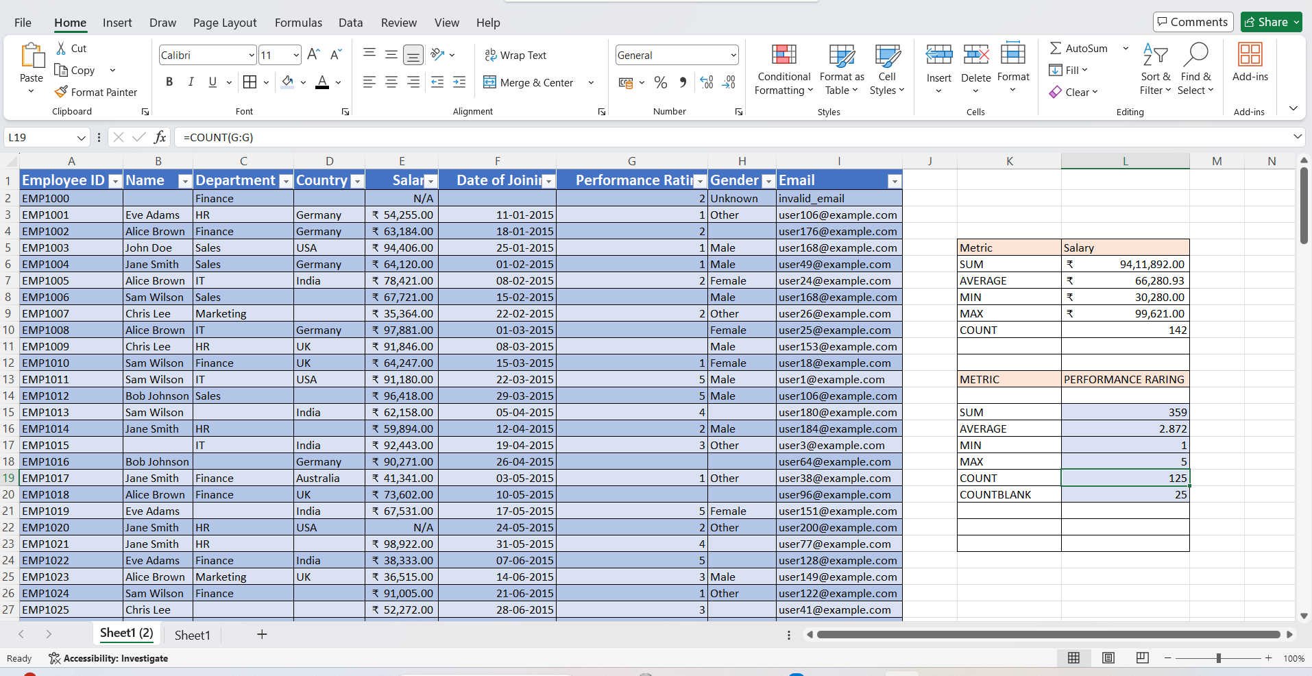
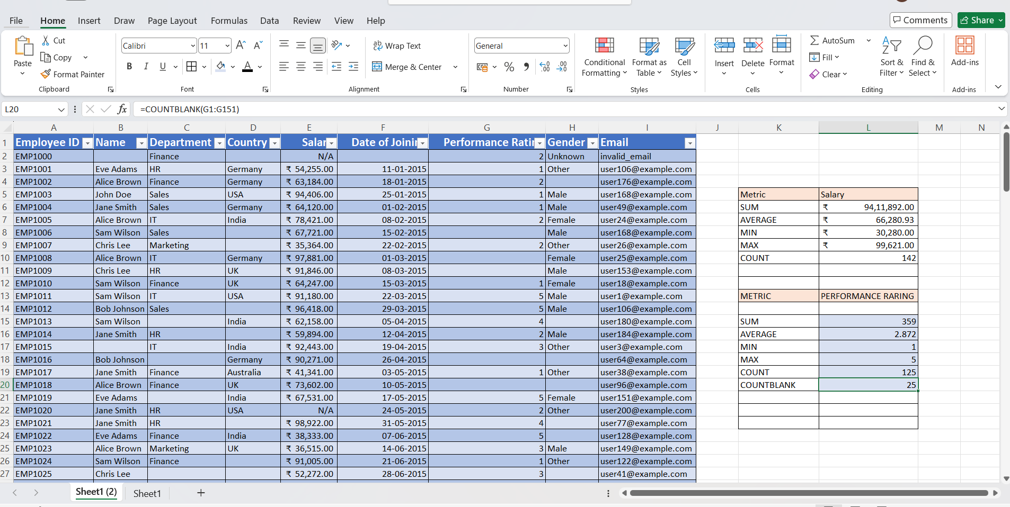

Day 4 – Basic Excel Formulas (Part 2)
Conditional functions such as IF, COUNTIF, SUMIF, and AVERAGEIF were used to analyze data based on specific conditions. These functions help in filtering and evaluating data efficiently, such as identifying high-performing employees or counting employees with salaries above a certain threshold.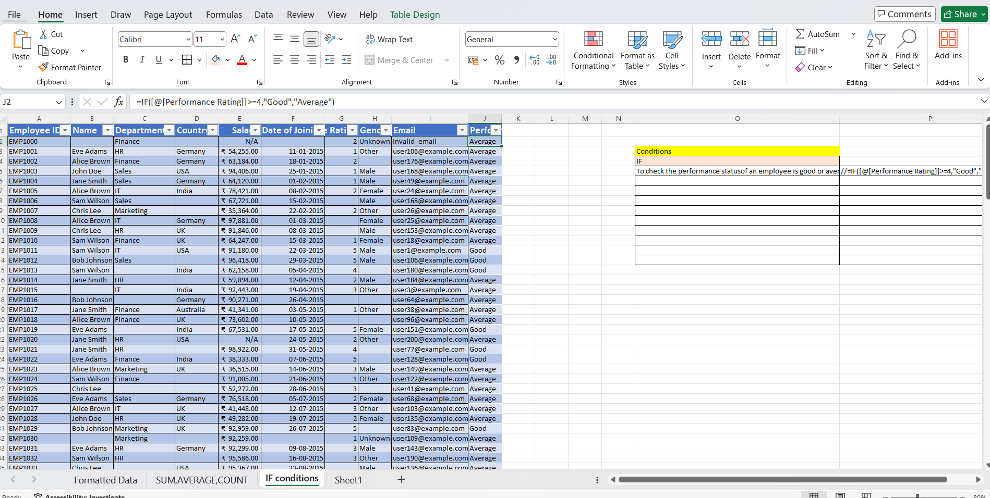
The IF function is used to check a condition and return different results based on whether the condition is true or false, such as identifying whether an employee is a high performer or not based on their performance rating.
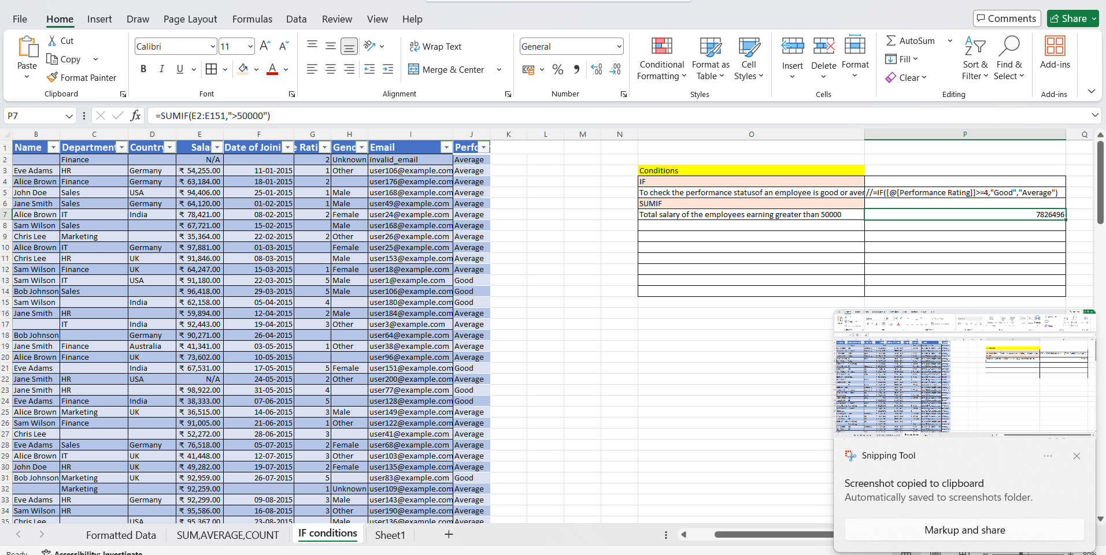
SUMIF function is used to calculate the total of values based on a given condition, such as finding the total salary of employees in a specific department.here we used this check the total salary of the employees whose earning is greater tha 50000.
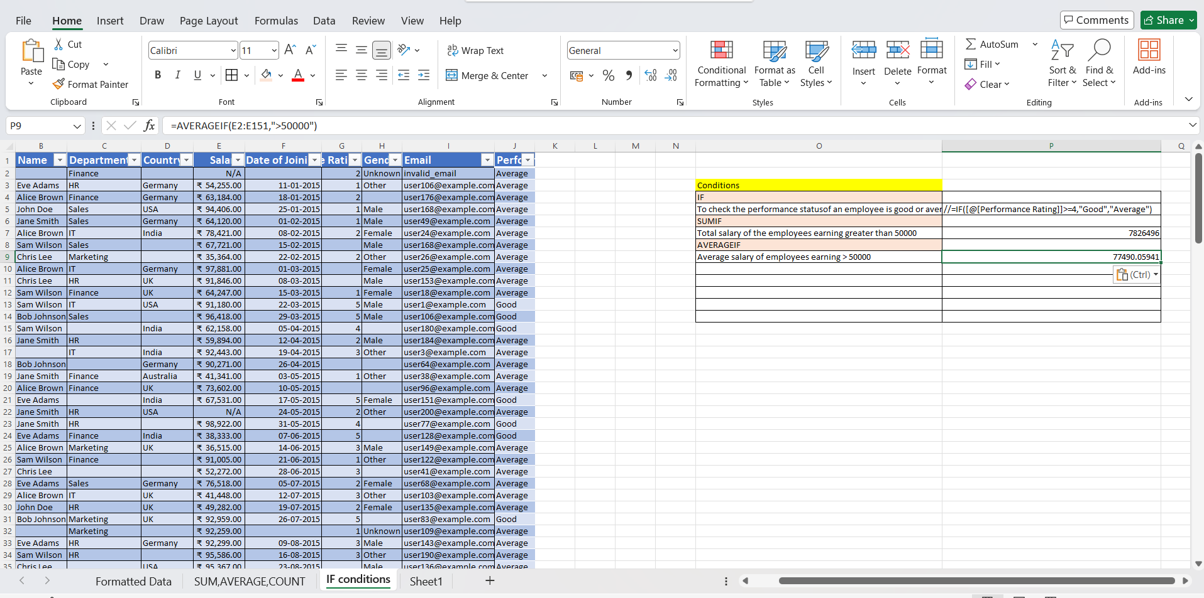
The AVERAGEIF function is used to calculate the average of values that meet a specific condition, such as determining the average salary of employees in a particular department.

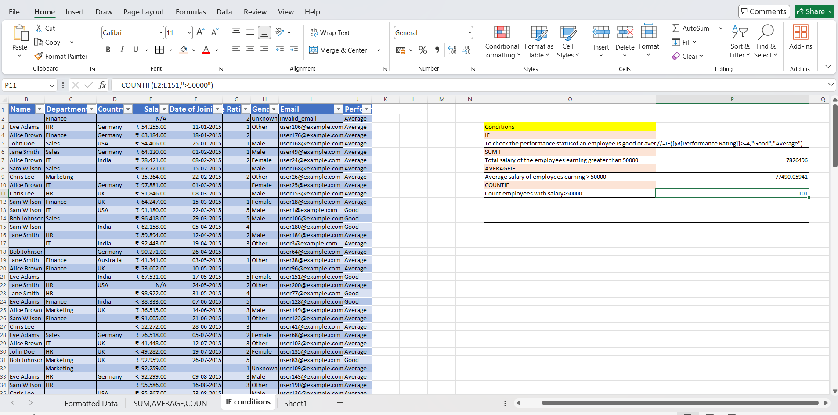
The COUNTIF function is used to count the number of employees who meet a specific condition, such as employees with salary above than 50000.

Day 5 – Text Functions Practice
LEFT(), RIGHT(), MID(), UPPER(), LOWER(), PROPER()
Text functions such as LEFT, RIGHT, LEN, FIND, TRIM, and PROPER were used to clean and manipulate text data.
LEFT
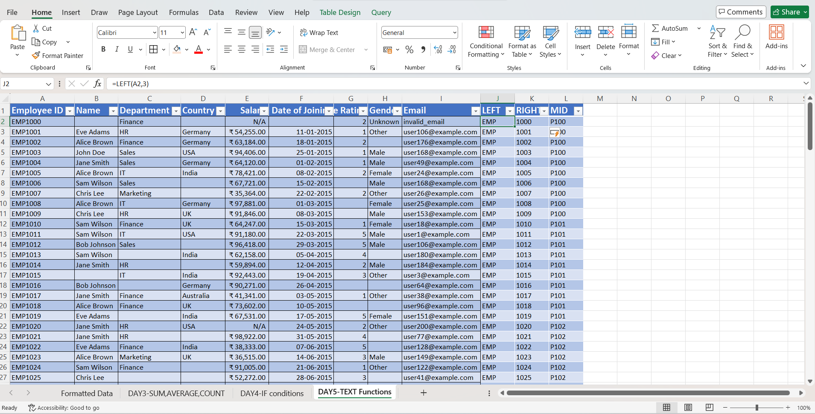

RIGHT
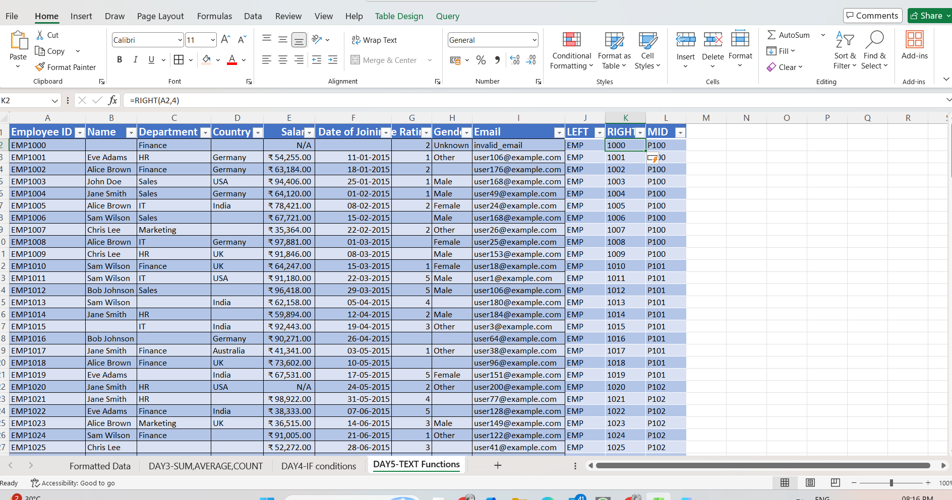
MID
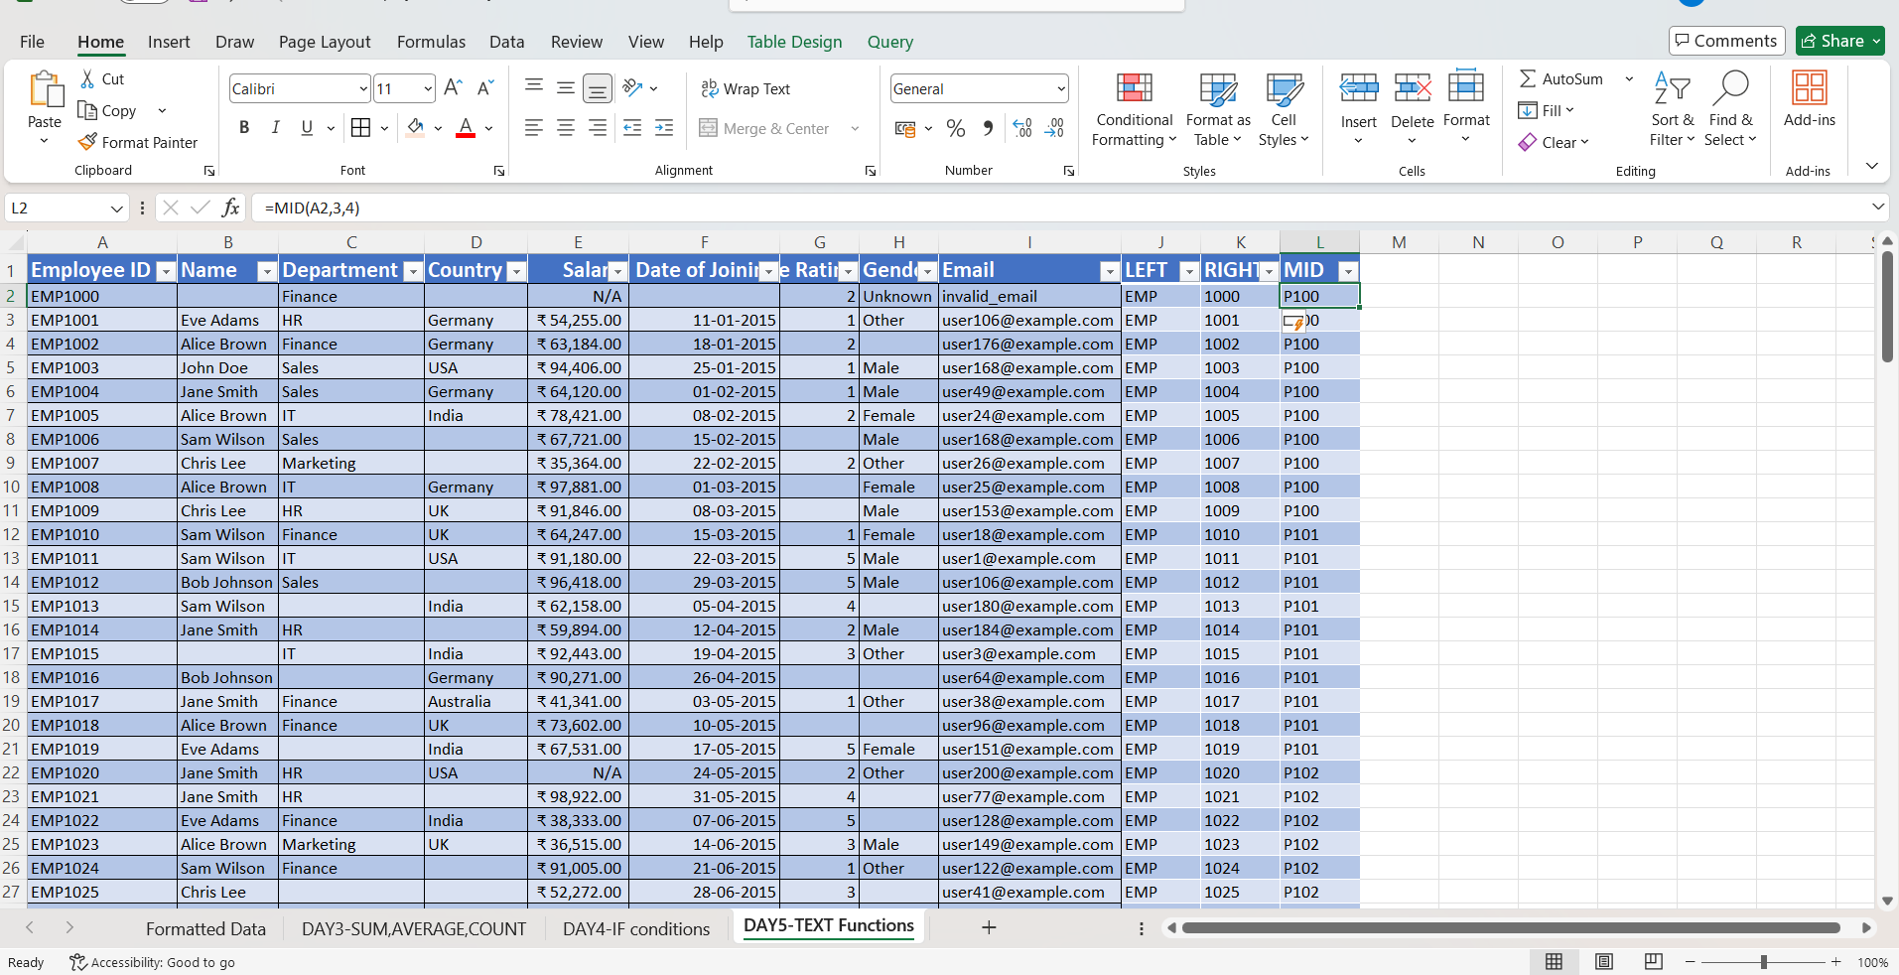

UPPER
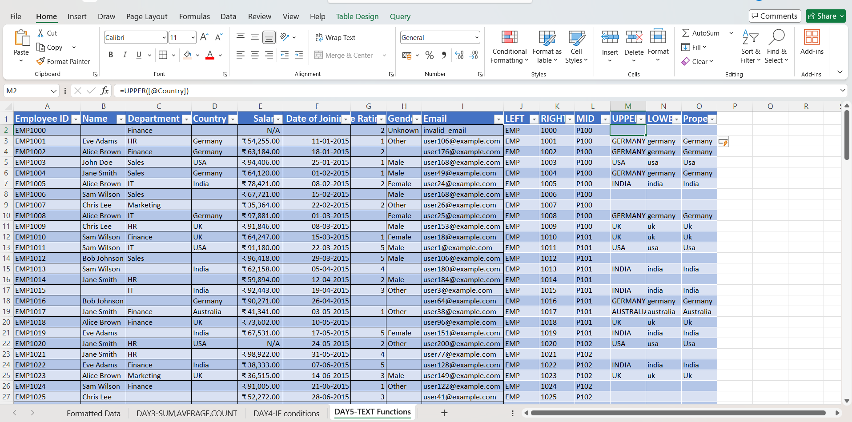

LOWER
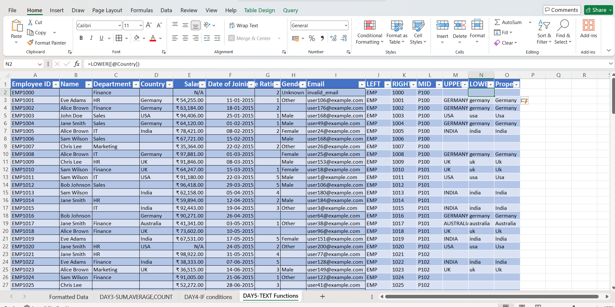

PROPER
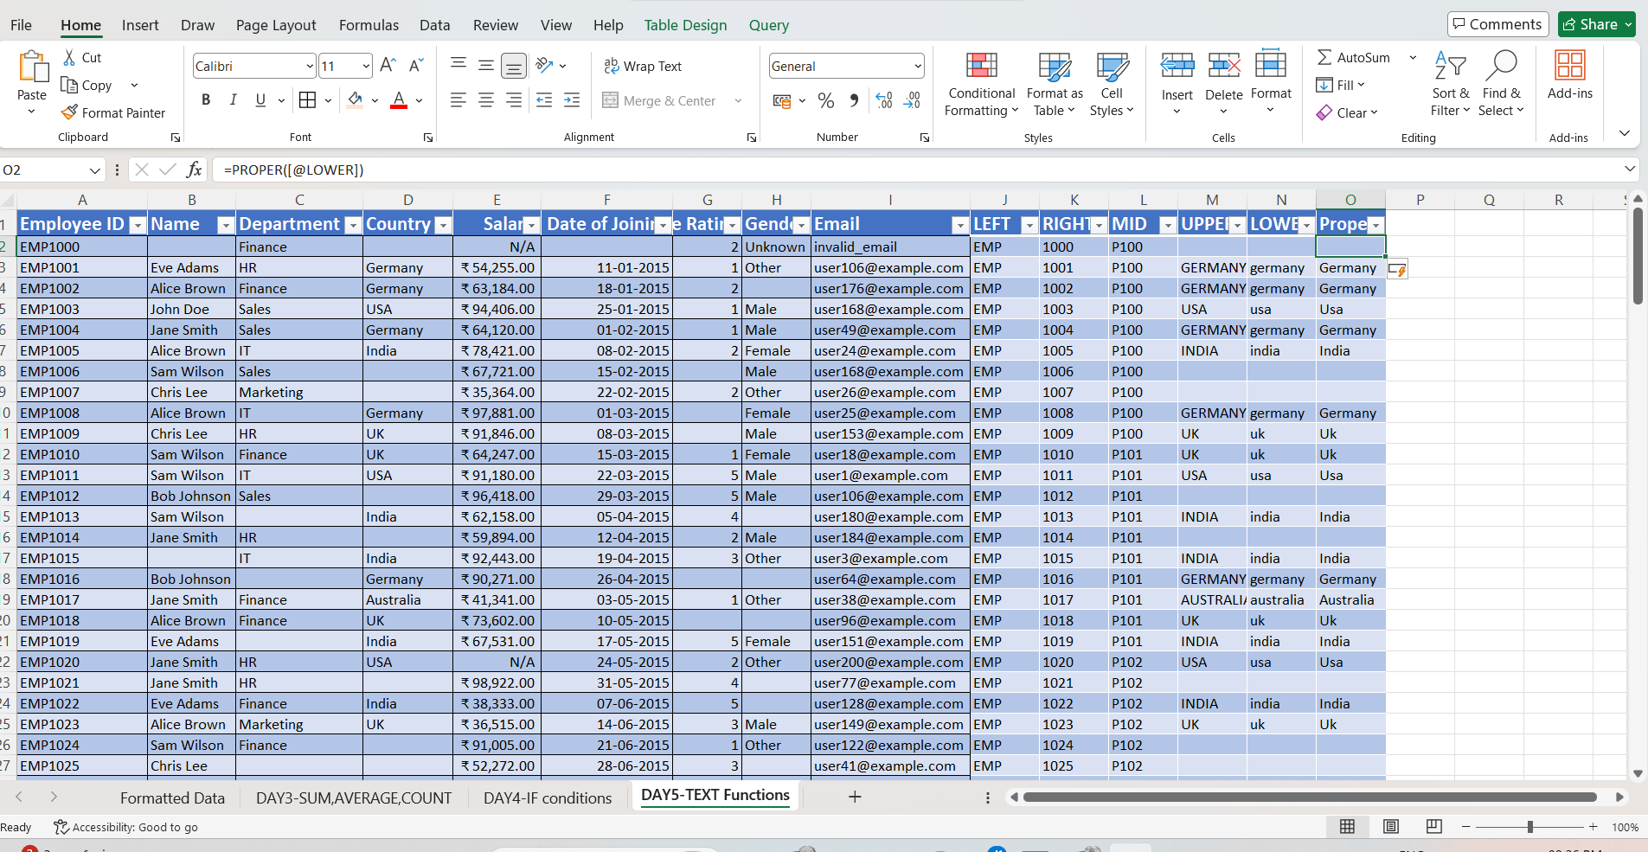

Day 6 – Data Validation & Cleaning
Remove nulls, duplicates, replace inconsistent data
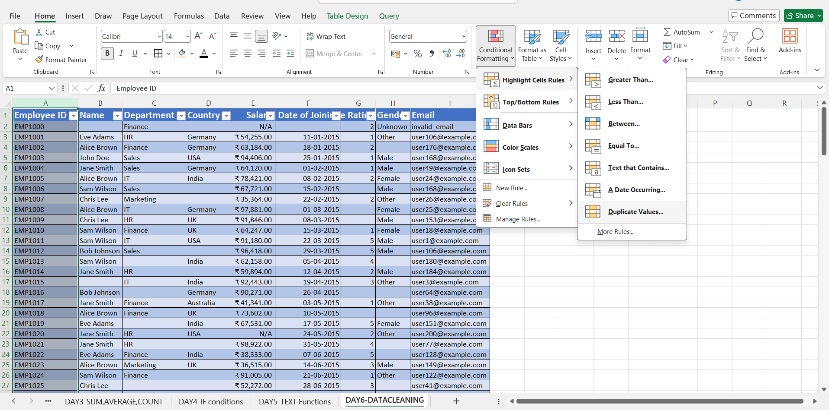
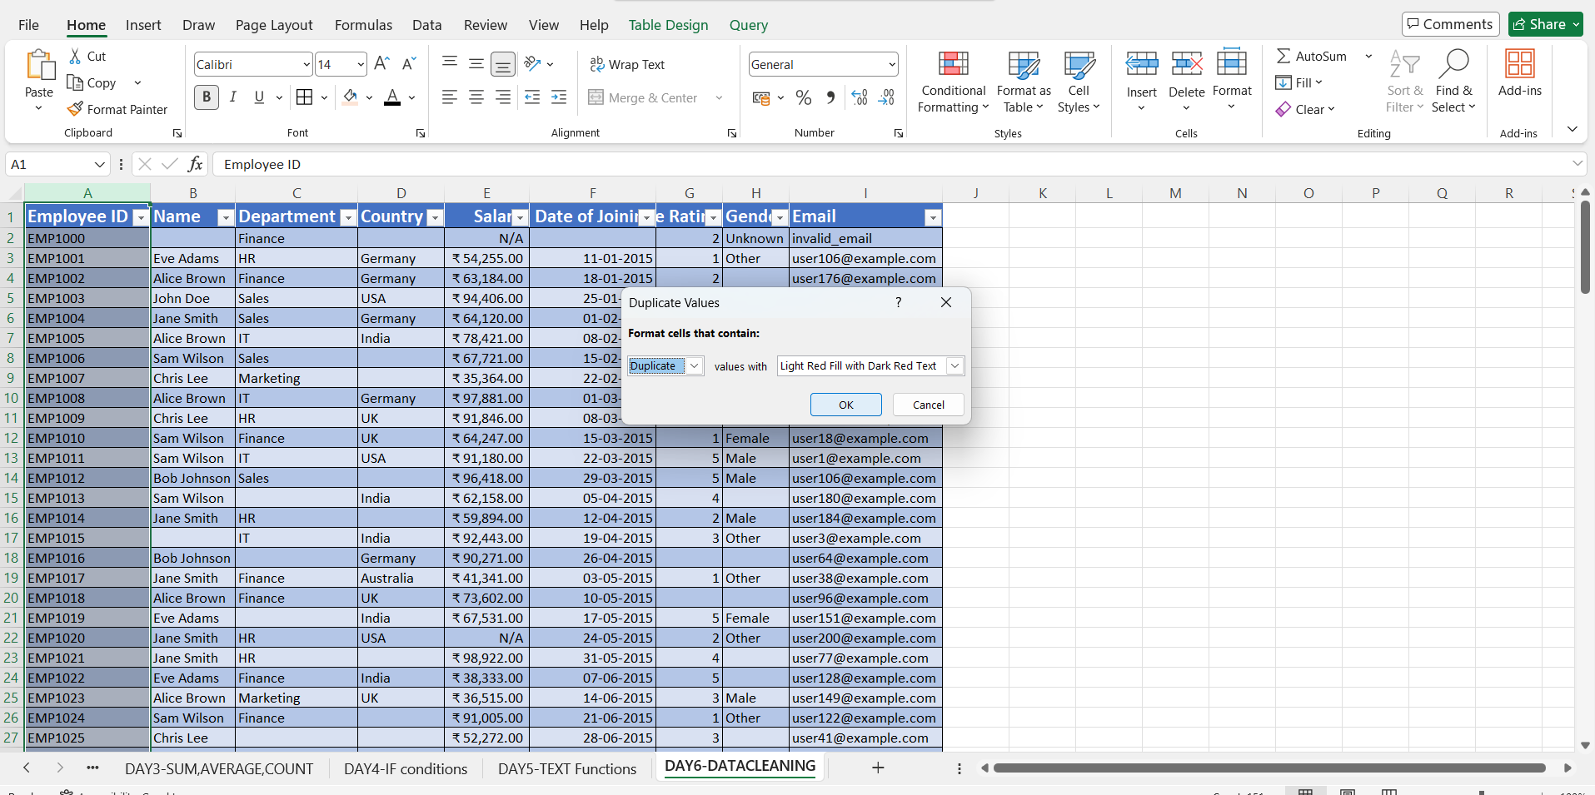
Duplicate values were checked using conditional formatting . No duplicate records were found in the Employee ID column, ensuring that each record is unique.
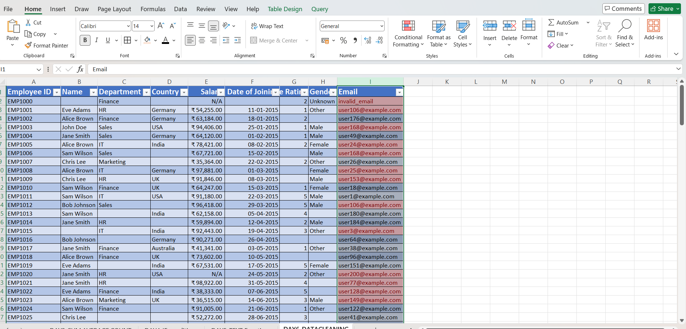
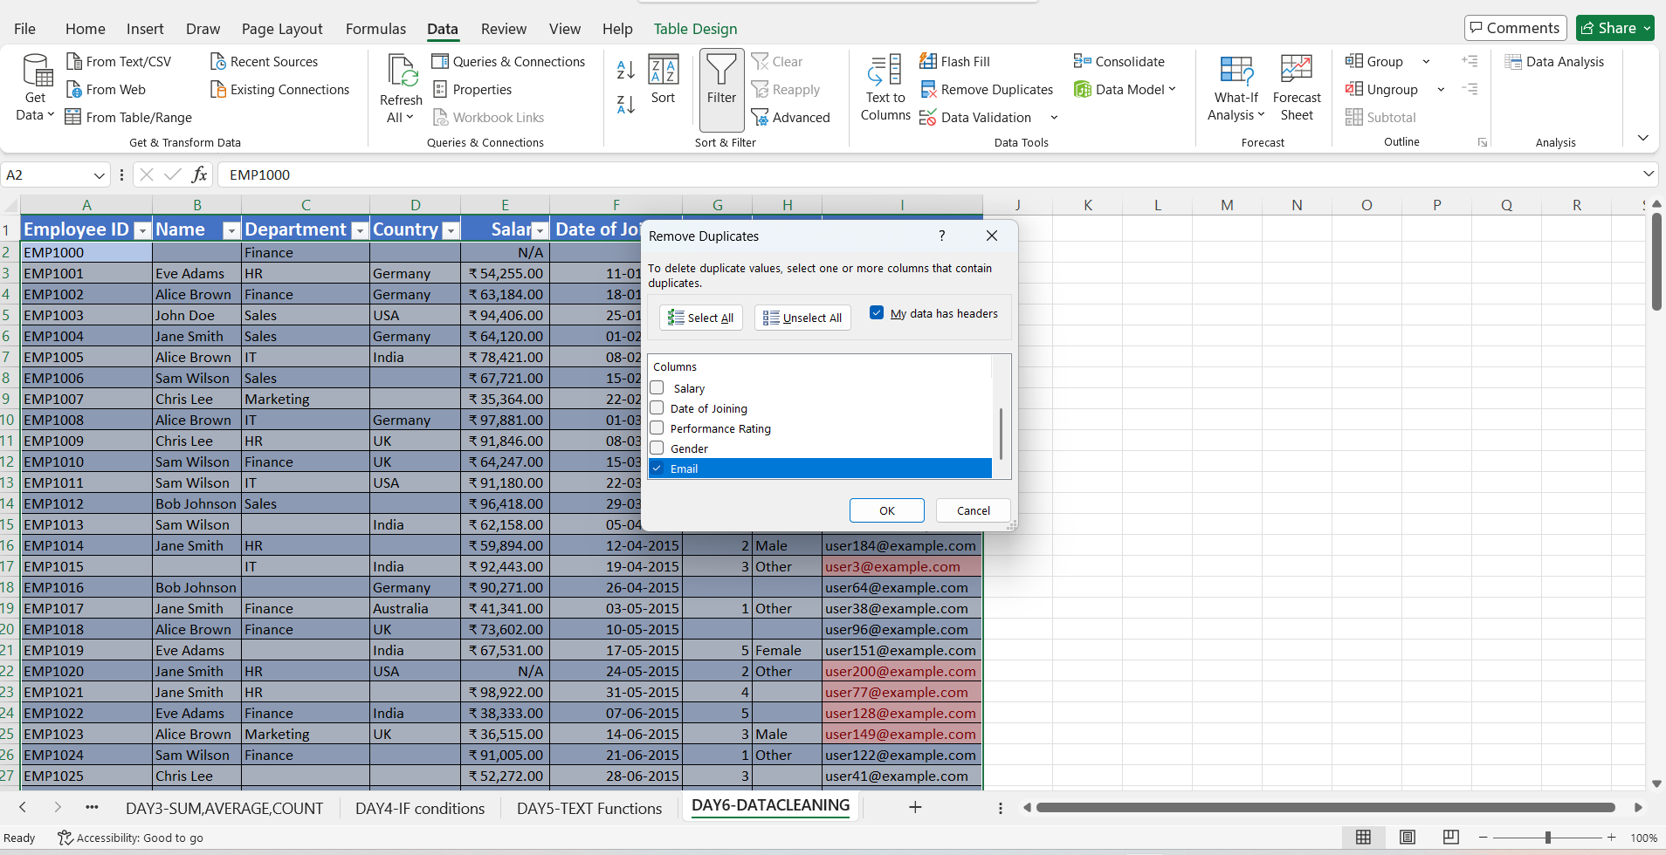
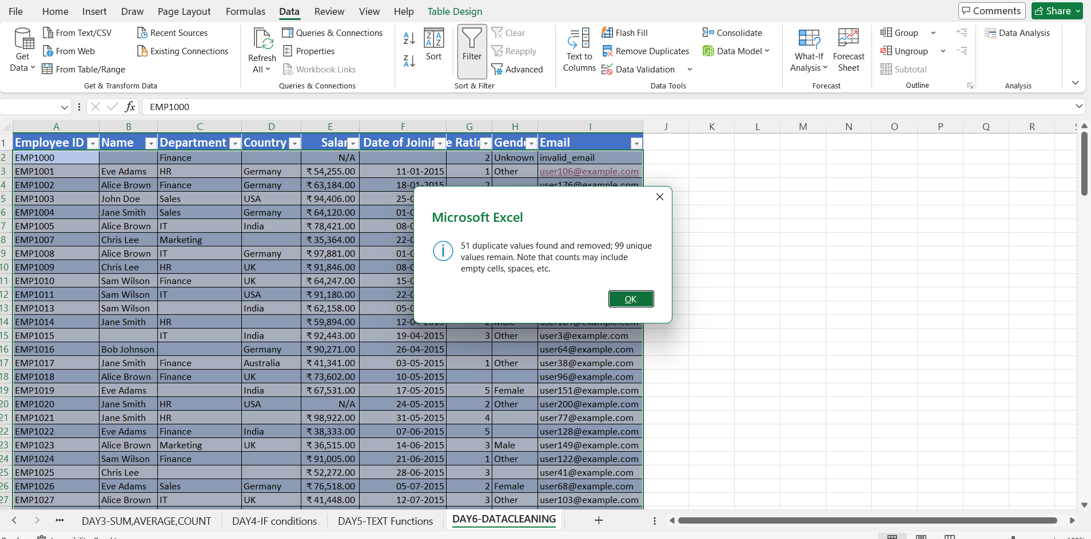
Duplicate email values were identified and handled by using filtering and conditional formatting techniques.
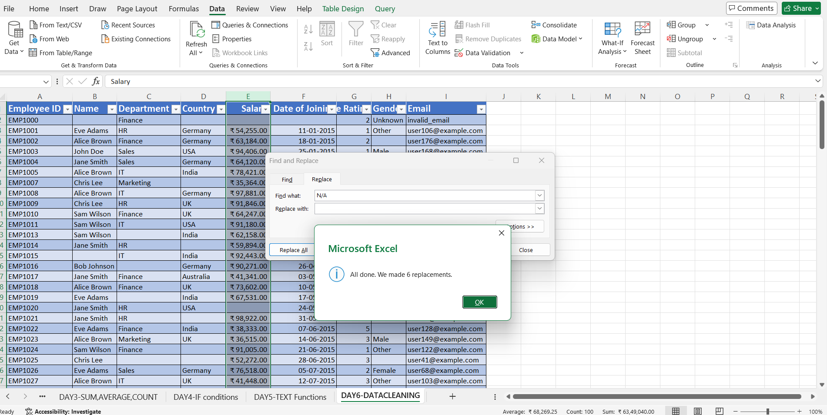

The missing name are filled by unknown
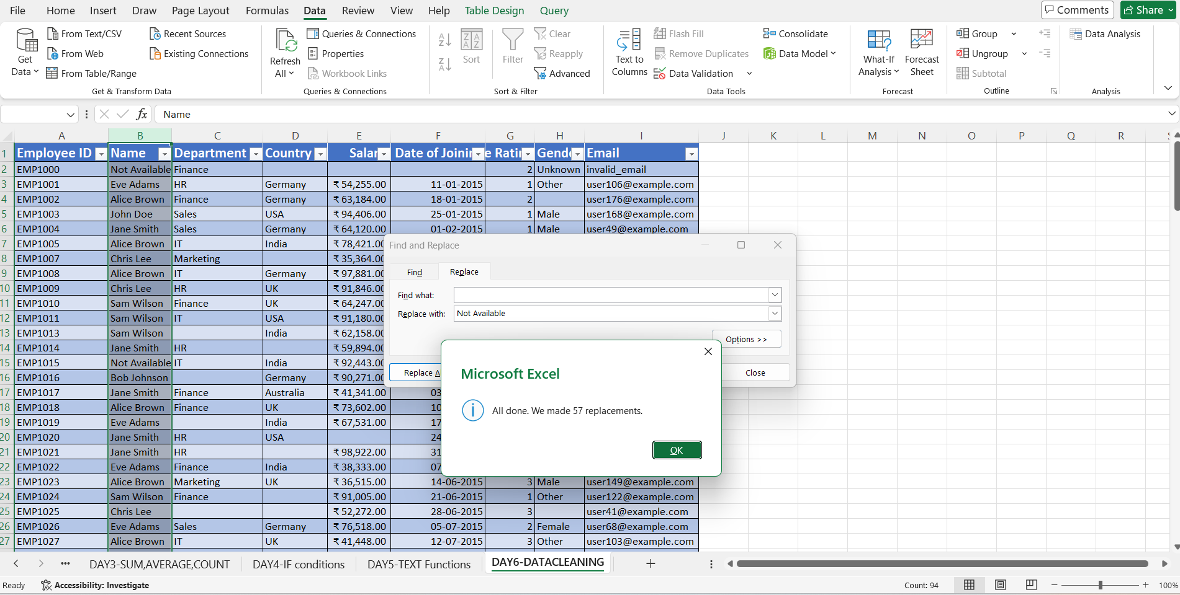
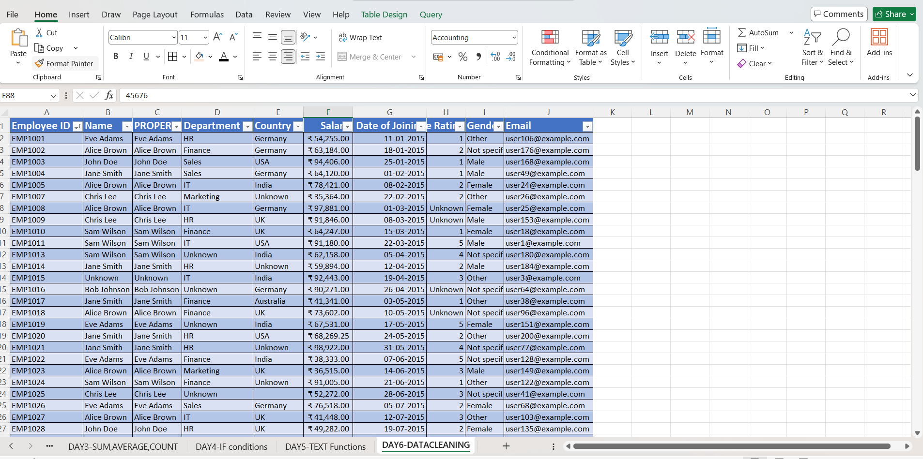
The final dataset after data cleaning.the salary column missing values are filled by calculating the average salary.

Day 7 – Power Query Introduction:
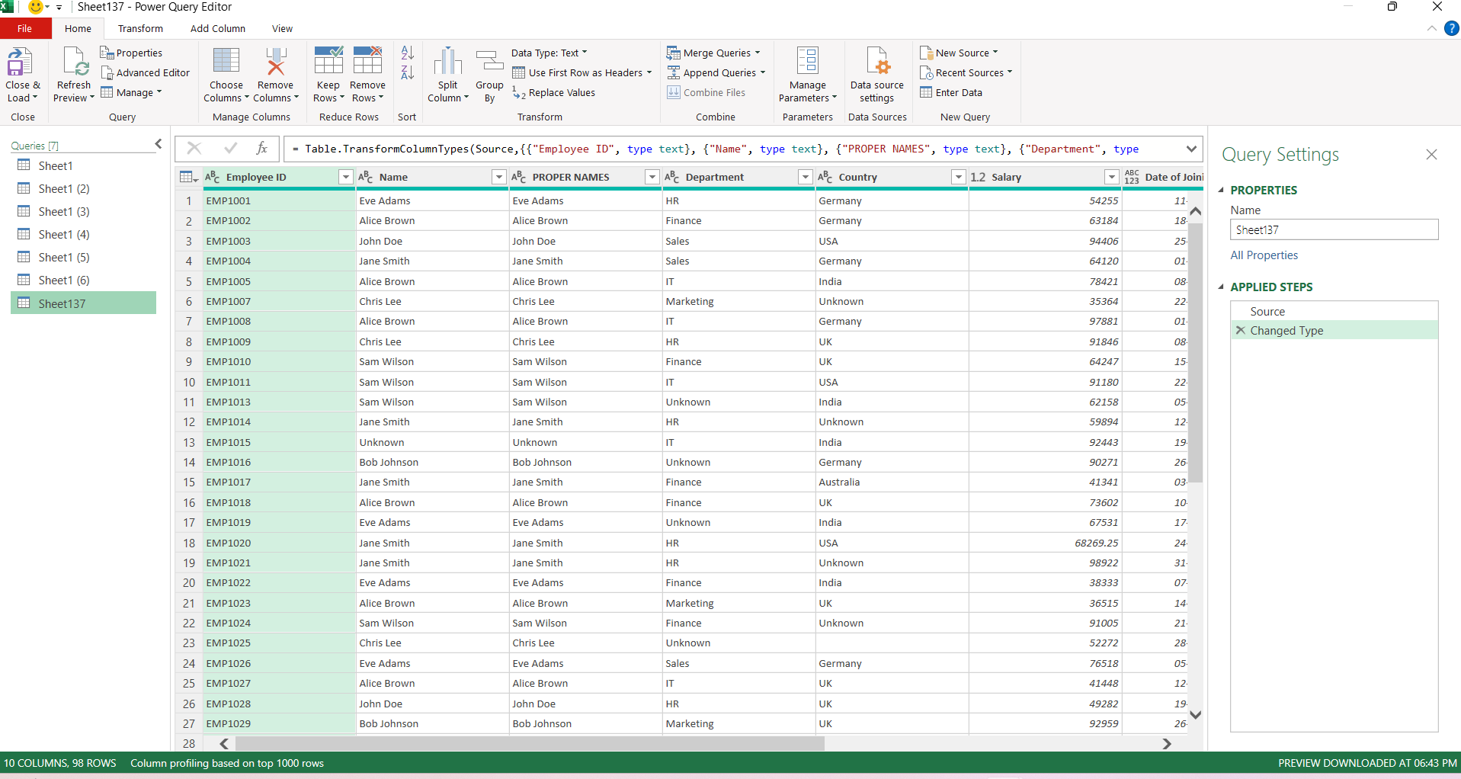
Loaded data into power query.
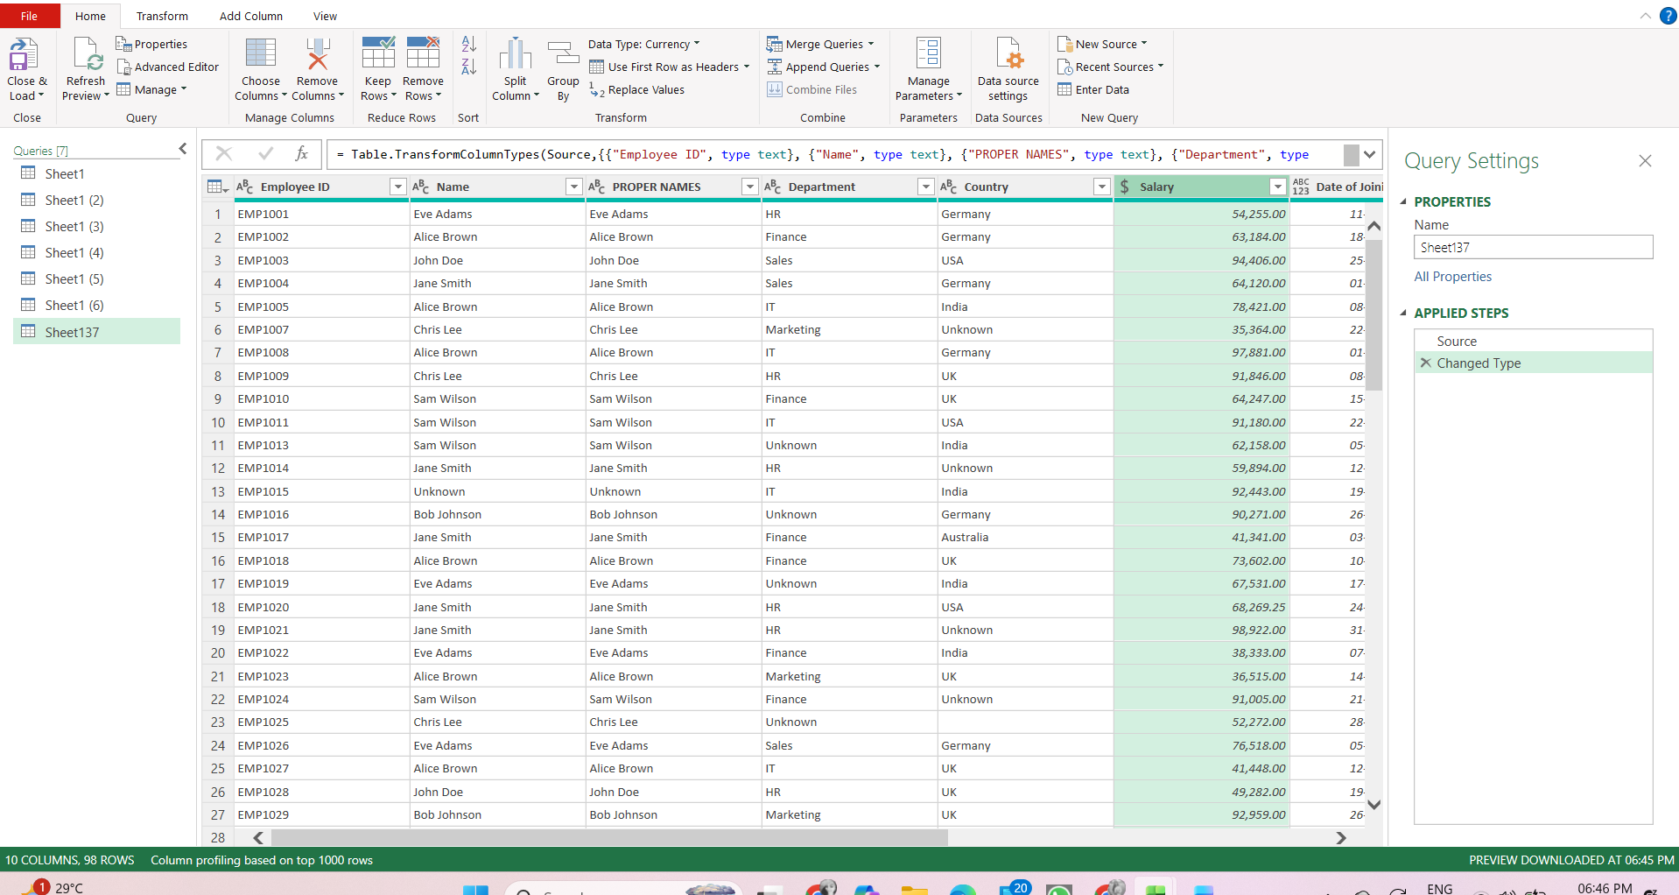
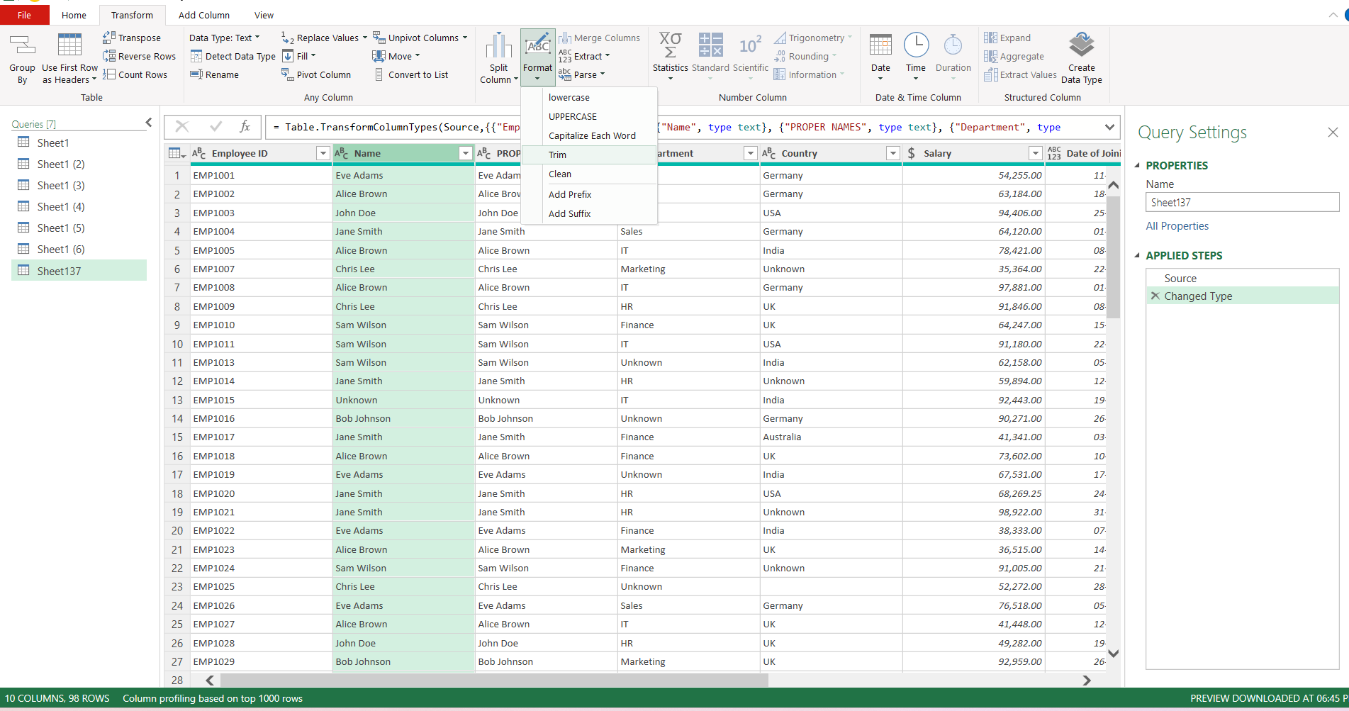
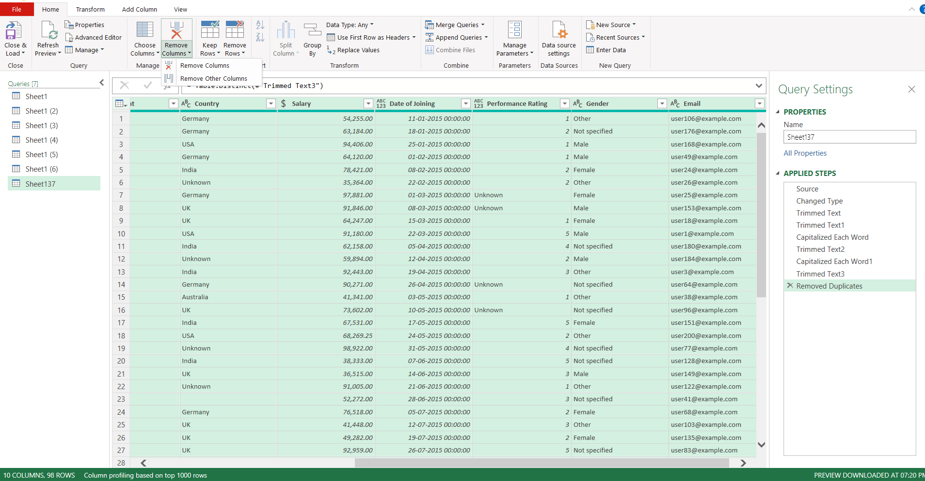
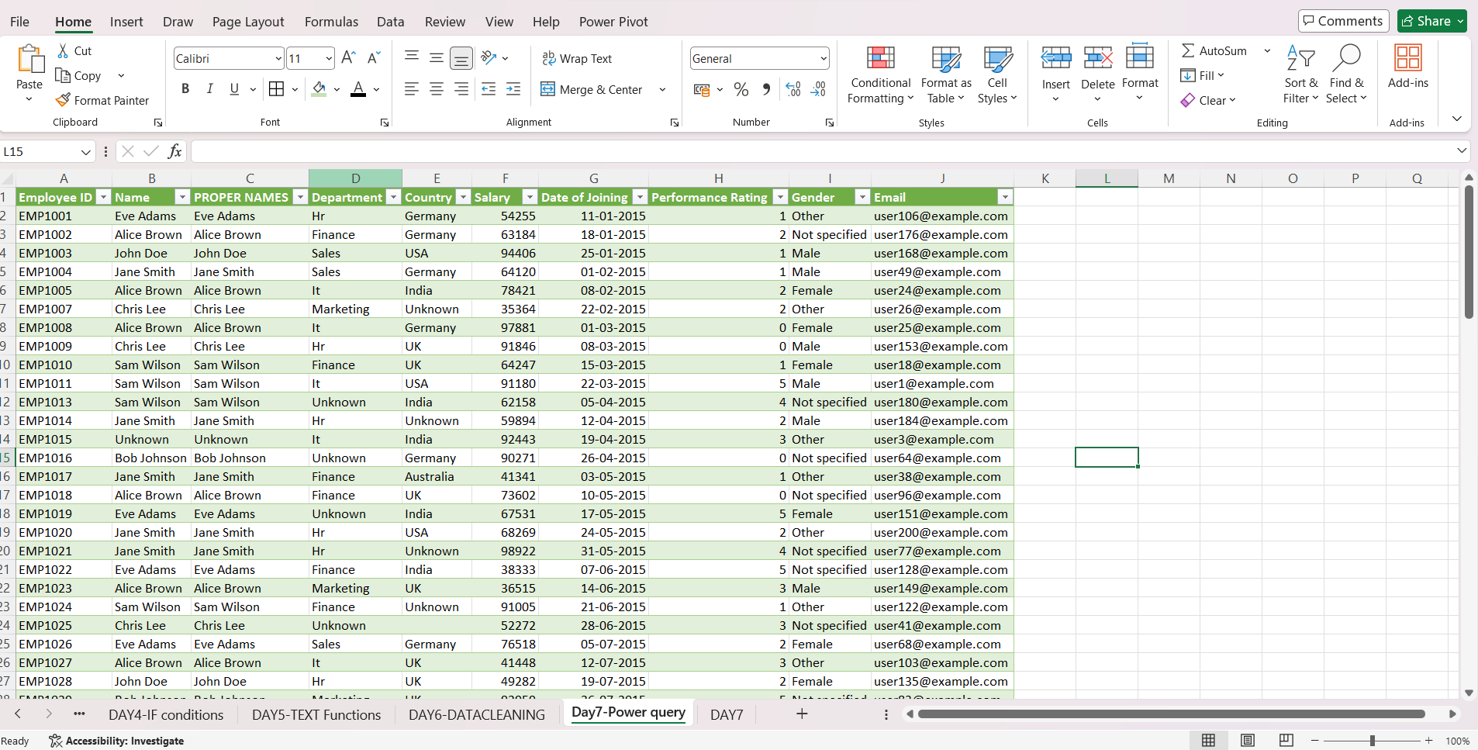
The dataset was loaded into Power Query using the “From Table/Range” option. Data cleaning operations such as replacing missing values, correcting invalid entries, trimming extra spaces, and standardizing text were performed within the Power Query Editor. Duplicate values were also handled. The cleaned dataset was then loaded back into Excel using the “Close & Load” option.

Day 8 – Handling Inconsistent Data

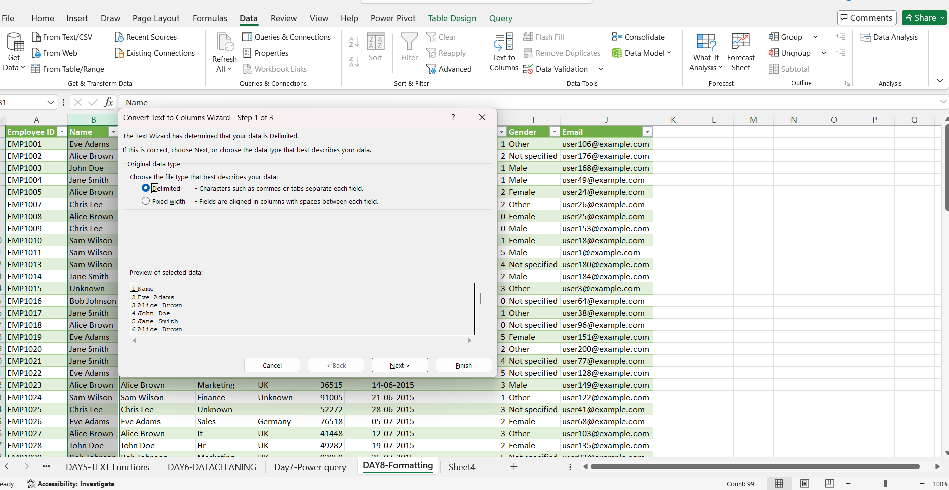
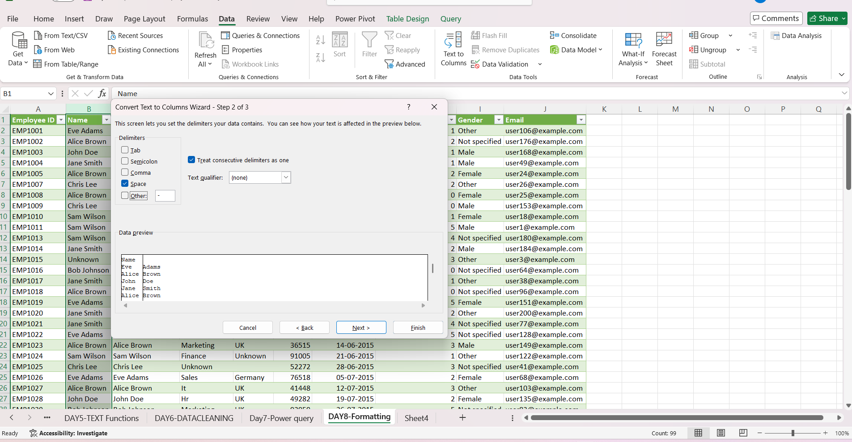

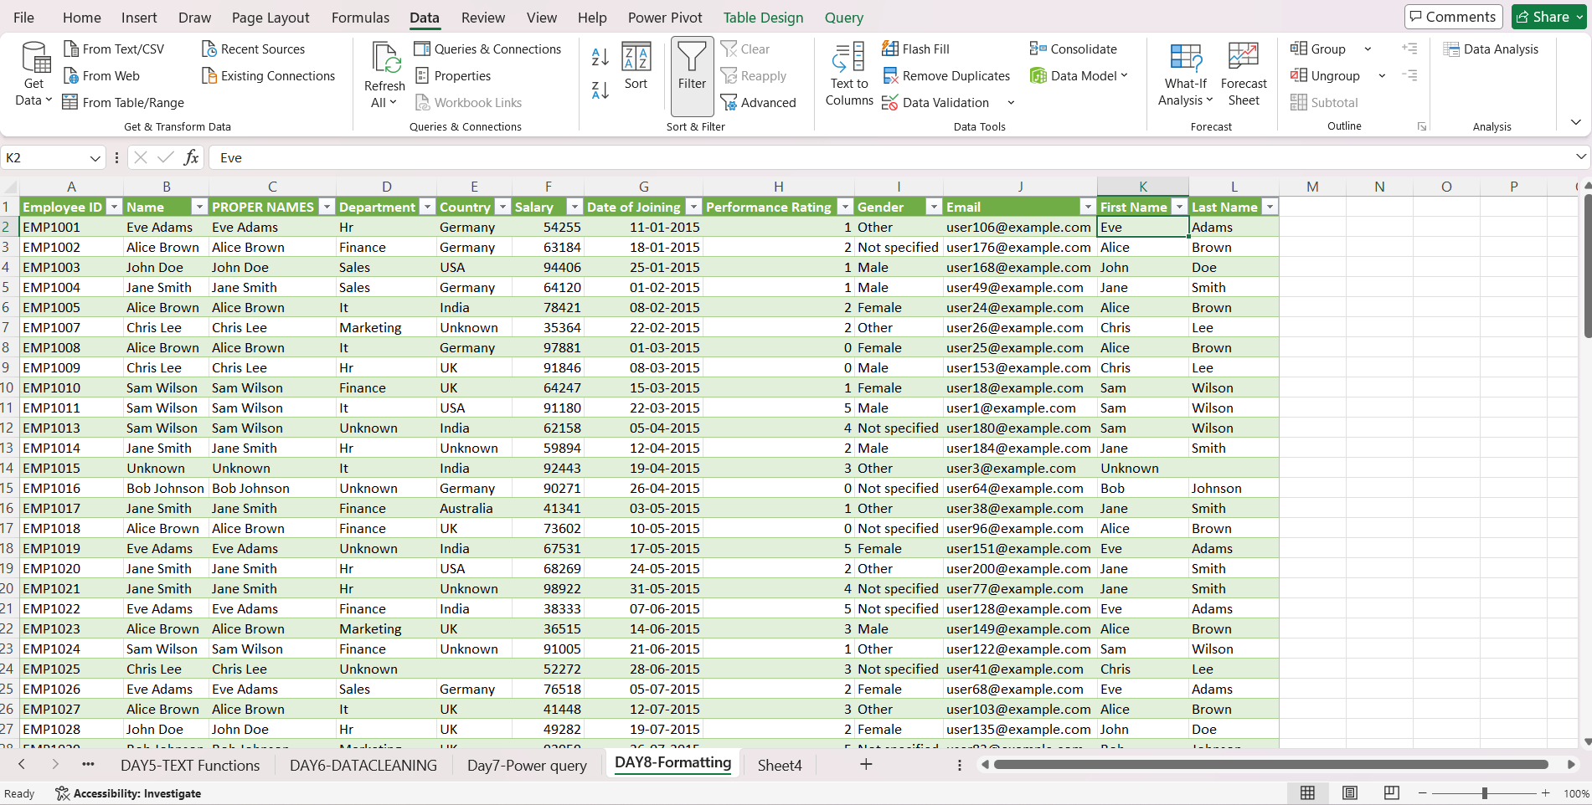
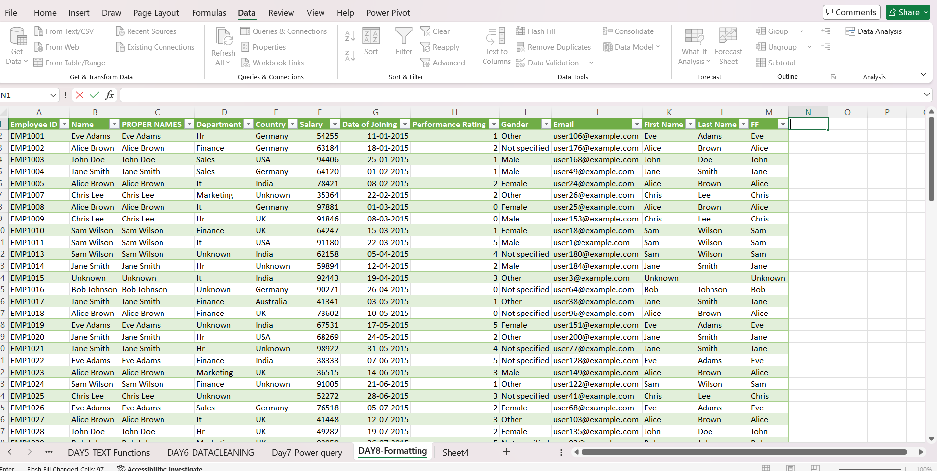
Inconsistent text data was handled using Text-to-Columns, Flash Fill, and TRIM functions. The Name column was split into First Name and Last Name using Text-to-Columns and Flash Fill. TRIM was used to remove extra spaces, ensuring clean and structured data for analysis.

Day 9 – Conditional Formatting for Data Cleaning
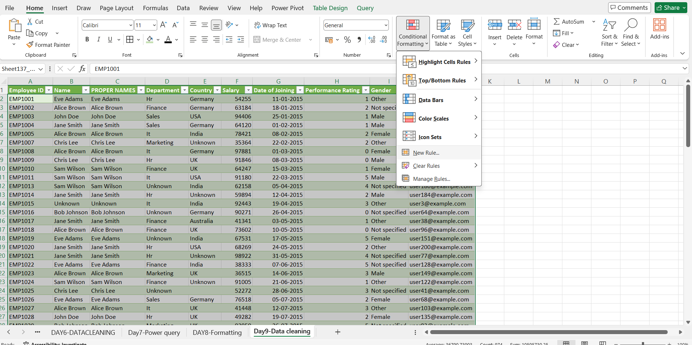
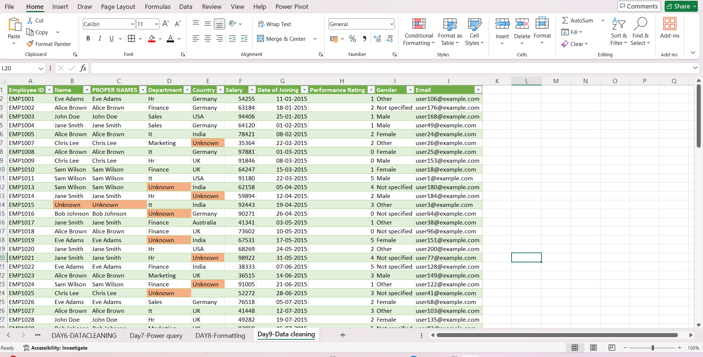
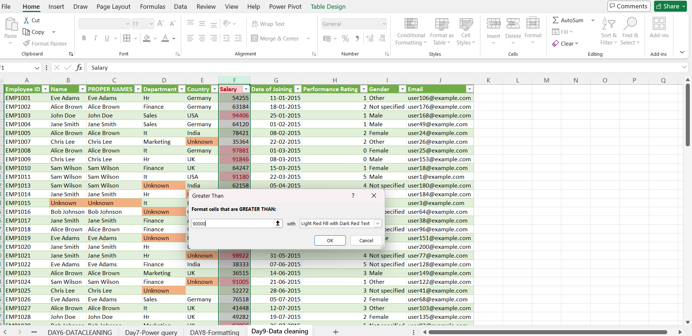
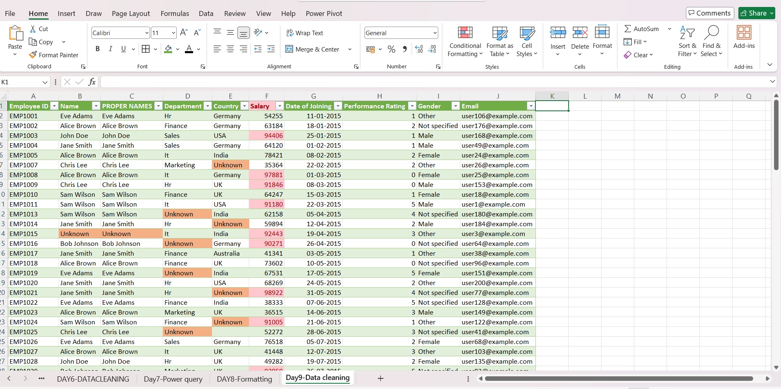
Conditional formatting was applied to visually identify data issues. Missing values were highlighted using a custom rule and outliers such as high were highlighted using conditional rules. This helped in quickly identifying and analysing inconsistencies in the dataset.

Day 10 – Descriptive Statistics
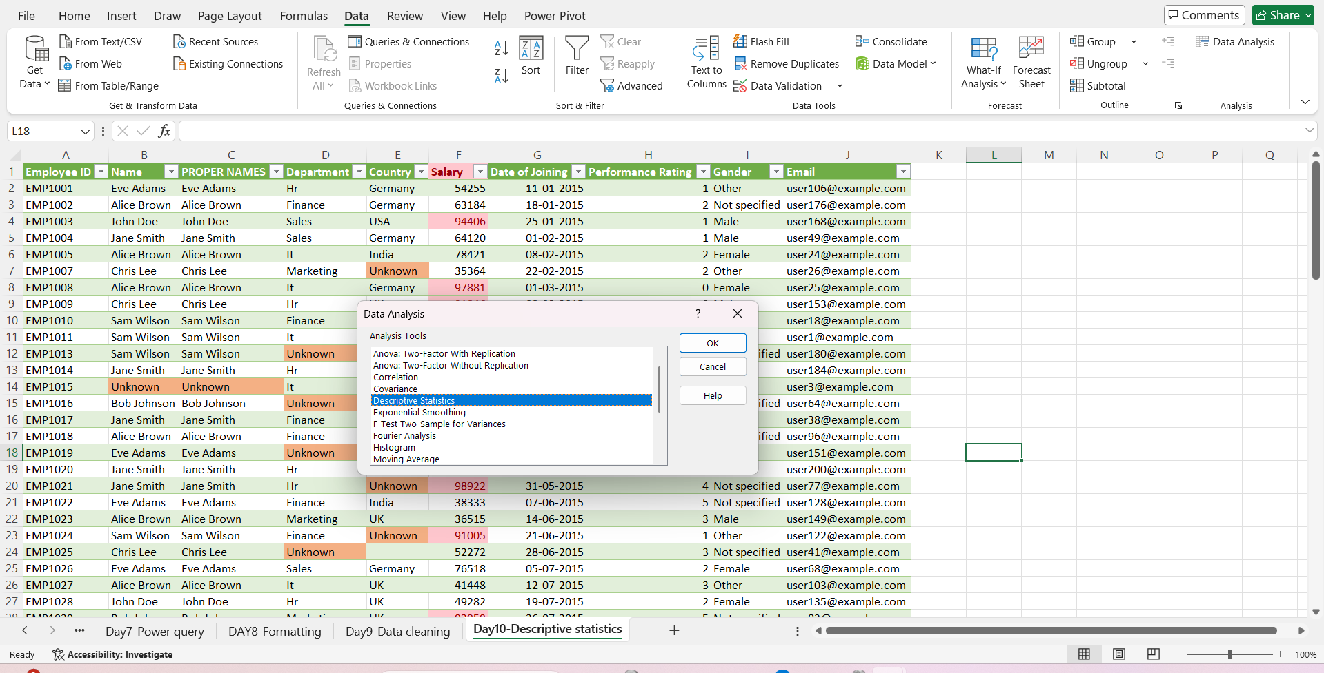
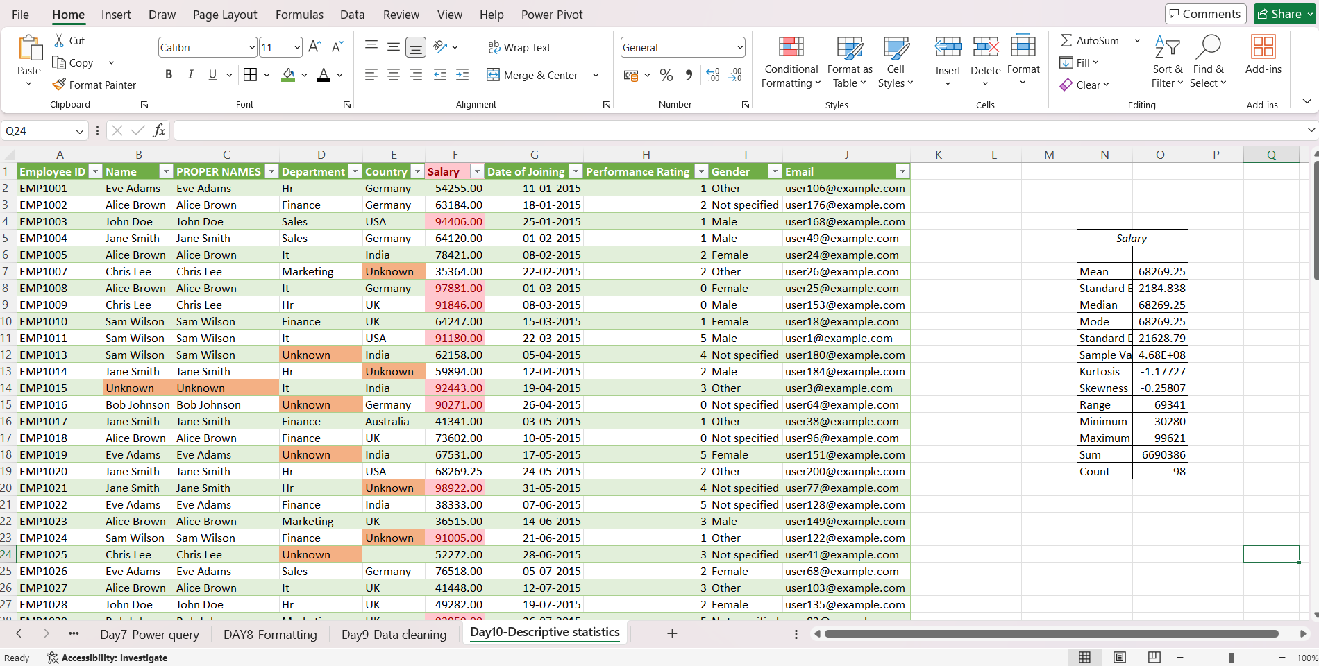
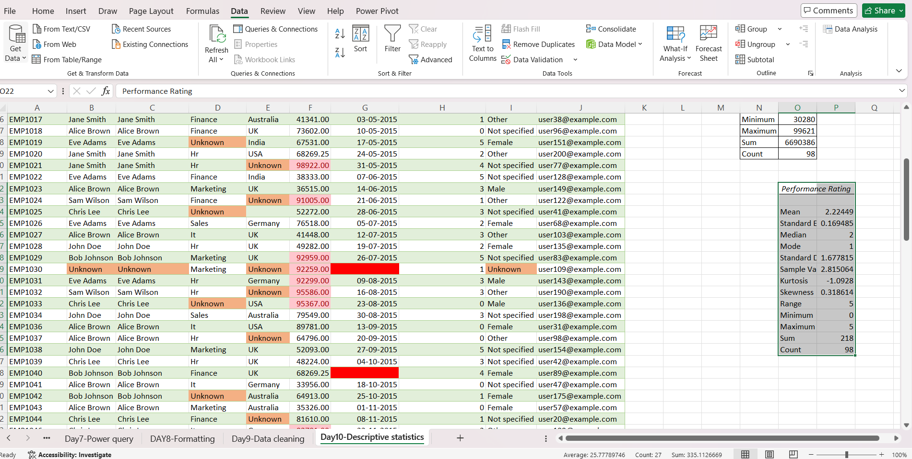
Descriptive statistics were generated using the Analysis ToolPak. Measures such as mean, median, and standard deviation were calculated for numerical columns like Salary and Performance Rating . These statistics help in understanding the distribution and variability of the data.

Day 11 – Filtering, Sorting & Exploring Data 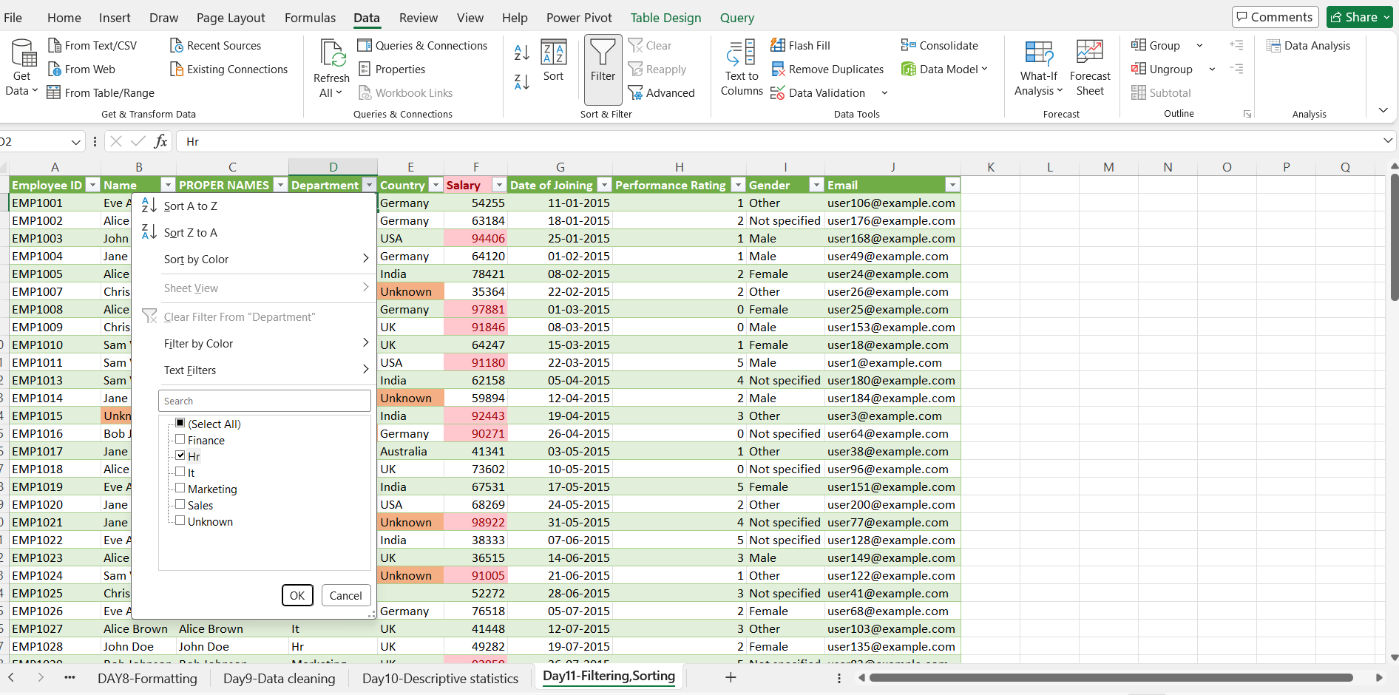
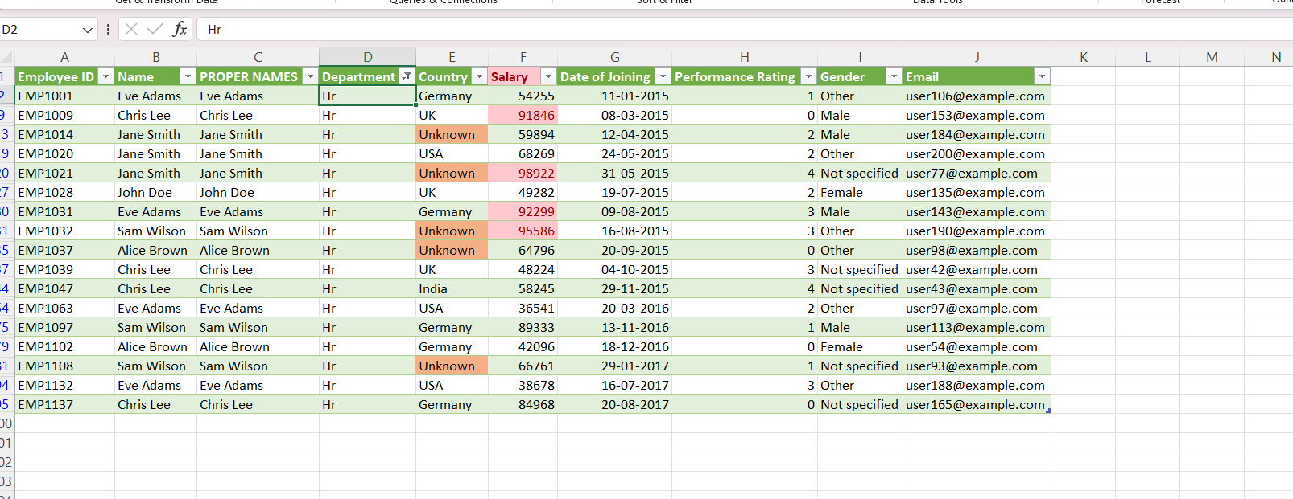
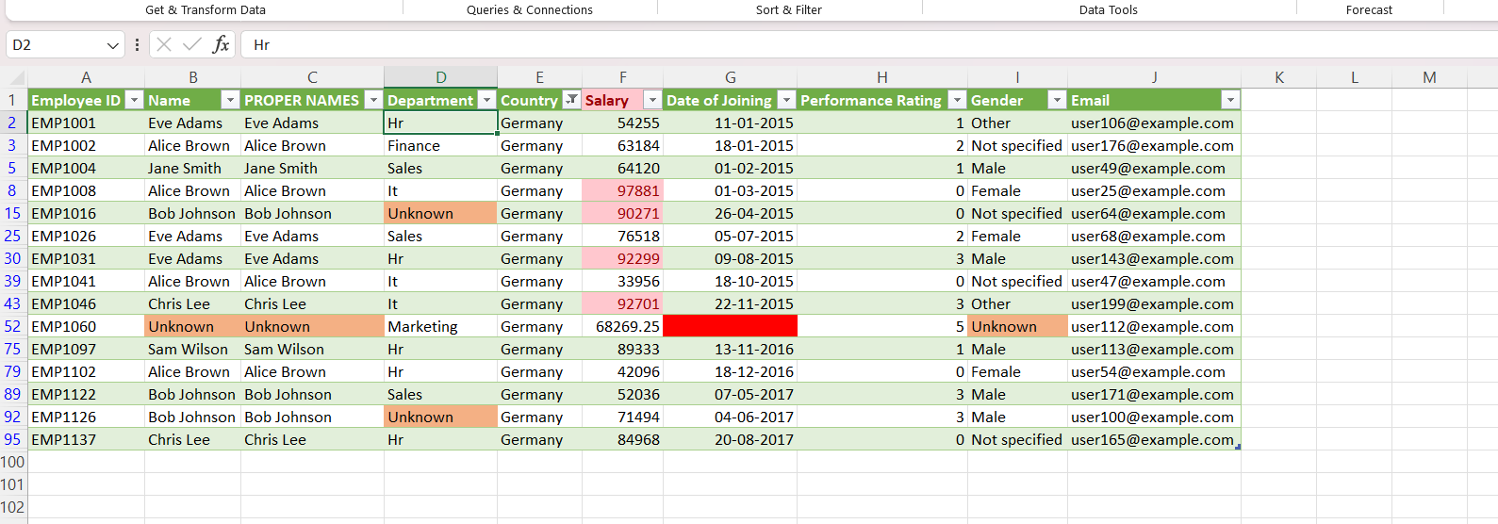
Filter:Country-Germany
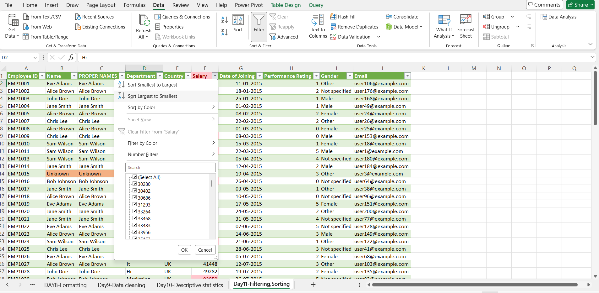
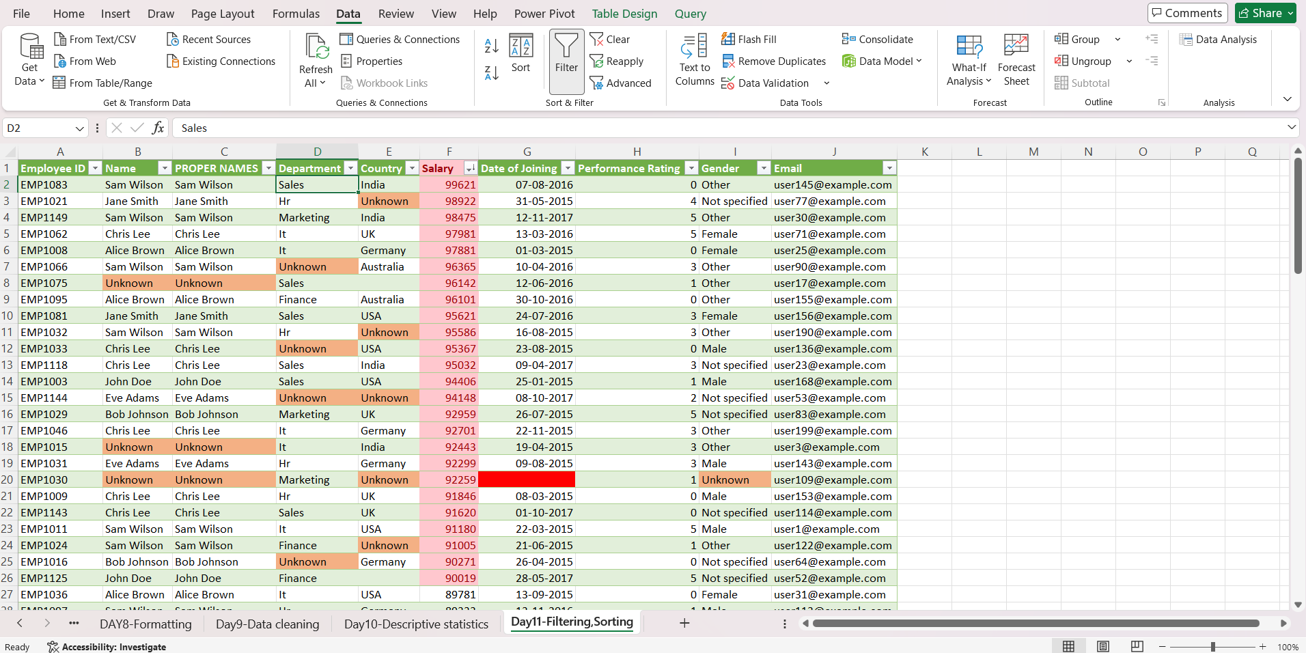
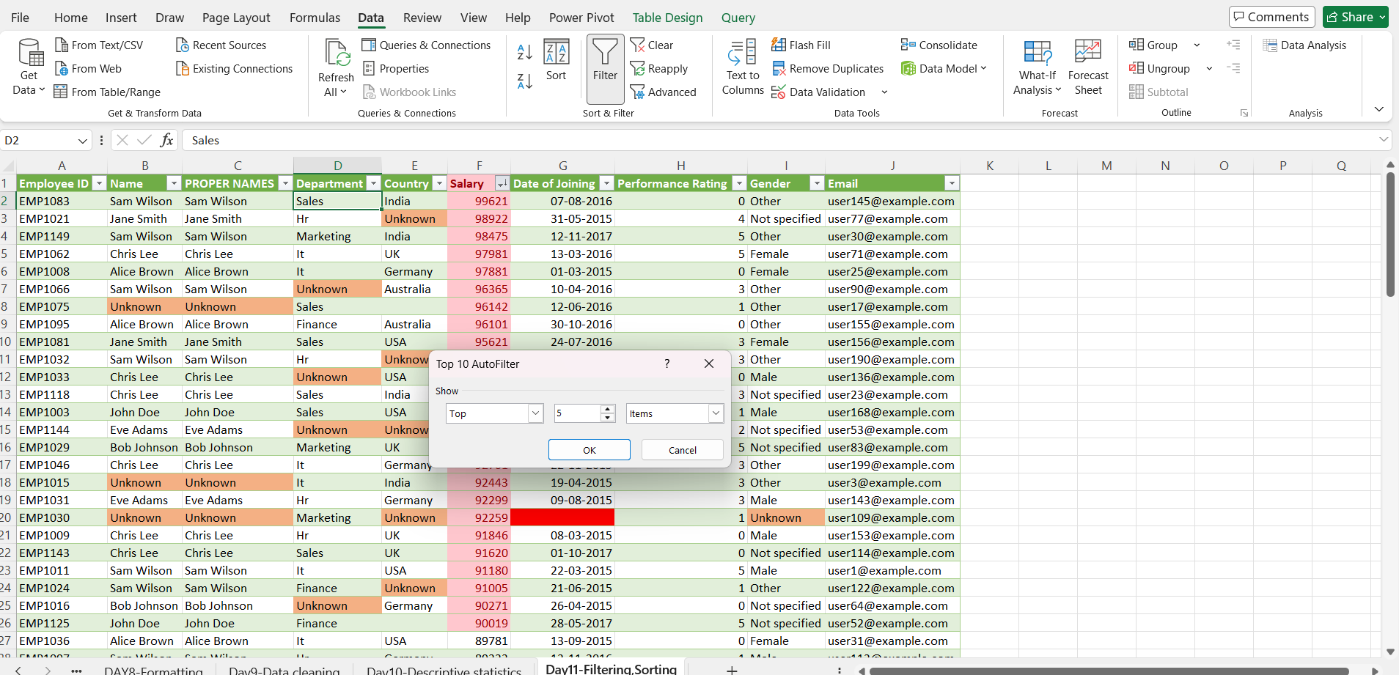
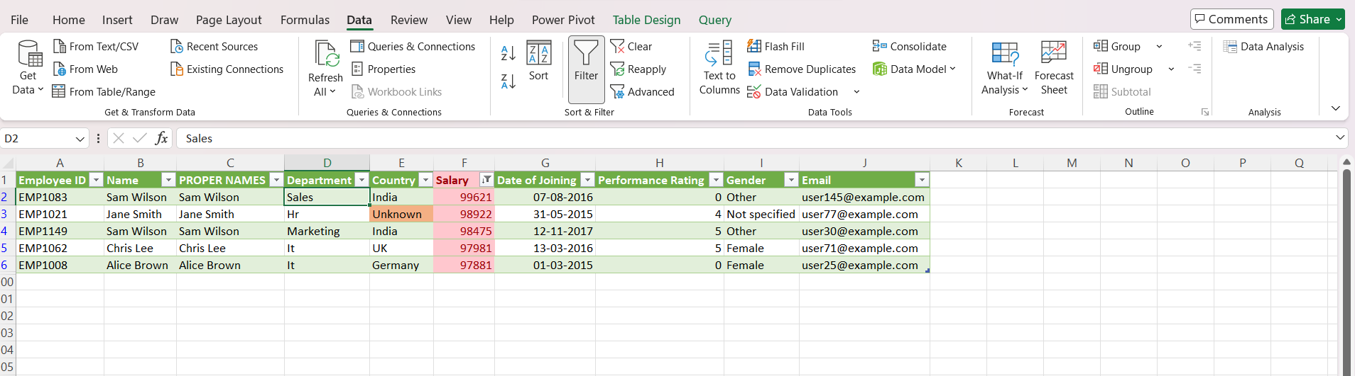
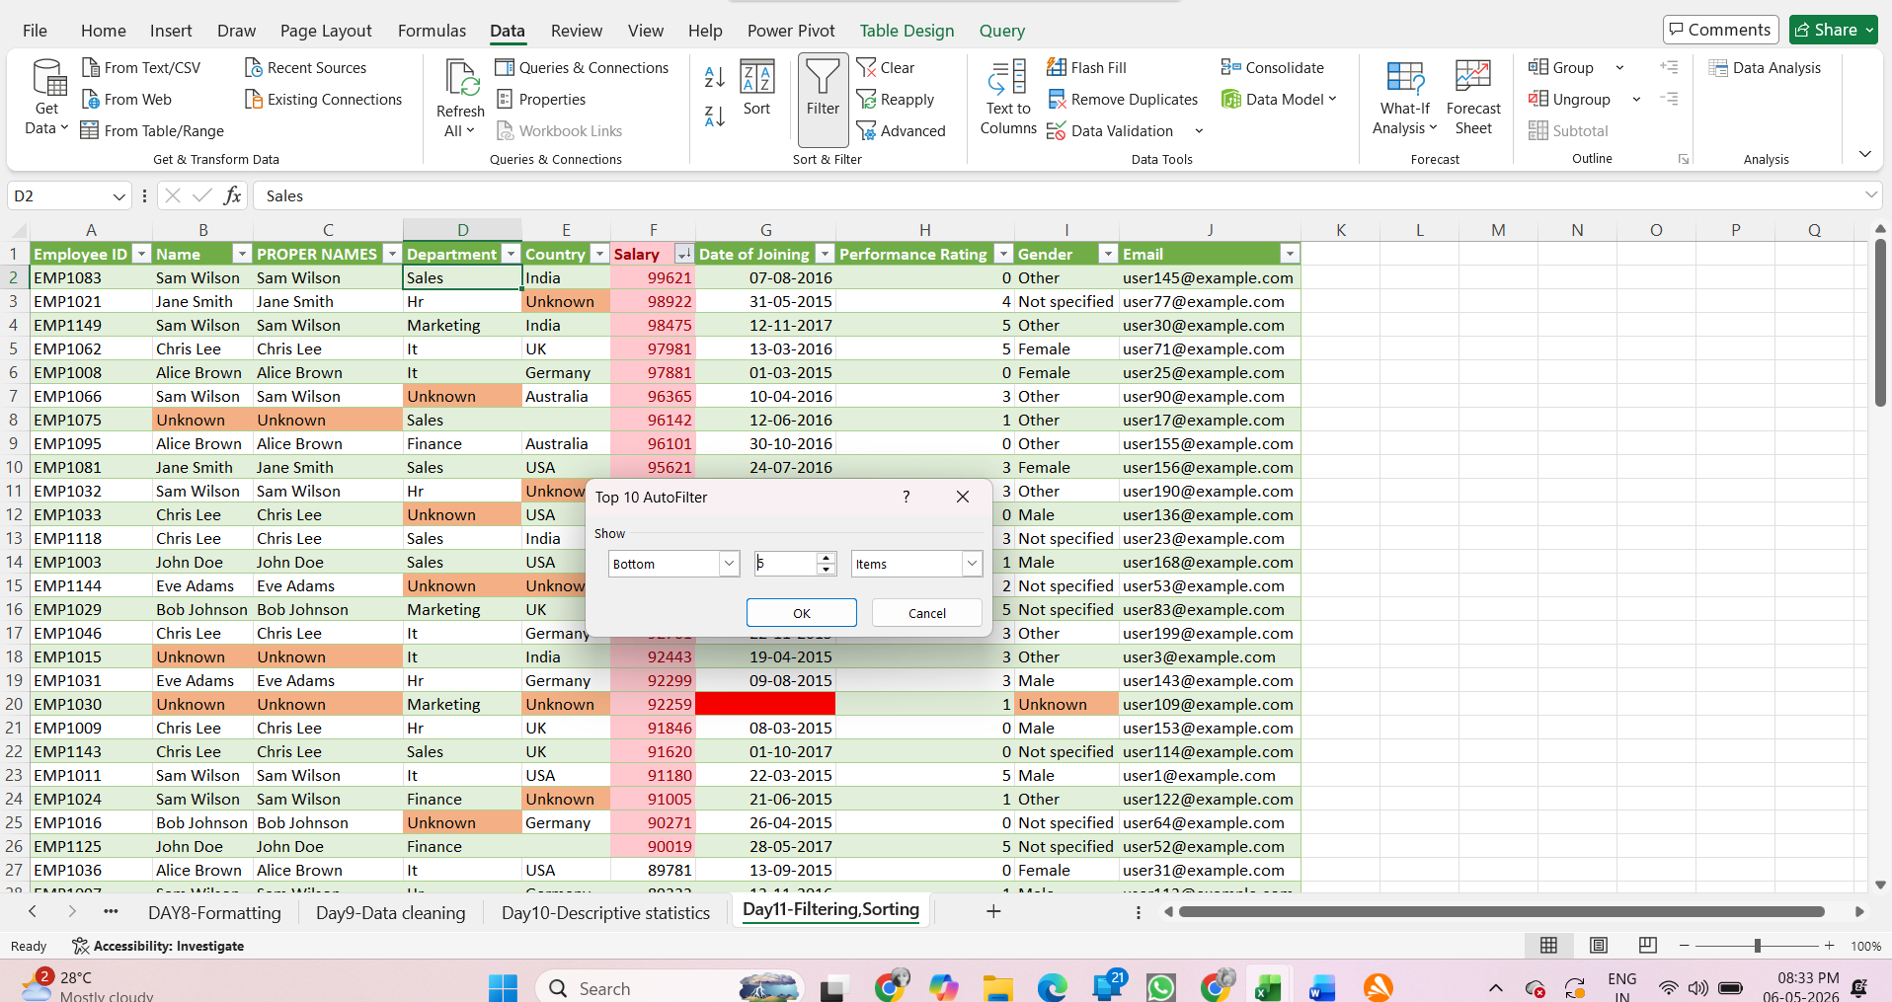
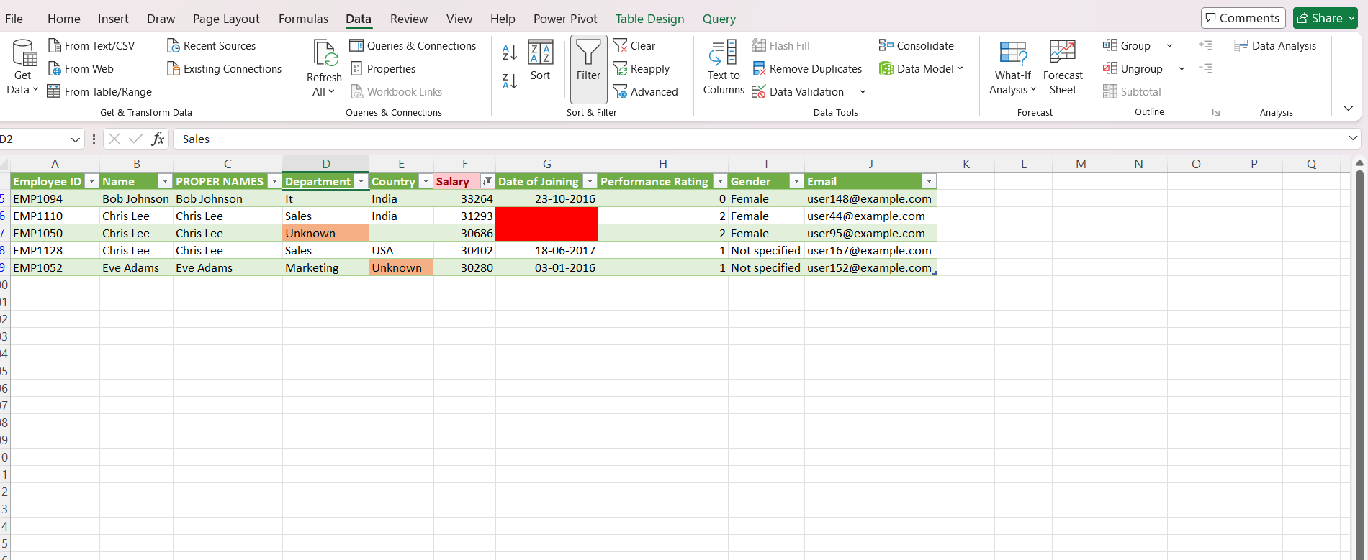
Filtering and sorting techniques were applied to explore the dataset. Multiple filters were used to analyze specific groups based on department and country. The Salary column was sorted to identify the top 5 and bottom 5 earning employees.
It was observed that higher salaries were concentrated in certain departments. Filtering helped in understanding patterns across different categories.

Day 12 – Date & Time Functions
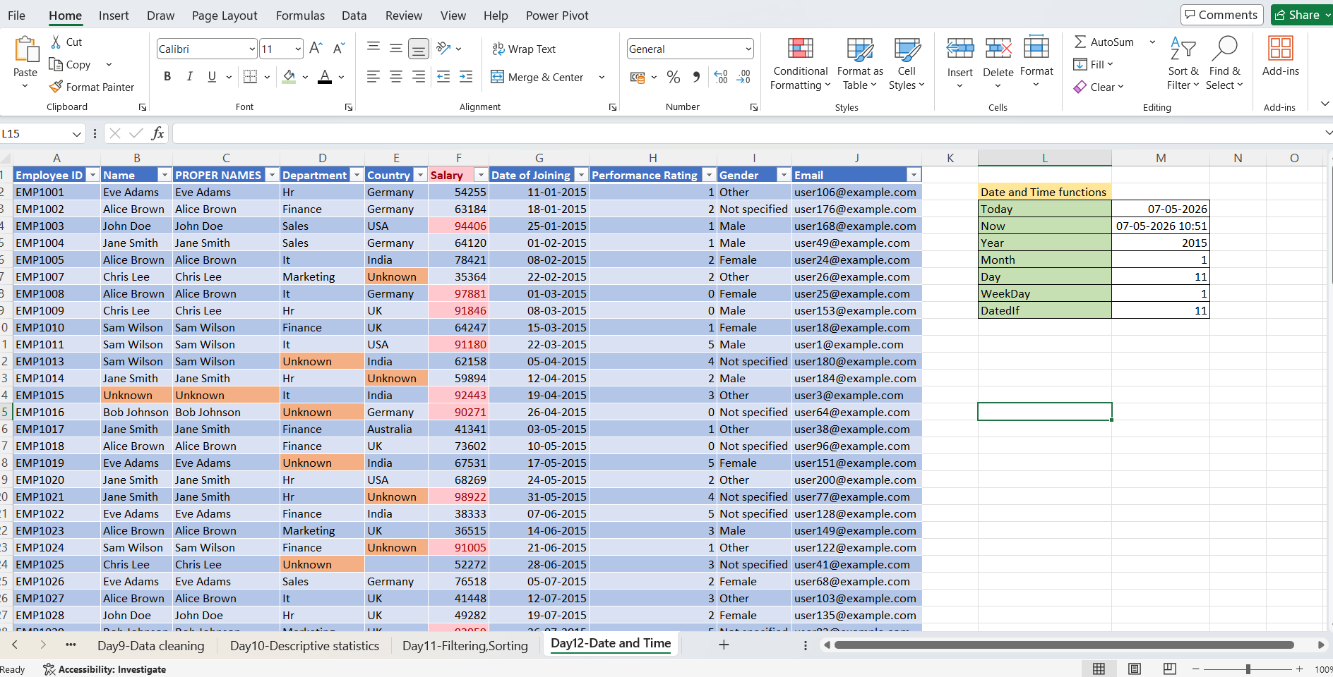
Date and time functions such as TODAY(), NOW(), YEAR(), MONTH(), WEEKDAY(), and DATEDIF() were used to analyze date-related data. The Date of Joining column was used to calculate employee experience in years using the DATEDIF function.

Day 13 – Lookup & Reference Functions (Part 1)
Use: VLOOKUP()
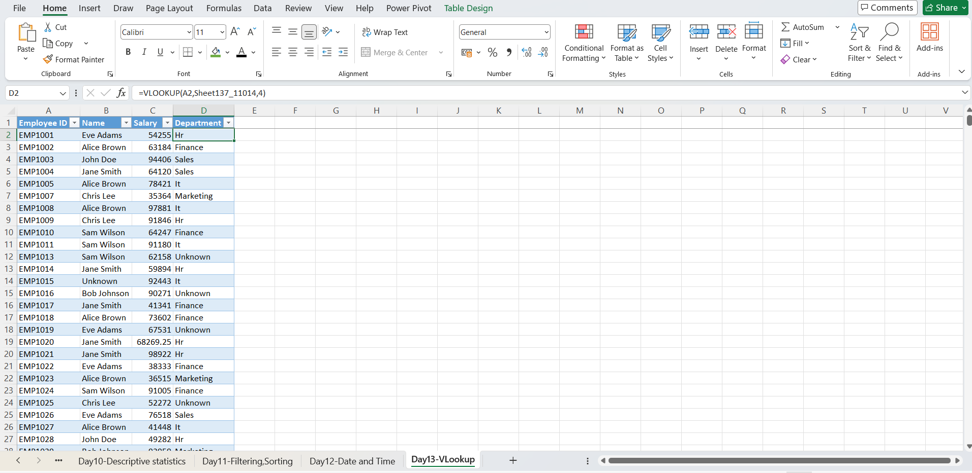
The VLOOKUP() function was used to duplicate the dataset by retrieving employee details from the original table based on Employee ID. Different columns such as Name, Department, and Salary were fetched using column index numbers and exact match lookup. This helped in understanding lookup and reference operations in Excel.

Day 14 – INDEX(), MATCH()
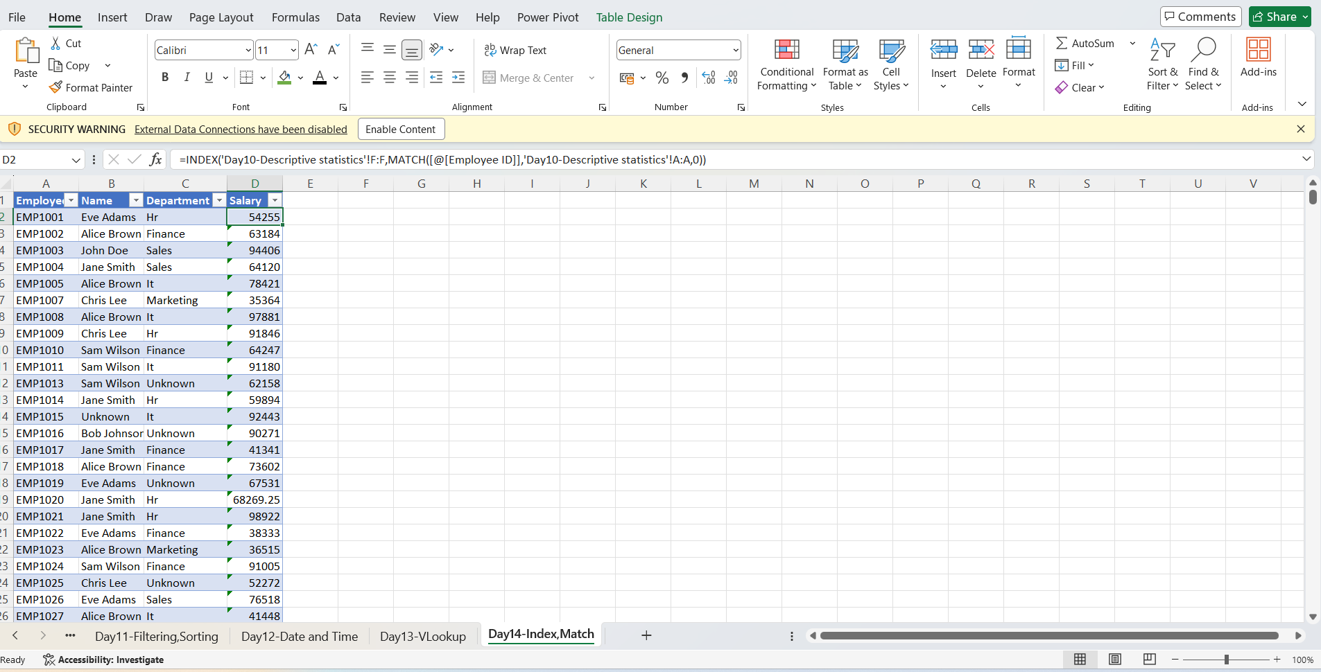
The INDEX() and MATCH() functions were used together to retrieve related data from another table based on Employee ID. MATCH() was used to locate the position of the Employee ID in the lookup table, and INDEX() returned the corresponding value from the required column such as Salary. This method helped in understanding advanced lookup techniques and is more flexible than VLOOKUP() because it can search in any direction.

Day 15 – Pivot Tables (Part 1)
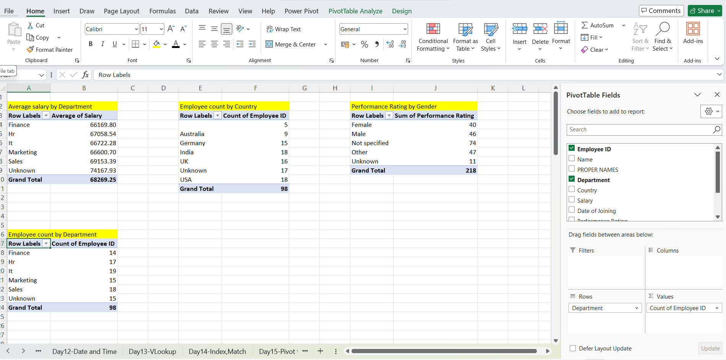
Pivot Tables were created to summarize and analyze employee data efficiently. Average Salary by Department, Employee Count by Country, and Average Performance Rating by Gender were calculated using PivotTables. This helped in identifying patterns and comparing data categories easily.

Day 16 – Pivot Tables (Part 2)
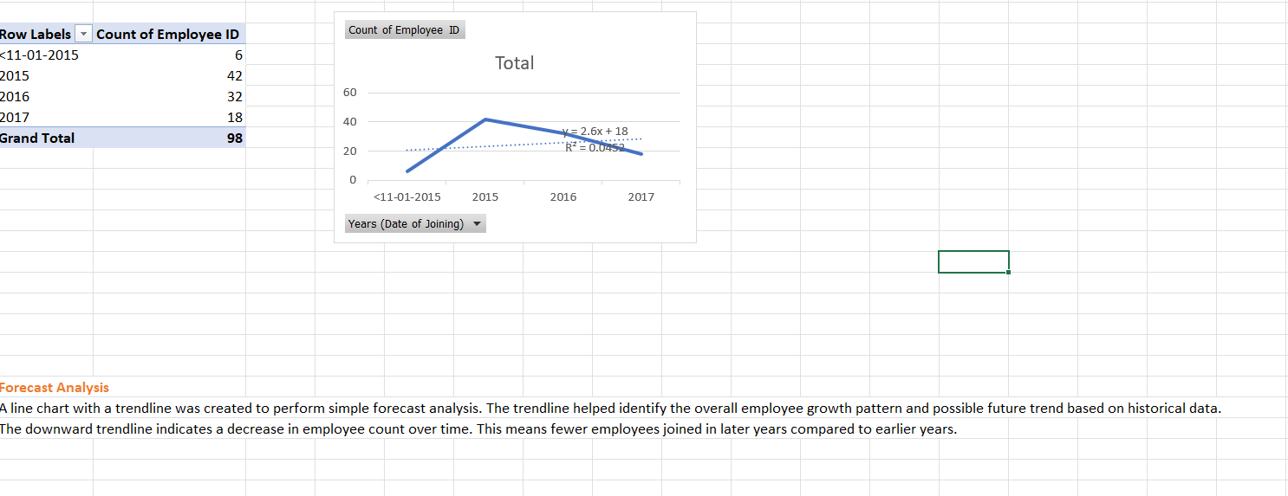
1. Descriptive Analysis
Descriptive analysis explains what happened in the dataset. Using PivotTables, the employee count by year and average salary by department were identified. The analysis showed that employee count decreased over the years and some departments had higher average salaries than others.
2. Diagnostic Analysis
Diagnostic analysis explains why something happened. From the PivotTable insights, it was observed that employee hiring reduced in later years, which caused the downward trend in employee count. Salary differences between departments may indicate variation in job roles and responsibilities.
3. Predictive Analysis
Predictive analysis helps forecast future trends based on historical data. Using a line chart with a trendline, the employee growth pattern was analyzed. The downward trendline predicts that employee count may continue to decrease in future years if the same trend continues.
4. Prescriptive Analysis
Prescriptive analysis suggests actions to improve future outcomes. Based on the insights, the company may improve hiring strategies, employee retention, and departmental performance to prevent further decline in employee count and maintain organizational growth.

Day 17-20-Pivot table and Dashboard Creation
A one-page interactive dashboard was created using PivotTables, PivotCharts, KPI cards, slicers, and trend analysis. The dashboard summarized employee distribution, salary analysis, performance insights, and hiring trends. Quick Analysis and AI-assisted Excel tools were explored to generate charts, formulas, and insights efficiently. The dashboard was designed with interactive filters and professional formatting to improve data visualization and storytelling.

Final Dashboard:
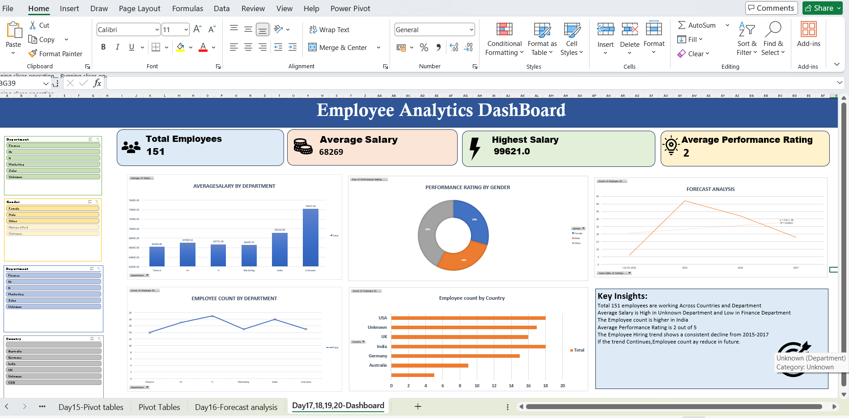
- PivotCharts were created directly from PivotTables using:Insert → PivotChart
- The PivotChart automatically linked with the PivotTable data.
- Any changes made in the PivotTable were dynamically reflected in the PivotChart.
- Different chart types such as Column, Pie, Line, and Combo charts were used for better visualization of insights.
- Departments with higher average salaries were identified.
- Employee distribution across countries and genders was analyzed.
- Hiring trends over different years were visualized using line charts and trendlines.
- Performance ratings helped identify top-performing employee groups.
- Missing and inconsistent values were cleaned to improve data quality and reporting accuracy.
- KPI cards were created to display important metrics such as:
- Total Employees
- Average Salary
- Highest Salary
- Average Performance Rating
- Interactive slicers were added for filtering data by Department, Gender, and Country.
- Charts and PivotTables were arranged systematically to improve storytelling and readability.
- Consistent formatting, colors, titles, and alignment were used to make the dashboard professional and presentation-ready.

Formulas Used:
COUNT() | Count numerical values

COUNTA() | Count non-empty cells

COUNTIF() | Count based on condition

SUMIF() | Calculate sum based on condition

AVERAGEIF() | Calculate average based on condition

IF() | Apply logical conditions

LEFT() | Extract characters from left

TRIM() | Remove extra spaces

PROPER() | Convert text into proper case

YEAR() | Extract year from joining date

INDEX() + MATCH() | Lookup and retrieve values

DATEDIF() | Calculate date differences

MAX() | Find highest value

MIN() | Find lowest value

