**WEEK-5_MICROSERVICES  
SUPERSET ID:6393676**

**Create Eureka Discovery Server and register microservices**

**SOLUTION:**

**EurekaDiscoveryServerApplication.java**

package com.cognizant;

import org.springframework.boot.SpringApplication;

import org.springframework.boot.autoconfigure.SpringBootApplication;

import org.springframework.cloud.netflix.eureka.server.EnableEurekaServer;

@SpringBootApplication

@EnableEurekaServer

public class EurekaDiscoveryServerApplication {

public static void main(String[] args) {

SpringApplication.run(EurekaDiscoveryServerApplication.class, args);

}

}

**application.properties**

server.port=8761

eureka.client.register-with-eureka=false

eureka.client.fetch-registry=false

logging.level.com.netflix.eureka=OFF

logging.level.com.netflix.discovery=OFF

**AccountApplication.java**

package com.cognizant.account;

import org.springframework.boot.SpringApplication;

import org.springframework.boot.autoconfigure.SpringBootApplication;

import org.springframework.cloud.client.discovery.EnableDiscoveryClient;

@SpringBootApplication

@EnableDiscoveryClient

public class AccountApplication {

public static void main(String[] args) {

SpringApplication.run(AccountApplication.class, args);

}

}

**AccountController.java**

@RestController

@RequestMapping("/account")

public class AccountController {

@GetMapping("/info")

public String getInfo() {

return "Account Service is up";

}

}

**application.properties**

server.port=8081

spring.application.name=account-service

eureka.client.service-url.defaultZone=http://localhost:8761/eureka

OUTPUT:

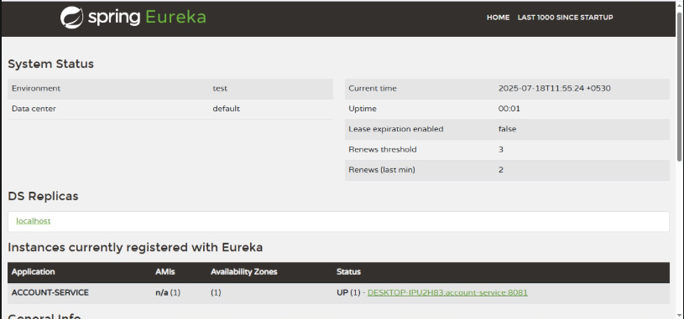

**Loan Controller.java**

@RestController

@RequestMapping("/loan")

public class LoanController {

@GetMapping("/info")

public String getInfo() {

return "Loan Service is up";

}

}

**LoanApplication.java**

package com.cognizant.loan;

import org.springframework.boot.SpringApplication;

import org.springframework.boot.autoconfigure.SpringBootApplication;

import org.springframework.cloud.client.discovery.EnableDiscoveryClient;

@SpringBootApplication

@EnableDiscoveryClient

public class LoanApplication {

public static void main(String[] args) {

SpringApplication.run(LoanApplication.class, args);

}

}

**application.properties**

server.port=8082

spring.application.name=loan-service

eureka.client.service-url.defaultZone=http://localhost:8761/eureka

**OUTPUT:**

