**Test Driven Development for Ansible using Ansible_spec Utility**

**TDD**:

|  |
| --- |
| Test-driven development (TDD) is an evolutionary approach to development which combines test-first development where we write a test case before we write just enough production code to fulfill that test and [refactoring](http://www.agiledata.org/essays/databaseRefactoring.html) |

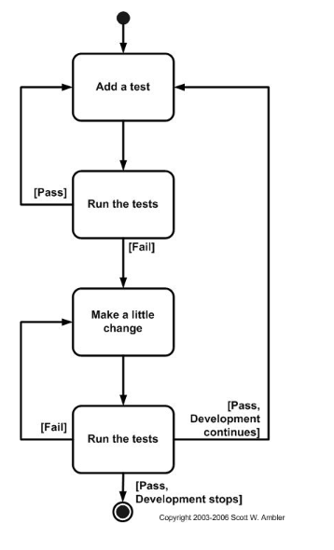

**Ansible_spec:**

It's ruby gem that connect Ansible & Serverspec for Test Driven Server Configuration (or TDD).

This is a Ruby gem that implements an Ansible Config Parser for Serverspec. It creates a Rake task that can run tests, using Ansible inventory files and playbooks. You can test multiple roles and multiple hosts.

**Installation**

$ gem install ansible_spec

Create Rakefile & spec/spec_helper.rb

$ ansiblespec-init

create spec

create spec/spec_helper.rb

create Rakefile

create .ansiblespec

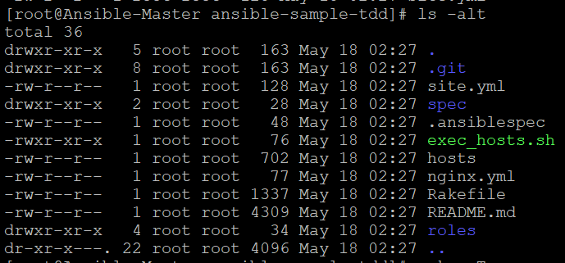

By default, site.yml will be used as the playbook and hosts as the inventory file. You can either follow these conventions or you can customize the playbook and inventory using an .ansiblespec file.

SITE.YML:

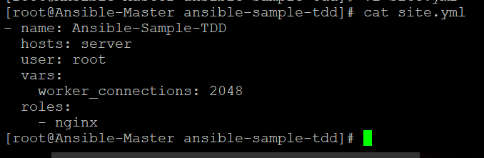

IVENTORIES.YML

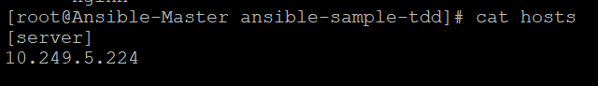

Run Test

After writing the test scenarios, we can run the test using ansible_spec. Since the actual functionality is not yet implemented, the following commands will throw errors.

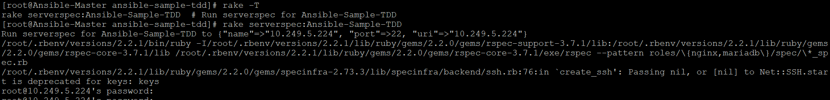

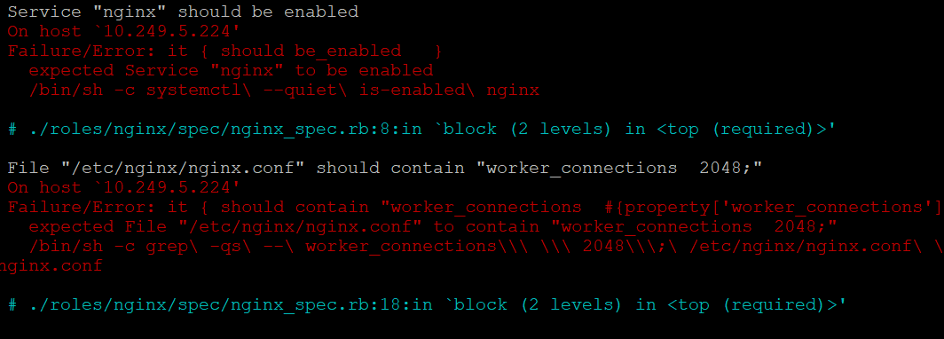

Make changes on remote machine in the nginx.cfg file & enable the nginx service.

RUN TEST CASE:

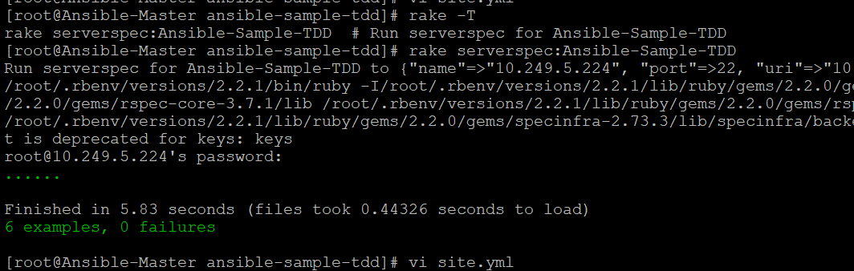

It started working, now test case is successful. Now this TDD can be used in production implementation.