**Deploy IIS Web server using Ansible scripts on Windows**

**Created Simple HTML file and deploy using Ansible**

Created playbooks and installed dependences.

To execute windows cmds in master, worker must have winrm module installed on master machine. Connection should thru wsinmr …

Hosts file includes IP address of client machine

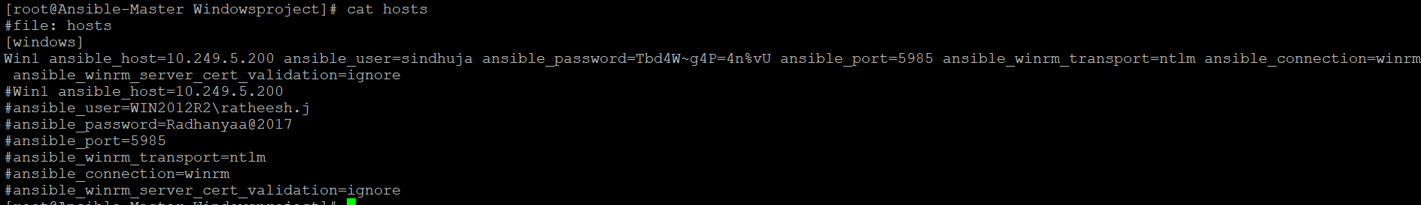

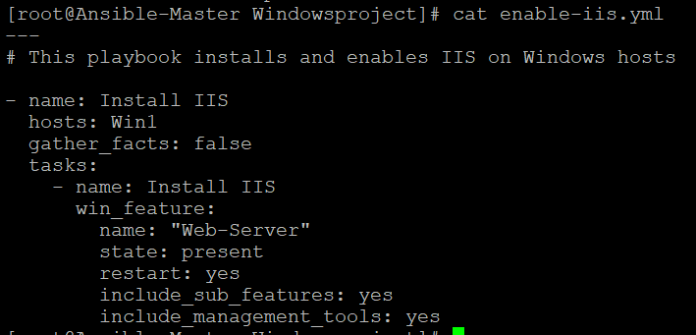

Enable-iis install IIS and enable IIS on windows hosts using winrm and win copy module.

Present – activate the IIS service (install and start)

Restart – already installed, it will restart

Include sub feauture: it will not impact already running service.

Manage tools: start stop, restart – management level configuration.

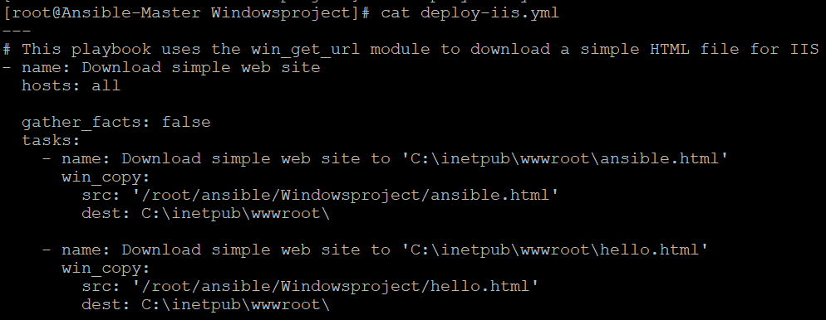

Deploy-IIS – download URL and put to destination, download the html file and place to the destination. So default page will appear.

**Executing Ansible playbook:**

Ansible-playbook –i hosts enable-iis.yml

Ansible-playbook –i hosts deploy-iis.yml

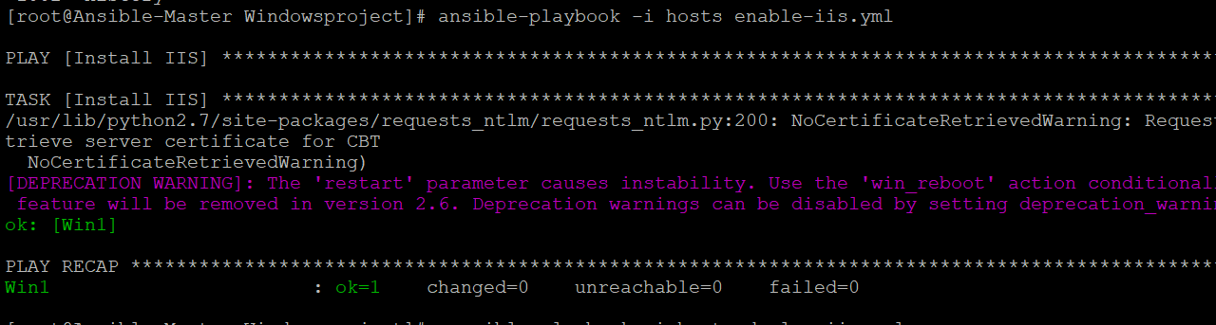

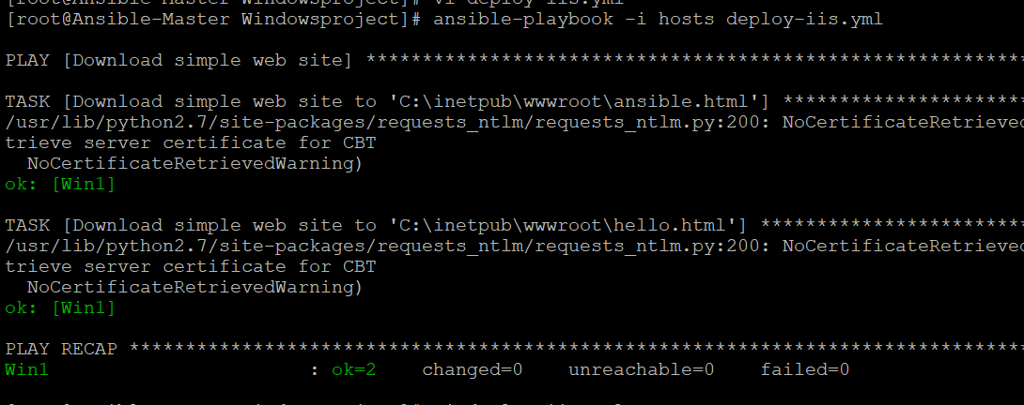

Deployed Ansible.html page on IIS using Ansible.

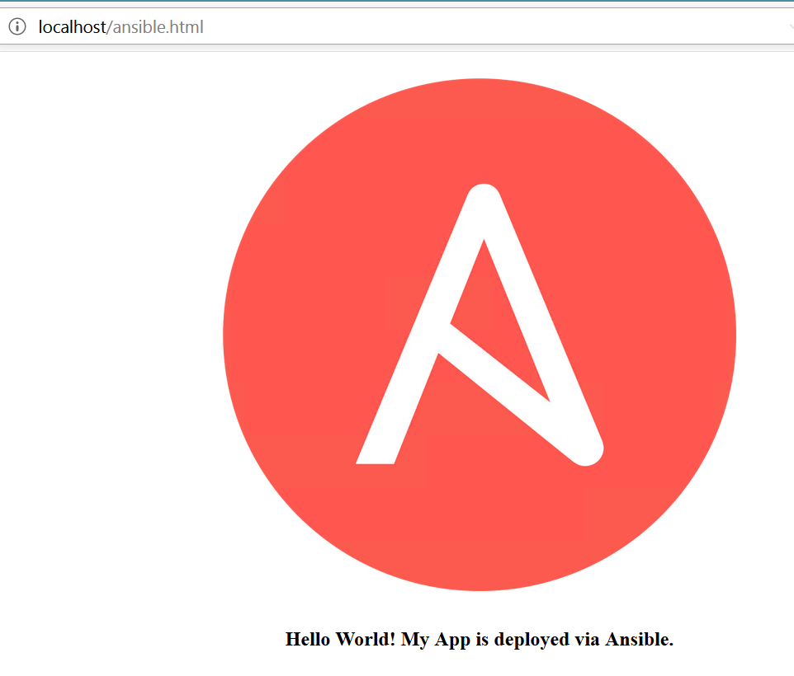

Deployed Hello.html page on IIS using Ansible.

