**Meeting Room Booking Room**

**Purpose:** The purpose of this document is to show structure of the database and the screens of the application that is developed using ASP.net MVC.

Created below two tables in SQL server:

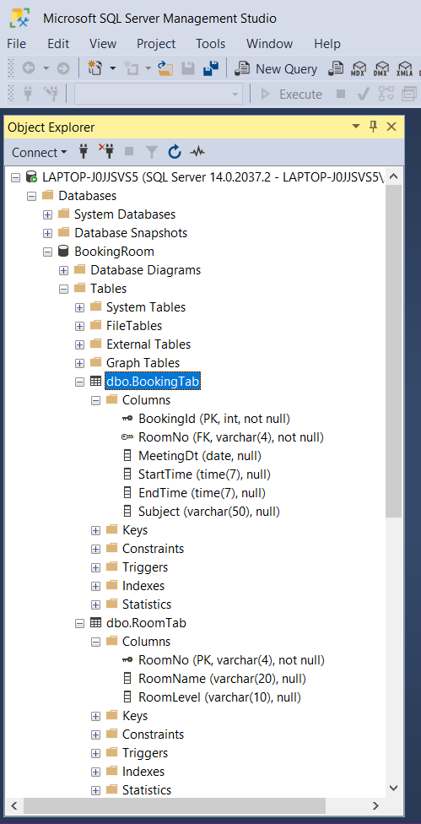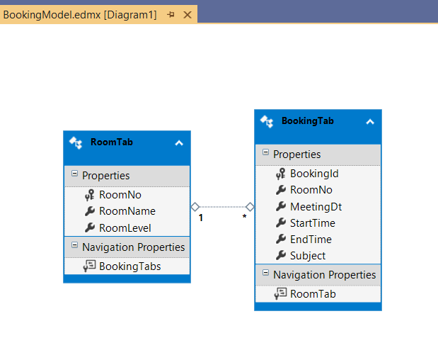

Execute Meeting Room Booking System, the below home page is displayed.

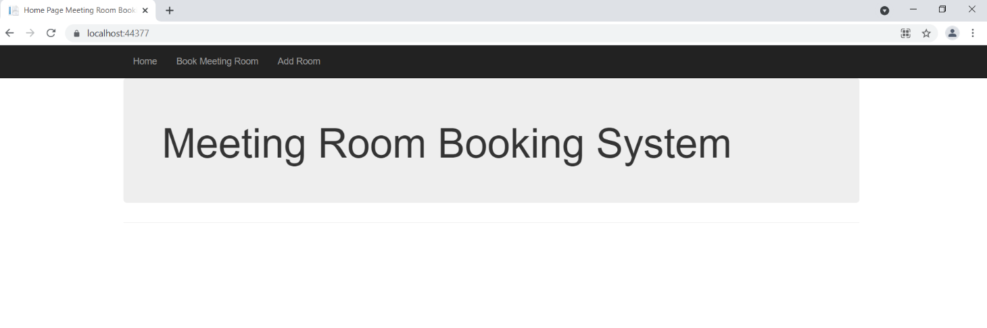

Click on Book Meeting Room Tab beside Home tab, the below booking details are displayed.

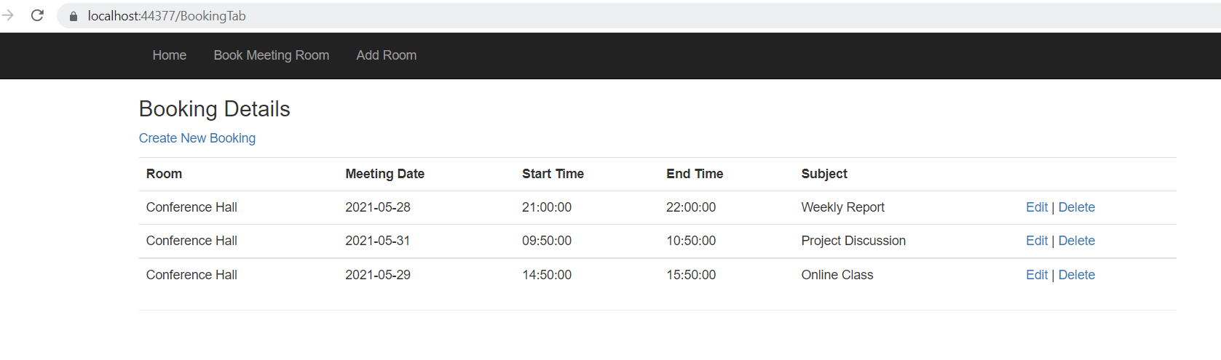

Click on Create New Booking, the below screen is displayed to book meeting room.

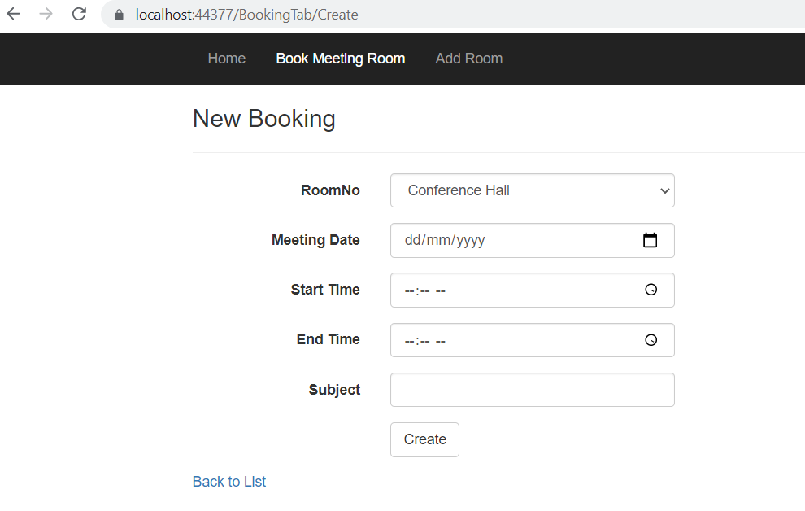

Click on Edit for first record to change the booking, the below error message is displayed. Past dated bookings cannot be changed.

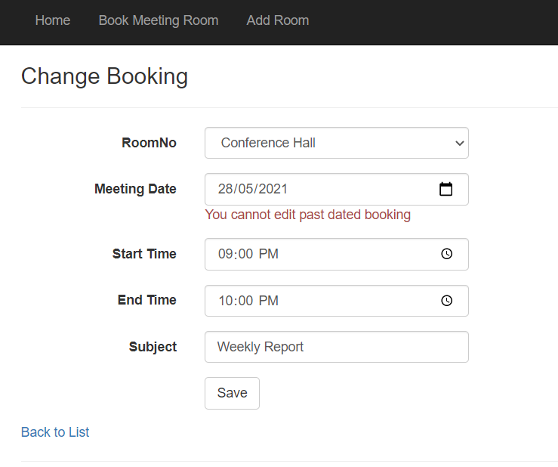

Click on Delete button, the below screen is displayed to delete booking.

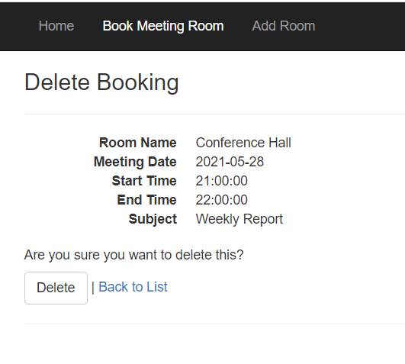

Click on Create New Booking and then click on Create button without any data, the below validations are done

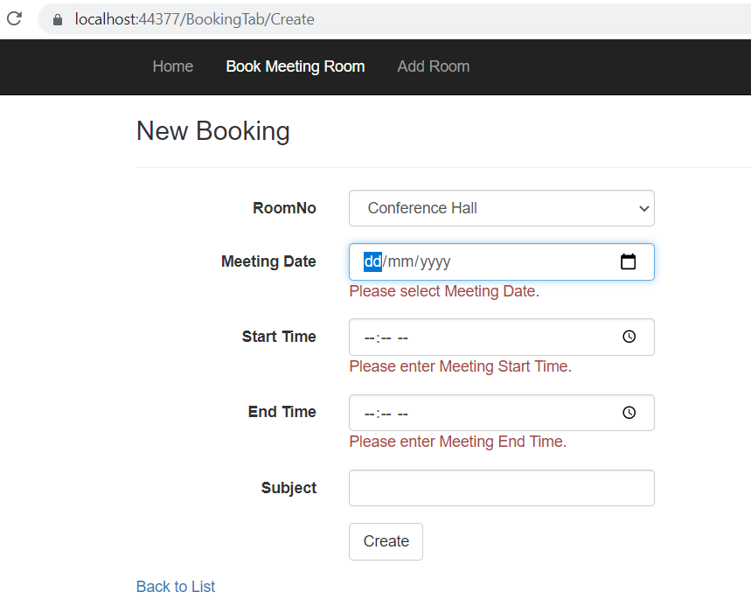

Enter start time which is after end time, the below error message is thrown.

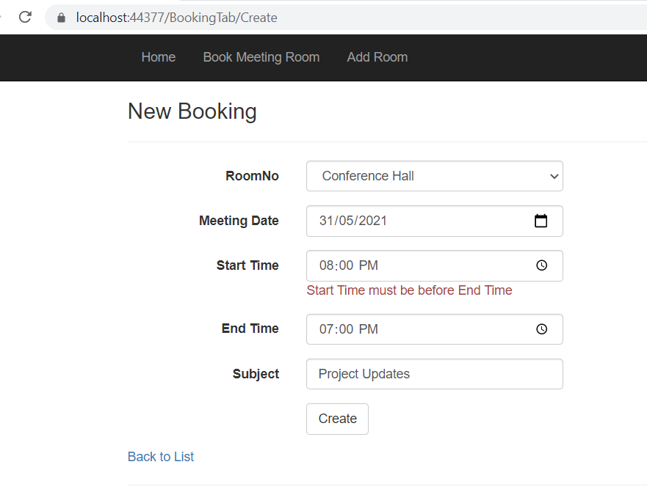

New booking is added to the list as highlighted below.

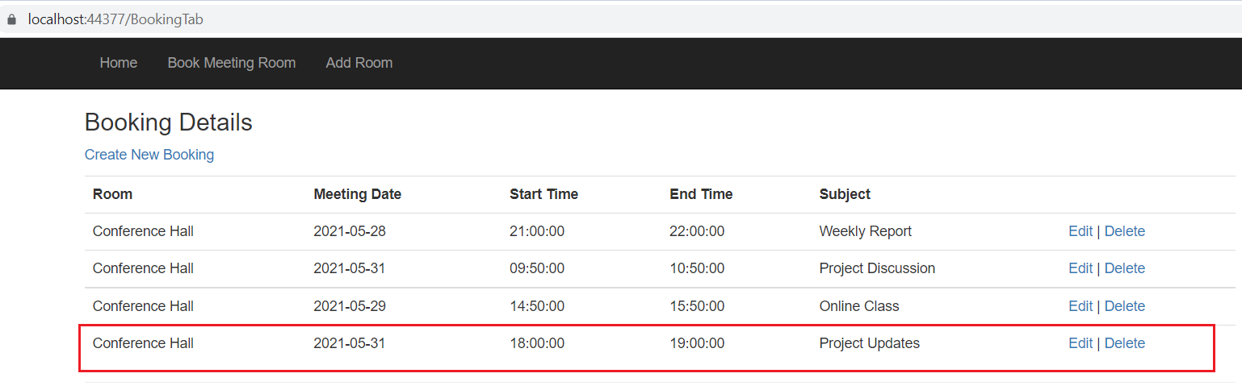

If we try to book meeting room for same date and time, it is not allowed to book the room and below error message is displayed.

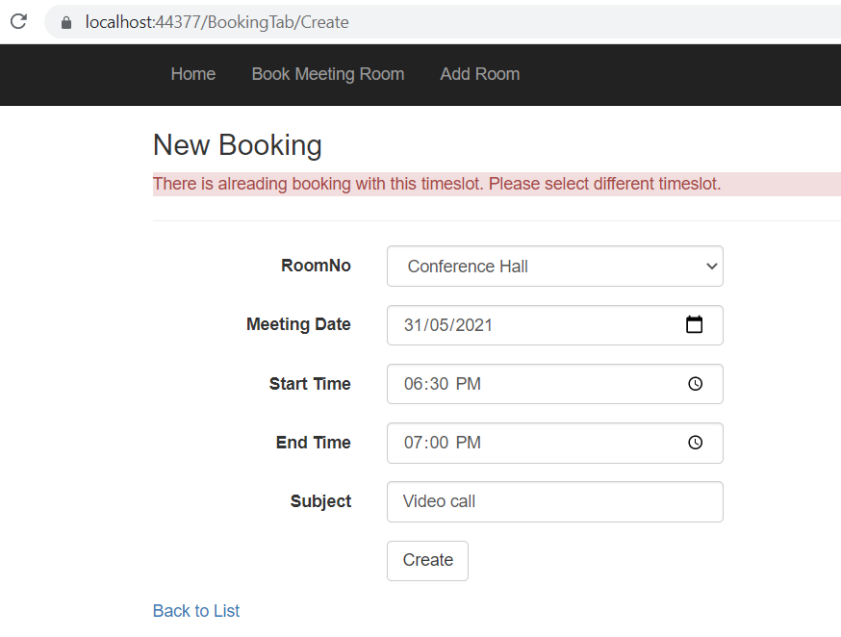

Click on Add Room Tab, the below screen is displayed.

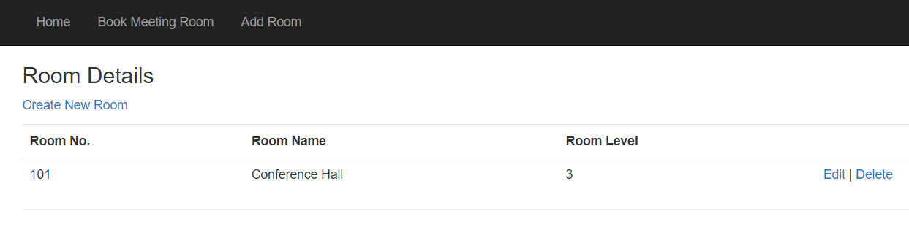

Click on EDIT Button, the below screen will be displayed and we can make changes to existing Meeting room details.

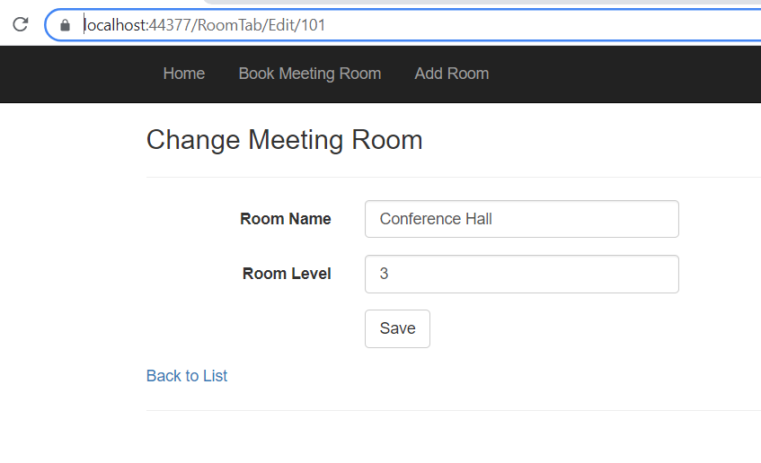

Click on Delete Button, the below screen will be displayed and can delete the meeting room which is not needed.

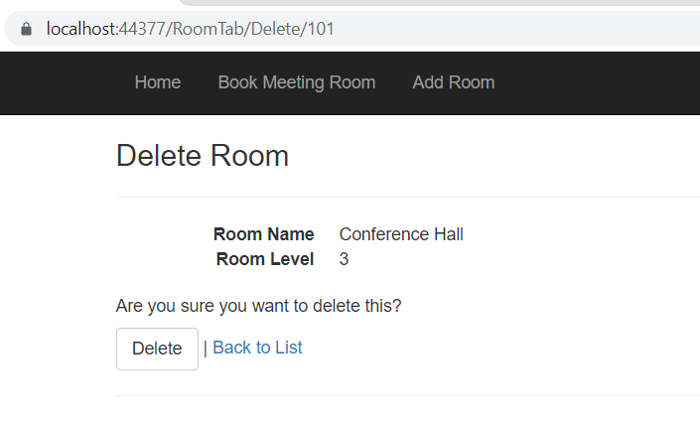

If the Admin try to delete the meeting room which has already been reserved for meeting, the below error message is shown and cannot delete the meeting room without deleting the meeting entries reserved with the corresponding room

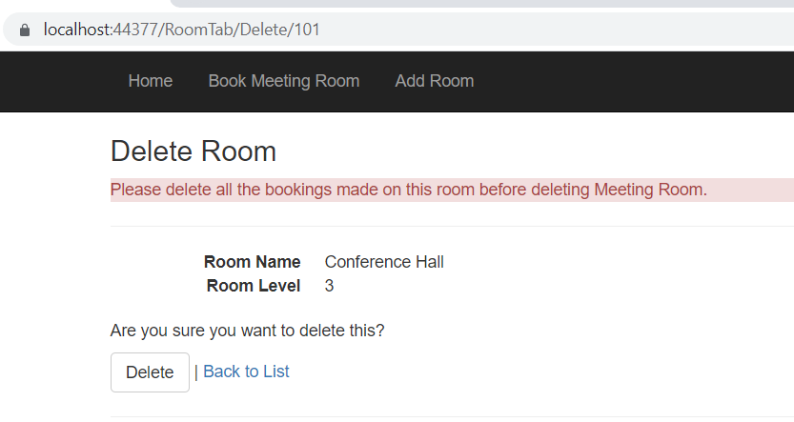

Click on Create New Room, it will allow user to add new room details.

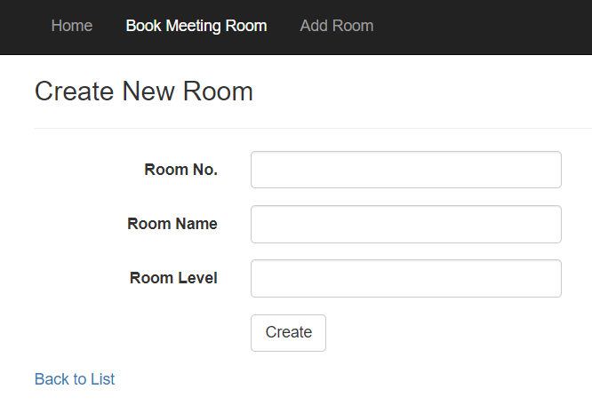

Example is shown below for adding New meeting room with test entries.

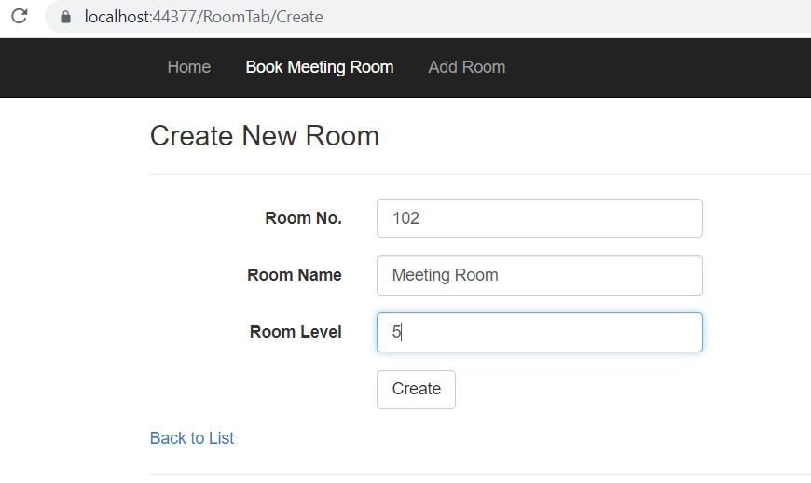

After clicking on Create button, the user is directed to below screen where he/she can see the list of meeting rooms that are available.

