**Unit Test for Meeting Room Booking System**

|  |  |  |  |  |
| --- | --- | --- | --- | --- |
| Test Case No. | Test Description | Expected Results | Actual Results | Pass/Fail |
| 1 | Click on create button without entering any data in the fields | Error Message will be displayed | The below error messages are displayed | Pass |

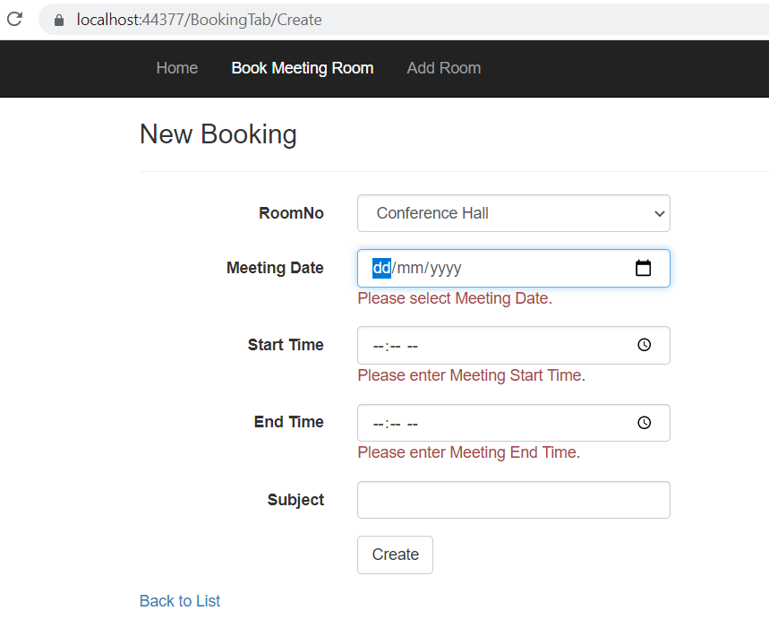

|  |  |  |  |  |
| --- | --- | --- | --- | --- |
| Test Case No. | Test Description | Expected Results | Actual Results | Pass/Fail |
| 2 | Click on Edit button to change the booking then enter meeting date as past dated and click on save button | Error Message will be displayed | Error Message “You cannot edit Past dated booking” is displayed | Pass |

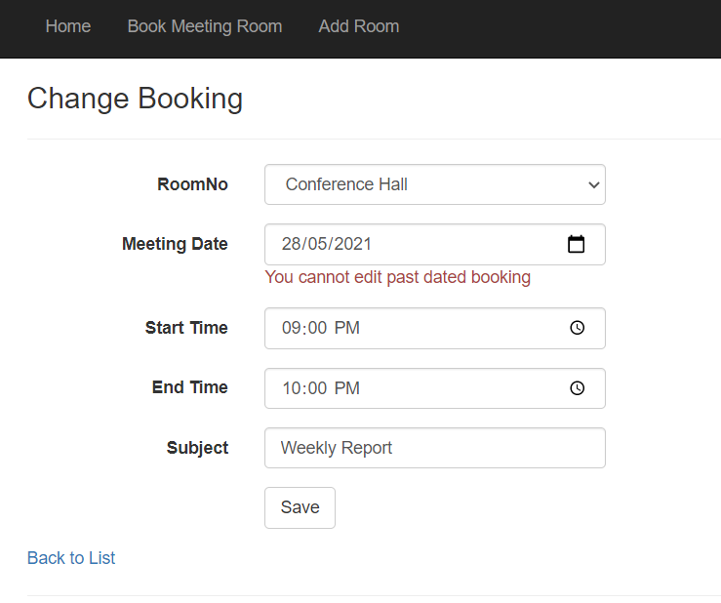

|  |  |  |  |  |
| --- | --- | --- | --- | --- |
| Test Case No. | Test Description | Expected Results | Actual Results | Pass/Fail |
| 3 | Click on Create New Booking button then enter Start time which is after End time and click on Create button | Error Message will be displayed | Error Message “Start Time must be before end Time booking” is displayed | Pass |

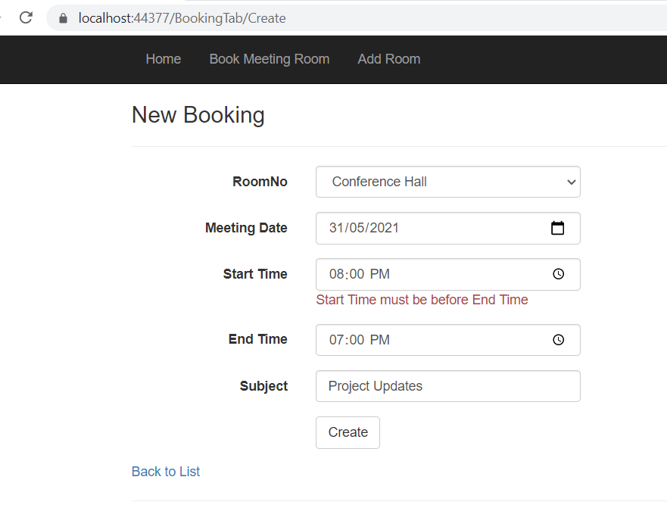

|  |  |  |  |  |
| --- | --- | --- | --- | --- |
| Test Case No. | Test Description | Expected Results | Actual Results | Pass/Fail |
| 4 | Click on Create New Booking button then enter Meeting Date, Start time, End Time and Subject then click on Create button | New booking will be created successfully. | The below booking is created for Conference Hall. | Pass |

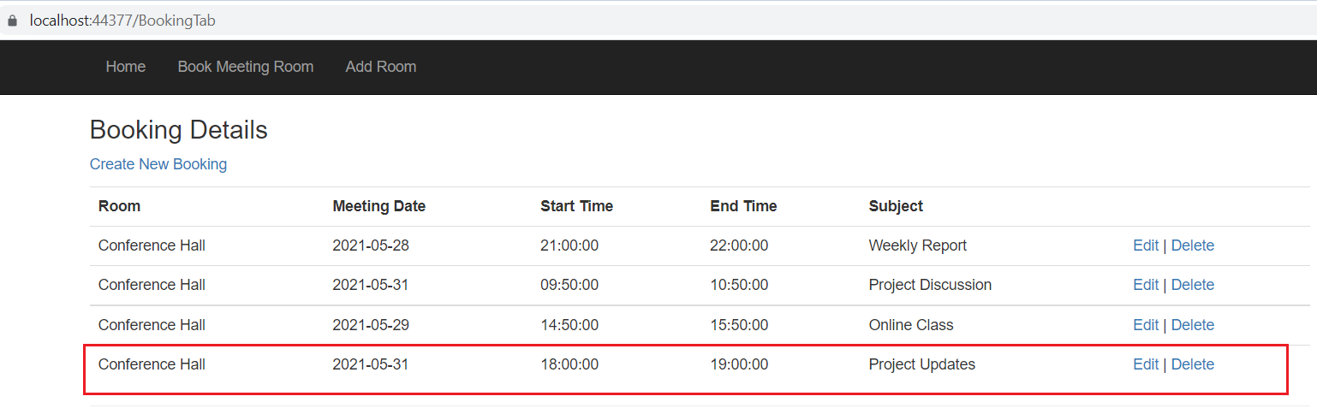

|  |  |  |  |  |
| --- | --- | --- | --- | --- |
| Test Case No. | Test Description | Expected Results | Actual Results | Pass/Fail |
| 5 | Click on Create New Booking button then enter Meeting Date, Start time and End Time same as existing booking record and click on Create button | Error Message will be displayed | The below error Message is displayed. Double booking is not allowed for same timeslot. | Pass |

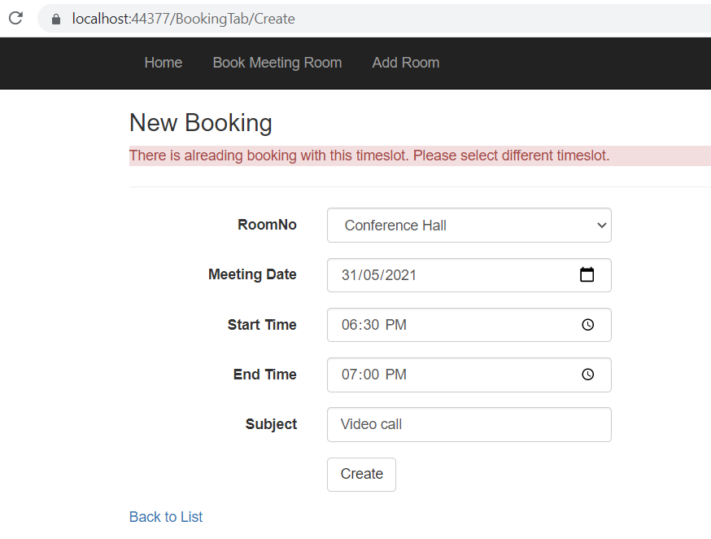

|  |  |  |  |  |
| --- | --- | --- | --- | --- |
| Test Case No. | Test Description | Expected Results | Actual Results | Pass/Fail |
| 6 | Click on Delete button to delete Room where Room is booked for meeting in booking system. | Error Message will be displayed | The below error Message is displayed. Here delete is not allowed because there is booking for this room, all the bookings for this room should be deleted before deleting meeting room. | Pass |

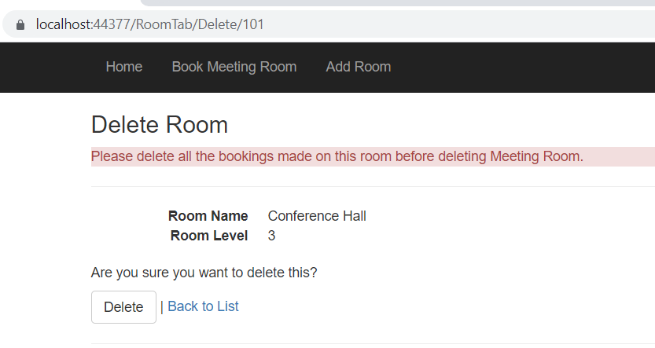

|  |  |  |  |  |
| --- | --- | --- | --- | --- |
| Test Case No. | Test Description | Expected Results | Actual Results | Pass/Fail |
| 7 | Click on Create New Room button to add new Room and enter Room No. as 102, Room Name as ‘Meeting Room’ and Level as 5 then click on Create button. | New Room will be added. | New Room which is Meeting Room is added successfully. | Pass |

