**Kick Start – Data Report**

* **what are three conclusions we can draw about Kickstarter campaigns?**
* **Three conclusions based on the data provided**

1. Film & Video, Music, and Theater are the top three categories (in terms of total projects and successful projects); all the Journalism projects are cancelled

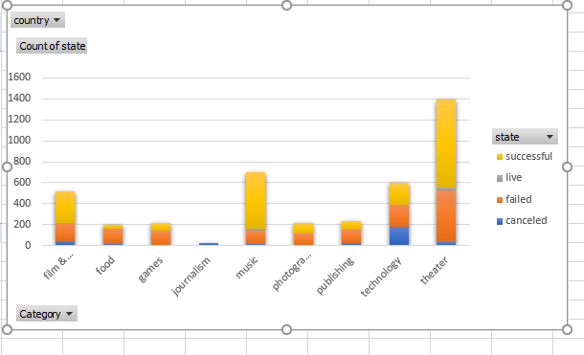

1. SubCategories Rock has most of the successful projects with 0% fail rate. Subcategories Food Truck has most of the failed projects with 0% success rate. Subcategories Plays has most of the projects and most of the successful and failed projects.

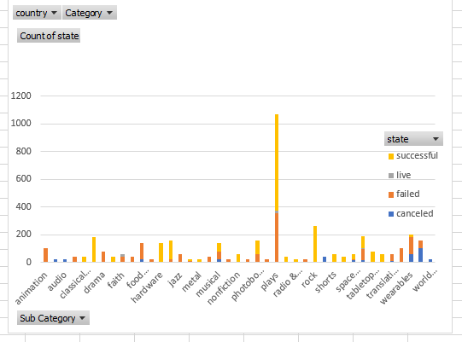

1. Canceled projects counts are consistent over the months. May has most of the successful project count over the years. But for Category film & Video, March has most of the successful project count over the years.

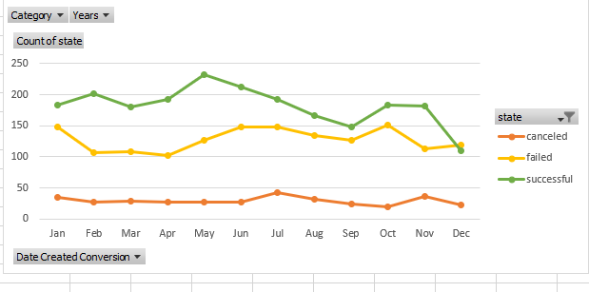

* **What are some limitations of this dataset?**
* **Limitations of Dataset**
  1. The data set only have limited amount sub-categories
  2. Regional limitation are there in the data, mostly projects are from United states.
  3. Future success cant be predicted with the given data.
* **What are some other possible tables and/or graphs that we could create?**
* **Other possible tables or graphs that could be created**

1. Goal Amounts by Category and Sub-Category
2. Outcome per Country

* **Statistical Analysis -mean or the median summarize**

Failed analysis Successfull analysis

