CMOS OTA Design and Simulation

Project Overview
Designed and simulated single-stage and two-stage CMOS operational transconductance amplifiers (OTAs) at transistor level using Cadence Virtuoso and Spectre with the gpdk180 library. The work covered NMOS characterization, differential-pair and current-mirror building blocks, OTA implementation, and AC/transient performance evaluation.

Designs Implemented

1. Single-stage CMOS OTA
Implemented an NMOS differential input pair with a tail-current mirror and PMOS active load. The project material reports a ±2.5 V supply, 100 µA bias current, and 5 pF load capacitance.
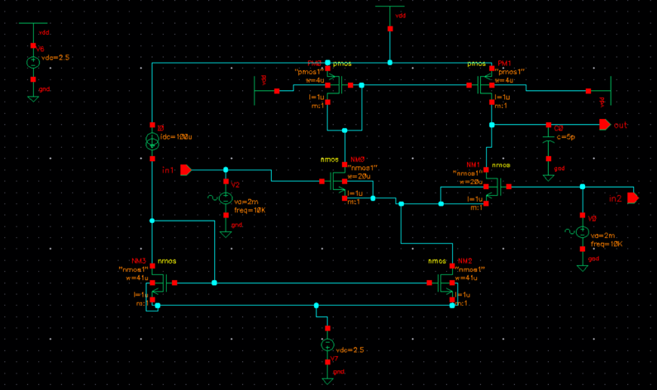
Figure 1. Single-stage CMOS OTA schematic in Cadence Virtuoso.

2. Two-stage Miller-compensated CMOS OTA
Implemented a two-stage architecture using an NMOS differential pair with PMOS current-mirror load in the first stage and a common-source second stage. Miller compensation was implemented with Cc = 2.5 pF and the reported load capacitance was CL = 3 pF.
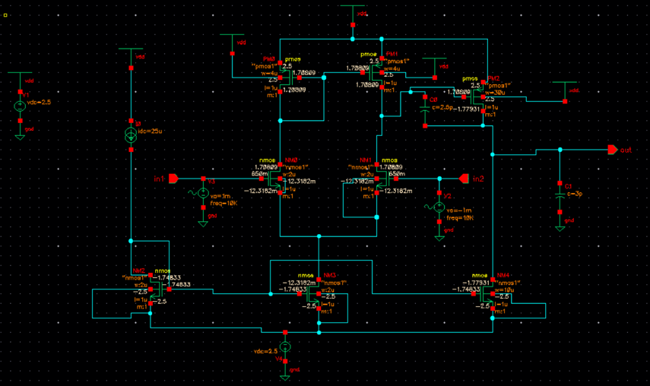
Figure 2. Two-stage CMOS OTA schematic with Miller compensation.

Reported Simulation Results
Values below are transcribed from the project material and should be interpreted under the original simulation conditions.
Metric | Single-stage OTA | Two-stage OTA
DC gain | 38.5 dB | 74.47 dB
Bandwidth metric | −3 dB frequency: 223.87 kHz | GBW: 7.477 MHz
Slew rate | 19.9 V/µs | 10.48 V/µs
Power dissipation | 0.53 mW | 131 µW
Phase margin |  | 96.09° (reported)
CMRR |  | 118.43 dB (reported)
Settling time |  | 98.03 ns (1%); 147.04 ns (0.1%)

AC and Transient Analysis
The following figures are the supplied Cadence screenshots. Confirm measurement setup and values against the original simulation before publishing.
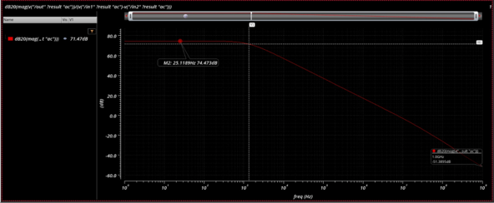
Figure 3. AC magnitude response; displayed low-frequency gain is approximately 74.47 dB.
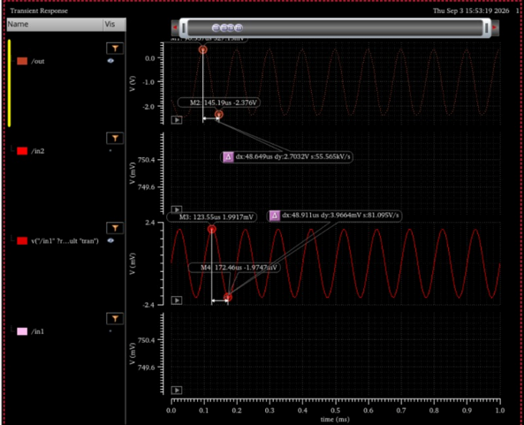
Figure 4. Transient response under the applied test signals.
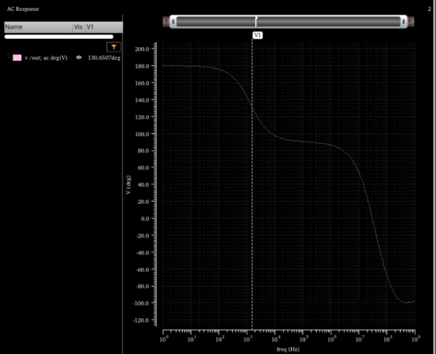
Figure 5. Simulated phase response versus frequency.

Tools and Key Learning
Tools: Cadence Virtuoso, Spectre, gpdk180 library. Key areas explored: MOSFET characterization; differential-pair and current-mirror operation; transistor-level OTA implementation; Miller compensation; AC gain/phase analysis; transient response; and gain, bandwidth, slew-rate, stability and power trade-offs.

