STUDENT PERFORMANCE CLASSIFICATION

A Project Report Submitted in
the partial fulfillment of the requirements for the award of the degree of

BACHELOR OF TECHNOLOGY
In

DEPARTMENT OF COMPUTER SCIENCE AND ENGINEERING
By
K. Sindhura – 2420030142
V. Arjun Risshi – 2420030395
M. Bharath Reddy – 2420030275

Under the Esteemed Guidance of

B. Prathusha
Assistant Professor

Department of Computer Science and Engineering

AY-2026–2027

Semester: Odd




K L (Deemed to be) University
DEPARTMENT OF COMPUTER SCIENCE AND ENGINEERING

Declaration

The Project Report entitled “Student Performance Classification Using Machine Learning” is a record of Bonafide work of K. Sindhura – 2420030142, V. Arjun Risshi – 2420030395, M. Bharath Reddy – 2420030275 submitted in partial fulfillment for the award of B. Tech in Computer Science and Engineering to the K L University. The results embodied in this report have not been copied from any other departments/University/Institute.

K. Sindhura – 2420030142
V. Arjun Risshi – 2420030395
M. Bharath Reddy – 2420030275

K L (Deemed to be) University
Department of Computer Science and Engineering

CERTIFICATE

This is certify that the mini project based report entitled “Student Performance Classification Using Machine Learning” is a bonafide work done and submitted by K. Sindhura – 2420030142, V. Arjun Risshi – 2420030395, M. Bharath Reddy – 2420030275 in partial fulfillment of the requirements for the award of the degree of BACHELOR OF TECHNOLOGY in Department of Computer Science and Engineering, K L (Deemed to be University), during the academic year 2026-2027.

_____________________  Signature of the Guide  B. Prathusha  Assistant Professor, CSE | _____________________  Course Coordinator  Department of CSE | _____________________  Head of the Department  Dr. P. Venkateswara Rao  Department of CSE

ACKNOWLEDGEMENT
The success in this project would not have been possible but for the timely help and guidance rendered by many people. Our wish is to express our sincere thanks to all those who have assisted us in one way or the other for the completion of our project.

Our greatest appreciation to our Course Coordinator and our guide B. Prathusha, Assistant Professor, Department of Computer Science and Engineering, which cannot be expressed in words, for her tremendous support, encouragement and guidance for this project.

We express our gratitude to Dr. P. Venkateswara Rao, Head of the Department of Computer Science and Engineering for providing us with adequate facilities, ways and means by which we were able to complete this project.

We thank all the members of teaching and non-teaching staff, and also those who have assisted us directly or indirectly in the successful completion of this project. Finally, we sincerely thank our parents, friends and classmates for their kind help and cooperation during our work.

K. Sindhura – 2420030142
V. Arjun Risshi – 2420030395
M. Bharath Reddy – 2420030275

Abstract
Student Performance Classification is an important application of machine learning that enables educational institutions to analyze academic data and predict student outcomes effectively. This project presents an end-to-end machine learning system designed to classify student performance using a structured student dataset containing academic, demographic and behavioral attributes.
The system begins with data acquisition and preprocessing, which includes data validation, handling missing values, removal of duplicate records, outlier detection, categorical data encoding, feature selection and normalization of numerical attributes. Exploratory Data Analysis (EDA) is performed to identify patterns, relationships and key factors influencing student performance. The dataset is then divided into training and testing subsets to develop reliable predictive models.
Five classification techniques, namely K-Nearest Neighbors (KNN), Support Vector Machine (SVM), Decision Tree, Random Forest and Artificial Neural Network (ANN), are implemented and compared. The models are evaluated using accuracy, precision, recall, F1-score, cross-validation accuracy and confusion matrix analysis.
The developed system predicts student performance categories (Low, Medium and High) and presents the results through visualizations and an interactive Streamlit dashboard. The application is developed using Python, Scikit-learn, Pandas, Matplotlib and Seaborn. This project demonstrates a complete machine learning workflow covering data collection, preprocessing, feature engineering, model development, evaluation and deployment, and highlights the practical use of machine learning in educational analytics and decision support systems.
Keywords: Student Performance Classification, Machine Learning, KNN, SVM, Decision Tree, Random Forest, ANN, Educational Data Analytics, Streamlit.
Index
S. No. | Chapters | Topics | Page.no
 |  | Acknowledgement | 4
 |  | Abstract | 5
1 | Introduction | 1.1 Background of the Project  1.2 Problem Statement  1.3 Scope of the Project  1.4 Objectives  1.5 Importance of the Application  1.6 Target Users/Audience
2 | System Requirements | 2.1 Hardware Requirements  2.2 Software Requirements  2.3 Development Tools and Frameworks
3 | Technology Stack | 3.1 Front-end – Streamlit  3.2 Application Logic – Python  3.3 Machine Learning – Scikit-learn  3.4 Data Handling – Pandas and NumPy  3.5 Data Visualization – Matplotlib and Seaborn  3.6 Model Storage – Joblib
4 | System Architecture | 4.1 High-Level Architecture Diagram  4.2 Description of System Modules  4.3 Application Execution Architecture
5 | Design | 5.1 User Interface Design and Screenshots  5.2 System Workflow / Data Flow Diagram
6 | Implementation | 6.1 Module-wise Implementation  6.2 Dataset and Data Upload  6.3 Data Preprocessing and Feature Selection  6.4 KNN, SVM, Decision Tree and Random Forest  6.5 ANN Model Implementation  6.6 Prediction and Performance Analysis
7 | Features | 7.1 List of Main Features  7.2 Working of Each Feature  7.3 Dataset Upload and Target Selection  7.4 Model Comparison Dashboard
8 | Testing | 8.1 Functional Testing  8.2 Integration Testing  8.3 Tools Used for Testing  8.4 Test Cases and Results  8.5 Model Performance Evaluation
9 | Deployment | 9.1 Steps to Run the Application  9.2 Python Environment Configuration  9.3 Local Application Execution
10 | Challenges & Limitations | 10.1 Issues Faced During Development  10.2 Solutions Applied  10.3 Current Limitations
11 | Future Enhancements | 11.1 Planned Features  11.2 Deep Learning Integration  11.3 Character Recognition and Cloud Deployment
12 | Conclusion | 12.1 Summary of the Project  12.2 Achievements  12.3 Skills Learned During Development
13 | References | Research Papers, Dataset and Technical Documentation
14 | Appendices | Application Screenshots  Sample Code Snippets  Installation and Setup Instructions  User Manual

CHAPTER 1
Introduction
1.1 Background of the Project
Student performance classification is a widely used application of machine learning in education. Educational institutions hold large volumes of student data, including academic records, attendance, demographic details and behavioral information. Machine learning can convert this data into early and actionable insight about how students are likely to perform.
Traditional evaluation depends mostly on final examination marks, which are available only after the learning period is over. A data-driven approach that studies several attributes together allows teachers to identify students who need support much earlier.
In this project, we developed an end-to-end machine learning system that classifies student performance into Low, Medium and High categories. Five algorithms, K-Nearest Neighbors (KNN), Support Vector Machine (SVM), Decision Tree, Random Forest and Artificial Neural Network (ANN), are implemented and compared on the same preprocessed dataset. The results are presented through an interactive Streamlit dashboard.
1.2 Problem Statement
Educational institutions possess large amounts of student data but lack automated, data-driven systems for proactive academic support. Early identification of at-risk students remains difficult, which leads to delayed interventions and lower retention rates. Existing tools often rely only on final examination marks instead of a holistic analysis of academic, demographic and behavioral attributes.
Therefore, the problem addressed in this project is to build a system that preprocesses student data, classifies student performance using multiple machine learning algorithms, compares their results fairly and presents the outcome through an easy-to-use dashboard.
1.3 Scope of the Project
The scope of this project includes:
- Classifying students into Low, Medium and High performance categories.
- Uploading a structured student dataset in CSV format.
- Data validation, missing value handling, duplicate removal and outlier treatment.
- Encoding of categorical attributes and scaling of numerical attributes.
- Feature selection using a statistical test.
- Implementation of KNN, SVM, Decision Tree, Random Forest and ANN classifiers.
- Evaluation using accuracy, precision, recall, F1-score, cross-validation and confusion matrices.
- An interactive dashboard with data exploration, model comparison and student-level prediction.
The current implementation works on one uploaded dataset at a time and is intended for offline analysis rather than live institutional data.
1.4 Objectives
The main objectives of this project are:
- To implement data preprocessing: validation, missing value imputation, duplicate removal, outlier detection, encoding, feature selection and normalization.
- To perform Exploratory Data Analysis to find the key factors that influence academic outcomes.
- To build and train KNN, SVM, Decision Tree, Random Forest and ANN classifiers.
- To compare the models using accuracy, precision, recall, F1-score and confusion matrix.
- To deliver an interactive dashboard for risk assessment and decision support.
1.5 Importance of the Application
Early identification of students who may perform poorly allows teachers and counsellors to provide timely guidance. The application shows how machine learning can support such decisions by combining many student attributes instead of relying on marks alone.
The project also gives practical experience of the complete machine learning workflow: data preprocessing, model training, evaluation and deployment of the results as a usable application.
1.6 Target Users/Audience
The intended users of the application include:
- Teachers and academic counsellors who want to identify students needing support.
- Educational institutions and administrators using data for decision making.
- Students learning machine learning and educational data analytics.
- Researchers and developers experimenting with classification models.

CHAPTER 2
System Requirements
2.1 Hardware Requirements
The following hardware configuration is suitable for running the project.
Processor : Intel Core i3 / i5 or equivalent
RAM : 4 GB minimum, 8 GB recommended
Storage : At least 1 GB of free space
Operating Input : Keyboard and Mouse
Display : Standard Laptop or Desktop Display
GPU : Not required

2.2 Software Requirements
- Operating System: Windows 10 or Windows 11.
- Programming Language: Python 3.x.
- Development Environment: Visual Studio Code / Jupyter Notebook.
- Application Framework: Streamlit.
- Machine Learning Library: Scikit-learn.
- Data Handling: Pandas and NumPy.
- Data Visualization: Matplotlib and Seaborn.
- Model Storage: Joblib.
- Version Control: Git and GitHub.
2.3 Development Tools and Frameworks
Python:
Python is the main programming language used for data preprocessing, model training, evaluation and application development.
Streamlit:
Streamlit is used to create the interactive web application, including dataset upload, model training, result display and student-level prediction.
Scikit-learn:
Scikit-learn provides the preprocessing utilities, feature selection, the KNN, SVM, Decision Tree, Random Forest and ANN (MLP) classifiers, and the evaluation metrics.
Pandas and NumPy:
Pandas is used to read, clean and transform the tabular dataset, and NumPy supports numerical operations.
Matplotlib and Seaborn:
These libraries generate the class distribution chart, correlation heatmap, box plots, confusion matrices, feature importance chart and model comparison graph.
Joblib:
Joblib is used to save the trained model and the preprocessing objects so that they can be reused without retraining.

CHAPTER 3
Technology Stack
3.1 Front-end – Streamlit
Streamlit is an open-source Python framework for building interactive web applications. In this project it provides the sidebar for dataset upload and settings, and four tabs: Dataset, EDA, Model comparison and Predict a student.
3.2 Application Logic – Python
Python implements the application logic. It manages data cleaning, feature selection, model training, evaluation and prediction, and connects all modules so that the data flows from the uploaded file to the final result.
3.3 Machine Learning – Scikit-learn
Scikit-learn is used to implement the five classifiers:
K-Nearest Neighbors (KNN): A distance-based algorithm that predicts the class from the nearest training samples.
Support Vector Machine (SVM): Learns decision boundaries that separate the performance classes.
Decision Tree: Builds an interpretable set of rules by splitting on the most informative features.
Random Forest: An ensemble of decision trees that reduces overfitting and gives feature importance.
Artificial Neural Network (ANN): A multi-layer perceptron that learns non-linear relationships between attributes.
3.4 Data Handling – Pandas and NumPy
Pandas reads the CSV file and performs missing value imputation, duplicate removal, outlier clipping and one-hot encoding. NumPy supports binning of numeric grades and numerical calculations.
3.5 Data Visualization – Matplotlib and Seaborn
Matplotlib and Seaborn create the graphs used for exploratory analysis and model evaluation, such as count plots, heatmaps, box plots and confusion matrices.
3.6 Model Storage – Joblib
Joblib stores the trained model, scaler, selected features and label encoder in a file. The saved file lets the system load the best model without training again.

CHAPTER 4
System Architecture
4.1 High-Level Architecture Diagram
The architecture follows the sequence: User Input → Data Preprocessing → Feature Selection and Train–Test Split → Model Training → Evaluation and Prediction → Dashboard.
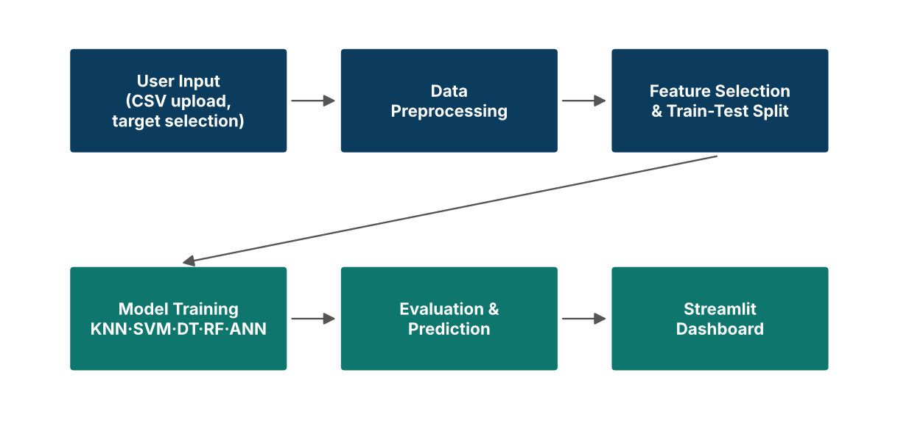
Figure 4.1: High-level architecture of the Student Performance Classification system.
4.2 Description of System Modules
1. User Input Layer
The user uploads a CSV dataset, selects the target column, chooses columns to exclude and sets the number of features to keep.
2. Data Preprocessing Layer
Duplicates are removed, missing values are filled (median for numeric, mode for categorical), outliers are clipped using the IQR rule and numeric grades are converted into Low, Medium and High.
3. Feature Selection and Split Layer
Categorical features are one-hot encoded, the best features are selected with an ANOVA F-test, the data is split 80:20 and numeric features are standardized.
4. Machine Learning Layer
KNN, SVM, Decision Tree, Random Forest and ANN are trained on the same training data.
5. Prediction and Performance Analysis Layer
Models are compared using accuracy, precision, recall, F1-score, cross-validation accuracy and confusion matrices, and a student can be classified using any trained model.
4.3 Application Execution Architecture
The application runs locally using Python and Streamlit. The user starts the application from the project folder, and Streamlit opens a local web interface in the browser. The same Python process handles the interface, training and prediction, so no separate back-end server is required.

CHAPTER 5
Design
5.1 User Interface Design and Screenshots
The application has a simple interface with a sidebar for settings and four tabs.
1. Sidebar
Dataset upload, target column selection, columns to exclude, number of features and the Train models button.
2. Dataset Tab
Shows a preview of the data, number of rows, missing values, duplicate rows and column types.
3. EDA Tab
Shows the class distribution, correlation heatmap, feature-versus-performance plots and Random Forest feature importance.
4. Model Comparison Tab
Shows the results table, the best model, a comparison graph and a confusion matrix for each model.
5. Predict a Student Tab
A form where student details are entered and the predicted performance category with class probabilities is displayed.
[Insert screenshots of the actual working application under this section: Dataset tab, EDA tab, Model comparison tab and Predict tab.]
5.2 System Workflow / Data Flow Diagram
The data flow starts with the uploaded dataset, which passes through preprocessing, training and evaluation. The results are displayed on the dashboard, and the user can then enter the details of a new student to obtain a predicted category.
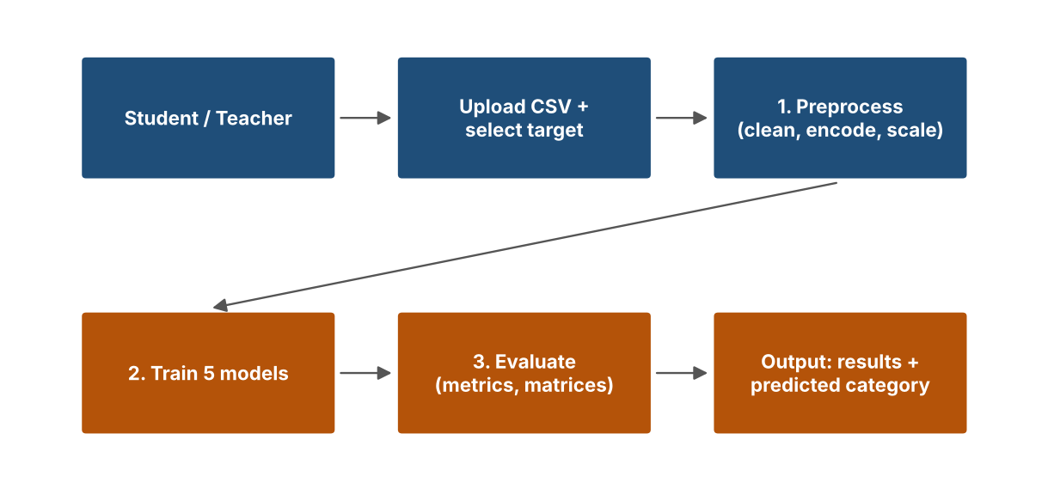
Figure 5.1: Data flow diagram of the system.

CHAPTER 6
Implementation
6.1 Module-wise Implementation
The project is divided into four major modules.
Module 1: Data Preprocessing Module (V. Arjun Risshi). Validates the data, removes duplicates, fills missing values, clips outliers, encodes categories and scales numeric features. Input: raw dataset. Output: clean, scaled data.
Module 2: EDA and Feature Selection Module (K. Sindhura). Studies distributions and correlations and selects the most relevant features. Input: clean data. Output: insights and selected features.
Module 3: Model Development and Evaluation Module (K. Sindhura, M. Bharath Reddy). Trains the five classifiers and computes the evaluation metrics. Input: training and testing data. Output: trained models and metrics.
Module 4: Dashboard and Visualization Module (M. Bharath Reddy). Displays the results and performs student-level prediction. Input: models and metrics. Output: interactive dashboard.
6.2 Dataset and Data Upload
The user uploads a structured student dataset in CSV format. The dataset contains academic, demographic and behavioral attributes and a performance column that is used as the target. Columns such as identifiers, or earlier grades that reveal the answer, can be excluded from the sidebar.
Dataset Detail | Value
Source | [Dataset name and link]
Number of records | [number of rows]
Number of features | [number of columns]
Missing values | [count]
Target classes | Low, Medium, High

6.3 Data Preprocessing and Feature Selection
The following preprocessing steps are applied:
- Duplicate rows are removed and rows without a target value are dropped.
- If the target is a numeric grade, it is converted into Low, Medium and High using two cut-off values.
- Missing numeric values are filled with the median and missing categorical values with the mode.
- Outliers are clipped using the interquartile range (IQR) rule, which keeps all rows.
- Categorical variables are one-hot encoded.
- The data is split into 80% training and 20% testing sets with stratification.
- The best features (default 10) are selected with an ANOVA F-test, fitted on training data only.
- Numeric features are standardized using a scaler fitted on training data only.
6.4 KNN, SVM, Decision Tree and Random Forest
Four classical classifiers are trained on the same training data with the following settings:
- KNN: 7 neighbors, majority voting on the nearest training samples.
- SVM: RBF kernel with C = 2 and probability estimates enabled.
- Decision Tree: maximum depth of 6.
- Random Forest: 300 trees, also used to compute feature importance.
6.5 ANN Model Implementation
The Artificial Neural Network is implemented with the multi-layer perceptron classifier of Scikit-learn. It has two hidden layers of 64 and 32 neurons, a maximum of 800 iterations and early stopping to avoid overfitting. It is trained on the same standardized features as the other models.
6.6 Prediction and Performance Analysis
Every model is evaluated on the unseen test set using the weighted precision, recall and F1-score, plus accuracy and 5-fold stratified cross-validation accuracy on the training data. Models are ranked by F1-score and the best one is highlighted. A confusion matrix is drawn for each model to show where students are misclassified, and the Random Forest feature importance shows which attributes matter most.
For prediction, the user enters the details of a student in a form. The same preprocessing is applied, and the chosen model returns the predicted category (Low, Medium or High) together with class probabilities where available.
Sample code used for training and evaluation:
X_tr, X_te, y_tr, y_te = train_test_split(X, y, test_size=0.2,
stratify=y, random_state=42)
sel = SelectKBest(f_classif, k=10).fit(X_tr, y_tr)
for name, m in models.items():
m.fit(X_tr, y_tr)
pred = m.predict(X_te)
print(name, f1_score(y_te, pred, average="weighted"))

CHAPTER 7
Features
7.1 List of Main Features
- Dataset upload and preview.
- Automatic data cleaning and preprocessing.
- Selectable target column and excluded columns.
- Exploratory data analysis charts.
- Five classification models: KNN, SVM, Decision Tree, Random Forest and ANN.
- Model comparison table with accuracy, precision, recall, F1-score and cross-validation accuracy.
- Confusion matrix for each model.
- Random Forest feature importance.
- Student-level prediction with class probabilities.
7.2 Working of Each Feature
Dataset Upload: The user selects a CSV file and the application reads it and shows a preview.
Preprocessing: Duplicates, missing values, outliers, encoding and scaling are handled automatically before training.
EDA: Charts show class balance, correlations and how each feature relates to performance.
Model Training: Clicking Train models trains all five classifiers on the same split.
Model Comparison: Results are shown in a table and graph, with the best model highlighted.
Prediction: The user enters student details and receives the predicted performance category.
7.3 Dataset Upload and Target Selection
The user can upload any suitable student dataset. The target column, the columns to exclude and the number of selected features are chosen in the sidebar. When the target is a numeric grade, cut-off values for the Low, Medium and High classes can be set.
7.4 Model Comparison Dashboard
The dashboard compares all five models side by side so that the user can see which model performs best and what kind of errors each model makes, using the results table, the comparison bar chart and the confusion matrices.

CHAPTER 8
Testing
8.1 Functional Testing
Functional testing verifies that the main features work as expected. The following operations are tested:
- Uploading a CSV dataset.
- Selecting the target column and excluded columns.
- Preprocessing the data.
- Training all five models.
- Displaying the results table and confusion matrices.
- Predicting the performance of a new student.
8.2 Integration Testing
Integration testing checks that the modules work together:
- The uploaded data is passed to the preprocessing module.
- The processed data is passed to all five models.
- Evaluation results are passed to the dashboard.
- Prediction input is processed in the same way as the training data.
8.3 Tools Used for Testing
- Python for executing the application.
- Streamlit for testing the user interface.
- Scikit-learn for model evaluation.
- Pandas and NumPy for data checks.
- Matplotlib and Seaborn for visualizing results.
- VS Code for development and testing.
8.4 Test Cases and Results
Test Case ID | Test Case | Expected Result | Status
TC-01 | Upload a CSV dataset | Data preview, row count and missing values are displayed | Pass (if successfully tested)
TC-02 | Handle missing values and duplicates | No missing values or duplicate rows remain | Pass (if successfully tested)
TC-03 | Train all five models | Results table with all five models is displayed | Pass (if successfully tested)
TC-04 | Open confusion matrices | A confusion matrix is shown for each model | Pass (if successfully tested)
TC-05 | Predict a new student | Predicted category and probabilities are displayed | Pass (if successfully tested)

8.5 Model Performance Evaluation
The models are evaluated on the 20% test set. Replace the values below with the results shown in the Model comparison tab of the application.
Evaluation Metric | KNN | SVM | Decision Tree | Random Forest | ANN
Accuracy | [value] | [value] | [value] | [value] | [value]
Precision | [value] | [value] | [value] | [value] | [value]
Recall | [value] | [value] | [value] | [value] | [value]
F1-score | [value] | [value] | [value] | [value] | [value]
CV Accuracy | [value] | [value] | [value] | [value] | [value]

[State the best model and its accuracy, for example: “Random Forest achieved the highest F1-score of __.” Add the model comparison graph and the confusion matrix of the best model here.]

CHAPTER 9
Deployment
9.1 Steps to Run the Application
- Install Python on the computer.
- Open the project folder in Visual Studio Code.
- Create and activate a Python virtual environment.
- Install the required libraries.
- Run the Streamlit application.
Commands to set up and run the application:
python -m venv venv
venv\Scripts\activate
pip install -r requirements.txt
streamlit run app.py

After executing the command, Streamlit displays a local URL (http://localhost:8501). Open that URL in a web browser to use the application.
9.2 Python Environment Configuration
The project uses a Python virtual environment so that the required libraries (Streamlit, Scikit-learn, Pandas, NumPy, Matplotlib, Seaborn and Joblib) are installed separately from other projects. The libraries are listed in the requirements.txt file.
9.3 Local Application Execution
The application runs locally through Streamlit. The interface and the application logic run in the same Python process, so separate front-end and back-end hosting is not required. The training script can also be run alone to generate charts and a results file:
python train_model.py --data yourfile.csv --target Performance

CHAPTER 10
Challenges and Limitations
10.1 Issues Faced During Development
Mixed Data Types: The dataset contains numeric and categorical attributes that must be converted into a form suitable for the models.
Missing Values and Outliers: Missing entries and extreme values can reduce model quality.
Overfitting Risk: Models such as Decision Tree and ANN can memorize the training data.
Fair Comparison: The five models must be evaluated under the same conditions.
Environment Configuration: Managing Python libraries, virtual environments and library versions needed careful setup.
10.2 Solutions Applied
- Categorical variables were one-hot encoded and numeric features were standardized.
- Missing values were imputed and outliers were clipped with the IQR rule.
- A train–test split, early stopping and cross-validation were used to reduce overfitting.
- All models used the same split and features.
- Feature selection kept only the most relevant attributes.
- A virtual environment and a requirements file were used to manage libraries.
10.3 Current Limitations
- The system depends on one structured dataset at a time.
- Results may not generalize to other institutions or student populations.
- The analysis is offline and does not use live student data.
- Prediction quality depends on the quality of the data supplied.

CHAPTER 11
Future Enhancements
11.1 Planned Features
Hyperparameter Tuning: Grid search or random search can be added to improve each model.
More Data and Features: Data from more institutions and attributes such as attendance and engagement logs can be added.
Early Warning Alerts: Automatic alerts can be sent to teachers when a student is predicted as Low performing.
Cloud Deployment: The application can be hosted online so that it can be used without local installation.
Data Privacy: Secure handling of student data can be introduced.
11.2 Deep Learning Integration
Deeper neural networks built with TensorFlow/Keras can be used to learn more complex patterns and may further improve classification performance.
11.3 Character Recognition and Cloud Deployment
The system can be extended to a web or mobile application with a live prediction API, and deployed on a cloud platform for use by many institutions.

CHAPTER 12
Conclusion
12.1 Summary of the Project
The project “Student Performance Classification” was developed as an end-to-end machine learning application. It accepts a student dataset, cleans and prepares the data, trains five classification models and compares them using accuracy, precision, recall, F1-score, cross-validation accuracy and confusion matrices. The results and a student-level prediction feature are presented through an interactive Streamlit dashboard.
[Add the final result here: which model performed best and its accuracy / F1-score.]
12.2 What Was Achieved
- Built a reusable preprocessing pipeline for academic, demographic and behavioral data.
- Performed exploratory data analysis to find factors affecting performance.
- Implemented KNN, SVM, Decision Tree, Random Forest and ANN classifiers.
- Compared all models with multiple evaluation metrics.
- Developed an interactive dashboard for decision support.
12.3 Skills Learned During Development
- Python programming.
- Data cleaning and preprocessing.
- Exploratory data analysis.
- Machine learning classification.
- Model training and evaluation.
- Streamlit application development.
- Data visualization.
- Team collaboration and technical documentation.

CHAPTER 13
References
- H. Pallathadka et al., “Classification and Prediction of Student Performance Data Using Various Machine Learning Algorithms.”
- Hilal et al., “Intelligent Epileptic Seizure Detection and Classification Model Using Optimal Deep Canonical Sparse Autoencoder,” Biology (MDPI), 2022.
- S. Dhahbi, “False-positive reduction in computer-aided mass detection using mammographic texture analysis and classification.”
- F. Pedregosa et al., “Scikit-learn: Machine Learning in Python,” Journal of Machine Learning Research, vol. 12, 2011.
- Scikit-learn Documentation. Available at: https://scikit-learn.org/stable/
- Streamlit Documentation. Available at: https://docs.streamlit.io/
- Pandas Documentation. Available at: https://pandas.pydata.org/docs/
- NumPy Documentation. Available at: https://numpy.org/doc/
- Matplotlib Documentation. Available at: https://matplotlib.org/stable/
- Seaborn Documentation. Available at: https://seaborn.pydata.org/
- [Dataset name and link]

CHAPTER 14
Appendices
14.1 Application Screenshots
The following screenshots demonstrate the working of the application:
- Dataset tab with data preview.
- EDA tab: class distribution and correlation heatmap.
- Feature importance chart.
- Model comparison table and graph.
- Confusion matrices.
- Predict a student tab with a result.
[Insert the screenshots here.]
14.2 Sample Code Snippets
class_models = {
"KNN": KNeighborsClassifier(n_neighbors=7),
"SVM": SVC(kernel="rbf", C=2, probability=True),
"Decision Tree": DecisionTreeClassifier(max_depth=6),
"Random Forest": RandomForestClassifier(n_estimators=300),
"ANN": MLPClassifier(hidden_layer_sizes=(64, 32), early_stopping=True),
}

14.3 Installation and Setup Instructions
python -m venv venv
venv\Scripts\activate
pip install -r requirements.txt
streamlit run app.py

14.4 User Manual
- Start the application and open http://localhost:8501 in the browser.
- Upload the student dataset (CSV) in the sidebar.
- Select the target (performance) column and exclude ID or leaking columns.
- Click Train models and wait for the training to finish.
- Open the EDA tab to study the data and the Model comparison tab to see the results.
- Open the Predict a student tab, enter the details and click Predict performance.

