Neural Signal Processing
- Understanding Neural Signals
  - What is a biological signal?
A biological signal is a measurable, time-varying quantity produced by a physiological process in a living organism. The term bio signal is often used to refer to biological, such as the electrical, chemical, and mechanical activities associated with processes like a beating heart or contracting muscle. These signals contain valuable information that can aid in understanding physiological mechanisms and may be utilized for medical diagnosis.
  - Resting membrane potential and action potential
For the nervous system to function, neurons must be able to send and receive signals. These signals are possible because each neuron has a charged cellular membrane (a voltage difference between the inside and the outside), and the charge of this membrane can change in response to neurotransmitter molecules released from other neurons and environmental stimuli. To understand how neurons communicate, one must first understand the basis of the baseline or “resting” membrane charge.

The lipid bilayer membrane that surrounds a neuron is impermeable to charged molecules or ions. To enter or exit the neuron, ions must pass through special proteins called ion channels that span the membrane. Ion channels have different configurations: open, closed, and inactive. Some ion channels need to be activated in order to open and allow ions to pass into or out of the cell. These ion channels are sensitive to the environment and can change their shape accordingly. Ion channels that change their structure in response to voltage changes are called voltage-gated ion channels. Voltage-gated ion channels regulate the relative concentrations of different ions inside and outside the cell. The difference in total charge between the inside and outside of the cell is called the membrane potential.

A neuron at rest is negatively charged: the inside of a cell is approximately 70 millivolts more negative than the outside (−70 mV, note that this number varies by neuron type and by species). This voltage is called the resting membrane potential; it is caused by differences in the concentrations of ions inside and outside the cell. If the membrane were equally permeable to all ions, each type of ion would flow across the membrane and the system would reach equilibrium. Because ions cannot simply cross the membrane at will, there are different concentrations of several ions inside and outside the cell.

This resting membrane potential is not a passive default but an actively maintained equilibrium, produced by three things working together. First, ion concentrations are unequal across the membrane: sodium (Na⁺) is concentrated outside the cell, potassium (K⁺) is concentrated inside, and large negatively charged proteins are trapped inside, unable to cross the membrane. Second, the membrane is selectively permeable, remaining far more permeable to K⁺ than to Na⁺ at rest through always-open "leak channels," so K⁺ continuously leaks out along its concentration gradient, dragging positive charge with it and leaving the inside more negative. Third, the sodium-potassium pump actively maintains this imbalance by continuously pumping three Na⁺ ions out for every two K⁺ ions it brings in, using cellular energy in the form of ATP; since it removes more positive charge than it returns, it directly reinforces the negative resting potential. Together, these mechanisms keep the neuron at a stable −70 mV baseline, much like a battery sitting fully charged and ready to discharge the moment it is triggered. Additionally, various membrane channels have different permeabilities to ions. At rest, the permeability of K+ channels in the neuronal membrane is much higher than that of other ion channels. Thus, driven by the great K+ concentration gradient across the membrane, K+ ions diffuse outward, carrying positive charges out. This results in accumulations of positive charges outside and negative charges inside the membrane. These opposite charges attract each other across the membrane, establishing a potential difference across the membrane. The force on K+ ions from this potential difference opposes the force from the concentration gradient. When these opposing forces reach equilibrium, K+ inflow equals outflow, resulting in no net movement of K+ ions across the membrane. At this equilibrium state, the potential difference that exactly balances an ionic concentration gradient is known as the transmembrane equilibrium potential for the ion, or simply equilibrium potential, termed as Eion, e.g., EK for K +. The Eion of a specific ion, determined by its concentration gradient across the membrane, can be calculated using the Nernst equation
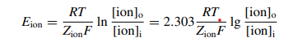
Here R is the gas constant of 8.314 J/(mol·K), T is the absolute temperature which equals Celsius temperature plus 273, F is the Faraday constant of 9.6485 × 104 C/mol, Zion is the number of charges carried by the ion, [ion]o is the extracellular ionic concentration, and [ion]i is the intracellular ion concentration. The equilibrium potential Eion is measured in volts (V). According to the Nernst equation, the equilibrium potential of K+ at 37 °C is EK = − 80 mV. The resting potential of neurons measured in actual experiments is slightly higher, around − 70 mV. This difference occurs because at rest, while K+ channels have high permeability, the membrane also has some permeability to Na+, chloride (Cl−) and other ions. The final equilibrium potential resulting from multiple ions permeating simultaneously can be calculated by the Goldman equation, also known as the GHK equation
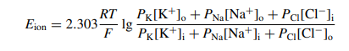

Here PK, PNa and PCl are the permeability coefficients of K+, Na+ and Cl− ions, respectively. [K+]o, [Na+]o and [Cl−]o are the extracellular concentrations of these three ions, while [K+]i, [Na+]i and [Cl−]i are t heir intracellular concentrations. At rest, the permeability ratio of K+, Na+ and Cl− is PK:PNa:PCl = 1:0.02:0.45. Therefore, the final equilibrium potential of the membrane at 37 °C is Eion = − 67 mV. The resting potential can vary with the permeability ratio of ion channels, with a typical resting potential around − 70 mV. If the PK:PNa ratio decreases, the resting potential becomes less negative; conversely, if the ratio increases, the resting potential becomes more negative, tending toward -80 mV—the K + equilibrium potential (EK). During an AP, the opening and closing of Na+, K+ and other ion channels change dynamically, causing corresponding changes in the permeability ratio of these ions. For instance, when the membrane potential reaches the AP peak, the opening of Na+ channels leads to PK:PNa:PCl = 1:20:0.45. At this moment, the equilibrium potential at 37°C is approximately 50 mV, which is close to the Na+ equilibrium potential (ENa).

In summary, ion concentrations are different between the inside and outside of a neuron. At rest, the neuronal membrane is highly permeable to K+ through K+ channels, resulting in K+ efflux that creates an equilibrium potential across the membrane. And, energy-consuming sodium–potassium pumps maintain the ion concentration gradients. Together, these mechanisms form the resting potential. The K+ concentration gradient plays a crucial role in generating the resting potential, which approximates the EK. The resting potential serves as the foundation for cell activity and bioelectricity generation. Significant changes in resting potential can seriously disrupt normal physiological functions and potentially cause fatal damage. To maintain stable resting potential, the extracellular K+ concentration must remain constant. In the brain, astrocyte glial cells create an effective K+ buffering system. These cells can rapidly absorb excess K+ nearby, then transport, diffuse and release the K+ ions to distant areas through extensive astrocytic networks. Once local neural activity causes an abnormal increase in [K+]o, the astrocytic buffer system can quickly adjust K+ distribution to protect neurons.

Action potential
An action potential is a brief, rapid, all-or-none reversal of a neuron's resting membrane voltage, and it unfolds in a precise sequence. It begins when some input, such as synaptic activity or a sensory stimulus, causes a local, graded depolarization, pushing the membrane potential from −70 mV toward less negative values. If this depolarization is strong enough to cross a threshold of about −55 mV, it triggers a full action potential; this is the all-or-none rule, meaning that below threshold nothing happens at all, while above threshold the complete spike fires every time regardless of how much stronger the triggering stimulus was. Crossing threshold causes voltage-gated sodium channels to snap open, and because the inside of the cell is now attracting the sodium ions that were concentrated outside, sodium floods in through a positive feedback loop in which further depolarization opens still more channels, driving the voltage rapidly upward to about +30 to +40 mV within a fraction of a millisecond this rising phase is called depolarization. Almost immediately afterward, the sodium channels inactivate while voltage-gated potassium channels open with a slight delay, and potassium now rushes out of the cell along its concentration gradient and under the push of the positive interior, rapidly bringing the voltage back down toward resting level in a phase called repolarization. Because the potassium channels close somewhat slowly, potassium continues leaving a little longer than necessary, briefly driving the membrane potential below its resting level to around −80 mV, a phase called hyperpolarization, before the sodium -potassium pump and the leak channels restore the normal resting distribution and the neuron becomes ready to fire again. The entire event, from threshold to return to rest, lasts only about one to two milliseconds.
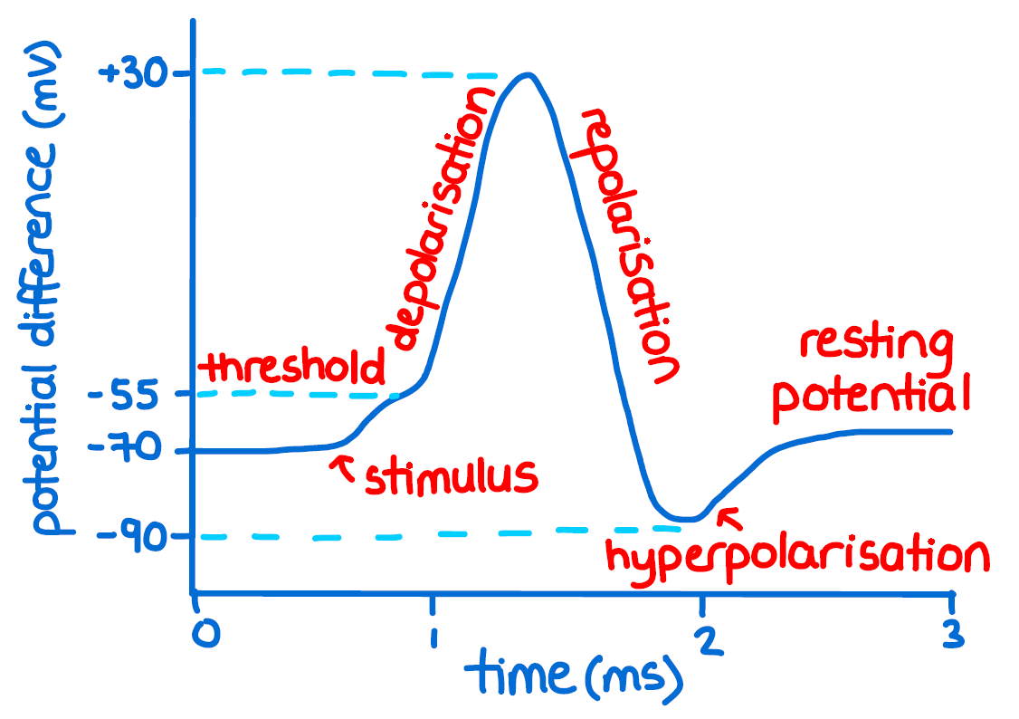
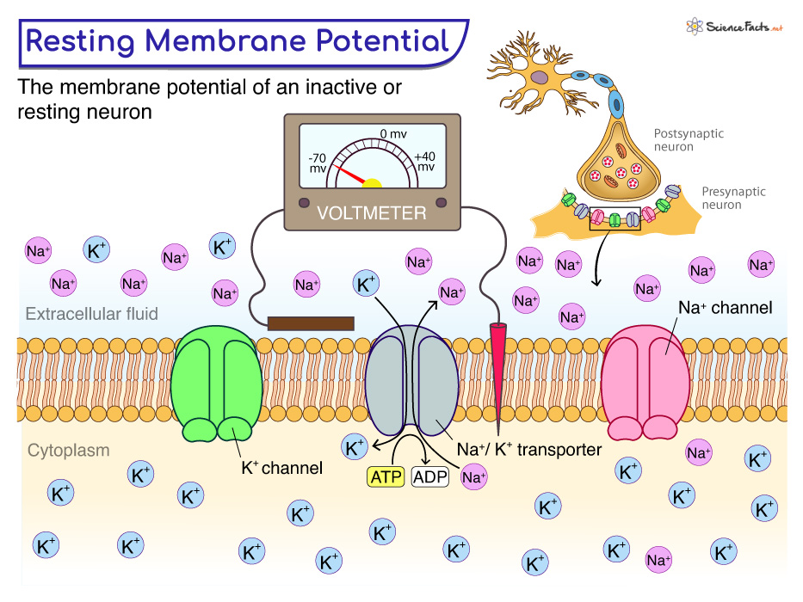

  - Neural signals at different scales
A single neuron's electrical activity does not produce just one kind of signal. Depending on how close the recording electrode is placed, and how many neurons are being captured at once, the same underlying electrical activity can look completely different from a sharp, brief spike belonging to one cell, to a smooth, slow wave summed across millions of cells, to a faint magnetic field detected outside the head entirely. Neural signals are therefore best understood as existing along a spectrum of scale, running from a single neuron up to the whole brain, with amplitude, frequency, and precision all changing as that scale changes.
SPIKE
When a neuron receives excitatory inputs or stimuli that depolarize its membrane to firing threshold, it can generate an action potential (AP). Both intracellular and extracellular measures APs from individual neurons, which yield distinct potential waveforms. For distinction, we refer to the intracellular waveform as an AP and the extracellular waveform as a unit spike or simply a spike. Intracellular recording measures the potential difference across the neuronal membrane. The AP, recorded by a glass pipette microelectrode positioned inside the membrane, is a sharp positive-going waveform with its rising phase primarily caused by Na+ influx. This Na+ influx simultaneously reduces the positive charges outside the membrane to create a current “sink” nearby. As a result, the corresponding spike recorded extracellularly exhibits a sharp negative-going wave form, opposite to the intracellular recording.

The diverse morphological structures of neurons result in various spike wave forms. The waveform differences enable the identification of neuronal types based on their spikes. In a wideband signal recording with a frequency range from several to thousands of hertz, the rising phase width of a pyramidal neuron spike (> 0.7 ms) is significantly wider than that of an interneuron (< 0.4 ms). This width index has become one of the best indices for distinguishing between the two neuron types. Obviously, the extracellular recording site can significantly affect both spike amplitude and waveshape. Spikes recorded near soma have a dominant negative peak due to Na+ influx during the initial action potential phase. In contrast, spikes recorded near dendrites exhibit a dominant positive peak due to the current outflux in its return loop
Furthermore, the larger soma membrane area can concentrate a greater Na+ flow, resulting in a larger spike, while the return current around dendrites is more dispersed, producing a smaller spike. Therefore, larger spikes typically have a negative peak, while spikes with a positive peak are usually smaller.

The amplitudes of intracellular and extracellular recordings are significantly different. Intracellular AP can exceed 100 mV in amplitude, while extracellular spikes are much smaller, mostly around 100 μV or below. Spike amplitude decreases rapidly and exponentially as the distance between the recording site and the neuronal membrane increases. Neurons within a ~ 100 μm radius around a recording point typically produce spikes with amplitudes ranging from tens to hundreds of microvolts. While an expanded radius contains more neurons, the spikes from these additional neurons have diminished amplitudes. These tiny spikes are difficult to detect and simply contribute to background activity, often considered as “noise”. Spikes are small in amplitude and short in duration, typically lasting no more than 2–3 ms. Their waveforms contain high-frequency components, mainly in the range of 300– 5000 Hz. As a result, spike recordings are susceptible to various high-frequency noises, like electronic thermal noises and background noises of indistinguishable spikes. The amplitude of such noises usually ranges in 5 to 20 μV. Generally, Spikes contain frequency content roughly from 300 Hz up to several kHz (up to ~7 kHz), which is why a 300 Hz high-pass filter is the standard method used to isolate spikes from the slower local field potential.

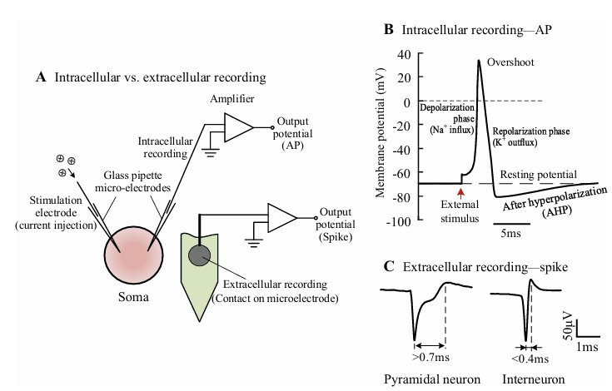
Local Field Potentials (LFP)

The local field potential is the electrical signal produced by the combined activity of a population of neurons surrounding a recording electrode, rather than the activity of any single cell. When an electrode is placed in neural tissue, it does not pick up the activity of just one neuron in isolation it sits within a small volume of tissue containing many neurons, and every one of them contributes something to the electrical field at that point. The LFP is what remains when this raw signal is separated from the sharp, individual spikes and only the slower, collective component is kept.

This collective component arises mainly from synaptic activity rather than from action potentials themselves. When a neuron receives input at its synapses, small currents flow across its membrane and through the surrounding tissue, even if that neuron never fires a full action potential. These synaptic currents are much slower and more graded than the sharp, all-or-none discharge of a spike, but when thousands of neurons are doing this simultaneously in the same region, their combined currents add together into a signal that is large enough to detect. The LFP, in essence, is the sound of a local neighbourhood of neurons communicating with one another, rather than the voice of any single neuron shouting.

Because it is generated this way, the LFP reflects something fundamentally different from a spike. A spike tells you when one neuron fired. The LFP tells you about the general level of synaptic activity and coordination within a small patch of brain tissue whether that region is quiet, active, or firing in a coordinated rhythm without being able to identify which individual neurons are responsible.

Extracellular recording of the electrical signal from brain results in a signal that can be roughly segregated by frequency-band separation into a high-frequency part (above 200–500 Hz), mainly reflecting multiple-unit spiking activity (MUA) and a lower part (below 200–500 Hz), the so-called ‘local field potential’ (LFP). While the MUA most likely represents extracellular action potentials of all neurons around the electrode within a sphere of about 140–300 mm radius LFP is primarily generated by transmembrane current passing through cellular membranes/synapses in the proximity of the electrode, ranging from several hundred micrometers to few millimeters, according to the recording conditions.

Consequently, LFPs capture a more spatially localized field that is typically larger in magnitude than an EEG. Perhaps more importantly, LFPs can be recorded from regions deeper in the brain, thus representing activity from neuronal populations less accessible to noninvasive methods. Nonetheless, many insights learned from the decades of EEG research can be translated into LFP analysis.

Although LFPs are recorded at depth, the type of electrode can vary, and the shape and impedance of the electrode also influence the recorded signal (Nelson and Pouget, 2010). Typical LFPs may be recorded from a low-impedance stimulating electrode, a high-impedance glass microelectrode, or a high-density microelectrode array. All of these electrodes implanted into the same brain region will yield a different representation of the underlying activity. The LFP recorded at the electrode is a spatial average of current sources in the surrounding brain area. The size and shape of this sampling field is in part dependent on the size and impedance of the electrode, but primarily based on the synchrony of neuronal firing in the region Perhaps the most important electrode consideration in a discussion of LFP analysis is the presence of multiple contacts. Multiple recording locations can enable analysis techniques that describe not only the activity of a single region, but the relationship between multiple local populations. This kind of information is helpful to describe network-level phenomena. For example, the phase of an oscillation is not so interesting to describe by itself. However, if two distal oscillations are phase-locked, you may conclude that those two regions are transmitting information in one or both directions. These kinds of comparisons are not possible with a single contact recording.

EEG
Electroencephalography (EEG) is the non-invasive recording of the brain's electrical activity using electrodes placed on the outer surface of the scalp. It was the first method ever developed that allowed scientists to record human brain activity without surgery, and it remains, decades later, one of the most widely used tools in both clinical medicine and brain research. EEG is a direct measure of neural activity, meaning it records the electrical signal generated by neurons themselves rather than a downstream proxy such as blood flow, and it offers exquisite temporal resolution, capable of tracking changes in brain activity on the order of milliseconds. It is also relatively low-cost and portable compared with alternatives such as functional MRI or magnetoencephalography, which require large, expensive, immobile equipment and specialized facilities.
Despite being a direct measure of neural electrical activity, EEG does not measure action potentials. It reflects a different and much slower physiological process, generated not by individual neurons firing in isolation but by large populations of neurons acting together in a coordinated, synchronized way. The current understanding is that EEG is primarily driven by large-scale voltage fluctuations resulting from synchronous post-synaptic activity. After an action potential is evoked in a neuron, that neuron releases neurotransmitters into the synaptic cleft; when these neurotransmitters bind to receptors on the post-synaptic neuron, they cause a change in charge across that neuron's body, and a passive outward flow of ions at the apical dendrites balances this charge shift. The net effect in a single neuron is only a small voltage differential, far too small to detect at the scalp. What is actually measured at the scalp is the combined activity of large neural assemblies, similarly oriented and firing synchronously together.
This dependence on both geometry and synchronous firing is why pyramidal neurons are considered the primary drivers of the EEG signal. Pyramidal neurons are an abundant class of excitatory neuron in the neocortex, arranged perpendicular to the cortical sheath and typically spanning multiple cortical layers, with their cell bodies and basal dendrites in deeper layers and their apical dendrites extending into more superficial layers. Because so many of these neurons share the same orientation, their individual electrical fields sum together in strength rather than cancel out, producing what are called open electrical fields. This geometric alignment is the physical reason a large enough signal survives to reach a scalp electrode at all.
Once generated in the cortex, this electrical activity must still travel through the meninges, the skull, and the scalp before reaching an electrode, and each of these layers is a relatively poor electrical conductor that further disperses the current along the way. This is why EEG is described as a volume-conducted signal: by the time the activity reaches the electrode, it no longer reflects the sharp, localized activity of one small patch of cortex, but a spatially blurred summation spread across a wider area of the scalp than its true source. This is the direct source of EEG's central trade-off. Its temporal resolution is excellent, since the signal is generated directly by large, synchronously active neural populations, but its spatial resolution is comparatively poor, since a signal detected at any single electrode could plausibly have originated from a fairly broad, ambiguous region of underlying cortex.
10-20 Electrode Placement System
EEG electrodes are positioned on the scalp using a standardized layout called the 10-20 system, developed by Herbert Jasper in 1958 and subsequently adopted as the international standard for EEG electrode placement. The name comes from the method used to set each electrode position: locations are determined using 10 percent or 20 percent intervals of the distance between fixed anatomical landmarks, specifically the nasion at the top of the nose, the inion at the back of the skull, and the two preauricular points in front of each ear. Because these measurements are taken relative to each individual's own skull landmarks rather than fixed absolute distances, the system automatically scales to different head sizes.
Each electrode position is identified using a letter and number code that encodes both the underlying brain region and hemisphere. Fp denotes the frontal pole, F the frontal region, C the central region, P the parietal region, O the occipital region, and T the temporal region. Odd numbers such as 1, 3, 5, and 7 indicate the left hemisphere, even numbers such as 2, 4, 6, and 8 indicate the right hemisphere, and the letter z denotes the midline, as in Cz, Fz, and Pz. The original 10-20 system specifies 21 electrode positions, and this remains common in clinical settings, with many standard clinical montages using around 19 to 21 electrodes. Research systems commonly use 32 electrodes as a middle ground, while high-density systems used for finer source localization employ 64, 128, or as many as 256 electrodes, sometimes exceeding 300 in specialized studies. Published studies do not always report these round numbers; because certain electrode positions are sometimes excluded due to noise or poor contact, reported counts can appear as less rounded figures such as 30, 61, 85, 96, or 118, all still derived from the same underlying 10-20 or extended 10-10 placement framework.
The EEG signal that reaches a scalp electrode is small in absolute terms, a direct consequence of how much the underlying cortical activity has been attenuated during its passage through the meninges, skull, and scalp. Typical EEG amplitude values fall in the range of roughly 10 to 200 microvolts, substantially smaller than the local field potential recorded closer to its cortical source, which can reach amplitudes as high as approximately 1 millivolt.
Despite its small amplitude, the EEG signal is information-rich, and much of that information is extracted by examining its frequency content. EEG activity is conventionally divided into named frequency bands. Delta activity, generally below about 4 Hz, is typically the dominant rhythm during deep, slow-wave sleep. Theta activity, in the range of roughly 4 to 8 Hz, is commonly associated with drowsiness and light sleep. Alpha activity, in the range of roughly 8 to 13 Hz, is typically most prominent during relaxed wakefulness with the eyes closed, and diminishes when the eyes open or attention becomes more focused. Beta activity, spanning roughly 13 to 30 Hz, generally increases during active thinking and focused concentration. Gamma activity, generally above about 30 Hz, has been associated with high-level cognitive processing. The exact frequency boundaries separating these bands vary slightly across sources and laboratories, and the ranges given here reflect the most commonly cited conventions rather than fixed, universally standardized limits.
Table: EEG Frequency Bands
Band | Frequency Range | Typical Brain State
Delta | Below ~4 Hz | Deep, slow-wave sleep
Theta | ~4 - 8 Hz | Drowsiness, light sleep
Alpha | ~8 - 13 Hz | Relaxed wakefulness, eyes closed
Beta | ~13 - 30 Hz | Active thinking, focused concentration
Gamma | Above ~30 Hz | High-level cognitive processing

0.1 to 100 Hz with typical signal amplitudes ranging from 10 to 100 µV (microvolts)
In summary, the overall EEG signal recorded at the scalp spans a frequency range of approximately 0.5 to 30 Hz across these five bands (with gamma activity extending above 30 Hz in some recordings), and its amplitude typically falls between approximately 10 and 200 microvolts, depending on the individual, electrode location, and brain state at the time of recording.
Once recorded, EEG signals are typically analyzed using one of two main approaches. The event-related potential approach examines how the signal changes in direct response to a specific event or stimulus; because the true response on any single trial is usually too small and too buried in background noise to see clearly, the same stimulus is presented many times and the recorded signal is averaged across all repetitions, allowing random noise to cancel out while the genuine, time-locked response survives and emerges as a clear waveform. The second approach, time-frequency or oscillation analysis, instead examines the signal's ongoing rhythmic structure, tracking how much power exists at different frequencies and how that power changes over time, which is better suited to studying continuous brain states rather than isolated responses to single events.
EEG remains a cornerstone tool in clinical neurology, most notably for diagnosing and monitoring epilepsy, where it can detect the abnormal, synchronized neural firing patterns characteristic of seizure activity, and it is widely used in the assessment of sleep disorders, since the frequency bands described above map closely onto different stages of sleep. Beyond clinical medicine, EEG is one of the primary tools used in cognitive neuroscience to study attention, memory, and perception, typically using the event-related potential and oscillation analysis techniques described above, and it forms the basis of many brain-computer interface systems that translate recorded brain activity directly into control signals for external devices.

Images
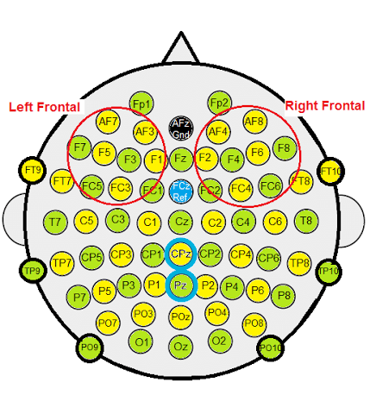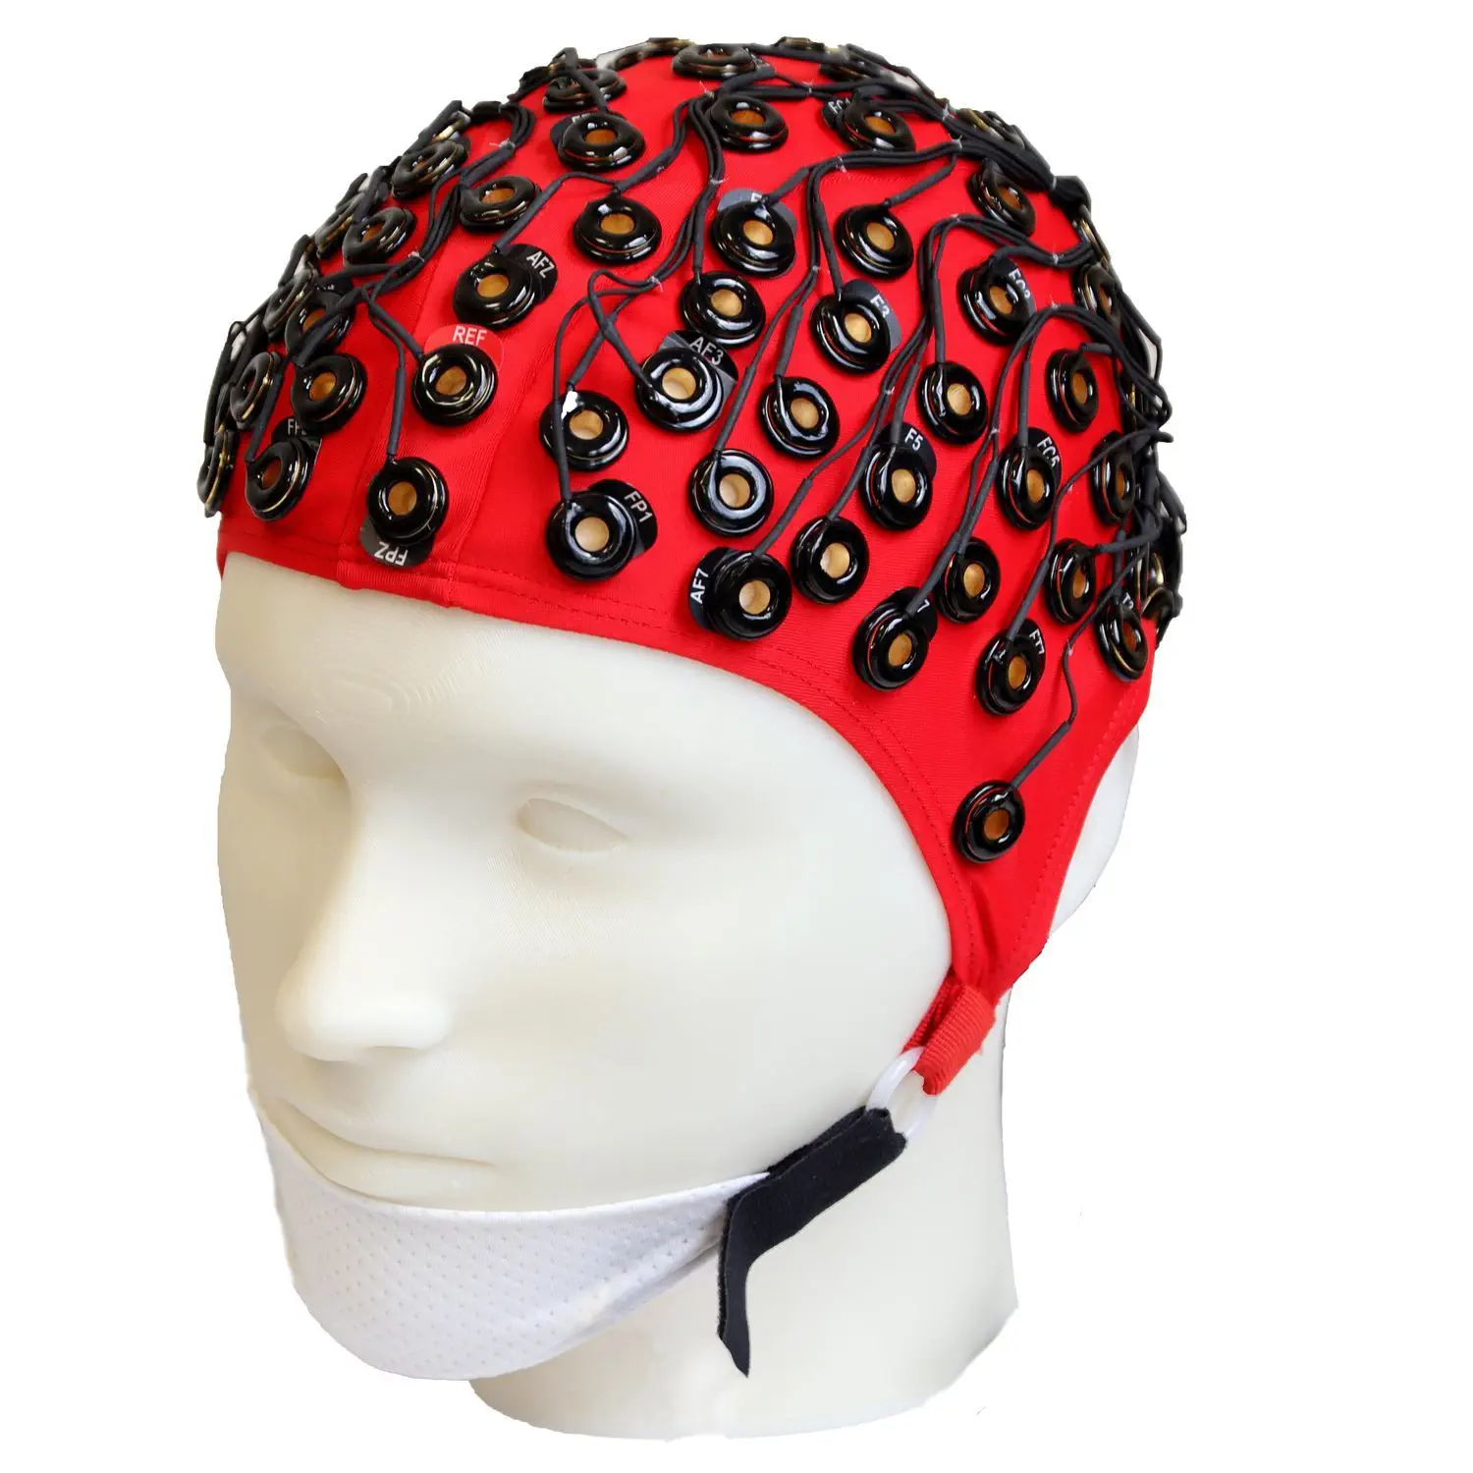

Electrocorticography
Electrocorticography is defined as the intracranial recording of EEG using subdural grids directly on the surface of the cortex to capture electrical activity from the cerebral cortex, typically requiring a craniotomy for grid implantation. Electrocorticography is the direct recording of electrical potentials associated with brain activity from the cerebral cortex.

ECoG was pioneered in the early 1950s by Wilder Penfield and Herbert Jasper, neurosurgeons at the Montreal Neurological Institute. The two developed ECoG as part of their groundbreaking Montreal procedure, a surgical protocol used to treat patients with severe epilepsy. The cortical potentials recorded by ECoG were used to identify epileptogenic zones regions of the cortex that generate epileptic seizures. These zones would then be surgically removed from the cortex during resectioning, thus destroying the brain tissue where epileptic seizures had originated. Penfield and Jasper also used electrical stimulation during ECoG recordings in patients undergoing epilepsy surgery under local anesthesia. This procedure was used to explore the functional anatomy of the brain, mapping speech areas and identifying the somatosensory and somatomotor cortex areas to be excluded from surgical removal.

ECoG grids are primarily used to identify the location of seizures in epileptic patients and to help planning epileptic surgery. Because the neural signal is not distorted by other tissue or bone, the signal-to-noise ratio and spatial resolution for ECoG systems can be much higher than that of EEG. Recently grids with smaller electrodes, sometimes called micro-ECoG, have been used as a BCI signal source, which increase the spatial resolution further. As the electrodes are placed on top of the brain surface, ECoG is considered less invasive than electrodes that penetrate the cortex. This has the additional advantage that the danger of inflammation is reduced and the immune response and eventual encapsulation of the electrodes are less problematic.

Electrophysiological basis
ECoG signals are composed of synchronized postsynaptic potentials (local field potentials), recorded directly from the exposed surface of the cortex. The potentials occur primarily in cortical pyramidal cells, and thus must be conducted through several layers of the cerebral cortex, cerebrospinal fluid (CSF), pia mater, and arachnoid mater before reaching subdural recording electrodes placed just below the dura mater (outer cranial membrane). However, to reach the scalp electrodes of a conventional electroencephalogram (EEG), electrical signals must also be conducted through the skull, where potentials rapidly attenuate due to the low conductivity of bone. For this reason, the spatial resolution of ECoG is much higher than EEG, a critical imaging advantage for presurgical planning. ECoG offers a temporal resolution of approximately 5 ms and spatial resolution as low as 1-100 μm.
Using depth electrodes, the local field potential gives a measure of a neural population in a sphere with a radius of 0.5–3 mm around the tip of the electrode. With a sufficiently high sampling rate (more than about 10 kHz), depth electrodes can also measure action potentials. In which case the spatial resolution is down to individual neurons, and the field of view of an individual electrode is approximately 0.05–0.35 mm.

The ECoG recording is performed from electrodes placed on the exposed cortex. In order to access the cortex, a surgeon must first perform a craniotomy, removing a part of the skull to expose the brain surface. This procedure may be performed either under general anesthesia or under local anesthesia if patient interaction is required for functional cortical mapping. Electrodes are then surgically implanted on the surface of the cortex, with placement guided by the results of preoperative EEG and magnetic resonance imaging (MRI). Electrodes may either be placed outside the dura mater (epidural) or under the dura mater (subdural). ECoG electrode arrays typically consist of sixteen sterile, disposable stainless steel, carbon tip, platinum, Platinum-iridium alloy or gold ball electrodes, each mounted on a ball and socket joint for ease in positioning. These electrodes are attached to an overlying frame in a "crown" or "halo" configuration. Subdural strip and grid electrodes are also widely used in various dimensions, having anywhere from 4 to 256 electrode contacts. The grids are transparent, flexible, and numbered at each electrode contact. Standard spacing between grid electrodes is 1 cm; individual electrodes are typically 5 mm in diameter. The electrodes sit lightly on the cortical surface, and are designed with enough flexibility to ensure that normal movements of the brain do not cause injury. A key advantage of strip and grid electrode arrays is that they may be slid underneath the dura mater into cortical regions not exposed by the craniotomy. Strip electrodes and crown arrays may be used in any combination desired. Depth electrodes may also be used to record activity from deeper structures such as the hippocampus.

