2.1 The Neural Signal Acquisition Chain
Duration: ~10 Minutes

2.1.1 Introduction
In the previous module, we learned how neurons generate electrical signals and how these signals can be recorded at different spatial scales. However, neural activity occurring inside the body cannot be observed directly on a computer.
This raises an important question.
How does a tiny biological signal generated inside the brain eventually become the waveform displayed on a computer screen?
The answer lies in a sequence of recording and processing steps collectively known as the neural signal acquisition chain.
Regardless of whether we are recording EEG, EMG, ECoG, or microelectrode signals, every recording system follows this same fundamental pathway. Understanding this acquisition chain provides the foundation for the remaining sections of this module.
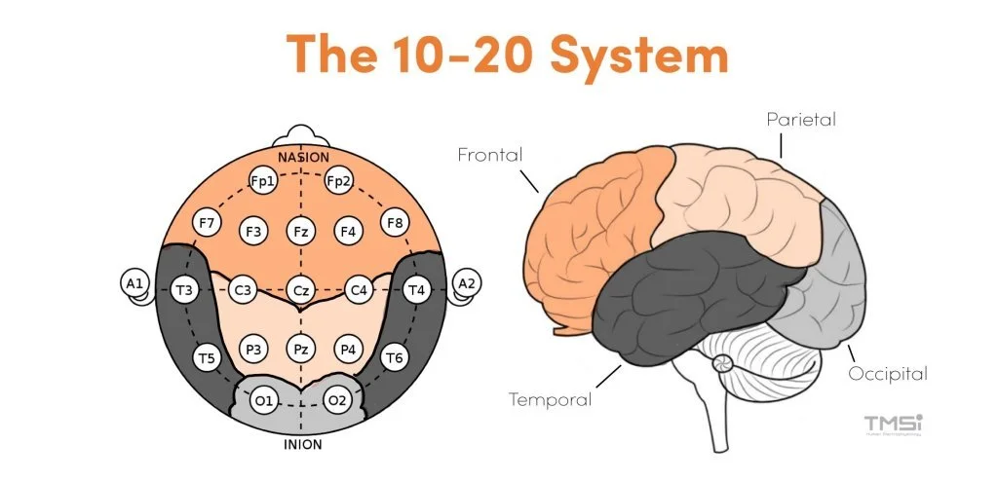

2.1.2 Learning Objective
After completing this section, you should be able to:
- Define the neural signal acquisition chain.
- Identify its major components.
- Explain the function of each stage.

2.1.3 The Neural Signal Acquisition Chain
The neural signal acquisition chain is the complete sequence of hardware and electronic components that convert biological activity into digital data.
Although different recording techniques employ different sensors, the overall workflow remains the same.
The acquisition chain can be represented as follows.
Biological Source → Electrode/Sensor → Amplifier → Filter → Analog-to-Digital Converter → Computer
Each component performs a specific function, and the quality of the final recording depends on the successful operation of every stage.
(Figure 2.1: Neural Signal Acquisition Chain)
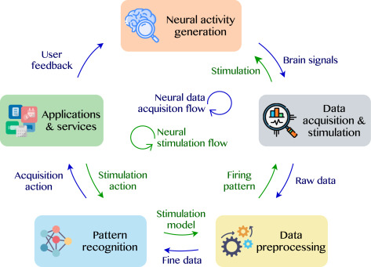

2.1.4 Components of the Acquisition Chain

Biological Source
Every recording begins with a biological event occurring inside the body.
Depending on the recording modality, the biological source may be the electrical activity of cortical neurons, muscle fibres, eye muscles, or individual neurons.
Without this physiological activity, there is no signal to record.

Electrode or Sensor
The electrode or sensor detects the biological signal and transfers it to the recording system.
Different recording techniques use different sensing devices.
For example,
- EEG uses scalp electrodes.
- EMG uses surface or needle electrodes.
- ECoG uses electrode grids placed directly on the cortical surface.
- MEG uses specialised magnetic sensors.
- 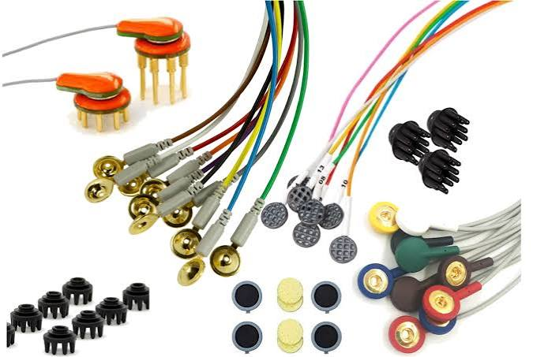
Although their designs differ, they all perform the same fundamental task—detecting physiological activity.

Amplifier
The detected biological signal is extremely small, often only a few microvolts.
Such weak signals cannot be processed reliably by electronic systems.
Therefore, the signal is passed through an amplifier, which increases its amplitude while preserving the information contained within the waveform.
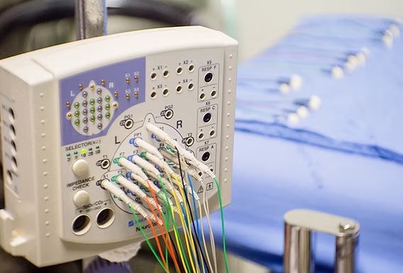

Filter
Even after amplification, the recorded signal contains unwanted electrical interference.
Filters remove these unwanted frequency components while preserving the signal of interest.
Different types of filters are used depending on the recording application.
The principles of filtering will be discussed in detail later in this course.
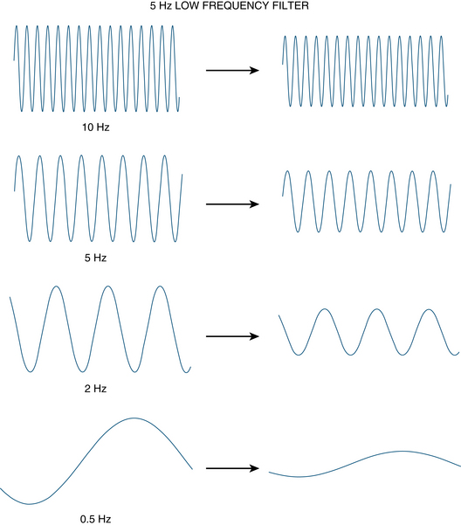

Analog-to-Digital Converter (ADC)
Up to this stage, the recorded signal is analogue.
Computers, however, process only digital information.
The Analog-to-Digital Converter samples the analogue signal at regular intervals and converts each sample into a numerical value, producing a digital representation of the original biological signal.
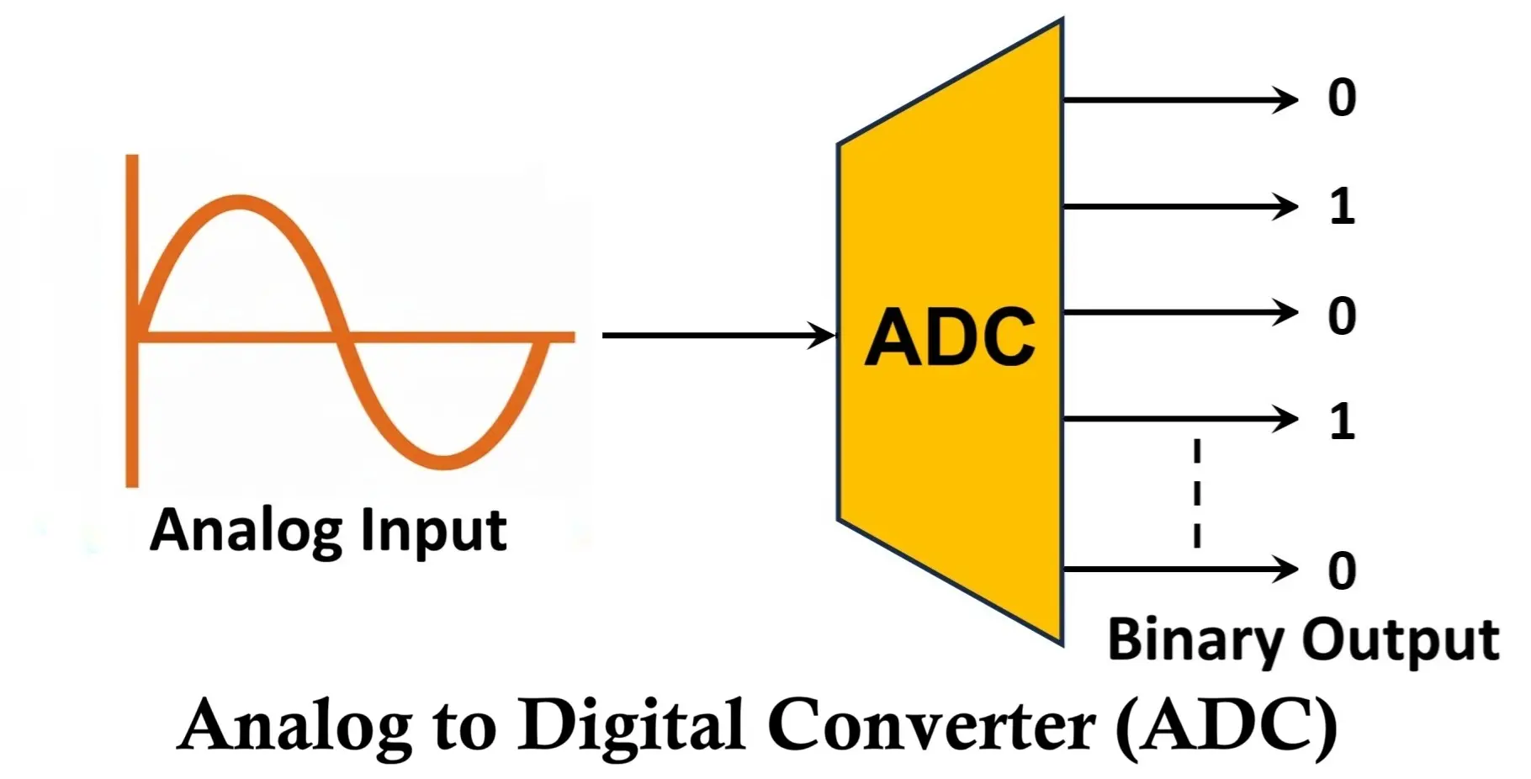

Computer
Once digitised, the signal is transferred to the computer.
Specialised software is then used to display, store, process, and analyse the recorded data.
Subsequent operations such as filtering, feature extraction, spectral analysis, and classification all depend on the quality of this acquired signal.

2.1.5 Putting the Components Together
The acquisition chain should not be viewed as a collection of independent devices.
Instead, it functions as an integrated system in which each stage prepares the signal for the next.
A poor electrode contact cannot be corrected by a better amplifier.
Similarly, incorrect sampling cannot be compensated for during later analysis.
Consequently, successful neural signal processing always begins with careful signal acquisition.

2.1.6 Summary
In this section, we introduced the neural signal acquisition chain and examined the purpose of each of its major components.
The most important point to remember is that every neural recording system follows the same fundamental workflow:
Biological Source → Electrode/Sensor → Amplifier → Filter → ADC → Computer
Although the sensing technology may differ across EEG, EMG, ECoG, or MEG, the overall acquisition process remains essentially the same.

Transition to Section 2.2
Now that we understand the overall acquisition process, the next logical step is to examine the component responsible for detecting the biological signal.
In the next section, we will discuss the different types of electrodes and sensors, their operating principles, and the recording modalities in which they are used.

