2.2 Electrodes and Sensors

Duration: ~10 Minutes

2.2.1 Introduction
In the previous section, we learned that every neural recording system follows the same acquisition chain. The first hardware component in this chain is the electrode or sensor.
Regardless of whether we are recording EEG, EMG, ECoG, or MEG, the recording process cannot begin unless the physiological signal is first detected. The device responsible for detecting this signal is the electrode or sensor.
In this section, we will examine the different types of electrodes and sensors used in neuroscience, understand how they differ from one another, and discuss why different recording techniques require different sensing technologies.

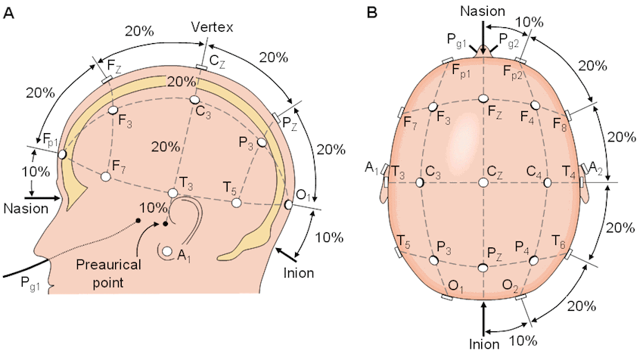

2.2.2 Learning Objectives
After completing this section, you should be able to:
- Explain the purpose of an electrode or sensor.
- Distinguish between surface electrodes, needle electrodes, and microelectrodes.
- Describe the electrodes used in EEG and ECoG recordings.
- Explain why MEG uses magnetic sensors instead of electrodes.
- Compare the advantages and limitations of different recording sensors.

2.2.3 What is an Electrode?

Definition
An electrode is a device that detects the electrical activity generated by biological tissues and transfers that signal to the recording system.
An electrode does not generate electrical signals. Instead, it acts as an interface between the body and the recording instrument, allowing naturally occurring physiological signals to be measured.

Lecture
Think about using a thermometer to measure body temperature.
The thermometer does not produce heat. It simply measures the heat already present in the body.
An electrode works in a very similar way.
It does not create electrical activity. Instead, it detects the electrical potentials already produced by neurons, muscles, or other biological tissues and delivers these signals to the acquisition system for further processing.
For accurate recordings, the electrode must maintain good electrical contact with the tissue. Poor contact can introduce unwanted noise, reduce signal quality, and make subsequent analysis less reliable.

Key Definition
Electrode: A conductive interface that detects biological electrical activity and transfers it to the recording system.

2.2.4 Surface Electrodes

Definition
Surface electrodes are electrodes placed directly on the skin without penetrating the body.
Because they do not require surgery or needle insertion, they are classified as non-invasive electrodes.

Lecture
Surface electrodes are among the most commonly used recording electrodes in biomedical engineering.
They are widely used for EEG, surface EMG, and ECG recordings because they are safe, inexpensive, and easy to apply.
Before placing a surface electrode, the skin is often cleaned and a conductive gel is applied. The gel improves electrical contact between the electrode and the skin by reducing contact resistance, allowing cleaner recordings.
Although surface electrodes are convenient, they are positioned some distance away from the actual biological source. As a result, the recorded signal is usually weaker and has lower spatial resolution than recordings obtained using invasive electrodes.

Advantages
- Non-invasive
- Comfortable for the subject
- Easy to apply
- Suitable for long-duration recordings

Limitations
- Lower signal amplitude
- More susceptible to motion artefacts
- Lower spatial resolution

2.2.5 Needle and Microelectrodes

Needle Electrodes
Needle electrodes are inserted directly into biological tissue.
Unlike surface electrodes, they are capable of recording signals much closer to their source.
They are commonly used during clinical EMG examinations to record the electrical activity of individual muscles.
Because they are positioned inside the muscle, needle electrodes provide higher-quality recordings than surface electrodes. However, they are invasive and may cause discomfort.

Microelectrodes
Microelectrodes are extremely small electrodes designed for recording neural activity at the cellular level.
They are capable of recording action potentials from individual neurons or very small groups of neurons.
These electrodes are widely used in neuroscience research, neurophysiology, and brain-computer interface studies where high spatial resolution is required.
Because microelectrodes penetrate neural tissue, they require surgical implantation and are therefore highly invasive.

Important Note
As the recording electrode moves closer to the biological source, signal quality generally improves. However, increasing proximity usually increases invasiveness.
This is one of the fundamental trade-offs in neural recording.

2.2.6 EEG Electrodes
EEG records electrical activity from the scalp using surface electrodes.
These electrodes are positioned according to standardized placement systems, most commonly the International 10–20 System.
Since EEG signals must travel through the meninges, skull, and scalp before reaching the electrodes, they are relatively small in amplitude.
For this reason, maintaining low electrode impedance and good contact with the scalp is essential for obtaining high-quality EEG recordings.
(A detailed discussion of the 10–20 system will be covered later when EEG is discussed in the applications module.)

2.2.7 ECoG Grids
Unlike EEG, Electrocorticography records electrical activity directly from the surface of the cerebral cortex.
Instead of individual scalp electrodes, ECoG uses flexible electrode grids or strips that are surgically placed on the exposed cortex.
Because the electrodes are much closer to the neural source, ECoG recordings provide higher signal amplitude, better spatial resolution, and an improved signal-to-noise ratio compared with EEG.
However, these advantages come at the cost of requiring neurosurgery, making ECoG an invasive recording technique.

2.2.8 MEG Sensors
Magnetoencephalography uses a different sensing principle.
Instead of measuring electrical voltage, MEG measures the extremely small magnetic fields generated by neuronal activity.
Therefore, MEG does not use electrodes.
Instead, it employs highly sensitive magnetic sensors positioned around the participant's head.
Although the sensing technology differs, the purpose remains the same: detecting neural activity so that it can enter the acquisition chain.

2.2.9 Comparison of Common Recording Sensors
Recording Technique | Sensor Used | Placement | Invasiveness
EEG | Scalp electrodes | On the scalp | Non-invasive
Surface EMG | Surface electrodes | On the skin | Non-invasive
Intramuscular EMG | Needle electrodes | Inside the muscle | Invasive
ECoG | Electrode grids | Cortical surface | Invasive
Microelectrode Recording | Microelectrodes | Inside neural tissue | Highly invasive
MEG | Magnetic sensors | Outside the head | Non-invasive

2.2.10 Summary
In this section, we examined the different types of electrodes and sensors used in neural signal acquisition.
Although these devices differ in their design and recording location, they all perform the same fundamental function—detecting physiological activity and transferring it to the acquisition system.
Selecting an appropriate sensor always involves balancing signal quality, spatial resolution, patient safety, and invasiveness.

Transition to Section 2.3
Now that we know how biological signals are detected, another challenge immediately becomes apparent.
The detected signals are extremely small—often only a few microvolts.
Such weak signals cannot be processed directly.
In the next section, we will explore how these signals are strengthened and prepared for further processing through amplification and signal conditioning.

