4.2 Why frequency-domain analysis is needed
The case for the frequency domain rests on four practical needs, only the first of which is about seeing the signal more clearly.
(a) Separating superimposed rhythms
Rhythms that are inseparable in time separate cleanly in frequency, because each occupies a distinct region of the spectrum. A trace containing a 3 Hz component, a 10 Hz component and a 22 Hz component appears in the time domain as a single irregular waveform with no obvious structure; its spectrum shows three unambiguous peaks whose heights give the relative contribution of each. This is the single most important reason for the transform, and it is why quantitative EEG is conducted almost entirely in the frequency domain.
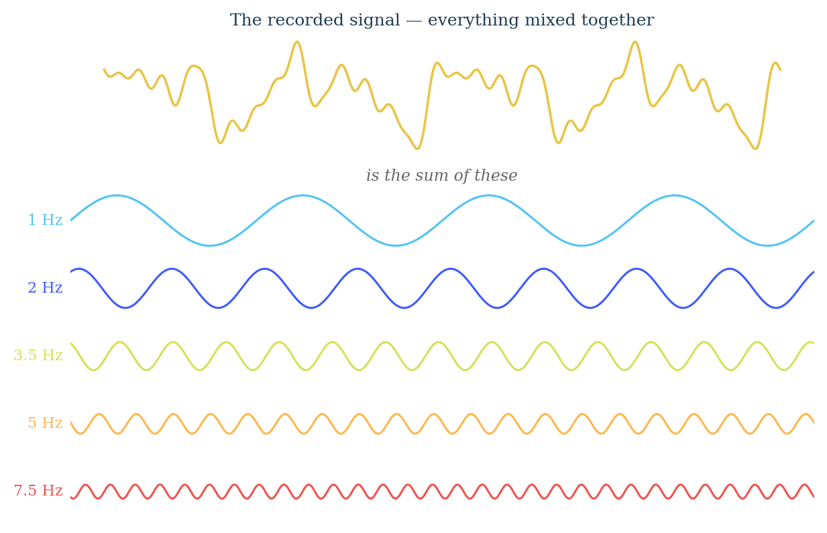
Figure 4.2.1 A recorded signal is the sum of many simple oscillations added together.
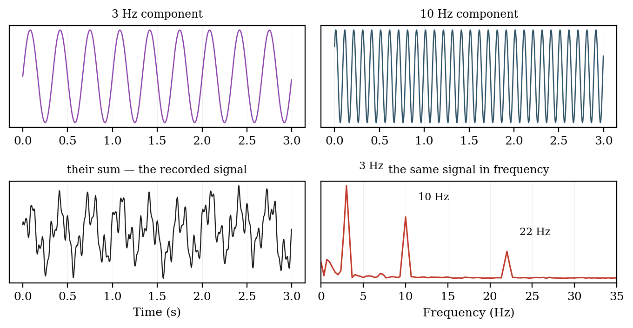
Figure 4.2.2 Components that are inseparable in time appear as distinct peaks in frequency.
(b) Designing filters
Every filtering decision taken in Module 3 presupposed spectral knowledge. Choosing a high-pass cut-off to remove electrode drift, a low-pass to remove muscle contamination, or a notch to remove mains interference all require knowing where in the spectrum the unwanted energy lies and, critically, whether it overlaps the signal. A filter cannot be specified in the time domain.
(c) Choosing the sampling rate
The sampling theorem, developed in Section 4.5, is stated entirely in terms of the highest frequency present in the signal. Without spectral knowledge the sampling rate cannot be justified, and an inadequate rate corrupts the recording irreversibly.
(d) Clinical and scientific interpretation
Many findings are defined spectrally and have no time-domain equivalent. Diffuse slowing — a shift of power from alpha into theta and delta — is a standard marker of encephalopathy. The individual alpha peak frequency correlates with cognitive performance and declines in dementia. Localised muscle fatigue is quantified by the fall in EMG median frequency described in Module 1. None of these can be measured by inspecting a trace.

