4.5 Sampling and the Nyquist principle
4.5.1 What sampling is
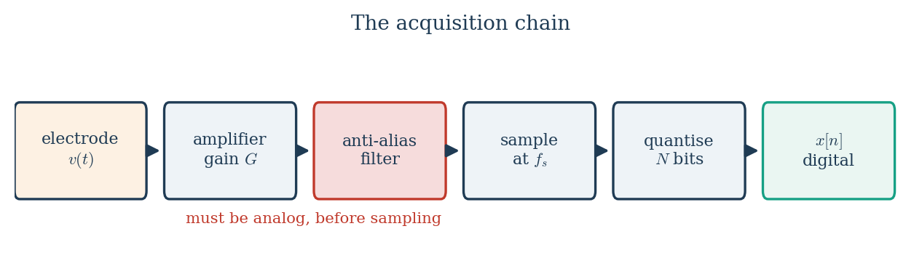
Figure 4.5.1 Where sampling sits in the acquisition chain.
Sampling is the replacement of a continuous signal by a sequence of values measured at regularly spaced instants. It is the step at which a physiological voltage becomes a set of numbers, and it is performed by the analog-to-digital converter at the end of the amplifier chain described in Module 3.
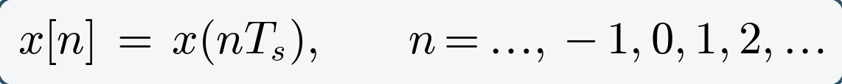 (4.7)
Two quantities define the process, and they are reciprocals of one another:
The sampling interval Tₛ is the time between consecutive samples; the sampling frequency or sampling rate fₛ is the number of samples taken per second. A clinical EEG sampled at fₛ = 500 Hz therefore has Tₛ = 2 ms between samples. The question that the sampling theorem answers is how large fₛ must be for the sample sequence to represent the original signal without loss.
4.5.2 What sampling does to the spectrum
Sampling has one consequence that explains everything else in this section: it makes copies of the spectrum. The original spectrum stays where it is, and an identical copy appears centred at every multiple of the sampling frequency.
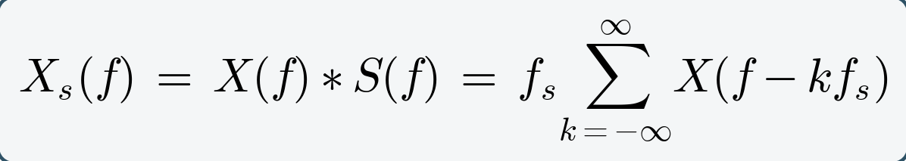 (4.9)
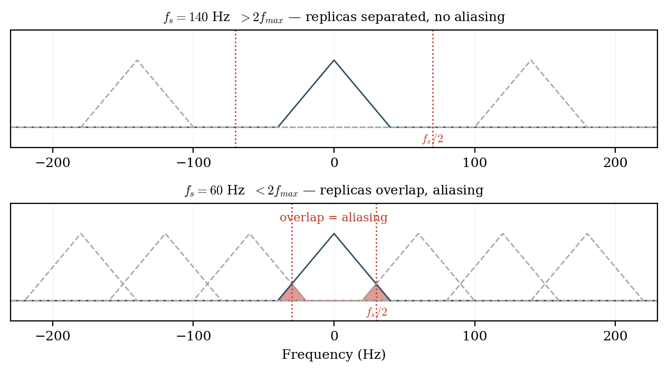
Figure 4.5.2 Sampling replicates the spectrum at every multiple of fₛ. The replicas stay separate only when fₛ > 2fₘₐₓ.
Nothing has been lost provided those copies do not touch one another. Everything that follows is a consequence of that single picture.
4.5.3 The Nyquist criterion
Suppose the signal contains no energy above fₘₐₓ. The baseband copy of the spectrum then occupies the range from −fₘₐₓ to +fₘₐₓ, and the first repeated copy is centred at fₛ and extends downward to fₛ − fₘₐₓ. The two copies remain separate provided the lower edge of the first replica lies above the upper edge of the baseband:
(4.10)
This is the Nyquist–Shannon sampling theorem, established by Nyquist in 1928 and given its information-theoretic form by Shannon in 1949. Two derived terms are used constantly and are frequently confused with one another:
The Nyquist frequency is a property of the recording system: it is half the rate at which that system samples, and it is the highest frequency that system can represent. The Nyquist rate is a property of the signal: it is twice the highest frequency the signal contains, and it is the minimum rate at which that signal must be sampled. A system samples above the Nyquist rate; a signal must contain nothing above the Nyquist frequency.
Figure 4.5.2 Sampling replicates the spectrum at every multiple of fₛ. The replicas stay separate only when fₛ > 2fₘₐₓ.
4.5.4 Aliasing
When the criterion is violated the replicas overlap, and energy from the region above fₛ/2 is added to the baseband where it is indistinguishable from genuine low-frequency content. This is aliasing, and it is irreversible: once two frequencies have produced identical sample sequences, no algorithm can separate them, because the information is not degraded but absent.
The frequency at which a component above the Nyquist frequency appears after sampling is given by
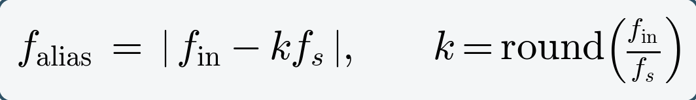 (4.11)
Worked example one. A 9 Hz sinusoid sampled at fₛ = 10 Hz. Here k = round(9/10) = 1, so f_alias = |9 − 10| = 1 Hz. The 9 Hz component is recorded as a 1 Hz component, as Figure 4.5.3 shows.
Worked example two. Mains interference at 50 Hz in an EEG sampled at fₛ = 80 Hz. Here k = round(50/80) = 1, so f_alias = |50 − 80| = 30 Hz. The interference appears at 30 Hz, inside the beta band, where it is completely indistinguishable from genuine beta activity and where no notch filter at 50 Hz will touch it.
Worked example three. A spike component at 600 Hz in a recording sampled at fₛ = 250 Hz. Here k = round(600/250) = 2, so f_alias = |600 − 500| = 100 Hz, which folds into the gamma range.
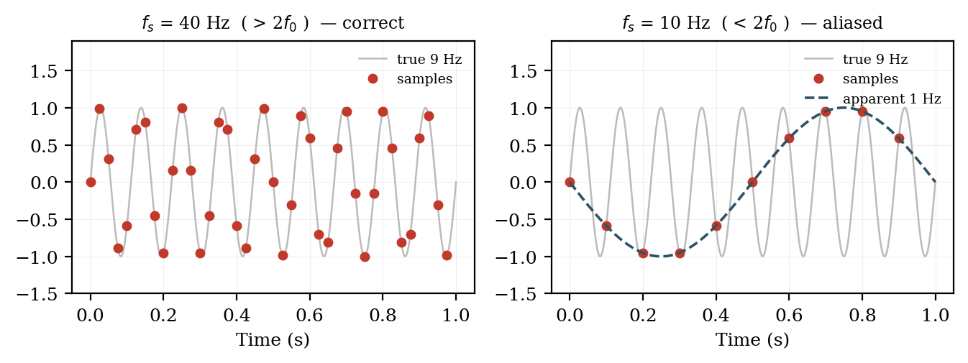
Figure 4.5.3 A 9 Hz sinusoid sampled correctly at 40 Hz, and aliased to 1 Hz when sampled at 10 Hz.
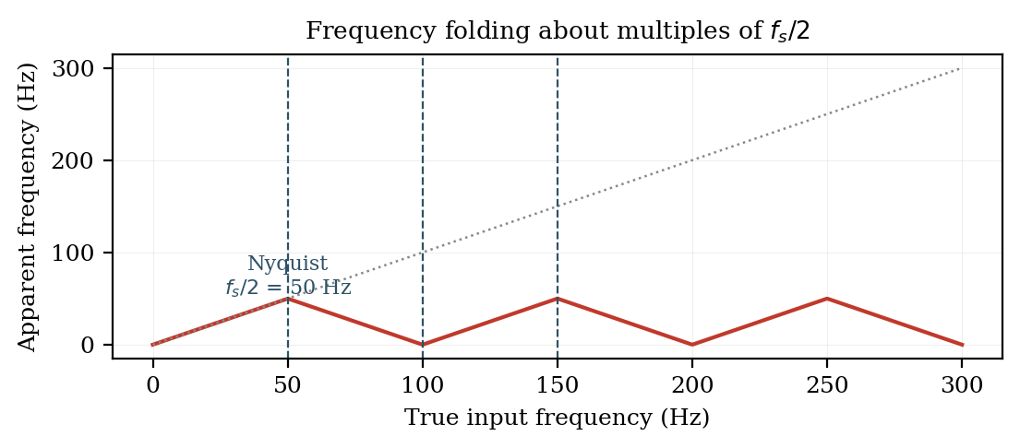
Figure 4.5.4 The folding relationship between true input frequency and apparent frequency.
4.5.5 The anti-aliasing filter
Because aliasing occurs at the instant of sampling, it must be prevented before the converter, never corrected afterwards. Every properly designed acquisition system therefore places an analog low-pass filter immediately ahead of the ADC, with its cut-off set below fₛ/2. A digital filter applied to the sampled data is useless for this purpose, since it operates on numbers in which the aliasing has already taken place. This is the single most common and most serious design error in low-cost biosignal hardware.
4.5.6 Reconstruction
If the Nyquist condition is met, the original continuous signal can be recovered exactly from its samples by low-pass filtering. The reconstructed curve passes through every sample and interpolates between them in the only way consistent with the band limit. Nothing is guessed.
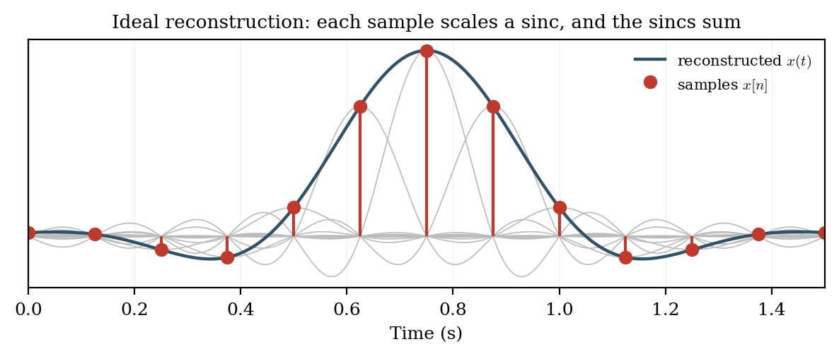
Figure 4.5.4 Reconstruction: each sample scales a smooth interpolating function, and their sum recovers the original signal.
4.5.7 Practical rates and quantisation
Because real anti-aliasing filters roll off over a finite transition band rather than cutting off abruptly, sampling at exactly twice fₘₐₓ leaves no margin. Practical systems oversample:
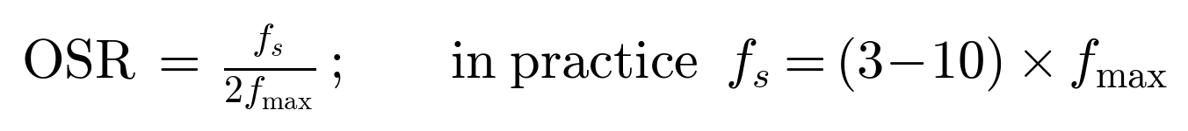
Oversampling also improves the fidelity of transient waveforms, which matters for spike morphology, and it relaxes the required steepness of the analog filter — the reason high-rate sigma-delta converters with gentle analog front ends have become the norm.
Sampling discretises time; quantisation discretises amplitude, and introduces its own error floor as described in Section 3.1.1:
Table 4.5.1: Sampling rates in practice
Signal | Useful band | Nyquist rate (2fₘₐₓ) | Typical fₛ used | OSR
EOG | DC – 10 Hz | 20 Hz | 100 – 256 Hz | 5 – 13
EEG (clinical) | 0.5 – 70 Hz | 140 Hz | 250 – 500 Hz | 2 – 4
EEG (gamma / HFO) | 0.5 – 500 Hz | 1 kHz | 1 – 2 kHz | 1 – 2
ECG | 0.05 – 150 Hz | 300 Hz | 500 Hz – 1 kHz | 2 – 3
Surface EMG | 20 – 500 Hz | 1 kHz | 1 – 2 kHz | 1 – 2
Extracellular spikes | 300 Hz – 5 kHz | 10 kHz | 20 – 30 kHz | 2 – 3

