4.6 Systems and the transfer function
So far the frequency domain has been used to describe a signal. It is also the natural way to describe what a system does to a signal, and this is where it earns most of its practical value.
4.6.1 Why filtering is easier in the frequency domain
Any linear system, such as an amplifier or a filter, is fully characterised by its impulse response h(t), which is simply its output when the input is a single sharp impulse. To find the output for any other input, the input must be convolved with h(t). Convolution is an awkward operation: every output sample depends on a weighted sum of many input samples.
In the frequency domain the same operation becomes a multiplication. The Fourier transform of the impulse response is called the transfer function H(f), and the output spectrum is simply the input spectrum multiplied by it, frequency by frequency.
(4.13)
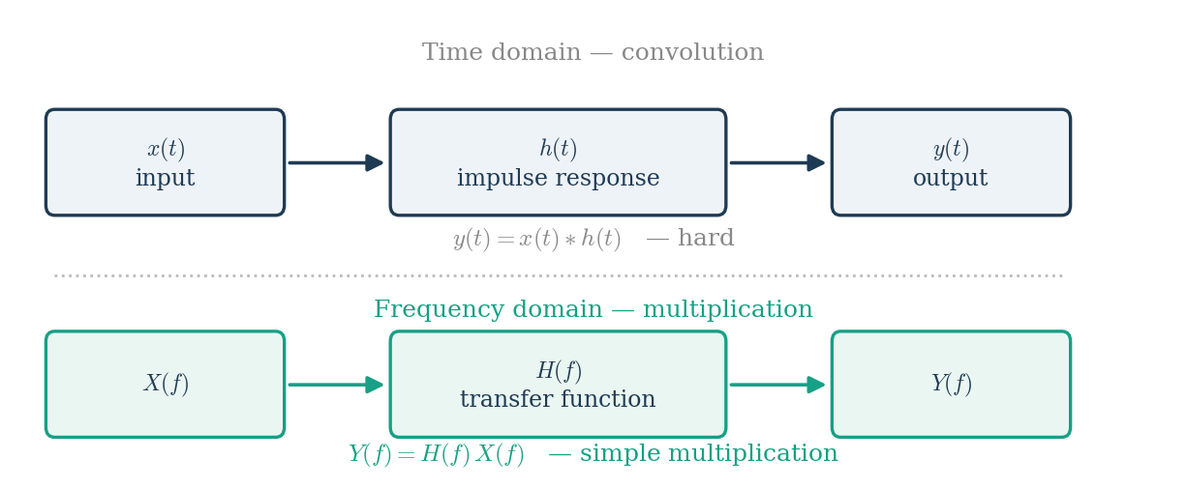
Figure 4.6.1 The same operation in both domains: convolution becomes multiplication.
This is the single most useful property of the frequency domain. A filter that is difficult to describe as a time-domain operation is trivial to describe as a curve of gain against frequency.
4.6.2 Reading a transfer function
H(f) is complex, so it has a magnitude and a phase. The magnitude states how much each frequency is amplified or attenuated, and the phase states how much each frequency is delayed.
- Where the magnitude is 1, that frequency passes unchanged.
- Where the magnitude is 0, that frequency is removed completely.
- The cut-off frequency is conventionally the point where the magnitude falls to 1/√2 of its passband value, which is half the power, or −3 dB.
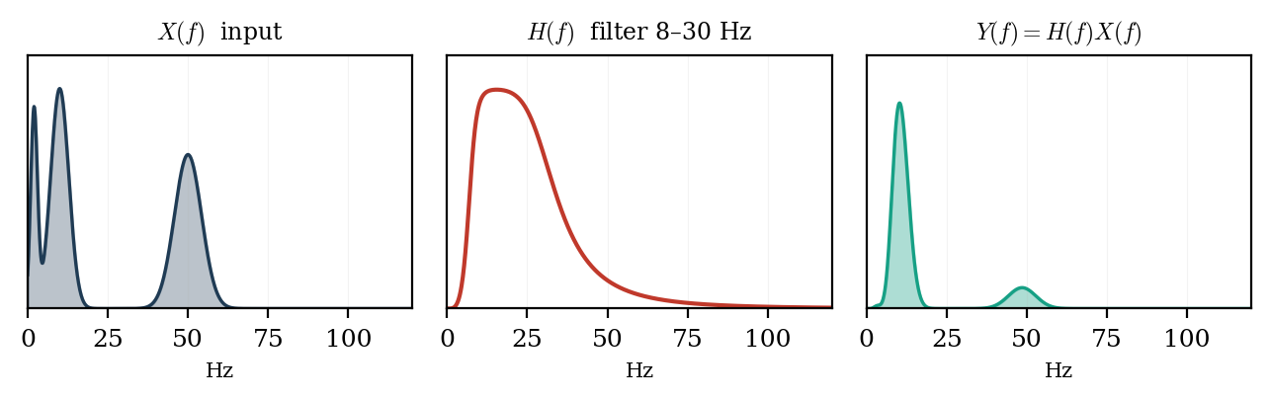
Figure 4.6.2 A band-pass filter applied in the frequency domain: the output spectrum is the input multiplied by the filter.
Figure 4.6.2 shows the whole idea in one line of arithmetic. The input contains slow drift near 1 Hz, an alpha peak near 10 Hz, and muscle activity near 50 Hz. The filter has a magnitude close to 1 between 8 and 30 Hz and close to 0 elsewhere. Multiplying the two leaves only the alpha peak. Nothing was subtracted or searched for; the unwanted content was simply multiplied by a number close to zero.
4.6.3 Filters used in biosignal recording
Table 4.6.1: Common filters and what they remove
Filter | Passes | Typical use
High-pass | Above the cut-off | Removes electrode drift and sweat artifact, cut-off 0.5 Hz
Low-pass | Below the cut-off | Removes muscle and high-frequency noise, cut-off 40 – 70 Hz
Band-pass | Between two cut-offs | Isolates one EEG band, or the 20 – 500 Hz EMG band
Band-stop (notch) | Everything except a narrow band | Removes 50 Hz mains interference
Anti-aliasing | Below fₛ/2 | Must be analog, placed before the converter

One caution follows from the phase of H(f). A filter that removes an unwanted band also shifts the timing of what remains, and a sharp filter shifts it more. For work where latency matters, such as evoked potentials, the filter must either have linear phase or be applied forwards and then backwards so that the phase shifts cancel.
4.6.4 Worked examples
Worked example 4.2 — a high-pass filter removing drift
An EEG recording contains slow electrode drift of 500 µV at 0.2 Hz and a genuine alpha rhythm of 40 µV at 10 Hz. A high-pass filter is applied whose magnitude response is |H| = 0.10 at 0.2 Hz and |H| = 0.98 at 10 Hz. Applying equation (4.13) at each frequency separately:
- Drift: 500 µV × 0.10 = 50 µV
- Alpha: 40 µV × 0.98 = 39.2 µV
The drift has been reduced tenfold while the alpha rhythm has lost only two per cent of its amplitude. Note that each frequency is handled independently. This is the whole convenience of the frequency domain: there is no interaction between the two components, only two separate multiplications.
Worked example 4.3 — reading a filter specification in decibels
Filter responses are usually quoted in decibels rather than as a plain ratio:
A notch filter specified as −40 dB at 50 Hz therefore has a magnitude of 10^(−40/20) = 0.01 at that frequency. Mains interference of 1 mV entering that filter leaves as 1 mV × 0.01 = 10 µV. Similarly, the −3 dB cut-off point quoted in every filter datasheet corresponds to a magnitude of 10^(−3/20) = 0.707, which is 1/√2, and therefore to exactly half the power.
Worked example 4.4 — filters in series
When several filters are applied one after another, their transfer functions multiply:
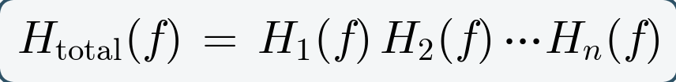
A recording chain applies a high-pass filter with |H₁| = 0.90 at 10 Hz, followed by a low-pass filter with |H₂| = 0.80 at 10 Hz. The overall magnitude at 10 Hz is 0.90 × 0.80 = 0.72, so a 40 µV alpha rhythm emerges at 28.8 µV. In decibels the same calculation is an addition rather than a multiplication: −0.9 dB plus −1.9 dB gives −2.8 dB, which is again a factor of 0.72. This is why filter responses are plotted in decibels: cascaded stages simply add.
Worked example 4.5 — choosing a sampling rate
A surface EMG signal contains no useful energy above 500 Hz. The Nyquist condition of equation (4.10) requires fₛ > 1000 Hz. Because a real anti-aliasing filter cannot cut off instantly, a practical oversampling factor of two is used, giving fₛ = 2000 Hz. With a 4-second record this gives N = 2000 × 4 = 8000 samples and a frequency resolution of Δf = 1/4 = 0.25 Hz.

