4.7 Neural frequency bands
The EEG spectrum is conventionally divided into five bands. The division is historical and empirical rather than derived from first principles — Berger named the alpha rhythm in 1929 simply because it was the first he identified, and beta followed as the next — but the bands have proved durable because each corresponds broadly to a distinct generating mechanism and behavioural state.
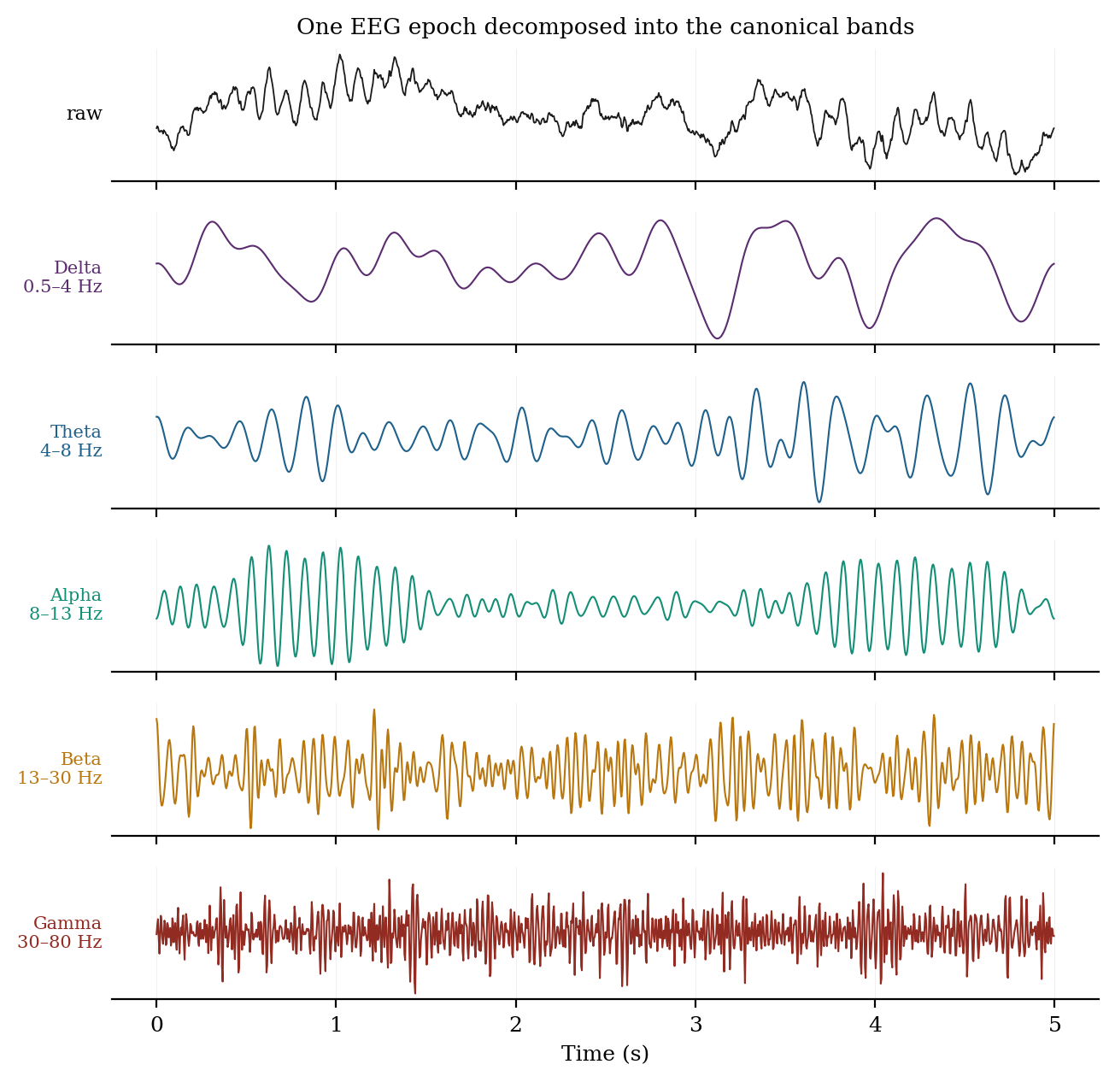
Figure 4.7.1 A single EEG epoch band-pass filtered into the five canonical bands.
Table 4.7.1: The canonical EEG frequency bands
Band | Range | Typical amplitude | Dominant topography | State and significance
Delta | 0.5 – 4 Hz | high (up to 100+ µV) | Frontal in adults | Deep (N3) sleep; infancy; focal delta suggests underlying lesion; diffuse delta indicates encephalopathy
Theta | 4 – 8 Hz | moderate | Frontal midline | Drowsiness and light sleep; frontal midline theta rises with working-memory load and sustained attention
Alpha | 8 – 13 Hz | 30 – 50 µV | Occipital / posterior | Relaxed wakefulness with eyes closed; blocked by eye opening and by mental effort; the classic Berger rhythm
Beta | 13 – 30 Hz | low (< 20 µV) | Frontocentral | Active thinking, alertness, motor control; suppressed before and during movement; markedly increased by benzodiazepines
Gamma | 30 – 100+ Hz | very low | Distributed | Associated with feature binding, attention and perception; heavily contaminated by muscle activity (Section 3.2.3)

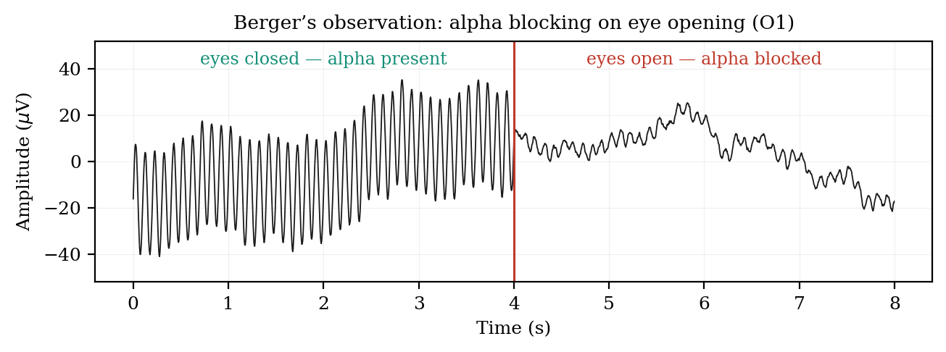
Figure 4.6.2 Alpha blocking on eye opening — the observation with which Berger established the EEG.
(a) Alpha and the reactivity principle
Alpha deserves particular attention because it illustrates a principle that generalises across the bands: a rhythm is identified not only by its frequency but by its reactivity, meaning the manipulation that reliably abolishes it. Occipital alpha appears within a second of eye closure and disappears within a second of eye opening. This reactivity, rather than the frequency alone, is what distinguishes genuine alpha from any other 10 Hz activity, and it is the reason the eyes-open and eyes-closed conditions are recorded separately in every standard clinical protocol. The individual alpha peak frequency is moreover a stable personal trait, typically between 9 and 11 Hz, which slows with age and in dementia.
(b) Two cautions about band analysis
The first caution is that band boundaries are conventions, not natural divisions, and they vary between laboratories and textbooks. An individual whose alpha peak sits at 12.5 Hz will have a substantial portion of genuine alpha power counted as beta by a fixed 13 Hz boundary. Where precision matters, the individual alpha frequency should be measured and the bands adjusted around it rather than applied as fixed limits.
The second caution is more fundamental and is now well established in the literature. The neural power spectrum is not composed solely of oscillations; it consists of an aperiodic, broadly 1/f-shaped background on which genuine periodic peaks are superimposed. Donoghue and colleagues showed in 2020 that standard band analysis conflates periodic parameters — centre frequency, power and bandwidth — with aperiodic ones — the offset and exponent of the background — and that this compromises physiological interpretation. A change in measured beta power may reflect no change in beta oscillation whatever, but merely a rotation of the aperiodic slope, which itself varies with age, task demands and level of consciousness. The same work concludes that band-ratio measures such as the theta-to-beta ratio are non-specific, since several distinct underlying spectral changes produce the same ratio. Current best practice is to parameterise the spectrum explicitly into aperiodic and periodic components before interpreting band power.
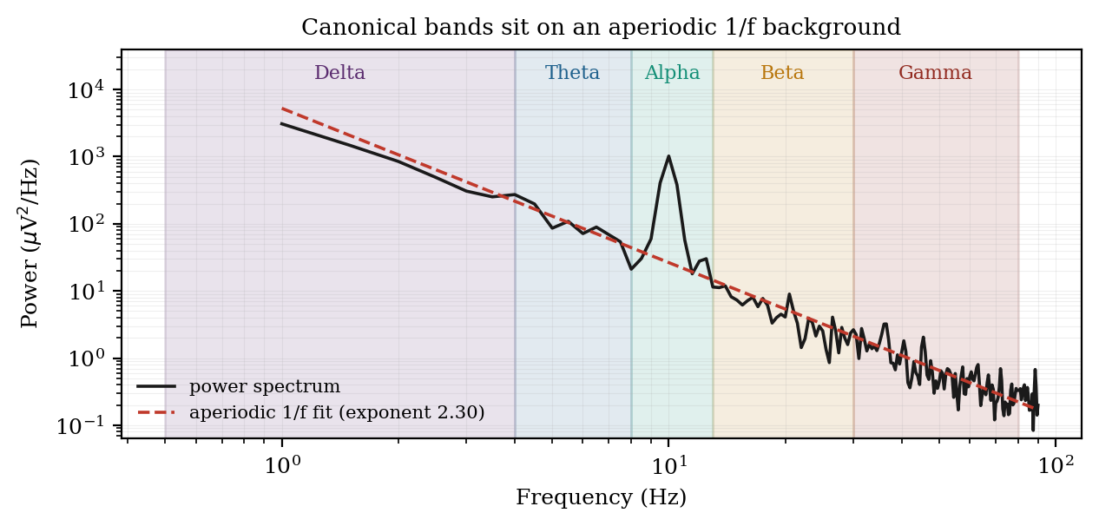
Figure 4.7.3 The canonical bands sit on an aperiodic 1/f background that must be separated before interpretation.
Summary
Time and frequency are two views of one object. The time domain shows when things happen and is the natural domain for transients, morphology and evoked responses. The frequency domain shows what the signal is made of and is the natural domain for rhythms, filter design and sampling decisions. The Fourier transform moves between them without loss, provided the signal is stationary over the interval analysed; the FFT makes the computation practical; windowing controls the leakage introduced by finite record length; and Welch averaging controls the variance of the estimate. The sampling theorem sets the one constraint that cannot be relaxed after the fact. Finally, the canonical bands are a useful vocabulary rather than a physiological taxonomy, and they should be applied with explicit awareness of the aperiodic background on which they rest.

