Module 2: Neural Signal Acquisition
Duration: 45 Minutes

Module Overview
In the previous module, we explored how neural signals are generated and examined the different types of neural signals that can be recorded, from the action potentials of individual neurons to large-scale recordings such as EEG and MEG. Understanding how these signals are produced is only the first step. Before they can be visualised, analysed, or interpreted, they must first be recorded accurately.
This recording process is known as neural signal acquisition.
Neural signal acquisition involves a sequence of hardware and electronic components that convert tiny biological signals into digital data that can be processed by a computer. Although different recording modalities use different sensors, they all follow the same fundamental acquisition pathway.
In this module, we will examine each stage of this acquisition process, beginning with the complete acquisition chain and progressing through electrodes, amplification, analogue-to-digital conversion, and electrical safety. By the end of this module, you will have a clear understanding of how biological signals are transformed into high-quality digital recordings suitable for further signal processing and analysis.

Learning Outcomes
After completing this module, you should be able to:
- Explain the complete neural signal acquisition chain.
- Describe the function of each component within the acquisition system.
- Differentiate between commonly used electrodes and recording sensors.
- Explain the importance of amplification and signal conditioning.
- Describe how analogue signals are converted into digital signals.
- Recognise the importance of electrical safety during neural recordings.

Module Structure
This module consists of five sections.
Section | Topic | Approx. Duration
2.1 | The Neural Signal Acquisition Chain | 10 min
2.2 | Electrodes and Sensors | 10 min
2.3 | Amplification and Signal Conditioning | 10 min
2.4 | Sampling and Analog-to-Digital Conversion | 10 min
2.5 | Electrical Safety and Isolation | 5 min

2.1 The Neural Signal Acquisition Chain
Duration: ~10 Minutes

2.1.1 Introduction
In the previous module, we learned how neurons generate electrical signals and how these signals can be recorded at different spatial scales. However, neural activity occurring inside the body cannot be observed directly on a computer.
This raises an important question.
How does a tiny biological signal generated inside the brain eventually become the waveform displayed on a computer screen?
The answer lies in a sequence of recording and processing steps collectively known as the neural signal acquisition chain.
Regardless of whether we are recording EEG, EMG, ECoG, or microelectrode signals, every recording system follows this same fundamental pathway. Understanding this acquisition chain provides the foundation for the remaining sections of this module.
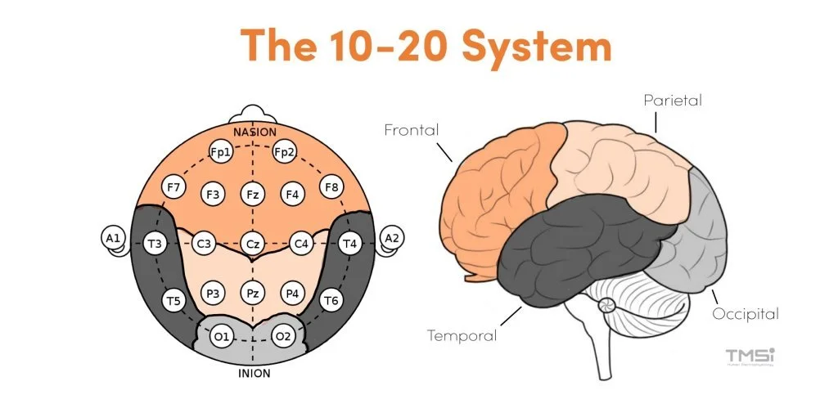

2.1.2 Learning Objective
After completing this section, you should be able to:
- Define the neural signal acquisition chain.
- Identify its major components.
- Explain the function of each stage.

2.1.3 The Neural Signal Acquisition Chain
The neural signal acquisition chain is the complete sequence of hardware and electronic components that convert biological activity into digital data.
Although different recording techniques employ different sensors, the overall workflow remains the same.
The acquisition chain can be represented as follows.
Biological Source → Electrode/Sensor → Amplifier → Filter → Analog-to-Digital Converter → Computer
Each component performs a specific function, and the quality of the final recording depends on the successful operation of every stage.
(Figure 2.1: Neural Signal Acquisition Chain)
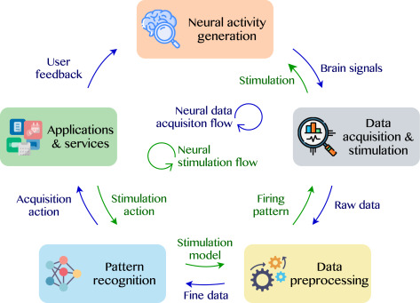

2.1.4 Components of the Acquisition Chain

Biological Source
Every recording begins with a biological event occurring inside the body.
Depending on the recording modality, the biological source may be the electrical activity of cortical neurons, muscle fibres, eye muscles, or individual neurons.
Without this physiological activity, there is no signal to record.

Electrode or Sensor
The electrode or sensor detects the biological signal and transfers it to the recording system.
Different recording techniques use different sensing devices.
For example,
- EEG uses scalp electrodes.
- EMG uses surface or needle electrodes.
- ECoG uses electrode grids placed directly on the cortical surface.
- MEG uses specialised magnetic sensors.
- 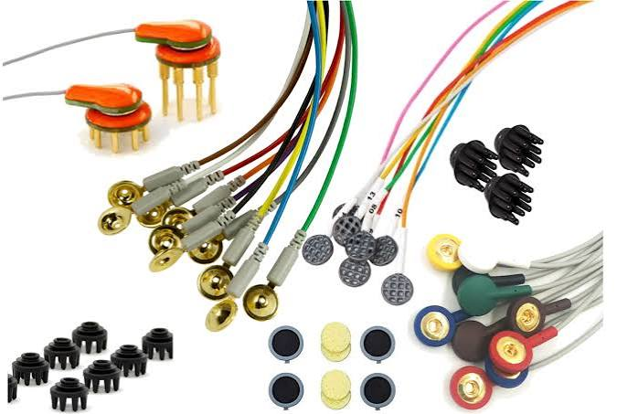
Although their designs differ, they all perform the same fundamental task—detecting physiological activity.

Amplifier
The detected biological signal is extremely small, often only a few microvolts.
Such weak signals cannot be processed reliably by electronic systems.
Therefore, the signal is passed through an amplifier, which increases its amplitude while preserving the information contained within the waveform.
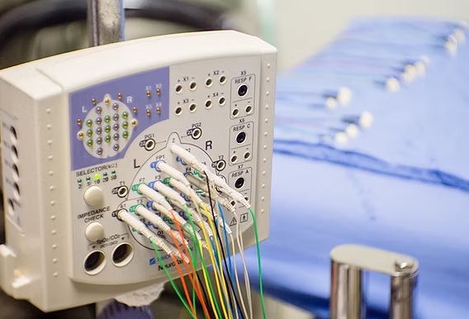

Filter
Even after amplification, the recorded signal contains unwanted electrical interference.
Filters remove these unwanted frequency components while preserving the signal of interest.
Different types of filters are used depending on the recording application.
The principles of filtering will be discussed in detail later in this course.
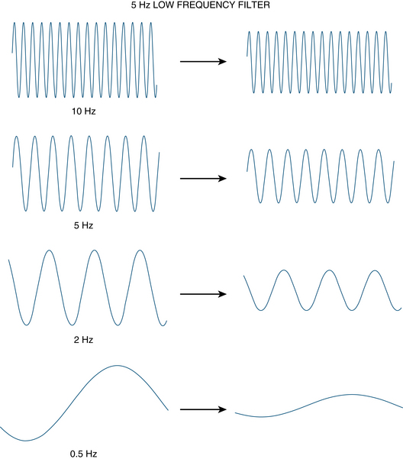

Analog-to-Digital Converter (ADC)
Up to this stage, the recorded signal is analogue.
Computers, however, process only digital information.
The Analog-to-Digital Converter samples the analogue signal at regular intervals and converts each sample into a numerical value, producing a digital representation of the original biological signal.
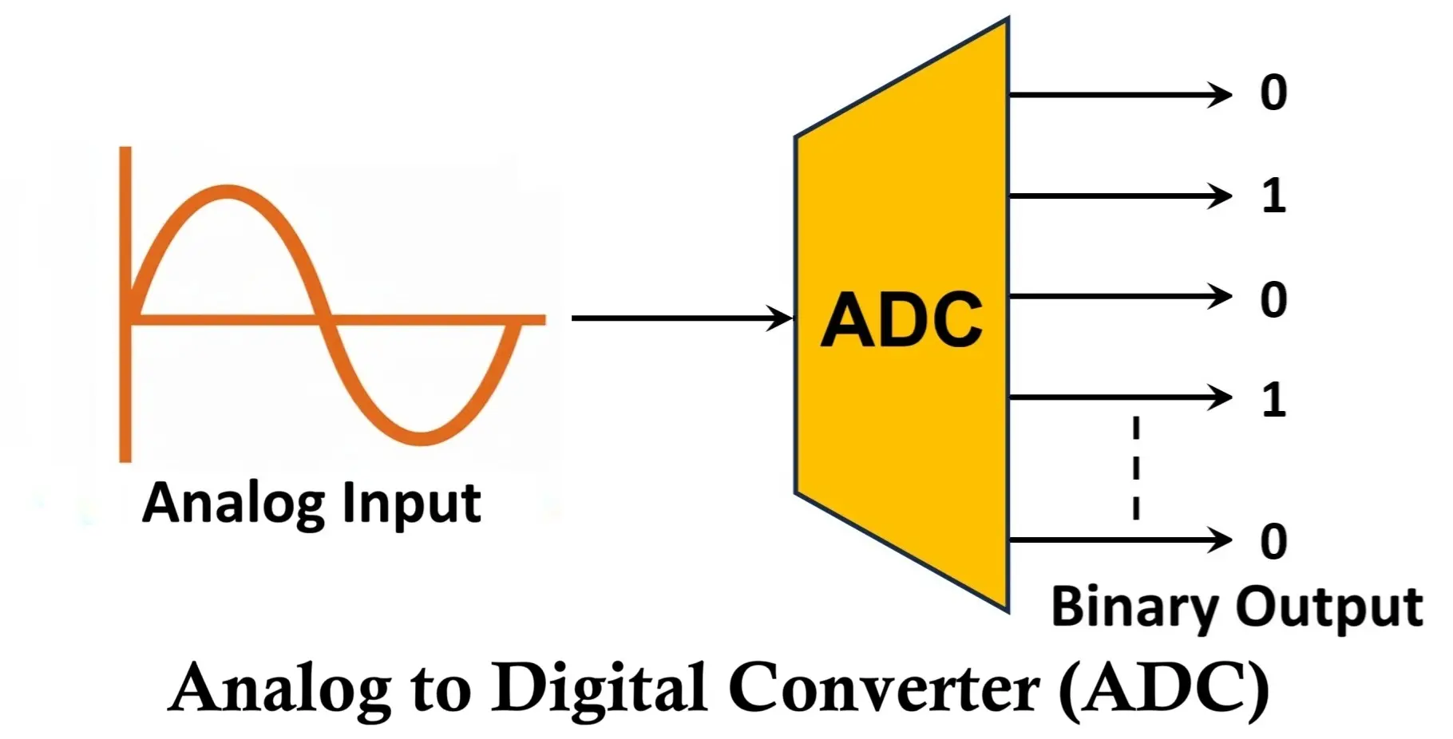

Computer
Once digitised, the signal is transferred to the computer.
Specialised software is then used to display, store, process, and analyse the recorded data.
Subsequent operations such as filtering, feature extraction, spectral analysis, and classification all depend on the quality of this acquired signal.

2.1.5 Putting the Components Together
The acquisition chain should not be viewed as a collection of independent devices.
Instead, it functions as an integrated system in which each stage prepares the signal for the next.
A poor electrode contact cannot be corrected by a better amplifier.
Similarly, incorrect sampling cannot be compensated for during later analysis.
Consequently, successful neural signal processing always begins with careful signal acquisition.

2.1.6 Summary
In this section, we introduced the neural signal acquisition chain and examined the purpose of each of its major components.
The most important point to remember is that every neural recording system follows the same fundamental workflow:
Biological Source → Electrode/Sensor → Amplifier → Filter → ADC → Computer
Although the sensing technology may differ across EEG, EMG, ECoG, or MEG, the overall acquisition process remains essentially the same.

Transition to Section 2.2
Now that we understand the overall acquisition process, the next logical step is to examine the component responsible for detecting the biological signal.
In the next section, we will discuss the different types of electrodes and sensors, their operating principles, and the recording modalities in which they are used.

2.2 Electrodes and Sensors

Duration: ~10 Minutes

2.2.1 Introduction
In the previous section, we learned that every neural recording system follows the same acquisition chain. The first hardware component in this chain is the electrode or sensor.
Regardless of whether we are recording EEG, EMG, ECoG, or MEG, the recording process cannot begin unless the physiological signal is first detected. The device responsible for detecting this signal is the electrode or sensor.
In this section, we will examine the different types of electrodes and sensors used in neuroscience, understand how they differ from one another, and discuss why different recording techniques require different sensing technologies.

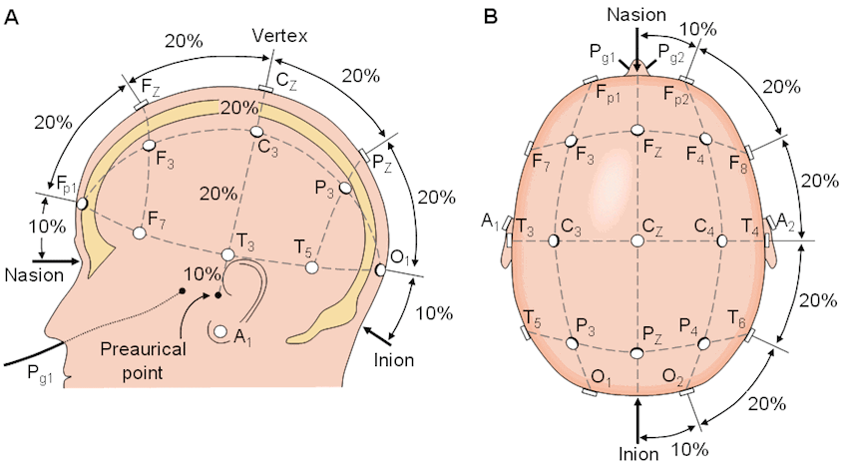

2.2.2 Learning Objectives
After completing this section, you should be able to:
- Explain the purpose of an electrode or sensor.
- Distinguish between surface electrodes, needle electrodes, and microelectrodes.
- Describe the electrodes used in EEG and ECoG recordings.
- Explain why MEG uses magnetic sensors instead of electrodes.
- Compare the advantages and limitations of different recording sensors.

2.2.3 What is an Electrode?

Definition
An electrode is a device that detects the electrical activity generated by biological tissues and transfers that signal to the recording system.
An electrode does not generate electrical signals. Instead, it acts as an interface between the body and the recording instrument, allowing naturally occurring physiological signals to be measured.

Lecture
Think about using a thermometer to measure body temperature.
The thermometer does not produce heat. It simply measures the heat already present in the body.
An electrode works in a very similar way.
It does not create electrical activity. Instead, it detects the electrical potentials already produced by neurons, muscles, or other biological tissues and delivers these signals to the acquisition system for further processing.
For accurate recordings, the electrode must maintain good electrical contact with the tissue. Poor contact can introduce unwanted noise, reduce signal quality, and make subsequent analysis less reliable.

Key Definition
Electrode: A conductive interface that detects biological electrical activity and transfers it to the recording system.

2.2.4 Surface Electrodes

Definition
Surface electrodes are electrodes placed directly on the skin without penetrating the body.
Because they do not require surgery or needle insertion, they are classified as non-invasive electrodes.

Lecture
Surface electrodes are among the most commonly used recording electrodes in biomedical engineering.
They are widely used for EEG, surface EMG, and ECG recordings because they are safe, inexpensive, and easy to apply.
Before placing a surface electrode, the skin is often cleaned and a conductive gel is applied. The gel improves electrical contact between the electrode and the skin by reducing contact resistance, allowing cleaner recordings.
Although surface electrodes are convenient, they are positioned some distance away from the actual biological source. As a result, the recorded signal is usually weaker and has lower spatial resolution than recordings obtained using invasive electrodes.

Advantages
- Non-invasive
- Comfortable for the subject
- Easy to apply
- Suitable for long-duration recordings

Limitations
- Lower signal amplitude
- More susceptible to motion artefacts
- Lower spatial resolution

2.2.5 Needle and Microelectrodes

Needle Electrodes
Needle electrodes are inserted directly into biological tissue.
Unlike surface electrodes, they are capable of recording signals much closer to their source.
They are commonly used during clinical EMG examinations to record the electrical activity of individual muscles.
Because they are positioned inside the muscle, needle electrodes provide higher-quality recordings than surface electrodes. However, they are invasive and may cause discomfort.

Microelectrodes
Microelectrodes are extremely small electrodes designed for recording neural activity at the cellular level.
They are capable of recording action potentials from individual neurons or very small groups of neurons.
These electrodes are widely used in neuroscience research, neurophysiology, and brain-computer interface studies where high spatial resolution is required.
Because microelectrodes penetrate neural tissue, they require surgical implantation and are therefore highly invasive.

Important Note
As the recording electrode moves closer to the biological source, signal quality generally improves. However, increasing proximity usually increases invasiveness.
This is one of the fundamental trade-offs in neural recording.

2.2.6 EEG Electrodes
EEG records electrical activity from the scalp using surface electrodes.
These electrodes are positioned according to standardized placement systems, most commonly the International 10–20 System.
Since EEG signals must travel through the meninges, skull, and scalp before reaching the electrodes, they are relatively small in amplitude.
For this reason, maintaining low electrode impedance and good contact with the scalp is essential for obtaining high-quality EEG recordings.
(A detailed discussion of the 10–20 system will be covered later when EEG is discussed in the applications module.)

2.2.7 ECoG Grids
Unlike EEG, Electrocorticography records electrical activity directly from the surface of the cerebral cortex.
Instead of individual scalp electrodes, ECoG uses flexible electrode grids or strips that are surgically placed on the exposed cortex.
Because the electrodes are much closer to the neural source, ECoG recordings provide higher signal amplitude, better spatial resolution, and an improved signal-to-noise ratio compared with EEG.
However, these advantages come at the cost of requiring neurosurgery, making ECoG an invasive recording technique.

2.2.8 MEG Sensors
Magnetoencephalography uses a different sensing principle.
Instead of measuring electrical voltage, MEG measures the extremely small magnetic fields generated by neuronal activity.
Therefore, MEG does not use electrodes.
Instead, it employs highly sensitive magnetic sensors positioned around the participant's head.
Although the sensing technology differs, the purpose remains the same: detecting neural activity so that it can enter the acquisition chain.

2.2.9 Comparison of Common Recording Sensors
Recording Technique | Sensor Used | Placement | Invasiveness
EEG | Scalp electrodes | On the scalp | Non-invasive
Surface EMG | Surface electrodes | On the skin | Non-invasive
Intramuscular EMG | Needle electrodes | Inside the muscle | Invasive
ECoG | Electrode grids | Cortical surface | Invasive
Microelectrode Recording | Microelectrodes | Inside neural tissue | Highly invasive
MEG | Magnetic sensors | Outside the head | Non-invasive

2.2.10 Summary
In this section, we examined the different types of electrodes and sensors used in neural signal acquisition.
Although these devices differ in their design and recording location, they all perform the same fundamental function—detecting physiological activity and transferring it to the acquisition system.
Selecting an appropriate sensor always involves balancing signal quality, spatial resolution, patient safety, and invasiveness.

Transition to Section 2.3
Now that we know how biological signals are detected, another challenge immediately becomes apparent.
The detected signals are extremely small—often only a few microvolts.
Such weak signals cannot be processed directly.
In the next section, we will explore how these signals are strengthened and prepared for further processing through amplification and signal conditioning.

2.3 Amplification and Signal Conditioning
Duration: ~10 Minutes

2.3.1 Introduction
In the previous section, we learned how electrodes and sensors detect biological signals. However, detecting a signal is only the first step.
The electrical signals generated by the human body are extremely small. For example, EEG signals are typically measured in microvolts, which are millions of times smaller than the voltages used by most electronic devices. If these tiny signals were sent directly to a computer, they would be difficult to distinguish from electrical noise and could not be processed reliably.
To overcome this problem, every neural recording system includes a stage known as amplification and signal conditioning.
In this section, we will understand why amplification is necessary, how amplifiers improve signal quality, and what is meant by signal conditioning.

2.3.2 Learning Objectives
After completing this section, you should be able to:
- Explain why neural signals require amplification.
- Describe the function of an amplifier.
- Understand the concept of signal conditioning.
- Explain why amplification must occur before further signal processing.

2.3.3 Why Do Neural Signals Need Amplification?

Lecture
Imagine trying to hear someone whispering in a crowded room.
Even though the person is speaking, their voice is so weak that it is easily overwhelmed by surrounding noise.
Neural signals present a similar challenge.
The electrical activity produced by neurons or muscles is very small. These signals must travel through biological tissue, electrodes, connecting cables, and electronic circuits before reaching the recording system. During this journey, they are easily affected by environmental interference and electronic noise.
If these signals are not strengthened before further processing, important physiological information may be lost.
Therefore, the first electronic component after the electrode is the amplifier.

Key Definition
Amplification is the process of increasing the amplitude of a biological signal without altering the information it contains.

2.3.4 What is an Amplifier?

Lecture
An amplifier is an electronic circuit designed to increase the strength of a weak electrical signal.
It is important to understand that an amplifier does not create new information.
Instead, it increases the magnitude of the existing signal so that it can be processed more accurately by the remaining components of the acquisition system.
For example, if an EEG signal has an amplitude of only a few microvolts, the amplifier increases this voltage to a level that electronic circuits can process reliably while preserving the original waveform.
A good amplifier should increase the desired signal while introducing as little additional noise or distortion as possible.

Important Note
The purpose of amplification is not to improve the quality of the signal.
Its primary purpose is to increase the signal level so that subsequent processing stages can operate correctly.

2.3.5 Signal Conditioning

Lecture
After amplification, the recorded signal still cannot be sent directly to the computer.
The signal may contain unwanted electrical interference, baseline drift, or other components that reduce recording quality.
Before digitisation, the signal is therefore prepared through a process known as signal conditioning.
Signal conditioning refers to the collection of operations that prepare the biological signal for accurate digital conversion.
Depending on the recording system, signal conditioning may include:
- Initial filtering
- Noise reduction
- Baseline stabilisation
- Impedance matching
- Signal isolation
The exact conditioning process depends on the recording modality and the design of the acquisition system.

Key Definition
Signal conditioning refers to all operations performed on a biological signal to prepare it for accurate digitisation and analysis.

2.3.6 Amplification and Signal Conditioning in the Acquisition Chain
Let us return to the neural signal acquisition chain.
Biological Source → Electrode → Amplifier → Signal Conditioning → ADC → Computer
Once the electrode detects the biological signal, the amplifier increases its strength.
The conditioned signal is then cleaned and prepared for digitisation.
Only after these steps is the signal suitable for conversion into digital data by the Analog-to-Digital Converter.
Understanding this sequence is important because later stages of the acquisition chain depend heavily on the quality of the amplified and conditioned signal.

2.3.7 Practical Considerations
When designing a neural recording system, amplification and signal conditioning must be performed carefully.
Too little amplification may produce a signal that is difficult to analyse.
Excessive amplification, however, may also amplify unwanted noise or even saturate the recording system.
Similarly, poor signal conditioning may remove useful physiological information or allow unwanted interference to remain in the recording.
For this reason, amplification and signal conditioning are considered critical stages in neural signal acquisition.

2.3.8 Summary
In this section, we examined the role of amplification and signal conditioning in neural signal acquisition.
Neural signals are extremely weak and therefore require amplification before further processing.
Signal conditioning prepares the amplified signal for digitisation by reducing unwanted interference and ensuring that the signal entering the ADC is suitable for accurate digital conversion.
Together, amplification and signal conditioning improve the reliability of the recorded signal and support accurate downstream analysis.

Transition to Section 2.4
At this stage, the neural signal has been detected, amplified, and conditioned.
However, it is still an analogue signal.
Since computers can process only digital information, the next step is to convert this continuous electrical signal into a sequence of numerical values.
In the next section, we will discuss sampling and Analog-to-Digital Conversion (ADC) and understand how analogue neural signals become digital data ready for computer analysis.

2.4 Sampling and Analog-to-Digital Conversion (ADC)
Duration: ~10 Minutes

2.4.1 Introduction
In the previous section, we learned that neural signals are amplified and conditioned before further processing. At this stage, the signal is still an analogue signal, meaning it varies continuously with time.
However, computers cannot process continuous electrical signals directly. They require information to be represented as digital numbers.
This conversion from a continuous analogue signal to digital data is one of the most important steps in neural signal acquisition. It enables neural recordings to be stored, displayed, processed, and analysed using digital signal processing techniques.
In this section, we will learn how analogue neural signals are converted into digital data through sampling and Analog-to-Digital Conversion (ADC).

2.4.2 Learning Objectives
After completing this section, you should be able to:
- Differentiate between analogue and digital signals.
- Explain the concept of sampling.
- Define sampling frequency.
- Describe the role of an Analog-to-Digital Converter (ADC).
- Understand why proper sampling is important for accurate neural signal recording.

2.4.3 Analog and Digital Signals

Definition
An analogue signal is a signal whose amplitude changes continuously over time.
A digital signal represents information as a sequence of discrete numerical values.

Lecture
The electrical signals generated by neurons are naturally analogue. As neural activity changes, the voltage also changes continuously.
Although this continuous representation accurately reflects physiological activity, computers cannot directly interpret continuously varying voltages. Digital systems store and process information as numbers.
Therefore, before a neural signal can be analysed using software, it must first be converted from its analogue form into a digital representation.
This conversion is performed by the Analog-to-Digital Converter.

Key Definition
Analogue Signal: A continuously varying electrical signal.
Digital Signal: A numerical representation of a signal obtained after analogue-to-digital conversion.

2.4.4 What is Sampling?

Definition
Sampling is the process of measuring the amplitude of an analogue signal at regular intervals of time.
Each measurement is called a sample.

Lecture
Imagine taking photographs of a moving object every second.
Instead of recording every instant continuously, you capture a series of individual images.
Sampling works in a similar manner.
Rather than recording every continuous change in voltage, the acquisition system measures the signal at equally spaced time intervals.
Each measurement represents the signal at that particular instant.
When thousands of samples are collected every second, they provide an accurate digital representation of the original analogue waveform.

Example
Suppose an EEG recording system samples the signal 1000 times every second.
This means that every second, the system records 1000 individual voltage measurements.
These measurements collectively represent the original EEG waveform in digital form.

2.4.5 Sampling Frequency

Definition
The sampling frequency, also called the sampling rate, is the number of samples collected every second.
It is measured in Hertz (Hz).

Lecture
Sampling frequency determines how frequently the analogue signal is measured.
A sampling frequency of:
- 250 Hz means 250 samples are collected every second.
- 500 Hz means 500 samples are collected every second.
- 1000 Hz means 1000 samples are collected every second.
Higher sampling frequencies provide more detailed information about the signal because more measurements are taken over the same period of time.
However, higher sampling rates also increase data storage requirements and computational cost.
Selecting an appropriate sampling frequency therefore involves balancing recording accuracy with efficient data processing.

Important Note
The sampling frequency must be sufficiently high to capture the important characteristics of the biological signal without losing information.

2.4.6 The Analog-to-Digital Converter (ADC)

Definition
An Analog-to-Digital Converter (ADC) is an electronic component that converts an analogue electrical signal into a sequence of digital numbers.

Lecture
The ADC serves as the bridge between the analogue world and the digital world.
After the biological signal has been amplified and conditioned, it enters the ADC.
The ADC performs two essential tasks:
- It samples the analogue signal at regular time intervals.
- It converts each sample into a numerical value that can be processed by a computer.
The resulting sequence of numbers forms the digital representation of the original neural signal.
Without an ADC, modern digital storage, visualization, and signal processing would not be possible.

Figure 2.4
Analog Signal → Sampling → ADC → Digital Data
(Insert a diagram illustrating the conversion of a continuous analogue waveform into discrete digital samples.)

2.4.7 Importance of Proper Sampling
The quality of the digital recording depends greatly on how the signal is sampled.
If too few samples are collected, important variations in the neural signal may not be represented accurately.
Conversely, collecting more samples than necessary increases storage requirements and processing time without always providing additional useful information.
For this reason, selecting an appropriate sampling frequency is an important consideration during the design of every neural recording system.

Important Note
The accuracy of later analyses—such as filtering, spectral analysis, and feature extraction—depends on the quality of the digital data produced during the sampling stage.
A poorly digitised signal cannot be fully corrected during later processing.

2.4.8 Summary
In this section, we introduced the process of converting analogue neural signals into digital data.
We learned that:
- Neural signals are naturally analogue.
- Computers require digital data for processing.
- Sampling measures the analogue signal at regular time intervals.
- The sampling frequency specifies how many samples are collected each second.
- The Analog-to-Digital Converter performs the conversion from analogue signals to digital numbers.
Accurate sampling is essential because every subsequent stage of digital signal processing depends on the quality of the digitised signal.

Transition to Section 2.5
At this point, we have completed the major stages of the neural signal acquisition chain—from detecting the biological signal to converting it into digital data.
However, one final aspect remains equally important.
Because neural recordings involve electronic equipment connected to the human body, ensuring electrical safety is essential for both the participant and the recording system.
In the final section of this module, we will discuss the principles of electrical safety and isolation in neural signal acquisition.

2.5 Electrical Safety and Isolation
Duration: ~5 Minutes

2.5.1 Introduction
In the previous sections, we examined how neural signals are detected, amplified, conditioned, and converted into digital data. While these processes are essential for acquiring high-quality recordings, another equally important consideration must never be overlooked—electrical safety.
During neural signal acquisition, electrodes and sensors are connected either directly to the skin or, in some applications, to tissues inside the body. Since the participant is physically connected to electronic equipment, every recording system must be designed to protect both the participant and the equipment from electrical hazards.
In this section, we will discuss the importance of electrical safety and understand the role of electrical isolation in biomedical recording systems.

2.5.2 Learning Objectives
After completing this section, you should be able to:
- Explain why electrical safety is essential in neural signal acquisition.
- Describe the concept of electrical isolation.
- Identify common safety measures used in biomedical recording systems.
- Recognise the importance of following safety standards during neural recordings.

2.5.3 Why is Electrical Safety Important?

Definition
Electrical safety refers to the measures taken to protect participants, operators, and equipment from electrical hazards during biomedical signal recording.

Lecture
Unlike many electronic measurement systems, neural signal acquisition involves direct contact between electronic equipment and the human body.
For example, EEG electrodes are attached to the scalp, EMG electrodes are placed on the skin or inserted into muscles, and ECoG electrodes are positioned directly on the surface of the brain during surgery.
Although these recording systems operate using extremely small biological signals, they are connected to powered electronic devices. Any unintended electrical current reaching the participant could pose a serious safety risk.
Therefore, ensuring electrical safety is not simply good laboratory practice—it is a fundamental requirement of every biomedical recording system.

Key Definition
Electrical Safety: The application of protective measures that minimise the risk of electrical injury during biomedical signal acquisition.

2.5.4 What is Electrical Isolation?

Definition
Electrical isolation is the separation of the participant from potentially hazardous electrical circuits while still allowing physiological signals to be recorded.

Lecture
One of the most effective methods of protecting participants is electrical isolation.
The principle is straightforward.
The biological signal is allowed to pass from the participant to the recording system, while direct electrical pathways that could carry hazardous currents are blocked.
Isolation therefore acts as a protective barrier between the participant and the powered electronic equipment.
Modern biomedical recording systems incorporate isolation as a standard safety feature, helping to ensure that neural signals can be recorded without compromising participant safety.

Figure 2.5
Participant → Electrodes → Isolation Circuit → Acquisition System → Computer
(Insert a block diagram illustrating how an isolation stage separates the participant from the recording equipment.)

2.5.5 Common Safety Measures
A safe neural recording system incorporates several protective measures throughout the acquisition chain.
Some of the most important safety practices include:
- Using electrically isolated recording equipment.
- Inspecting electrodes and connecting cables before use.
- Ensuring proper grounding of the recording system where appropriate.
- Using equipment that has been designed for biomedical applications.
- Following established laboratory or clinical safety procedures.
Together, these measures reduce the likelihood of electrical hazards and contribute to reliable signal acquisition.

Important Note
High-quality recordings should never come at the expense of participant safety.
Protecting the participant is always the first priority in any biomedical recording procedure.

2.5.6 Safety and Signal Quality
Electrical safety and signal quality are closely related.
Poor electrode connections, damaged cables, or improperly configured equipment can affect both the quality of the recorded signal and the safe operation of the recording system.
For this reason, recording systems should always be checked before data acquisition begins.
Routine inspection and proper equipment maintenance are essential parts of good laboratory practice.

2.5.7 Summary
In this section, we discussed the importance of electrical safety in neural signal acquisition.
We learned that:
- Neural recording systems connect electronic equipment to the human body.
- Electrical safety is essential for protecting both participants and equipment.
- Electrical isolation separates the participant from potentially hazardous electrical circuits while allowing physiological signals to be recorded.
- Safe recording practices and properly designed biomedical equipment are fundamental components of every neural signal acquisition system.

Module 2 Recap
In this module, we examined the complete process of neural signal acquisition. Beginning with the acquisition chain, we explored how biological signals are detected by electrodes and sensors, strengthened through amplification, prepared by signal conditioning, converted into digital data using an Analog-to-Digital Converter, and finally protected through appropriate electrical safety measures.
The key concepts covered in this module are:
- The neural signal acquisition chain provides the complete pathway from biological activity to digital data.
- Different recording modalities use different electrodes or sensors depending on the application.
- Amplification increases the strength of weak biological signals before further processing.
- Signal conditioning prepares the signal for accurate digitisation.
- Sampling and ADC convert continuous analogue signals into digital data suitable for computer analysis.
- Electrical safety and isolation are essential to protect both participants and recording equipment.
Together, these concepts form the foundation of neural signal acquisition and prepare us for the subsequent modules, where we will explore preprocessing techniques, filtering, frequency-domain analysis, and applications of neural signal processing.

