4. Time and Frequency Domains
Overview
A biosignal can be described in two complementary ways. The first is the way it is recorded: a voltage that rises and falls as time passes, which is the time domain. The second asks a different question — not what the signal is doing at each instant, but which rhythms it is built from, and how much of each is present. That is the frequency domain. The two descriptions contain exactly the same information; neither adds anything the other lacks. What differs is which features are visible. A sharp epileptiform spike is obvious in the time domain and almost invisible in a spectrum; an alpha rhythm buried under muscle noise is invisible in the time domain and unmistakable in a spectrum.
This module builds the bridge between the two. It begins with what can be read directly from a time trace, establishes why that is insufficient, develops Fourier analysis from an intuitive starting point rather than an algebraic one, states the transform and the power spectrum formally, and then addresses the constraint that governs every digital recording: the sampling theorem. It closes with the canonical neural frequency bands, together with a warning about how they are commonly misused.
By the end of the module a student should be able to explain why the same signal looks different in the two domains, compute and interpret a power spectrum with an appropriate window, choose a sampling rate and justify it, recognise aliasing when it occurs, and describe the physiological significance of each EEG band without over-claiming.
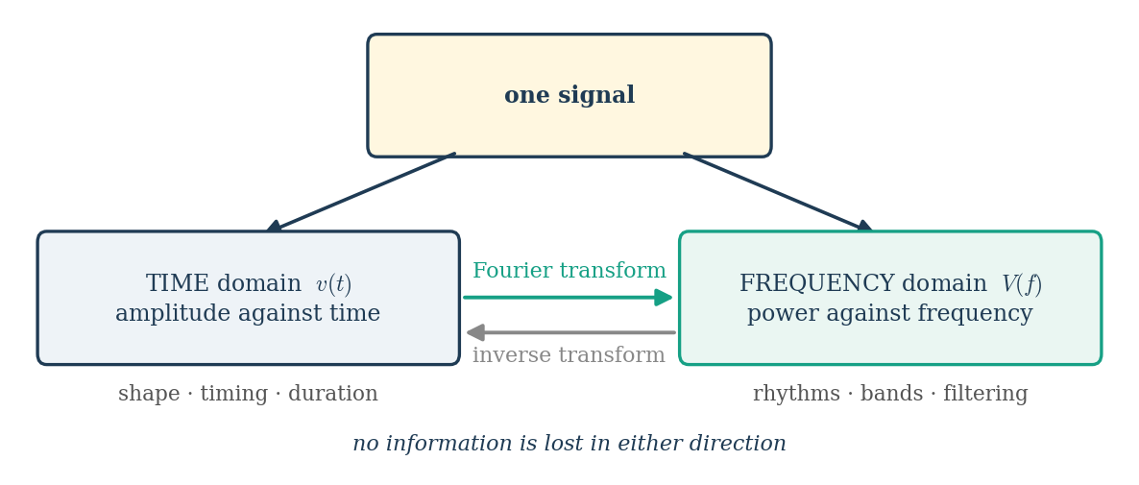
Figure 4.0.1 The two domains and the transform that connects them.
4.1 Time-domain representation
The time-domain representation is the raw form in which every biosignal is acquired: a sequence of amplitude values indexed by time, written v(t) for a continuous signal and v[n] for its sampled counterpart. It is the representation clinicians actually read. An electroencephalographer scanning a record for epileptiform discharges, a cardiologist measuring a PR interval, an electromyographer assessing motor unit potential duration — all of these are time-domain operations performed by eye.
Four properties can be read directly from a time trace, and they were defined quantitatively in Module 1: amplitude, whether expressed as peak, peak-to-peak or RMS; latency, the time from a stimulus or fiducial point to a feature of interest; duration, the temporal extent of a discrete event; and morphology, the shape of the waveform itself, which carries diagnostic weight independent of any numerical measure. A QRS complex, a K-complex and a blink artifact are each recognised primarily by shape.
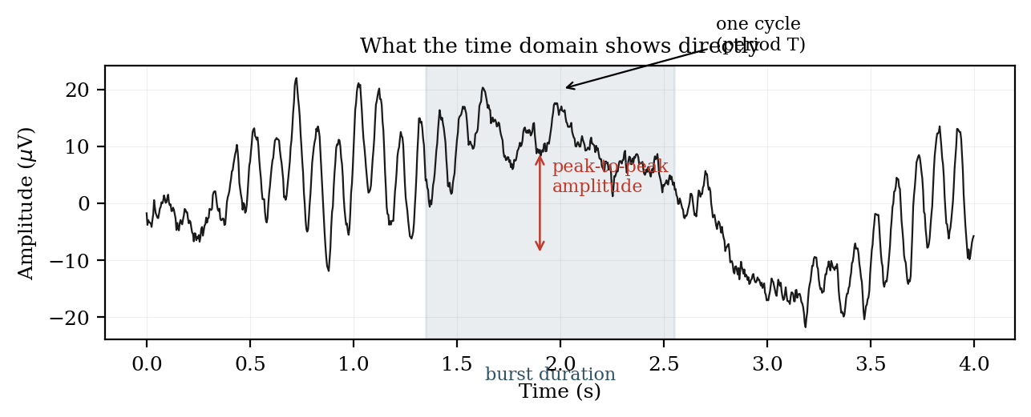
Figure 4.1.1 Amplitude, duration and periodicity read directly from a time trace.
Several useful descriptors are computed entirely in the time domain without any transform. The mean and variance summarise the amplitude distribution. The zero-crossing rate — the number of times per second the signal crosses its baseline — is a crude but computationally trivial index of dominant frequency, and is still used in low-power implantable devices where a Fourier transform would be prohibitive. Autocorrelation, introduced in Module 1, reveals periodicity without leaving the time domain. Ensemble averaging of stimulus-locked epochs, the basis of all evoked-potential work, is likewise a purely time-domain operation.
The limitation of the time domain is the superposition problem. The scalp EEG at any instant is the sum of several rhythms generated by different populations, plus aperiodic background, plus whatever artifacts have survived. Their sum is a single fluctuating trace in which the individual contributors are no longer separately visible. The eye can extract a strong alpha rhythm from a quiet background, but it cannot reliably judge whether theta power has increased by thirty per cent, nor detect a rhythm whose amplitude is below that of the activity it is mixed with. For that, the signal must be re-expressed.
4.2 Why frequency-domain analysis is needed
The case for the frequency domain rests on four practical needs, only the first of which is about seeing the signal more clearly.
(a) Separating superimposed rhythms
Rhythms that are inseparable in time separate cleanly in frequency, because each occupies a distinct region of the spectrum. A trace containing a 3 Hz component, a 10 Hz component and a 22 Hz component appears in the time domain as a single irregular waveform with no obvious structure; its spectrum shows three unambiguous peaks whose heights give the relative contribution of each. This is the single most important reason for the transform, and it is why quantitative EEG is conducted almost entirely in the frequency domain.
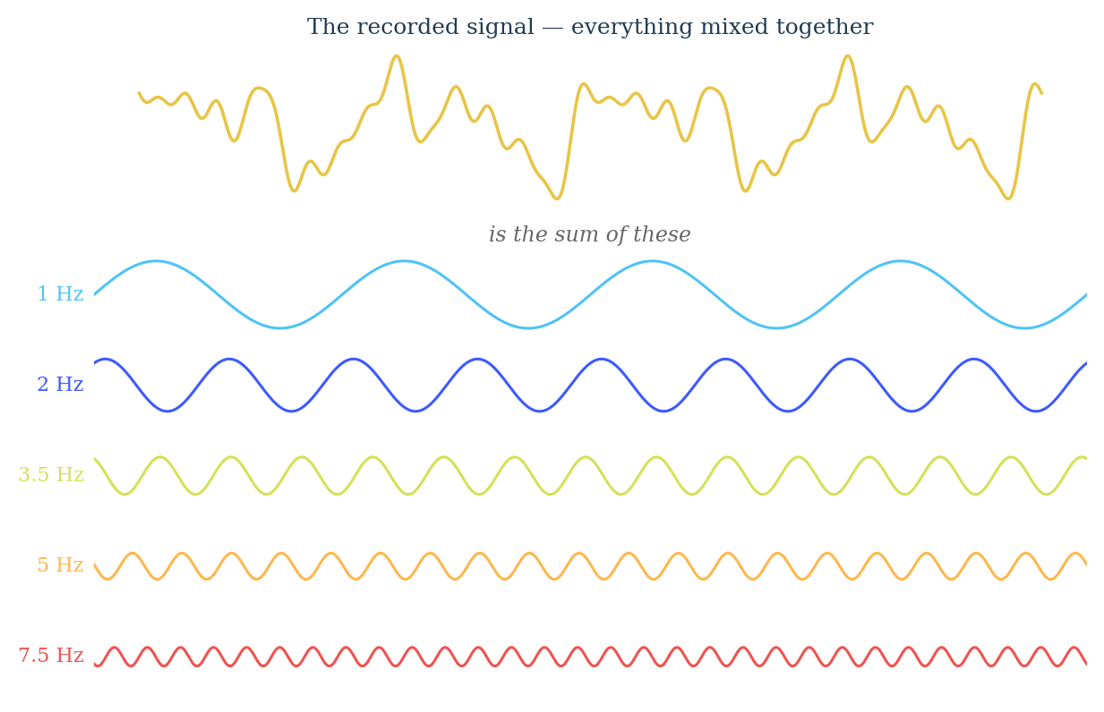
Figure 4.2.1 A recorded signal is the sum of many simple oscillations added together.
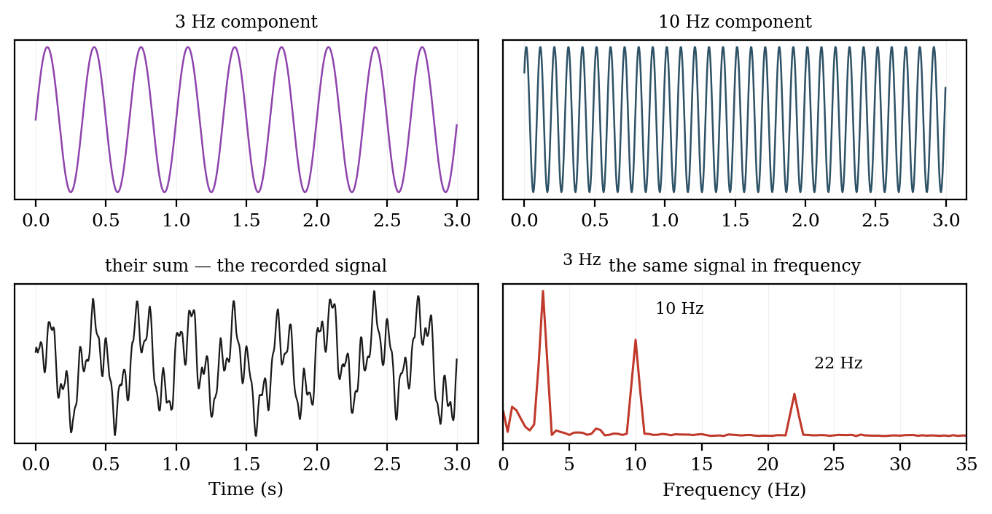
Figure 4.2.2 Components that are inseparable in time appear as distinct peaks in frequency.
(b) Designing filters
Every filtering decision taken in Module 3 presupposed spectral knowledge. Choosing a high-pass cut-off to remove electrode drift, a low-pass to remove muscle contamination, or a notch to remove mains interference all require knowing where in the spectrum the unwanted energy lies and, critically, whether it overlaps the signal. A filter cannot be specified in the time domain.
(c) Choosing the sampling rate
The sampling theorem, developed in Section 4.5, is stated entirely in terms of the highest frequency present in the signal. Without spectral knowledge the sampling rate cannot be justified, and an inadequate rate corrupts the recording irreversibly.
(d) Clinical and scientific interpretation
Many findings are defined spectrally and have no time-domain equivalent. Diffuse slowing — a shift of power from alpha into theta and delta — is a standard marker of encephalopathy. The individual alpha peak frequency correlates with cognitive performance and declines in dementia. Localised muscle fatigue is quantified by the fall in EMG median frequency described in Module 1. None of these can be measured by inspecting a trace.
4.3 Intuitive introduction to Fourier analysis
Fourier's insight, published in 1822 in the Théorie analytique de la chaleur while he was studying heat conduction rather than signals, was that any reasonable periodic function can be represented as a sum of sinusoids at integer multiples of a fundamental frequency. The claim was controversial at the time precisely because it seemed implausible that smooth sinusoids could reconstruct a discontinuous function such as a square wave.
(a) Synthesis: building a signal from sinusoids
The Fourier series expresses a periodic signal of period T as
v(t) = a₀ + Σₙ [ aₙ cos(2πnf₀t) + bₙ sin(2πnf₀t) ], f₀ = 1/T
where the coefficients aₙ and bₙ give the amount of each harmonic present. Adding successive harmonics of a square wave demonstrates the idea concretely: the fundamental alone is a poor approximation, three harmonics already show the flat top forming, and by ten the shape is recognisable. The residual overshoot at the discontinuities, which does not disappear as harmonics are added but merely narrows, is the Gibbs phenomenon, and it reappears in practice as the ringing produced by a sharp filter acting on a transient — the effect warned about in Section 3.1.3 when notch filtering an epileptiform spike.
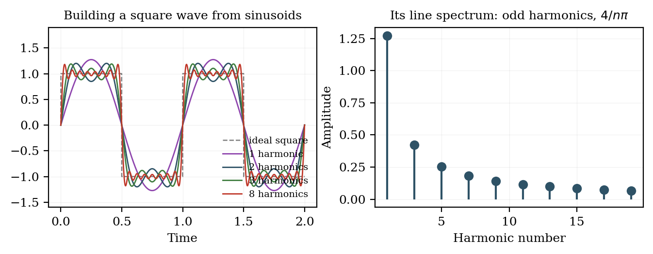
Figure 4.3.1 Synthesis of a square wave from odd harmonics, and its line spectrum.
(b) Analysis: detecting how much of a frequency is present
The reverse operation — determining the coefficients from the signal — rests on an equally simple idea. To test whether a signal contains a particular frequency, multiply it point by point with a sinusoid at that frequency and average the product over the record. If the two match, positive and negative half-cycles align, the product is predominantly positive and the average is large. If they do not match, the product is as often positive as negative and averages toward zero. This is the orthogonality of sinusoids, and it is the whole mechanism of the Fourier transform.
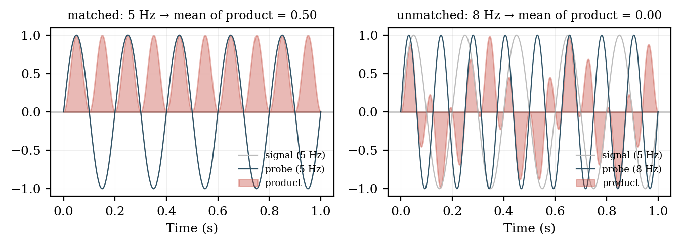
Figure 4.3.2 Correlation with a probe sinusoid: matched frequency yields a large average, unmatched yields zero.
Two probes are needed at each frequency, a sine and a cosine, because a signal component may be shifted in phase relative to either. Their two coefficients are conventionally combined into a single complex number whose magnitude gives the amplitude of that frequency component and whose argument gives its phase. This is why the Fourier transform is complex-valued: the imaginary part carries phase, not anything imaginary in the physical sense.
4.4 The Fourier transform and the power spectrum
4.4.1 What the Fourier transform is
The Fourier transform is an operation that takes a signal expressed as a function of time and returns a function of frequency describing how much of each frequency the signal contains, and with what phase. It is not an approximation and it discards nothing: the transform is invertible, so the original signal can be recovered exactly from its transform. The two functions are two representations of one object.
The formula
The Fourier transform of a signal x(t) is defined by the integral
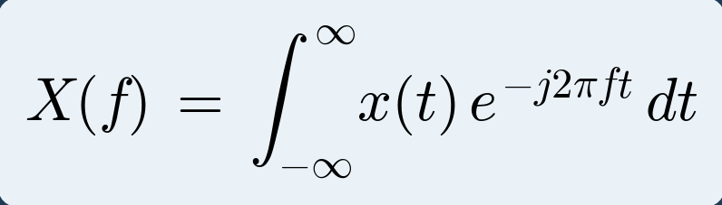 (4.1)
and the original signal is recovered from its spectrum by the inverse transform
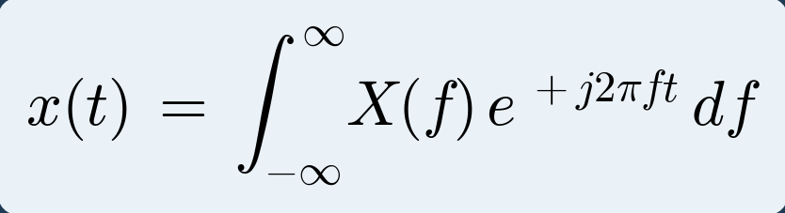 (4.2)
These two together are called the Fourier transform pair. Every symbol in them is as follows.
Table 4.4.1: Terms in the Fourier transform
Symbol | Meaning
x(t) | The signal, as a function of time. What is recorded.
X(f) | The spectrum, as a function of frequency. Complex-valued.
f | Frequency in hertz. The variable being tested for.
t | Time in seconds. Integrated out, so it does not appear in the answer.
e⁻ʲ²ᵖᶠᵗ | The test waveform: a complex sinusoid of frequency f.
j | The imaginary unit, √−1. Written i in mathematics, j in engineering.
∫ dt | Sum over all time. This is what performs the comparison.

Read in words, the forward transform says: multiply the signal by a test sinusoid of frequency f, add up the result over all time, and the answer tells you how much of that frequency the signal contained. Repeat for every f and you have the whole spectrum. This is exactly the correlation idea from Section 4.3, written as an integral.
An alternative form uses angular frequency ω = 2πf, giving X(ω) = ∫ x(t) e^(−jωt) dt, with a factor 1/2π appearing in the inverse. The form in f used here is preferred in signal processing because frequencies are read directly in hertz.
Why complex exponentials
The building block used is the complex exponential rather than the sine and cosine separately, because Euler's relation lets a single complex function carry both:
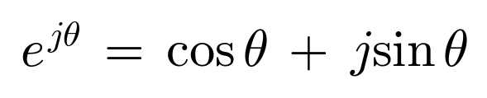
A complex exponential of frequency f therefore contains a cosine in its real part and a sine in its imaginary part. Testing a signal against one complex exponential simultaneously performs both the sine and the cosine correlation described in Section 4.3, and returns the amplitude and phase together as a single complex number. There is a second and deeper reason for this choice: complex exponentials are the eigenfunctions of linear time-invariant systems, meaning that a filter can change the amplitude and phase of such a signal but never its frequency. This is precisely why frequency-domain analysis is the natural language of filtering.
4.4.2 Where the transform comes from
The Fourier transform is not a separate invention. It is the Fourier series stretched to cover signals that never repeat, and seeing that connection removes most of the mystery.
A periodic signal of period T is built from harmonics spaced 1/T apart in frequency. Make the period longer and those harmonics move closer together. Make the period infinite, which is what an aperiodic signal is, and the spacing shrinks to zero. The discrete line spectrum becomes a continuous curve, and the sum over harmonics becomes an integral over frequency.
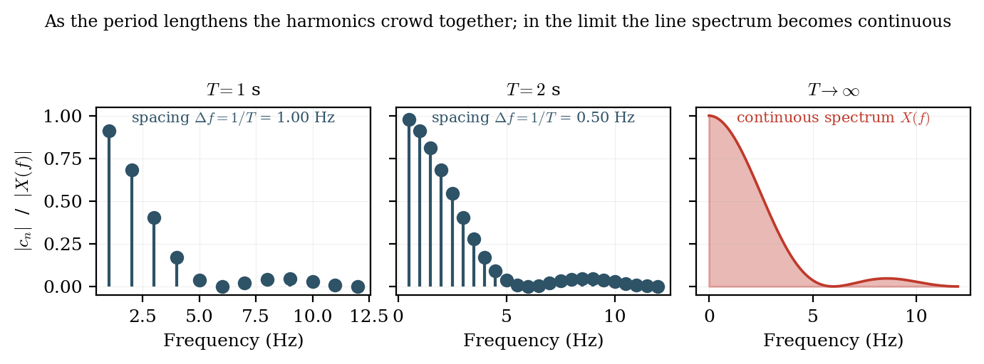
Figure 4.4.1 As the period lengthens the harmonic lines crowd together; in the limit the line spectrum becomes continuous.
That limit gives the Fourier transform pair. The first expression is the analysis equation, which finds the spectrum from the signal. The second is the synthesis equation, which rebuilds the signal from its spectrum. Nothing is lost in either direction.
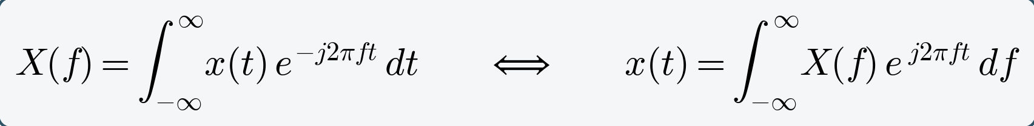 (4.3)
4.4.3 Magnitude and phase
Because X(f) is complex it is normally separated into a magnitude and a phase:
The magnitude spectrum |X(f)| states how much of each frequency is present and is what is almost always plotted. The phase spectrum φ(f) states the relative timing of each component. Phase is routinely discarded in spectral analysis, which is a genuine loss of information: two signals with identical magnitude spectra but different phase can look completely different in the time domain. Phase is retained and used explicitly in coherence, phase-locking and cross-frequency coupling analyses.
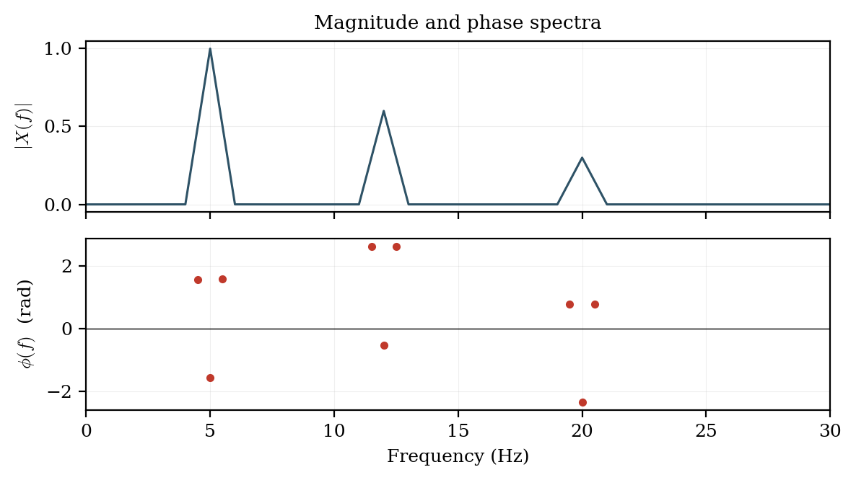
Figure 4.4.2 Magnitude and phase spectra of a signal containing components at 5, 12 and 20 Hz.
4.4.4 The discrete Fourier transform
Recorded data are finite and sampled, so the integral of equation (4.1) is replaced by a finite sum over N samples. This gives the discrete Fourier transform:
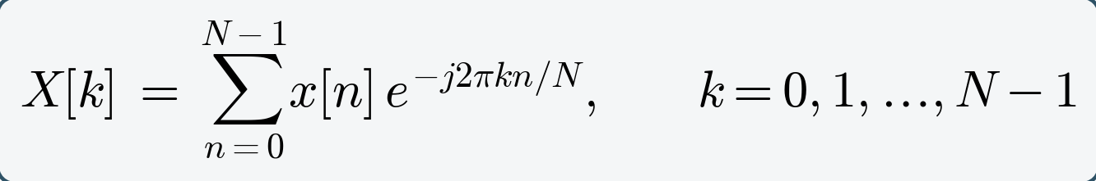 (4.2)
with the inverse transform
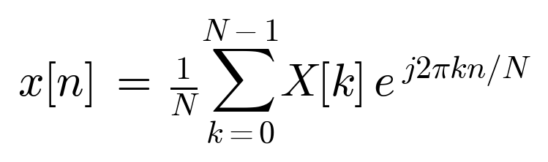
The output index k does not denote a frequency in hertz directly. The frequency of bin k is
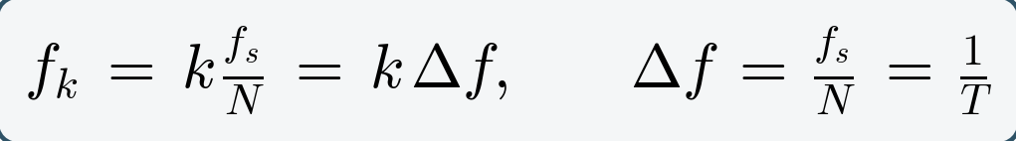 (4.3)
so that bin spacing depends only on the record duration T, while the highest representable bin is governed by fₛ. Because the input is real, the output is conjugate-symmetric and only the bins from k = 0 to k = N/2 carry independent information; the upper half is a mirror image and is discarded when a one-sided spectrum is plotted.
Evaluated directly the DFT costs order N² complex multiplications. For a single one-minute EEG channel at 250 Hz this is about 2.25 × 10⁸ operations. The fast Fourier transform of Cooley and Tukey (1965) exploits the symmetry and periodicity of the exponential kernel to reduce the cost to order N log₂ N — roughly 2.4 × 10⁵ operations for the same record, an improvement of nearly a thousandfold. It is this algorithm, not the transform itself, that made routine spectral analysis of biosignals feasible.
Worked example 4.1 — computing a DFT by hand
Take the four-point sequence x[n] = {1, 2, 1, 0}, sampled at fₛ = 8 Hz. With N = 4 the exponential kernel takes a very simple value:
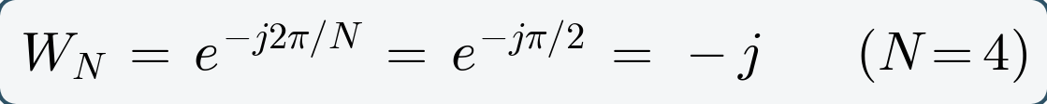
Substituting into equation (4.4) and evaluating each output bin in turn:
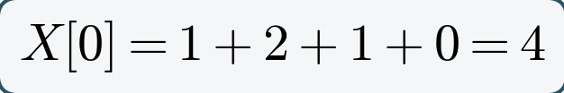
So X = {4, −2j, 0, +2j}, and the magnitudes are |X| = {4, 2, 0, 2}. Three checks confirm the result. X[0] equals the sum of the samples, which it must, because bin 0 is the DC component. X[1] and X[3] are complex conjugates of one another, which is the conjugate symmetry expected from a real input. And Parseval's theorem balances:
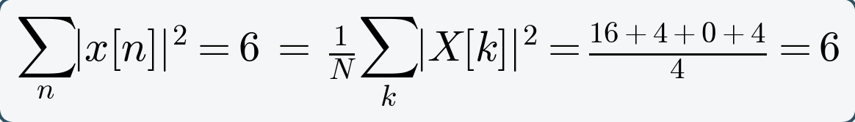
Finally, the bin frequencies follow from equation (4.5): Δf = fₛ/N = 8/4 = 2 Hz, so the four bins sit at 0, 2, 4 and 6 Hz. Only bins 0, 1 and 2 carry independent information; bin 3 mirrors bin 1.
Table 4.4.3: Result of the worked example
Bin k | Frequency | X[k] | |X[k]|
0 | 0 Hz (DC) | 4 | 4
1 | 2 Hz | −2j | 2
2 | 4 Hz (Nyquist) | 0 | 0
3 | 6 Hz (mirror of bin 1) | +2j | 2

4.4.5 From transform to power spectrum
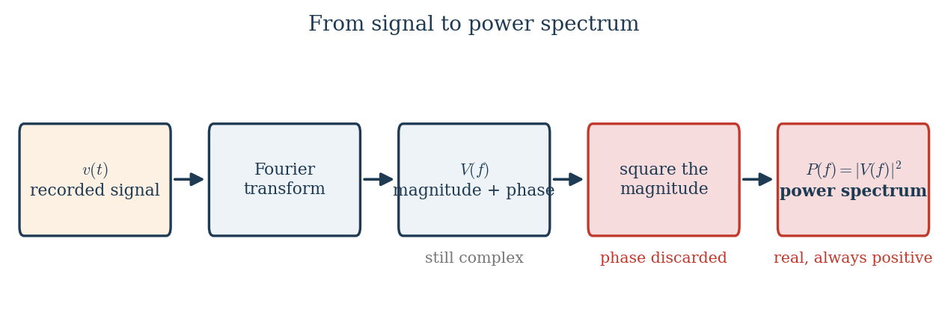
Figure 4.4.3 The steps from a recorded signal to a power spectrum.
The transform gives amplitude and phase at each frequency. For most purposes what is wanted instead is how power is distributed across frequency, obtained by squaring the magnitude and discarding phase.
For a finite-energy signal, Parseval's theorem guarantees that total energy computed in the two domains agrees, so the transform neither creates nor destroys energy:
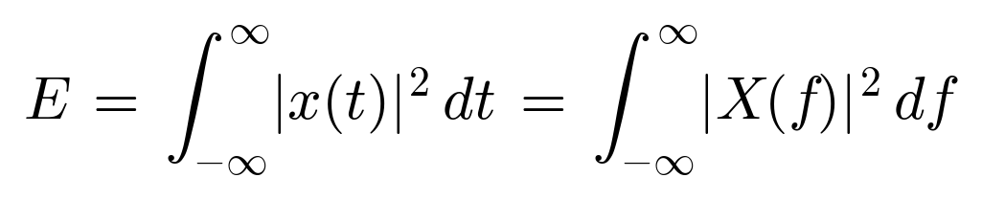
Biosignals are better modelled as finite-power rather than finite-energy signals, since they continue indefinitely. The appropriate quantity is then the power spectral density, defined as the limit of the squared magnitude per unit time:
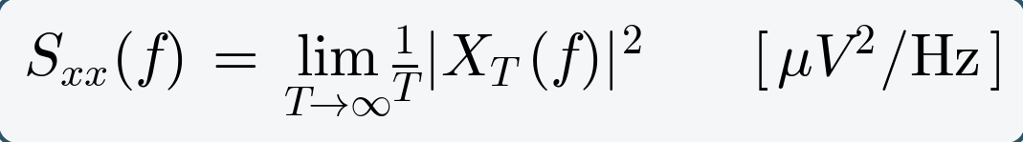 (4.4)
with units of squared amplitude per hertz — conventionally µV²/Hz for EEG. The practical estimator computed from an N-point record is the periodogram:
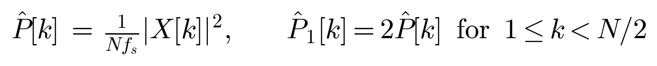
The factor of two in the one-sided form accounts for the discarded negative-frequency half, so that integrating the one-sided spectrum over frequency returns the true total power. Forgetting this factor is a common source of a silent factor-of-two error in reported band powers.
An equivalent definition connects the spectrum to the correlation description of Module 1. The Wiener–Khinchin theorem states that the power spectral density is the Fourier transform of the autocorrelation function:
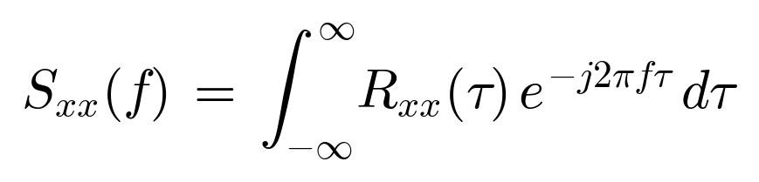 (4.5)
This is the formal reason that wide-sense stationarity, discussed in Section 3.3, is the precondition for a power spectrum to exist: if the autocorrelation depends on absolute time rather than lag alone, the transform in equation (4.7) is not defined, and there is no single spectrum to speak of.
Because neural power spans several orders of magnitude across the band, spectra are usually plotted on a decibel or logarithmic scale:
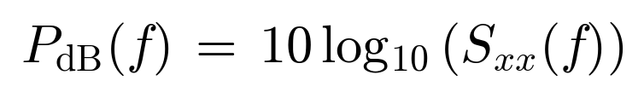
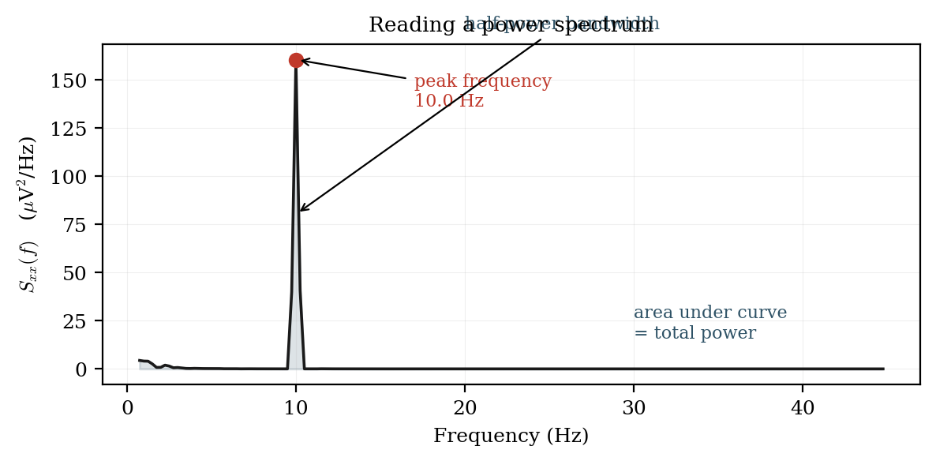
Figure 4.4.3 Reading a power spectrum: peak frequency, half-power bandwidth, and total power as the area under the curve.
4.4.6 Windowing and spectral leakage
The DFT implicitly assumes the finite record repeats periodically. Unless the record contains a whole number of cycles of every component, the wrap-around from its end to its beginning creates a discontinuity that the transform interprets as broadband energy, smearing power from a true peak across neighbouring bins. This is spectral leakage. The remedy is to multiply the record by a window function that tapers smoothly to zero at both ends, removing the discontinuity at the cost of slightly widening the main peak. Harris's 1978 review remains the standard reference on the trade-offs.
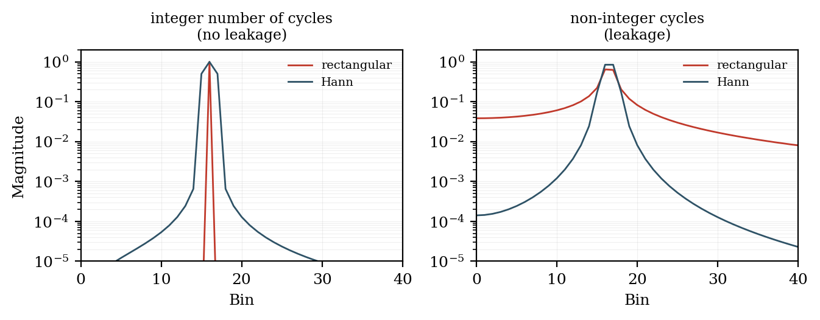
Figure 4.4.4 Spectral leakage with a rectangular window, and its suppression by a Hann window.
Table 4.4.2: Common window functions
Window | Main-lobe width | Peak sidelobe | Typical use
Rectangular (none) | narrowest (2 bins) | −13 dB | Transients; when resolution is critical
Hann | 4 bins | −31 dB | General-purpose EEG/EMG spectra
Hamming | 4 bins | −43 dB | When nearby peaks must be resolved
Blackman | 6 bins | −58 dB | Large dynamic range; weak peak near a strong one
Flat-top | wide | −86 dB | Accurate amplitude calibration

4.5 Sampling and the Nyquist principle
4.5.1 What sampling is
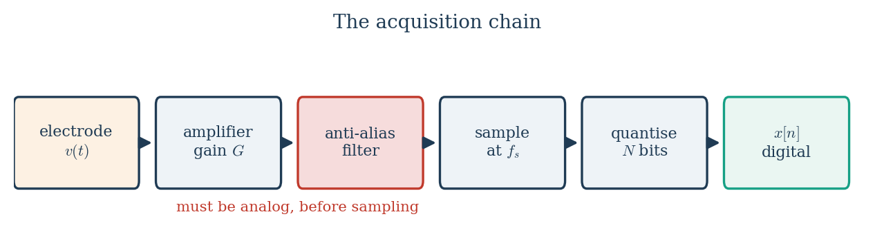
Figure 4.5.1 Where sampling sits in the acquisition chain.
Sampling is the replacement of a continuous signal by a sequence of values measured at regularly spaced instants. It is the step at which a physiological voltage becomes a set of numbers, and it is performed by the analog-to-digital converter at the end of the amplifier chain described in Module 3.
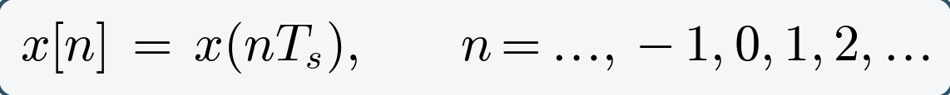 (4.7)
Two quantities define the process, and they are reciprocals of one another:
The sampling interval Tₛ is the time between consecutive samples; the sampling frequency or sampling rate fₛ is the number of samples taken per second. A clinical EEG sampled at fₛ = 500 Hz therefore has Tₛ = 2 ms between samples. The question that the sampling theorem answers is how large fₛ must be for the sample sequence to represent the original signal without loss.
4.5.2 What sampling does to the spectrum
Sampling has one consequence that explains everything else in this section: it makes copies of the spectrum. The original spectrum stays where it is, and an identical copy appears centred at every multiple of the sampling frequency.
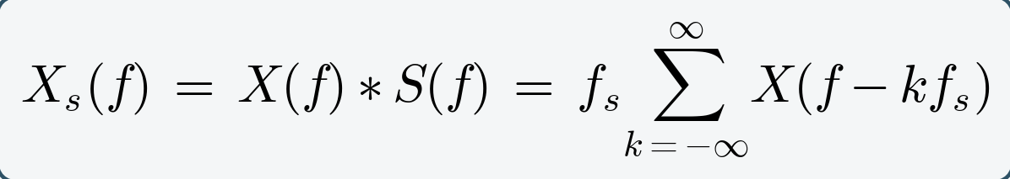 (4.9)
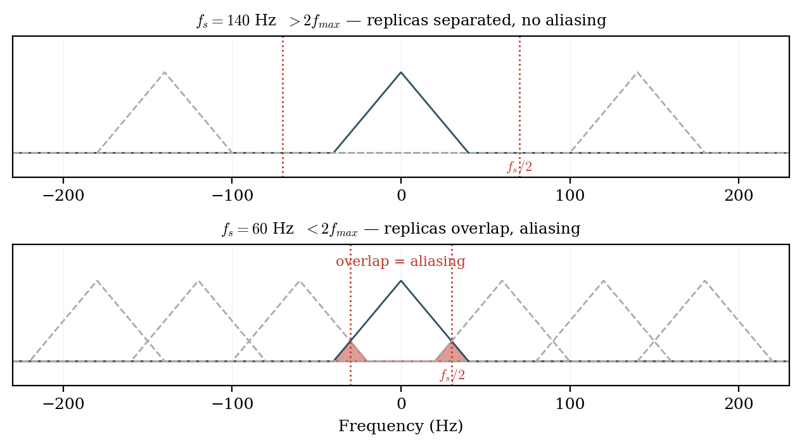
Figure 4.5.2 Sampling replicates the spectrum at every multiple of fₛ. The replicas stay separate only when fₛ > 2fₘₐₓ.
Nothing has been lost provided those copies do not touch one another. Everything that follows is a consequence of that single picture.
4.5.3 The Nyquist criterion
Suppose the signal contains no energy above fₘₐₓ. The baseband copy of the spectrum then occupies the range from −fₘₐₓ to +fₘₐₓ, and the first repeated copy is centred at fₛ and extends downward to fₛ − fₘₐₓ. The two copies remain separate provided the lower edge of the first replica lies above the upper edge of the baseband:
(4.10)
This is the Nyquist–Shannon sampling theorem, established by Nyquist in 1928 and given its information-theoretic form by Shannon in 1949. Two derived terms are used constantly and are frequently confused with one another:
The Nyquist frequency is a property of the recording system: it is half the rate at which that system samples, and it is the highest frequency that system can represent. The Nyquist rate is a property of the signal: it is twice the highest frequency the signal contains, and it is the minimum rate at which that signal must be sampled. A system samples above the Nyquist rate; a signal must contain nothing above the Nyquist frequency.
Figure 4.5.2 Sampling replicates the spectrum at every multiple of fₛ. The replicas stay separate only when fₛ > 2fₘₐₓ.
4.5.4 Aliasing
When the criterion is violated the replicas overlap, and energy from the region above fₛ/2 is added to the baseband where it is indistinguishable from genuine low-frequency content. This is aliasing, and it is irreversible: once two frequencies have produced identical sample sequences, no algorithm can separate them, because the information is not degraded but absent.
The frequency at which a component above the Nyquist frequency appears after sampling is given by
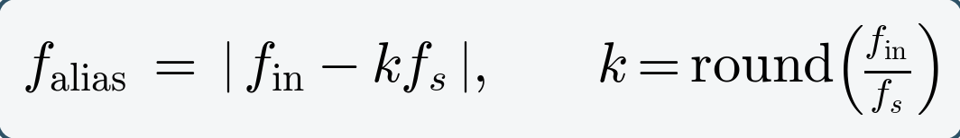 (4.11)
Worked example one. A 9 Hz sinusoid sampled at fₛ = 10 Hz. Here k = round(9/10) = 1, so f_alias = |9 − 10| = 1 Hz. The 9 Hz component is recorded as a 1 Hz component, as Figure 4.5.3 shows.
Worked example two. Mains interference at 50 Hz in an EEG sampled at fₛ = 80 Hz. Here k = round(50/80) = 1, so f_alias = |50 − 80| = 30 Hz. The interference appears at 30 Hz, inside the beta band, where it is completely indistinguishable from genuine beta activity and where no notch filter at 50 Hz will touch it.
Worked example three. A spike component at 600 Hz in a recording sampled at fₛ = 250 Hz. Here k = round(600/250) = 2, so f_alias = |600 − 500| = 100 Hz, which folds into the gamma range.
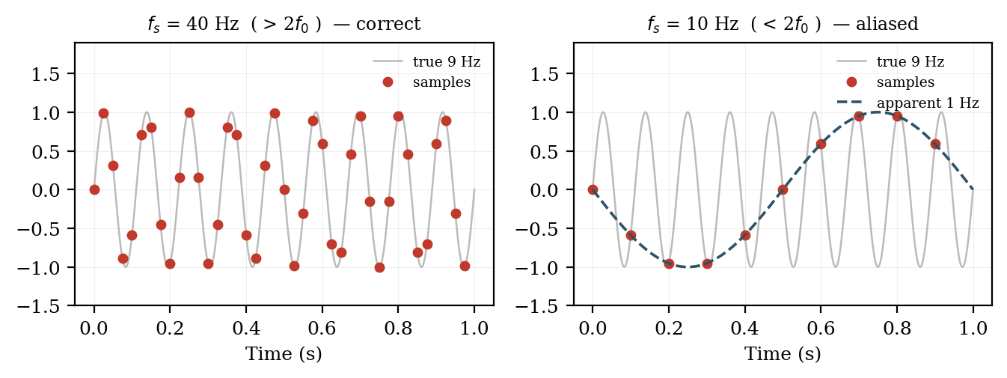
Figure 4.5.3 A 9 Hz sinusoid sampled correctly at 40 Hz, and aliased to 1 Hz when sampled at 10 Hz.
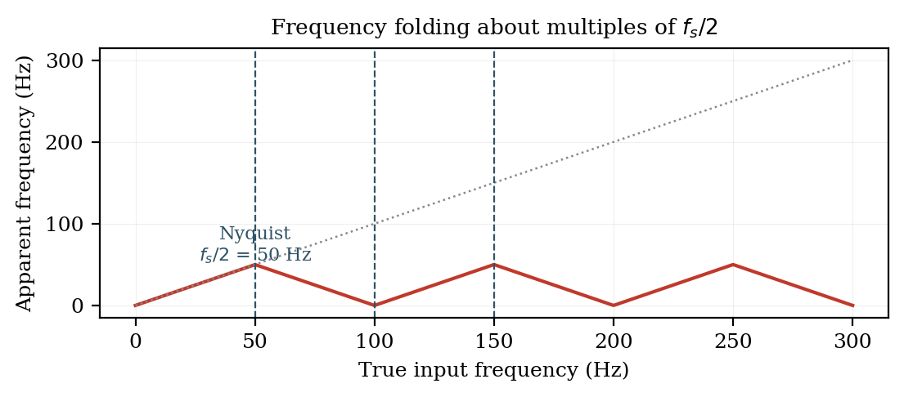
Figure 4.5.4 The folding relationship between true input frequency and apparent frequency.
4.5.5 The anti-aliasing filter
Because aliasing occurs at the instant of sampling, it must be prevented before the converter, never corrected afterwards. Every properly designed acquisition system therefore places an analog low-pass filter immediately ahead of the ADC, with its cut-off set below fₛ/2. A digital filter applied to the sampled data is useless for this purpose, since it operates on numbers in which the aliasing has already taken place. This is the single most common and most serious design error in low-cost biosignal hardware.
4.5.6 Reconstruction
If the Nyquist condition is met, the original continuous signal can be recovered exactly from its samples by low-pass filtering. The reconstructed curve passes through every sample and interpolates between them in the only way consistent with the band limit. Nothing is guessed.
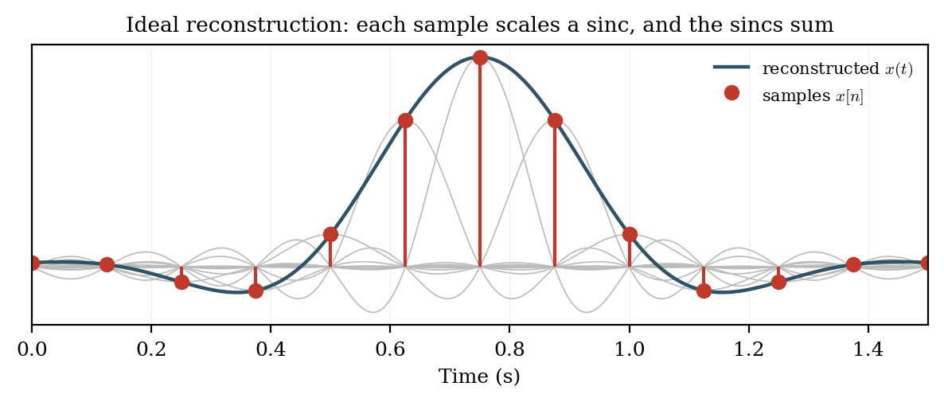
Figure 4.5.4 Reconstruction: each sample scales a smooth interpolating function, and their sum recovers the original signal.
4.5.7 Practical rates and quantisation
Because real anti-aliasing filters roll off over a finite transition band rather than cutting off abruptly, sampling at exactly twice fₘₐₓ leaves no margin. Practical systems oversample:
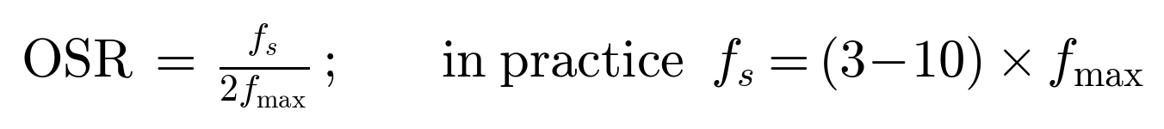
Oversampling also improves the fidelity of transient waveforms, which matters for spike morphology, and it relaxes the required steepness of the analog filter — the reason high-rate sigma-delta converters with gentle analog front ends have become the norm.
Sampling discretises time; quantisation discretises amplitude, and introduces its own error floor as described in Section 3.1.1:
Table 4.5.1: Sampling rates in practice
Signal | Useful band | Nyquist rate (2fₘₐₓ) | Typical fₛ used | OSR
EOG | DC – 10 Hz | 20 Hz | 100 – 256 Hz | 5 – 13
EEG (clinical) | 0.5 – 70 Hz | 140 Hz | 250 – 500 Hz | 2 – 4
EEG (gamma / HFO) | 0.5 – 500 Hz | 1 kHz | 1 – 2 kHz | 1 – 2
ECG | 0.05 – 150 Hz | 300 Hz | 500 Hz – 1 kHz | 2 – 3
Surface EMG | 20 – 500 Hz | 1 kHz | 1 – 2 kHz | 1 – 2
Extracellular spikes | 300 Hz – 5 kHz | 10 kHz | 20 – 30 kHz | 2 – 3

4.6 Systems and the transfer function
So far the frequency domain has been used to describe a signal. It is also the natural way to describe what a system does to a signal, and this is where it earns most of its practical value.
4.6.1 Why filtering is easier in the frequency domain
Any linear system, such as an amplifier or a filter, is fully characterised by its impulse response h(t), which is simply its output when the input is a single sharp impulse. To find the output for any other input, the input must be convolved with h(t). Convolution is an awkward operation: every output sample depends on a weighted sum of many input samples.
In the frequency domain the same operation becomes a multiplication. The Fourier transform of the impulse response is called the transfer function H(f), and the output spectrum is simply the input spectrum multiplied by it, frequency by frequency.
(4.13)
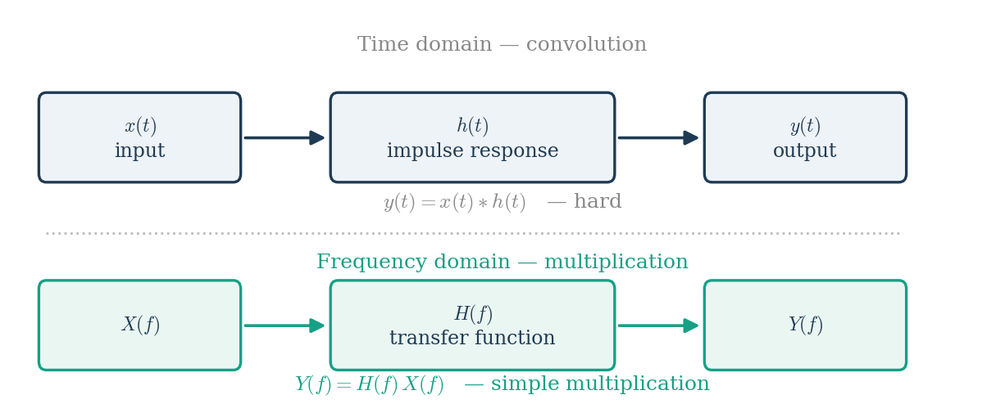
Figure 4.6.1 The same operation in both domains: convolution becomes multiplication.
This is the single most useful property of the frequency domain. A filter that is difficult to describe as a time-domain operation is trivial to describe as a curve of gain against frequency.
4.6.2 Reading a transfer function
H(f) is complex, so it has a magnitude and a phase. The magnitude states how much each frequency is amplified or attenuated, and the phase states how much each frequency is delayed.
- Where the magnitude is 1, that frequency passes unchanged.
- Where the magnitude is 0, that frequency is removed completely.
- The cut-off frequency is conventionally the point where the magnitude falls to 1/√2 of its passband value, which is half the power, or −3 dB.
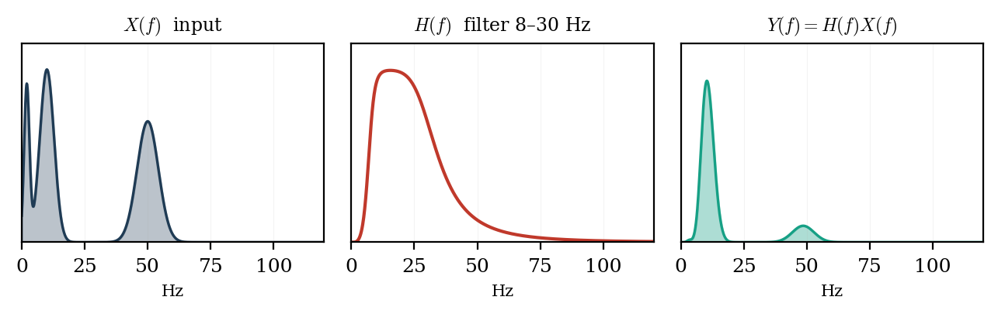
Figure 4.6.2 A band-pass filter applied in the frequency domain: the output spectrum is the input multiplied by the filter.
Figure 4.6.2 shows the whole idea in one line of arithmetic. The input contains slow drift near 1 Hz, an alpha peak near 10 Hz, and muscle activity near 50 Hz. The filter has a magnitude close to 1 between 8 and 30 Hz and close to 0 elsewhere. Multiplying the two leaves only the alpha peak. Nothing was subtracted or searched for; the unwanted content was simply multiplied by a number close to zero.
4.6.3 Filters used in biosignal recording
Table 4.6.1: Common filters and what they remove
Filter | Passes | Typical use
High-pass | Above the cut-off | Removes electrode drift and sweat artifact, cut-off 0.5 Hz
Low-pass | Below the cut-off | Removes muscle and high-frequency noise, cut-off 40 – 70 Hz
Band-pass | Between two cut-offs | Isolates one EEG band, or the 20 – 500 Hz EMG band
Band-stop (notch) | Everything except a narrow band | Removes 50 Hz mains interference
Anti-aliasing | Below fₛ/2 | Must be analog, placed before the converter

One caution follows from the phase of H(f). A filter that removes an unwanted band also shifts the timing of what remains, and a sharp filter shifts it more. For work where latency matters, such as evoked potentials, the filter must either have linear phase or be applied forwards and then backwards so that the phase shifts cancel.
4.6.4 Worked examples
Worked example 4.2 — a high-pass filter removing drift
An EEG recording contains slow electrode drift of 500 µV at 0.2 Hz and a genuine alpha rhythm of 40 µV at 10 Hz. A high-pass filter is applied whose magnitude response is |H| = 0.10 at 0.2 Hz and |H| = 0.98 at 10 Hz. Applying equation (4.13) at each frequency separately:
- Drift: 500 µV × 0.10 = 50 µV
- Alpha: 40 µV × 0.98 = 39.2 µV
The drift has been reduced tenfold while the alpha rhythm has lost only two per cent of its amplitude. Note that each frequency is handled independently. This is the whole convenience of the frequency domain: there is no interaction between the two components, only two separate multiplications.
Worked example 4.3 — reading a filter specification in decibels
Filter responses are usually quoted in decibels rather than as a plain ratio:
A notch filter specified as −40 dB at 50 Hz therefore has a magnitude of 10^(−40/20) = 0.01 at that frequency. Mains interference of 1 mV entering that filter leaves as 1 mV × 0.01 = 10 µV. Similarly, the −3 dB cut-off point quoted in every filter datasheet corresponds to a magnitude of 10^(−3/20) = 0.707, which is 1/√2, and therefore to exactly half the power.
Worked example 4.4 — filters in series
When several filters are applied one after another, their transfer functions multiply:
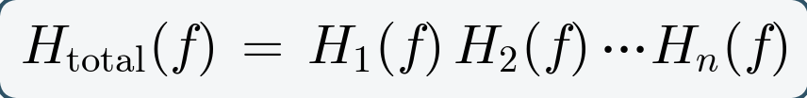
A recording chain applies a high-pass filter with |H₁| = 0.90 at 10 Hz, followed by a low-pass filter with |H₂| = 0.80 at 10 Hz. The overall magnitude at 10 Hz is 0.90 × 0.80 = 0.72, so a 40 µV alpha rhythm emerges at 28.8 µV. In decibels the same calculation is an addition rather than a multiplication: −0.9 dB plus −1.9 dB gives −2.8 dB, which is again a factor of 0.72. This is why filter responses are plotted in decibels: cascaded stages simply add.
Worked example 4.5 — choosing a sampling rate
A surface EMG signal contains no useful energy above 500 Hz. The Nyquist condition of equation (4.10) requires fₛ > 1000 Hz. Because a real anti-aliasing filter cannot cut off instantly, a practical oversampling factor of two is used, giving fₛ = 2000 Hz. With a 4-second record this gives N = 2000 × 4 = 8000 samples and a frequency resolution of Δf = 1/4 = 0.25 Hz.
4.7 Neural frequency bands
The EEG spectrum is conventionally divided into five bands. The division is historical and empirical rather than derived from first principles — Berger named the alpha rhythm in 1929 simply because it was the first he identified, and beta followed as the next — but the bands have proved durable because each corresponds broadly to a distinct generating mechanism and behavioural state.
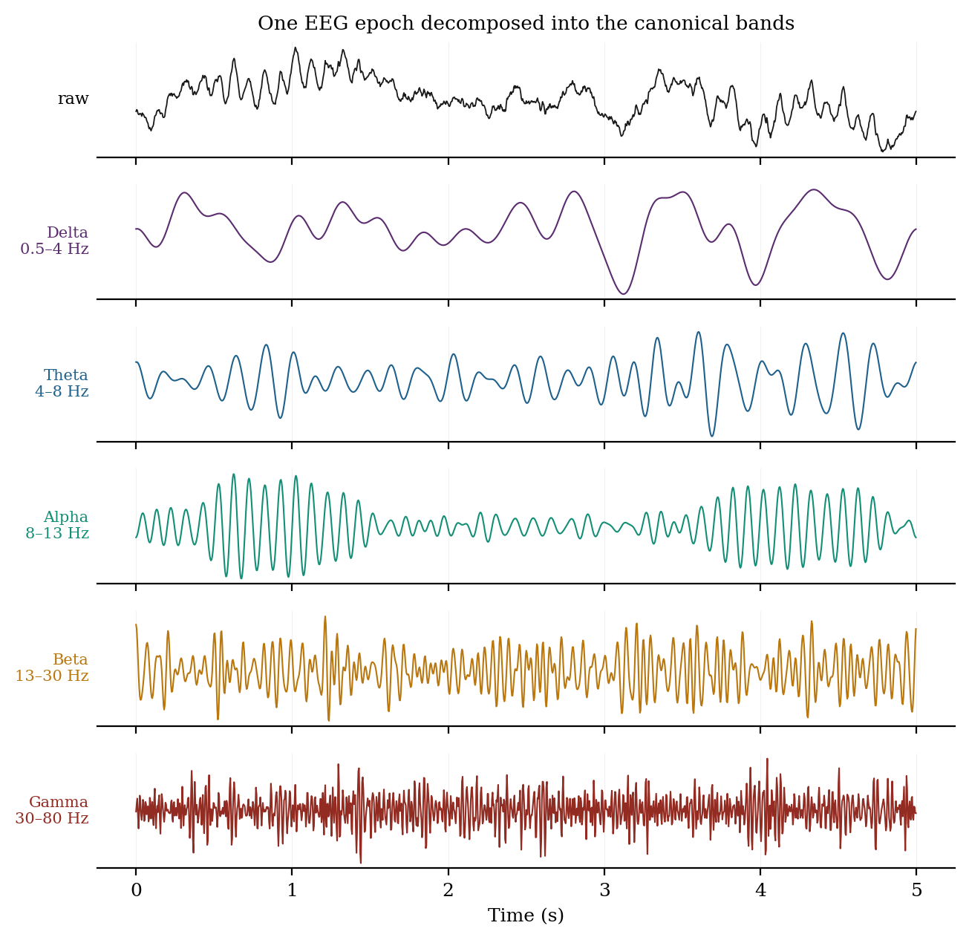
Figure 4.7.1 A single EEG epoch band-pass filtered into the five canonical bands.
Table 4.7.1: The canonical EEG frequency bands
Band | Range | Typical amplitude | Dominant topography | State and significance
Delta | 0.5 – 4 Hz | high (up to 100+ µV) | Frontal in adults | Deep (N3) sleep; infancy; focal delta suggests underlying lesion; diffuse delta indicates encephalopathy
Theta | 4 – 8 Hz | moderate | Frontal midline | Drowsiness and light sleep; frontal midline theta rises with working-memory load and sustained attention
Alpha | 8 – 13 Hz | 30 – 50 µV | Occipital / posterior | Relaxed wakefulness with eyes closed; blocked by eye opening and by mental effort; the classic Berger rhythm
Beta | 13 – 30 Hz | low (< 20 µV) | Frontocentral | Active thinking, alertness, motor control; suppressed before and during movement; markedly increased by benzodiazepines
Gamma | 30 – 100+ Hz | very low | Distributed | Associated with feature binding, attention and perception; heavily contaminated by muscle activity (Section 3.2.3)

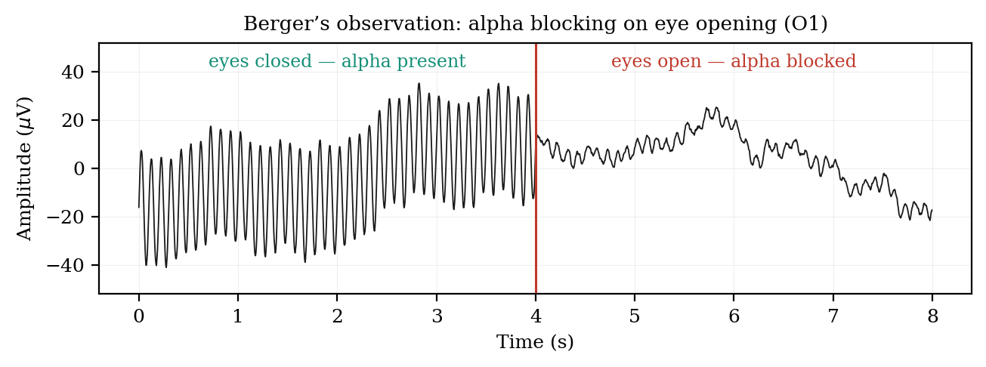
Figure 4.6.2 Alpha blocking on eye opening — the observation with which Berger established the EEG.
(a) Alpha and the reactivity principle
Alpha deserves particular attention because it illustrates a principle that generalises across the bands: a rhythm is identified not only by its frequency but by its reactivity, meaning the manipulation that reliably abolishes it. Occipital alpha appears within a second of eye closure and disappears within a second of eye opening. This reactivity, rather than the frequency alone, is what distinguishes genuine alpha from any other 10 Hz activity, and it is the reason the eyes-open and eyes-closed conditions are recorded separately in every standard clinical protocol. The individual alpha peak frequency is moreover a stable personal trait, typically between 9 and 11 Hz, which slows with age and in dementia.
(b) Two cautions about band analysis
The first caution is that band boundaries are conventions, not natural divisions, and they vary between laboratories and textbooks. An individual whose alpha peak sits at 12.5 Hz will have a substantial portion of genuine alpha power counted as beta by a fixed 13 Hz boundary. Where precision matters, the individual alpha frequency should be measured and the bands adjusted around it rather than applied as fixed limits.
The second caution is more fundamental and is now well established in the literature. The neural power spectrum is not composed solely of oscillations; it consists of an aperiodic, broadly 1/f-shaped background on which genuine periodic peaks are superimposed. Donoghue and colleagues showed in 2020 that standard band analysis conflates periodic parameters — centre frequency, power and bandwidth — with aperiodic ones — the offset and exponent of the background — and that this compromises physiological interpretation. A change in measured beta power may reflect no change in beta oscillation whatever, but merely a rotation of the aperiodic slope, which itself varies with age, task demands and level of consciousness. The same work concludes that band-ratio measures such as the theta-to-beta ratio are non-specific, since several distinct underlying spectral changes produce the same ratio. Current best practice is to parameterise the spectrum explicitly into aperiodic and periodic components before interpreting band power.
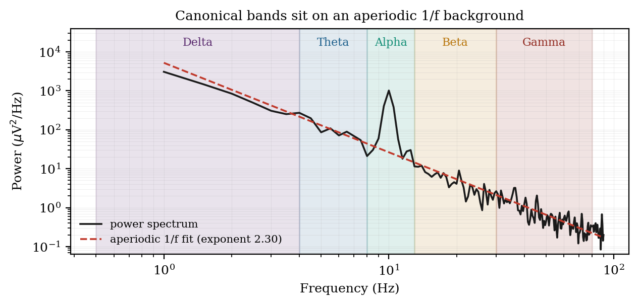
Figure 4.7.3 The canonical bands sit on an aperiodic 1/f background that must be separated before interpretation.
Summary
Time and frequency are two views of one object. The time domain shows when things happen and is the natural domain for transients, morphology and evoked responses. The frequency domain shows what the signal is made of and is the natural domain for rhythms, filter design and sampling decisions. The Fourier transform moves between them without loss, provided the signal is stationary over the interval analysed; the FFT makes the computation practical; windowing controls the leakage introduced by finite record length; and Welch averaging controls the variance of the estimate. The sampling theorem sets the one constraint that cannot be relaxed after the fact. Finally, the canonical bands are a useful vocabulary rather than a physiological taxonomy, and they should be applied with explicit awareness of the aperiodic background on which they rest.

