4.1 Time-domain representation
The time-domain representation is the raw form in which every biosignal is acquired: a sequence of amplitude values indexed by time, written v(t) for a continuous signal and v[n] for its sampled counterpart. It is the representation clinicians actually read. An electroencephalographer scanning a record for epileptiform discharges, a cardiologist measuring a PR interval, an electromyographer assessing motor unit potential duration — all of these are time-domain operations performed by eye.
Four properties can be read directly from a time trace, and they were defined quantitatively in Module 1: amplitude, whether expressed as peak, peak-to-peak or RMS; latency, the time from a stimulus or fiducial point to a feature of interest; duration, the temporal extent of a discrete event; and morphology, the shape of the waveform itself, which carries diagnostic weight independent of any numerical measure. A QRS complex, a K-complex and a blink artifact are each recognised primarily by shape.
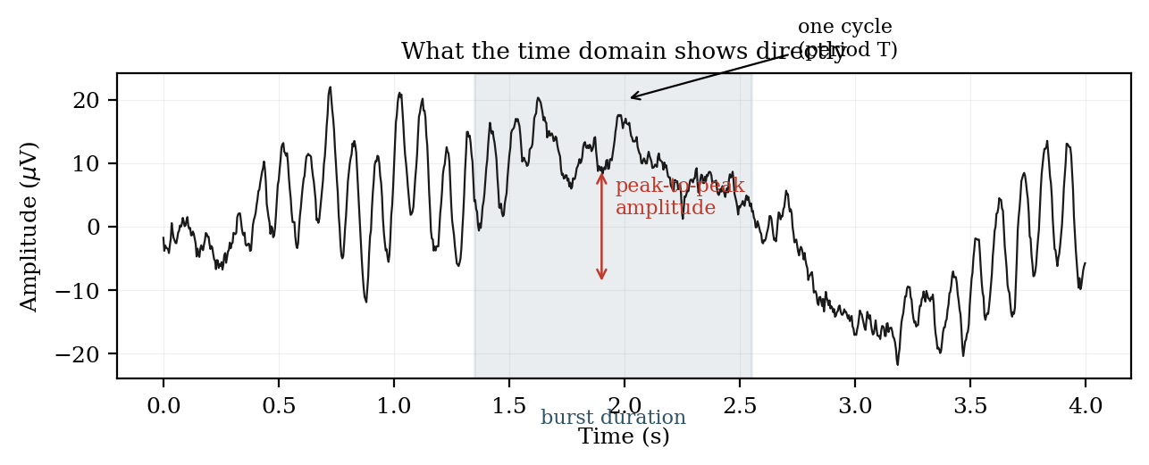
Figure 4.1.1 Amplitude, duration and periodicity read directly from a time trace.
Several useful descriptors are computed entirely in the time domain without any transform. The mean and variance summarise the amplitude distribution. The zero-crossing rate — the number of times per second the signal crosses its baseline — is a crude but computationally trivial index of dominant frequency, and is still used in low-power implantable devices where a Fourier transform would be prohibitive. Autocorrelation, introduced in Module 1, reveals periodicity without leaving the time domain. Ensemble averaging of stimulus-locked epochs, the basis of all evoked-potential work, is likewise a purely time-domain operation.
The limitation of the time domain is the superposition problem. The scalp EEG at any instant is the sum of several rhythms generated by different populations, plus aperiodic background, plus whatever artifacts have survived. Their sum is a single fluctuating trace in which the individual contributors are no longer separately visible. The eye can extract a strong alpha rhythm from a quiet background, but it cannot reliably judge whether theta power has increased by thirty per cent, nor detect a rhythm whose amplitude is below that of the activity it is mixed with. For that, the signal must be re-expressed.

