4.3 Intuitive introduction to Fourier analysis
Fourier's insight, published in 1822 in the Théorie analytique de la chaleur while he was studying heat conduction rather than signals, was that any reasonable periodic function can be represented as a sum of sinusoids at integer multiples of a fundamental frequency. The claim was controversial at the time precisely because it seemed implausible that smooth sinusoids could reconstruct a discontinuous function such as a square wave.
(a) Synthesis: building a signal from sinusoids
The Fourier series expresses a periodic signal of period T as
v(t) = a₀ + Σₙ [ aₙ cos(2πnf₀t) + bₙ sin(2πnf₀t) ], f₀ = 1/T
where the coefficients aₙ and bₙ give the amount of each harmonic present. Adding successive harmonics of a square wave demonstrates the idea concretely: the fundamental alone is a poor approximation, three harmonics already show the flat top forming, and by ten the shape is recognisable. The residual overshoot at the discontinuities, which does not disappear as harmonics are added but merely narrows, is the Gibbs phenomenon, and it reappears in practice as the ringing produced by a sharp filter acting on a transient — the effect warned about in Section 3.1.3 when notch filtering an epileptiform spike.
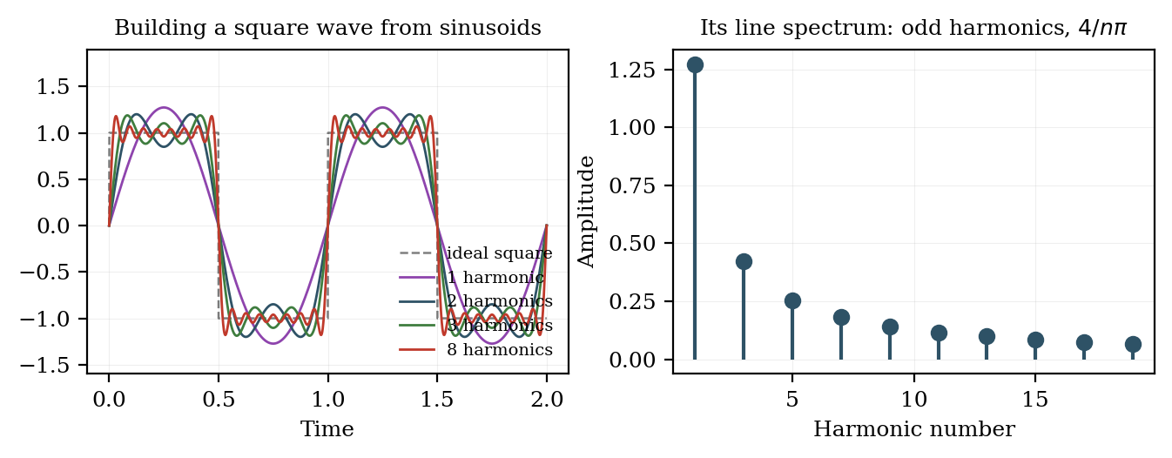
Figure 4.3.1 Synthesis of a square wave from odd harmonics, and its line spectrum.
(b) Analysis: detecting how much of a frequency is present
The reverse operation — determining the coefficients from the signal — rests on an equally simple idea. To test whether a signal contains a particular frequency, multiply it point by point with a sinusoid at that frequency and average the product over the record. If the two match, positive and negative half-cycles align, the product is predominantly positive and the average is large. If they do not match, the product is as often positive as negative and averages toward zero. This is the orthogonality of sinusoids, and it is the whole mechanism of the Fourier transform.
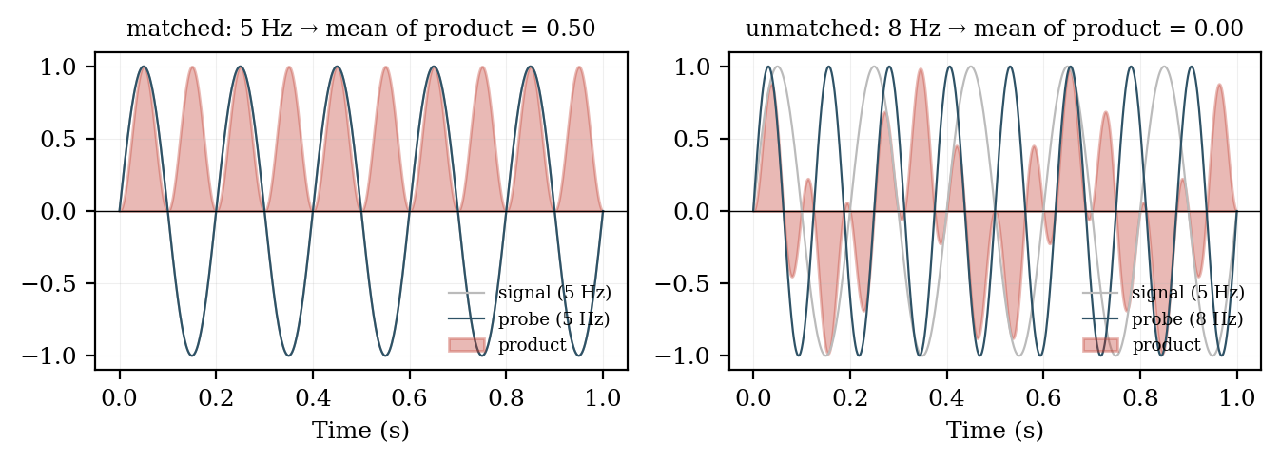
Figure 4.3.2 Correlation with a probe sinusoid: matched frequency yields a large average, unmatched yields zero.
Two probes are needed at each frequency, a sine and a cosine, because a signal component may be shifted in phase relative to either. Their two coefficients are conventionally combined into a single complex number whose magnitude gives the amplitude of that frequency component and whose argument gives its phase. This is why the Fourier transform is complex-valued: the imaginary part carries phase, not anything imaginary in the physical sense.

