4.4 The Fourier transform and the power spectrum
4.4.1 What the Fourier transform is
The Fourier transform is an operation that takes a signal expressed as a function of time and returns a function of frequency describing how much of each frequency the signal contains, and with what phase. It is not an approximation and it discards nothing: the transform is invertible, so the original signal can be recovered exactly from its transform. The two functions are two representations of one object.
The formula
The Fourier transform of a signal x(t) is defined by the integral
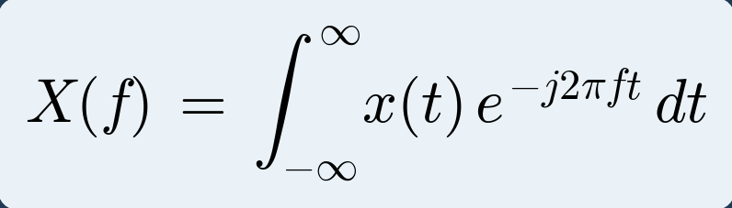 (4.1)
and the original signal is recovered from its spectrum by the inverse transform
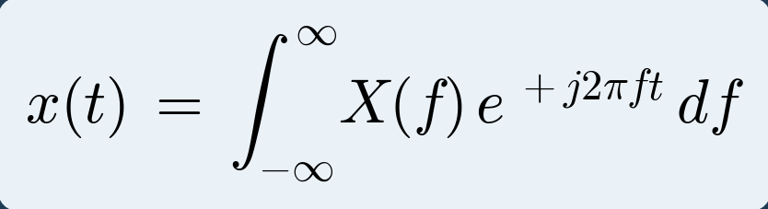 (4.2)
These two together are called the Fourier transform pair. Every symbol in them is as follows.
Table 4.4.1: Terms in the Fourier transform
Symbol | Meaning
x(t) | The signal, as a function of time. What is recorded.
X(f) | The spectrum, as a function of frequency. Complex-valued.
f | Frequency in hertz. The variable being tested for.
t | Time in seconds. Integrated out, so it does not appear in the answer.
e⁻ʲ²ᵖᶠᵗ | The test waveform: a complex sinusoid of frequency f.
j | The imaginary unit, √−1. Written i in mathematics, j in engineering.
∫ dt | Sum over all time. This is what performs the comparison.

Read in words, the forward transform says: multiply the signal by a test sinusoid of frequency f, add up the result over all time, and the answer tells you how much of that frequency the signal contained. Repeat for every f and you have the whole spectrum. This is exactly the correlation idea from Section 4.3, written as an integral.
An alternative form uses angular frequency ω = 2πf, giving X(ω) = ∫ x(t) e^(−jωt) dt, with a factor 1/2π appearing in the inverse. The form in f used here is preferred in signal processing because frequencies are read directly in hertz.
Why complex exponentials
The building block used is the complex exponential rather than the sine and cosine separately, because Euler's relation lets a single complex function carry both:
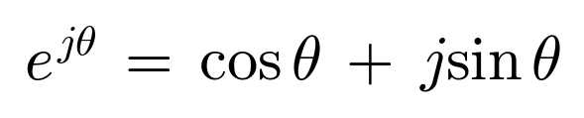
A complex exponential of frequency f therefore contains a cosine in its real part and a sine in its imaginary part. Testing a signal against one complex exponential simultaneously performs both the sine and the cosine correlation described in Section 4.3, and returns the amplitude and phase together as a single complex number. There is a second and deeper reason for this choice: complex exponentials are the eigenfunctions of linear time-invariant systems, meaning that a filter can change the amplitude and phase of such a signal but never its frequency. This is precisely why frequency-domain analysis is the natural language of filtering.
4.4.2 Where the transform comes from
The Fourier transform is not a separate invention. It is the Fourier series stretched to cover signals that never repeat, and seeing that connection removes most of the mystery.
A periodic signal of period T is built from harmonics spaced 1/T apart in frequency. Make the period longer and those harmonics move closer together. Make the period infinite, which is what an aperiodic signal is, and the spacing shrinks to zero. The discrete line spectrum becomes a continuous curve, and the sum over harmonics becomes an integral over frequency.
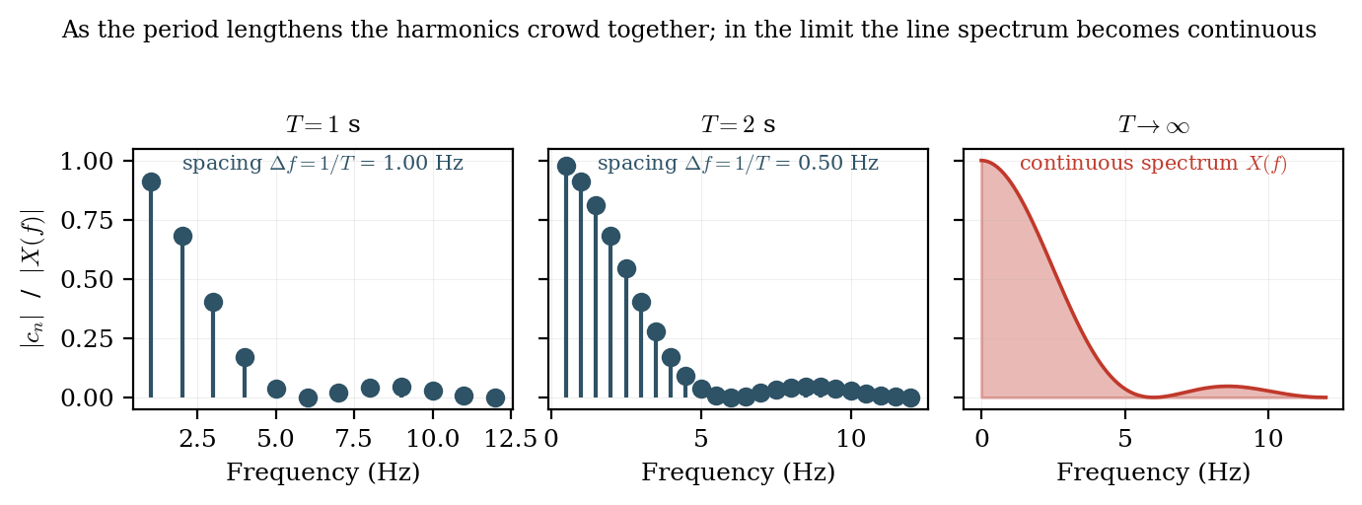
Figure 4.4.1 As the period lengthens the harmonic lines crowd together; in the limit the line spectrum becomes continuous.
That limit gives the Fourier transform pair. The first expression is the analysis equation, which finds the spectrum from the signal. The second is the synthesis equation, which rebuilds the signal from its spectrum. Nothing is lost in either direction.
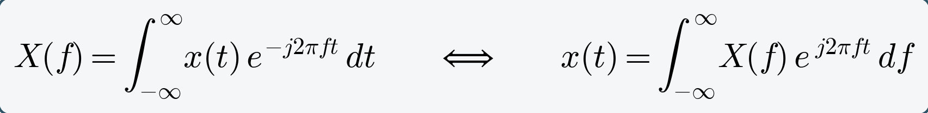 (4.3)
4.4.3 Magnitude and phase
Because X(f) is complex it is normally separated into a magnitude and a phase:
The magnitude spectrum |X(f)| states how much of each frequency is present and is what is almost always plotted. The phase spectrum φ(f) states the relative timing of each component. Phase is routinely discarded in spectral analysis, which is a genuine loss of information: two signals with identical magnitude spectra but different phase can look completely different in the time domain. Phase is retained and used explicitly in coherence, phase-locking and cross-frequency coupling analyses.
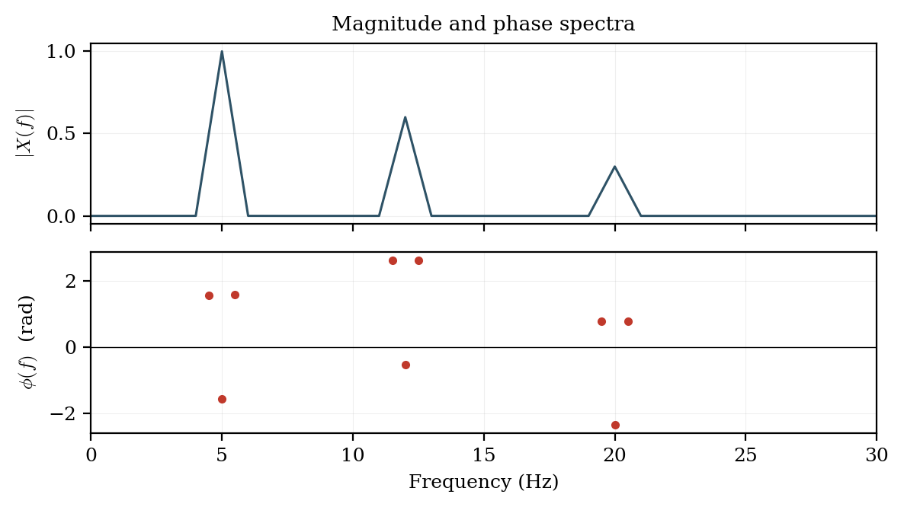
Figure 4.4.2 Magnitude and phase spectra of a signal containing components at 5, 12 and 20 Hz.
4.4.4 The discrete Fourier transform
Recorded data are finite and sampled, so the integral of equation (4.1) is replaced by a finite sum over N samples. This gives the discrete Fourier transform:
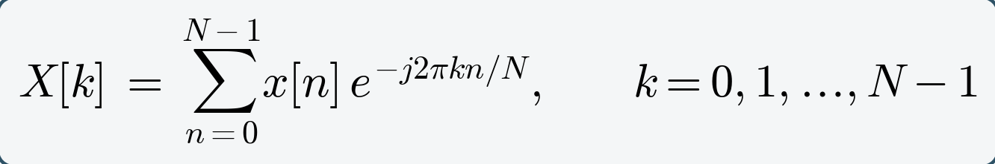 (4.2)
with the inverse transform
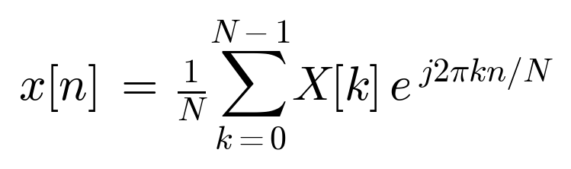
The output index k does not denote a frequency in hertz directly. The frequency of bin k is
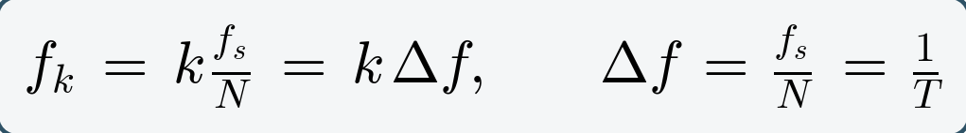 (4.3)
so that bin spacing depends only on the record duration T, while the highest representable bin is governed by fₛ. Because the input is real, the output is conjugate-symmetric and only the bins from k = 0 to k = N/2 carry independent information; the upper half is a mirror image and is discarded when a one-sided spectrum is plotted.
Evaluated directly the DFT costs order N² complex multiplications. For a single one-minute EEG channel at 250 Hz this is about 2.25 × 10⁸ operations. The fast Fourier transform of Cooley and Tukey (1965) exploits the symmetry and periodicity of the exponential kernel to reduce the cost to order N log₂ N — roughly 2.4 × 10⁵ operations for the same record, an improvement of nearly a thousandfold. It is this algorithm, not the transform itself, that made routine spectral analysis of biosignals feasible.
Worked example 4.1 — computing a DFT by hand
Take the four-point sequence x[n] = {1, 2, 1, 0}, sampled at fₛ = 8 Hz. With N = 4 the exponential kernel takes a very simple value:
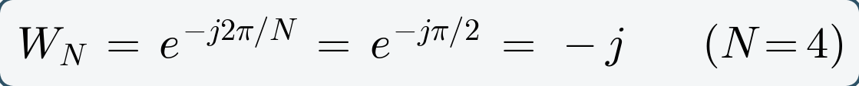
Substituting into equation (4.4) and evaluating each output bin in turn:
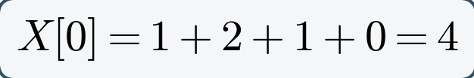
So X = {4, −2j, 0, +2j}, and the magnitudes are |X| = {4, 2, 0, 2}. Three checks confirm the result. X[0] equals the sum of the samples, which it must, because bin 0 is the DC component. X[1] and X[3] are complex conjugates of one another, which is the conjugate symmetry expected from a real input. And Parseval's theorem balances:
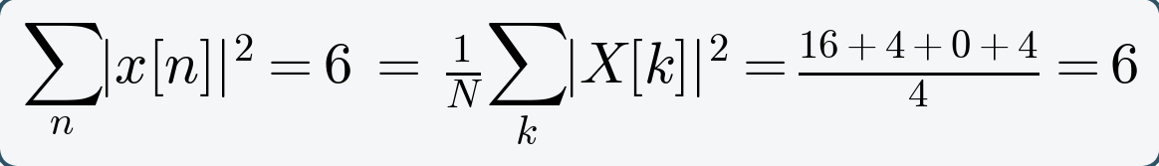
Finally, the bin frequencies follow from equation (4.5): Δf = fₛ/N = 8/4 = 2 Hz, so the four bins sit at 0, 2, 4 and 6 Hz. Only bins 0, 1 and 2 carry independent information; bin 3 mirrors bin 1.
Table 4.4.3: Result of the worked example
Bin k | Frequency | X[k] | |X[k]|
0 | 0 Hz (DC) | 4 | 4
1 | 2 Hz | −2j | 2
2 | 4 Hz (Nyquist) | 0 | 0
3 | 6 Hz (mirror of bin 1) | +2j | 2

4.4.5 From transform to power spectrum
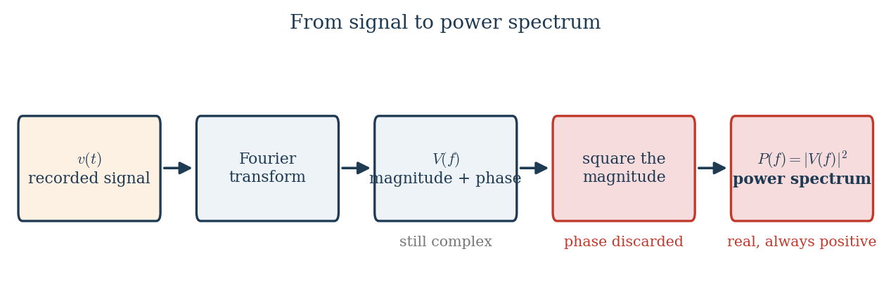
Figure 4.4.3 The steps from a recorded signal to a power spectrum.
The transform gives amplitude and phase at each frequency. For most purposes what is wanted instead is how power is distributed across frequency, obtained by squaring the magnitude and discarding phase.
For a finite-energy signal, Parseval's theorem guarantees that total energy computed in the two domains agrees, so the transform neither creates nor destroys energy:
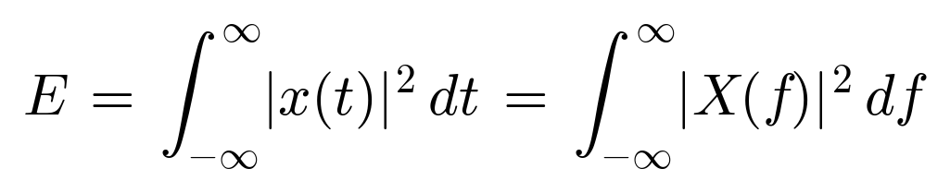
Biosignals are better modelled as finite-power rather than finite-energy signals, since they continue indefinitely. The appropriate quantity is then the power spectral density, defined as the limit of the squared magnitude per unit time:
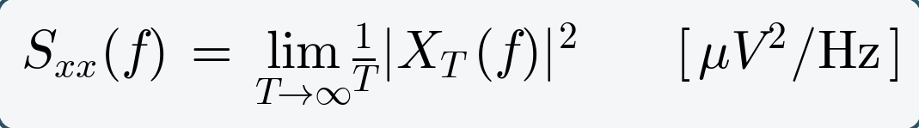 (4.4)
with units of squared amplitude per hertz — conventionally µV²/Hz for EEG. The practical estimator computed from an N-point record is the periodogram:
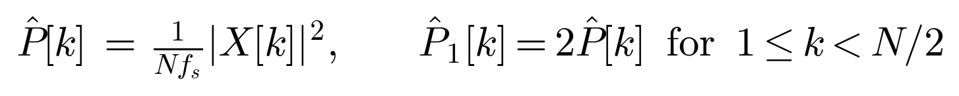
The factor of two in the one-sided form accounts for the discarded negative-frequency half, so that integrating the one-sided spectrum over frequency returns the true total power. Forgetting this factor is a common source of a silent factor-of-two error in reported band powers.
An equivalent definition connects the spectrum to the correlation description of Module 1. The Wiener–Khinchin theorem states that the power spectral density is the Fourier transform of the autocorrelation function:
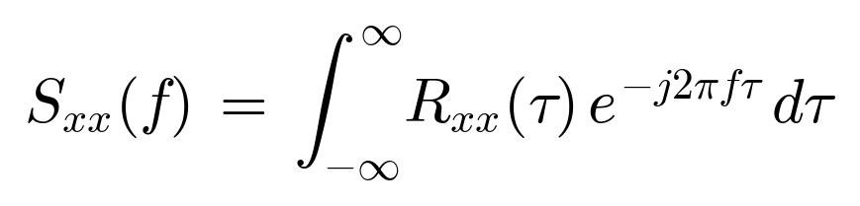 (4.5)
This is the formal reason that wide-sense stationarity, discussed in Section 3.3, is the precondition for a power spectrum to exist: if the autocorrelation depends on absolute time rather than lag alone, the transform in equation (4.7) is not defined, and there is no single spectrum to speak of.
Because neural power spans several orders of magnitude across the band, spectra are usually plotted on a decibel or logarithmic scale:
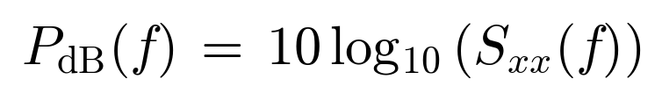
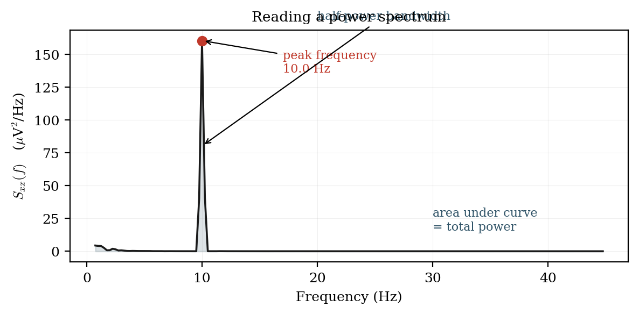
Figure 4.4.3 Reading a power spectrum: peak frequency, half-power bandwidth, and total power as the area under the curve.
4.4.6 Windowing and spectral leakage
The DFT implicitly assumes the finite record repeats periodically. Unless the record contains a whole number of cycles of every component, the wrap-around from its end to its beginning creates a discontinuity that the transform interprets as broadband energy, smearing power from a true peak across neighbouring bins. This is spectral leakage. The remedy is to multiply the record by a window function that tapers smoothly to zero at both ends, removing the discontinuity at the cost of slightly widening the main peak. Harris's 1978 review remains the standard reference on the trade-offs.
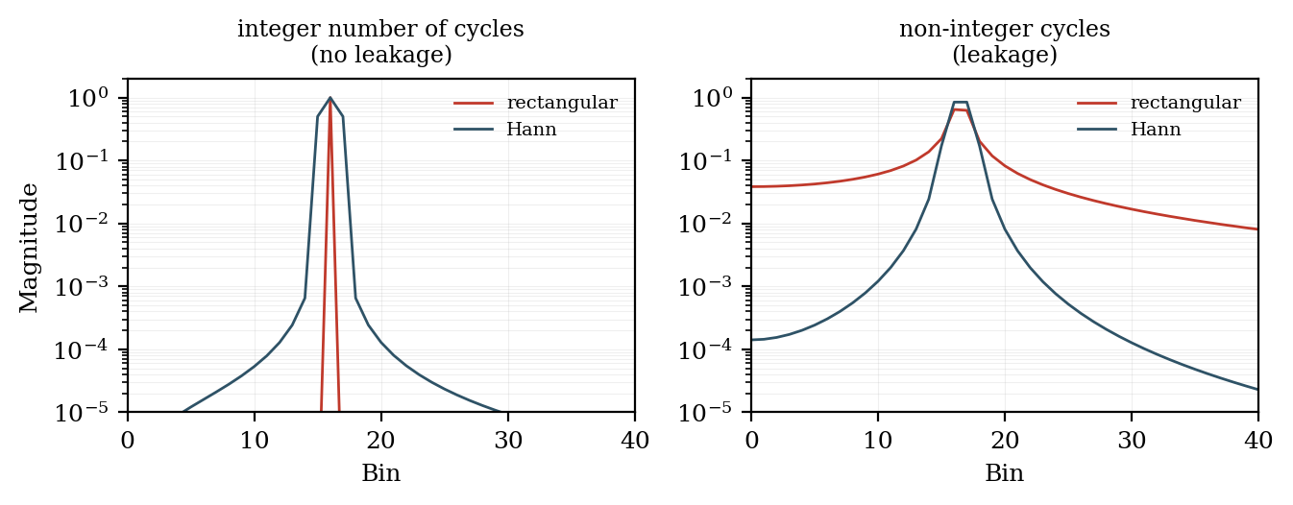
Figure 4.4.4 Spectral leakage with a rectangular window, and its suppression by a Hann window.
Table 4.4.2: Common window functions
Window | Main-lobe width | Peak sidelobe | Typical use
Rectangular (none) | narrowest (2 bins) | −13 dB | Transients; when resolution is critical
Hann | 4 bins | −31 dB | General-purpose EEG/EMG spectra
Hamming | 4 bins | −43 dB | When nearby peaks must be resolved
Blackman | 6 bins | −58 dB | Large dynamic range; weak peak near a strong one
Flat-top | wide | −86 dB | Accurate amplitude calibration

