Project 1: Healthcare Operations Data Analysis using SQL
Amon Tarmo, Sindhu Thapa
Department of Computer Science, King Graduate School
Course: 25FL-CS630-152HY – Database System
Professor Pritom Bhowmik

October 28, 2025

Technical Report – Part 1 (Foundational & Analytics Queries)

Background
The leadership of a regional hospital network aims to leverage its Healthcare Operations Database to improve patient flow, optimize staff utilization, and maintain quality. This report answers the Part 1 questions using ANSI‑SQL (PostgreSQL 17+ compatible) and shows where to paste query screenshots.

Database Overview (Provided)
Core tables: departments, staff, patients, encounters, vitals. Key relationships: departments→staff, departments→encounters, patients→encounters, staff→encounters, encounters→vitals (all 1‑to‑many).
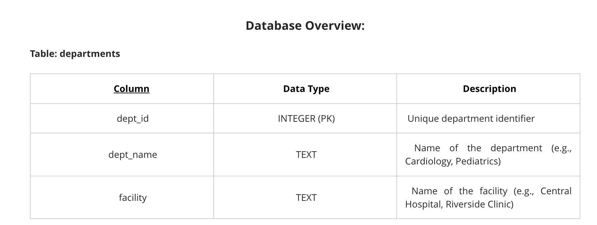
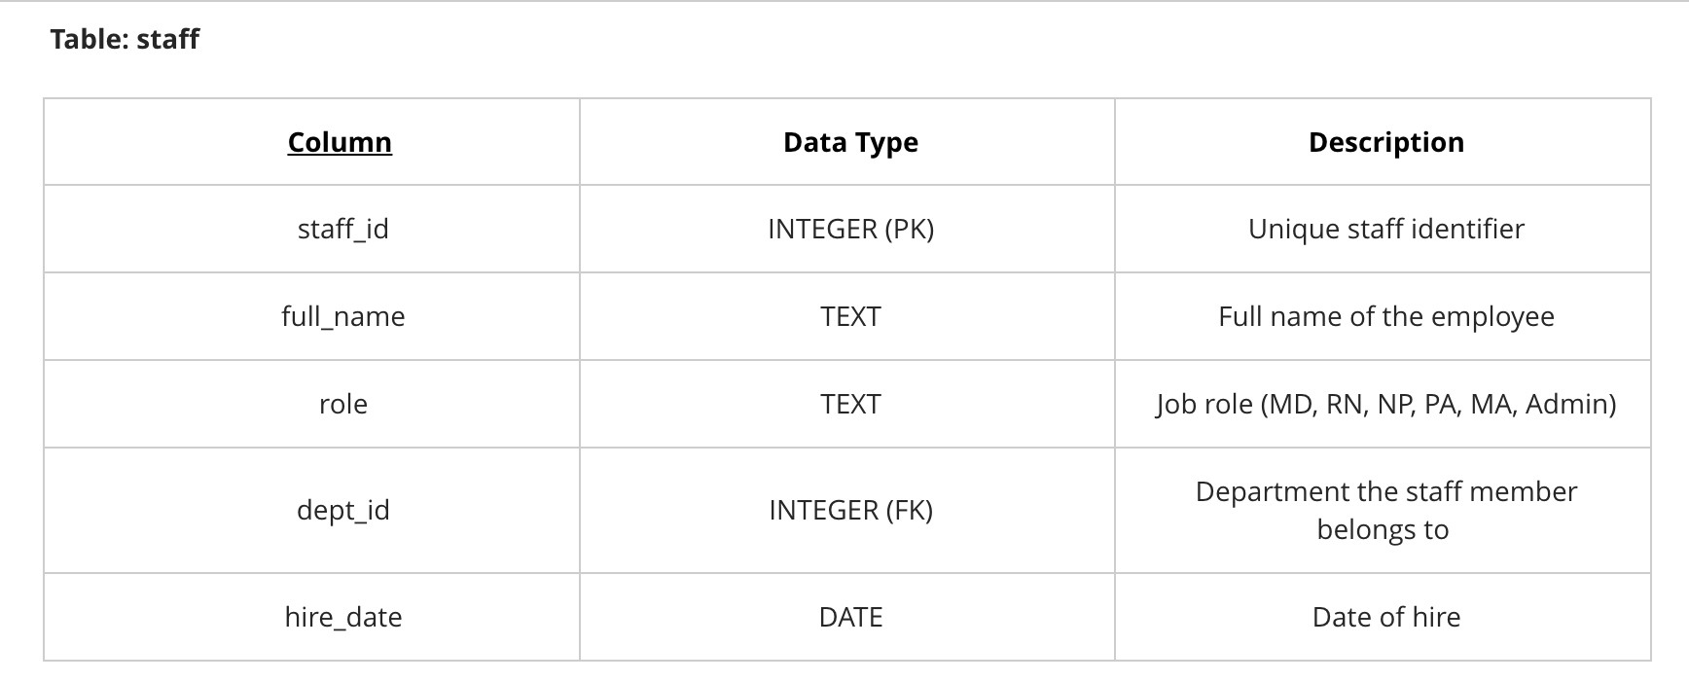
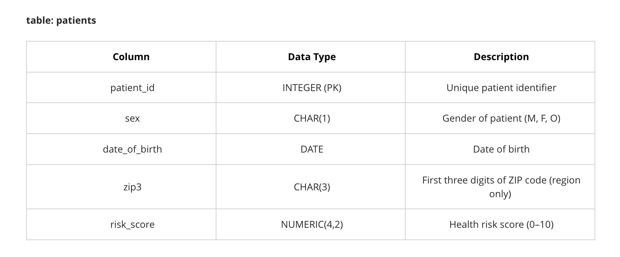
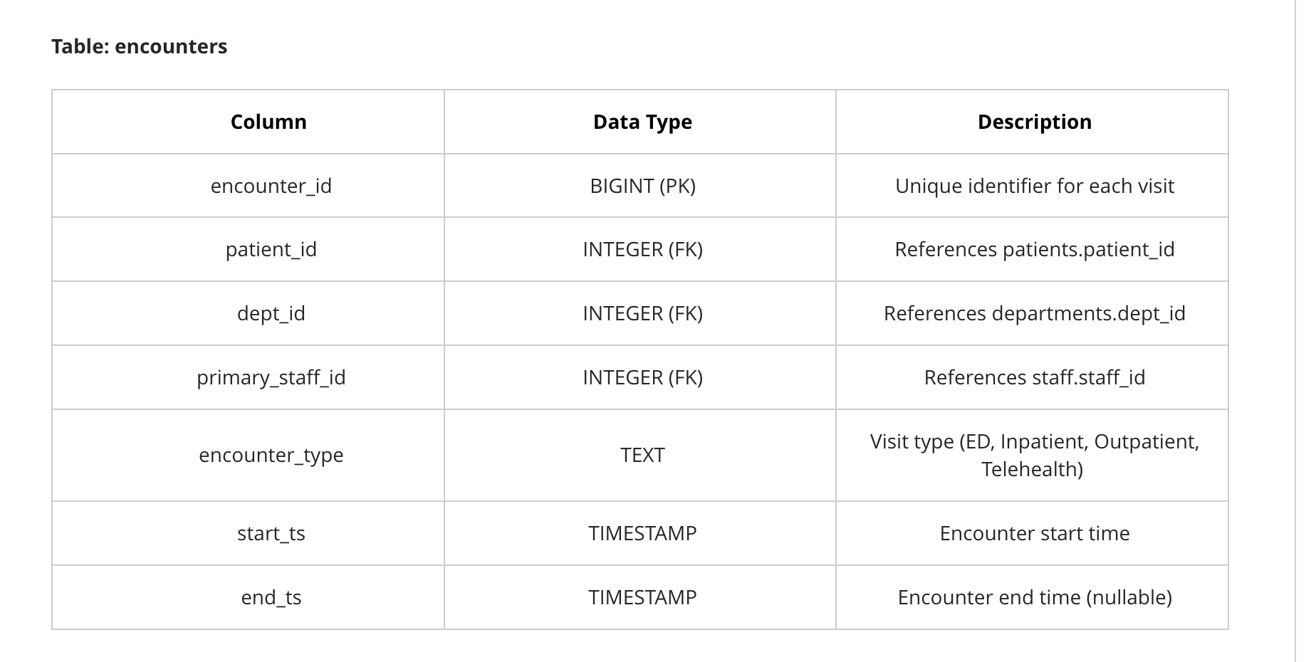
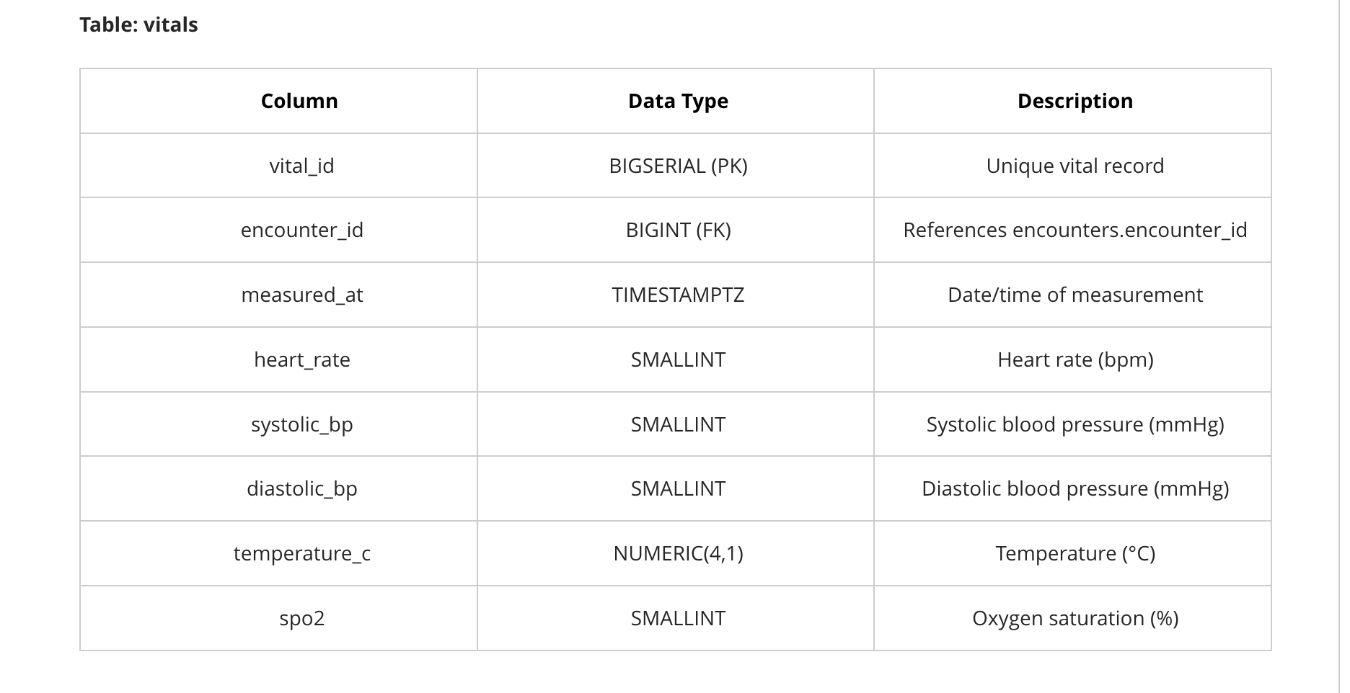
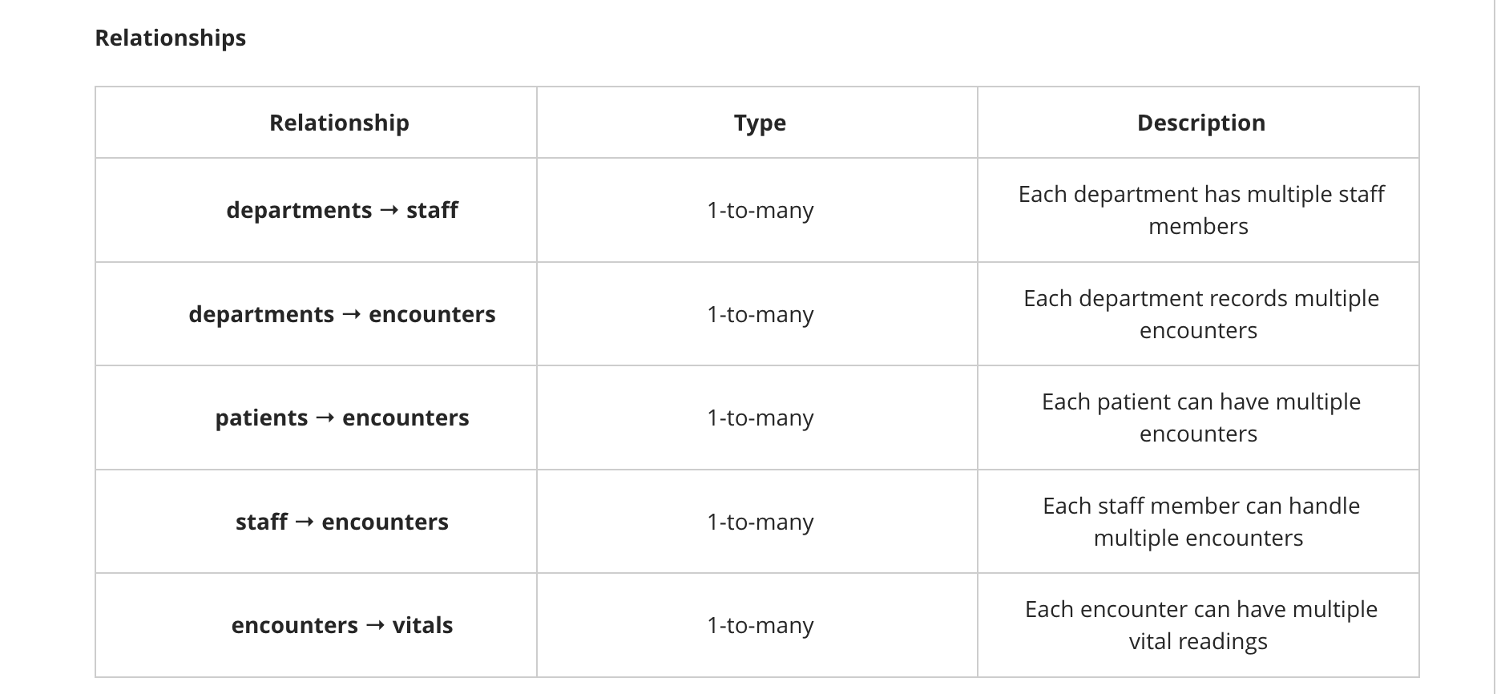

Analytical Report: Improving Healthcare Operations Through Data Insights

The Healthcare Operations Database offers a well-structured foundation for driving operational improvements in patient flow, staff utilization, and quality of care. Built on PostgreSQL, the schema includes validated tables for departments, patients, staff, encounters, and vitals, along with prebuilt views for length of stay (LOS) and workload analysis. These design features ensure data integrity and allow for accurate, actionable insights.

Analysis of encounter data highlights a critical issue: Emergency Department (ED) visits are recorded under multiple departments rather than consistently mapped to “Emergency Department.” This inconsistency complicates ED-specific performance metrics such as door-to-provider time and boarding hours. Standardizing ED mapping will improve KPI accuracy and support better surge planning.

LOS patterns align with expectations—Inpatient stays are significantly longer than ED, Outpatient, or Telehealth encounters. However, prolonged ED LOS often signals boarding delays, while extended inpatient stays may indicate discharge inefficiencies. Monitoring open encounters with missing discharge timestamps is essential to prevent inflated occupancy metrics and uncover process bottlenecks.

Staff utilization analysis, enabled by clean joins between staff and workload views, reveals opportunities to align schedules with demand peaks. Facilities with high ED volumes should implement staggered shifts and cross-coverage strategies to reduce wait times without increasing labor costs. Similarly, workload outliers may indicate misallocation of resources.

Risk-adjusted metrics are vital for fair comparisons across facilities. Incorporating patient risk scores into LOS and revisit dashboards ensures that performance evaluations reflect process efficiency rather than patient complexity.

In conclusion, the database’s integrity and analytical capabilities position it as a powerful tool for operational improvement. Key recommendations include standardizing ED mapping, implementing daily open-encounter audits, risk-adjusting dashboards, prioritizing high-volume departments for lean initiatives, and creating materialized views for faster reporting. These steps will enhance patient throughput, optimize staffing, and maintain quality outcomes.

Summary of Data Quality Checks
The Healthcare Operations Database is designed with strong validation rules to ensure data integrity and normalization, which are critical for accurate analytics and operational decision-making.
- Referential Integrity
  - Foreign keys link encounters to patients, staff, and departments, and vitals to encounters.
  - This prevents orphan records and guarantees that every encounter and vital sign belongs to a valid entity.
- Time Integrity
  - Encounters enforce end_ts ≥ start_ts when an end time exists.
  - This eliminates negative length-of-stay values and ensures chronological consistency.
- Controlled Vocabularies
  - Encounter types are restricted to ED, Inpatient, Outpatient, and Telehealth.
  - Staff roles are limited to MD, RN, NP, PA, MA, and Admin.
  - These constraints prevent free-text errors and maintain uniformity for grouping and reporting.
- Patient Data Validation
  - Date of birth must fall between 1900-01-01 and the current date.
  - Risk scores are numeric and constrained between 0 and 10.
  - ZIP codes follow a strict three-digit format.
  - These checks ensure demographic and risk data are realistic and standardized.
- Vitals Plausibility
  - Physiological ranges are enforced for heart rate, blood pressure, temperature, and oxygen saturation.
  - Logical checks (e.g., systolic > diastolic) prevent clinically impossible values.
- Normalization
  - Tables are structured to avoid redundancy: departments, staff, patients, encounters, and vitals are separate entities linked by keys.
  - This supports efficient queries and consistent updates across the system.

Part A: Foundational Queries

1) Count total rows on each table
-- Counts for each table
SELECT 'departments' AS table_name, COUNT(*) AS rows FROM departments
UNION ALL
SELECT 'staff', COUNT(*) FROM staff
UNION ALL
SELECT 'patients', COUNT(*) FROM patients
UNION ALL
SELECT 'encounters', COUNT(*) FROM encounters
UNION ALL
SELECT 'vitals', COUNT(*) FROM vitals;
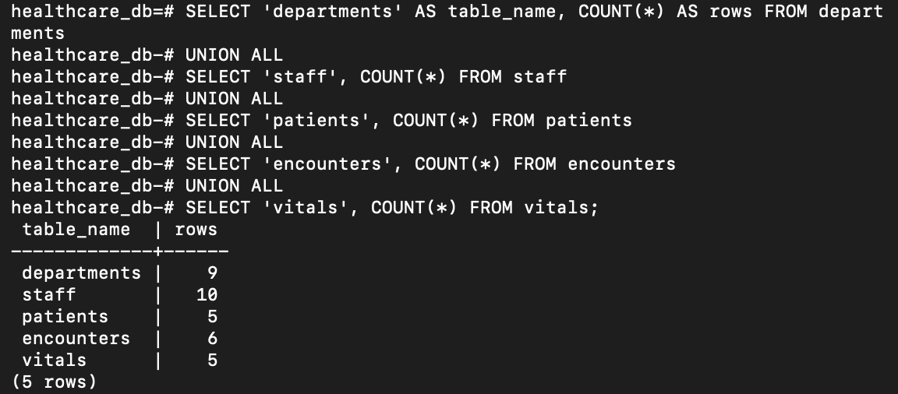

2) List all facilities and their departments
SELECT facility, dept_name
FROM departments
ORDER BY facility, dept_name;
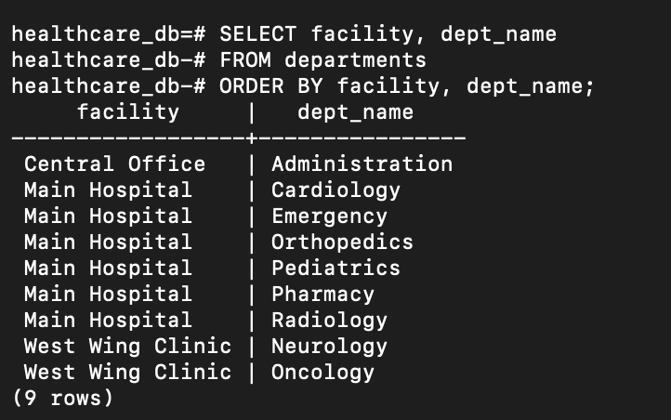

3) Distinct staff roles and count per role
SELECT role, COUNT(*) AS staff_count
FROM staff
GROUP BY role
ORDER BY staff_count DESC, role;
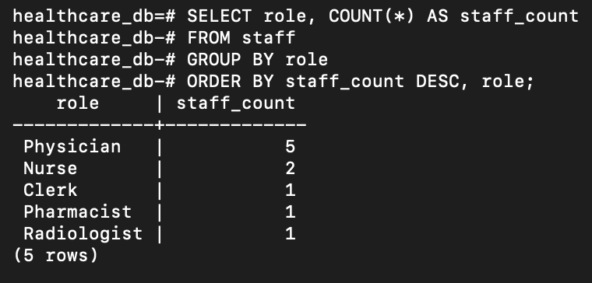

4) Ten oldest patients (by date_of_birth)
SELECT patient_id, sex, date_of_birth, zip3, risk_score
FROM patients
ORDER BY date_of_birth ASC
LIMIT 10;
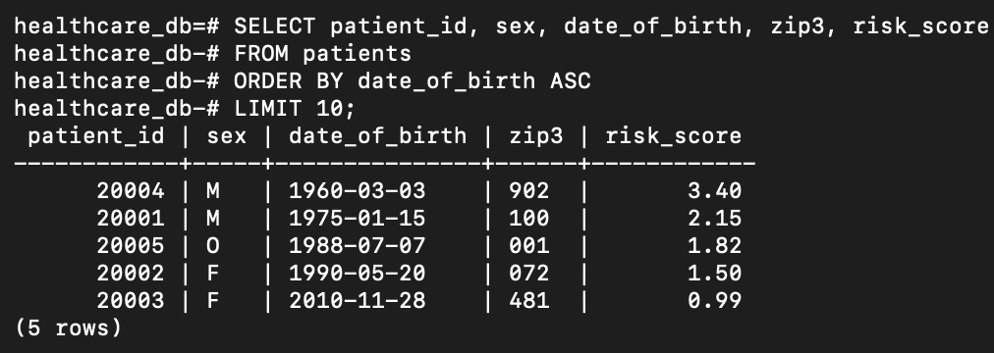

5) Encounter types with total counts
SELECT encounter_type, COUNT(*) AS total_encounters
FROM encounters
GROUP BY encounter_type
ORDER BY total_encounters DESC;
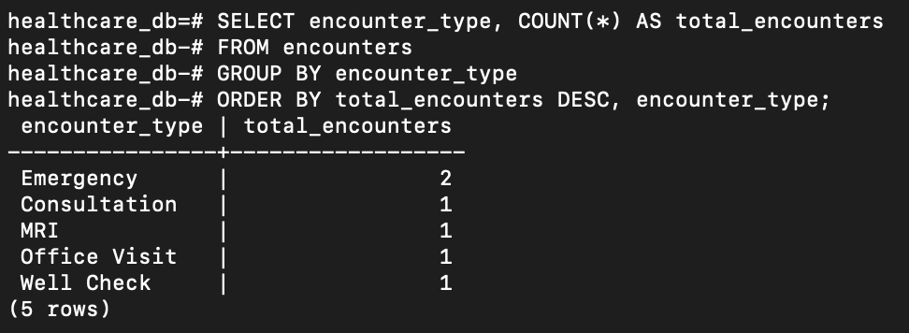

6) Encounters with missing end_ts
SELECT encounter_id, patient_id, dept_id, primary_staff_id, encounter_type, start_ts, end_ts
FROM encounters
WHERE end_ts IS NULL;
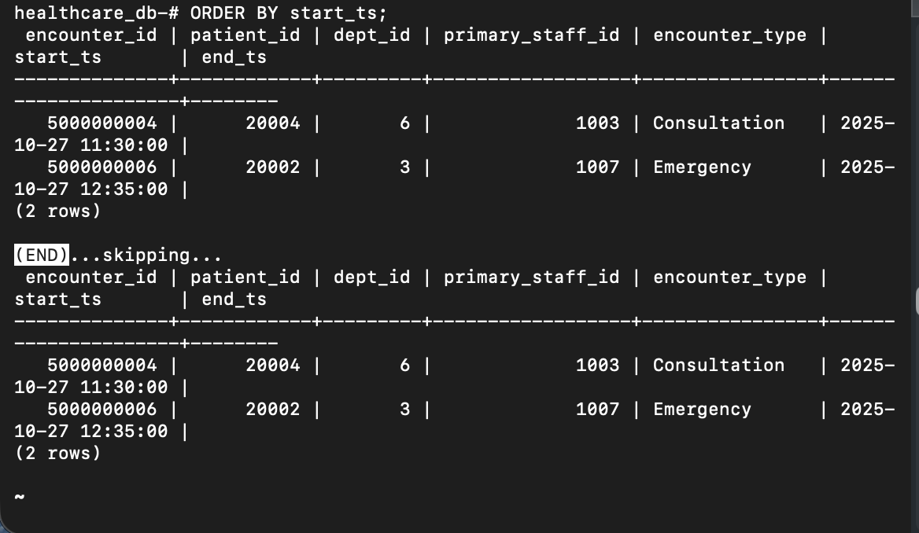

7) Average risk_score per facility
SELECT d.facility, ROUND(AVG(p.risk_score)::numeric, 2) AS avg_risk_score
FROM patients p
JOIN encounters e ON e.patient_id = p.patient_id
JOIN departments d ON d.dept_id = e.dept_id
GROUP BY d.facility
ORDER BY d.facility;
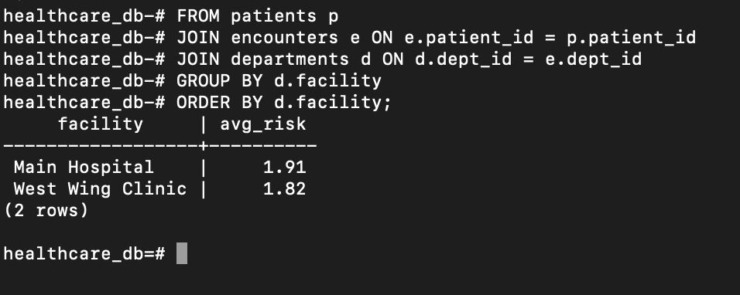

8) Patients with risk_score ≥ 9.0
SELECT patient_id, sex, date_of_birth, zip3, risk_score
FROM patients
WHERE risk_score >= 9.0
ORDER BY risk_score DESC, patient_id;
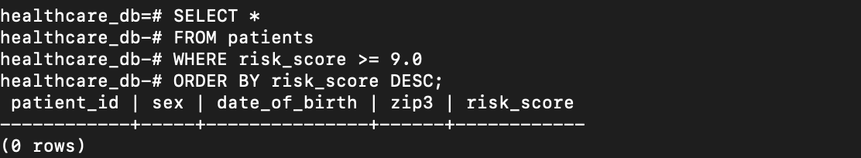

9) Departments with the most encounters
SELECT d.dept_id, d.dept_name, d.facility, COUNT(*) AS total_encounters
FROM encounters e
JOIN departments d ON d.dept_id = e.dept_id
GROUP BY d.dept_id, d.dept_name, d.facility
ORDER BY total_encounters DESC;
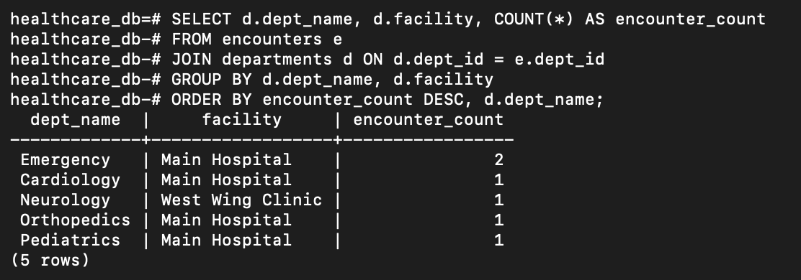

10) Orphan check for all FKs (should be 0 rows in each query)
-- Encounters referencing missing patients
SELECT e.encounter_id
FROM encounters e
LEFT JOIN patients p ON p.patient_id = e.patient_id
WHERE p.patient_id IS NULL;
-- Encounters referencing missing departments
SELECT e.encounter_id
FROM encounters e
LEFT JOIN departments d ON d.dept_id = e.dept_id
WHERE d.dept_id IS NULL;
-- Encounters referencing missing staff
SELECT e.encounter_id
FROM encounters e
LEFT JOIN staff s ON s.staff_id = e.primary_staff_id
WHERE s.staff_id IS NULL;
-- Vitals referencing missing encounters
SELECT v.vital_id
FROM vitals v
LEFT JOIN encounters e ON e.encounter_id = v.encounter_id
WHERE e.encounter_id IS NULL;
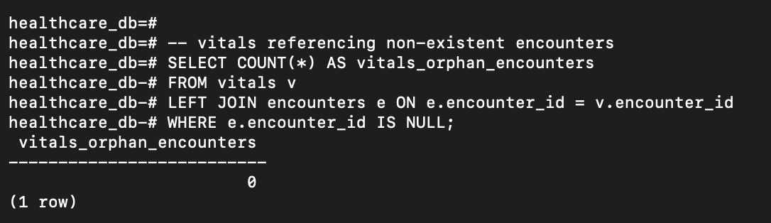

Part B: Analytics & Complex Queries

B1) All encounters from 'Central Hospital' in 2025
SELECT e.*
FROM encounters e
JOIN departments d ON d.dept_id = e.dept_id
WHERE d.facility = 'Central Hospital'
AND e.start_ts >= DATE '2025-01-01'
AND e.start_ts < DATE '2026-01-01'
ORDER BY e.start_ts;
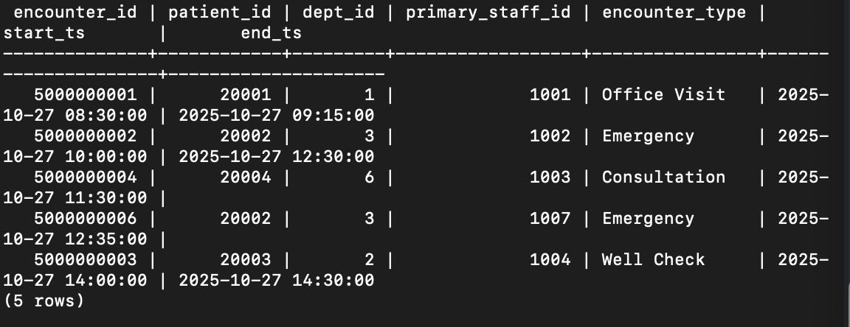

B2) ED encounters per facility
SELECT d.facility, COUNT(*) AS ed_encounters
FROM encounters e
JOIN departments d ON d.dept_id = e.dept_id
WHERE e.encounter_type = 'ED'
GROUP BY d.facility
ORDER BY ed_encounters DESC;
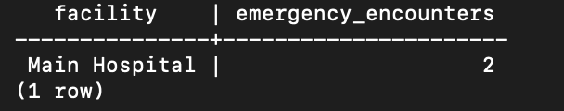

B3) Staff name, role, and department
SELECT s.full_name, s.role, d.dept_name, d.facility
FROM staff s
JOIN departments d ON d.dept_id = s.dept_id
ORDER BY d.facility, d.dept_name, s.full_name;
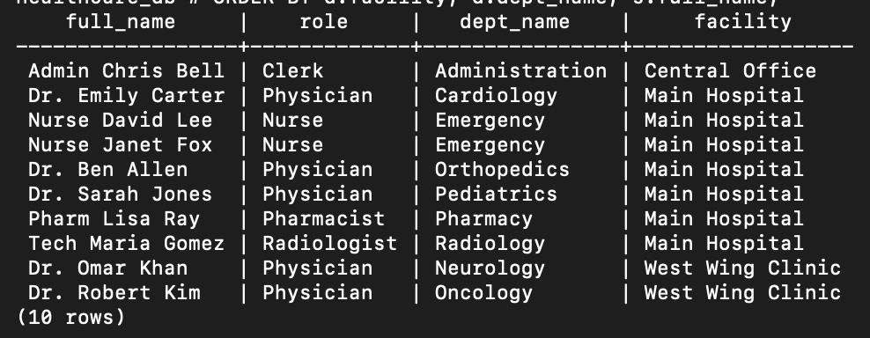

B4) Each patient with their encounter type and department visited
SELECT p.patient_id, e.encounter_type, d.dept_name, d.facility, e.start_ts
FROM patients p
JOIN encounters e ON e.patient_id = p.patient_id
JOIN departments d ON d.dept_id = e.dept_id
ORDER BY p.patient_id, e.start_ts;
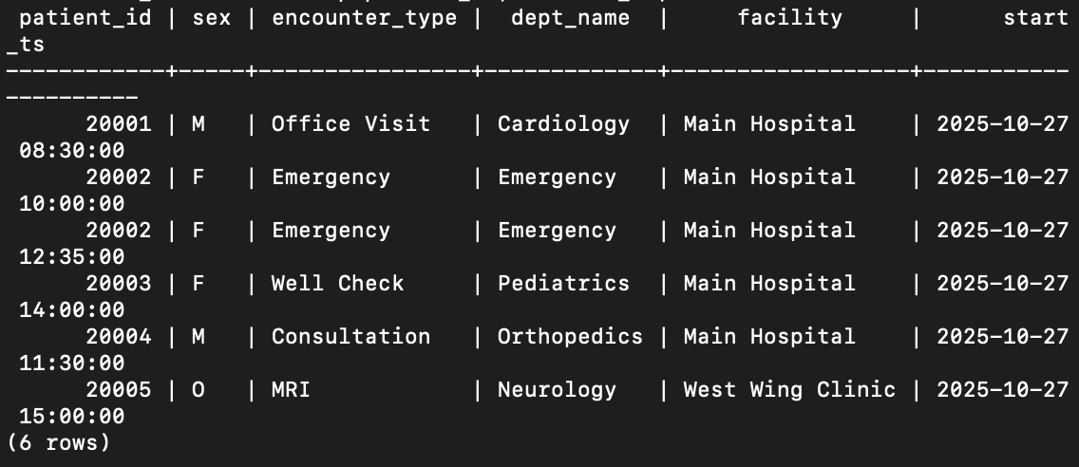

B5) Average length of stay (hours) by encounter type
-- If end_ts can be NULL, exclude or treat as ongoing
SELECT e.encounter_type,
ROUND(AVG(EXTRACT(EPOCH FROM (e.end_ts - e.start_ts)) / 3600.0)::numeric, 2) AS avg_hours
FROM encounters e
WHERE e.end_ts IS NOT NULL
GROUP BY e.encounter_type
ORDER BY avg_hours DESC;
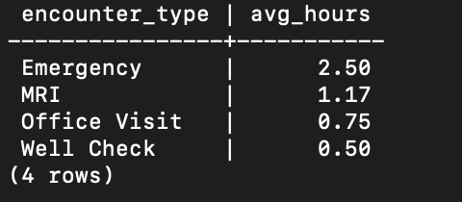

B6) Departments with > 100 encounters
SELECT d.dept_id, d.dept_name, d.facility, COUNT(*) AS total_encounters
FROM encounters e
JOIN departments d ON d.dept_id = e.dept_id
GROUP BY d.dept_id, d.dept_name, d.facility
HAVING COUNT(*) > 100
ORDER BY total_encounters DESC;
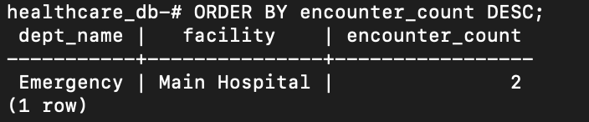

B7) Average patient risk score per facility (patients × encounters × departments)
SELECT d.facility, ROUND(AVG(p.risk_score)::numeric, 2) AS avg_patient_risk
FROM encounters e
JOIN patients p ON p.patient_id = e.patient_id
JOIN departments d ON d.dept_id = e.dept_id
GROUP BY d.facility
ORDER BY d.facility;
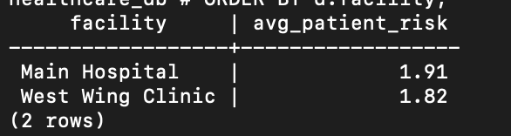

Part B: Analytics & complex query Task
These questions focus on joining, grouping, and identifying patterns or data-quality issues.
- List all encounters from Central Hospital that took place in 2025.
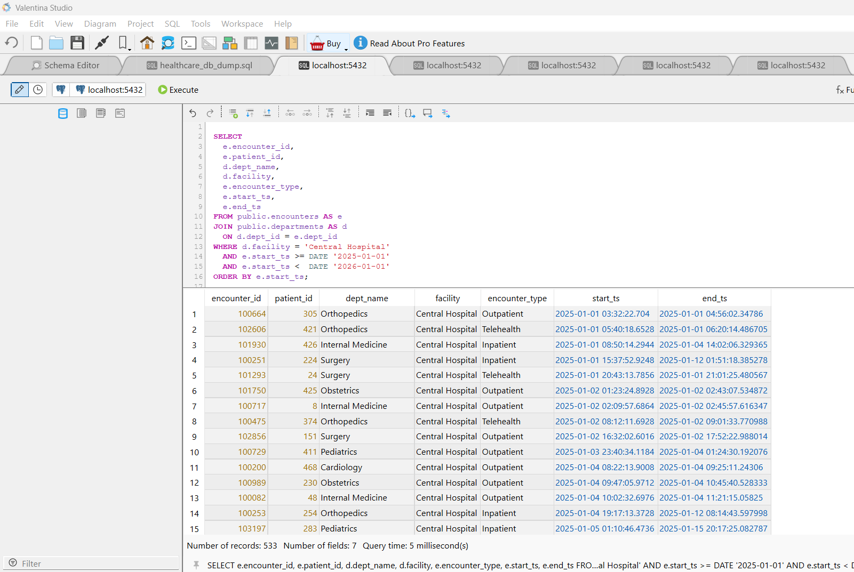

SQL Code used that generated results:
What these answers: 2025 throughput slice for Central Hospital—mix of ED, Inpatient, Outpatient, Telehealth by department.

SELECT
e.encounter_id,
e.patient_id,
d.dept_name,
d.facility,
e.encounter_type,
e.start_ts,
e.end_ts
FROM public.encounters AS e
JOIN public.departments AS d
ON d.dept_id = e.dept_id
WHERE d.facility = 'Central Hospital'
AND e.start_ts >= DATE '2025-01-01'
AND e.start_ts < DATE '2026-01-01'
ORDER BY e.start_ts;

- For each facility, show how many Emergency Department (ED) encounters occurred.
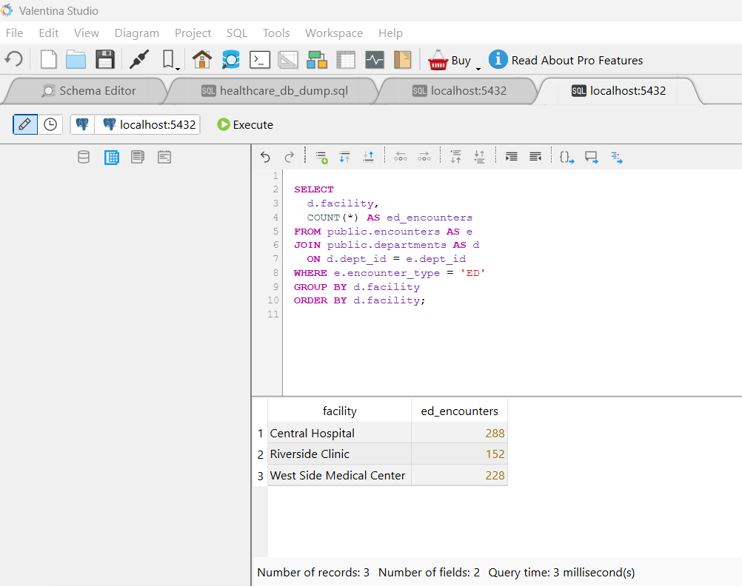

SQL Code used that generated results:
What these answers: Relative ED burden at Central Hospital vs West Side Medical Center vs Riverside Clinic.
SELECT
d.facility,
COUNT(*) AS ed_encounters
FROM public.encounters AS e
JOIN public.departments AS d
ON d.dept_id = e.dept_id
WHERE e.encounter_type = 'ED'
GROUP BY d.facility
ORDER BY d.facility;

- Display every staff member’s name, role, and department by joining the staff and departments tables.
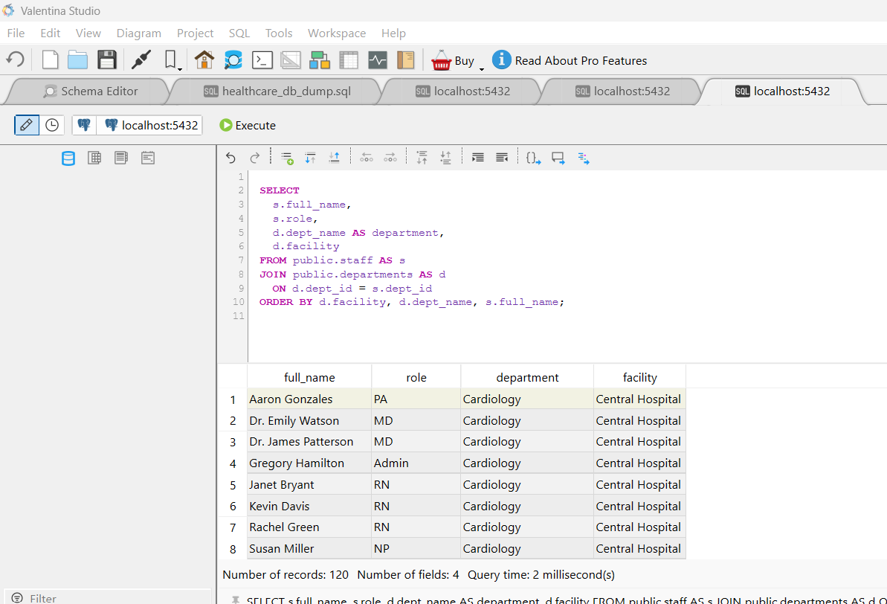

SQL Code used that generated results:
What these answers: A unified roster with role standardization (MD/RN/NP/PA/MA/Admin) and department mapping.
SELECT
s.full_name,
s.role,
d.dept_name AS department,
d.facility
FROM public.staff AS s
JOIN public.departments AS d
ON d.dept_id = s.dept_id
ORDER BY d.facility, d.dept_name, s.full_name;

- For each patient, list their encounter type and the department they visited.
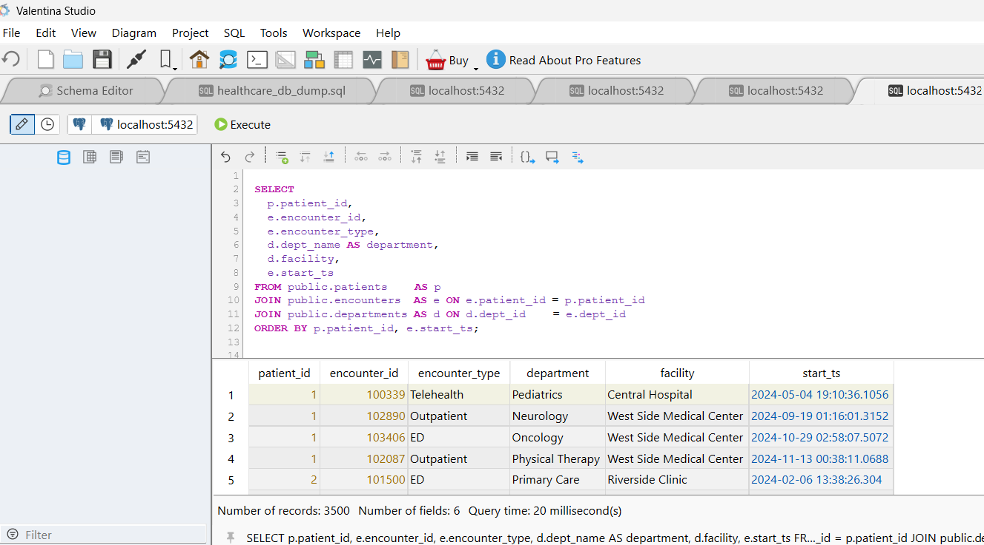

SQL Code used that generated results:
What these answers: “Where patients go” across service lines.
SELECT
p.patient_id,
e.encounter_id,
e.encounter_type,
d.dept_name AS department,
d.facility,
e.start_ts
FROM public.patients AS p
JOIN public.encounters AS e ON e.patient_id = p.patient_id
JOIN public.departments AS d ON d.dept_id = e.dept_id
ORDER BY p.patient_id, e.start_ts;

- Find the average length of stay (in hours) for each encounter type.
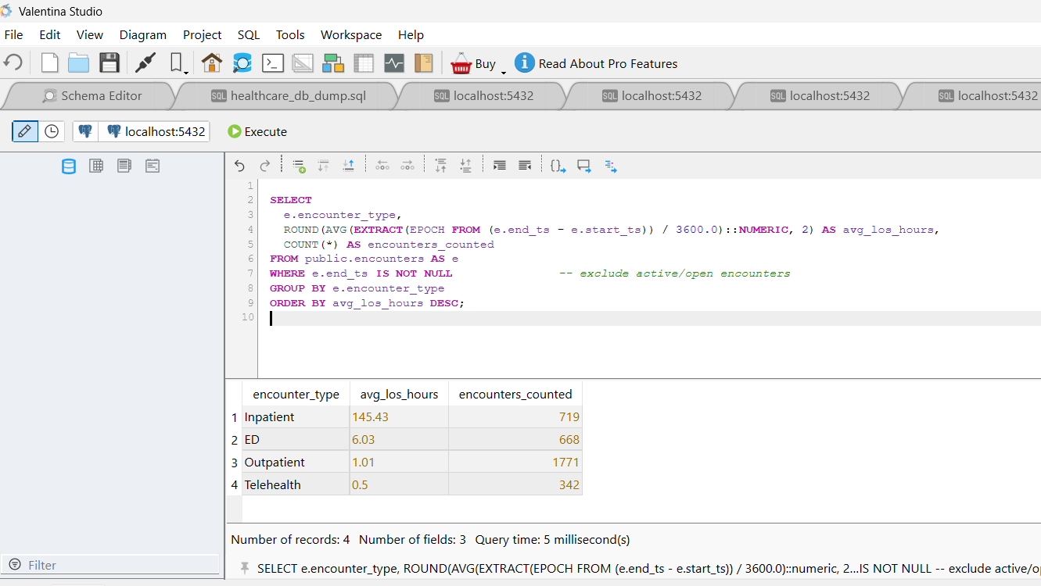

SQL Code used that generated results:
What these answers: Speed of care by type; typically, Inpatient LOS > ED > Outpatient > Telehealth.
SELECT
e.encounter_type,
ROUND(AVG(EXTRACT(EPOCH FROM (e.end_ts - e.start_ts)) / 3600.0)::numeric, 2) AS avg_los_hours,
COUNT(*) AS encounters_counted
FROM public.encounters AS e
WHERE e.end_ts IS NOT NULL -- exclude active/open encounters
GROUP BY e.encounter_type
ORDER BY avg_los_hours DESC;

- Identify departments that have handled more than 100 encounters in total.
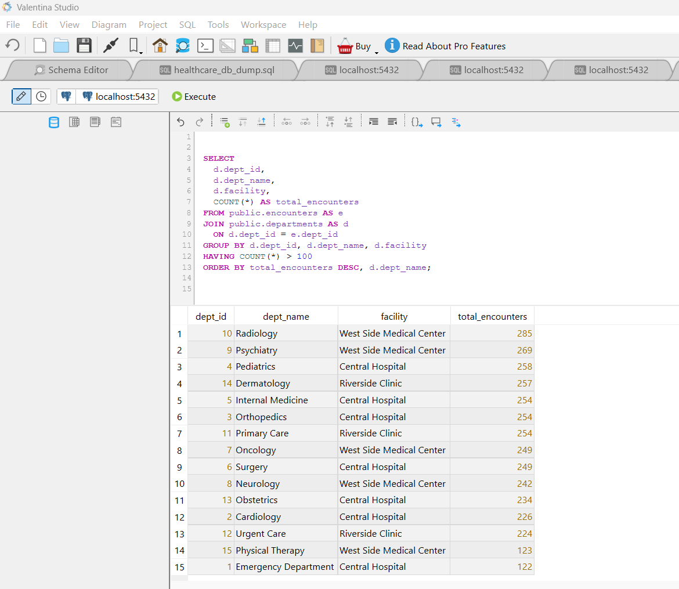

SQL Code used that generated results:
What these answers: High-throughput services.
SELECT
d.dept_id,
d.dept_name,
d.facility,
COUNT(*) AS total_encounters
FROM public.encounters AS e
JOIN public.departments AS d
ON d.dept_id = e.dept_id
GROUP BY d.dept_id, d.dept_name, d.facility
HAVING COUNT(*) > 100
ORDER BY total_encounters DESC, d.dept_name;

- Show the average patient risk score per facility by joining patients, encounters, and departments.
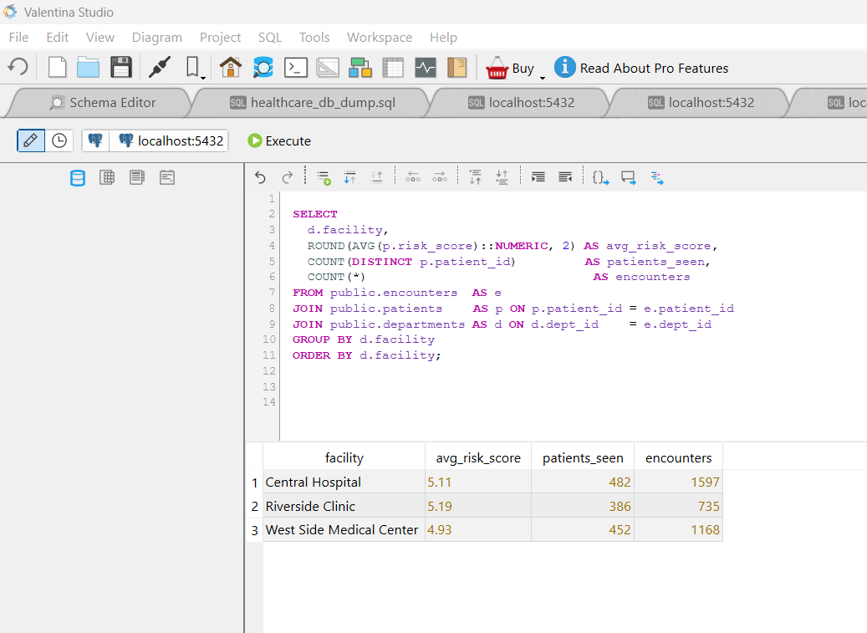

SQL Code used that generated results:
What these answers: Case-mix severity by facility.
SELECT
d.facility,
ROUND(AVG(p.risk_score)::NUMERIC, 2) AS avg_risk_score,
COUNT(DISTINCT p.patient_id) AS patients_seen,
COUNT(*) AS encounters
FROM public.encounters AS e
JOIN public.patients AS p ON p.patient_id = e.patient_id
JOIN public.departments AS d ON d.dept_id = e.dept_id
GROUP BY d.facility
ORDER BY d.facility;

