Lunch Decider – Application Run & Design Documentation
A backend RESTful application that allows a group of users to collaboratively decide where to have lunch. Users can create a session, join it, submit restaurant options, and randomly select a restaurant when the session ends.
This project is implemented using Spring Boot, Spring Data JPA, Spring Batch, Flyway, and Swagger OpenAPI.

Prerequisites (Environment Preparation)
• Java 17 (JDK 17)
• Maven 3.9+
• Git
• Optional: Postman
Verify:
java -version
mvn -v
git –version

Note: Install mvn if not found. Add MAVEN_HOME to system variable in environment variables and ensure MAVEN_HOME/bin is added to your PATH, then restart the terminal.
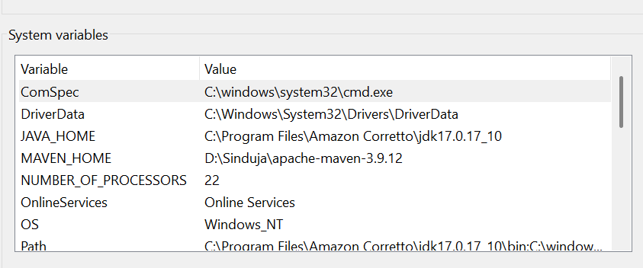
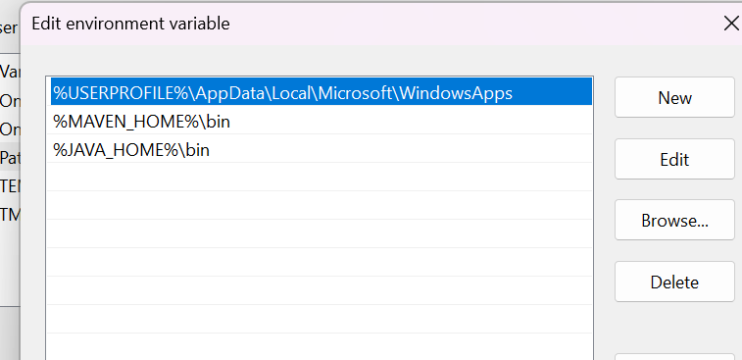

Clone and Run the Application
- Clone repository:
git clone https://github.com/SindujaRaghavan/lunch-decider.git
cd lunch-decider
2. Run tests:
mvn clean test
3. Start application:
mvn clean spring-boot:run
Note: Started LunchDeciderApplication.. in console means application is up and running.
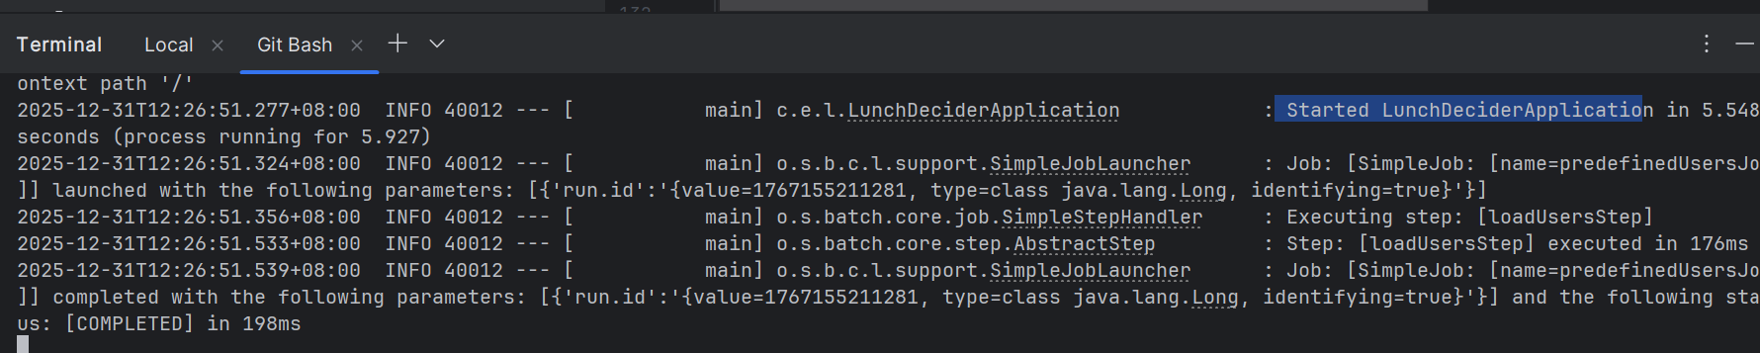

- Application URLs:
• Swagger: http://localhost:8080/swagger-ui.html
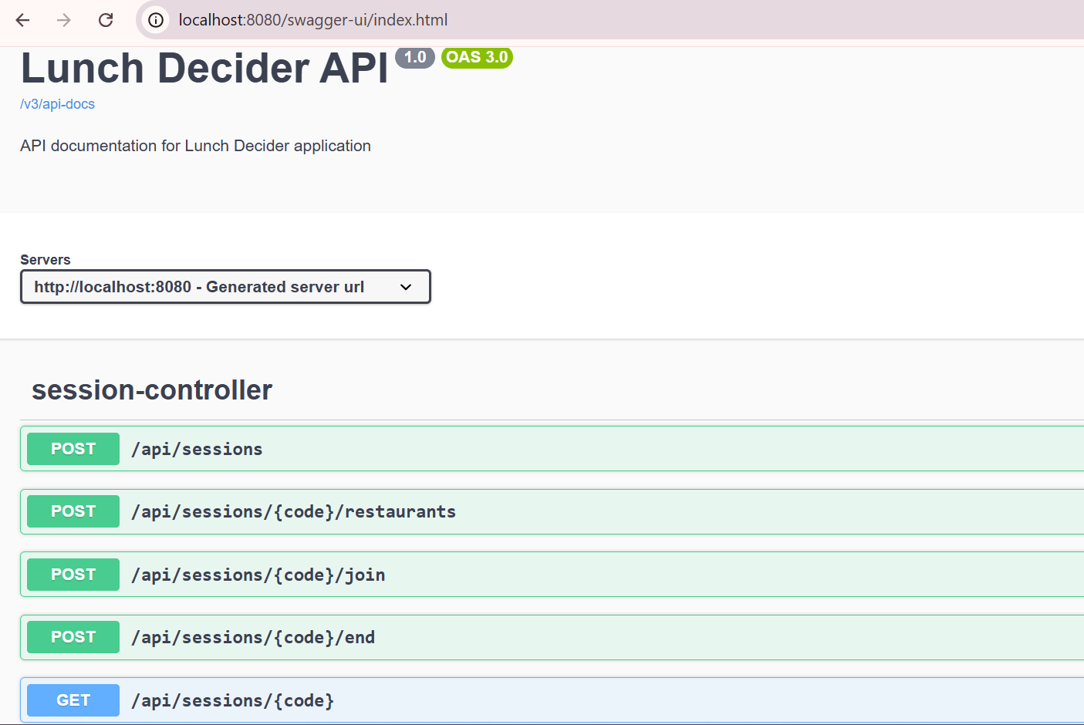
• H2 Console: http://localhost:8080/h2
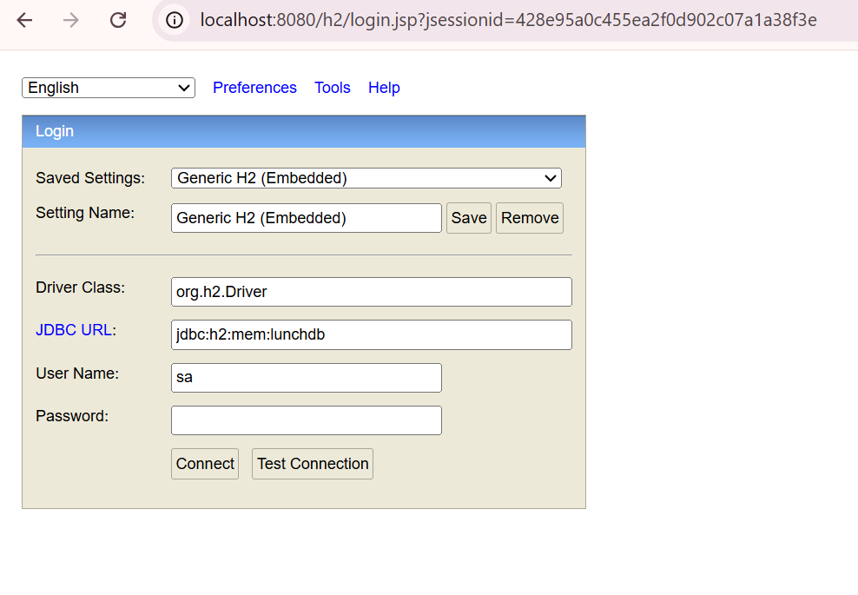
JDBC URL: jdbc:h2:mem:lunchdb
Username: sa
Password: (empty)
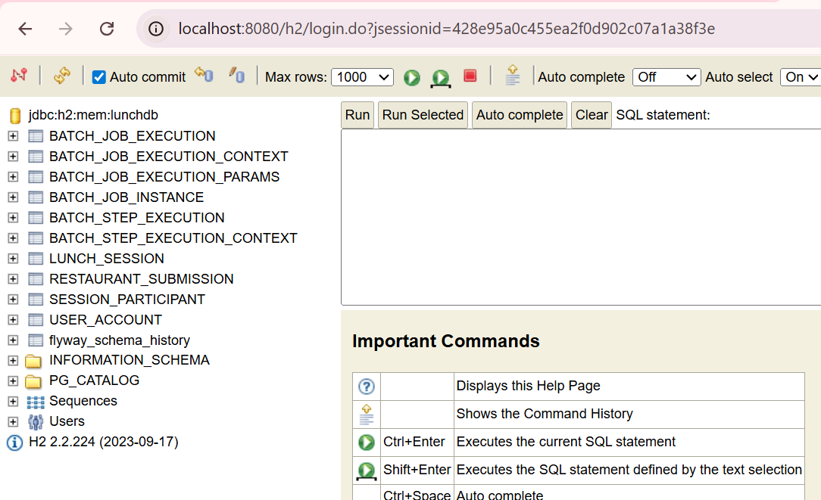

Database Initialization
• In-memory H2 database
• Flyway creates schema on startup
• Spring Batch loads predefined users from CSV
Users:
alice, bob, charlie, David
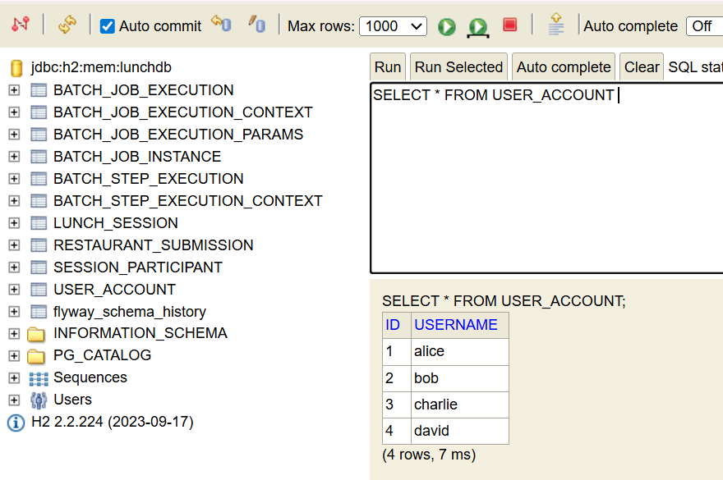

API Documentation
All APIs are documented via Swagger UI.
Endpoints:
POST /api/sessions
POST /api/sessions/{code}/join
POST /api/sessions/{code}/restaurants
GET /api/sessions/{code}
POST /api/sessions/{code}/end

Postman Testing:
POST api/sessions
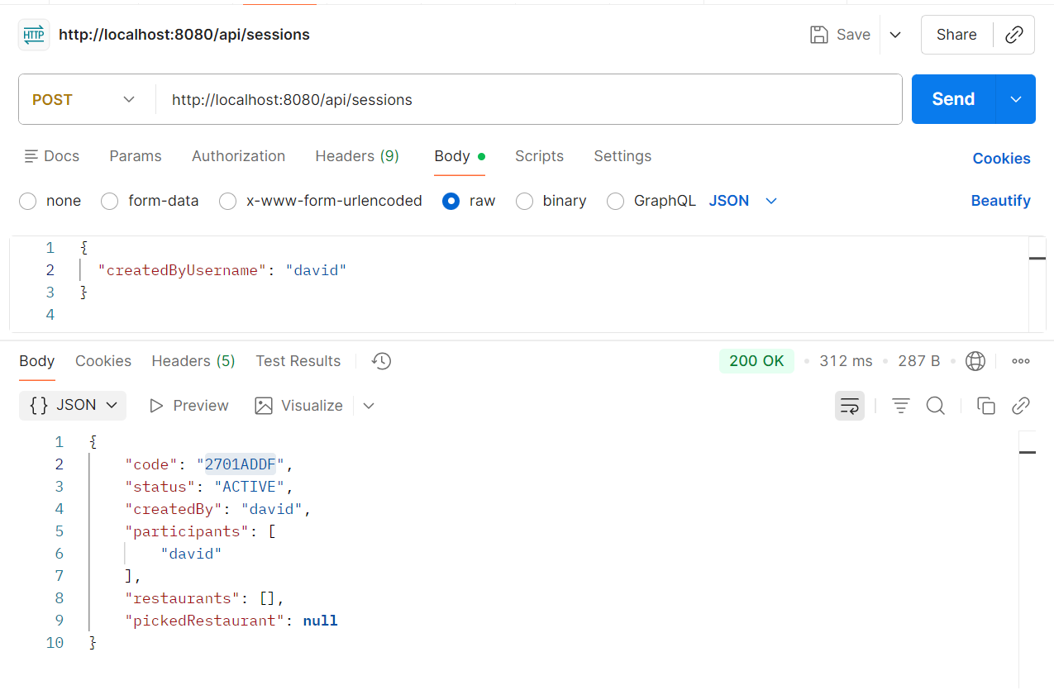
POST api/sessions/2701ADDF/join
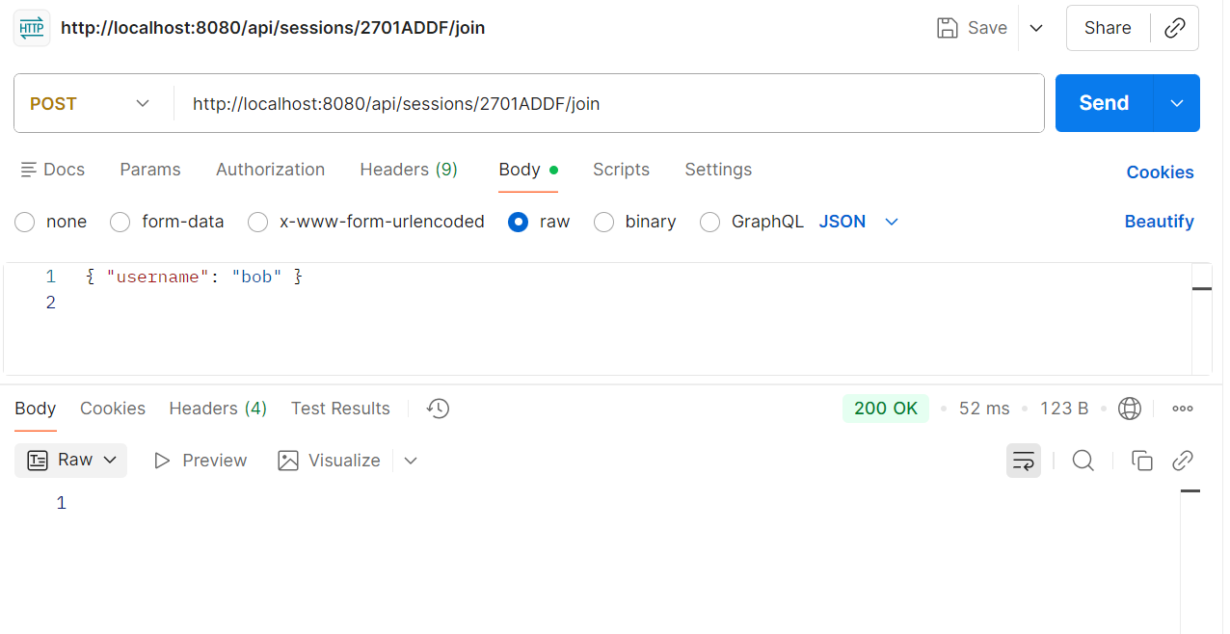
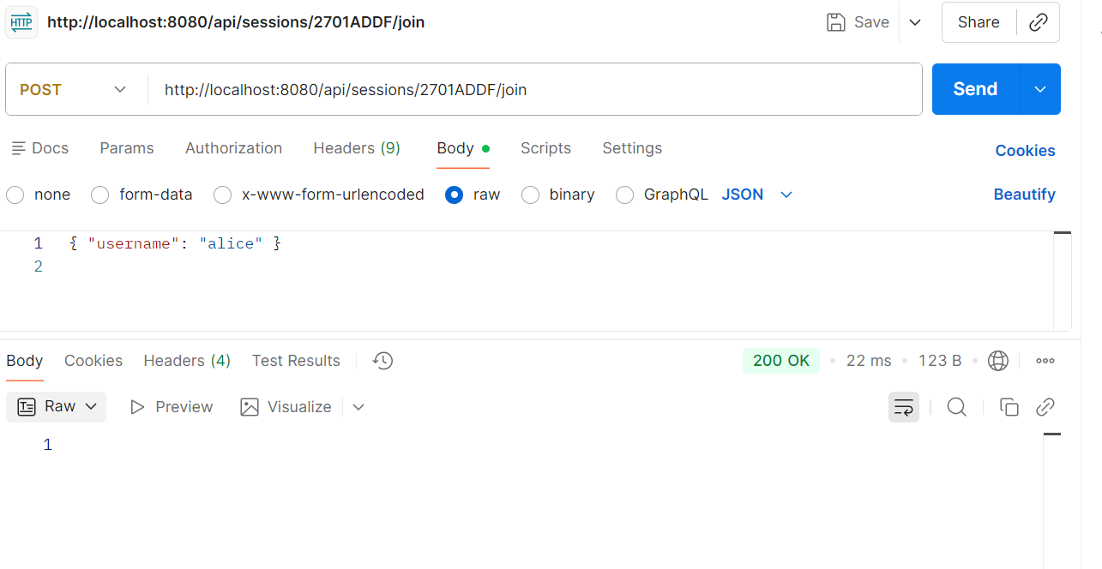
POST /api/sessions/2701ADDF/restaurants
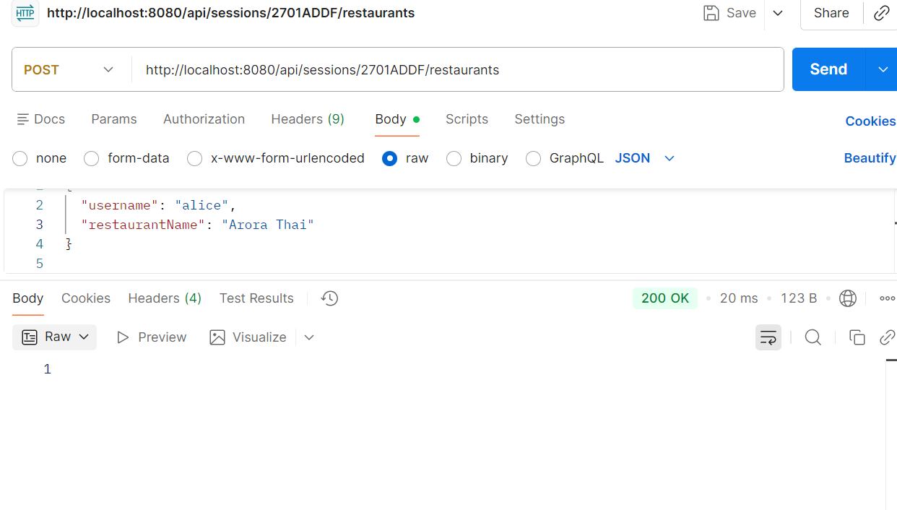
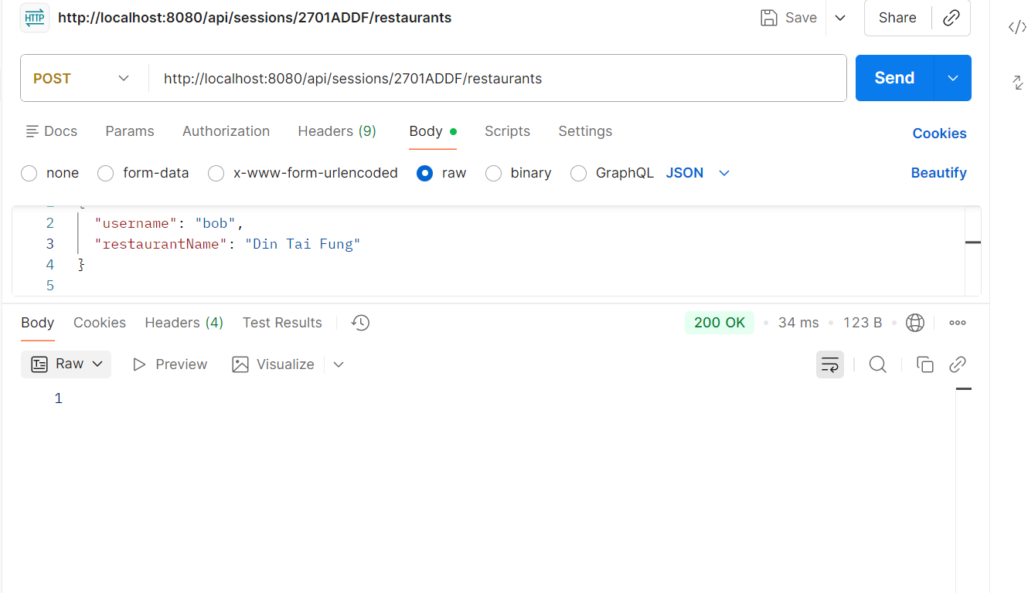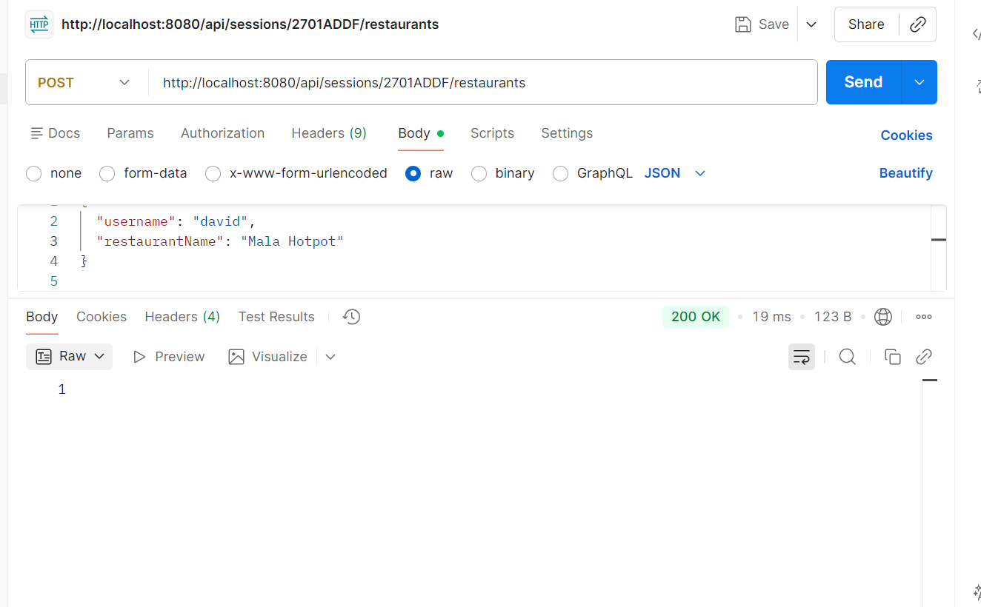
GET /api/sessions/2701ADDF
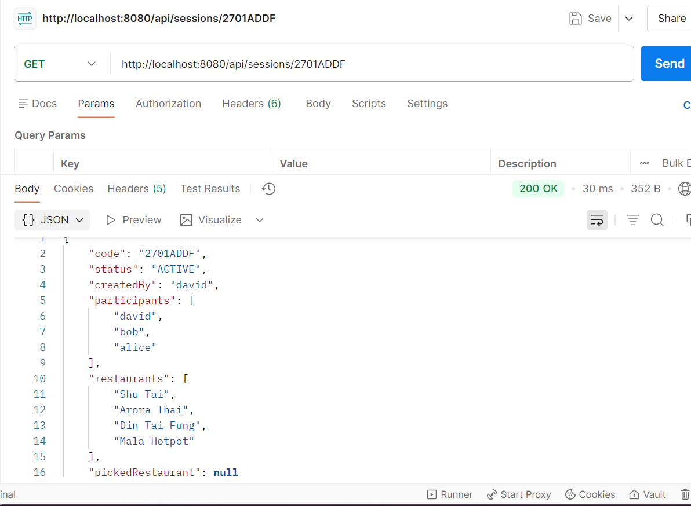
POST /api/sessions/2701ADDF/end
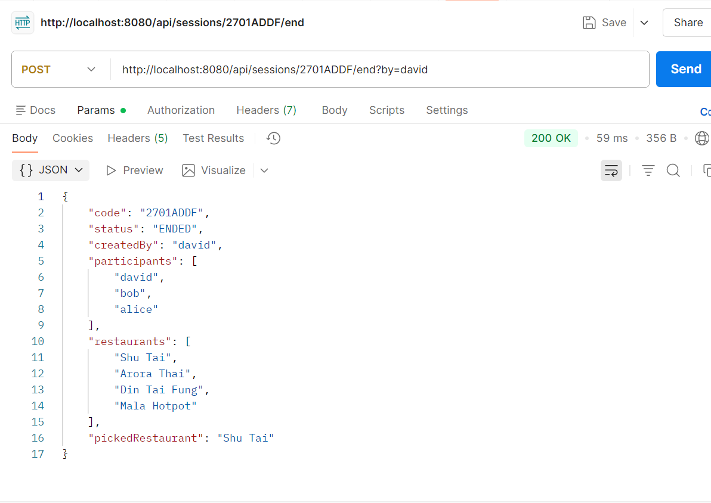

Database Verification:
Verify predefined users
SELECT * FROM USER_ACCOUNT ORDER BY ID;
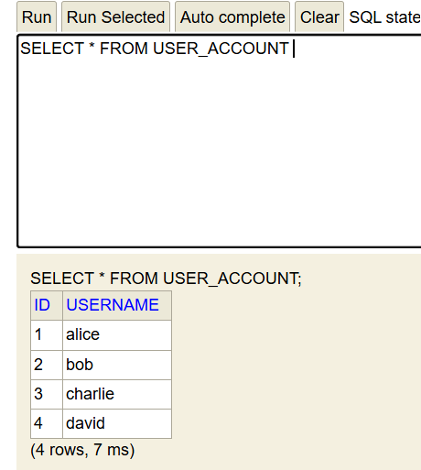
Verify session creation
SELECT CODE, STATUS, CREATED_AT, ENDED_AT, PICKED_RESTAURANT
FROM LUNCH_SESSION;
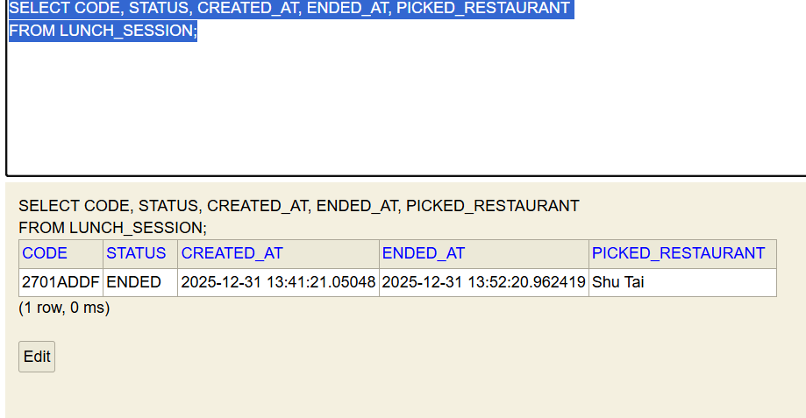
Verify session creator
SELECT s.CODE, u.USERNAME AS CREATED_BY
FROM LUNCH_SESSION s
JOIN USER_ACCOUNT u ON u.ID = s.CREATED_BY;
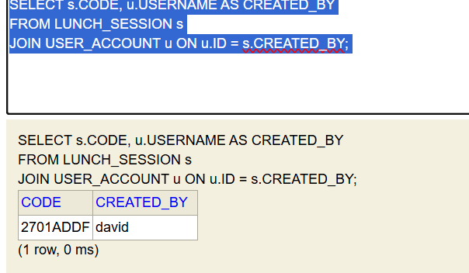
Verify restaurant submissions
SELECT s.CODE, u.USERNAME, rs.RESTAURANT_NAME, rs.CREATED_AT
FROM RESTAURANT_SUBMISSION rs
JOIN LUNCH_SESSION s ON s.ID = rs.SESSION_ID
JOIN USER_ACCOUNT u ON u.ID = rs.USER_ID;
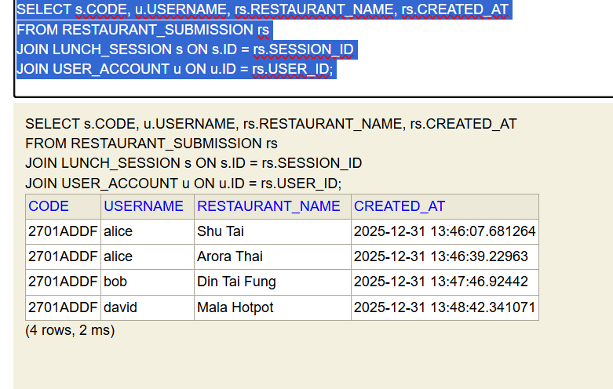
Verify picked restaurant
SELECT CODE, PICKED_RESTAURANT
FROM LUNCH_SESSION;
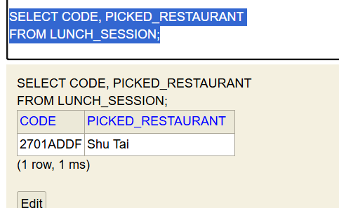
Verify uniqueness constraints
Duplicate participants
SELECT SESSION_ID, USER_ID, COUNT(*)
FROM SESSION_PARTICIPANT
GROUP BY SESSION_ID, USER_ID
HAVING COUNT(*) > 1;
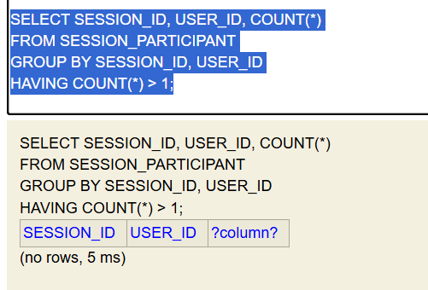

Duplicate restaurants per session
SELECT SESSION_ID, RESTAURANT_NAME, COUNT(*)
FROM RESTAURANT_SUBMISSION
GROUP BY SESSION_ID, RESTAURANT_NAME
HAVING COUNT(*) > 1;
