**Coefficient of variation**

**Expectation**: Coefficient of variation (precision) of survey would be reduced by increasing sample size and increasing catchability (i.e., reducing zero catch).

**Methods**: I used 2 trawled areas (0.03 and 0.06 km2) and 2 set density (2/1000 km2 and 4/1000 km2) for 20 populations for cod like and yellowtail like species. For these surveys, I applied bootstrapping of the design-based index. The resampling of sets among the stratum was repeated 1,000 times, from which mean annual bootstrapped, 95% bias-corrected and adjusted (BCa) confidence intervals, and coefficient of variations (CV) were calculated. Then for each population, mean CV% and mean zero catch % are calculated from all years of each population.

**Results**:

Figure 1:

* Overall, both species’ mean CV % is lower than 20 %.
* Most of the time, increasing the area trawled decreased the zero catch % (increased the catchability). (from red to blue points and from green to purple points on the x-axis).
* Only increasing the sample size (set density) didn’t have much effect on zero catch % (catchability). (red-green and blue-purple pairs comparison on x-axis).
* Increasing sample size had more effect on lowering the CV than increasing the area trawled (increasing catchability). (comparing the blue-red and purple-green pairs on the y-axis).
* Increasing sample size resulted in smaller CVs for the mean estimates of all years (not shown on Figure 1). However, increasing the trawl area had mixed results and the change of the CV are not always that distinct as increasing sample size. So it looks like the imprecision is largely a sample size issue as expected.
* We decided to use the blue points (0.06 km2 trawl area with 2/1000 km2 set density).

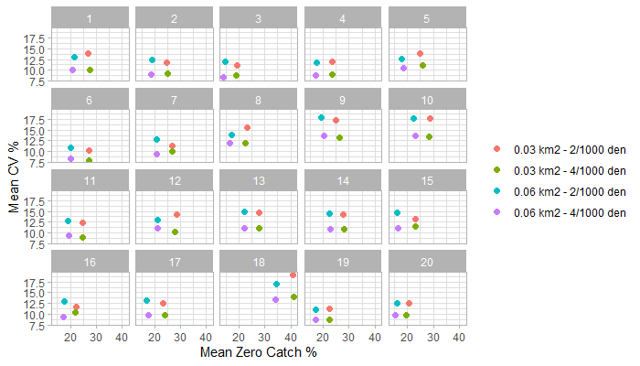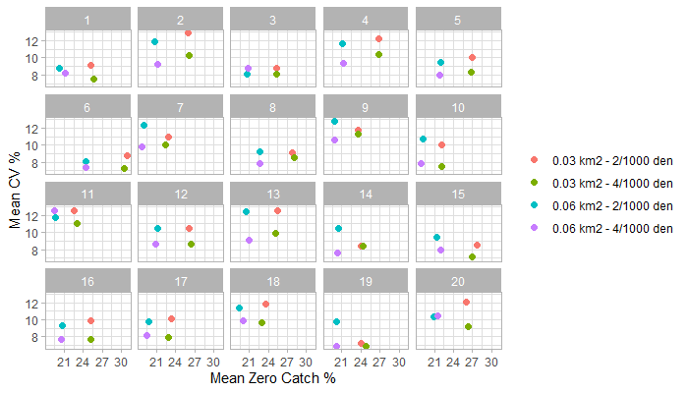

Cod like

Yellowtail like

**Figure 1** Bootstrapped results (cod like and yellowtail like). % CV vs % Zero

**Updating the workflow**

We updated (simplified) the workflow (below). We decided to focus on only one reduction scenario (same % change) for now and develop further as we go.

**Figure 2**. Updated workflow (7 June, 2022)

**Preliminary Results**

Here are some exciting results! Overall, model estimations are better for both species (most of the cases)! Depth is important for yellowtail models (its distribution is more homogenous than cod).

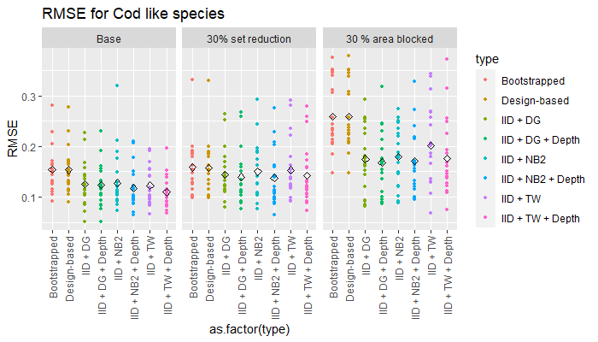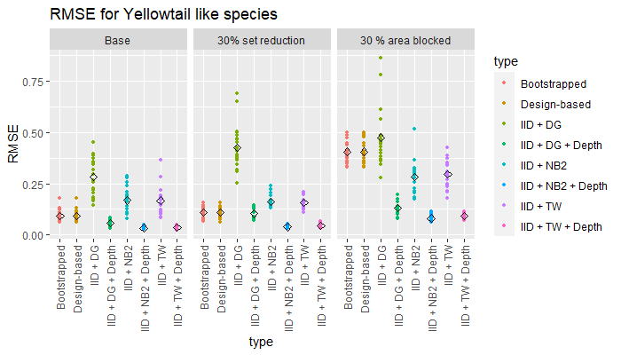

**Figure 3**. Root means square error of each population of cod like and yellowtail like species. Each colored point is the mean value of populations. The diamond point is the mean of RMSE of all populations.