HEALTH AI
Co-Creation & Innovation Platform
Software Design Document
(SDD)

Project Name | HEALTH AI Co-Creation & Innovation Platform
Course | SENG-384
Group No / Name | SoloStack
Group Members | Sinem Ünsal – 202228051
Submission Date | 25/04/2026
Version | 1.0

Revision History
Date | Version | Change Description | Author
25/04/2026 | 1.0 | Initial version — prepared from the HEALTH AI codebase and SRS v1.0 | Sinem Ünsal

Table of Contents
This table of contents is generated for the final document structure.
Revision History ·················································· 2
1. Introduction ··················································· 4
1.1 Purpose ······················································· 4
1.2 Scope ························································· 4
1.3 Reference Documents ··········································· 4
1.4 Definitions and Abbreviations ································· 4
2. Architectural Design ··········································· 5
2.1 Architectural Overview ········································ 5
2.2 Layers ························································ 5
2.3 Deployment Diagram ············································ 6
3. Component Design ··············································· 7
3.1 Component List ················································ 7
3.2 Component Interaction Diagram ································· 7
4. Database Design ················································ 8
4.1 ER Diagram ···················································· 8
4.2 Table Definitions ············································· 9
5. API Design ····················································· 12
5.1 Authentication (Auth) ········································· 12
5.2 Post Management (Posts) ······································· 13
5.3 Meeting Requests (Meetings) ··································· 13
5.4 Admin ························································· 14
6. UI Design ······················································ 15
6.1 Screen List and Navigation ···································· 15
6.2 Wireframes / Mockups ·········································· 16
7. Security Design ················································ 17
8. State Diagrams ················································· 18
8.1 Post Lifecycle ················································ 18
8.2 Meeting Request Lifecycle ····································· 18
9. SRS–SDD Traceability Matrix ···································· 19
10. Appendices ···················································· 21

1. Introduction

1.1 Purpose
This Software Design Document (SDD) describes how the requirements defined in the SENG-384 SRS for the HEALTH AI Co-Creation & Innovation Platform are addressed at the architectural and design level. It defines the system architecture, component structure, database schema, API endpoints, UI screen flow, security mechanisms, and state transitions. The document is intended for the development team, course instructors, and evaluators.

1.2 Scope
The design covers a full-stack web application consisting of:
- A React 18 / TypeScript single-page application (frontend, Vite + Tailwind CSS)
- A Node.js / Express REST API (backend, TypeScript)
- A PostgreSQL 16 relational database managed through Prisma ORM

The platform enables engineers and healthcare professionals to publish collaboration opportunities, search for partners, and manage a structured meeting-request workflow. Out of scope: patient data, financial transactions, integrated video conferencing, and contract management. This scope is fully consistent with the SRS.

1.3 Reference Documents
Document | Version / Date | Author
HEALTH AI Co-Creation & Innovation Platform – Software Requirements Specification (SRS) | v1.0 / 24 March 2026 | Sinem Ünsal
SENG-384 Course Project Brief | — | Course Instructor

1.4 Definitions and Abbreviations
Term / Abbreviation | Definition
SDD | Software Design Document
SRS | Software Requirements Specification
API | Application Programming Interface
REST | Representational State Transfer – architectural style for HTTP APIs
JWT | JSON Web Token – stateless authentication mechanism (HS256)
ORM | Object-Relational Mapping – Prisma is the ORM used in this project
RBAC | Role-Based Access Control – access governed by user role
SPA | Single-Page Application – the React frontend
MVC | Model-View-Controller – structural pattern applied in the backend
GDPR | General Data Protection Regulation – EU data privacy law
NDA | Non-Disclosure Agreement – acceptance gate before meeting requests
UUID | Universally Unique Identifier – primary key format used throughout
WCAG | Web Content Accessibility Guidelines

2. Architectural Design

2.1 Architectural Overview
The system follows a Client-Server architecture with a three-tier layered structure: Presentation, Business Logic, and Data. The backend additionally applies MVC conventions — controllers handle HTTP routing and input validation (Zod schemas), Prisma acts as the model/data-access layer, and business rules (RBAC enforcement, NDA gate, lifecycle state transitions) are implemented within controller functions and middleware.

The frontend (React SPA) and the backend (Express API) communicate exclusively via HTTP/JSON. All protected requests include a Bearer JWT in the Authorization header, which is verified by authMiddleware before the controller logic executes.

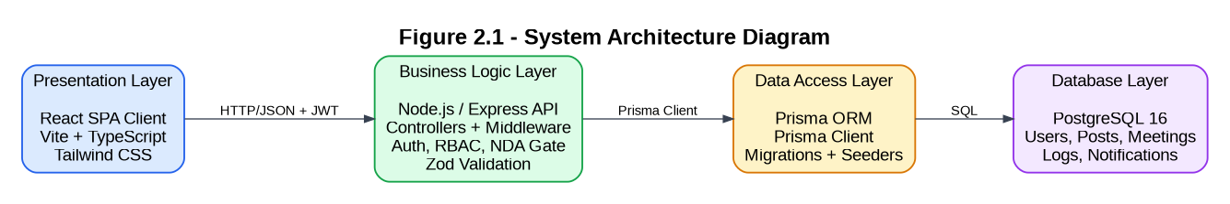

2.2 Layers
The layered structure of the system is described in the table below.

Layer | Responsibility | Technology Choice
Presentation | User interface rendering, client-side routing, component state management, form validation feedback | React 18, TypeScript, Vite (dev server / bundler), Tailwind CSS, React Router v6
Business Logic | HTTP request handling, input validation, JWT issuance and verification, RBAC enforcement, rate limiting, business rules (NDA gate, ownership checks, lifecycle transitions), error handling | Node.js, Express 4, TypeScript, Zod (validation), jsonwebtoken, bcryptjs, express-rate-limit, Helmet, Morgan
Data Access | ORM-based database queries, schema definition, migrations, seeding | Prisma ORM (prisma-client-js), Prisma Migrate
Database | Persistent relational data storage for all entities (users, posts, meeting_requests, activity_logs, notifications) | PostgreSQL 16

2.3 Deployment Diagram
The diagram below shows the Docker Compose (development) deployment. Three containers run on the same host: frontend (port 5173), backend (port 5000), and postgres (port 5432). A named Docker volume (postgres_data) persists the database.

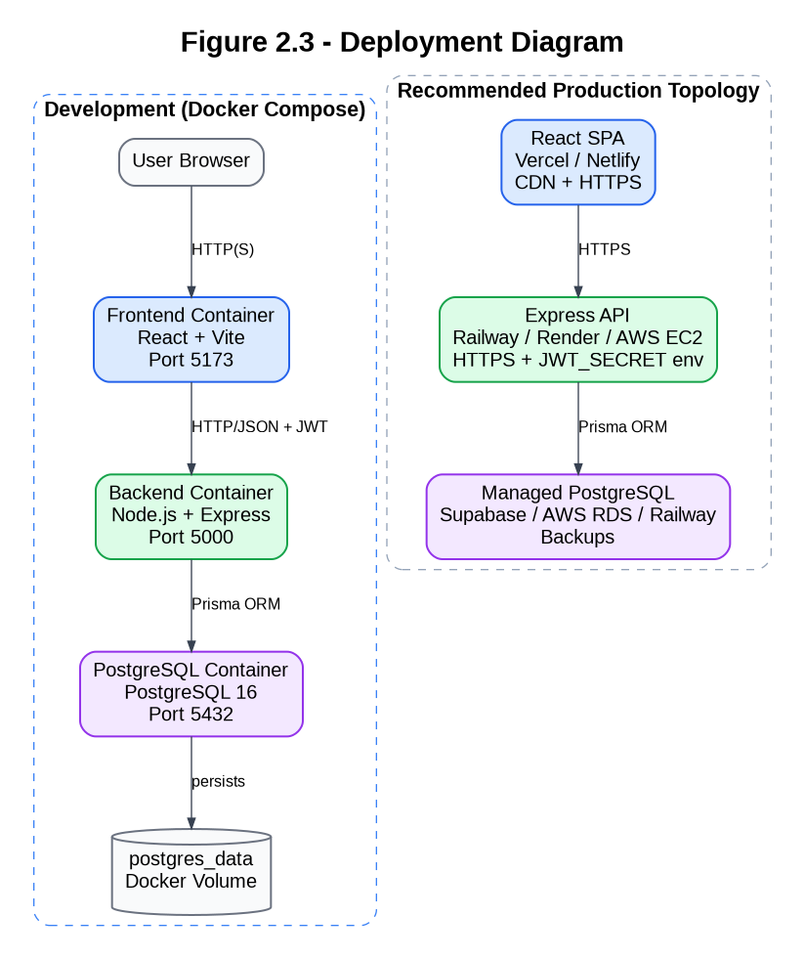

Recommended production topology: React SPA → Vercel / Netlify (CDN, HTTPS). Express API → Railway / Render / AWS EC2 (HTTPS enforced, JWT_SECRET via env variable). Database → Supabase / AWS RDS / Railway Postgres (managed, automated backups).

3. Component Design
The backend is organised into independent router modules, each mounted on a dedicated path in app.ts. Each module owns its own routes, validation schemas, and controller logic. The frontend is organised into page components (src/pages/) and shared components (src/components/).

3.1 Component List
Component | Responsibility | Technology / Notes
AuthModule | User registration with .edu / .edu.tr institutional email validation; bcrypt password hashing (10 salt rounds); JWT issuance (HS256, 10 h expiry); email verification token generation (crypto.randomBytes); rate limiting (20 req / 15 min window) on register and login routes | Express Router · bcryptjs · jsonwebtoken · express-rate-limit · Zod · Node crypto Mounted at: /auth
PostModule | Full post CRUD; lifecycle status management (DRAFT → ACTIVE → MEETING_SCHEDULED → PARTNER_FOUND / EXPIRED); owner-only edit and delete; admin delete override; creation notification trigger; match explanation generation for search results | Express Router · Prisma · Zod Mounted at: /posts
Matching  Module | Search and filter posts by domain, required_expertise, city, country, project_stage, status using case-insensitive Prisma contains queries; inline match explanation appended to each result | Implemented inside PostModule (GET /posts) Prisma filtered queries
MeetingModule | Meeting request creation gated by NDA acceptance (Zod .refine) and ACTIVE post status; blocks owner self-request; owner accept / reject / propose-new-time responses; automatic post status update to MEETING_SCHEDULED on accept; requester edit and delete of PENDING requests | Express Router · Prisma · Zod Mounted at: /meetings
AdminModule | Admin-only (requireRole(['ADMIN'])) user list with role filter; suspend / activate user; view all posts; delete inappropriate posts; platform statistics | Express Router · Prisma · requireRole middleware Mounted at: /admin
AuditModule | Activity log querying with optional filters; results capped at 100 entries; full CSV export via Content-Disposition attachment; admin-only access | Express Router · Prisma · CSV serialisation Mounted at: /logs
Notification  Module | List last 20 in-app notifications for the authenticated user (newest first); mark individual notification as read | Express Router · Prisma Mounted at: /notifications
ProfileModule | Authenticated user profile retrieval; GDPR data export (GET /profile/export); GDPR account deletion (DELETE /profile) with Cascade removal | Express Router · Prisma Mounted at: /profile

3.2 Component Interaction Diagram
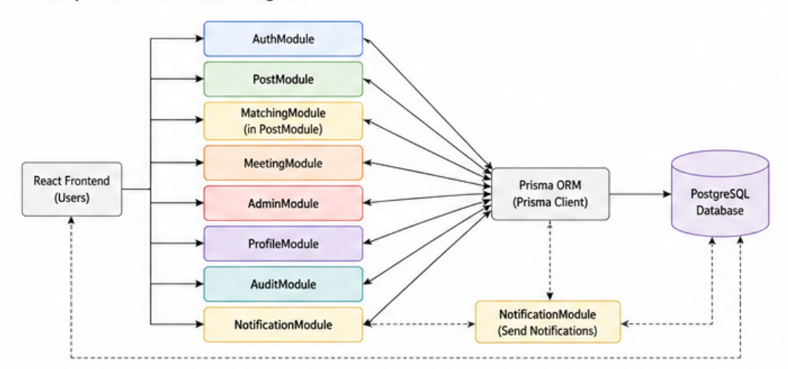
The diagram below shows how the frontend pages call the backend modules and how the backend modules interact with the database through Prisma ORM.

4. Database Design

4.1 ER Diagram
The diagram below shows the five core entities and their relationships. All primary keys are UUIDs (auto-generated by Prisma). All foreign keys are configured with onDelete: Cascade. The schema source is backend/prisma/schema.prisma.

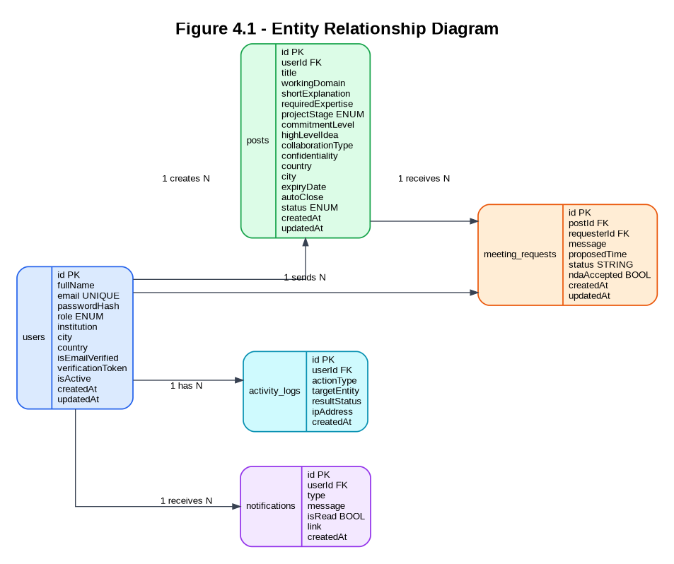

4.2 Table Definitions
All tables are derived directly from backend/prisma/schema.prisma. The notifications table is included as required by the SRS data model (FR-17).

4.2.1 users
Field Name | Data Type | Required | Constraint | Description
id | UUID (String) | Yes | PK, auto-generated (uuid()) | Unique user identifier
fullName | VARCHAR | Yes | — | First name + last name concatenated at registration
email | VARCHAR(255) | Yes | UNIQUE; must end with .edu or .edu.tr | Institutional email address
passwordHash | VARCHAR(255) | Yes | — | bcrypt hash, 10 salt rounds; plaintext never stored
role | ENUM | Yes | ENGINEER │ HEALTHCARE_PROFESSIONAL │ ADMIN; default ENGINEER | User role — controls RBAC throughout the system
institution | VARCHAR | No | — | User's academic or medical institution
city | VARCHAR | No | — | City (used for post matching)
country | VARCHAR | No | — | Country
isEmailVerified | BOOLEAN | Yes | Default: false | Email verification status flag
verificationToken | VARCHAR | No | — | Random 32-byte hex token generated at registration
isActive | BOOLEAN | Yes | Default: true | Account active flag; set to false by admin suspend action
createdAt | TIMESTAMP | Yes | Auto (now()) | Record creation timestamp
updatedAt | TIMESTAMP | Yes | Auto (@updatedAt) | Last update timestamp

4.2.2 posts
Field Name | Data Type | Required | Constraint | Description
id | UUID (String) | Yes | PK | Unique post identifier
userId | UUID (String) | Yes | FK → users.id, CASCADE | Owner of the post
title | VARCHAR | Yes | min 3 chars | Post title
workingDomain | VARCHAR | Yes | min 2 chars | Collaboration domain (e.g. AI, Cardiology, Radiology)
shortExplanation | TEXT | Yes | min 10 chars | Description of the collaboration opportunity
requiredExpertise | VARCHAR | Yes | min 2 chars | Skills or expertise being sought
projectStage | ENUM | Yes | IDEA │ CONCEPT_VALIDATION │ PROTOTYPE_DEVELOPED │ PILOT_TESTING │ PRE_DEPLOYMENT | Current stage of the project
commitmentLevel | VARCHAR | Yes | — | Expected time / effort commitment from collaborator
confidentiality | VARCHAR | Yes | — | Confidentiality level of the collaboration
city | VARCHAR | Yes | — | City where the collaboration is based
country | VARCHAR | Yes | — | Country
status | ENUM | Yes | DRAFT │ ACTIVE │ MEETING_SCHEDULED │ PARTNER_FOUND │ EXPIRED; default DRAFT | Post lifecycle status
expiryDate | TIMESTAMP | No | — | Optional post expiry date
autoClose | BOOLEAN | Yes | Default: false | Reserved for automated expiry logic (future)
createdAt | TIMESTAMP | Yes | Auto (now()) | Creation timestamp
updatedAt | TIMESTAMP | Yes | Auto (@updatedAt) | Last update timestamp
highLevelIdea | TEXT | No | — | Optional extended description of the idea
collaborationType | VARCHAR | No | — | Optional collaboration type (e.g. Research, Pilot, Co-development)

4.2.3 meeting_requests
Field Name | Data Type | Required | Constraint | Description
id | UUID (String) | Yes | PK | Unique meeting request identifier
postId | UUID (String) | Yes | FK → posts.id, CASCADE | The post this meeting is requested for
requesterId | UUID (String) | Yes | FK → users.id, CASCADE | The user who sent the meeting request (cannot be the post owner)
message | TEXT | No | — | Optional message from the requester
proposedTime | TIMESTAMP | No | — | Optional proposed meeting time; can be updated by owner via PROPOSE_NEW_TIME
ndaAccepted | BOOLEAN | Yes | Must be true (Zod .refine); default false | NDA acceptance gate — request is rejected if false
status | VARCHAR | Yes | PENDING │ ACCEPTED │ REJECTED; default PENDING | Current status of the meeting request
createdAt | TIMESTAMP | Yes | Auto | Creation timestamp
updatedAt | TIMESTAMP | Yes | Auto | Last update timestamp

4.2.4 activity_logs
Field Name | Data Type | Required | Constraint | Description
id | UUID (String) | Yes | PK | Log entry identifier
userId | UUID (String) | Yes | FK → users.id, CASCADE | User who performed the action ('SYSTEM' for anonymous actions)
actionType | VARCHAR(100) | Yes | — | LOGIN │ FAILED_LOGIN │ REGISTER │ LOGOUT │ POST_CREATE │ POST_EDIT │ POST_STATUS_CHANGE │ POST_DELETE │ MEETING_REQUEST │ MEETING_RESPOND │ ADMIN_ACTION
targetEntity | VARCHAR | Yes | — | The request path affected (e.g. /posts/uuid, /meetings/uuid)
resultStatus | VARCHAR | Yes | — | SUCCESS (HTTP < 400) or FAILED (HTTP ≥ 400)
ipAddress | VARCHAR | No | — | Originating IP address (req.ip or socket.remoteAddress)
createdAt | TIMESTAMP | Yes | Auto | Log entry timestamp

4.2.5 notifications
Additional table — notifications (required by SRS FR-17):

Field Name | Data Type | Required | Constraint | Description
id | UUID (String) | Yes | PK | Unique notification identifier
userId | UUID (String) | Yes | FK → users.id, CASCADE | Recipient user
type | VARCHAR | Yes | — | SYSTEM │ MEETING_REQUEST │ MEETING_RESPONSE
message | TEXT | Yes | — | Human-readable notification message
isRead | BOOLEAN | Yes | Default: false | Read / unread flag
link | VARCHAR | No | — | Optional deep-link URL
createdAt | TIMESTAMP | Yes | Auto | Creation timestamp

5. API Design
All endpoints follow RESTful conventions. Protected routes require the Authorization: Bearer <token> header. Validation failures return HTTP 400 with a structured Zod error body. Authorisation failures return HTTP 401 / 403.

5.1 Authentication (Auth)
Method | Endpoint | Description | Auth | SRS Ref.
POST | /auth/register | Register a new user. Validates institutional email (.edu / .edu.tr), rejects duplicate email, hashes password with bcrypt (10 rounds), generates verificationToken. Rate-limited (20 req / 15 min). | Public | FR-01 – FR-06
POST | /auth/login | Authenticate user by email and password. Issues a JWT (HS256, 10 h expiry) containing { id, role }. Rate-limited (20 req / 15 min). Returns HTTP 401 on invalid credentials. | Public | FR-07
POST | /auth/verify | Verify email using the verificationToken sent to the user. Sets isEmailVerified: true and clears the token. | Public | FR-06

5.2 Post Management (Posts)
Method | Endpoint | Description | Auth | SRS Ref.
GET | /posts | List all posts (ordered by createdAt desc). Supports optional query filters: domain, required_expertise, city, country, project_stage, status (all case-insensitive). Returns a matchExplanation field per result. | Public | FR-13, FR-20 – FR-22
POST | /posts | Create a new post. Required fields: title, description, domain, required_expertise, project_stage, commitment_level, confidentiality_level, city, country. Optional: status (default DRAFT), high_level_idea, collaboration_type, expiry_date. Triggers a SYSTEM notification to the owner. | Authenticated | FR-10 – FR-12, FR-17
GET | /posts/:id | Retrieve full post detail including the owner summary (id, fullName, role, city, institution) and all associated meeting requests. | Public | FR-13
PUT | /posts/:id | Update post content (owner only). Returns HTTP 403 if caller is not the owner. | Owner | FR-14
PATCH | /posts/:id/status | Change post lifecycle status (owner only). Accepted values: DRAFT, ACTIVE, MEETING_SCHEDULED, PARTNER_FOUND, EXPIRED. | Owner | FR-15
DELETE | /posts/:id | Delete the post. Allowed for the post owner and for ADMIN-role users. Cascade-deletes all associated meeting requests. | Owner / Admin | FR-16

5.3 Meeting Requests (Meetings)
Method | Endpoint | Description | Auth | SRS Ref.
POST | /meetings/posts/:postId | Create a meeting request for the specified post. The post must have status ACTIVE. The requester cannot be the post owner. nda_accepted must be true in the request body; it is stored as ndaAccepted in the database. On success: creates PENDING meeting request, notifies post owner (MEETING_REQUEST) and requester (SYSTEM). | Authenticated | FR-30 – FR-33
PATCH | /meetings/:id/respond | Post owner responds to a meeting request. action: ACCEPT — sets meeting status to ACCEPTED and automatically sets the related post status to MEETING_SCHEDULED. action: REJECT — sets meeting status to REJECTED. action: PROPOSE_NEW_TIME — status stays PENDING, proposedTime is updated. | Post Owner | FR-34, FR-35
PUT | /meetings/:id | Requester edits their own meeting request (message and/or proposed_time). Only allowed while status is PENDING; returns HTTP 400 if the status is not PENDING. | Requester | FR-36
DELETE | /meetings/:id | Requester deletes their own meeting request. Only the requester can delete; returns HTTP 403 otherwise. | Requester | FR-36

5.4 Admin
Method | Endpoint | Description | Auth | SRS Ref.
GET | /admin/users | List all users. Optional ?role= filter (ENGINEER │ HEALTHCARE_PROFESSIONAL │ ADMIN). Response includes post count, meeting request count, activity log count, and a profile completeness percentage. | Admin | FR-40, FR-41
PATCH | /admin/users/:id/suspend | Suspend a user account (sets isActive: false). The user can no longer log in. | Admin | FR-42
PATCH | /admin/users/:id/activate | Activate a previously suspended user account (sets isActive: true). | Admin | FR-42
GET | /admin/posts | List all posts on the platform (admin view, includes owner info). | Admin | FR-43
DELETE | /admin/posts/:id | Delete an inappropriate post. Cascade-deletes all associated meeting requests. | Admin | FR-43
GET | /admin/platform-stats | Return platform-wide statistics: totalUsers, totalPosts, totalMeetings, activePosts. | Admin | FR-44
GET | /logs | List activity logs (newest first, capped at 100). Optional filters: ?userId=, ?date= (single day), ?actionType=. | Admin | FR-52
GET | /logs/export | Download all activity logs as a CSV file (Content-Disposition: attachment; filename=activity_logs.csv). Columns: ID, Timestamp, User ID, User Email, Role, Action Type, Target Entity, Result Status, IP Address. | Admin | FR-53

6. UI Design

6.1 Screen List and Navigation
The frontend is a React Router v6 SPA. Unauthenticated users can access public routes. Protected routes are wrapped in ProtectedRoute which redirects to /login if no JWT is found in localStorage.

Screen | Description | Access
Landing Page (/) | Hero section with platform value proposition, statistics cards, Sign Up and Log In CTAs. Links to /register and /login. | Public
Register (/register) | Registration form: first name, last name, institutional email (.edu / .edu.tr enforced with inline error), password (min 8 chars), role selection, institution, city, country. Redirects to /login on success. | Public
Login (/login) | Email + password form. On success, stores JWT in localStorage and redirects to /dashboard. | Public
Dashboard (/dashboard) | Lists the authenticated user's own posts as cards showing title, domain, status chip, and created date. Includes a Create Post CTA and quick-access Edit / Delete buttons per post. | Authenticated
Search / Explore Posts (/search) | Filterable post card grid. Filter bar: domain, required_expertise, city, country, project_stage, status. Each card shows a match explanation badge when domain or city matches. | Public
Create Post (/posts/new) | Full post creation form with all required fields and optional fields (high-level idea, collaboration type, expiry date, initial status). | Authenticated
Edit Post (/posts/:id/edit) | Pre-filled post editing form. Accessible only to the post owner. | Owner
Post Detail (/posts/:id) | Full post view with owner summary card, status chip, and all post fields. Non-owner authenticated users see a Request Meeting button (only visible when post status is ACTIVE). Post owner sees the list of incoming meeting requests. | Public; authenticated actions for meeting requests
Meeting Request (/posts/:id/meetings/new) | NDA acceptance checkbox (required — submit is blocked until checked), optional message textarea, optional date-time picker for proposed meeting time. | Authenticated (non-owner)
Profile (/profile) | Displays authenticated user's profile data. Includes GDPR buttons: Download My Data and Delete My Account. | Authenticated
Admin Panel (/admin) | Four tabbed sections: (1) Users — filterable by role, suspend/activate buttons; (2) Posts — all platform posts with admin delete; (3) Statistics — four metric cards; (4) Activity Logs — filterable table with CSV export. | Admin
Notifications (header popover) | Bell icon in the sticky header opens a popover listing the latest 20 in-app notifications (newest first). Mark-as-read on click. | Authenticated

Navigation flow diagram:

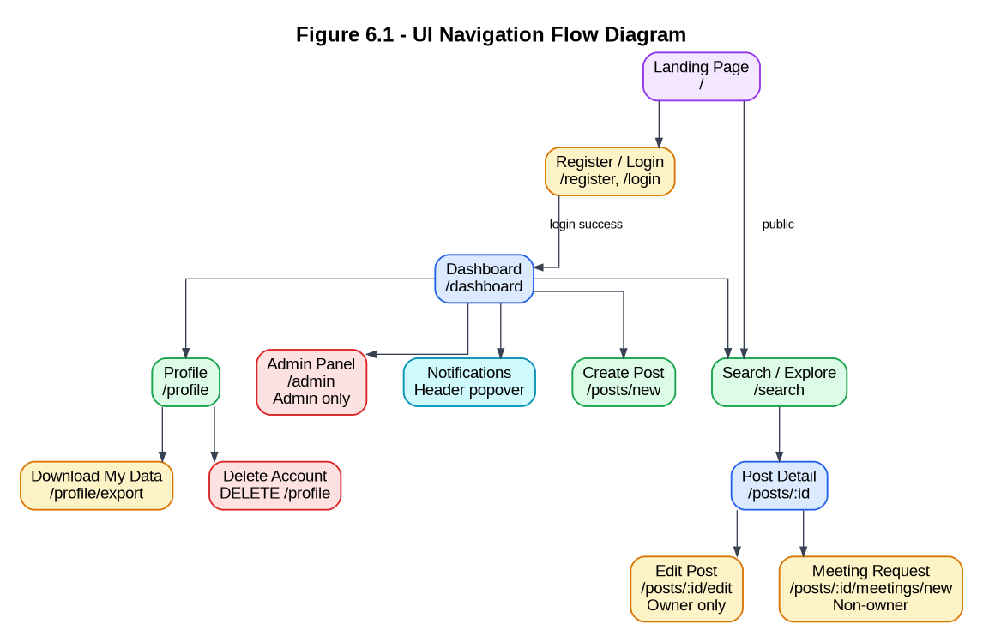

6.2 Wireframes / Mockups
Wireframes / mockups for the four key screens listed below are described with the key UI elements. The implemented component files are in frontend/src/pages/ and frontend/src/components/.

Screen | Key UI Elements
Registration Page (/register) | Form fields with inline validation: First Name, Last Name, Email (label: 'Must be .edu or .edu.tr'), Password, Role dropdown, Institution, City, Country. Submit button. 'Already have an account? Log in' link.
Dashboard (/dashboard) | Page title 'My Posts'. 'Create New Post' button (top right). Post cards in a responsive grid: each card shows Title, Domain chip, Status chip (colour-coded), Created date, Edit button, Delete button (with confirmation). Empty state message when no posts exist.
Post Detail + Meeting Request Form (/posts/:id) | Left column: full post details (all fields), owner info card (name, role, institution, city). Right column for non-owners: 'Request a Meeting' section with NDA checkbox, Message textarea, Proposed Time datepicker, Submit button (disabled until NDA checked). For owners: incoming meeting request list with requester name, message, proposed time, and Accept / Reject / Propose New Time buttons.
Admin Panel (/admin) | Tab bar: Users │ Posts │ Statistics │ Activity Logs. Users tab: search/filter bar, table with columns Name, Email, Role, Status (Active/Suspended), Posts Count, Actions (Suspend/Activate). Statistics tab: four metric cards in a 2×2 grid. Activity Logs tab: filter row (User ID, Date, Action Type) + table + Export CSV button.

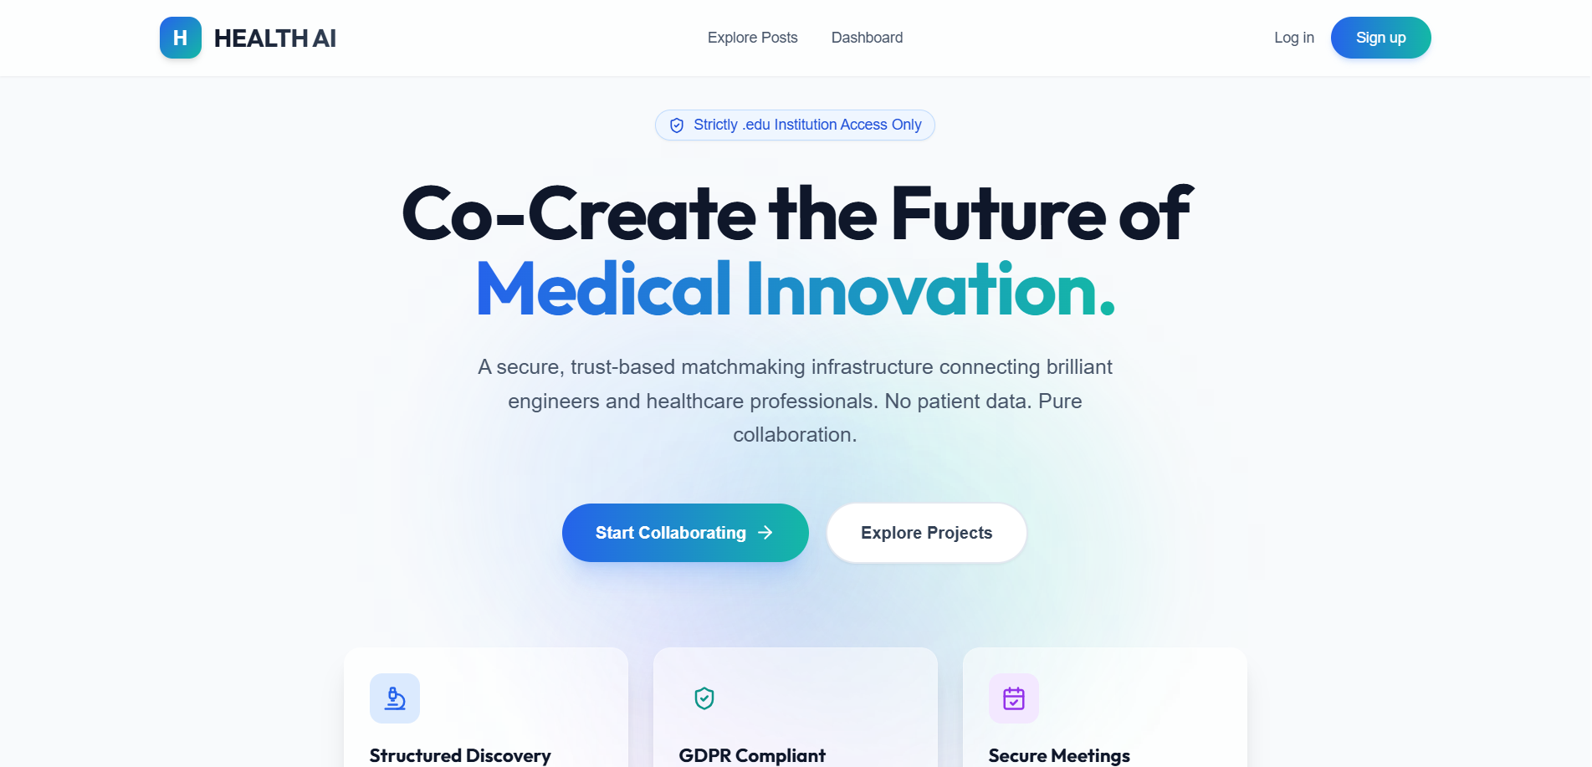

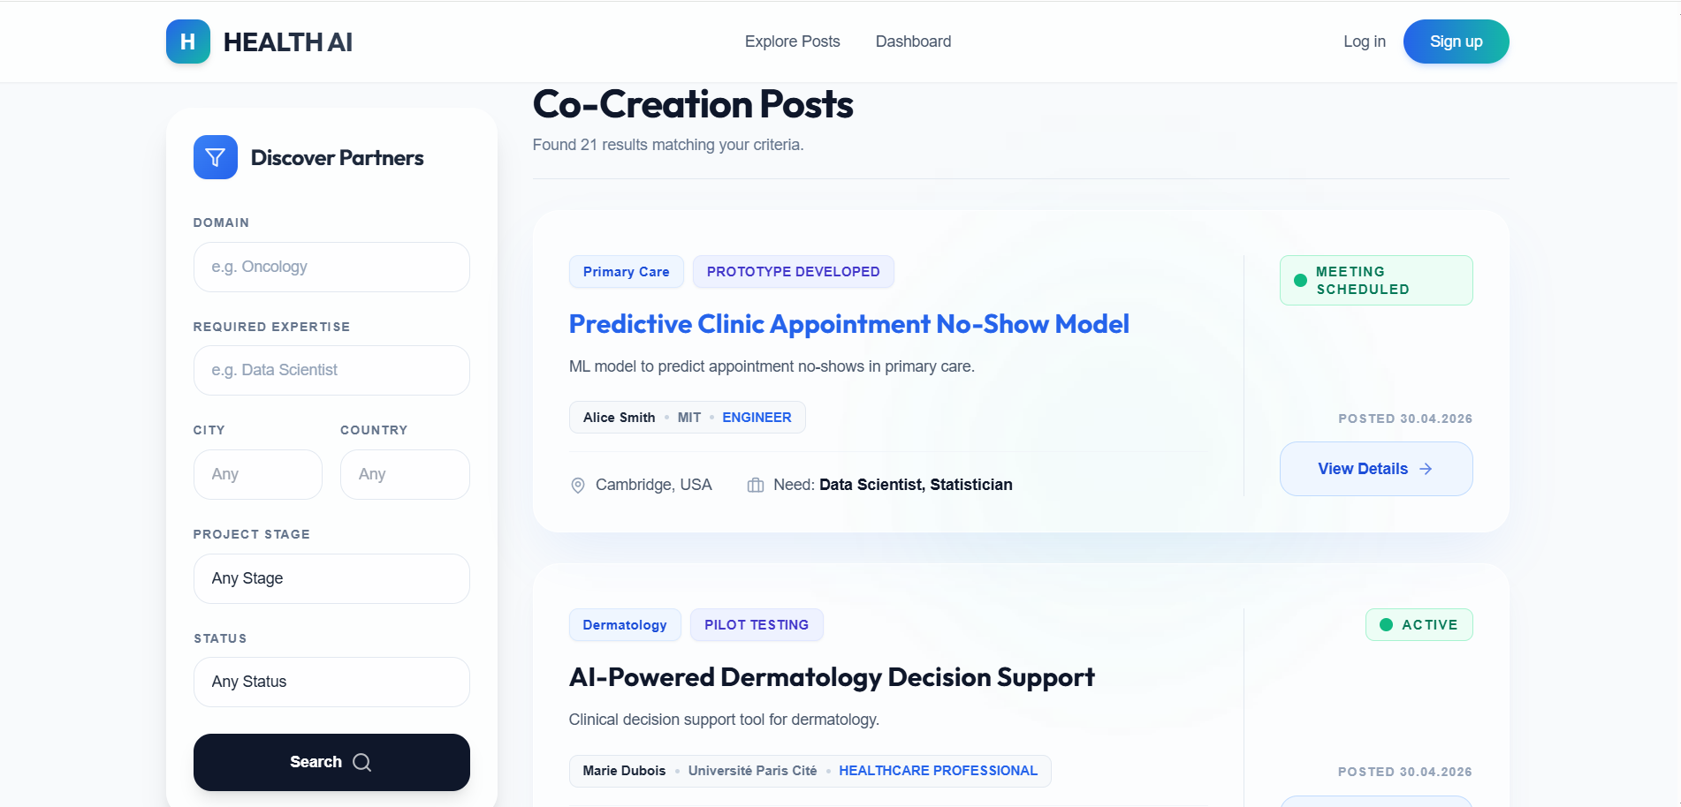

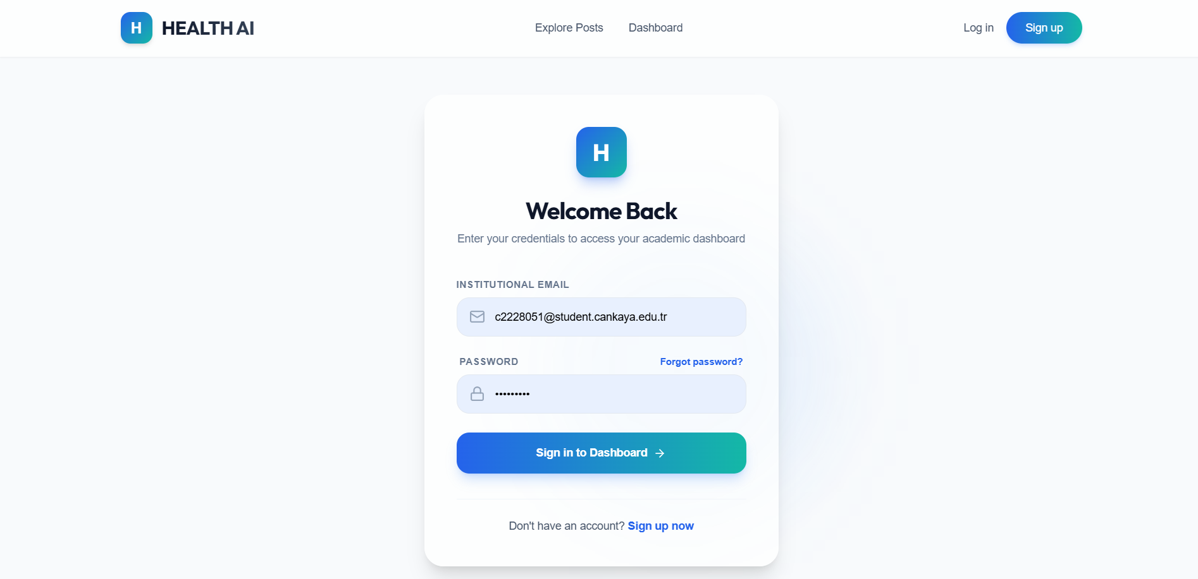

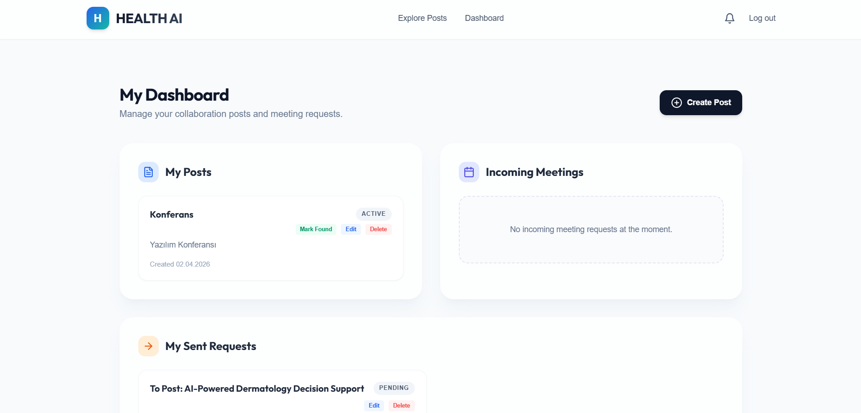

7. Security Design
The table below explains how each security and GDPR requirement from the SRS is addressed at the design level.

Security Requirement | Design Decision | SRS Ref.
Authentication | JWT-based stateless authentication. Tokens are signed using HS256 with the JWT_SECRET environment variable. Expiry is 10 hours (configurable for production). The authMiddleware verifies the token on every protected request and attaches req.user = { id, role } for downstream use. No server-side session store is used. | NFR-03, FR-07
Password Storage | Passwords are hashed using bcryptjs with 10 salt rounds before storage. bcrypt.compare() is used for login verification. Plaintext passwords are never stored, logged, or returned in any API response. | NFR-04, FR-05
Authorization (RBAC) | Two middleware functions enforce access control: (1) authMiddleware — validates JWT and attaches the user to the request; (2) requireRole(['ADMIN']) — checks req.user.role against an allowlist. Ownership checks are performed inside individual controller functions (HTTP 403). | FR-08, FR-40
Institutional Email Restriction | The registration endpoint checks that the email ends with .edu or .edu.tr before proceeding. Non-compliant emails receive HTTP 400: 'Only institutional .edu or .edu.tr emails are allowed'. | FR-01, NFR-03
Input Validation | All request bodies are parsed and validated through Zod schemas before any business logic executes. Invalid input returns HTTP 400 with a structured Zod error. This prevents injection attacks and malformed data from reaching the database. | FR-03, FR-10, FR-30
Security Headers | Helmet middleware is applied globally in app.ts (app.use(helmet())). Helmet sets X-Frame-Options: SAMEORIGIN, X-Content-Type-Options: nosniff, Content-Security-Policy, and other protective headers. | NFR-03
Rate Limiting | express-rate-limit (authLimiter) restricts each IP to 20 requests per 15-minute window on the /auth/register and /auth/login endpoints. Requests exceeding the limit receive HTTP 429. | NFR-05
CORS Configuration | CORS is configured with origin: process.env.FRONTEND_ORIGIN (defaults to '*' in development) and credentials: true. In production the origin must be set to the exact frontend domain. | NFR-03
Session Management | Sessions are stateless (JWT). The client stores the token in localStorage and removes it on logout (client-side only). Token expiry is 10 hours. There is no server-side token blacklist in the current version. | NFR-03
NDA Acceptance Gate | Meeting request creation requires nda_accepted: true in the request body, enforced by a Zod .refine() rule. Any request where ndaAccepted is false or missing is rejected with HTTP 400: 'NDA must be accepted to request a meeting'. | FR-32
GDPR Compliance | GET /profile/export returns the authenticated user's own data as a downloadable JSON attachment. DELETE /profile deletes the user account — Prisma CASCADE rules automatically remove all associated posts, meeting requests, activity logs, and notifications. | NFR-06
Activity Logging | The activityLogger middleware fires on the res 'finish' event for every non-GET mutating request. It records actionType, targetEntity (request path), resultStatus, ipAddress, and userId. Failed logins are distinguished as FAILED_LOGIN. | FR-50, FR-51

8. State Diagrams

8.1 Post Lifecycle
The diagram below shows the post states and the events that trigger each transition. A summary transition table follows.
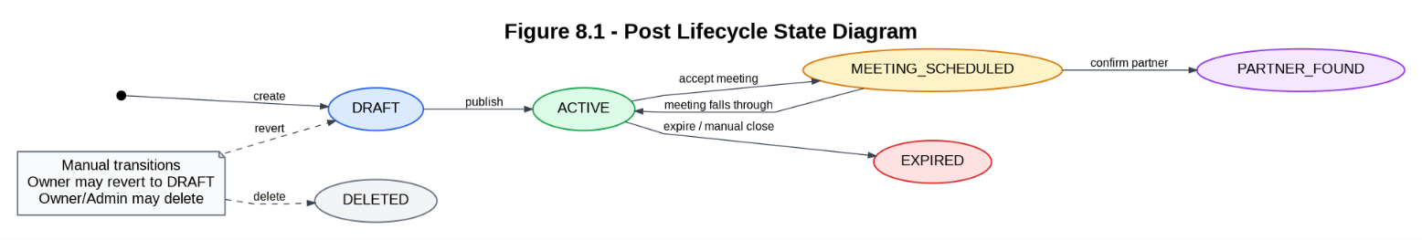

Transition | Triggering Event
DRAFT → ACTIVE | Post owner sets status: ACTIVE at creation (POST /posts) or manually via PATCH /posts/:id/status
ACTIVE → MEETING_SCHEDULED | Post owner accepts a meeting request (PATCH /meetings/:id/respond, action: ACCEPT). The system automatically updates the post status to MEETING_SCHEDULED.
MEETING_SCHEDULED → PARTNER_FOUND | Post owner manually sets status: PARTNER_FOUND via PATCH /posts/:id/status after offline confirmation of collaboration.
ACTIVE → EXPIRED | Post owner manually sets status: EXPIRED via PATCH /posts/:id/status, or the expiry date is reached.
MEETING_SCHEDULED → ACTIVE | Post owner reverts to ACTIVE via PATCH /posts/:id/status if a scheduled meeting falls through.
Any state → DRAFT | Post owner reverts to DRAFT via PATCH /posts/:id/status for content rework.
Any state → (deleted) | Post owner or Admin deletes the post via DELETE /posts/:id. All associated meeting requests are cascade-deleted.

8.2 Meeting Request Lifecycle
The diagram below shows the meeting request states and transition events.

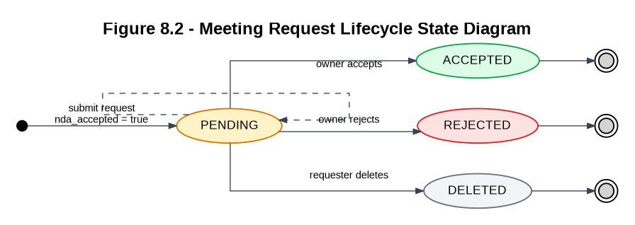

Transition | Triggering Event
(none) → PENDING | Requester submits meeting request with nda_accepted: true via POST /meetings/posts/:postId. Post must have status ACTIVE. Requester cannot be the post owner.
PENDING → ACCEPTED | Post owner responds with action: ACCEPT via PATCH /meetings/:id/respond. System simultaneously sets the related post status to MEETING_SCHEDULED.
PENDING → REJECTED | Post owner responds with action: REJECT via PATCH /meetings/:id/respond. Status is set to REJECTED; the post status is unchanged.
PENDING → PENDING (updated time) | Post owner uses action: PROPOSE_NEW_TIME with a new_time value. Status remains PENDING; proposedTime is updated to the new value.
PENDING → PENDING (edited by requester) | Requester edits message and/or proposed_time via PUT /meetings/:id. Only allowed while status is PENDING; returns HTTP 400 otherwise.
PENDING → (deleted) | Requester deletes their own meeting request via DELETE /meetings/:id. Only possible while status is PENDING.

9. SRS–SDD Traceability Matrix
The matrix below maps every SRS functional and non-functional requirement to the SDD component and section(s) that address it. All requirements are covered.

SRS Ref. | Requirement Summary | SDD Component | SDD Section
FR-01 | .edu / .edu.tr email restriction on registration | AuthModule | S3.1, S5.1, S7
FR-02 | Reject duplicate email registration | AuthModule | S3.1, S5.1
FR-03 | Required fields at registration (name, email, password, institution, city, country) | AuthModule | S3.1, S4.2.1, S5.1
FR-04 | Role selection at registration; default to ENGINEER | AuthModule | S3.1, S4.2.1
FR-05 | bcrypt password hashing before storage | AuthModule | S3.1, S7
FR-06 | Email verification via token and /auth/verify endpoint | AuthModule | S3.1, S4.2.1, S5.1
FR-07 | JWT-based login and access token issuance | AuthModule | S3.1, S5.1, S7
FR-08 | JWT authorization middleware on all protected routes | AuthModule | S3.1, S7
FR-10 | Create structured collaboration post with all required fields | PostModule | S3.1, S4.2.2, S5.2
FR-11 | Optional post fields (high-level idea, collaboration type, expiry date) | PostModule | S4.2.2, S5.2
FR-12 | Save new post as DRAFT or ACTIVE | PostModule | S4.2.2, S5.2, S8.1
FR-13 | List posts (descending by createdAt) and retrieve individual post by ID | PostModule / MatchingModule | S5.2
FR-14 | Post owner updates post content | PostModule | S5.2
FR-15 | Post owner changes post lifecycle status | PostModule | S5.2, S8.1
FR-16 | Post owner or admin deletes a post | PostModule / AdminModule | S5.2, S5.4
FR-17 | Notification created for owner on successful post creation | NotificationModule | S3.1, S4.2.5
FR-20 | Search/filter posts by domain, expertise, city, country, project stage, status | MatchingModule | S3.1, S5.2
FR-21 | Match explanation returned when domain or city matches the search query | MatchingModule | S3.1, S5.2
FR-22 | Post owner summary (id, fullName, role, city, institution) returned in results | PostModule / MatchingModule | S5.2
FR-30 | Meeting request allowed only for posts with ACTIVE status | MeetingModule | S3.1, S5.3, S8.2
FR-31 | Post owner cannot request a meeting on their own post | MeetingModule | S5.3
FR-32 | NDA acceptance (nda_accepted: true) required to create a meeting request | MeetingModule | S5.3, S7, S8.2
FR-33 | Optional proposed time and message in meeting request | MeetingModule | S4.2.3, S5.3
FR-34 | Post owner accepts, rejects, or proposes new time for a meeting request | MeetingModule | S5.3, S8.2
FR-35 | Post status automatically set to MEETING_SCHEDULED on meeting acceptance | MeetingModule | S5.3, S8.1, S8.2
FR-36 | Requester can edit or delete their own PENDING meeting request | MeetingModule | S5.3
FR-40 | Admin-only access restriction enforced via requireRole(['ADMIN']) middleware | AdminModule | S3.1, S5.4, S7
FR-41 | Admin can list users and filter by role | AdminModule | S5.4
FR-42 | Admin can suspend and activate user accounts | AdminModule | S4.2.1, S5.4
FR-43 | Admin can view all posts and delete inappropriate ones | AdminModule | S5.4
FR-44 | Platform statistics: totalUsers, totalPosts, totalMeetings, activePosts | AdminModule | S5.4
FR-50 | Activity logging of all major events | AuditModule | S3.1, S4.2.4, S7
FR-51 | Each log entry records: actionType, targetEntity, resultStatus, ipAddress, timestamp, userId | AuditModule | S4.2.4
FR-52 | Admin can filter activity logs by userId, date, and actionType | AuditModule | S5.4
FR-53 | Admin can export activity logs as CSV download | AuditModule | S5.4
NFR-01 | Search results returned within 1.5 seconds for typical filtered queries | MatchingModule | S5.2
NFR-02 | Core pages load within 3 seconds under normal load | Presentation Layer | S2.2, S6
NFR-03 | HTTPS, Helmet headers, JWT on protected routes, RBAC on admin endpoints | AuthModule / AdminModule | S7
NFR-04 | bcrypt hashing (10 rounds); plaintext password storage prohibited | AuthModule | S7
NFR-05 | Rate limiting: 20 requests per 15-minute window on auth endpoints | AuthModule | S7
NFR-06 | GDPR: authenticated users can export their data and delete their account | ProfileModule | S5, S7
NFR-07 | React SPA is responsive across standard desktop and mobile breakpoints | Presentation Layer | S2.2, S6.1
NFR-08 | Semantic page structure, form validation feedback, WCAG-conscious design | Presentation Layer | S6.1, S6.2

10. Appendices
Appendix | Content / Location
A — Prisma Schema | backend/prisma/schema.prisma — defines all five models, enums, and relations. Can be imported into dbdiagram.io or used with prisma-erd-generator to produce a visual ER diagram.
B — Database Initial Migration | backend/prisma/migrations/20260314130513_init/migration.sql — raw SQL for the initial schema creation.
C — Seed Data Scripts | backend/prisma/seed.ts and backend/prisma/seed-sinem.ts — scripts for populating test data (run via 'npx prisma db seed').
D — Docker Compose Configuration | 384/docker-compose.yml — defines three services (postgres, backend, frontend) with environment variables, port mappings, and volume configuration.
E — Backend Source Files | backend/src/modules/ — individual controller files: auth.controller.ts, post.controller.ts, meeting.controller.ts, admin.controller.ts, log.controller.ts, notification.controller.ts, profile.controller.ts.
F — Frontend Source Files | frontend/src/pages/ — page components: LandingPage, RegisterPage, LoginPage, DashboardPage, SearchResultsPage, CreatePostPage, EditPostPage, PostDetailPage, MeetingRequestPage, ProfilePage, AdminPanelPage.

