Software Requirements Specification
(SRS)

Project Name | HEALTH AI Co-Creation & Innovation Platform
Course | [SENG-384]
Group No / Name | [SoloStack]
Group Members | [Sinem Ünsal – 202228051]
Submission Date | 24/03/2026
Version | 1.0
Revision History
Date | Version | Change Description | Author
24/03/2026 | 1.0 | Initial version prepared from the uploaded HEALTH AI codebase | Sinem Ünsal

Table of Contents
Table of Contents 2
1. Introduction 3
1.1 Purpose 3
1.2 Scope 3
1.3 Definitions and Abbreviations 3
1.4 Intended Audience 3
2. Overall Description 3
2.1 Product Perspective 3
2.2 User Roles 3
2.3 Assumptions and Dependencies 4
2.4 Constraints 4
3. Functional Requirements 4
3.1 User Registration & Access Control 4
3.2 Post Management 5
3.3 Search & Matching 5
3.4 Meeting Request Workflow 5
3.5 Administrative Dashboard 6
3.6 Activity Logging & Audit Trail 6
4. Non-Functional Requirements 6
5. Use Cases 7
5.1 UC-01: User Creates a Collaboration Post 7
5.2 UC-02: User Requests a Meeting 8
5.3 UC-03: Post Owner Responds to a Meeting Request 8
5.4 UC-04: Admin Moderates the Platform 8
6. Data Model 9
7. Interface Requirements 9
7.1 User Interface (UI) 9
7.2 External System Interfaces 9
8. Requirements Traceability Matrix 9
9. Appendices 10
9.1 AI Use Cases 10

1. Introduction

1.1 Purpose
This Software Requirements Specification (SRS) defines the functional and non-functional requirements of the HEALTH AI Co-Creation & Innovation Platform. The document is prepared for the academic full-stack web application implemented in the uploaded project and serves as a reference for development, testing, review, and demonstration.

1.2 Scope
The system is a web-based partner discovery and first-contact platform that enables engineers and healthcare professionals to publish collaboration opportunities, search relevant posts, and request meetings. The platform does not store patient data, medical files, or clinical records, and it does not provide financial transactions, contract management, or medical advice. Meeting execution is handled outside the platform through external tools such as Zoom or Microsoft Teams.

1.3 Definitions and Abbreviations
SRS: Software Requirements Specification. RBAC: Role-Based Access Control. GDPR: General Data Protection Regulation. JWT: JSON Web Token. API: Application Programming Interface. UI: User Interface. NDA: Non-Disclosure Agreement. WCAG: Web Content Accessibility Guidelines. ORM: Object-Relational Mapping. SPA: Single-Page Application.

1.4 Intended Audience
This document is intended for the project team, software developers, testers, course instructors, evaluators, and future maintainers of the HEALTH AI platform.

2. Overall Description

2.1 Product Perspective
The platform addresses the difficulty of creating a structured and trustworthy first-contact environment between healthcare professionals and engineers. Existing communication channels are often informal, scattered, and weak in access control. HEALTH AI provides a controlled collaboration workflow with institutional email restriction, post publication, search and matching, meeting requests, notifications, administrative moderation, and audit logging.

2.2 User Roles
Role | Description | Key Permissions
Engineer | Creates and manages collaboration posts, searches opportunities, and requests meetings with relevant collaborators. | Register and log in; create, edit, update status of, and delete own posts; browse/search posts; send, edit, and delete own meeting requests; view notifications; export/delete own data.
Healthcare Professional | Publishes healthcare-driven collaboration needs, reviews incoming interest, and responds to meeting requests. | Register and log in; create, edit, update status of, and delete own posts; browse/search posts; receive and respond to meeting requests on owned posts; view notifications; export/delete own data.
Admin | Moderates platform activity, oversees users and posts, and monitors logs and platform statistics. | Access admin-only routes; list/filter users; activate or suspend users; view all posts; delete inappropriate posts; view platform statistics; filter and export activity logs.

2.3 Assumptions and Dependencies
It is assumed that users have valid institutional email addresses ending with .edu or .edu.tr. The platform depends on a PostgreSQL database, a running backend API, a frontend SPA, JWT secret configuration, and an email verification workflow design. External meeting tools are not integrated for hosting meetings; they are only referenced as off-platform meeting channels.

2.4 Constraints
The system design is constrained by academic project scope and privacy rules. No patient data or document uploads are stored. The application only supports structured first-contact and meeting-request workflows. Authentication is JWT-based, the backend is implemented with Node.js/Express and Prisma, and the frontend is implemented with React and TypeScript.

3. Functional Requirements
Each requirement below is derived from the uploaded implementation and aligned with the structure of the course template. Priority values indicate implementation importance for correct platform behavior.

3.1 User Registration & Access Control
ID | Requirement Description | Priority | Source
FR-01 | The system shall allow registration only with institutional email addresses ending in .edu or .edu.tr. | High | Project Brief Section 4.1 – User Registration & Access Control
FR-02 | The system shall reject registration when the email address is already registered. | High | Project Brief Section 4.1 – User Registration & Access Control
FR-03 | The system shall require password, first name, last name, institution, city, and country during registration. | High | Project Brief Section 4.1 – User Registration & Access Control
FR-04 | The system shall allow role selection for Engineer, Healthcare Professional, or Admin; if no role is provided, the default role shall be Engineer. | Medium | Project Brief Section 4.1 – User Registration & Access Control
FR-05 | The system shall hash passwords using bcrypt before storing them. | High | Project Brief Section 4.1 – User Registration & Access Control
FR-06 | The system shall support an email verification workflow through a verification token and verification endpoint. | Medium | Project Brief Section 4.1 – User Registration & Access Control
FR-07 | The system shall authenticate users through login and issue a JWT access token on successful authentication. | High | Project Brief Section 4.1 – User Registration & Access Control
FR-08 | The system shall protect authenticated endpoints through JWT-based authorization middleware. | High | Project Brief Section 4.1 – User Registration & Access Control

3.2 Post Management
ID | Requirement Description | Priority | Source
FR-10 | The system shall allow authenticated users to create a post with title, description, domain, required expertise, project stage, commitment level, confidentiality level, city, and country. | High | Project Brief Section 4.2 –Post Management
FR-11 | The system shall support optional post fields including high-level idea, collaboration type, and expiry date. | Medium | Project Brief Section 4.2 –Post Management
FR-12 | The system shall allow a new post to be saved with DRAFT or ACTIVE status. | High | Project Brief Section 4.2 –Post Management
FR-13 | The system shall list posts in descending creation order and allow retrieval of post details by identifier. | High | Project Brief Section 4.2 – Post Management
FR-14 | The system shall allow the owner of a post to update post content. | High | Project Brief Section 4.2 – Post Management
FR-15 | The system shall allow the owner of a post to change post status among DRAFT, ACTIVE, MEETING_SCHEDULED, PARTNER_FOUND, and EXPIRED. | High | Project Brief Section 4.2 – Post Management
FR-16 | The system shall allow the owner of a post, or an admin, to delete a post. | High | Project Brief Section 4.2 – Post Management
FR-17 | The system shall create a notification for the owner when a post is successfully created. | Medium | Project Brief Section 4.2 – Post Management
The implemented post lifecycle is centered on DRAFT, ACTIVE, MEETING_SCHEDULED, PARTNER_FOUND, and EXPIRED states.

3.3 Search & Matching
ID | Requirement Description | Priority | Source
FR-20 | The system shall allow users to search or filter posts by domain, required expertise, city, country, project stage, and status. | High | Project Brief Section 4.3 – Search & Matching
FR-21 | The system shall return match explanations for relevant search results when a domain or city match is detected. | Medium | Project Brief Section 4.3 – Search & Matching
FR-22 | The system shall expose post owner summary information together with search results and post detail data. | Medium | Project Brief Section 4.3 – Search & Matching

3.4 Meeting Request Workflow
ID | Requirement Description | Priority | Source
FR-30 | The system shall allow an authenticated user to request a meeting only for a post whose status is ACTIVE. | High | Project Brief Section 4.4 – Meeting Workflow
FR-31 | The system shall prevent a post owner from requesting a meeting on their own post. | High | Project Brief Section 4.4 – Meeting Workflow
FR-32 | The system shall require NDA acceptance before a meeting request is created. | High | Project Brief Section 4.4 – Meeting Workflow
FR-33 | The system shall allow a meeting request to include an optional proposed time and optional message. | Medium | Project Brief Section 4.4 – Meeting Workflow
FR-34 | The system shall allow the post owner to accept, reject, or propose a new time for a meeting request. | High | Project Brief Section 4.4 – Meeting Workflow
FR-35 | The system shall update the related post status to MEETING_SCHEDULED when a meeting request is accepted. | High | Project Brief Section 4.4 – Meeting Workflow
FR-36 | The system shall allow the requester to edit or delete their own meeting request while its status is PENDING. | Medium | Project Brief Section 4.4 – Meeting Workflow

3.5 Administrative Dashboard
ID | Requirement Description | Priority | Source
FR-40 | The system shall restrict administrative functions to users with the ADMIN role. | High | Project Brief Section 4.5 – Admin Dashboard
FR-41 | The system shall allow admins to list users and filter them by role. | High | Project Brief Section 4.5 – Admin Dashboard
FR-42 | The system shall allow admins to suspend or activate users. | High | Project Brief Section 4.5 – Admin Dashboard
FR-43 | The system shall allow admins to view all posts and delete inappropriate posts. | High | Project Brief Section 4.5 – Admin Dashboard
FR-44 | The system shall provide platform statistics including total users, total posts, total meetings, and active posts. | Medium | Project Brief Section 4.5 – Admin Dashboard

3.6 Activity Logging & Audit Trail
ID | Requirement Description | Priority | Source
FR-50 | The system shall log important actions such as register, login, failed login, post creation/edit/status change/delete, meeting requests, meeting responses, and admin actions. | High | Project Brief Section 4.6 – Activity Logging
FR-51 | The system shall record the action type, target entity, result status, timestamp, and IP address for each activity log entry. | High | Project Brief Section 4.6 – Activity Logging
FR-52 | The system shall allow admins to filter activity logs by user, date, and action type. | Medium | Project Brief Section 4.6 – Activity Logging
FR-53 | The system shall allow admins to export activity logs in CSV format. | Medium | Project Brief Section 4.6 – Activity Logging

4. Non-Functional Requirements
The following non-functional requirements are defined using concrete targets that match the technical direction of the implementation, including response time, security, privacy, usability, and accessibility.
ID | Requirement | Metric / Target | Category
NFR-01 | Search results shall be returned within a specified time. | < 1.5 seconds for typical filtered queries | Performance
NFR-02 | Page load time shall be limited. | < 3 seconds for core pages under normal load | Performance
NFR-03 | Authentication and administrative endpoints shall be protected against common web threats. | Use HTTPS in production, Helmet security headers enabled, JWT required for protected routes, role checks on admin endpoints | Security
NFR-04 | Passwords shall be stored securely. | bcrypt hashing with salt rounds; plaintext password storage is prohibited | Security
NFR-05 | Authentication endpoints shall limit excessive requests. | Rate limiting of 20 requests per 15-minute window on auth routes | Security
NFR-06 | The platform shall support GDPR-related user rights. | Authenticated users can export their data and request account deletion through profile endpoints | GDPR/Privacy
NFR-07 | The user interface shall be responsive and usable on common desktop and mobile viewport sizes. | React SPA pages shall remain readable and operable without horizontal scrolling at standard responsive breakpoints | Usability
NFR-08 | The interface shall support accessible and understandable interaction. | Semantic page structure, form validation feedback, and WCAG-conscious design practices shall be applied | Accessibility
Categories covered: Performance, Security, GDPR/Privacy, Usability, Accessibility.

5. Use Cases
The following use cases capture the main operational flows present in the current system implementation.

5.1 UC-01: User Creates a Collaboration Post
Name | UC-01: User Creates a Collaboration Post
Actor(s) | Engineer or Healthcare Professional
Precondition | The user is logged in with a valid authenticated session.
Main Flow | 1. The user opens the Create Post page. 2. Enters the required post fields such as title, description, domain, expertise, project stage, commitment, confidentiality, city, and country. 3. Optionally adds high-level idea, collaboration type, expiry date, and an initial status. 4. Submits the form. 5. The system validates the input, stores the post, and creates a notification confirming creation.
Postcondition | A new post is stored in the database and becomes available according to its saved status.
Alternative Flow | 2a. If required fields are missing or invalid, the system returns validation errors and the post is not saved.

5.2 UC-02: User Requests a Meeting
Name | UC-02: User Requests a Meeting
Actor(s) | Authenticated user who is not the owner of the selected post
Precondition | The user is logged in and the selected post exists with ACTIVE status.
Main Flow | 1. The user opens a post detail page. 2. Starts a meeting request. 3. Accepts the NDA requirement. 4. Optionally enters a message and proposed time. 5. Submits the request. 6. The system stores the meeting request and notifies both sides.
Postcondition | A new meeting request is saved with PENDING status and is linked to the relevant post and requester.
Alternative Flow | 3a. If NDA acceptance is not confirmed, the system rejects the request. 2a. If the user is the owner of the post, the system blocks the action.

5.3 UC-03: Post Owner Responds to a Meeting Request
Name | UC-03: Post Owner Responds to a Meeting Request
Actor(s) | Engineer or Healthcare Professional who owns the post
Precondition | The user is logged in and has received a meeting request for one of their posts.
Main Flow | 1. The owner reviews the incoming meeting request. 2. Chooses to accept, reject, or propose a new time. 3. The system updates the meeting request status. 4. If accepted, the related post status is updated to MEETING_SCHEDULED.
Postcondition | The meeting request reflects the owner’s decision and the related post status is updated when applicable.
Alternative Flow | 2a. If the acting user is not the owner of the post, the system returns a forbidden error.

5.4 UC-04: Admin Moderates the Platform
Name | UC-04: Admin Moderates the Platform
Actor(s) | Admin
Precondition | The admin user is logged in with ADMIN role permissions.
Main Flow | 1. The admin opens the Admin Panel. 2. Reviews user lists, posts, and platform statistics. 3. Optionally filters users by role. 4. Suspends or activates a user, or deletes an inappropriate post. 5. Reviews or exports activity logs when needed.
Postcondition | Administrative moderation action is applied and the platform state is updated accordingly.
Alternative Flow | 4a. If a non-admin user attempts to access admin routes, the system denies access.
The use cases above cover the core implemented workflows of the current system.

6. Data Model
The core data model of the system is defined around user accounts, collaboration posts, meeting requests, notifications, and activity logs. The main persistent relationships are summarized below.

Entity | Key Fields | Relationships
User | id, fullName, email, passwordHash, role, institution, city, country, isEmailVerified, isActive, createdAt | User 1..N Post; User 1..N MeetingRequest (as requester); User 1..N ActivityLog; User 1..N Notification
Post | id, title, workingDomain, shortExplanation, requiredExpertise, projectStage, commitmentLevel, confidentiality, city, country, status, expiryDate, userId | Post N..1 User (owner); Post 1..N MeetingRequest
MeetingRequest | id, postId, requesterId, proposedTime, message, ndaAccepted, status, createdAt | MeetingRequest N..1 Post; MeetingRequest N..1 User (requester)
ActivityLog | id, userId, actionType, targetEntity, resultStatus, ipAddress, createdAt | ActivityLog N..1 User
Notification | id, userId, type, message, isRead, link, createdAt | Notification N..1 User

7. Interface Requirements

7.1 User Interface (UI)
The user interface is a React-based single-page application with dedicated screens for landing, registration, login, dashboard, create/edit post, post detail, search results, meeting request, profile, notifications, and admin panel.

7.2 External System Interfaces
The system interacts with external infrastructure and services such as PostgreSQL, JWT-based authentication libraries, and external meeting platforms such as Zoom or Microsoft Teams for meetings that occur outside the platform. An email verification flow is modeled at backend level, even though the current demo configuration auto-verifies users during registration.

8. Requirements Traceability Matrix
The matrix below links representative requirements to the corresponding brief section and use cases so that coverage can be checked systematically.

Req. ID | Requirement Summary | Source (Brief) | Related Use Case
FR-01 | Institutional .edu / .edu.tr email restriction | Project Brief Section 4.1 – User Registration & Access Control | UC-01
FR-07 | JWT-based login and access control | Project Brief Section 4.1 – User Registration & Access Control | UC-01, UC-02, UC-03, UC-04
FR-10 | Create structured collaboration post | Project Brief Section 4.2 – Post Management | UC-01
FR-15 | Manage post lifecycle status | Project Brief Section 4.2 – Post Management | UC-01, UC-03
FR-20 | Search/filter posts by multiple criteria | Project Brief Section 4.3 – Search & Matching | UC-02
FR-30 | Request meeting only for active post | Project Brief Section 4.4 – Meeting Workflow | UC-02
FR-32 | NDA acceptance required for meeting request | Project Brief Section 4.4 – Meeting Workflow | UC-02
FR-34 | Owner responds to meeting request | Project Brief Section 4.4 – Meeting Workflow | UC-03
FR-40 | Admin-only moderation access | Project Brief Section 4.5 – Admin Dashboard | UC-04
FR-43 | Admin deletes inappropriate posts | Project Brief Section 4.5 – Admin Dashboard | UC-04
FR-50 | Activity logging of major events | Project Brief Section 4.6 – Activity Logging | UC-02, UC-03, UC-04
FR-53 | Export activity logs as CSV | Project Brief Section 4.6 – Activity Logging | UC-04

9. Appendices

9.1 AI Use Cases

Post matching algorithm

Smart search recommendations

Meeting suggestion logic

9.2 ER Diagram

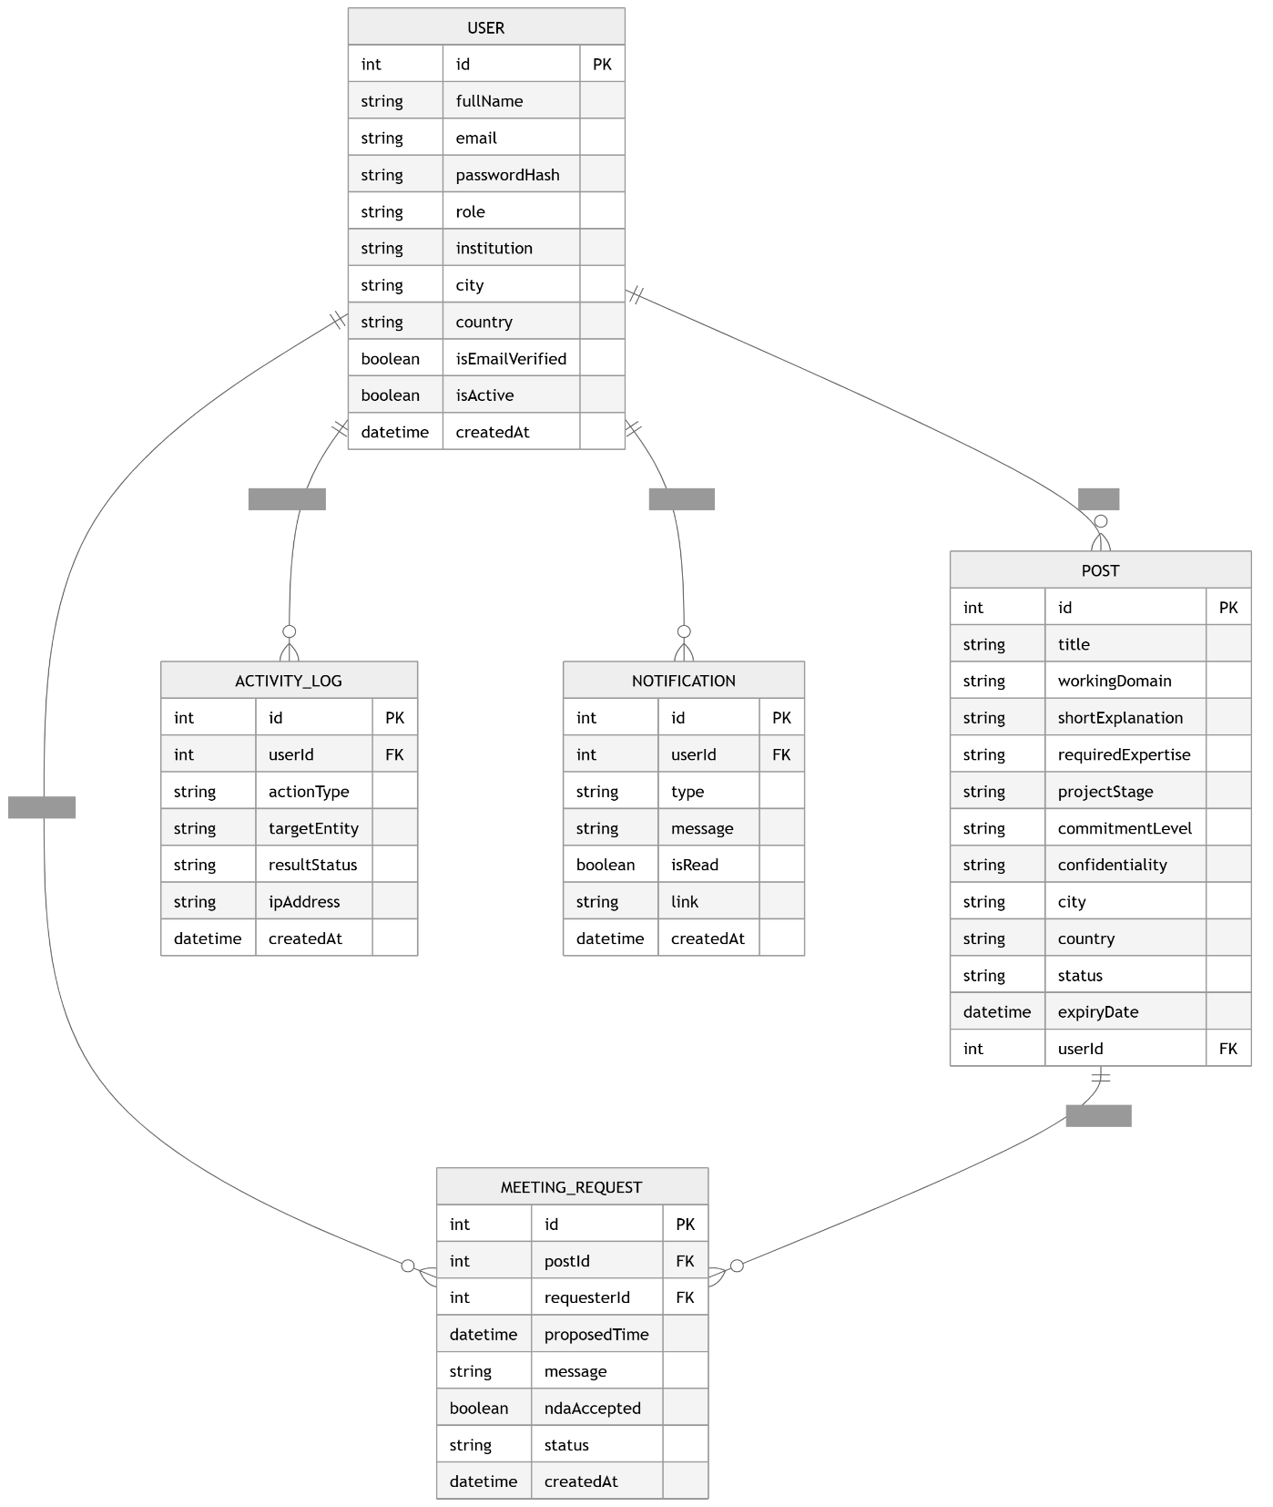

9.3 Use Case Diagram

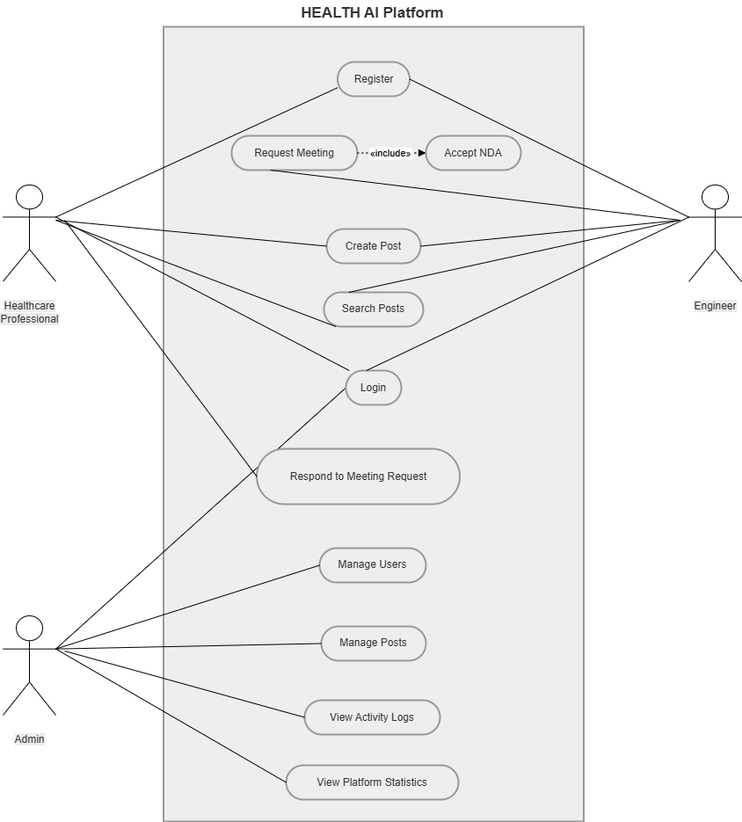

9.4 Sequence Diagram

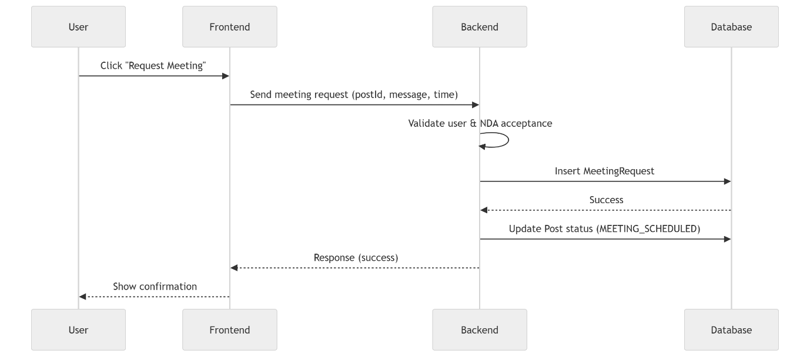

9.5 Activity Diagram

