HANOI UNIVERSITY
FACULTY OF INFORMATION TECHNOLOGY


ADVANCED TOPIC IN INFORMATION TECHNOLOGY
FINAL REPORT
RETINAL DISEASE CLASSIFICATION

Course: Advanced Topic in IT
Class: ATI-CLC 01
Instructor: PhD. Nguyen Xuan Thang
Group 8:
Trinh Ngoc Hoang Nam_2201140055
Nguyen Phu Cuong_2201140016
Nguyen Van Thanh_2201140085
December 5th, 2025

Abstract
Retinal diseases are a major cause of visual impairment, and early diagnosis is essential for effective treatment. In clinical practice, retinal fundus images often exhibit multiple co-existing pathological signs, making automated analysis a challenging multi-label classification problem.
In this work, we propose a deep learning framework for multi-label retinal disease classification based on EfficientNet. Each fundus image is associated with an eight-dimensional binary label vector, representing the presence or absence of different retinal conditions. To address severe class imbalance, we employ a weighted binary cross-entropy loss that emphasizes rare disease categories.
A highly optimized data pipeline using the TensorFlow tf.data framework is designed to enable efficient image decoding, augmentation, caching, and prefetching. Training is conducted in two stages, including backbone freezing and selective fine-tuning, to balance convergence stability and representation adaptability.
Experimental results demonstrate that the proposed approach achieves strong discriminative performance across multiple disease categories, as measured by per-class ROC-AUC and macro-averaged F1-score. The model is capable of detecting multiple concurrent retinal diseases within a single image, highlighting its potential applicability as a clinical decision-support tool.
Overall, this study confirms the effectiveness of transfer learning and weighted optimization strategies for multi-label medical image classification.

1. Introduction
Retinal diseases are among the leading causes of preventable blindness worldwide. Early detection of multiple co-existing retinal conditions such as diabetic retinopathy, glaucoma, and macular degeneration is crucial for timely clinical intervention. However, manual diagnosis from fundus images is time-consuming and highly dependent on expert ophthalmologists.
In recent years, deep learning-based computer vision models have demonstrated strong performance in medical image analysis. Nevertheless, most existing approaches focus on single-label classification, while real-world retinal images often exhibit multiple pathological signs simultaneously. This motivates the formulation of retinal disease recognition as a multi-label classification problem rather than a traditional multi-class task.
In this project, we propose a deep learning framework based on EfficientNet for multi-label classification of retinal fundus images into eight disease categories. Our approach integrates a carefully designed data pipeline, class imbalance handling, weighted loss functions, and fine-tuning strategies to achieve robust performance across multiple disease labels.

2.Dataset & Problem Definition
The dataset consists of retinal fundus images accompanied by a CSV annotation file. Each image is associated with a binary label vector of length eight, corresponding to the presence or absence of the following conditions: (N), (D), (G), (C), (A), (H), (M), and Other abnormalities (O).
Unlike single-label classification, each image may contain multiple positive labels, reflecting the coexistence of several retinal diseases in real clinical scenarios. Therefore, the task is formulated as a multi-label classification problem, where independent probabilities are predicted for each disease.
An analysis of label distribution reveals significant class imbalance across disease categories, with certain conditions appearing far less frequently than others. This imbalance poses challenges for model training and motivates the use of weighted loss functions and appropriate evaluation metrics beyond standard accuracy.

3.Methodology
We adopt EfficientNet-B0 as the backbone architecture due to its favorable trade-off between performance and computational efficiency. The pretrained ImageNet weights are used to initialize the network, while the classification head is redesigned for multi-label prediction using sigmoid activation functions.
To address class imbalance, a weighted binary cross-entropy loss is employed, where positive samples of rare diseases are assigned higher importance during optimization. This allows the model to learn meaningful representations for under-represented conditions and prevents bias toward majority classes.
Data loading and preprocessing are implemented using the TensorFlow tf.data pipeline, enabling parallel image decoding, resizing, caching, and prefetching. This significantly reduces I/O bottlenecks and improves training efficiency. Data augmentation techniques such as random flipping, rotation, zoom, and contrast adjustment are applied during training to improve generalization and robustness to imaging variability.
Training is conducted in two stages. In the first stage, the backbone network is frozen and only the classification head is trained to stabilize convergence. In the second stage, selected upper layers of the backbone are unfrozen for fine-tuning using a lower learning rate, allowing the model to adapt domain-specific retinal features while minimizing the risk of overfitting.

4.Experimental Setup
The dataset is split into training and validation sets using a custom multi-label balancing strategy to minimize distribution mismatch between splits. Model performance is evaluated using per-class ROC-AUC and macro-averaged F1-score, which are more suitable than accuracy for imbalanced multi-label tasks.
Training is performed on a GPU-accelerated environment with mixed-precision enabled to reduce memory usage and improve computational efficiency. Early stopping and learning rate scheduling are applied to prevent overfitting and stabilize convergence.

5.Results & Analysis
Per-Class ROC-AUC:
Disease | AUC | Precision | Recall | F1 | Support
(M) | 0.9959 | 0.623 | 0.971 | 0.759 | 34
(C) | 0.9921 | 0.600 | 0.955 | 0.737 | 44
(G) | 0.8761 | 0.142 | 0.911 | 0.246 | 45
(H) | 0.8725 | 0.205 | 0.348 | 0.258 | 23
(A) | 0.8584 | 0.138 | 0.814 | 0.236 | 43
(N) | 0.7571 | 0.608 | 0.826 | 0.700 | 430
(D) | 0.7248 | 0.344 | 0.760 | 0.473 | 233
Other (O) | 0.6481 | 0.163 | 0.720 | 0.266 | 107
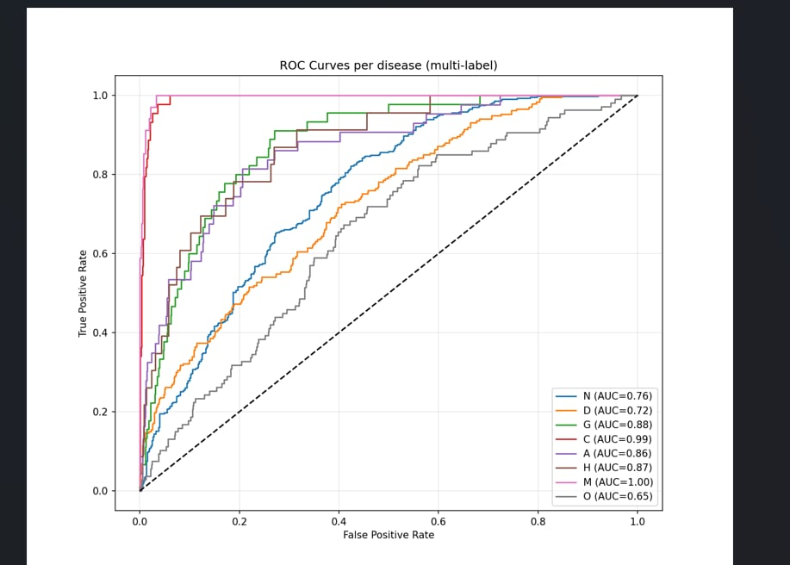
The figure above illustrates the ROC curves for all eight disease categories in the multi-label setting. Overall, the model demonstrates strong discriminative capability, with most ROC curves remaining well above the random baseline, confirming effective separation between positive and negative samples.
The highest performance is observed for (M) (AUC = 0.9959) and (C) (AUC = 0.9921), whose ROC curves rapidly approach the top-left corner, indicating near-perfect classification. These conditions exhibit distinct structural and visual patterns, making them more easily distinguishable by convolutional features. Similarly, (G), (H), and (A) achieve high AUC values above 0.85, demonstrating robust detection performance despite their relatively limited sample sizes.
Moderate performance is observed for (N) (AUC = 0.7571) and (D) (AUC = 0.7248). In particular, Diabetes presents a wide range of disease severity and visual manifestations, which increases classification difficulty. The Other category yields the lowest AUC (0.6481), reflecting its heterogeneous nature and lack of consistent visual characteristics.
At a fixed decision threshold of 0.5, recall values are generally high across most disease categories, indicating strong sensitivity and a low false-negative rate. However, precision remains comparatively low for several rare classes, leading to reduced F1-scores. This behavior suggests that the weighted loss function prioritizes sensitivity for under-represented diseases, which is desirable for screening-oriented applications but may increase false positives. Overall, the macro-averaged F1-score indicates balanced multi-label performance, while the ROC-AUC results confirm the effectiveness of the weighted optimization and fine-tuning strategy.

6.Discussion & Limitations
Despite the promising results, several limitations remain. First, the dataset size is relatively limited for deep multi-label learning, particularly for rare retinal diseases. Although the weighted loss function alleviates class imbalance, extremely low sample counts for certain conditions still constrain the model’s ability to learn robust and discriminative features, leading to reduced precision and higher performance variance for minority classes.
Second, the current approach treats disease labels as independent, while in clinical practice many retinal conditions exhibit strong co-occurrence patterns, such as diabetes and hypertension. Ignoring these correlations may limit predictive consistency and clinical realism. Future work could incorporate label-correlation modeling or structured prediction methods to better capture inter-disease relationships.
Finally, the model focuses primarily on classification performance and lacks explicit interpretability mechanisms. Integrating attention-based or visualization techniques, as well as exploring semi-supervised learning to leverage additional unlabeled data, may further enhance both performance and clinical applicability.

7.Conclusion
This project presents an effective deep learning framework for multi-label retinal disease classification from fundus images. By integrating EfficientNet architectures with transfer learning, weighted binary cross-entropy loss, and an optimized data processing pipeline, the proposed approach achieves strong and stable performance across multiple disease categories, including both common and rare conditions.
Experimental results demonstrate that the model is capable of simultaneously detecting multiple co-existing retinal diseases with high discriminative ability, as reflected by robust per-class ROC-AUC scores. These findings confirm the feasibility of automated multi-disease retinal screening and its potential to support clinical decision-making, particularly in large-scale screening scenarios.
While promising, the study also highlights opportunities for further improvement, including better modeling of label correlations, refinement of decision thresholds, and expansion of training data for rare diseases. Overall, this work establishes a solid foundation for future research and practical deployment of multi-label retinal disease classification systems.

