Budget Tracker – Project Report

1. Introduction
This project is a Python-based budget tracking system integrated with a MySQL database. It allows users to add expenses, store them securely, calculate monthly totals, view remaining budgets, and set monthly spending limits. The project uses a menu-driven command-line interface for user interaction.

2. Project Overview
The system is built using Python for the logic and MySQL for persistent storage. Users interact with a CLI menu that triggers database operations. The program supports adding expenses, viewing stored expenses, computing monthly totals, adding budgets, and calculating remaining budget.

3. Objectives
• Track day-to-day expenses.
• Store financial data securely using MySQL.
• Automate monthly total calculations.
• Provide remaining budget estimation.
• Create a modular system that can be extended with GUI later.

4. System Features
1. Add Expense – Stores name, category, amount, and date.
2. View Expense – Displays all stored expenses.
3. Monthly Total – Computes total spending for the current month.
4. Add Budget – Sets a monthly limit.
5. Remaining Budget – Calculates remaining amount after expenses.
6. Exit – Terminates the application.

5. Technologies Used
• Python 3
• MySQL Server
• mysql-connector-python library
• Command-Line Interface

6. System Design
The application follows a simple layered design:
• User interacts through CLI menu.
• Python functions handle operations such as adding expenses and calculating totals.
• SQL queries are executed through mysql.connector.
• MySQL stores persistent data in two tables: expenses and budget.
SCREENSHOT:
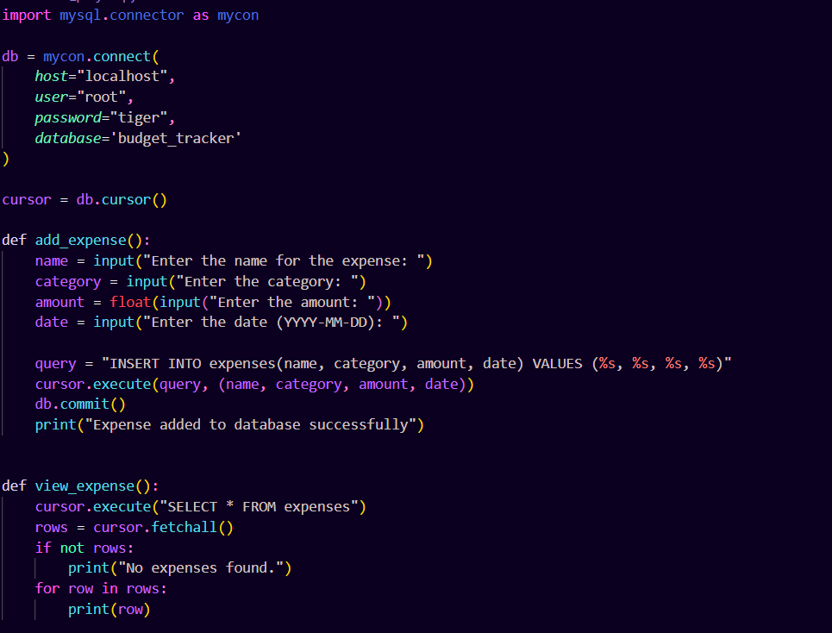
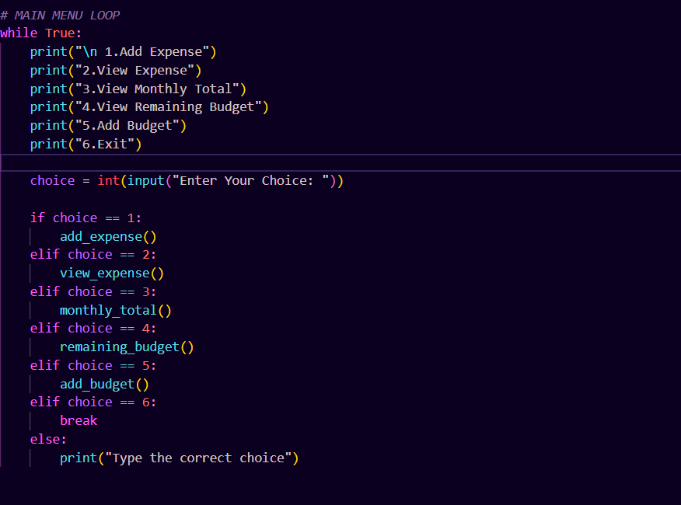

Database Schema
Database: budget_tracker
Table: expenses
• id – Auto Increment Primary Key
• name – Expense name
• category – Category of expense
• amount – Amount spent
• date – Date (YYYY-MM-DD)

Table: budget
• mon – Month name
• limit – Monthly budget limit

8. Working of the System
The user selects an option from the menu. Each option triggers a specific function. These functions execute SQL queries to insert or fetch data. Monthly totals are calculated using SQL's MONTH() function. Remaining budget is computed by subtracting total spent from the stored monthly limit.

9. Testing
The system was tested with various inputs such as numeric values, text, empty budgets, and multiple expenses. It performed correctly under all expected conditions. Database operations were validated, and the program handled missing data safely.

10. Conclusion
The project successfully implements a functional budget tracking system. It provides essential features such as expense tracking, budget setting, and financial calculation. The structure is robust and allows easy expansion into GUI applications or analytics-based systems.

11. Future Enhancements
• Full Tkinter GUI interface.
• Export reports to PDF/CSV.
• Add expense editing & deletion.
• Graphical charts using Matplotlib.
• Multi-user login system.

