MINISTRY OF EDUCATION AND SCIENCE OF UKRAINE
NATIONAL TECHNICAL UNIVERSITY
“KHARKIV POLYTECHNIC INSTITUTE”
DEPARTMENT OF SOFTWARE ENGINEERING AND MANAGEMENT INFORMATION TECHNOLOGIES”

Report of laboratory work № 1
Discipline «Software Engineering»

Executed by: Student of group KN226-e
Yurii Vaschinskyi
Checked by: Associate professor
Melnyk K.V.

Kharkiv
2026
Theme: Lab 1
Work objective: Learn basic principles of C++
Task: 1.4
Goal: learning basic principles of C++.
Task (Variant 3): the program reads the integer range x_start, x_end, the integer step, and the integer n. It calculates the value of the assigned function at each x in the range:

Task 2.1 Program for the Task from the Previous Lab
The program is divided into four source modules. main.cpp starts the interface, interface.cpp reads input and manages the menus and files, algorithm.cpp validates the calculation parameters and evaluates the formula, and global.cpp stores the shared parameters and results. The input file contains four integers in this order: x_start x_end step n.
The calculation of y is implemented in src/algorithm.cpp:
auto calculate(int x_start, int x_end, int step, int n) -> std::vector<double> {
auto x = x_start;
std::vector<double> results;
while ((step > 0 && x <= x_end) || (step < 0 && x >= x_end)) {
double y = x >= 0 ? 1.0 : 0.0;
if (x >= 0) {
for (int i = 0; i <= n; ++i) {
double y_j = 1;
for (int j = 1; j < n; ++j) {
y_j *= i + (std::pow(x, 2) / (i + j)) - 3*j;
}
y *= y_j;
}
} else {
for (int i = 1; i <= n; ++i) {
const double term = static_cast<double>(x) + i;
y += term * term;
}
y += 5.0 * x;
}
std::cout << "x: " << x << "; y: " << y << '\n';
results.push_back(y);
if ((step > 0 && x > std::numeric_limits<int>::max() - step) ||
(step < 0 && x < std::numeric_limits<int>::min() - step)) break;
x += step;
}
return results;
}
For negative x, the program sums the squared terms and adds 5x. For nonnegative x, it calculates the nested products. It prints and stores the result for each value of x. The range ends when the next value would pass x_end; the integer-bound check prevents overflow when adding the step.
The input routine in algorithm.cpp reads the step, n, and range endpoints. It rejects a zero step and n values below 2. If the sign of the step does not lead from x_start toward x_end, the user may replace one of those three values.
if (step == null || step == 0) {
gather_v("step", step, "Must not be zero");
} else if (n == null || n < 2) {
gather_v("n", n, "must be within range [2, ∞)");
} else if (x_start == null && x_end == null) {
gather_v("x_start", x_start, "must be lower than x_end");
gather_v("x_end", x_end, "must be higher than x_start");
} else if ((step > 0 && x_start > x_end) ||
(step < 0 && x_start < x_end)) {
std::cout << "incorrect combination of x_start, x_end and step.\n";
output_candidate_for_input("x_start", "must be lower than x_end", true);
output_candidate_for_input("x_end", "must be higher than x_start", true);
output_candidate_for_input("step", "must not be zero", true);
std::cout << "Your input: ";
parse_into_candidate(
std::make_tuple("x_start", "x_end", "step"),
std::tie(x_start, x_end, step));
}
gather_v() parses a complete integer line with std::from_chars. If parsing fails, it asks for the value again:
const auto [ptr, ec] = std::from_chars(begin, end, parsed);
if (ec == std::errc{} && ptr == end) {
v = parsed;
return;
}
std::cout << "Invalid integer; try again.\n";
When parameters are loaded from a file, read_input_file() requires four integers, checks the step direction and n, and rejects additional values before saving the parameters in the shared state:
if (!(ifs >> x_start >> x_end >> step >> n)) {
std::cout << "Invalid file format. Expected: x_start x_end step n\n";
return false;
}
if (step == 0 ||
(step > 0 && x_start > x_end) ||
(step < 0 && x_start < x_end) || n < 2) {
std::cout << "Invalid parameter values\n";
return false;
}
std::string extra;
if (ifs >> extra) {
std::cout << "Too many values in input file\n";
return false;
}
global::x_start = x_start;
global::x_end = x_end;
global::step = step;
global::n = n;
return true;
The enter() function controls the main menu. Option 1 calculates the function, option 2 opens file input/output settings, option 3 displays the stored values, and option 0 exits. After calculation, the last value is stored for output to a file.
switch (choice) {
case 0:
return;
case 1:
global::results = calculate(global::x_start, global::x_end,
global::step, global::n);
global::calc_result = global::results.empty()
? std::nan("") : global::results.back();
std::cout << "Calculated!" << std::endl;
break;
case 2:
file_io();
break;
case 3:
for (std::size_t i = 0; i < global::results.size(); ++i)
std::cout << i + 1 << ": " << global::results[i] << std::endl;
wait();
break;
}
The program starts by calling enter() from main.cpp:
int main(int argc, char **argv) {
enter();
return 0;
}
Figure 1.1 – Main function
The program wireframes are stored in wf/enter.puml and wf/calc.puml. Figure 1.2 shows the entry and main-menu flow. Figure 1.3 shows the calculation sequence and display of values.
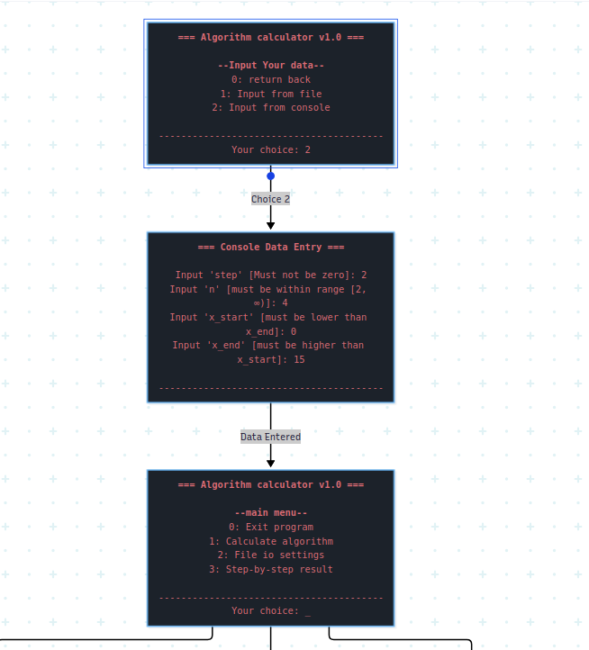
Figure 1.2 – Wireframe: input and main menu
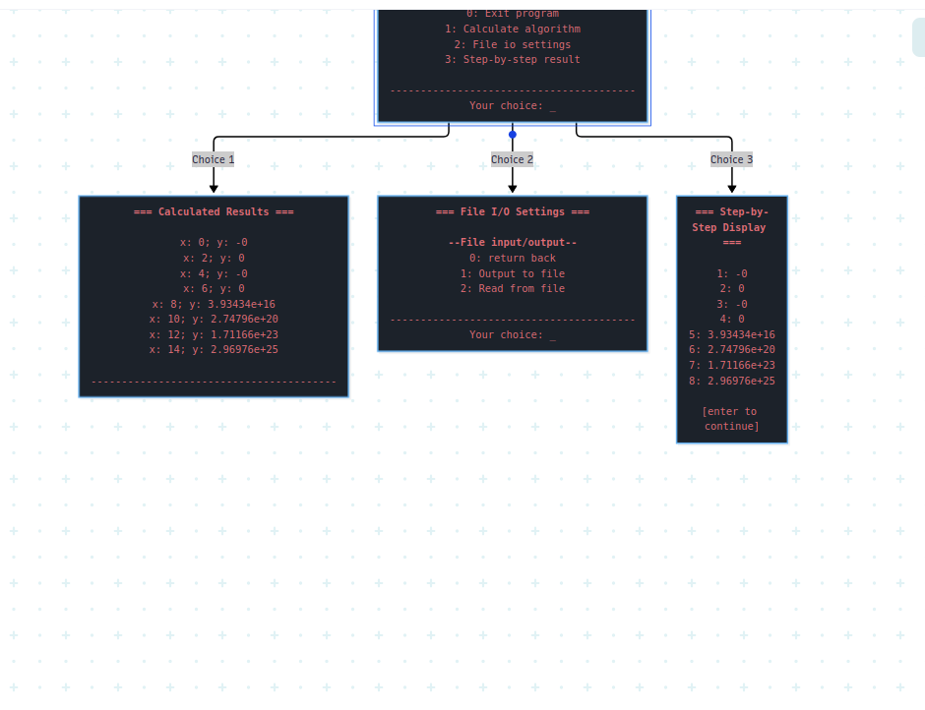
Figure 1.3 – Wireframe: calculation and results

Task 2.2 Enhancing Interface and User Experience. Wireframe
The console program displays a framed menu and asks for a numbered choice. The first screen offers input from a file or from the console. The main menu allows the user to calculate, open file I/O settings, display stored results, or exit. The file I/O menu reads parameters from a file or writes the last calculated value to a file.
The input prompt identifies the required parameter. Integer parsing rejects extra characters and non-integer values. File input checks for missing, invalid, or extra values. The program reports errors and pauses for Enter after file operations and result display.
Use Case 1: Input data from the console. The user selects “Input from console” and enters step, n, x_start, and x_end. If step is zero or its direction does not match the interval, the program requests a corrected value.
Use Case 2: Read data from a file. The user selects “Input from file” and provides a path. The file contains x_start x_end step n. If the values are valid, the program loads them for calculation.
Use Case 3: Calculate the function. The user selects “Calculate algorithm.” The program computes y for each x in the range, displays each pair, and stores the results.
Use Case 4: View calculation results. The user selects “Step-by-step result.” The program displays the stored result values in order.
Use Case 5: Save a result. The user opens “File io settings” and selects “Output to file.” The program writes the last calculated result to the specified file. If no calculation has been made, it reports that the result must be calculated first.
Use Case 6: Exit. The user selects 0 from the main menu.

Conclusions
During this laboratory work we learned the basic principles of C++ by implementing a console program for the assigned function. The program calculates values across a specified range, validates parameters from the console or a file, stores and displays the results, and supports file input and output. We also prepared wireframes for the program’s input, menu, calculation, and result screens.

