MINISTRY OF EDUCATION AND SCIENCE OF UKRAINE
NATIONAL TECHNICAL UNIVERSITY
“KHARKIV POLYTECHNIC INSTITUTE”
DEPARTMENT OF SOFTWARE ENGINEERING AND MANAGEMENT INFORMATION TECHNOLOGIES

Report of laboratory work № 2
Discipline «Software Engineering»
Theme: Coding of Domain

Executed by:
Student of group KN-226e
Yurii Vashynskyi
Checked by:
Associate professor
Melnyk K. V.

Kharkiv
2026

Goal: learning basic principles of C++.
Task (Variant 3): the program reads the range x_start, x_end, the step and the integer n, and calculates y for every x of the range:
$$\left\{\begin{aligned}\sum_{i = 1}^{n}{{(x+i)}^{2}+5x}, x < 0 \\ \prod_{i=0}^{n}{\prod_{j=1}^{n − 1}{(i+\frac{x^{2}}{i + j})}}−3j, x >= 0\end{aligned}\right.$$
Task 2.1 Program for the Task from the Previous Lab
The program src/main.cpp file - the enrty point, simply points to an enter funciton, located at src/interface.cpp. The program at whole is divided under files. File src/algorithm.cpp contains calculate and input_loop (the function to take input out of console) functions. File corelib.h contains functions such as output_candiate_for_input, gather_v and parse_into_candiate. All are responsible for taking, parsing and returning input in it’s easy to use, machine structures. File global.cpp contains namespace with global variable declarations used across program, so it should not carry a large port of parameters in most of functions called. File Interface.cpp is large portion responsible for interface and user communication: it shows user the frames, performs file i/o operatins related to input and also performs some sort of parsing.
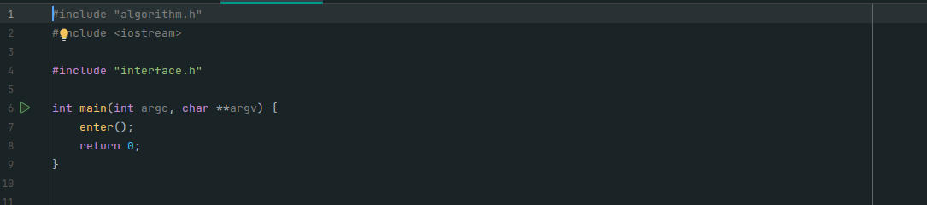
Figure 1.1 – The entry point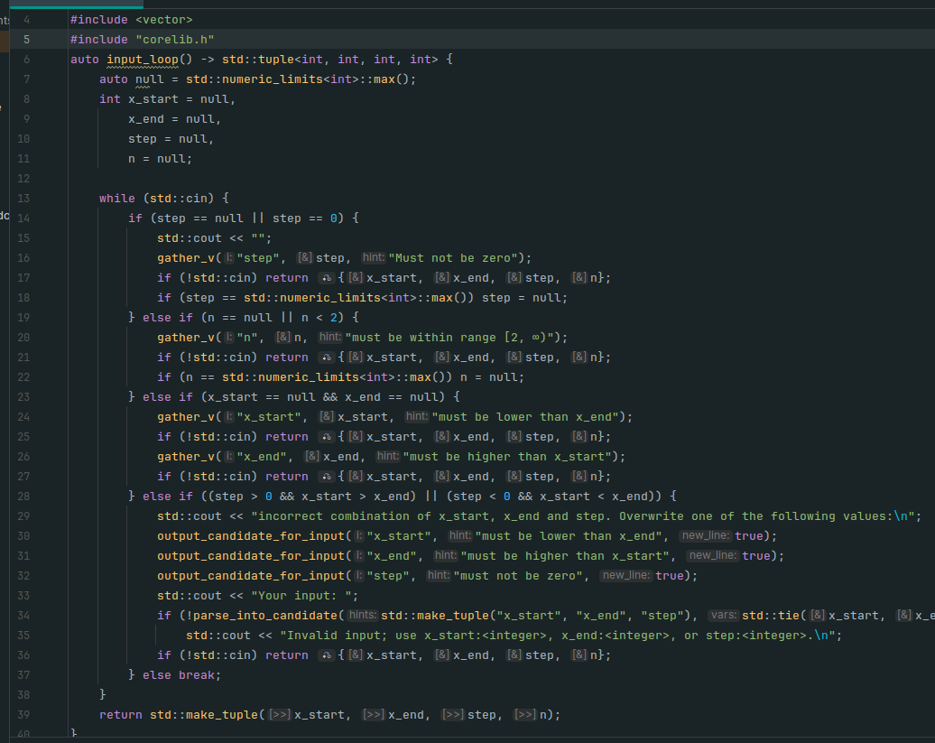
Figure 1.2 - The input loop function
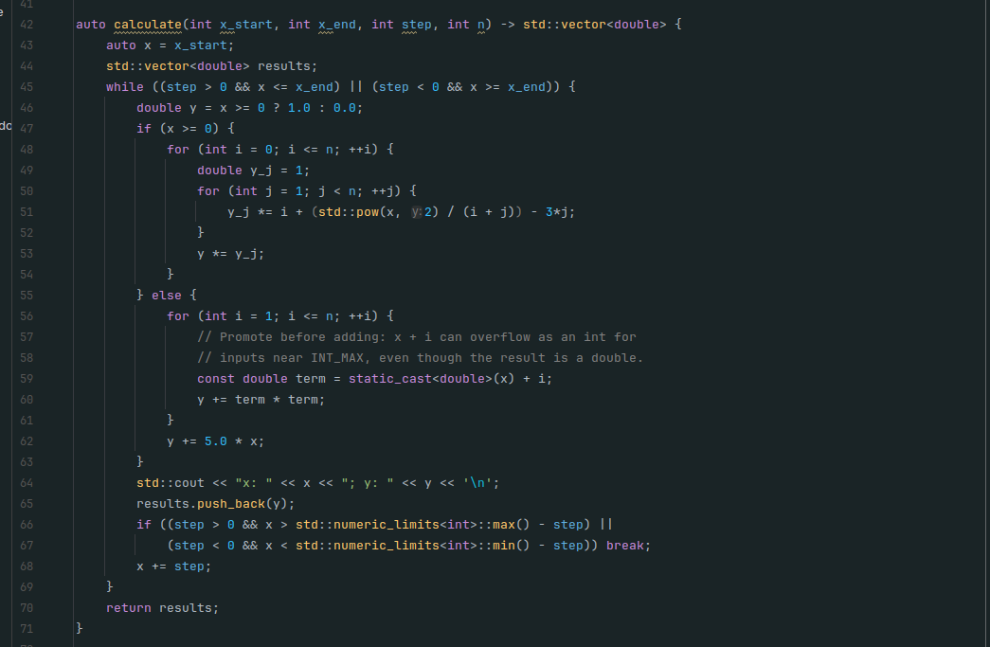Figure 1.3 - the calculate function
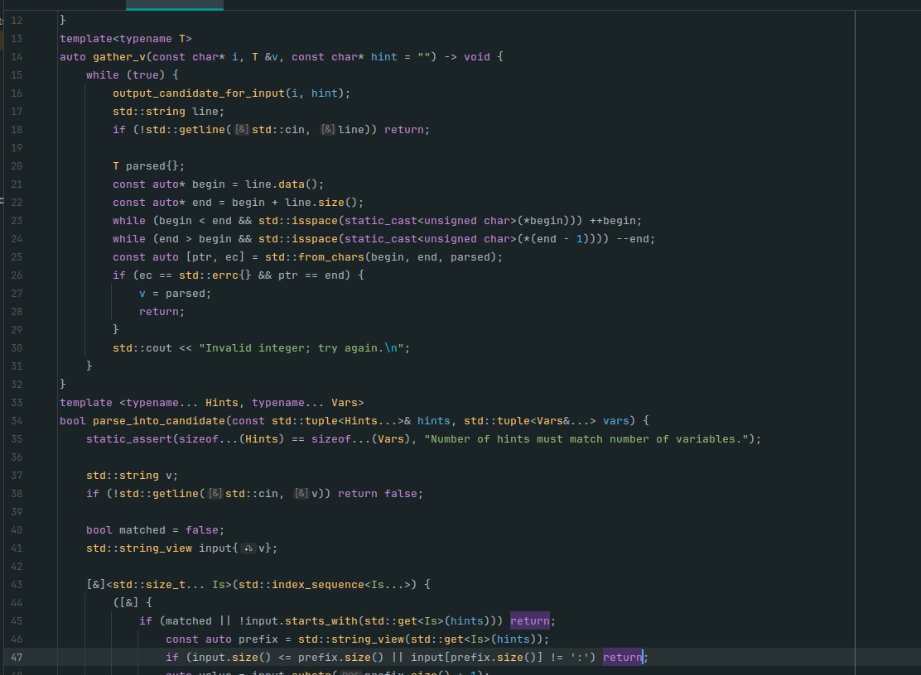
Figure 1.4 - the corelib template-heavy API
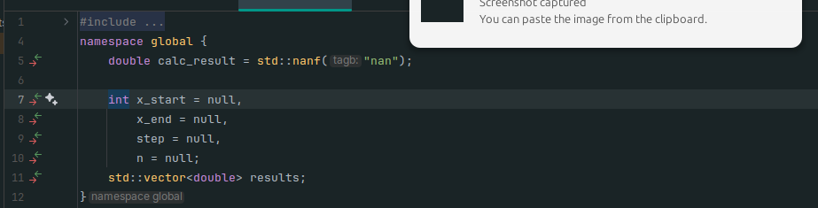
Figure 1.5 - the global program declarations
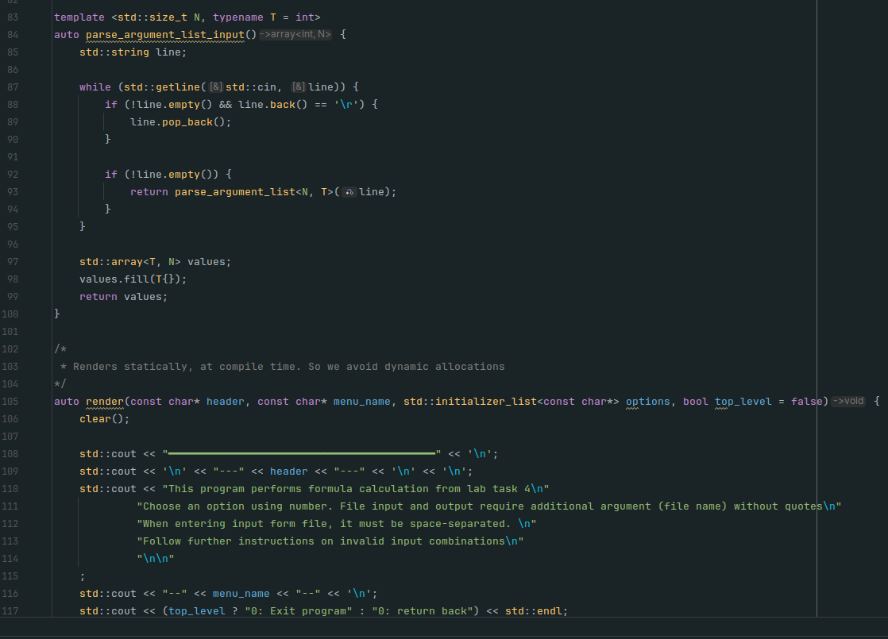
Figure 1.6 - the chunk of interface.cpp
Figure 1.6 – Code of the program (main function)
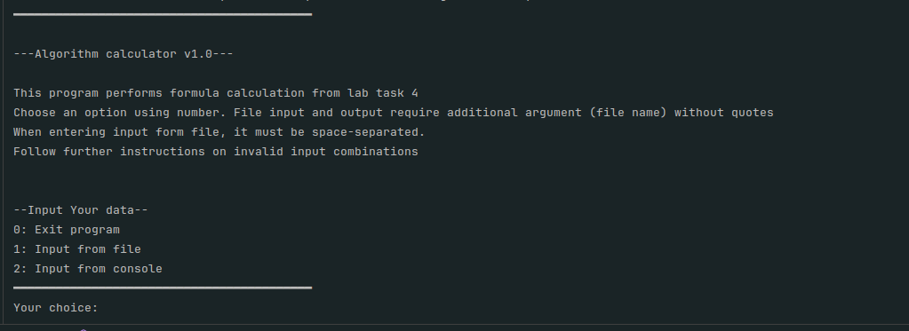
Figure 1.7 – Work of the program: start menu
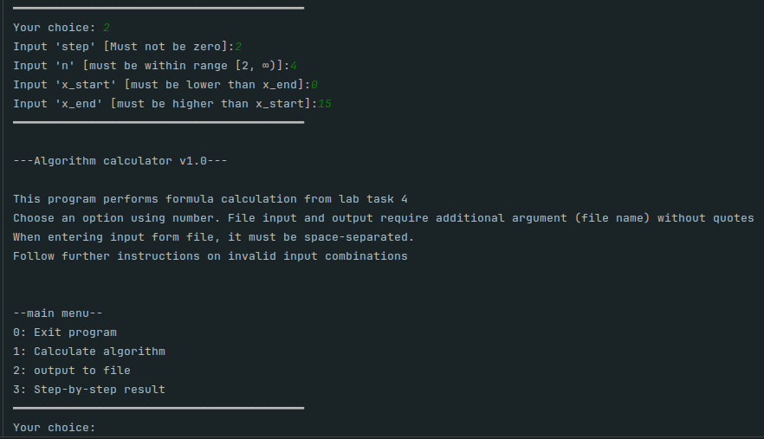
Figure 1.8 – Work of the program: input from keyboard and jump to main menu
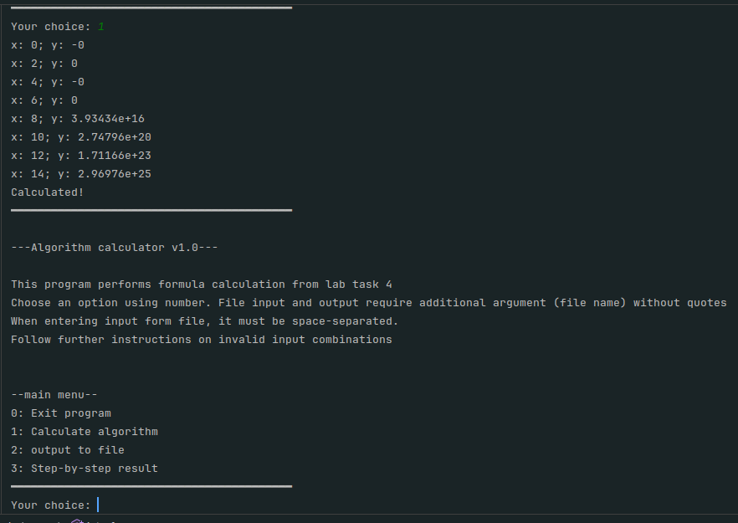
Figure 1.9 – Work of the program: Algorithm work, execution and calculation
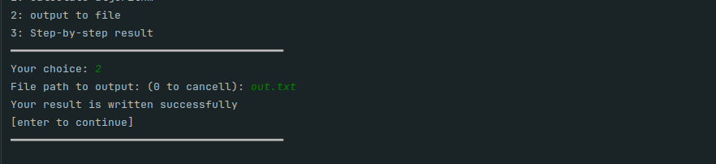
Figure 1.10 – Work of the program: Output to file
Task 2.2 Enhancing Interface and User Experience. Wireframe
To make user experience far better with this console application, the following UX points were applied:
- clarity of commands and a title in a frame with short explanation of every menu
- help and clean usage guidelines right in the interface
- the result of operation, or elseway reported feedback on successfull or failed operation, potentially explaining the case shortly
- screens are same so user is easier to navigate and 0 always means to abort operation
The wireframe of the screens is shown in Figure 2.1. It shows the structure of every screen without real values: [number] and [user input] mark the places where the user types data, [hint] marks short explanations, and “or” separates the successful result from the error message. The possible transitions between the screens are shown in Figure 2.2.

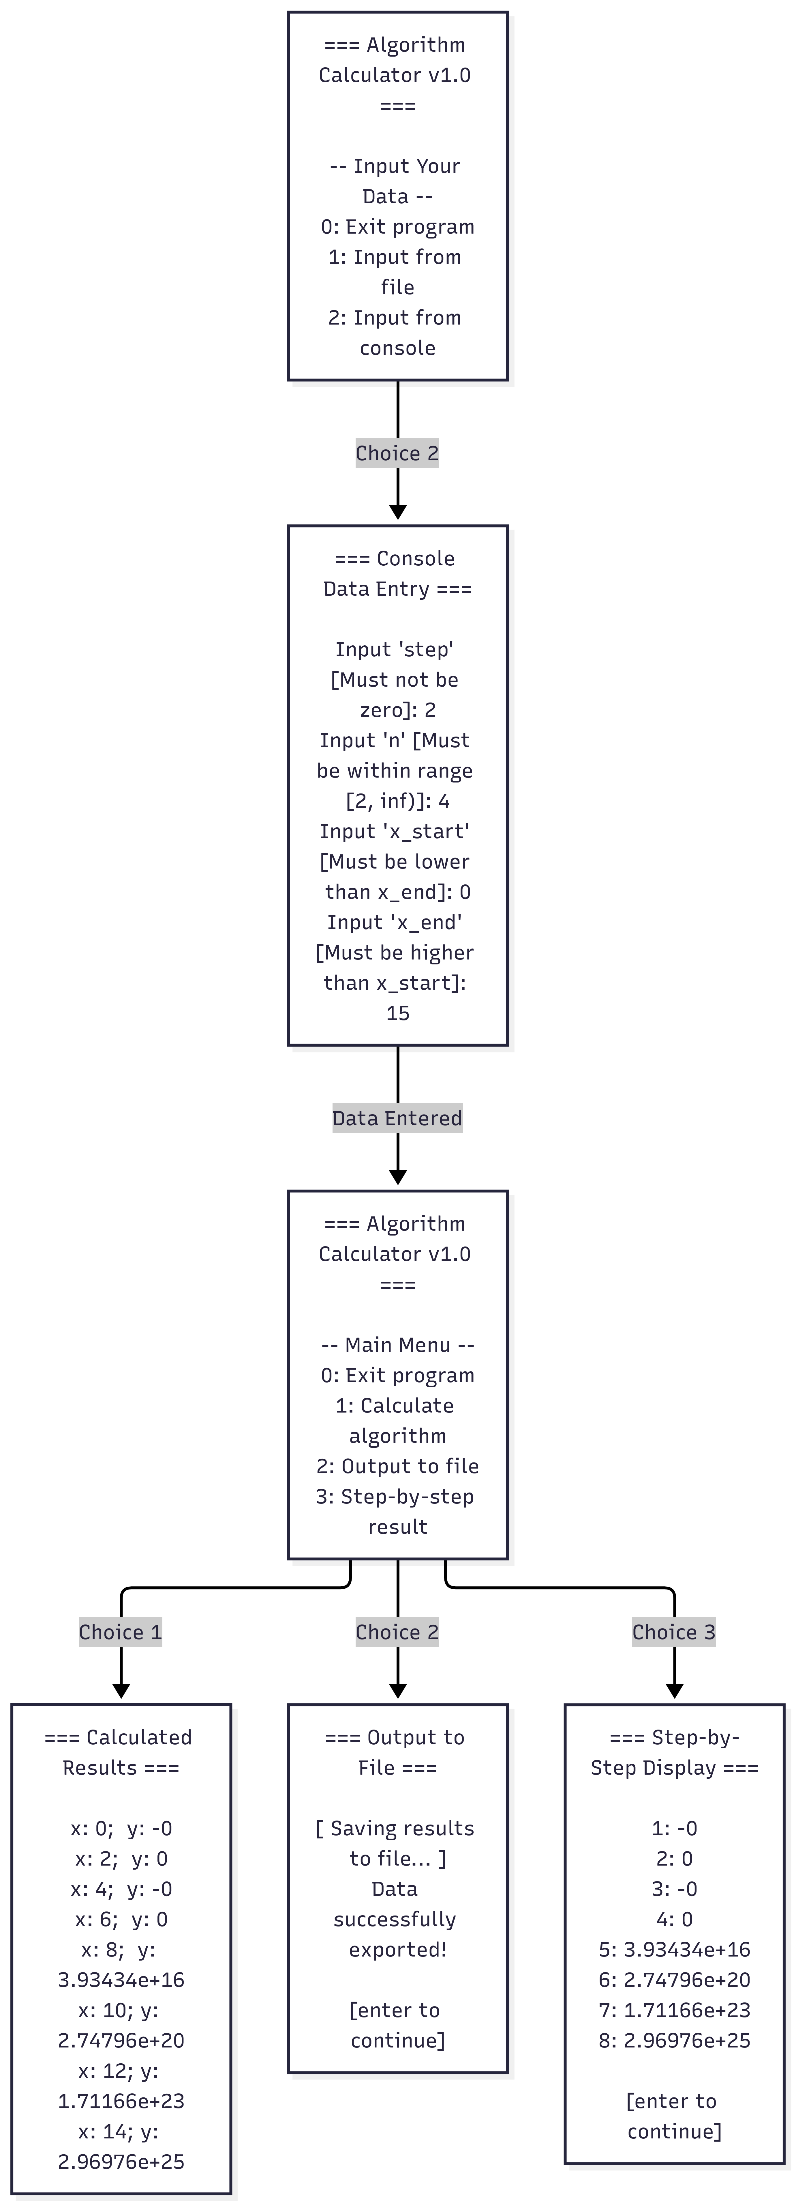
Figure 2.2 – Possible transitions between screens
Use case scenarios:
Use Case 1: Enter data from keyboard. The user chooses 1 and types the start value −2, then the end value −5. The program explains that the end value cannot be smaller than the start value and asks only the end value again. The user types 4, the step 1 and n = 4, and the program prints “Data accepted”.
Use Case 2: Load data from file. The user chooses 2 and presses Enter, so input.txt is used. The program checks the four values by the same rules and prints “Data loaded”. If the file does not exist or is wrong, the program explains the reason and keeps the previous data.
Use Case 3: Calculate and show table. The user chooses 3. The program prints the table of x and y with “not defined” at x = 0 and asks whether to save it; after “y” the table is written to results.txt. If there is no data yet, the program asks to choose option 1 or 2 first.
Use Case 4: Help. The user chooses 4 and reads what every value means, the rules, the file format and the special results in the table.
Use Case 5: Exit. The user chooses 0, the program prints “Goodbye!” and ends.
Conclusions
In this laboratory work we have learned the basic principles of C++ by writing a console program for Variant 3 according to the Activity diagram from Lab 1. The program calculates the function for the whole range with the given step, checks every input value separately with the same rules for the keyboard and the file, shows “not defined” at x = 0 and can save the table to a file. The interface was improved with a described menu, prompts with examples, a Help screen, feedback and errors that explain what is wrong, and it was designed with a wireframe and a diagram of transitions between screens.

