Test Loss: 0.0026

Test Accuracy: 0.9935

Test Precision: 0.9934

Test Recall: 0.9838

Test Specificity: 0.9991

Validation Loss: 0.0026

Validation Accuracy: 0.9935

10/10 [==============================] - 1s 15ms/step

Confusion Matrix:

[[31 0 0 0 0 0 0 0]

[ 1 42 0 0 0 0 1 0]

[ 0 0 33 0 0 0 0 0]

[ 0 0 0 45 0 0 0 0]

[ 0 0 0 0 31 0 0 0]

[ 0 0 0 0 0 52 0 0]

[ 0 0 0 0 0 0 37 0]

[ 0 0 0 0 0 0 0 35]]

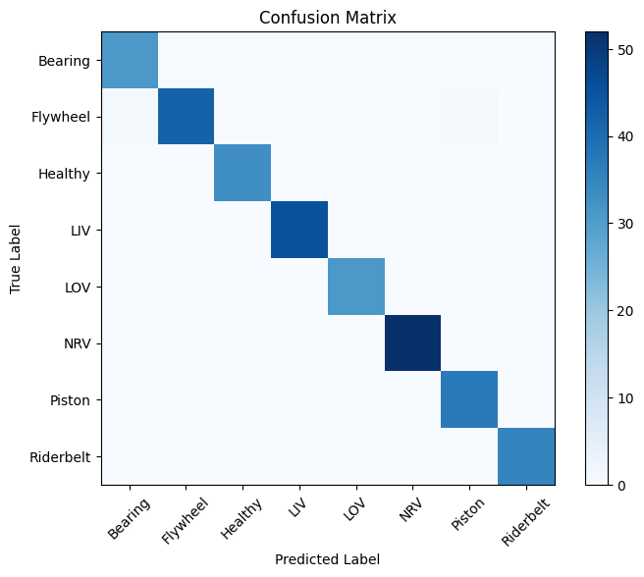

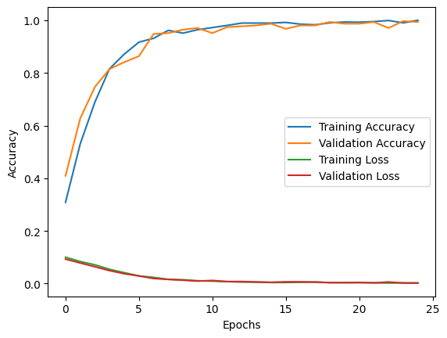

1/1 [==============================] - 0s 29ms/step

Shape of prediction: (1, 8)

The Status of Air Compressor Predicted using LSTM: ['Healthy']